SPATIAL IMPACT OF NEW TECHNOLOGY IN TRANSPORT IN LDCS
( A SAM-BASED GENERAL EQUILBRIUM APPROACH )

by Cristela Goce-Dakila
Economics Department, De La Salle University
2401 Taft Avenue, Manila 1004
PHILIPPINES
Email :dakilac@dlsu.edu.ph

&

Shoshi Mizokami
Department of Civil & Environmental Engineering
Kumamoto University
2-39-1 Kurokami , Kumamoto 860-8555
JAPAN
Email: smizo@gpo.kumamoto-u.ac.jp

ABSTRACT
This paper depicts the spatial impact of a technological improvement within the transport sector across households and administrative regions in the Philippines. The framework used is that of a social accounting matrix (SAM)-based spatial computable general equilibrium model with five regions and disaggregated production and household sectors. The paper finds that the welfare effects of transport infrastructure investment, as measured by equivalent variation are highest in middle income households in the richest and poorest regions in the Philippines. Increase in interregional economic activity as measured by the change in impedance ratio is highest in the regional transport sector where technological innovation originated.

Key Words : technological improvement, spatial impact, social accounting matrix , general equilibrium

I. Introduction
This paper is an experiment in the usage of social accounting matrix (SAM)-based spatial computable equilibrium (SCGE) model in impact assessment of technological improvement within the transport sector in a developing country like the Philippines.
Motivated by the drive to improve efficiency and to remain competitive , firms within the transport industry have sought to adopt cost-effective technology which addresses their need to increase capacity and speed. This technological innovation translates to a higher output elasticity with respect to transport input and consequently to increases in employment and income.
This study analyzes the economy-wide repercussion of such an event by using parameters calibrated from a five-region social accounting matrix constructed by the authors. It aims to give transport and economic planners a general overview of the magnitude and direction of the impact a 5% increase in output elasticity with respect to transport inputs caused by technological change. The impact of technological change takes on a generic representation in the form of an increase in monetary value of output. within each transport mode – air , water and land .While this is the expected outcome of better transport technology, this paper looks into the distribution of benefits of such a change across different regional production sectors and across different regional household income groups.
This is the first spatial equilibrium model with a disaggregated transport sector in the Philippines. All Philippine CGE models devised in the past have been national in scope. This is also a first attempt in constructing a five-region social accounting matrix as database for SCGE modeling in the Philippines.
II . Concept & Financing of Technological Improvement In Transport Sector
2.1 Concept of Technological Improvement
A technological innovation has been defined as a concept which encompasses new alternatives not yet there or not well known; any new idea set in motion to solve urgent problems or new activities or reorganization of activities.( Giannopoulos : 1993). According to Vleugel, technological improvement within the transport sector can be related to new types of technology concerning vehicles, new modes of transport and new means for upgrading the performance and service of existing modes of transport. Also included are all advances in information technology ( relating to creating, handling storing and transmitting information ) affect the operation and organization of transport system. In developing countries, technological change in transport can take the form of any innovation which improves the delivery of tranport services and enhances their efficiency. Generic examples for developing countries , mostly based on the Philippine experience, are shown in italics in Tables 1 and 2
There are various key factors which affect technological innovations in transport. Among these are economic conditions, government intervention, changes in transport demand and social perception. (Vleugel : 1994). Economic conditions include favorable economic growth ( macro level), competition ( meso level) or the quality of management (micro level). Stable macroeonomic conditions lead to higher level of investment during period of economic boom. Intensive competition motivates firms to invest in R & D. At the micro level, firms adopt new technology to remain competitive. On the part of government , it affects state of technology through its regulation of vehicles and infrastructure requirements. Government affects technological innovation in transport through its anti-pollution policies, taxation policies and level of government subsidies to various modes of public transport.
There are five forces which drive inventors to institute technological change in the transport sector. These are the desires to (1) improve speed in transport mode, (2) increase capacity, (3) lower cost of transport, (4) institute more comfort , quality, safety measures on transport mode(5)improve the image of the service. These characteristics can be seen as the driving forces of innovation.
Examples of specific types of technological change in passenger transport in LDCs are juxtaposed with those in developed countries in Table 1. In the case of LDCs, the dominant motivating force for technological innovation in passenger transport maybe increased speed , comfort and security. The simplest form of technological change in rail transport in LDCs for example, can be modernization of railway tracks, removal of foot trolleys or elimination of informal settlements along the railway. Since road transport is the most frequently used service in LDCs, any road-widening project , or installation of working traffic lights or better intermodal linkage among land, water and air transport would be ideal types of technological change. The table for developed countries is revised to include parallel types of technological change in LDCs.
INSERT Table 1 Technological Change in Passenger Transport
In Table 2 , the following types of technological change in the freight transport markedt were forecasted up to year 2020 in developed countries ( Giannopoulos : 1993). These were contrasted with changes in LDCs as perceived by the authors. For freight transport, even simpler technological improvements in LDCs can be undertaken. These are detailed in italic prints in Table 2.
INSERT Table 2 : Technological Change in Freight Transport
An important type of technological innovation in freight transport is the process change which occurs in logistics These include new technologies in the field of telematics, improved vehicle utilization handling systems, and product flow rescheduling. These changes enhance efficiency and affect the flow of goods transported. Other types of technological change include the realignment of supply chains and new patterns of sourcing raw materials..( Giannopolous : 1993)
2.2 Financing of Technological Improvement
Since inducing technological change within the transport sector is resource-intensive, the problem of sourcing funds is a major concern for developed and developing countries. However, there is a very distinct difference between the two.
While technological innovation in developed countries is manifested by a total shifting of their production possibility curve, most developing countries (LDCs) operate inside their production possibility frontier . Therefore most of the resource mobilization for implementing technological change in LDCs takes the form of institutional reforms, better utilization of transport infrastructure funds and reliance on foreign aid.
This study assumes that fund-sourcing for developing countries like the Philippines takes the form of improving the quality of budget allocation for transport like increasing the absorptive capacity of government agencies tasked to implement transport technological change. Since transport infrastructure takes on a quasi-public good dimension, it is government that bears the burden of financing such projects mainly through foreign transfers.
The financing of exogenous shock in the model therefore takes on a revenue-sourcing scheme which has neutral reallocation effects on the whole economy.
III. Overview of Transport-Oriented General Equilibrium Models
To understand the impact of improved technology in transport sector, a review of different transport-oriented general equilibrium models is undertaken. This type of models proliferated during the nineties and through early 21st century. Differences in modeling transport in a general equilibrium setting arise from the way the cost concept is conceived.
Buckley (1992) formulated a transportation-oriented general equilibrium model where capital and labor cannot shift at the interregional level. Therefore, factor income rates vary among regions and there is specialization among regions. Buckley model is composed of three regions within which differently located agents operate. Each transaction requires transport services, even in the case of intraregional exchange. Buckley model includes a clearinghouse in each region through which all transactions pass through, whether intraregional, interregional or international. The production function is a combination of Cobb-Douglas and Leontief where Leontief function combines intermediate inputs with factor inputs like labor and capital in fixed proportions.
Elbers (1996) created a multi-region SCGE where some sectors adopt the Armington assumption and others adopt the rules of the theory of spatial price equilibrium. His model considered the transport sector as an independent sector. He solved SCGE using the rules of spatial price equilbirum analysis. Elbers hypothesized that the transport sector produced services offered by a hypothetical region, which is different from those linked by commercial transactions. He defined his transport cost function as determined by the prices of goods exchanged and the demand for these goods .According to Elbers, his model clashes with the nature of transport sector as a multi-firm sector and a multi-product sector. In consideration of the concept of transport costs linked with volume transported, Elbers devised a another model of transport sector. In this model, apart from labor and capital, a third input in the form of M , the motive power factor was added. The movement of a unit of commodity in this model required a certain unit cost of quantity M which is used for transport along a distance with length 1. Economic agents leased M to whoever produced the transport service and therefore made transport service production endogenous. Here, there is no unique equilibrium.
The Van den Bergh model (1997) is a multi-region spatial model in which goods produced by the regions differ from each other. It considered a closed economy with two integrated regions, . Each region has a single industry which produces a commodity different from the one produced by the other region. This single industry in each region uses as intermediate input the output produced by the other region and the two production factors, capital and labor. On the consumption side, each region has a representative consumer whose utility is determined by a combination of two commodities and who determines his location exogenously. The individual region does not have a spatial dimension. The transport sector is a national sector ,used only for interregional exchanges. Transport services are purchased by whoever imports.
The next branch of general equilibrium models with transport sector is composed of network models.. Network equilibrium models are used in engineering and operations research as a means of forecasting traffic flow. Today, they are integrated in CGE models to obtain estimates of cost per transport link.
The possibility of inserting network equilibrium models into CGE models was first developed by Harker (1987) and then further elaborated on by Roson ( 1993 ) and Friesz (2000). Roson ( 1993) integrated network equilibrium and Walrasian equilibrium into a single model. He introduced space in his structure of general equilibrium, wherein a location in space is uniquely assigned to each economic agent and each movement across space creates a demand for transport. The search for global equilibrium is composed of the search for the equilibrium values of prices, the quantities of the goods and the costs associated with the links so that there is network equilibrium and economic equilibrium calculated simultaneously. Roson’s model is composed of three interdependent submodels linked to each other by an iterative calculation procedure. He used his model called MITER to assess the impact of congestion in the Italian economy.
Friesz, Suo and Westin (1998) formulated an integrated network equilibrium- general equilibrium model with a transport sector . However, the model contained only one mode of transport. The demand for transport is non price-elastic and depended only on the production level of each sector.
In Asia , transport-oriented SCGE models were formulated in Japan by Miyagi (2001) with the goal of estimating the geographic impact of a major highway link in central Japan. . Other SCGE models for Japan include those constructed by Koike et al ( 2000) and Ueda et al ( 2001 )which sought to analyze the economic impact of a major earth quake which damaged the high speed rail network to Tokyo. For Korea, the work of Hewings and Kim on the the regional welfare impact of highways utilized an SCGE model (1999). For Brazil, Haddad and Hewing created a spatial CGE model with a transport sector under imperfectly competitive markets (2003). For China, the work by Li (2003), utilized an interregional CGE model to determine the interrelationship among economic growth, energy use and environmental protection. . For the Philippines, no SCGE model has been estimated yet and this paper is the first endeavor in such direction.
In Europe, Brocker developed CGEurope in 1999 which covered 800 regions . Brocker’s model quantified regional welfare effects of transport related and financial-economic policies like Trans-European Networks (TENs) investments and transport pricing Other European SCGE models developed include the BROBISSE model for Denmark ( Caspensen et al 2000 ; the PINGO model in Norway (Ivanova et al 2002); the RAEM model for the Netherlands(Knaap & Oosterhaven:2002). Other SCGE models include those developed in Sweden ( Hussain & Westin : 1997; Nordman: 1998 and Sundberg : 2002 ). In the USA, the most recent interregional CGE model with transport sector was that developed by Lofgren and Robinson (1999).
In the Philippines, this is the first spatial general equilibrium model devised for the Philippines , using a five-region model. All previous CGE models devised have been national in scope. These include the Agricultural Policy Experiment (APEX) model (1992); Bautista C. model (1987 & 1992); Bautista R. model (1986); Clarete (1984 & 1991); Cororaton(1988), (1989), (2000); Habito (1984 & 1989) and Jemio & Vos (1993).

Despite the models already devised, general equilibrium models with a transport sector have certain limitations when used for transport project appraisal. An article by Tavassy, Thissen, Muskens,Oosterhaven (2002) discussed this and proposed alternative specifications. Based on their experience in the construction of Dutch CGE model called RAEM, the article pinpointed that the main limitation of using SCGE models was in the specification of transport costs within a spatial framework. Other areas of concern in SCGE were the problem of locational boundedness of economic activities and the impact of transport infrastructure on passenger flow. They attributed these problems to the lack of empirical data on the consumption of transport services by various sectors, a possible mismatch in the definition of transport costs as they are produced in transport models and as they are inputted in SCGE models. The article also described how the use of 4-step transport models introduce inconsistencies in appraisal results. The article stated that the use of iceberg transport costs is empirically acceptable in one-sector economy but can lead to underestimation of impact in those sectors most sensitive to the reduction in tranport costs when applied to multi-sector models. In the end, they proposed that hysteresis and locational boundedness of production should be into account in modeling transport within SCGE models.
IV. Model Specification
4.1 Database
. The calibration of the SCGE model required the construction of a special
five-region social accounting matrix (SAM) that was used as the benchmark for deriving the baseline values for the SCGE model. All parameters used in the model were taken from the multi-region SAM constructed by the authors .No parameter was borrowed from other studies. For example, elasticity coefficients in Cobb-Douglas utility function were taken from expenditure shares of various commodities in the household’s consumption basket.
A SAM represents transactions in a complete economic system during an accounting period, usually one year. It integrates, within a macroeconomic framework, several detailed accounts for factors of production and institutions—especially households—so as to focus on the living standards of different groups in society. Round (2003) elaborated on the main features of a SAM, which are threefold: (1) The accounts in a SAM are represented as a square matrix, in which the incomings and outgoings for each account are shown in corresponding matrix rows and columns. The transactions are shown in the cells, so the matrix displays the interconnections between agents in an explicit way. The corresponding row and column totals in the SAM must be equal to each other. (2) The SAM is comprehensive: it portrays all the economic activities of the system (consumption, production, accumulation and distribution), although not necessarily with equivalent emphasis. (3) The SAM is flexible, in that, although it is usually set up in a standard, basic framework, there is a large measure of discretion both in the degree of disaggregation and in the emphasis placed on different parts of the economic system.
When a national SAM is split into regional SAMs (RSAM), the flow of income from production units to consuming units is given a spatial dimension. In line with this objective, a five-region SAM was constructed in order to analyze ripple effects of particular shocks, particularly on regional income disparity and other aspects of the regional economies. This multiregional SAM (MRSAM) is presented in detail in Dakila, C. and Mizokami, S. (2006). The main data source for the study is the 1994 five-region Philippine inter-regional input-output (PIRIO) table, which regrouped the 15 administrative regions of the country in 1994 (now 17) into five greater regions according to geographic proximity (Secretario, 2002). This regional classification is carried over to the present paper. As described in Dakila and Mizokami (2006), there were three major activities undertaken to derive the MRSAM. First, the coverage of the 1994 PIRIO was expanded. In particular, the personal consumption expenditures component in the final demand column was further disaggregated according to income class. Greater attention was paid to the components of value added across sectors.Import transactions were broken down into CIF values, tariffs and import taxes. Second, the PIRIO was transformed from an open-type input-output model (i.e., one with an exogenous household sector) into a closed input-output model, with the household sector endogenized within the production system of regional economies. This closed input-output ( I-O )framework accounted for the balance between the different sources of incomes for households. For this, the Philippine Family Income Expenditures Survey (FIES) was the primary data source. Finally, the multi-region SAM (MRSAM) was compiled based on the expanded Philippine interregional input-output table (PIRIO).
4 .2 Assumptions of Model
The assumptions adopted are as follows (1.)All product and factor markets operate under perfectly competitive conditions. (2) Economic agents like households and firms maximize an objective function subject to constraints. Households maximize utility whereas firms maximize profit. (3) Equilibrium is defined as a state where the actions of all agents are mutually consistent and can be executed simultaneously. Quantities adjust in the model and prices follow to equate the notional and effective demand for labor. (4) In this model, adjustment to equilibrium is implemented by specifiying that markets adjust to minimize the sum of excess supplies. (5) Among the seven-production sectors; three belong to the transport sector, namely, water transport services sector, air transport services sector, land transport services sector. The demand for services of each type of transport mode is a derived demand associated with the demand of intermediate production goods. (5) Between the two factors of production , capital is immobile and labor is mobile among the five regions. (6) The economy has 36 markets . This is composed of thirty-four product markets of each the aforementioned five regions with seven production sectors each except for NCR, one capital market and one labor market.

INSERT Table 3 : Sectoral Disaggregation
4.3 Description of Model
The framework takes off from Mizokami model of two region economy in the Philippines with four production sectors including transport. (Mizokami et al :2005). However, there are variations in specification of the production function. A three-nested production function is estimated. The transport sector intermediate input is isolated in the second level of production function. A more detailed disaggregation of transport sector is delineated – namely water transport services sector, air transport services sector and land transport services sector. Another point of difference is that households in each region are decomposed into three income levels - low, middle and high. Finally, the rest-of-the-Philippines region is divided into four regions namely Northern Luzon, Southern Luzon, Visayas and Mindanao vis-à-vis National Capital Region.
The model presented below is a simple representation of an economic system with assumption of perfect competition in goods and factor markets and constant returns to scale in production. This is the start of promising experiments into the usage of SCGE modeling for developing countries with limited data like the Philippines. Also, it is recognized that recent advances in spatial computable general equilibrium (SCGE) modeling have incorporated such assumptions as increasing returns to scale, agglomeration economies , imperfect competition in the model. Given that SCGE modeling is at its infancy stage in the Philippines, these modifications will be undertaken in future studies.
4.3.1 Production Sector
Production is modeled assuming a three-stage production function. At the first stage, capital and labor are combined to produce value-added, using a Cobb-Douglas production technology.
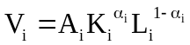 (1)
where for sector i and region r, V = value added, K = capital, L = labor, α = share of capital in value-added, and 1-α = share of labor in value-added. Thus, the specification of the Cobb-Douglas function assumes constant returns to scale. Capital is assumed to be immobile across sectors while labor is mobile.
In stage 2, value-added is combined with non-transport intermediate inputs under a Leontief technology, to produce a composite good, which is output net of transport; where Q_{1i}….Q_{2i} represent the nontransport intermediate input, V_{i}is the value added per sector and and the a_{i} represents the Leontief coefficient..
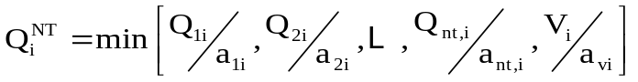 (2)
Finally, stage 3 combines output net of transport with transport intermediate inputs under a Cobb-Douglas production function to yield total output gross of transport.
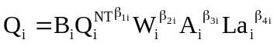;where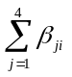=1 (3)
where W is water transport intermediate input, A is air transport intermediate input and La is land transport intermediate input. W, A and L represent the different transport intermediate inputs which go into sector i. Thus, this specification allows substitutability among the various transport modes – water transport, air transport and land transport. =
The firm is assumed to maximize profits. Because of the nature of the production function, profit maximization can be described in three stages. The bottom stage entails choosing the optimum levels of capital and labor so as to maximize the contribution of value added to profits. Let Π_{VA} represent this contribution of value added. Then the optimization problem is
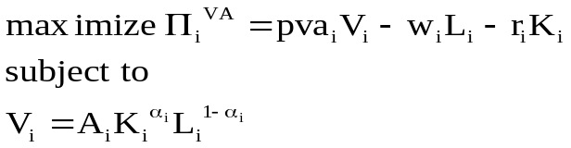 (4)
where V represents value added, and pva is its corresponding price. Since capital is immobile, of particular interest is the first-order condition for labor, which is
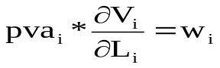
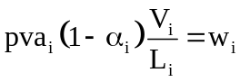 (5)
It is convenient to move next to the top stage of the production process, since this is likewise of Cobb-Douglas structure. There the optimization problem is
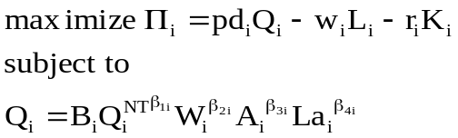 (6)
and the corresponding first order conditions are
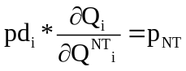 or 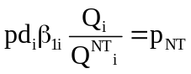 (7)
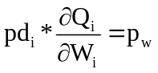 or 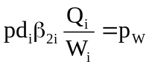
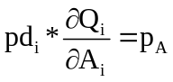 or 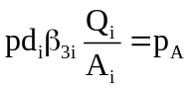
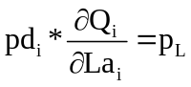or 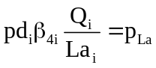
Finally, once output net of transport is determined, the different non-transport inputs as well as total value added can be derived using the fixed coefficients technology (2). While this may seem to over-determine value-added in the system, we take (5) as actually determining pva. We turn to this in greater detail in the section on prices.
4.3.2. Household Sector
The model distinguishes between 15 representative households, with 3 household types (representing the low, middle, and high income classes) for each of the five regional groupings distinguished in this paper. The preferences of each household type are summarized by a corresponding Cobb-Douglas utility function:
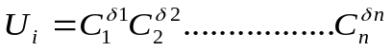 (8)
Each representative household maximizes its utility subject to its income constraint,which we describe below.
For each region, household labor income is assumed to be the equal to the sum of the labor incomes that each household income group earns from supplying labor within the region. The endowments of labor of different income classes within a region are taken to be a constant; this then determines how labor income is distributed within each region. Since capital is fixed, then each household income group is assumed to own a fixed share of total capital, and this ratio is maintained through the policy experiments. Household income is assumed to be the sum of labor income (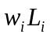) plus that portion of capital income that accrues to the households (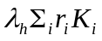), plus transfers from government and from the rest of the world. The latter two are exogenously determined. Thus, if we partition the indices h and i so that the rth partition belongs to the rth region, then total income per household type is therefore given by
(9)
where the ω’s are the labor income distribution parameters, and, as indicated, the summation is for industries belonging to the rth region. Total disposable income is found by subtracting direct taxes imposed on the household from the foregoing quantity:
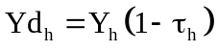 (10)
where Y_{d} is disposable income and τ_{h} is the direct tax rate imposed on household h. The summation is now applied for each household type, so that we have dropped the subscript r referring to the partitioning across regions.
Each household type is assumed to consume a constant proportion of its disposable income.Thus, households maximize utility subject to the budget constraint.
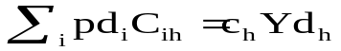 (11)
where pd_{i} is the domestic price of the good and c_{h} is the average propensity to consume of household h. Given the Cobb-Douglas utility function, the first order conditions require that:
(12)
where 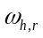is the labor income distribution parameter; is distribution parameter of capital income of households and is the income tax rate.
4.3.3 Government Sector
The model incorporates a national government sector, i.e. the behavior of regional government units is not considered. Government enters the economy in several ways: it purchases output from each sector, imposes indirect taxes on production and tariffs on imported goods, and direct taxes on income of each household type. Government expenditures on each commodity are taken as exogenous in the model, while taxes are endogenous. Tariff revenues per commodity equal the product of the tariff rates and import values:
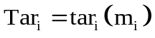 (13)
where Tar_{i} and tar_{i} are total tariff collections from i and the tariff rate on commodity i, respectively. Indirect tax collections are given by the product of the indirect tax rate imposed on domestic production and the rate imposed on imports of the product:
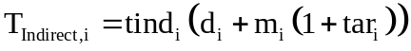 (14)

Direct tax collections per household type in the model are computed as:
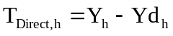 (15)
At this stage of model specification, imports and exports are taken as exogenous.

4 .3.4 Investment-Saving Balance
Total household savings in the model are given by the aggregate difference between household disposable income and consumption expenditures:
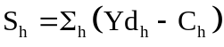 (16)
Total government savings are the sum of the various revenue sources minus total government purchases of the outputs of the various sectors, total government transfers to households, and total net transfers of the government to the foreign sector:
(17)
Total foreign savings, S_{FOR}, are given by the current account balance minus net dividends to foreigners. Thus, total savings are
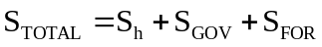 (18)
Conceptually, total savings should equal total investment. Our framework allows for statistical discrepancy by introducing a factor φ which transforms savings to investments. Investment distribution per sector is then modeled as constant proportion of total investment, with the distribution coefficients γ_{i} calibrated according to the sectoral distribution of investment in 1994:
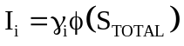 (19)
4.3.5 Prices
The firm is assumed to maximize profits. The first order condition for this entails equating the marginal product to the marginal cost of labor.
(5)
For any given employment, equilibrium entails that the corresponding level of production equal the demand forthcoming at the employment level. This determines the price levels in the economy, relative to the price of labor. The labor price is assumed to be the numeraire, and is thus taken to be fixed.
The total product cost can then be built up from the components in a standard way. Thus, average cost per unit is
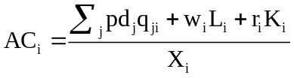 (20)
where X_{i} is the total output of commodity i and qji is the amount of inputs of j into industry i. Therefore, if we partition the input j’s into two sets, NT, the non-transport inputs, and Trans, the transport inputs, the unit cost is divisible into three parts :
(1)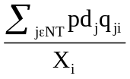 the cost of non transport intermediate inputs per unit of ; (20. 1) (2)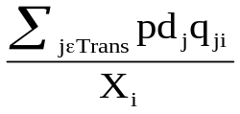cost of transport inputs; (20.2)
(3)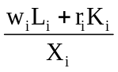the cost of value added per unit of X (20.3)
The excess supply for each commodity is given by:
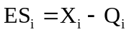 (21)
The model treats all the foregoing relationships as constraints in a nonlinear programming problem. Markets are assumed to operate so as to minimize the value of sum of squared excess supplies for all commodities; i.e., the objective of the programming problem is to minimize the quantity
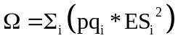 (22)
4.3.6 Equilibrium Condition :
Y = C + I + G + X- M
Where Y = aggregate supply
C= total consumption expenditures of the national economy
I = total investment expenditures of the national economy
G = total government expenditures of the national economy
M = total purchases of foreign-made goods by domestic residents
Total consumption (C) can be represented by
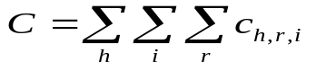 Where h: household income class group (23.1)
r : region
i : production sector
Total disposable income (Yd) is estimated by
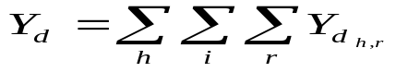 (23.2)
Savings-Investment Balance is depicted by

I = a ( Y_{d} - C ) where “a “ is balancing parameter (23.3)

Distribution of investment across sectors is embodied in the equation

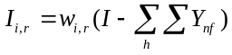, where Y_{nf} is income of informal sector and (23.4)
I_{i,r} is formal investment

4.4. Impedance Ratio
Once equilibrium output is determined, the impedance ratio adjusts due to changes in the matrix of interindustry flows (Mat_{ij} ). The change in impedance ratio is generated within the economic system via the change in Mat_{ij} divided by capacity of three transport mode -land, air and water, taken alternatively. 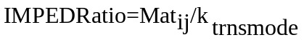 (24)
Δ IMPED Ratio = Imped Ratio_{b4shck} – Imped Ratio_{aftrshck} (24.1)
Δ IMPED Ratio = Mat_{ijb4shck}/ k_{trnsmode} - Mat_{ijaftrshck}/ k_{trnsmode} (24.2)
where Δ IMPED Ratio : change in impedance ratio
Imped Ratio_{b4shck} : impedance ratio before exogenous shock
Imped Ratio _{aftrshck} : impedance ratio after exogenous shock
k_{trnsmode} : transport capacity – either land, air or water
V . Empirical Results
5.1. Change in Relative Welfare Across Regional Household Income Group
Welfare is measured in terms of equivalent variation (EV). EV is the change in money income that would put the household on the new indifference curve at the old prices. EV measures the scale of welfare change achieved through transport infrastructure improvement, which would put households on a higher utility level at previously existing prices. The profits of industries in the equilibrium condition are all zero and the welfare gains go to the household. The welfare gains to either low-income, middle income and high income households depending on their absolute levels of income. The utility maximization problem of households yields the equivalent variation of a price change in one of the goods. Relative welfare refers to the percentage change in utility levels after the introduction of the policy shock. The equation for equivalent variation is detailed below (Mizokami et al: 2005).
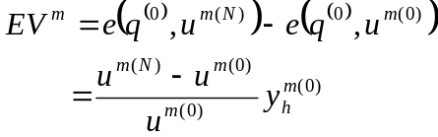

EV_{m}: Equivalent variation of a price change on households
u^{m(0)} : utility level of households before transport infrastructure improvement
u^{m(N)} : utility level of households after transport infrastructure improvement
y^{m(0)}_{h} : The amount of final consumption expenditures of households before transport infrastructure improvement

Among the different transport modes, it is land mode which resulted in the highest relative welfare gain . This may be due to the fact that the road network has strong interlinkage with water and air transport mode. In terms of income groups, the middle income group across all regions was the main beneficiary of technological progress within the transport sector. This is because in terms of absolute numbers, they include the biggest number of households. They also have the biggest access to usage of land vehicles and have high opportunity cost of time. So any technological change which increases speed or capacity of land vehicles, or which leads to better land traffic management or wider road network generates benefits which redound to this group. The National Capital Region (NCR) middle income group is biggest gainer. Very significant is that the Mindanao (MIN) low income group ( where some of the poorest provinces in the Philippines are located ) registered the next highest relative welfare gain. . The relatively lowest welfare gain took place when technological improvements in Southern Luzon (SOL )land transport sector. This maybe because SOL transport system is mainly dependent on ports.
Shifting to the water transport mode, technological improvement in NCR and Visayas water transport sectors caused the highest welfare gain to be experienced by low income households in Visayas and the lowest welfare gain in SOL high income group. This is because movement of people to and from the Visayas takes place via water transport mode. With regards to technological improvements in air, NCR air transport had the highest welfare impact on mostly middle income groups in most regions. They are main users of airline services for business, pleasure or migration purposes.
INSERT Figure 1 : Change in Relative Welfare Due to Transport Techno Change

5.2. Change in Output Levels Across Regional Production Sectors
INSERT Figure 2 : Change in Output Due To Transport Technological Change
Technological improvement in air transport and land transport service mode in NCR resulted in the biggest increase in output among all the regions. This maybe due to the fact that wider road network and faster airplanes generate faster movement of goods and persons from NCR as origin and destination area.
5.3. Change in Impedance Ratio Across All Regional Production Sectors
The tables below show the impact of technological improvement in land transport sector across all regions on interindustry flows via the impedance ratio ( trafficvolume/ transport capacity ). See Tables 4.1 to 4.5. All of the cell entries depict the change in volume to capacity ratio. This was caused by land transport technological change in each region. A positive change in impedance ratio means that there was an increase in traffic flow due to higher output.
All inter industry flows with origin and destination from each of the five region’s land transport services sector had positive changes in impedance ratio. This means that high traffic volume generated by technological change. In contrast, all interindustry flows with water transport sector as destination sector had substantively huge decline in impedance ratio. This maybe indicative of substitution effects which have taken place away from usage of water transport mode to land transport mode.
Due to space and length limits, only the changes in impedance ratios of technological change in land transport sector are depicted in Tables 4.1 to 4.5. This can be justified by the fact that land transport services sectors in all five regions have the biggest impact on interregional economic activity.
Different impedance ratios can be calculated for the other two transport modes namely air transport and water transport. This was done in related papers written by the authors.
INSERT Table 4.1. Change in Impedance Ratio due to Land Transport Technological Change ( Destination Sectors 1 to 8 – Ind NCR to Ind NOL)

INSERT Table 4.2 Change in Impedance Ratio due to Land Transport Technological Change ( Destination- Sectors 9 to 16 – OtrSrvNOL to OtrSrvSOL)

INSERT Table 4.3 Change in Impedance Ratio due to Land Transport Technological Change ( Destination- Sectors 17 to 24 – WtrSrvSOL to WtrSrvVIS)

INSERT Table 4.4 Change in Impedance Ratio due to Land Transport Technological Change ( Destination - Sectors 25 to 32 – AirTrSOL to AirTrMIN )

INSERT Table4.5 Change in Impedance Ratio due to Land Transport Technological Change ( Destination Sectors 33 to 34 – landTrMIN to GovSrvMIN )

VI. Conclusion
The preceding discussion highlighted how an economy-wide interregional general equilibrium model can give some general indications of impact of technological innovation within the transport sector. This is in terms of changes in output, and interregional economic activity via the impedance ratio of regional production sectors and welfare of households in different regions belonging to different income classes.
It was shown that in the case of a developing country like the Philippines, technological change in land transport mode had the highest impact on middle income households in the most affluent region, NCR and the least affluent region, Mindanao. Due to this , interregional flows which had land transport sector as origin and destination, registered an increase in impedance ratio .This can be attributed to the increase in the trade volume over capacity ratio after output increased due to technological change. This finding is validated by a 2004 JICA ( Japan International Cooperation Agency )- DOTC ( Department of Transportation & Communication ) survey of commodity-passenger flow where around 90 percent of such flows go through the road network. Hence, any speed or capacity-enhancing technological change in land vehicles or better traffic management has large multiplier effects on regional economies in the Philippines.
The economy-wide perspective adopted through the spatial general equilibrium model enables the transport planner to pinpoint exactly where and on whom the benefits and costs of technological improvement fall. They also enable the planner to know what type of substitution effects occur across major transport modes and what type of transport modal interlinkages happen. However, an important prerequisite for this exercise is the creation of a robust multi-regional social accounting matrix database .
In the end, it may be said that the spatial impact of technological improvement has positive intraregional and interregional equity and efficiency effects. This may be tapped by policy makers for the attainment of higher levels of social welfare.

REFERENCES :
Bautista, Carlos .(1987). Macroeconomic Adjustment : An Applied Non-Walrasian General Equilibrium Approach “ Unpublished Ph.D. dissertation, UP School of . Economics

Bautista, Romeo. (1988). “ General Equilibrium Effects of Increasing Productivity in Philippine Manufacturing, with Special Reference to Food Processing “. Journal of Philippine Development.

Brocker, J. ( 1999 ). Trans-European Effects of “Trans-European Networks “ :A Spatial CGE Analysis. Mimeo. University of Technology, Dresden.

Buckley, P. ( 1992). A Transportation-Oriented Interregional Computable General Equilibrium Model of the United States. Annals of Regional Science.Vol 26. pp 331-348.; Springer-Verlag Dec. 1992

Caspersen, Eriksen & Larsen . (2000). A Spatial General Equilibrium Model to Evaluate the Great Belt Link in Denmark. AFK, Institute of Local Government Studies, Copenhagen

Clarete,R. & Warr,P.( 1992).“ The Theoretical Structure of the APEX Model of the Philippine Economy “

Cororaton Caesar.(2000). Philippine Computable General Equilibrium Model (PCGEM). Philippine Institute for Development Studies. Discussion Paper Series 2000-03.

David Simmonds Consultancy. (1999) Analaysis of Transport Schemes : Economic Impact Studies. Reort tot the Standing Advisory Committee on Trunk Road Assessment (SACTRA), Oct. 1999.

Brocker,J. (2001). Assessing Spatial Economic Effects of Transport By CGE Analysis :State of the Art & Possible Extensions . Oct.13,2001. Paper Presented at First International ITEM Workshop , Montreal Canada.

Dakila C. & Mizokami S. (2006) . Reconciling I-O Data with O-D Data For SCGE Modeling in a Developing Country. Infrastructure Planning Review.Vol 23.No. 3
Japan Society of Civil Engineers –JSCE publication, Tokyo , Japan; pp.725-736.

Dakila C. & Mizokami S (2006 ). A General Equilibrium Model of the Impact of Impedance Factor in Transport on Interregional Flows in the Philippines Paper Presented During the 2006 International Conference on Economic Modeling in Hongkong Convention & Exhibition Center; under auspices of EcoMod Network, in CD-ROM of Conference Proceedings, June 28-30,2006.

Dakila C. & Mizokami S (2006 ) A SAM Based General Equilibrium Model of the Impact of the Impedance Factor in Transport on Regional Economies in the Philippines. Paper presented during the 2006 Intermediate Input-Output Meeting in Sendai City, Japan; under the auspices of International Input-Output Association, July 26-28, 2006.

Dakila C G. (2007) Impact of Transport Infrastructure Investment on Interregional Economic Activity & Regional Welfare : A SAM-Based General Equilibrium A SAM-Based General Equilibrium Approach. Dissertation Submitted to Kumamoto University.

Dakila C.G. (2006). “Interregional Multiplier Effects of Urban Transport Infrastructure in National Capital Region, Philippines: A Spatial General Equilibrium Approach.” Paper presented during the 31st Annual Conference of the Federation of ASEAN Economic Association (FAEA) held in Singapore Management University, Nov. 23-25, 2006.

Giannopoulos, G.A.( 1993).Technical Innovation in Transport. In: J. Polak and A. Heertje, European Transport Economics, Oxford/Cambridge.

Ginsburgh & Keyser (2002). The Structure of Applied General Equilibrium Models. MIT Press.

Habito C.F. “ ( 1986). “ A General Equilibrium Model for Philippine Agricultural Policy Analysis “ . Journal of Philippine Development.

Hussain & Westin (1997). Network Benefits from Transport Investments Under Increasing Returns to Scale : A SCGE Analysis. Umea Economic Studies, Paper No. 432. Center for Regional Science (CERUM), Umea.

Ivanova, Vold & Jean-Hansen (2002). PINGO a Model for Prediction of Regional &Interregional Freight Transport. TOI Report 578/2002. Institute of Transport Economics, Oslo.

Jemio & Vos (1993). “ External Shocks Debt & Adjustment: A CGE Model for the Philippines“ Institute of Social Studies, Working Paper Series No.45

JICA-DOTC Survey of Interregional Passenger and Freight Flow in the Philippines , December.( 2004). Philippine Department of Transportation & Communication Report.

Koike, Ueda & Miyashista (2000 ). Spatial Computable General Equilibrium Model for Passenger Transport Improvement : Evaluation of Japanese New Shinkansen Project. Presented at the World Conference of RSAI , Lugano. May 2000.

Li, Aijun. (2003) Interregional CGE Analysis of Economy-Environment-Energy Interactions. Unpulbished Ph.D. Dissertation Submitted to Faculty of Engineering. Toyohashi University of Technology.

Lofgren & Robinson (1999 ). Spatial Networks in Multi-region Computable General Equilibrium Models. TMD Discussion Paper No. 35, IFPRI, Washington, D.C.

Miller & Blair. (1985). Input-Output Analysis: Foundations and Extensions. Englewood-Cliffs: Prentice-Hall.

Mizokami, Shoshi. (2002). Utilizing Interregional Input-Output Analysis in Interregional Transportation Policy: Methodology and Case Study in Japan. In T. Ohmachi & E. Roman (eds.), Metro Manila: In Search of a Sustainable Future. JSPS-Univ. of Philippines Press, Quezon City.

Mizokami S.( 2003). “ An Interregional Freight Demand Model by Spatial Applied General Equilibrium Analysis “ . Journal of EASTS. Vol. 5, pp.287-299.

Mizokami S, Itose M & Dakila C. (2005). “ Application of SCGE to A Developing Country “ Journal of Eastern Asia Society for Transport Studies EASTS. Vol 6, pp 3985 –4000.

Mizokami, S & Dakila C. (2005) . “ An Analysis of the Linkage Between 2004 JICA-DOTC Commodity-Passenger Flow Survey & Interregional Flows in Multi-Regional SAM in the Philippines “.Paper presented during the 31st Conference of Japan Society of Civil Engineers. Hiroshima University, Japan ; June 4-5, 2005.

National Statistics Office (1995), 1994 Family Income & Expenditure Survey, Manila.

National Statistics Office , (1995) 1994 Census of Establishments, Manila, 1995.

National Statistical Coordination Board (1999). 1994 Philippine Input-Output Tables.

National Statistical Coordination Board. (1995). Manual on Philippine System of National Accounts. Draft paper.

National Statistical Coordination Board. (1990) Social Accounting Matrix for the Philippines

Oosterhaven, Knaap, Ruijgrok & Tavasszy (2001). On the Development of RAEM : the Dutch SCGE Model and Its First Application . 41st European RSA Conference, Zagreb, 2001

Round, J. (2003), “Constructing SAMs for Development Policy Analysis: Lessons Learned and Challenges Ahead”, Economic Systems Research, Vol 15. No. 2.

Secretario, F. (2002), 1994 Philippines Interregional Input-Output Table – 5 Region, Japan Society for the Promotion of Science-Manila Project.

Venables A And Gasiorek, M (1999) The Welfare Implications of Transport Improvement in the Presence of Market Failure ; The Incidence of Imperfect Competition in UK Sectors and Regions. DETR, London

Van Bergh J.C.J.M. van den, Jeroen C.J.M. ( 1997). Economy-Wide Effects of Freight Transport in spatial General Equilibrium Setting, IJTE XXIV No.1

Van Bergh J.C.J.M. van den, Nijkamp P, Rietveld P., Eds. ( 1996) Recent Advances in Spatial Equilibrium Modeling : Methodology and Application. Springer Verlag, Berlin- Heidelberg.

Vleugel, J., S. Rienstra ( 1994).Comparative Analysis of Options for Sustainable Transport and Traffic Systems in the 21st century, Phase 1: State of the art, Amsterdam

Whalley, John. (1993) Applied General Equilibrium Analysis. Cambridge University Press.

MODE OF TRANSPORT | DOMINANT DRIVING FORCE | MOST IMPORTANT TECHNOLOGICAL CHANGE
Air Transport | Environment, cost  Capacity,Comfort,  Security, Cost | New planes, weight reduction New & bigger Airport
Rail Transport | Velocity  Modernization;  Security | High speed rail New Railroad Tracks; Removal of Squatter Settlements Along Tracks
Road Transport | Environment  Speed, Comfort , Enhanced Capacity | Engines & Fuel  Road Widening, Acquire  Right-of-Way

Table 1 : Technological Change in Passenger Transport in Developed & Developing Countries ( in italics )

Basis : Giannopoulos – 1993 & Authors’ Perception

Table 2 : Technological Change in Freight Transport in Developed & Developing Countries ( in italics )

MODE OF TRANSPORT | DOMINANT DRIVING FORCE | TECHNOLOGICAL CHANGE
Air Transport | Capacity  Cost; Capacity, Speed | Larger aircrafts, increased automation  Larger Airports & Modern Airplanes
Rail Transport | Image  Speed, Capacity | Freight Information System; Transhipment Facilities,  Wider Intermodal Linkage
Road Transport | Environment  Speed, Capacity | Engines & Fuel  Better Traffic Management, Wider Roads, Integrated Intermodal Linkage
Water Transport | Capacity/cost  Speed , Capacity | Trans-shipment facility & upscaling  Better Containerized Facilities
Basis : Giannopoulos – 1993 & Authors’ Perception

Table 3 : Sectoral Disaggregation
Production Sectors | Regions | Households
Agriculture (Ag) | National Capital Region (NCR) | Low-Income (LOW)
Industry (Ind) | Northern Luzon (NOL) | Middle-Income (MID)
Water Transport Services (WtrTr) | Southern Luzon (SOL) | High-Income (HGH)
Air Transport Services( Air Tr) | Visayas (VIS)
Land Transport (Lnd Tr) | Mindanao (MIN)
Other Services (OtSrv)
Government Services (GovSrv)

Figure 1 : Change in Relative Welfare Due to Transport Technological Change
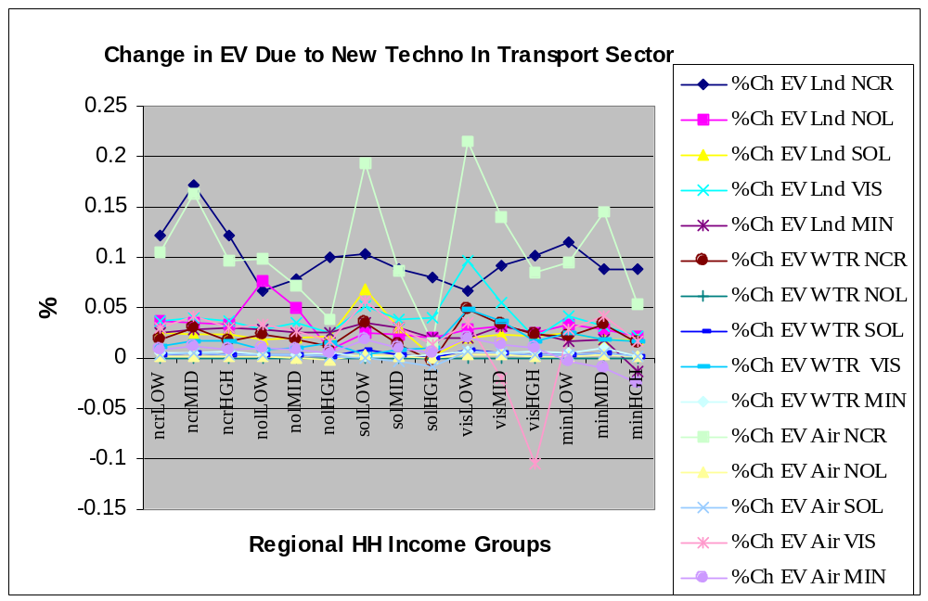

Figure 2: Change in Total Output Due to New TransportTechnology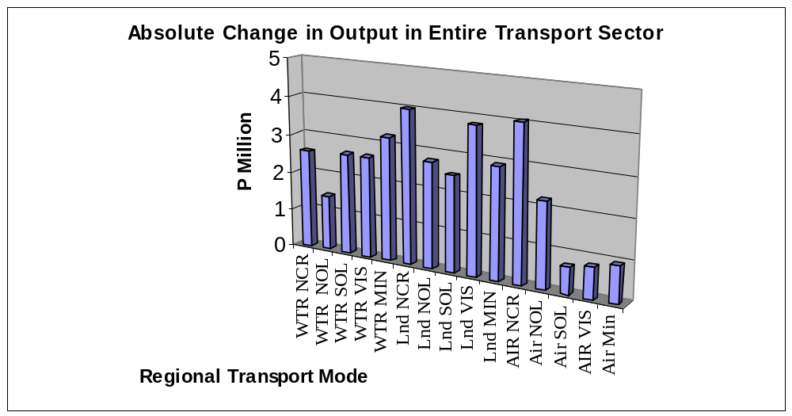

Table 4.1. Change in Impedance Ratio due to Land Transport Technological Change
( Destination – Sectors 1 to 8 – Ind NCR to Ind NOL)
 | ind NCR | otsrvNCR | wtrsrNCR | airtrNCR | lndtrNCR | govsrvNCR | agNOL | indNOL
ind NCR | 0.061 | 0.1 | 0.007 | 0.139 | 2.569 | -0.046 | 0.078 | 0.097
otsrvNCR | 0.061 | 0.1 | 0.007 | 0.139 | 2.569 | -0.046 | 0.078 | 0.097
wtrsrNCR | 0.123 | 0.127 | 0.125 | 0.141 | 2.84 | -0.124 | 0.07 | 0.161
airtrNCR | 0.178 | 0.182 | 0.18 | 0.197 | 2.897 | -0.069 | 0.125 | 0.217
lndtrNCR | 5.051 | 5.054 | 5.053 | 5.07 | 7.901 | 4.791 | 4.995 | 5.091
govsrvNCR | 0 | 0 | 0 | 0 | 0 | 0 | 0 | 0
agNOL | 0.061 | 0.1 | 0.007 | 0 | 0 | 0 | 0.078 | 0.097
indNOL | 0.061 | 0.1 | 0.007 | 0.139 | 2.569 | -0.046 | 0.078 | 0.097
otsrvNOL | 0.061 | 0.1 | 0.007 | 0.139 | 2.569 | -0.046 | 0.078 | 0.097
wtrsrNOL | 0 | 0 | 0 | 0 | 0 | 0 | 0.114 | 0.205
airtrNOL | 0 | 0 | 0 | 0 | 0 | 0 | 0.104 | 0.196
lndtrNOL | 5.062 | 5.066 | 5.064 | 0 | 7.913 | 4.802 | 5.006 | 5.102
govsrvNOL | 0 | 0 | 0 | 0 | 0 | 0 | 0 | 0
agSOL | 0.061 | 0.1 | 0.007 | 0 | 0 | -0.046 | 0.078 | 0.097
indSOL | 0.061 | 0.1 | 0.007 | 0.139 | 2.569 | -0.046 | 0.078 | 0.097
otsrvSOL | 0.061 | 0.1 | 0 | 0.139 | 2.569 | -0.046 | 0.078 | 0.097
wtrsrSOL | 0 | 0 | 0 | 0 | 0 | 0 | 0 | 0
airtrSOL | 0 | 0 | 0 | 0 | 0 | 0 | 0 | 0
lndtrSOL | 4.433 | 4.436 | 0 | 0 | 7.266 | 4.175 | 4.377 | 4.473
govsrSOL | 0 | 0 | 0 | 0 | 0 | 0 | 0 | 0
agVIS | 0.061 | 0.1 | 0.007 | 0 | 0 | -0.046 | 0.078 | 0.097
indVIS | 0.061 | 0.1 | 0.007 | 0.139 | 2.569 | -0.046 | 0.078 | 0.097
otsrvVIS | 0.061 | 0.1 | 0.007 | 0.139 | 2.569 | -0.046 | 0.078 | 0.097
wtrsrVIS | 0.119 | 0.123 | 0.121 | 0 | 2.836 | -0.128 | 0.066 | 0.157
airtrVIS | 0 | 0 | 0 | 0 | 0 | 0 | 0.053 | 0.144
lndtrVIS | 5.023 | 5.026 | 0 | 0 | 7.872 | 4.763 | 4.967 | 5.063
govsrVIS | 0 | 0 | 0 | 0 | 0 | 0 | 0 | 0
agMIN | 0.061 | 0.1 | 0.007 | 0 | 0 | 0 | 0.078 | 0.097
indMIN | 0.061 | 0.1 | 0.007 | 0 | 2.569 | -0.046 | 0.078 | 0.097
otsrvMIN | 0.061 | 0.1 | 0.007 | 0.139 | 2.569 | -0.046 | 0.078 | 0.097
wtrsrMIN | 0.109 | 0.112 | 0.11 | 0 | 2.825 | -0.139 | 0.055 | 0.147
airtrMIN | 0 | 0 | 0 | 0 | 0 | 0 | 0 | 0
lndtrMIN | 4.626 | 4.63 | 0 | 0 | 0 | 0 | 4.57 | 4.666
govsrMIN | 0 | 0 | 0 | 0 | 0 | 0 | 0 | 0

Table 4.2 Change in Impedance Ratio due to Land Transport Technological Change
( Destination - Sectors 9 to 16 – OtrSrvNOL to OtrSrvSOL)
 | otsrvNOL | wtrsrNOL | airtrNOL | lndtrNOL | govsrvNOL | agSOL | indSOL | otsrvSOL
ind NCR | 0.061 | 0.049 | 0.074 | 2.382 | -0.06 | 0.12 | 0.138 | 0.044
otsrvNCR | 0.061 | 0.049 | 0.074 | 2.382 | -0.06 | 0.12 | 0.138 | 0.044
wtrsrNCR | 0.172 | 0 | 0 | 2.644 | -0.112 | 0.081 | 0.285 | 0.14
airtrNCR | 0.227 | 0.098 | 0.182 | 2.701 | -0.056 | 0.136 | 0.341 | 0.195
lndtrNCR | 5.101 | 4.967 | 5.054 | 7.696 | 4.804 | 5.006 | 5.221 | 5.068
govsrvNCR | 0 | 0 | 0 | 0 | 0 | 0 | 0 | 0
agNOL | 0.061 | 0 | 0.074 | 0 | -0.06 | 0.12 | 0.138 | 0.044
indNOL | 0.061 | 0.049 | 0.074 | 2.382 | -0.06 | 0.12 | 0.138 | 0.044
otsrvNOL | 0.061 | 0.049 | 0.074 | 2.382 | -0.06 | 0.12 | 0.138 | 0.044
wtrsrNOL | 0.216 | 0 | 0 | 2.689 | -0.068 | 0 | 0 | 0
airtrNOL | 0.206 | 0 | 0 | 2.679 | -0.077 | 0 | 0 | 0
lndtrNOL | 5.113 | 4.978 | 5.066 | 7.708 | 4.816 | 5.018 | 5.232 | 5.08
govsrvNOL | 0 | 0 | 0 | 0 | 0 | 0 | 0 | 0
agSOL | 0.061 | 0 | 0.074 | 0 | -0.06 | 0.12 | 0.138 | 0.044
indSOL | 0.061 | 0.049 | 0.074 | 2.382 | -0.06 | 0.12 | 0.138 | 0.044
otsrvSOL | 0.061 | 0 | 0 | 0 | -0.06 | 0.12 | 0.138 | 0.044
wtrsrSOL | 0 | 0 | 0 | 0 | 0 | 0.095 | 0.299 | 0.154
airtrSOL | 0 | 0 | 0 | 0 | 0 | 0.062 | 0.266 | 0.121
lndtrSOL | 4.483 | 0 | 0 | 7.063 | 4.188 | 4.389 | 4.602 | 4.45
govsrSOL | 0 | 0 | 0 | 0 | 0 | 0 | 0 | 0
agVIS | 0.061 | 0 | 0.074 | 0 | -0.06 | 0.12 | 0.138 | 0.044
indVIS | 0.061 | 0 | 0.074 | 0 | -0.06 | 0.12 | 0.138 | 0.044
otsrvVIS | 0.061 | 0 | 0.074 | 2.382 | -0.06 | 0.12 | 0.138 | 0.044
wtrsrVIS | 0.168 | 0.039 | 0 | 2.64 | -0.116 | 0.077 | 0.281 | 0.136
airtrVIS | 0.154 | 0 | 0 | 2.627 | -0.129 | 0.064 | 0.268 | 0.123
lndtrVIS | 5.074 | 4.939 | 5.026 | 7.668 | 4.776 | 4.979 | 5.193 | 5.04
govsrVIS | 0 | 0 | 0 | 0 | 0 | 0 | 0 | 0
agMIN | 0.061 | 0 | 0.074 | 0 | -0.06 | 0.12 | 0.138 | 0.044
indMIN | 0.061 | 0 | 0.074 | 2.382 | -0.06 | 0.12 | 0.138 | 0.044
otsrvMIN | 0.061 | 0 | 0 | 2.381 | -0.06 | 0.12 | 0.138 | 0.044
wtrsrMIN | 0.157 | 0 | 0 | 2.63 | -0.126 | 0.067 | 0.271 | 0.125
airtrMIN | 0 | 0 | 0 | 0 | 0 | 0 | 0 | 0
lndtrMIN | 4.677 | 0 | 0 | 0 | 0 | 4.582 | 4.796 | 4.644
govsrMIN | 0 | 0 | 0 | 0 | 0 | 0 | 0 | 0

Table 4.3 Change in Impedance Ratio due to Land Transport Technological Change
( Destination - Sectors 17 to 24 – WtrSrvSOL to WtrSrvVIS)
 | wtrsrvSOL | airtrSOL | lndtrSOL | govsrSOL | agVIS | indVIS | otsrvVIS | wtrsrvVIS
ind NCR | 0.073 | 0.049 | 2.028 | -0.052 | 0.089 | 0.072 | 0.078 | 0.02
otsrvNCR | 0.073 | 0.049 | 2.028 | -0.052 | 0.089 | 0.072 | 0.078 | 0.02
wtrsrNCR | 0 | 0 | 2.974 | -0.119 | 0 | 0 | 0 | 0
airtrNCR | 0.12 | 0.27 | 3.03 | -0.064 | 0.111 | 0.102 | 0.236 | 0.25
lndtrNCR | 4.99 | 5.146 | 8.041 | 4.797 | 4.98 | 4.971 | 5.111 | 5.126
govsrNCR | 0 | 0 | 0 | 0 | 0 | 0 | 0 | 0
agNOL | 0 | 0 | 0 | 0 | 0.089 | 0.072 | 0.078 | 0
indNOL | 0.073 | 0.049 | 2.028 | -0.052 | 0.089 | 0.072 | 0.078 | 0.02
otsrvNOL | 0.073 | 0.049 | 2.028 | -0.052 | 0.089 | 0.072 | 0.078 | 0.02
wtrsrNOL | 0 | 0 | 0 | 0 | 0 | 0 | 0 | 0
airtrNOL | 0 | 0 | 0 | 0 | 0 | 0 | 0 | 0
lndtrNOL | 5.001 | 5.157 | 8.053 | 4.808 | 4.992 | 4.982 | 5.122 | 5.138
govsrvNOL | 0 | 0 | 0 | 0 | 0 | 0 | 0 | 0
agSOL | 0.073 | 0.049 | 0 | -0.052 | 0.089 | 0.072 | 0.078 | 0
indSOL | 0.073 | 0.049 | 2.028 | -0.052 | 0.089 | 0.072 | 0.078 | 0.02
otsrvSOL | 0.073 | 0.049 | 2.028 | -0.052 | 0.089 | 0.072 | 0.078 | 0.02
wtrsrSOL | 0 | 0 | 2.988 | -0.105 | 0 | 0 | 0 | 0
airtrSOL | 0.046 | 0.195 | 2.954 | -0.138 | 0 | 0 | 0 | 0
lndtrSOL | 4.373 | 4.528 | 7.406 | 4.18 | 4.363 | 4.353 | 4.493 | 4.508
govsrSOL | 0 | 0 | 0 | 0 | 0 | 0 | 0 | 0
agVIS | 0 | 0 | 0 | 0 | 0.089 | 0.072 | 0.078 | 0.02
indVIS | 0.073 | 0.049 | 2.028 | -0.052 | 0.089 | 0.072 | 0.078 | 0.02
otsrvVIS | 0.073 | 0.049 | 2.028 | -0.052 | 0.089 | 0.072 | 0.078 | 0.02
wtrsrVIS | 0.061 | 0 | 2.969 | -0.123 | 0.052 | 0.043 | 0.177 | 0.191
airtrVIS | 0 | 0.197 | 2.956 | -0.136 | 0.039 | 0.03 | 0.163 | 0.178
lndtrVIS | 0 | 0 | 8.013 | 4.769 | 4.952 | 4.943 | 5.083 | 5.098
govsrVIS | 0 | 0 | 0 | 0 | 0 | 0 | 0 | 0
agMIN | 0 | 0 | 0 | 0 | 0.089 | 0.072 | 0.078 | 0.02
indMIN | 0.073 | 0.049 | 2.028 | -0.052 | 0.089 | 0.072 | 0.078 | 0.02
otsrvMIN | 0 | 0.049 | 2.028 | -0.052 | 0.089 | 0.072 | 0.078 | 0.02
wtrsrMIN | 0.051 | 0 | 2.959 | -0.133 | 0 | 0 | 0 | 0
airtrMIN | 0 | 0 | 0 | 0 | 0 | 0 | 0 | 0
lndtrMIN | 0 | 0 | 7.605 | 4.373 | 4.556 | 4.546 | 4.686 | 0
govsrMIN | 0 | 0 | 0 | 0 | 0 | 0 | 0 | 0

Table 4.4 Change in Impedance Ratio due to Land Transport Technological Change
( Destination - Sectors 25 to 32 – AirTrSOL to AirTrMIN )
 | airtrVIS | lndtrVIS | govsrVIS | agMIN | indMIN | otsrvMIN | wtrsrMIN | airtrMIN
ind NCR | 0.06 | 3.369 | -0.066 | 0.057 | 0.062 | 0.026 | -0.056 | 0.049
otsrvNCR | 0.06 | 3.369 | -0.066 | 0.057 | 0.062 | 0.026 | -0.056 | 0.049
wtrsrNCR | 0 | 0 | 0 | 0 | 0 | 0 | 0 | 0
airtrNCR | 0.304 | 3.756 | -0.05 | 0.054 | 0.081 | 0.174 | 0.183 | 0.219
lndtrNCR | 5.182 | 8.803 | 4.811 | 4.92 | 4.948 | 5.046 | 5.055 | 5.093
govsrvNCR | 0 | 0 | 0 | 0 | 0 | 0 | 0 | 0
agNOL | 0 | 0 | 0 | 0 | 0 | 0 | 0 | 0
indNOL | 0.06 | 3.369 | -0.066 | 0.057 | 0.062 | 0.026 | -0.056 | 0.049
otsrvNOL | 0.06 | 3.369 | -0.066 | 0.058 | 0.062 | 0.026 | 0 | 0.049
wtrsrNOL | 0 | 0 | 0 | 0 | 0 | 0 | 0 | 0
airtrNOL | 0 | 0 | 0 | 0 | 0 | 0 | 0 | 0
lndtrNOL | 5.193 | 8.814 | 4.822 | 4.932 | 4.96 | 5.057 | 5.067 | 5.104
govsrvNOL | 0 | 0 | 0 | 0 | 0 | 0 | 0 | 0
agSOL | 0 | 0 | 0 | 0 | 0 | 0 | 0 | 0
indSOL | 0.06 | 3.369 | -0.066 | 0.057 | 0.062 | 0.026 | -0.056 | 0.049
otsrvSOL | 0.06 | 3.369 | -0.066 | 0.057 | 0.062 | 0.026 | -0.056 | 0.049
wtrsrSOL | 0 | 0 | 0 | 0 | 0 | 0 | 0 | 0
airtrSOL | 0 | 0 | 0 | 0 | 0 | 0 | 0 | 0
lndtrSOL | 0 | 8.163 | 4.194 | 4.303 | 4.331 | 4.428 | 4.437 | 0
govsrSOL | 0 | 0 | 0 | 0 | 0 | 0 | 0 | 0
agVIS | 0.06 | 0 | -0.066 | 0 | 0 | 0 | 0 | 0
indVIS | 0.06 | 3.369 | -0.066 | 0.057 | 0.062 | 0.026 | -0.056 | 0.049
otsrvVIS | 0.06 | 3.369 | -0.066 | 0.057 | 0.062 | 0.026 | -0.056 | 0.049
wtrsrVIS | 0.244 | 3.695 | -0.109 | 0 | 0 | 0 | 0 | 0
airtrVIS | 0.231 | 3.681 | -0.123 | -0.018 | 0.009 | 0.101 | 0 | 0.146
lndtrVIS | 5.154 | 8.774 | 4.783 | 4.892 | 4.921 | 5.018 | 5.027 | 5.065
govsrVIS | 0 | 0 | 0 | 0 | 0 | 0 | 0 | 0
agMIN | 0 | 0 | 0 | 0.057 | 0.062 | 0.026 | -0.056 | 0.049
indMIN | 0.06 | 3.369 | -0.066 | 0.057 | 0.062 | 0.026 | -0.056 | 0.049
otsrvMIN | 0.06 | 3.369 | -0.066 | 0.057 | 0.062 | 0.026 | -0.056 | 0.049
wtrsrMIN | 0 | 0 | 0 | -0.016 | 0.011 | 0.104 | 0.113 | 0.149
airtrMIN | 0 | 0 | 0 | 0.023 | 0.05 | 0.143 | 0.152 | 0.188
lndtrMIN | 0 | 8.363 | 4.386 | 4.496 | 4.524 | 4.621 | 4.631 | 4.669
govsrMIN | 0 | 0 | 0 | 0 | 0 | 0 | 0 | 0

Table4.5 Change in Impedance Ratio due to Land Transport Technological Change
( Destination - Sectors 33 to 34 – landTrMIN to GovSrvMIN )
 | landtrMIN | govsrvMIN
ind NCR | 2.265 | -0.073
otsrvNCR | 2.265 | -0.073
wtrsrNCR | 0 | 0
airtrNCR | 3.226 | -0.043
lndtrNCR | 8.246 | 4.819
govsrvNCR | 0 | 0
agNOL | 0 | 0
indNOL | 2.265 | -0.073
otsrvNOL | 0 | -0.074
wtrsrNOL | 0 | 0
airtrNOL | 0 | 0
lndtrNOL | 8.258 | 4.83
govsrvNOL | 0 | 0
agSOL | 0 | 0
indSOL | 2.265 | -0.073
otsrvSOL | 2.266 | -0.073
wtrsrSOL | 0 | 0
airtrSOL | 0 | 0
lndtrSOL | 7.61 | 4.202
govsrSOL | 0 | 0
agVIS | 0 | 0
indVIS | 0 | -0.073
otsrvVIS | 2.265 | -0.073
wtrsrVIS | 0 | 0
airtrVIS | 3.151 | -0.115
lndtrVIS | 8.218 | 4.791
govsrVIS | 0 | 0
agMIN | 0 | -0.073
indMIN | 2.265 | -0.073
otsrvMIN | 2.265 | -0.073
wtrsrMIN | 3.154 | -0.112
airtrMIN | 3.194 | -0.073
lndtrMIN | 7.809 | 4.395
govsrMIN | 0 | 0

