Analysis of Urban Surface Ozone based on a Structural Equation Model with State Dependence and Serial Correlation in Jakarta City

SUDARMANTO Budi Nugroho
Doctor Candidate
Transportation Engineering Laboratory,
Graduate School for International Development and Cooperation,
Hiroshima University, 1-5-1 Kagamiyama, Higashi Hiroshima, 739-8529, Japan
Phone and Fax: 81-82-424-6922; e-mail: totoksbn@hiroshima-u.ac.jp

Akimasa FUJIWARA
Professor
Transportation Engineering Laboratory,
Graduate School for International Development and Cooperation,
Hiroshima University, 1-5-1 Kagamiyama, Higashi Hiroshima, 739-8529, Japan
Phone and Fax: 81-82-424-6921; e-mail: afujiw@hiroshima-u.ac.jp

Junyi ZHANG
Associate Professor
Transportation Engineering Laboratory,
Graduate School for International Development and Cooperation,
Hiroshima University, 1-5-1 Kagamiyama, Higashi Hiroshima, 739-8529, Japan
Phone and Fax: 81-82-424-6919; e-mail: zjy@hiroshima-u.ac.jp

Abstract
Surface ozone is potentially high in Jakarta and largely caused by transportation activities and favorable surface meteorological conditions. The relationships between precursor pollutants and ozone, thus, depend on the emissions, meteorology and atmospheric chemistry. In this paper, analysis of surface ozone patterns are conducted based on data collected by five air quality monitoring stations installed at near roadway of five major roads in Jakarta City. Accordingly, a time series data model is proposed to analyze weekdays and weekend data during April to May and September to October 2005. In this study, the model gives results supporting the existence of influence of traffic heterogeneity on the diurnal of surface ozone variations. To do so, this paper attempts to apply a structural equation model with latent variables, where are used to represent the above-mentioned state dependence and serial correlation of the complex cause-effect relationships. The effectiveness of the established surface ozone models is empirically confirmed in the sense that the goodness-of-fit indices is around 0.807 for daily diurnal variations. The models give us a better way to analyze the surface ozone behavior in roadside areas in Jakarta city. However, because of the limited data sources, some model results cannot be explained clearly, and further development of model is needed.

1. INTRODUCTION
Based on Pollutants Standard Index (PSI) which subsequently published on data displays to the public, the number of healthy days decreased year by year. According to Head of Bapedal Decree No. 107 (1997), PSI number gives information about the city’s air quality conditions with the six scales i.e., good, moderate, unhealthy, very unhealthy, and dangerous. In the recent years, ozone (O₃) and particle (PM₁₀) are frequently occurring pollutants, to cause the poor air quality. Ozone problem in Jakarta City is largely contributed from transportation sector (2) and nowadays, it is a widespread phenomenon in many of the world’s population centers (3). Two important pollutants associated with transportation are diesel PM (predominantly from non-passenger vehicles) and ozone (a highly reactive, secondary pollutants) (26).
In tropical regions, high ozone level may be expected due to high rate of precursor emissions from anthropogenic and biogenic sources coupled with high sunlight intensity. Yet, there is only a limited research about tropical tropospheric ozone focusing on Asian cities. The lack of systematic monitoring data of ozone and its precursors is one of the barriers to scientific research for photochemical smog in most of the developing Asian countries (4).
Ground-level ozone (O₃) which does not emitted directly into the atmosphere but formed from its precursors, nitrogen oxides (NOx) and non-methane hydrocarbon (NMHC), by a complex and non-linear photochemical reaction in sunlight (5). The variations of O₃ concentration are influenced by the sources of O₃ precursor emission such as NOx and non-methane hydrocarbon (NMHC), as well as by meteorological conditions (6). However, since O₃ formation reactions are non-linear (7), various factors, such as precursor emissions, atmospheric chemistry, meteorology, and deposition may influence the concentration of ambient ozone.
There are three mechanisms affecting the O₃ concentration: Photochemical production, NO chemical destruction, and the accumulation due to the poor dispersion. Chemical reactions of O₃ production and destruction progresses take place simultaneously. O₃ is closely related to NO₂, NO and NO_{x} according to photochemical oxide interaction in local environment (8). The relationship between precursor pollutants and O₃, thus differ from one place to another due to the emission intensity and meteorology (4). In urban areas, NO₂, NO and NO_{x}, which are generally highly associated with primary sources of air pollution, come from both mobile source and stationary sources. The influence of hydrocarbons (HC) on the transformation of NO is important in the regional and long-range transport scale. In urban scale, their influence is less significant, due to short transport system (27)
Study by Lin and Niemeier (9) demonstrated that traffic variability can result in significant difference in total vehicle emissions. Traffic heterogeneity from weekdays and weekends are better reflected in the air quality measurements (6). Jakarta city has the unique vehicle emission pattern in having more motorcycle population than cars. In some areas in especially in the city center of Jakarta, according to the limitation of motorbike lane, cars became dominant in the determining of vehicle compositions. Other, both inner city and sub-urban area at the non-protocol roads, the number of motorcycle flow is greater than cars. Thus, the different precursor emission ratio among Non-methane hydrocarbons (NMHC) which mainly emitted from motorcycle and NOx from as observed from traffic data and also measured pollutants concentration on weekdays and weekend affects the ozone concentration. The influence of precursor emissions reduction on O₃ concentration is different depending on the degree of photochemical reaction and atmospheric dispersion. Sometimes, the precursor reductions may, on the contrary, result in higher O₃ concentration (6). Unlike primary pollutants, the O₃ concentration does not show obviously weekly cycles (10). Thus, understanding surface ozone (O₃) behavior is essential for study of pollution oxidation process in urban areas (11). In urban areas, principally, a decrease of secondary pollutants can be achieved by a control precursor emissions (nitrogen oxides) and volatile organic compound. However, the efficiency of emission control policies depends on the relationship between secondary and primary pollutants (12).
Concerning the analysis methods about O₃, there have been proposed several multiple regression models to analyze O₃. It is however difficult to apply these models to deal with the complex cause-effect relationships among vehicles emissions, meteorological factors, primary pollutants under different atmospheric chemical conditions, and their influences on surface ozone. The objective of this study is to analyze the cause-effect relationships among traffic precursor emissions, meteorology and primary pollutant in the determining of O₃ concentration in several areas near roadways in Jakarta city by using Structural Equation Model (SEM) with state dependence and serial correlations. The results will provide the necessary information for preliminary drafting O₃ control strategy in Jakarta city.

2. surface ozone, its precursors and their influential factors
2.1 Observed Relationships between Surface Ozone and Its Precursors
In the O₃-NOx system, the dominant chemical reactions in the atmosphere are described below:

RO₂ + NO → RO+NO₂ (1)
NO₂ + hv → NO + O (2)
O + O₂ + M → O₃ + M (3)
NO + O₃ → NO₂ + O₂ (4)

The alkyl radical(R*) can react rapidly with an oxygen molecule to form an alkyl peroxy radical (RO₂*). The RO₂ radicals play a key role in tropospheric ozone production. They oxidize the NO from the emission sources to yield NO₂ (1). When NO₂ is exposed to UV light (λ< 424 nm) an odd oxygen atom and a NO molecule are generated via the NO₂ photolysis reaction. As a result, O₃ is formed as the product of the reaction between O and O₂. The NO from reaction (2) can react with another RO₂* radical and be converted back to NO₂ and thus generate additional O₃. Reaction (1) – (4) form a catalytic O₃ production cycles, and the ozone production rate depends on how long the cycle runs (13).
M represents N₂ or O₂ or another third molecule that absorbs excess energy and consequently stabilizes the O₃ molecule formed (4). The time scale of reaction (3) is very small (~10⁻⁶s) relative to the scales of reactions (2) and (4) (~100s and 30s, respectively) (11). This is the result of O₃ destruction by NO in the nitrogen dioxide photolytic cycle, which is effective at a close distance to NO source due to its short cycle time (about several minutes) (10). Since the conversion from NO to NO₂ involving reactive hydrocarbons and the OH radical usually takes several hours, the higher O₃ level is observed at a distant area from the pollution sources (5).
It is known that O₃ and NO show a logarithmic relationship, and the relationship between O₃ and NO₂ shows a typical linear function. A logarithmic relationship is also found between NO and NO₂ (11). A case study in 1999 and 2000 in Hong Kong confirms a strong linear relationship between O₃ and NO₂/NO (8).
In the roadside area, nitrogen oxides are emitted into the atmosphere from ground-based by fuel combustion. High emission of NO from automobile traffic should be the major reason for low O₃ at the roadside and lower O₃ at ambient monitoring station. In Bangkok, where the emission of NO from traffic is rather uniformly spread over a large area, the processes of O₃ destruction (by NO) and formation should be competing at any locations. (4). The photochemical block includes about 150 gas-phase and heterogeneous reaction and photo-dissociation reaction (14). In this study, we includes the parameter which measured by monitoring stations (PM₁₀, SO₂, CO, O₃, NO, NO₂ & NO_{x}). In roadside area, all pollutants are transported and dispersed in vertical and horizontal directions.
2.2 Meteorological Factors Influencing Surface Ozone
The meteorological conditions also directly affect the ozone. Episodes of high ozone concentration are associated with slow-moving, clear skies, sunshine, and warm conditions that usually accompany high-pressure system and accelerating the photochemical formation of ozone (15). The relationship between the meteorological variation and daily maximum ozone concentration can be well represented by a linear function (16).

Solar Radiation
O₃ production is dependent on solar radiation (SR) and consequently SR and O₃ usually show positive correlation (11).

Ambient Air Temperature
High temperature is frequently associated with high pressure, stagnant conditions that lead to high O₃ concentration at vertical level (5). The rate of photochemical reaction increases as air temperature rises. In urban roadside areas, paved surface, high-rise building and other constructed surfaces cause air to be higher due to the heat transfer of these surfaces. The vertical temperature profiles significantly influence to the Mixing Height value. Mixing height which represents the dispersion depth of the atmospheric boundary layer is a crucial input parameter in air pollution model (17). In many O₃ prediction models, air temperature was found to be the strongest single predictor of O₃ concentration (18).

Wind Speed and Direction
Wind speed in urban area is typically low. Therefore pollutants stay longer over urban areas and accumulate in the atmosphere (15). Light winds allow more emissions to accumulate over large area, which result in higher concentration of O₃ precursors. Ozone formation and transport is a complex phenomenon, and O₃ concentration depends on wind speed and direction among others (19). The dispersion of air pollutants is roughly inversely related to wind speed (4). Wind direction is also highly related to O₃ level, downwind locations of precursor emission sources are strongly inclined to high concentration of O₃.

Precipitation
Precipitation which in this study expressed as relative humidity is one of O₃ destruction mechanisms due to a wet deposition. Most tropical rain forest countries such as Indonesia have high relative humidity, especially at nighttime and wet season.

3. SURFACE OZONE MODEL FOR ROADSIDE AREAS IN JAKARTA CITY

3.1 Existing Models
Various models have been developed to describe the relationship among factors to surface ozone. During the last three decades, significant progress has been made in the understanding of O₃-precursors relationships through laboratory, field, and modeling studies (25). Continuing the previous work by Nugroho S.B et, al. (20) (21), this model includes daily variation of emissions intensity which are represented by traffic volume data, fleet composition and average vehicle speed. In this study, monitoring of ambient roadside air quality, micro meteorological and traffic measurement were done simultaneously. However, it is quite difficult to properly capture the nonlinear relationships among variables, and to represent the inherent state dependence and serial correlation of complex cause-effect relationships in the model. Other previous work (22) has shown that roadside concentration levels of pollutants are highly varies due to spatial traffic heterogeneity. Therefore, it is required to establish an alternative surface ozone model, which feasible to identify cause-effects relationships among factors. This paper present a model that captures the effects of heterogeneous traffic conditions on roadside primary pollutants and finally to the secondary pollutants (ozone). This is done by using a Structural Equation Model (SEM) with state dependence of latent variables and serial correlations among error terms of observed pollutants. The development of such models usually involves the choice of appropriate model structures and nonlinear data transformation methods.

3.2 Structural Equation Model with Serial Correlation
Structural equation model (SEM) is a modeling technique that can handle a large number of the observed endogenous and exogenous variables, as well as (unobserved) latent variables specified as linear combinations (weighted averages) of the observed variables (23). The models play many roles, including simultaneous equation systems, linear causal analysis, path analysis, structural equation models, dependence analysis, and cross-legged panel correlation technique (24). In this study, we modified previous model by Nugroho et al., (21) by applying state dependence and serial correlation technique. It is a confirmatory, rather than explanatory method, because the modeler is required to construct a model in term of a system of unidirectional effects of one variable on another. SEM is used to specify the phenomenon under study in terms of putative cause-effect variables and their indicators. Following the descriptions by Jöreskog and Sörbom (24), the full model structure can be summarized by the following three equations.

Structural Equation Model:
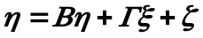 (5)

(6)

Measurement Model for y:
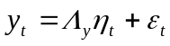 (7)
Measurement Model for x:
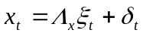 (8)
Here, 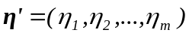 and 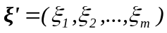 are latent dependent and independent variables, respectively. Vectors η and ξ are not observed, but instead 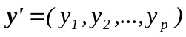 and 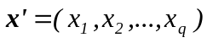 are observed dependent and independent variables. 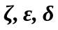 are the vectors of error terms, and 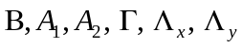 are the unknown parameters.
An important feature of SEM is that it can calculate not only direct effects, but also total effects (23). Direct effect is the link between a productive variable and the variable that is the target of the effect, which corresponds to an arrow in a path diagram. These direct effects embody the causal modeling aspect of SEM. Total effects are defined to be the sum of direct effects and indirect effects, where the indirect effects represent the sum of all the effects along paths between two variables that involve intervening variables. Advantages of SEM compared to most other linear-in-parameter statistical methods include the following capabilities: (a) treatment of both endogenous and exogenous variables as random variables with error of measurement, (b) latent variables with multiple indicators, (c) test of a model overall rather than coefficients individually, (d) modeling of mediating variables, (e) modeling of dynamic phenomena such as habit and inertia (15).

One can see that SEM has a very flexible model structure to simultaneously represent various interdependent variables. Also, this model is eligible to do time series analysis. Therefore, in this study, we adopt the SEM to describe and analyze surface ozone behavior at roadside of Jakarta city.

4. DATA

4.1 Study Area and Data Collection
The area of Jakarta is around 664 km² with flat topography, closed to the Java Sea and has an average elevation 7 meters above sea level. Jakarta is a part of the greater Metropolitan Jabodetabek (Jakarta, Bogor, Depok, Tangerang and Bekasi). Climate can be classified into wet season from November to March and dry season from May to September. A few weeks in April and October are transition period, respectively.
Jakarta has been experiencing serious air pollution problems which are mainly contributed from automobiles. Rapid urbanization and motorization in greater Jabodetabek areas is further worsening current situations. It is estimated that automobiles produce more than 70% of PM₁₀ emission and 69% of NO_{x} emission (2).
The data collected from 5 mobile ambient roadside air quality monitoring stations in Jakarta which is located 5-10 meter from main roads. We use a set of data on weekdays and weekend on several days in April, May, September and October 2005. All sampling points selected to describes the air quality situations of major roads in five districts of Jakarta. The monitoring stations operated at Thamrin road in central Jakarta, Fatmawati road in South Jakarta, Perintis Kemerdekaan road in East Jakarta, Yos Sudarso road in North Jakarta and Daan Mogot road in West Jakarta. The Fatmawati station is a sub-urban area of Jakarta city, and the others stations described the urban areas in Jakarta.
All monitoring stations were operated automatically and those are capable to measure CO, NO, NO₂, SO₂, PM₁₀, and O₃. In-situ meteorological data (solar radiation-SR, temperature-T, relative humidity-RH, wind speed-WS and wind direction-WD) were also recorded by using the basic meteorological sensors, which attached and installed at 10 meter height above the ground. The interval of measurement data of the average pollutants concentration and meteorological data are 30 minutes. Besides, traffic is monitored by video recording at the same locations. From video images, vehicles in the traffic are classified into 9 categories which consist of motorcycles, three wheeler (bajaj), passenger car, taxi, mini and medium bus, bus, small truck, truck and heavy truck. In this study, we categorize data into 3 categories which will adopt in the SEM. Those categories consist of motorcycle and three wheeler (MC), passenger cars (PC), high duty trucks (HDT) which includes all diesel vehicles. As input for the model, all observed traffic data converted to the traffic volume per road capacity (V/C) ratio for each road. Altogether observation data consist of 715 time points obtained from 5 stations. After careful inspection of the data for checking disorders in measurements, the original data size is reduced to 672 time points. Table 1 supplies basic description of the data obtained from air quality and traffic measurements
4.2 Diurnal Variation
Figures 1 show diurnal variations of O₃ in near roadway areas, where one can clearly notice variation among different stations. The highest concentration of ozone measured at monitoring station-at near Fatmawati Road in a suburban location in south south of Jakarta city which approximately 20 km from city center. The traffic volume at south station is the lowest among others. The ozone concentration at all stations increases after sunrise and reaches their peak levels at around 10:00-12:30 a.m. Based on this, the ozone production is larger than O₃ consumption in the morning period until the ozone concentration reaches its peaks around 12.30 p.m. During these periods, O₃ is thought to be transported from the upper atmosphere to the ground level accompanied by convection in the mixing layer (11). Afterward, this period of increasing trends in ozone concentration is followed by a decreasing period of ozone concentration until the evening from when the ozone concentration remains stable.

4.3 Observed Relationships among ozone concentration over time
To better understand the surface ozone behavior in Jakarta City, firstly, it is necessary to examine the relationships among emissions of ozone precursors and other primary pollutants which generated from vehicles, ozone precursor concentration in the ambient air and meteorological factors. In the previous work by Nugroho S.B et al. (19), we found some relationships among pollutants and meteorological factor, such as NO-O₃, NO-NO₂ and O₃-Solar Radiation. In this study, we only found the relationship among Solar Radiation and Ozone (Figure 3) which is consistent with the previous works. The relationships between O₃-SR might be derived from the reactions (2) ~ (4) as mentioned in the earlier section of this paper and follow the basic photochemical cycle of NO, NO₂, CO, O₃ and SR (3).
In order to better understand the relationship among factors in time series data, we apply state dependence among latent variables and also serial correlations of error terms of observed pollutants at time (t-1) and (t). We try to estimate the SEM model starting from (t-2) up to the concentration of pollutants and ozone at time (t). The relationship between pollutants at time (t-1) and (t) for several pollutants (O₃, NO, NO₂) shows a high value of coefficient correlation (Figure 4). The estimation results applied for Daily Diurnal variations of O₃.

5. BUILDING A ROADSIDE SURFACE OZONE MODEL FOR JAKARTA CITY
Altogether, in the model, we use 15 observed variables which characterize the emissions sources (V/C MC,V/C PC,V/C HDT), meteorological factors (Solar Radiation-SR, Ambient Temperature-T and Humidity-RH), wind (wind speed -WS, Sine Wind Direction and Cosine Wind Direction), primary pollutants (NO, NO₂, CO, SO₂ and PM₁₀) and the last variable is O₃. These five groups of variables respectively determine nine latent variables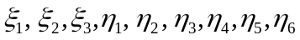, where 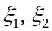 indicates exogenous latent variables at time (t-1), 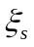 indicates exogenous latent variables at time (t-2), 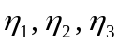 are all the endogenous latent variables at time (t-1) and 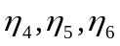 re all the endogenous latent variables at time (t) (Figure 5). The latent variables, 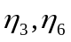which are defined by using both O₃ and its precursor NO, are used to describe the photochemical matters at time (t-1) and at the time (t), respectively. The latent variables, 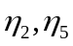which are used to defined the ozone precursors NO,NO₂,NOx and CO which involved in the Photochemical Cycles (5), at time (t-1) and at the time (t), respectively. To capture the non-linear relationship between some variables, here several observed variables need to be properly transformed. The existing research (4) suggests that a linear function is better for O₃ and NO₂, than others. Based previous works (21), we propose to apply a natural logarithm (LN) function to transform the pollutant NO, resulting in a new variable LN_NO. In our model, here, state dependence correlations for each latent variable at time (t-1) and (t) in the model structure written as β₆₃, β₅₂ and β₄₁ for latent variables photochemical, precursors and non-precursors respectively. In figure 5, the serial correlations among pollutants which showed as the correlation among the error terms written as θ₈₁, θ₉₂, θ₁₀₃, θ₁₁₄, θ₁₂₅, θ₁₃₆, and θ₁₄₇ for pollutants O₃,NO,NO₂,NO_{x}, CO,SO₂ and PM₁₀ respectively. These state dependence and serial correlations used to support time series analysis in this study.
The latent variables, 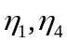which are used to defined the non-precursors pollutants which measured at time (t-1) and at the time (t), respectively. CO, SO₂ and PM₁₀ are specified in one-to-one relationships with the latent variables “Non-Precursors” (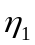&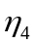). These latent variables were specified to represent the influence of pollutants which emitted by vehicles but they didn’t give a direct effects to photochemical cycle. All these pollutants influence to the ambient NOx concentration by other pollutants cycles. The latent variables “Precursors” () was specified to represent gasses which give a direct effects or take a part in the photochemical cycles.
Structural equation model with multiple endogenous latent variables, state dependence and serial correlation, model estimation becomes more challenging, and quite a few different methods have been developed (23). The most commonly used estimation methods are maximum likelihood (ML), general least squares (GLS), weighted least squares (WLS), asymptotically distribution free weighted least squares (ADF or ADF-WLS) and elliptical reweighted least squares (EGLS or ELS). The most often used estimation method is ML, which maximizes the joint probabilities that the observed covariances are drawn from a population that has its variance-covariance generated by the process implied by the model, assuming a multivariate normal distribution.
Several criteria have been developed for assessing overall goodness-of-fit of a structural equation model and are used to determine how well one model performs than others. Such model accuracy indices includes: (1) root mean square residual (RMR), (2) standardized RMR (SRMR), (3) the goodness-of-fit index (GFI), (4) adjusted goodness-of-fit index (AGFI) which adjusts GFI for the degree of freedom in the model, and (5) the parsimony-adjusted goodness-of-fit index (PGFI). We used GFI and AGFI to assess our models and use AMOS-SPSS software, which has a very attractive and user-friendly interface.
In the work by Boriboonsomsin and Uddin (9), they incorporated precursor emissions into the model and found that traffic is highly associated with the change of O₃ concentration. In this study, we include traffic data in order to describe the cause-effect relationships among them. We classify emission sources based on the type of vehicles, which are volume per road capacity (V/C) of Motorcycles (MC), Passenger Car (V/C PC) and High duty trucks (V/C HDT) are specified in one-to-one relationship with the latent variable of ‘Vehicles Emissions’. We found an appropriate model which can capture the existing cause-effect relationships among them. The model consists of the traffic data at time (t-2), meteorology conditions at time (t-1) as main factor in the air dispersion modeling and the ambient concentration of pollutants at time (t-1) which affect to ambient concentration at time (t).
6. MODEL ESTIMATION RESULTS AND DISCUSSION
About the model, total number of distinct samples moments are 231 and the number of distinct parameters to be estimated are 69 units. After 27 iterations, the minimum was achieved. Observing the model accuracy indices, the model shows the GFI (AGFI) value 0.807 (0.725). Environmental data usually have some measurement and sampling errors (14). Due to the disordered operation of measurement equipments, there were some missing observations, and also some very small observed data that fluctuated around the detection limit of monitoring equipments and sometimes irrelevant measurements. This kind of measurement issues might influence model performance. Based on the calculated GFI and AGFI values, the established model cannot statistically be rejected.
For all of the structural equation models and measurement models, it is found that all the parameters are statistically significant at the 1% or 5% level, suggesting the validity of the postulated model structure in this case study. The log-transformed variable LN_NO also got statistically meaningful parameter. All the signs of the estimated parameters are intuitive and consistent with expectations. Focusing on the latent variable “Photochemical” at time (t-1), it receives the largest positive influence from the latent variable “Wind” at time (t-1) (Table 2a) follows by ‘Meteorology’ (t-1), and ‘Non-Precursors’ (t-1). At the same time, Photochemical also received negative impacts from ‘Vehicles Emission’. It is also confirmed that parameter of wind at time (t-1) has negative value on Precursors and Non-Precursors. On the other hand, wind speed gives positive influence to surface ozone. These phenomena could be describes the dispersions in the roadside areas. The importance of micro-environmental factors depends on the amount of time spent in a microenvironment and ambient air. Exposures in near source microenvironments contribute a greater fraction of total intake for rapidly decaying primary pollutants (e.g., ultrafine PM) than for non-reactive species. Because of the transport and dispersion that occurs during the interval between precursor release and secondary pollutants formation, local and microenvironment emissions will be less important for secondary pollutants that take ~0.5 h or more to form than primary pollutants. Vehicles emission may reduce ozone concentration locally (because fresh NO emission remove ozone) but increase ozone concentration in areas that are downwind of the emissions. Uncertainty and variability in the emission-to-intake relationship tend to be larger for secondary pollutants than for primary pollutants (26).
The latent variable ‘Non-Precursors’ will give positive influence to ‘Photochemical’ at time (t-1) greater than the influence at time (t). This might relevant with the rapidly decaying of PM₁₀ as mention in above paragraph.
The highest correlations among error terms of observed pollutants at time (t-1) and (t), that represent the serial correlation, is 0.94 for SO₂ pollutant. The lowest one is 0.604 which found for the correlation between error terms of NO₂ at time (t-1) and (t). The estimation results also show high correlations of state dependence among the same latent variables at time (t-1) and (t). All estimation results are higher than 0.8. The highest is 0.982 which found for interaction between ‘Photochemical’ at time (t-1) and (t).
Concerning the interactions among the “Meteorology”, “Wind”, Precursors and Non-Precursors, it is found that “Meteorology” positively affects Precursors and negative to non-precursors at time (t-1). “Wind” has positive influence on “Photochemical” at time (t-1), but negative on Non-Precursors and Precursors at time (t-1). Looking at the total effects as shown in Table 3, one can see that at time (t-1) and (t), influence of “Meteorology” on “Photochemical” at time (t-1) is clearly larger than “Wind Speed”, and it remain stable at time (t).

7. CONCLUSIONS AND FUTURE RESEACH ISSUES
Surface ozone is potentially high in Jakarta and serious problem. In this paper, surface ozone analyzed at roadside areas in all districts in Jakarta. A study was conducted by using time series data with interval of measurement 30 minutes at five monitoring stations on weekdays and weekend days in April to May and September to October in 2005. It is confirmed that O₃ concentration in sub-urban of Jakarta higher than the city center although traffic volume in sub-urban area is the lowest.
This paper first established a structural equation model, which can endogenously incorporate various cause-effect relationships among meteorological factors, wind, and primary pollutants, which affect the surface ozone. The established model also incorporated non-linear relationships existing in the observed variables and time series analysis. The effectiveness of the established model is empirically confirmed. The model has the high value of goodness-of-fit index and adjusted goodness-of-fit index which statistically cannot be rejected.
The established model consistently shows that meteorological factors have the largest influence on photochemical at the same time (t-1). Wind at time (t-1) has the second largest influence on photochemical and Precursors come last. Total effects calculated from the model show that influence of meteorological factors on photochemical is clearly larger than other latent variables at time (t-1)and it continues to influence on photochemical at time (t). Wind plays a significant role in air pollution dispersion at the roadside areas which shows as coefficient of the influence for Precursor, Non-Precursors and Photochemical. It is also confirmed that precursor emissions emitted from vehicles at time (t-2) will give a significant effects on the photochemical at time (t).
The model shows that Precursors and Non-Precursors play a significant role in the ozone production and ozone destruction cycles. In this study, it is also found in the relationship between non-precursors and photochemical. It should be needs further analysis by applying the model for the inclining and declining periods which represent the diurnal variations of ozone concentration. Furthermore, considering the confirmed the influence traffic on surface ozone at roadside areas, based on the traffic composition. In practice, continuous monitoring in roadside can be expensive and therefore the results of this study can be useful tool for academic research and regulatory analysis in the way to control ozone in Jakarta city.

ACKNOWLEDGEMENTS
Data was provided by Swisscontact-Clean Air Project for Jakarta city. This research is partially supported by the 21st Century Center of Excellence Program “Social Capacity Development for Environmental Management and International Development” at Graduate School of International Development and Cooperation, Hiroshima University, Japan.

REFERENCES
- Syahril, S., Budi, P.R., Haryo, S.T. (2002) ‘Study on Air Quality in Jakarta, Indonesia’, ADB Report, Manila 2002.
- Japan International Cooperation Agency (JICA) (1997) ‘The Study on the Integrated Air Quality Management for Jakarta Metropolitan Area’, Final Report collaborated with the Environmental Impact Management Agency (BAPEDAL) the Republic of Indonesia, Nippon Koei Co., Ltd., and Suuri Keikaku Co., Ltd 1997.
- Stern, A.C., Wohlers, H.C., Boubel, R.W. and Lowry, W.P. (1973) Fundamentals of Air Pollution. Academic Press, Inc., New York.
- Zhang, B.N. and Oanh, N.T.K. (2002) ‘Photochemical smog pollution in the Bangkok Metropolitan Region of Thailand in relation to O₃ precursor concentrations and meteorological conditrions’, Atmospheric Environment, 36, pp. 4211-4222.
- Seinfeld, J.H. and Pandis, S.N. (1998) Atmospheric Chemistry and Physics. John Wiley and sons, Inc., New York.
- Chang, S.C., Chung, T.L. (2006) ‘Ozone variations through vehicle emission reductions based on air quality monitoring data in Taipei City, Taiwan, from 1994 to 2003’. Atmospheric Environment, 40, pp. 3513-3526.
- Bronnimann, S., Neu, U. (1997) ‘Weekend-weekday difference of near-surface ozone concentrations in Switzerland for different meteorological conditions’, Atmospheric Environment, 31, pp. 1127-1135.
- Wang, W., Lu, W., Wang, X. and Leung, A.Y.T. (2003) ‘Prediction of maximum daily ozone level using combined neural network and statistical characteristics’. Environmental International, 29, pp. 555-562.
- Lin, J., Neimeier, D.A. (2003) ‘Regional driving characteristics, regional driving cycles’, Transportation Research Part D, 8, pp. 361-381.
- Jenkin, M.E., Davies, T.J., Stedman, J.R. (2002) ‘The origin and day-of-week dependence of photochemical ozone episodes in the U.K’, Atmospheric Environment, 36, pp. 999-1012.
- Monoura, H. (1999) ‘Some characteristic of surface ozone concentration observed in an urban atmosphere’, Atmospheric Research, 51, pp. 153-169.
- Honore, C., Robert, V., Matthias, B. (2000) ‘Low and high NOx chemical regimes in an urban environment’, Environmental Modeling and Software, 15, pp. 559-564.
- Chou, C.C.K., Shaw, C.L., Chuan, Y.L., Chein, J.S., Ken, H.C., (2006) ‘The trend of surface ozone in Taipei, Taiwan, and its causes: Implications for ozone control strategies’, Atmospheric Environment, 40, pp. 3898-3908.
- Kiselev, A.A., Igor, L.K. (2000) ‘Model of tropospheric composition response to NOx and CO pollution’, Environmental Modeling and Software, 15, pp. 583-588.
- Rubin, E.S. (2001) Introduction to Engineering and the Environment. McGraw-Hill International Edition, Singapore.
- Gardner, M.W. and Dorling, S.R. (1998) ‘Artificial Neural networks (the multilayer perceptron)-a review of applications in the atmospheric sciences’, Atmospheric Environment, 32, pp. 2627-2636
- Nath, S., Rashmi, S.P. (2006) ‘Prediction of air pollution concentration using an in situ real time mixing height model’, Atmospheric Environment, 40, pp. 3816-3822.
- Boriboonsomsin, K. and Uddin, W. (2005) ‘Tropospheric ozone modeling considering vehicle emission and point & aviation source, validation, and implementation in rural areas’, Paper presented at the 84th Annual Meeting of Transportation Research Board, Washington D.C 2005. (CD-ROM).
- Hubbard, M.C. and Cobourn, W.G. (1998) ‘Development of regression model to forecast ground-level ozone concentration in Louisville, KY’, Atmospheric Environment, 32, pp. 2637-2647
- Nugroho, S.B., Fujiwara, A., Zhang, J. (2006) ‘A Comparative Analysis of Surface Ozone Patterns at Different Land Use Types in Jakarta City based on a Structural Equation Model with Latent Variables. Paper presented at the 85th Annual Meeting of Transportation Research Board, Washington D.C (2006). (CD-ROM).
- Nugroho, S.B., Fujiwara, A., Zhang, J. (2006) ‘Analysis of Roadside Air Quality in Jakarta City: A Structural Equation Approach’, JSME International Journal Series B, 49, pp. 8-18.
- Lin, J., Ge, Y.E. (2006) ‘Impacts of Traffic heterogeneity on roadside air pollution concentration’, notes and comments, Transportation Research part D, 11, 166-170.
- Golob, T. F. (2003) ‘Structural equation modeling for travel behavior research’, Transportation Research Part B, 37, 1-25.
- Jöreskog, K.G. and Sörbom, D. (1989) LISREL7, A Guide to the Program and Application, 2nd Edition. SPSS Inc., Chicago.
- Oanh Kim, N.T and B.Zhang. (2004) ‘Photochemical Smog Modeling for Assessment of Potential Impact of Different Management Strategies on Air Quality of the Bangkok Metropolitan Region, Thailand’, Journal the of Air and Waste Management Association, 54,1321-1338.
- Julian D Marshall et al. (2005) ‘Inhalation of motor vehicle emissions: effects of uban population and land area’, Journal of Atmospheric Environment, 39,283-295.
- A Karpinen, et al. (2000) ‘ A modeling system for predicting urban air pollution: modeling description and applications in the Helsinki metropolitan area’, Journal of Atmospheric Environment, 34, 3723-3733.

LIST OF TABLES
Table 1 Roadside Ambient Air Quality and Traffic Monitoring Data in Jakarta city, 2005
Table 2a Estimation Results (latent variables & error term correlations) of Roadside Surface Ozone Model in Jakarta City
Table 2b Estimation Results (Endogenous & Exogenous Observed Variables) of Roadside Surface Ozone Model in Jakarta City
Table 3 Estimated Standardized Total Effects of Roadside Surface Ozone Model in Jakarta City

LIST OF FIGURES
Figure 1 Diurnal variations of O₃ in Roadside, Jakarta City.
Figure 2 Daily Traffic volume in Major Roads, Jakarta City
Figure 3 Relationships between Solar Radiation and O_{3(t)}
Figure 4 Relationships between O_{3(t)} – O_{3(t-0.5h)}
Figure 5 Structural equation model of roadside surface ozone for Jakarta City
TABLE 1 Roadside Ambient Air Quality Monitoring Data in Jakarta city, 2005

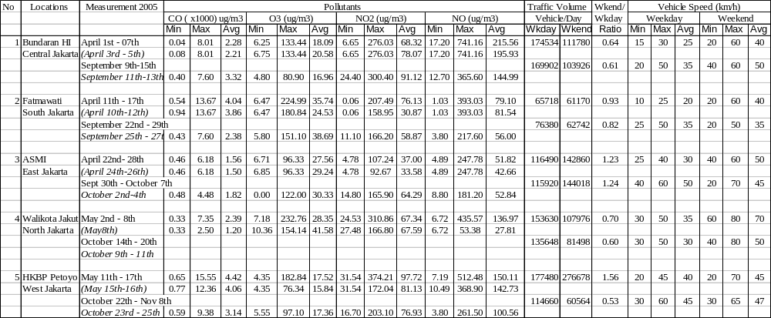

TABLE 2a. Estimation Results (Latent Variables & Error Term Correlations) of Roadside Surface Ozone Model in Jakarta City
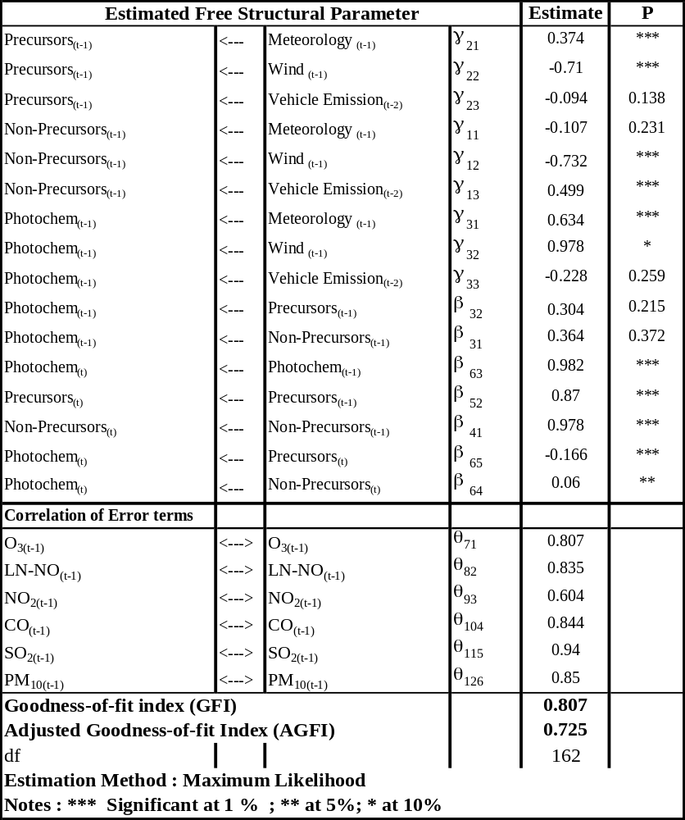

TABLE 2b. Estimation Results (Endogenous & Exogenous Observed Variables) of Roadside Surface Ozone Model in Jakarta City
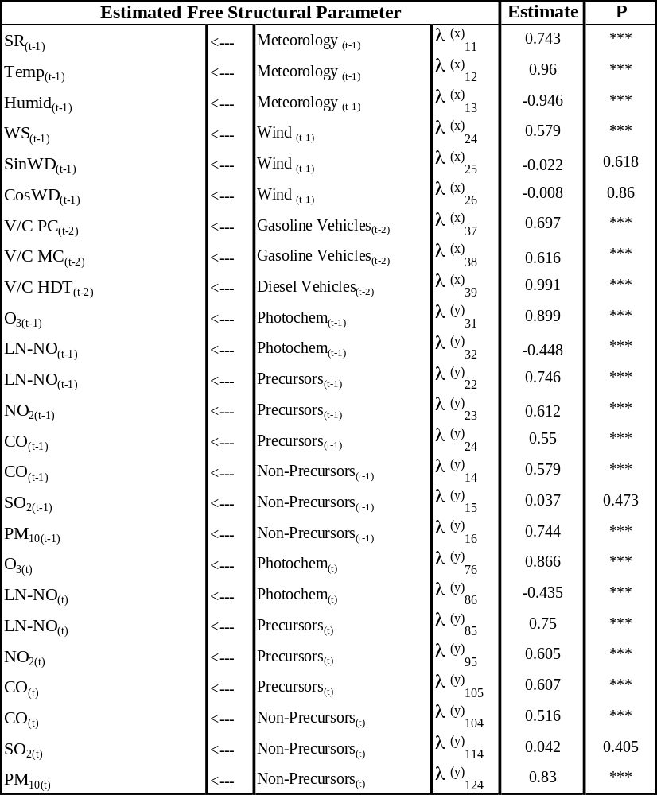

TABLE 3 Estimated Standardized Total Effects of Roadside Surface Ozone Model in Jakarta City

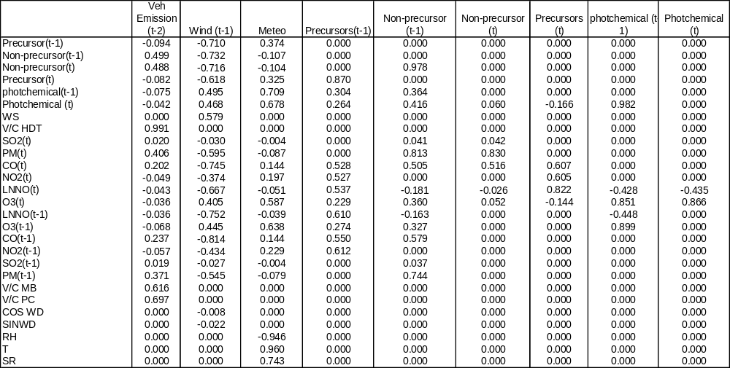
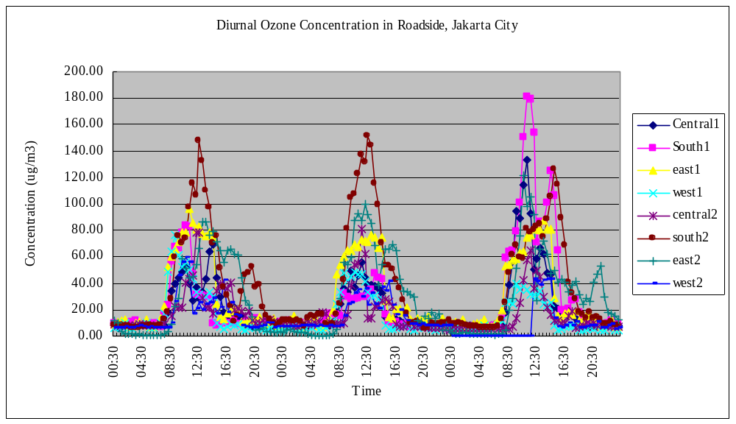
FIGURE 1 Diurnal variations of O₃ in Roadside, Jakarta City

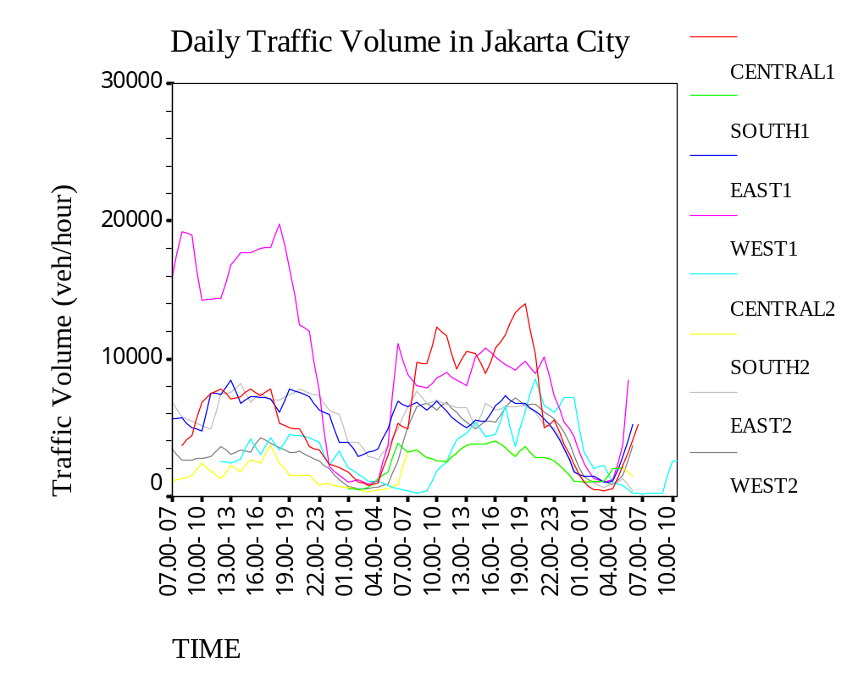
FIGURE 2 Daily Traffic Volume in Major Roads, Jakarta City

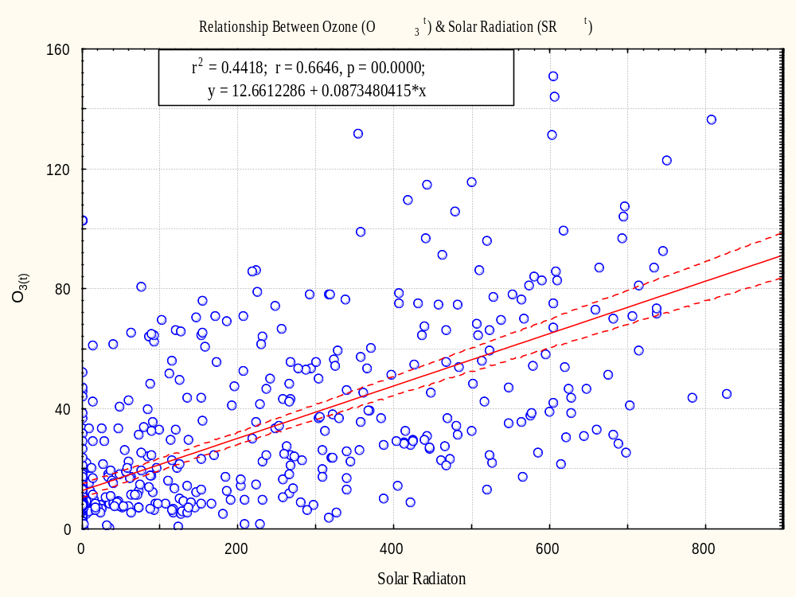

FIGURE 3 Relationships between Solar Radiation and O_{3(t)}

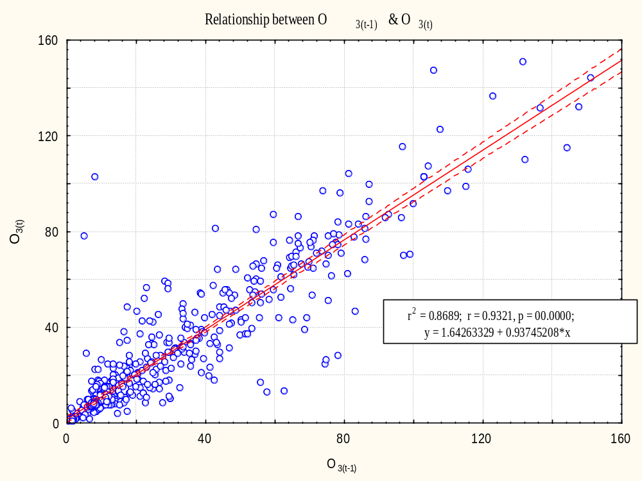

FIGURE 4 Relationships between O_{3(t-1)} – O_{3(t)}

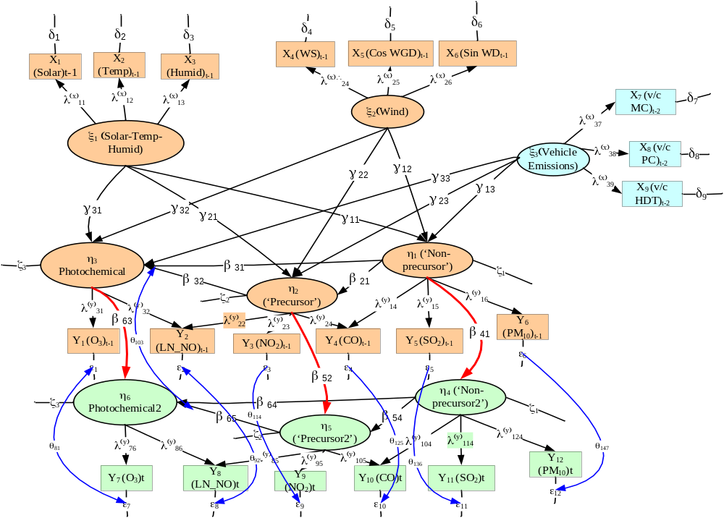

FIGURE 5 Structural equation model of roadside surface ozone for Jakarta City

Paper submitted to The 11th World Conference on Transportation Research, June, 24-28, 2007, University of Barkeley, California, in response to Topic Area “Transportation and Air Quality (F5)”. Please send any correspondence to Sudarmanto, Tel./fax: +81-82-424-6922; e-mail: totoksbn@hiroshima-u.ac.jp

