The acoustic climate in the city: an approach to define noise indicators in urban context for a sustainable transport planning

Cristina Pronello
Dipartimento di Idraulica, Trasporti e Infrastrutture Civili
Politecnico di Torino
Corso Duca degli Abruzzi, 24
I-10129 Torino, ITALY
Tel. +39 011 564 5613 – Fax +39 011 564 5699
E-mail: cristina.pronello@polito.it

Cristian Camusso
Dipartimento di Idraulica, Trasporti e Infrastrutture Civili
Politecnico di Torino
Corso Duca degli Abruzzi, 24
I-10129 Torino, ITALY
Tel. +39 011 564 5640 – Fax +39 011 564 5699
E-mail: cristian.camusso@polito.it

Abstract

The aim of the research is a first definition of alternative noise indicators that should be able to better characterize the acoustic climate in urban environments and to support a more sustainable transport planning. Through our methodology we have defined a set of “standard sites” by different characteristics, i.e. entities defined by a precise combination of variables characterising the infrastructure, the vehicles and the surrounding environment. This approach was used on two Italian cities, Torino and Vercelli, where som site has been analysed. Some first results concerning the effectiveness of the site selection, the selection of the variables involved in noise production and dispersion and human perception and a first indication about the noise indicators are given.

1 Introduction

Noise pollution is one of the central problems of urban areas, and its more precise characterization is the condition to set up policies to more effectively contrast it. One European citizen out of five is daily exposed to traffic noise exceeding the tolerance limit, but it would be utopian to think to solve the problem with a merely technology-driven approach. Improvements in vehicles and roads are important, but the strategic challenge is to more effectively tackle it with a global policy.
There is currently no agreement, not only among European countries, concerning the methodology of evaluation of noise pollution, and the indicators being used present several limitations, particularly in urban ambits. The construction of a common data base used by the different countries for a more accurate description of noise events and background noise in urban situations should be foreseen.
As the characterisation of the only noise source is not sufficient to well describe the noise event, the focus is to individuate some standard sites that are “recurrent” (both in urban and interurban context) and that are characterised by a precise combination of variables characterising the infrastructure, the vehicles and the surrounding environment.

2 Methodology

The methodology has been defined to analyze the urban system as a whole, and examine the interactions between the variables involved in noise production and dispersion, in order to:
- identify the variables influencing the noise produced by urban activities (transport, humans, etc.);
- define the “standard sites” in which to carry out the measurements.
The identification of the characteristics of the “standard sites” for the measurements is fundamental because the characterization of the noise source, by itself, it is not sufficient to really understand the noise event; this event, really, causes a different effect in function of the location and environmental conditions in which it happens. This means that two subsystems are present and interact in the environment: the infrastructure and the vehicles (Pronello, 2003; Pronello and Iannelli, 2002).
For the system and the subsystems mentioned, the following variables have been singled out:
  - the vehicles:
      - their characteristics (
      - the typology;
      - the lenght, number and typology of the carriages -for trams and trains;
      - the characteristics of the rolling stock: typology of the bogies and braking system;
      - the age;
      - the engine displacement;
      - the type of traction: electric, gasoline, diesel, gpl, methane, hydrogen;
      - the maintenance conditions);
      - their cinematic driving characterisation (driving cycles), greatly influenced by driving attitude and behaviour;
      - their composition in term of traffic flow: continuous, discontinuous, flow’s intervals, influenced by the road/rail typology and by the presence of interruptions (traffic lights, cross-roads, etc.; see infrastructure);
  - the infrastructure:
- the geometrical characteristics of the line:
- the plane altimetry of the road/track route (straight, bend, flat slope);
- the constructive typology (ground level, trench, elevated), the number of tracks/lanes and the presence of artifacts (bridges, vaiducts, tunnels);
- the power: electrified line or not (for trams, trolleybuses and trains);
- the typology of the track equipment, characterised by the type of ballast (traditional ballast or reinforced concrete platform), of sleepers (wood or reinforced concrete) and of junction (welded or joined), the type of rail (rack, grooved, etc.); and the paving typology: asphalt, porphyry, stones, etc.;
- the track/paving maintenance conditions;
- the ordinary interrructions: traffic lights, cross-roads, roundabout, etc., and the straordinary hold up as restrictions due to works, accidents, etc..
  - the environment:
- the presence of obstacles: the vegetation, characterised by its typology (trees or bushes), by the height and distance from the line; the buildings, characterised by the continuity or not of the skyline, by the height and distance from the line; the man made artifacts and the natural hills.
- the lack of obstacles: free field condition. The propagation of sound waves is influenced by the type of ground (vegetal or artificial, absorbing or reflecting);
- the meteorological conditions during which the noise source occurs: lack or presence of wind and, in this last case, its intensity and direction ; air temperature, pressure and humidity; degree of sky cover; rain, snow (Berengier, 1998). Recent studies have shown that the meteorological conditions become more important as the distance between source and receptor increases (De Vita, 1997). Close to the road/railway the most relevant effects are due to the geometrical spreading and to the ground effect; the air absorption as well as the temperature gradient are not significant, (Makarewicz, 1996);
- the quality of life in term of:
- visual aspects:
- green areas;
- shape of buildings;
- road conformation and urban equipment (e.g. bus stop decor, gardens, etc.), and road visual impact
- social and economical aspects:
- human density, people tipology, building typology (popular, middle or high level);
- density and vicinity (attraction area of influence) of shops, social structures, schools, restaurants, loisir;
- buildings’ quality (comfort, noise isolation, maintenance conditions);
- accessibility for private transport (parkings, cycle paths) and transit (stop locations, frequency) and their location on urban land (good insertion or cut causing divisions between areas); safety for transport users and pedestrians; people perception;
- political aspects: authorities (e.g. public actions and municipality’s change); quartier’s associations, spectacles, events, etc..
From these variables can be built a long number of combinations that can characterize different sites and produce certain noise levels. The analysis of all the combinations, at all the levels, for an high number of factors, needs too many tests, thus the design of experiments (DOE) has been used. DOE is a multivariate statistical technique designing a set of experiments, and it allows for the individuation of the factors able to influence the mean and the variance of an examined characteristic (Fowlkes and Creveling, 1995), in our case the noise level.
To define the optimal number and typology of combinations of the variables that will form the sites in which to carry out the measurements,

the orthogonal matrixes allow to select a fraction of all the combinations, maintaining the efficiency of the experiment.

2.1 The application of the methodology in two towns

Analysing the road network in two Italian cities, Torino and Vercelli, a first classification based on some of the variables above mentioned was attempted and in the sites so individuated noise measurements were carried out along the years.
The first result of the methodology has showed that too many variables were selected, and the matrix gives combinations not existing in the reality.
Thus, a simplification was done following three principles:
      - the number of lanes were divided in two groups: 1-2 lanes and 2-4 lanes, and, for each group a classification using the other remaining factors has been done (figs. 2.1, 2.2);
      - some factors have been used as proxy for other factors; for example the number of lanes gives an indirect information about the road width and, for the urban context (buildings lining the sides of the road), also about the distance between the road axis and the buildings. Generally, the number of lanes determines the road typology and, hence, the traffic that can flow on it;
      - the analysis of variance in the selected sites was carried out to highlight the effects of the different variables on the noise and has allowed to disregard some factors. For example, the speed (in the sites where it was known) has not revealed any important effect in the most part of the urban roads. In Vercelli, a constant narrow range was envisaged (40-50 km/h) in some roads. This means that in certain day periods (above all in the peak hour period) the traffic is quite constant and intense so that its speed is usually ranging in a very short interval.
Thus, some factors as traffic quantity and speed have not been considered in the first classification, due to the lack of homogeneous information in the available sites, but we considered them in a later statistical anaysis.
The first screening emphasized that the number of lanes (expressing the road width), the presence of tram, and the shape of the surrounding elements (presence or not of buildings: U or L section or free field) were the most important elements in determining a certain noise levels and were chosen as the first factors to be used in the determination of the factorial plan.
On the basis of these few factors, at two levels each, in one case (roads having 1-2 lanes and asphalt pavement) a full factorial plan has been built instead to use the orthogonal matrixes, no more necessary due to the strong decrease of the factors (fig. 2.1), and, in the other case (roads having 2-4 lanes and asphalt pavement), a fractional factorial plan has been built adopting a L₄ matrix (fig. 2.2).
The factorial plans have allowed to individuate the road sections and to highlight the “missing sites” in our data base in which to carry out the measurements, as depicted in the last column of the figures 2.1 and 2.2 (the “Roads ID” represents the street number in the database).
After the sites definition and the traffic and noise measurements, a new statistical analysis has been carried out to verify if the first classification of the sites was reliable or not in terms of the noise produced by the sources and the dispersion allowed by the “geometric characteristics” of the site.

3 The measurement campaign and the survey

3.1 The measurement campaign

In the sites individuated thanks to the DOE, a survey to the people living in the buildings lining the section has been carried out to investigate the degree of disturbance of the people exposed to noise.
The aim is to build a data base containing all the factors influencing the noise level and the people annoyance to characterize the site and find the cause-effect principle in the noise production and perception.
The data contained in the data base are so classified and described:
      - location of the site;
      - section typology : U (with n° of floors), L, free field;
      - location of measurement; position of microphone; an hypertext link goes to different maps and figures;
      - time of measurement: time interval on which the data are available;
      - traffic measurements: the data are available in different time interval as 1, 5, 10, 20, 30 minutes or 1 hour; for all the intervals the average speed is reported as also a classification of vehicles in three classes: mortorbikes, car and heavy vehicles;
      - noise data: the traditional data are available thanks to the measurements:

  - energetic indexes:
  - L_{Aeq(6h-22h)}, L_{Aeq(22h-6h)}, L_{Aeq(6h-18h)}, L_{Aeq(18h-22h)} (only in two sites);
  - L_{den} (only in two sites);
  - L_{Aeq(hourly)} calculated on an hourly basis or a shorter period (e.g. 1 min, 5 min, 10 min, 15 min, 30 min);
  - L_{eq} relative to the straordinary events highlighting the difference in respect to pre-determined threshold values;
  - statistical indexes:
  - L₁; L₅₀ ; L₉₀; L₉₅ for the traditional diurnal, night and evening periods and also hourly;
  - L₅₀ ; L₉₀; L₉₅ for 10, 20 and 30 minutes’ period;

  - event indexes:
  - SEL; L_{max} ; partial L_{eq} relative to single events (vehicles’ passage, etc.);
  - the number of events exceeding pre-determined threshold (fixed or changeable during the day) values during traditional periods and also during shorter periods as one hour, 30, 20, 15, 10 minutes;
  - frequency indexes:
  - average spectrum of the event and the spectrum relative to the event’s maximum noise level;
  - sonogram of the event;

3.2 The epidemiological survey

In addition to the noise indexes, we obtained the variables relative to the disturbance (e.g. the degree of disturbance, the number of times the people are disturbed, etc.) thanks to the survey carried out in the defined sites.
The survey is composed by different sections:
- the first section concerns with the individual data: birth-date, sex, occupation, etc;
- the second section concerns with the working place and house:
noise in the working place;
duration of living in the house (since how many years/months/… people live in their house);
at which floor is the flat;
layout of the flat (position of the rooms on the road, etc.);
windows typology of the flat and their position;
degree of disturbance either with the open or closed windows;
how many hours people spend at home;
degree of disturbance perceived in the house for each hourly range (6.00-8.00, 8.00-10.00, 10.00-12.00, 12.00-14.00, 14.00-16.00, 16.00-18.00, 18.00-20.00, 20.00-22.00, 22.00-24.00, 0.00-3.00, 3.00-6.00) using the Likert scale (from 1 – not disturbed at all – to 7 – very much disturbed);
specification of the typology of noise causing annoyance inside the house and its definition (sharp or low);
if the noise causes problems in falling asleep;
if the noise causes sudden awakenings;
definition of the acoustical quality of the road in which people are living (using the Likert scale from 1 to 7: quiet to very noisy);
ownership of the house/flat;
interest to install special windows if there are not yet.
- the third section concerns with the attitude and behaviour towards the noise:
sensitivity to noise;
judgment on the responsibility of people for the noise;
judgment on the influence of own behaviour on the noise;
need to organize groups of complaint or sensitization for the noise problems;
reading pamphlet, articles or other on noise before today;
belief in solutions to noise;
belief in technology to solve the noise problems;
- the fourth section concerns with the health of people:
presence of problems concerning the ears;
general health conditions (good or not);
presence of stress;
presence of insomnia;
difficulty in concentration;
problem of depression.

This could allow to relate the measured noise values to the disturbance effects recorded during the survey and to cross the available data caming from different classification of the sites.

4 The data analysis

The first type of analysis is the in depth analysis within each site to verify which are the influent variables under the classification point of view and verify if the designed variables were properly defined. The methodological approach chosen to test the above relationships has been the analysis of variance (ANOVA) as the scope was to verify the scheme obtained using the complete factorial and fractional matrixes, based on the variance concept. The analysis was focused on testing the relationships between noise and geometrical and traffic flow characteristics to verify if the geometrical characteristics are good proxy of the traffic flow.
Firstly, an analysis within each site has been carried out to evaluate the noise variation in function of the time integration intervals and the traffic flows; secondly, an analysis of comparison among the sites has been carried out.

Firstly, an analysis within each site has been carried out to evaluate the noise variation in function of the time integration intervals and the traffic flows; secondly, an analysis of comparison among the sites has been carried out. These analyses were finalized to understand some general trends and it has to be considered as a preliminary study to a deeper insight for the definition of some innovative noise indicators.

4.1 Analysis within each sites
The analyses within each site are focused to evaluate the relationships between the traffic data (especially the flow) and the noise levels calculated on different time intervals.
The analyses have put in relation the traffic flows measured on different time intervals (1, 2, 5, 10, 15, 20, and 30 minutes) with the noise indexes in the same time intervals. In particular, the following relationships have been investigated;
- Leq — traffic flow
- L₉₀ — traffic flow
- L₅₀ — traffic flow
- L₁₀ — traffic flow.

The analyses show that there is not a linear correlation between the Leq and the traffic volumes. Only for low time integration – 1, 2 or 5 minutes – a certain link is evident: when the number of vehicles increases, also the noise grows. Table 4.1 shows the analyses on 2 minutes time interval in Susa road (p=0.035 F=2.002 R=0.255). Concerning the statistical noise indexes, a correlation between the background noise level (L₉₀) and the number of vehicles passing through the site section has been envisaged. The trend shows the increase of the background noise with the increase of number of vehicles, for almost all the time integration intervals. This first result has induced to make analyses of linear correlation for all the sites and all the time integration intervals. The result of this analysis shows a growing trend related to the increase of number of vehicles where the correlation coefficients range from 0.3 to 0.6 for time integration intervals till to 20 minutes; beyond this interval no trend has been found.
Concerning the index L₁₀, it is influenced from the number of vehicles only when the analysis is done on low time integration intervals and in only two sites: Susa road (p=0.001 F=3.306 R=0.25), and Town Hall Square (p<1% F=3.803 R=0.273); on these data we have observed that when the time intervals increase, the number of vehicles is less important in explaining the difference of the average values.
In addition, in these sites the traffic flow is less constant in respect to other sites as in these ones the mentioned correlation has not been envisaged.
The correlation between L₅₀ and the traffic flow is recordable only on short integration periods, from 1 to 10 minutes; some examples are: Susa road on 1 minute (p=0.005 F=2.726 R=0.279), Town Hall Square on 2 minute (p<1% F=3.954 R=0.337), Cigna road on 2 minutes (p<1% F=2.916 R=0.582).
For higher integration times, the average values are not related to the change of the number of vehicles.

4.2 Analysis of comparison among the sites (full factorial matrix)

4.2.1 Analysis of the hourly flow vs standard site

The data base is formed by data measured in different days and in different hourly ranges.
Thus, a first analysis to evaluate the dispersion of the data has been carried out.
The analysis shows that the sites are different in respect to the hourly traffic flow.
Then, the ANOVA has been carried out to investigate the influence of the site on the Leq, the noise levels are statistically different in the different sites and the trend is similar to that envisaged for the site vs traffic flow.
The data used in the analysis were measured in different hourly ranges; to evaluate if the aforementioned differences depend on the standard site or on the hourly range of measurement, analyses on homogeneous time intervals have been carried out from 7.00 to 9.00 a.m. and from 5.00 to 8.00 p.m.
Hourly range 5.00 – 8.00 p.m.
As we have only three hours, we have used the measurement referred to time intervals of ten minutes. Five out of the eight standard sites provided in the full factorial matrix have been used (where the data were complete). The ANOVA carried out in these sites has shown that the five considered sites are different, not only under the point of view of the geometrical characteristics, but also from the traffic side (average traffic on ten minutes). On the same data base an anlysis concerning the Leq has been done, and, also in this case, the five sites are different in respect to the short Leq integrated on ten minutes. The result of the analyses are depicted in the table 4.2.
Hourly range 7.00 – 9.00 a.m.
In this case the sites where we have complete data were three out of eight.
The analysis shows that the three sites are different in respect to the average traffic flow on ten minutes as also in respect to the relative short Leq (ten minutes).
The results of the analyses show that the the geometrical variables, more simple to use than the traffic variables, are appropriate to carry out the site classification. The classes obtained using the geometrical characteristics allow to obtain typologies of road sections which are different also in respect to the traffic levels; thus the traffic flow is a variable dependent on the geometrical factors we used in the DOE (see section 2.1).
This fact confirms the goodness of the methodology for the site classification.
More details and graphic representations can be found in Predit Final Report. (Robin et al., 2007).

4.2.2 Pair comparison of the sites of the full factorial matrix

Sites 1 and 7
The sites 1 and 7 differs for the number of lanes – one lane in the Town Hall Square and two lanes in Cigna road – while they have both a “L” shape and one tramway lane.
The data have been ordered in function of the hourly Leq and the data having the same Leq values have been used; in table 4.3 we see how the same Leq is produced from two very different traffic “compositions”.
In Cigna road the traffic flow is congested and the speeds are very low due to the numerous traffic lights; this implies that the noise is not so high as thought related to the high number of vehicles. Looking at the background noise, we see that the traffic flow influence L₉₀, as already seen in other sites and, Leq being equal, in Cigna road the background noise is higher because the traffic quantity is higher.
Sites 3 and 4
The sites 3 and 4 are both formed by one lane without tramway, but they differ for the section typology: the site 3 has a “U” shape while the site 4 has a “L” shape.
In these sites we have few hourly Leq data, the values show that in the site 3 (U shape) the Leq is higher than in site 4 (L shape), but this increase cannot be influenced only by the section shape as the traffic flow is higher in the first site in respect to the second one.
Due to the few hourly data, the pair comparison has been done on the 10 minutes basis where the traffic flow is known; thus the traffic flow has been classified in three groups:
- less than 20 vehicles per 10 minutes;
- from 20 to 40 vehicles per 10 minutes;
- more than 40 vehicles per 10 minutes.
The ANOVA has been carried out considering the Leq as dependent variable and the section typology and the classes of vehicles as parameters. The results are depicted in the table 4.4.
The analysis shows that in the sites having one lane without tramway, generally the “U” sections are noisier than the “L” sections, being the number of vehicles equal; in fact, observing the figure in the table 4.4, we can see that, for each group/class of vehicles during the ten minutes period, the “U” sections have a Leq higher of about 4 dB(A).
In this case the noise level is influenced by the site typology and not by the traffic quantity.
Sites 5 and 6
The sites 5 and 6 have two lanes without tramway and differ for the section typology: the site 5 has the “U” shape while the site 6 has the “L” shape; they are similar to sections 3 and 4, but they have a wider section.
The analysis has been done on data integrated on ten minutes; the traffic flows have been so classified:
- less than 50 vehicles per 10 minutes;
- from 50 to 150 vehicles per 10 minutes;
- from 150 to 200 vehicles per 10 minutes;
- more than 250 vehicles per 10 minutes.

The analyses show that, in this case with two lanes and no tramway, the sections having “U” shape are noisier than the “L” shape sections; the difference is about 3 dB(A) for the traffic flows range from 50 to 250 vehicles/10 minutes while for traffic flows less than 50 vehicles/10 minutes and greater than 250 vehicles/10 minutes an inversion of trend occurs in respect to the one lane sites: when the road width increases, the difference between the two section typologies decreases.

Sites 3 and 5
The sites 3 and 5 have a “U” shape, without tramway. The difference lays in the number of lanes and, hence, in the road width: one lane in the site 3 and two lanes in the site 5.
Making the analysis on the data integrated on 10 minutes time basis, the traffic flow is classified in two groups:
- less than 50 vehicles per 10 minutes;
- from 50 to 100 vehicles per 10 minutes.
The results from ANOVA show that the considered variables (on ten minutes time basis) do not influence the noise.
Considering the five minutes time basis, the analysis is carried out classifying the traffic in two groups:
- less than 50 vehicles per 5 minutes;
- from 50 and 100 vehicles per 5 minutes.
To analyse the influence of traffic on noise, it is necessary that a similar traffic quantity is present in all the analysed sites; thus, the traffic flow has been divided in two classes because in the sites 3 the flow is quite modest while in the sites 5 there are some time intervals where the traffic reaches 150 vehicles/5 minutes (not observable in the sites 3).
In table 4.5 the results are presented.

The results show that the two lanes “U” sections without tramway are noisier of about 4 dB(A) in respect to those having one lane.
Sites 1 and 4
The sites 1 and 4 have the “L” shape and one lane; they differ for the presence of tramway in the sites 1. The ANOVA has ben carried out on the hourly data and to keep into account the traffic this has been divided in two classes:
- less than 200 vehicles per hour;
- more than 200 vehicles per hour.
The results are depicted in table 4.6.
The results show an important difference between the average values of the hourly Leq. Being the traffic equal, the site with the tramway is noisier of about 5 dB(A) in respect to the sites without tramway.
The same analysis has been done using the ten and five minutes time basis, to have more data, and the traffic flow is divided in two classes:
- using ten minutes time basis
- less than 30 vehicles per 10 minutes;
- from 30 to 50 vehicles per 10 minutes (in the analysis this group is labelled as “> 30”);
- using five minutes time basis
- less than 15 vehicles per 5 minutes;
- from 15 to 30 vehicles per 5 minutes.
In both cases the analysis show that the sites having one lane and the “L” shape are noisier than those without tramway of about 5-6 dB(A), as already seen.
Sites 7 and 8
Unfortunately for these sites there are not enough data referred both to one hour and ten minutes, not any ANOVA has been carried out.

4.2.3 Matrix L₄
The one-way Anova has been done in respect to the Leq, using all the available data referred to one hour in the different sites. This means that a measurements in a site having a four hours duration gives four hourly values of noise and traffic flow and, in the matrix, that site has four data. The analysed data are referred to measurements done in different hourly intervals during the day. The results show that, among the sites, the average noise values are similar (p = 13%), but we cannot say that the sites are similar in respect to noise due the different time periods (morning or afternoon ranges) in which the measurements have been done.
The same consideration can be done when the Anova is carried out in respect to the traffic flow; the results show that the hourly traffic volumes are statistically different (p<1%) among the sites, but this difference cannot be attributed to the standard site as the hourly ranges used in the analysis are referred to some to peak-hour periods and others to non peak-hour period.

4.2.4 ANOVA in function of road width
Crossing the data from the matrix L₄ with those from the full factorial matrix, we can analyse the influence of the road width on the noise. We show here only two cases out of all the studied cases.

“L” section without tramway, variable width
The analysed sections have the “L” shape without the tramway line; the variable factor is the road width, and, hence, the number of lanes:
- one lane road;
- two lanes roads;
- four lanes roads with service road.
The data are hourly values.
The ANOVA has been firstly carried out on the hourly flows; the data of three site typologies differ in terms of the traffic flows.
If we analyse the road width in function of the Leq, we can see the same trend above, but, in this case, the noise values are more influenced by the road width. The traffic flow is similar to that of the previous analysis, but the noise levels are 5-6 dB(A) less than the sections with the tramway, in the case of one lane roads. In the two and four lanes sections having the service road the noise levels are close to that of two lanes with service road. The explanation could be that in the larger sections the tram noise is masked by the noise level due to the high traffic. In table 4.7 these results are shown.
“U” section with tramway, variable width
The analysed sections have the “U” shape with the tramway line; the variable factor is the road width, and, hence, the number of lanes:
- one lane road;
- two lanes roads;
- four lanes roads with service road.
The data are hourly values.
The ANOVA has been firstly carried out on the hourly flows; the data on the three site typologies differ in terms of the traffic flows.
If we analyse the same data in function of the Leq, we can see that the sections have similar noise values also having very different traffic flows. In fact, in the narrow roads, also a low traffic produces high noise levels

4.2.5 Summary and findings on the analysis of the variables
The result of different analysis on the geometrical variables are depicted on figure 4.1. Comparing the sections 3 and 4 (fig. 4.1), the analysis on the ten minutes data shows that the sites 3 are noisier than sites 4 of about 4 dB(A), also the traffic flow being equal. Thus, the “U” shape sections have a higher Leq of about 4 dB(A) for every traffic flow.

In the case of two lanes road without tramway (sites 5 and 6, fig. 4.1), the “U” shape sections are noisier than the “L” shape sections. The variation is about 3 dB(A) for traffic flows from 50 to 250 vehicles/10 min; for flows less than 50 veh/10 min and greater than 250 veh/10 min the sections 6 are noisier.
In respect to the sites having one lane, we observe a decrease of the difference between the two road typologies increasing the road width.
The comparison between sites 5 and 3 (fig. 4.1) uses the five minutes data. In these time intervals the “U” sections with two lanes and without tram are noisier of about 3-4 dB(A) than those having one lane, also being the traffic flow equal.
The comparison between the sites 1 and 4 (fig. 4.1), following the analysis on 5 and 10 minutes time basis, shows that the one lane road having “L” shape and with the tram are noisier than those without tram of about 5-6 dB(A). Precisely, the traffic flow does not influence the noise level, being the sections narrow and with moderate traffic volumes, while the presence of tramway is discriminant.
Basing on the road width, in general, the “L” sections having 1-2 lanes and the tramway (sites 1 and 2) are noisier than the same without the tramway (4 and 6) of about 4 dB(A). Instead, in the “L” sections having two lanes and the service road, the tramway does not influence the noise level. This could highlight that in the roads having more than two lanes plus the service roads (quite large) the tramway does not contribute to increase the noise level because the road infrastructure (and hence the traffic) becomes the prevalent noise source.

5 The noise indicators

In this chapter the focus is the evaluation of the epidemiological survey in respect to the measured physical variables (traffic and noise).
The survey, as said in the section 3.2, has been focused to understand the degree of disturbance perceived by the people living in the buildings in the selected standard sites.
To this scope, some questions have been put to the interviewed using the Likert scale to describe the annoyance in the different hourly ranges and, thus, to evaluate the link between the noise levels and the disturbance in the same hourly intervals.

5.1 The analysis of the disturbance in respect to the measured noise
The ANOVA has been used to put in relation the seven levels of disturbance in the Likert scale with several noise indicators (Leq, L_{min}, L_{max}, statistical levels, number of events) measured during the on site campaign.
The independent variable is represented by the seven levels of disturbance (from 1 – not disturbed - to 7 higly disturbed) of the Likert scale and the dependent variable by the noise level (expressed in turn by the different indexes). In this way we can observe the dispersion of the noise levels at the different degrees of disturbance.
The results show that at different degrees of disturbance correspond same intervals of the noise level; the only exception is the L_{max} where we note that a same stimulus (noise level) can be perceived and interpreted through different degrees of disturbance.
In table 5.1 and 5.2 the relationships between the disturbance and, respectively, Leq and L_{max} are depicted.
The number of events exceeding a determined noise threshold has been also considered as an additional noise indicator.
We have individuated the events exceeding 70 and 75 dB(A), evaluated on the time history integrated on the time basis of one second. Also in this case there is not any change among the disturbance degrees declared by the interviewed (p=12% F=1.761; and p=42% F=1.004).
Observing the data dispersion of the frequency of respondent per each declared disturbance, we can observe that, in general, three groups of levels can be defined, presenting the same variation range, allowing to reduce the scale from seven to three values:
- ≤ 2: little disturbed;
- from 3 to 5: medium disturbed;
- ≥ 6: very disturbed.
The analyses follow the same approach of the aforementioned ones, but the results are more representative and show significant differences between the levels (tab. 5.3).
In the figure 5.1 the new frequencies of respondent are shown, after the aggregation of the degrees of disturbance.
In the tables from 5.4 to 5.7 the relationships between the levels of disturbance and some of the noise indicators, through the use of ANOVA, are shown.
The mentioned tables show some concepts that we can summarize:
- L_{min}, L₉₀, L₉₅, and L₅₀ are not significant in explaining the difference of the levels of disturbance. The first three indicators represents the backround noise and the disturbance perceived by people can be low or high in function of the personal sensibility to the noise. This is the most subjective case. The real difference is envisageable between the little and the medium/high disturb.
- the number of events are significant only if the threshold is equal to 70 dB(A), otherwise not. As above, the real difference is envisageable between the little and the medium/high disturb. For the people is easier to distinguish the quiet (little disturb) from the higher and here the statistical difference is evident;
- the indicators better explaining the people answers are the peak levels as L_{max}, L₅ and, L₁₀.
- This means that the very high level events are that disturbing more the people and that the number of events does not run well as the peak statistical levels.
If we analyse the data, we can see that the most disturbed people are living in Cigna road (hourly Leq about 69 dB(A)) and Trapani avenue (hourly Leq about 71-73 dB(A)). Cigna road is a “U” section with tramway while Trapani avenue is a “L” section (very large and with high traffic flow: more than 3,000 veh/h) without tramway. We can observe that the hourly Leq is not a good indicator in highlighting the variation of the annoyance, because 3-4 dB(A) are not enough to produce different people reactions. Instead, the road shape and the presence of tramway are the most important causes of the people annoyance, also being Leq equal (as in most of the analysed cases).
Thus, the worst situations envisaged that the people perception is influenced by:
- the narrow sections where there is a tramway line producing several high noise peaks;
- the large sections having a very high traffic flow and high speed producing very high noise peaks.
People are quite used to live with quite high noise background, but the very high noise levels (more than 90 dB(A)) are well perceived and are the main cause for the declaration of a high disturbance.

6 Conclusions

On the basis of the results we can make some first suggestions about the most appropriate indicators for the different and complex urban sites.
The followed approach allows the transferability of the results to every site having the same variable’s combination, that is a new approach in respect to the traditional ones as proposed by several ISO (ISO 1996-2: 1987).
More investigation, instead, are needed in term of the annoyance. It is clear as the people are more disturbed by isolated and high events than by a high background level. The sites presenting certain geometrical configurations are more linked to the highest noise levels and are related to the highest levels of annoyance. In addition, the people express also very dispersed perceptions due to different sensibility and life style.
Our data base is not large enough to allow a statistical analysis on the different hourly range and the research has to continue with a new and larger campaign of measurements and a new and larger epidemiological survey, adding to the questionnaire some questions related to the health, life style, habits, etc. of the respondents.

References
- Berengier, M. (1998) ‘Il rumore delle infrastrutture stradali - Il nuovo metodo francese di previsione del rumore da traffico che include gli effetti meteorologici sulla propagazione’, In: Atti del XXVI Convegno Nazionale AIA, Turin, pp. 385-390.

- De Vita, F. (1997) ‘A global methodology for the acoustic assessment in correspondence of modern railway infrastructures’, In: Proceedings of the World Congress on Railway Research WCCR '97 vol. E, Florence, pp. 251-257.
- Fowlkes, W.Y., Creveling, C.M. (1995) ‘Engineering Methods for Robust Product Design’, Addison-Wesley Publishing Company, Reading, MA.
- Makarewicz, R., Yoshida, M. (1996) ‘Railroad Noise in an Open Space’, Applied Acoustics 49, pp. 291-306.
- Pronello C. (2003), ‘The measurement of train noise: a case study in northern Italy’, Transportation Research Part D: Transport and Environment, Vol. 8, Issue 2, March, 2003, pp. 113-128.
- Pronello C., Iannelli F. (2002) ‘I modelli di previsione del rumore da traffico: variabili caratteristiche e modalità di rilevamento dei dati’, in Rilievi e modellizzazione del traffico veicolare, Collana Trasporti, Editore Franco Angeli.
- Robin, B., Pronello, C., Polack, J.D., Arras, C., Bozzetto, D., Beaumont, J., Droin, L. (2007) ‘Pertinence des descripteurs d’ambiance sonore urbaine: application aux bruits des transports pendant les périodes sensibles’ Final report. Programme "Bruit et nuisances sonores" Programmation SRP/BCRD 2003 Convention de recherche - 18 A/2003 (référence d'accord n° CV 04000014).
- ISO 1996-2 (1987) : “Acoustics- Description and measurement of anvironmental noise” Part 2.

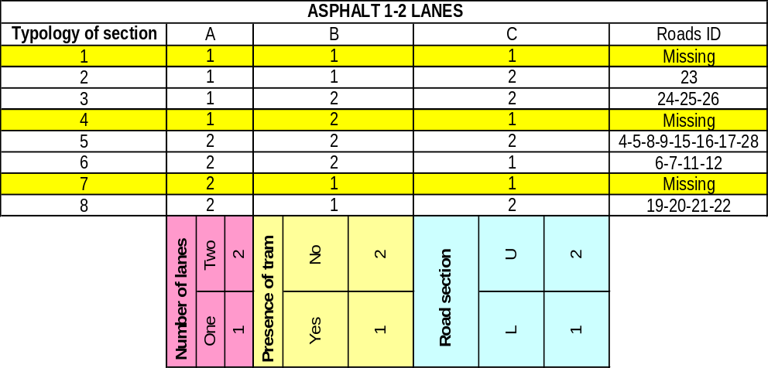
Figure 2.1 – Full factorial experiment for the group of roads having 1-2 lanes

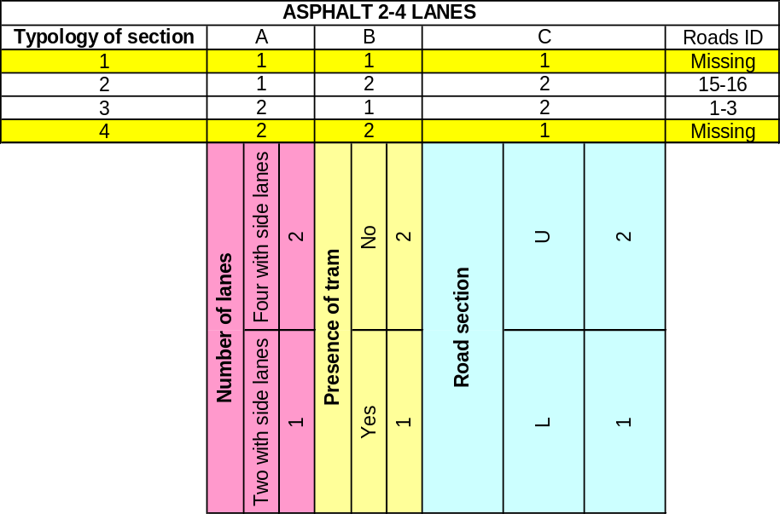
Figure 2.2 – Fractional factorial experiment for the group of roads having 2-4 lanes

Table 4.1 – Analysis on 2 minutes (Leq vs Vehicles) – Susa road
Integration on 2 minutes  Dep Var: Leq N: 121  Multiple R: 0.4  Squared multiple R: 0.206 |  |  |  |  |  | 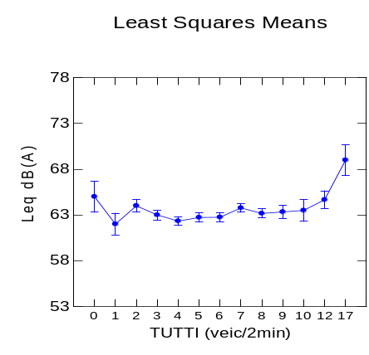
Source | Sum-of-squares | df | Mean-Square | F-ratio | P
TUTTI (ALL) | 68.867 | 12 | 5.739 | 2.002 | 0.035
Error | 223.573 | 78 | 2.866
Linear regression on 2 minutes data
Dep Var: LEQ
Multiple R: 0.255 Squared multiple R: 0.065
Effect | Coefficient | Std Error | Std Coef | Tolerance | t | P(2 Tail)
CONSTANT | 62.238 | 0.428 | 0.000 | . | 145.379 | 0.000
TOT | 0.164 | 0.066 | 0.255 | 1.000 | 2.483 | 0.015

Table 4.2 – ANOVA standard site (ten minutes) – afternoon period
ANOVA standard site vs traffic flow  (ten minutes) afternoon period  Dep Var: Vehicle/10min N: 185  Multiple R: 0.784 Squared multiple R: 0.614 |  |  |  |  |  | 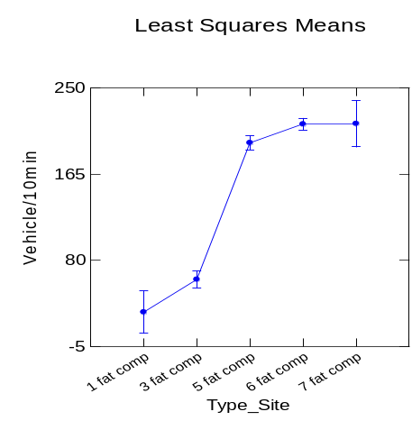
Source | Sum-of-squares | df | Mean-Square | F-ratio | P
TUTTI (ALL) | 751651.105 | 4 | 187912.776 | 71.664 | 0.00
Error | 471983.901 | 180 | 2622.133
ANOVA standard site vs short Leq  (ten minutes) afternoon period  Dep Var: Leq N: 185  Multiple R: 0.349 Squared multiple R: 0.122 |  |  |  |  |  | 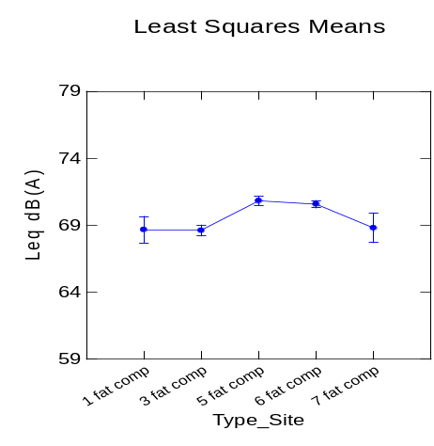
Source | Sum-of-squares | df | Mean-Square | F-ratio | P
TUTTI (ALL) | 148.620 | 4 | 37.155 | 6.236 | 0.000
Error | 1072.515 | 180 | 5.958

Table 4.3 – Comparison between the sites 1 and 7 in terms of number of lanes
One hour data
Standard site | Site name | Veic/h | Leq | Lmin | Lmax | L95 | L90 | L50 | L10 | L5 | Average speed (km/h)
1 | Town Hall Square | 194 | 69 | 50 | 94 | 56 | 57 | 63 | 71 | 74 | Estimated
1 | Town Hall Square | 196 | 69 | 50 | 100 | 55 | 56 | 64 | 72 | 74 | Estimated
7 | Cigna road | 1140 | 69 | 55 | 94 | 60 | 61 | 66 | 72 | 74 | Estimated
7 | Cigna road | 1226 | 69 | 57 | 94 | 61 | 62 | 66 | 71 | 74 | Estimated

Table 4.4 – Two-way ANOVA ten minutes values standard site 3 and 4
Dep Var: LEQ N: 176 Multiple R: 0.484 Squared multiple R: 0.235
Source | Sum-of-Squares | df | Mean-Square | F-ratio | P
SEZIONE$ | 169.838 | 1 | 169.838 | 16.151 | 0.000
GRUP_VEICOL$ | 16.161 | 2 | 8.080 | 0.768 | 0.465
SEZIONE$*GRUP_VEICOL$ | 13.196 | 2 | 6.598 | 0.627 | 0.535
Error | 1787.702 | 170 | 10.516
WARNING ***
Case 129 is an outlier (Studentized Residual = 3.769)
Case 143 is an outlier (Studentized Residual = 5.234)
Durbin-Watson D Statistic 1.297
First Order Autocorrelation 0.351
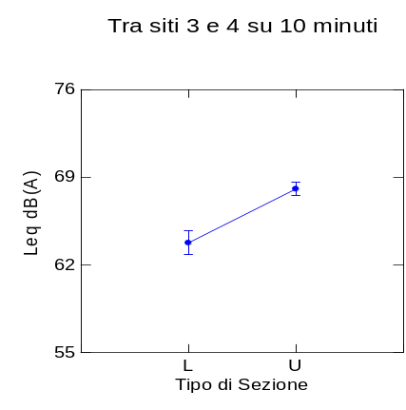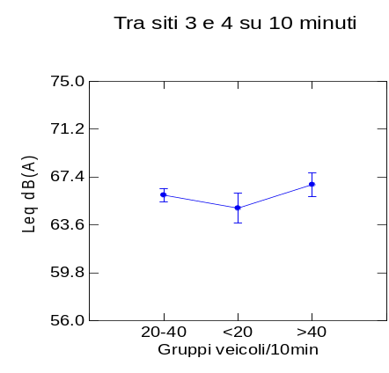
Dispersion keeping constant the group of vehicles – sites 3 and 4
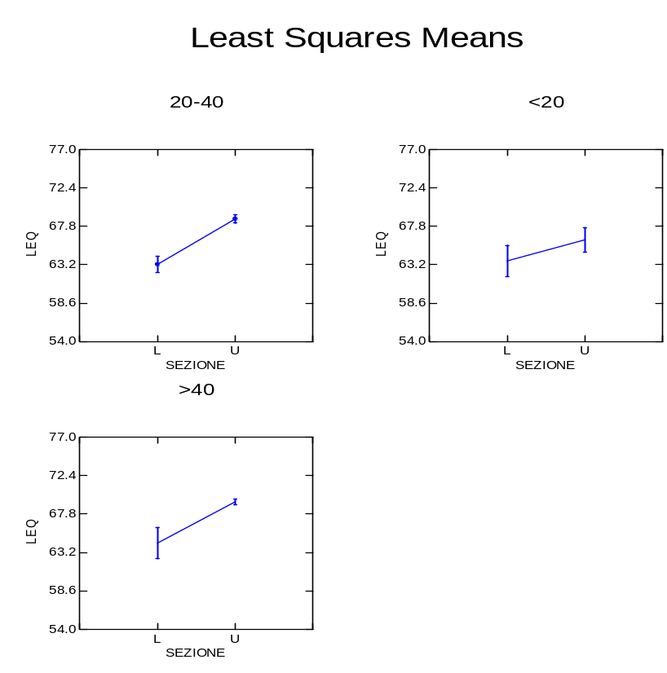

Table 4.5 – Two-way ANOVA number of lanes and group of vehicles vs Leq – sites 3 and 5 (five minutes values)
Dep Var: LEQ N: 842 Multiple R: 0.473 Squared multiple R: 0.224
Case 157 is an outlier (Studentized Residual =-5.530)
Case 211 is an outlier (Studentized Residual = 4.561)
Case 398 is an outlier (Studentized Residual = 4.779)
Case 425 is an outlier (Studentized Residual = 6.075)
Durbin-Watson D Statistic 1.038
First Order Autocorrelation 0.480
Source | Sum-of-Squares | df | Mean-Square | F-ratio | P
NUM_CORSIE$ | 103.835 | 1 | 103.835 | 9.348 | 0.002
GRUP_VEIC$ | 46.410 | 1 | 46.410 | 4.178 | 0.041
NUM_CORSIE$*GRUP_VEIC$ | 0.550 | 1 | 0.550 | 0.050 | 0.824
Error | 9308.782 | 838 | 11.108
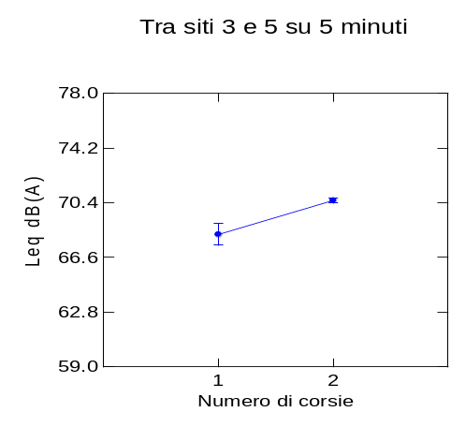 <50 <50 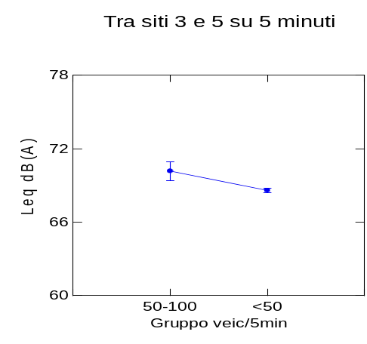
Dispersion keeping constant the group of vehicles – sites 3 and 5

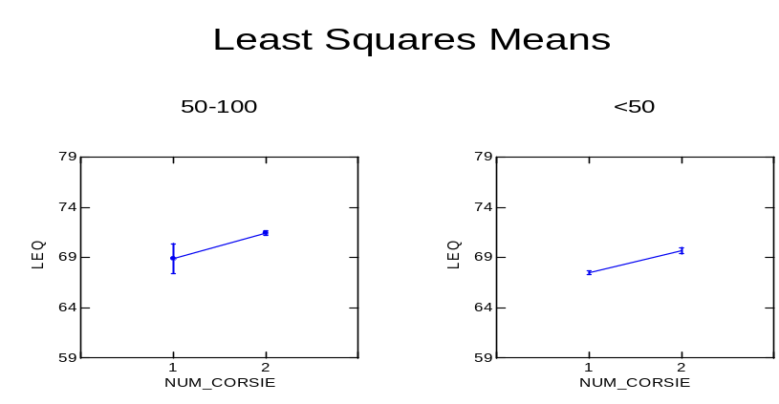

Table 4.6 – Two-way ANOVA standard site and group of vehicles vs Leq – sites 1 and 4 (one hour data)
Dep Var: LEQ N: 7 Multiple R: 0.992 Squared multiple R: 0.985
Case 1 is an outlier (Studentized Residual = 1.414)
Case 2 is an outlier (Studentized Residual = -1.414)
Case 6 is an outlier (Studentized Residual = -1.414)
Case 7 is an outlier (Studentized Residual = 1.414)
Durbin-Watson D Statistic 2.500
First Order Autocorrelation -0.500
Source | Sum-of-Squares | df | Mean-Square | F-ratio | P
SITO_TIPO$ | 57.600 | 1 | 57.600 | 172.800 | 0.001
GRUP_VEIC$ | 1.600 | 1 | 1.600 | 4.800 | 0.116
SITO_TIPO$*GRUP_VEIC$ | 0.400 | 1 | 0.400 | 1.200 | 0.353
Error | 1.000 | 3 | 0.333
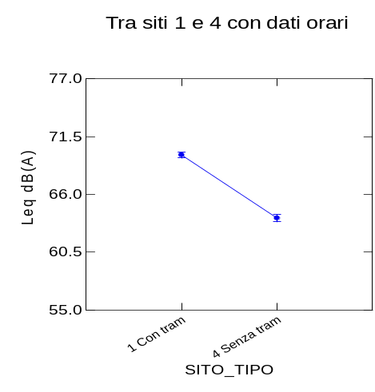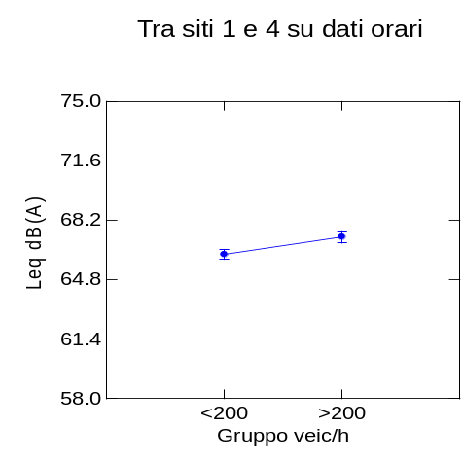
Dispersion keeping constant the group of vehicles – sites 1 and 4
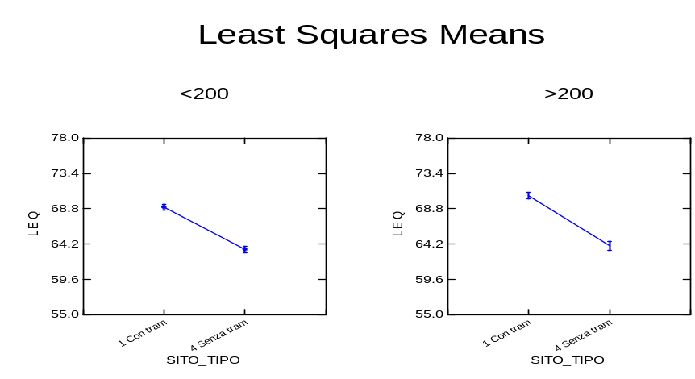

Table 4.7 – ANOVA number of lanes vs vehicles/hour and Leq
ANOVA-number of lanes vs vehicles/hour
Integration on 1 hour  Dep Var: VEIC_ORA N: 18  Multiple R: 0.960  Squared multiple R: 0.921  Durbin-Watson D Statistic 2.796  First Order Autocorrelation -0.429 |  |  |  |  |  | 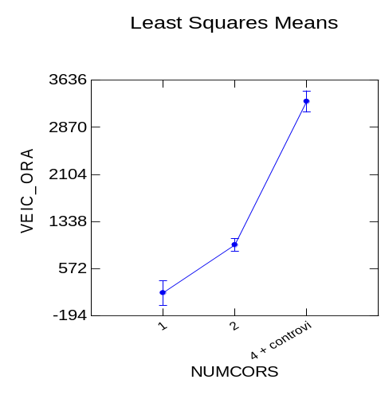
Source | Sum-of-squares | df | Mean-Square | F-ratio | P
NUMCORS$  Num. of lanes | 2.08854E+07 | 2 | 1.04427E+07 | 87.666 | 0.000
Error | 1786781.659 | 15 | 119118.777
ANOVA-number of lanes vs Leq
Integration on 1 hour  Dep Var: LEQ N: 18  Multiple R: 0.955  Squared multiple R: 0.912  *** WARNING ***  Case 15 is an outlier  (Studentized Residual = -2.946)  Durbin-Watson D Statistic 2.648  First Order Autocorrelation -0.361 |  |  |  |  |  | 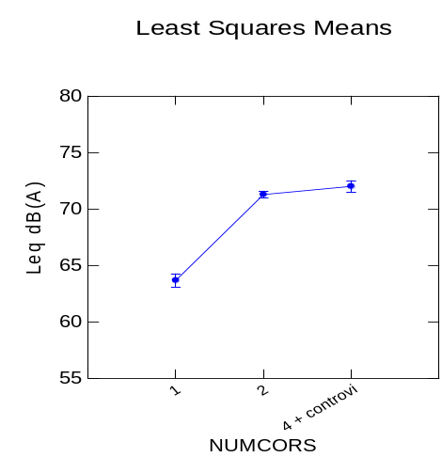
ource | Sum-of-squares | df | Mean-Square | F-ratio | P
NUMCORS$  Num. of lanes | 153.652 | 2 | 76.826 | 77.610 | 0.00
Error | 14.848 | 15 | 0.990

“U” Section, 1 lane, no tram | “L” Section, 1 lane, no tram
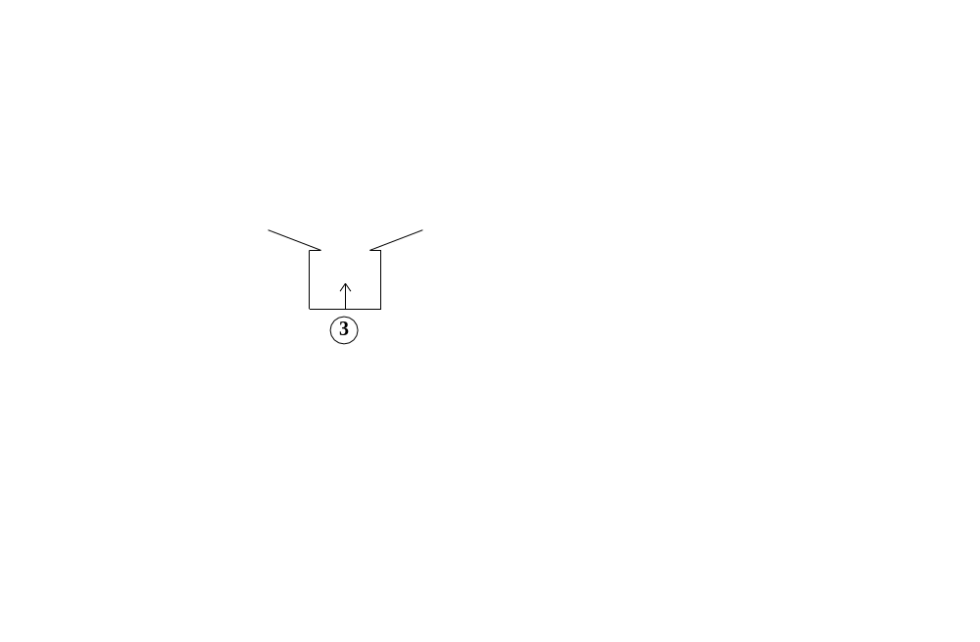  +4 dB(A) | 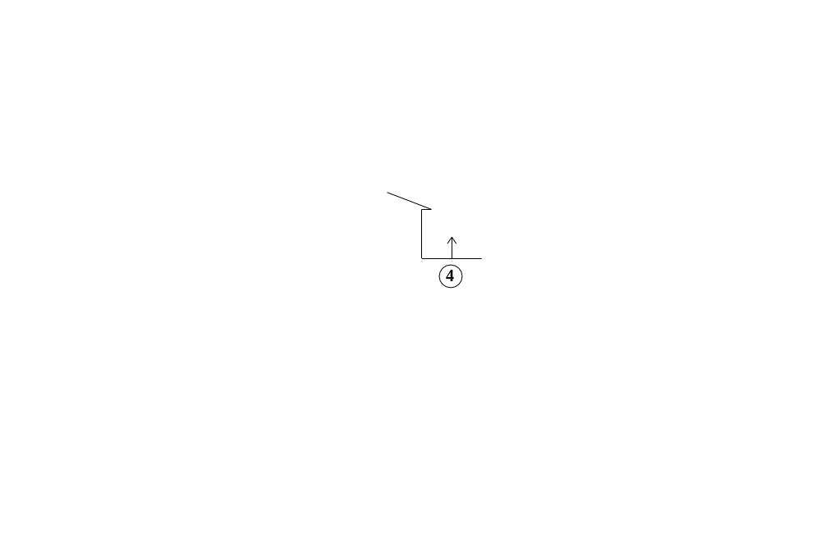
“U” Section, 2 lanes, no tram | “L” Section, 2 lanes, no tram
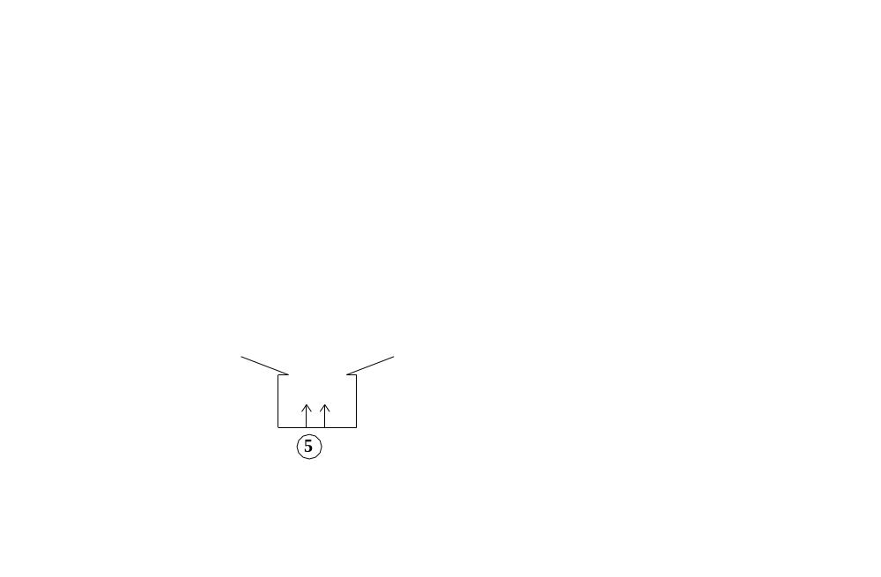  +3 dB(A) | 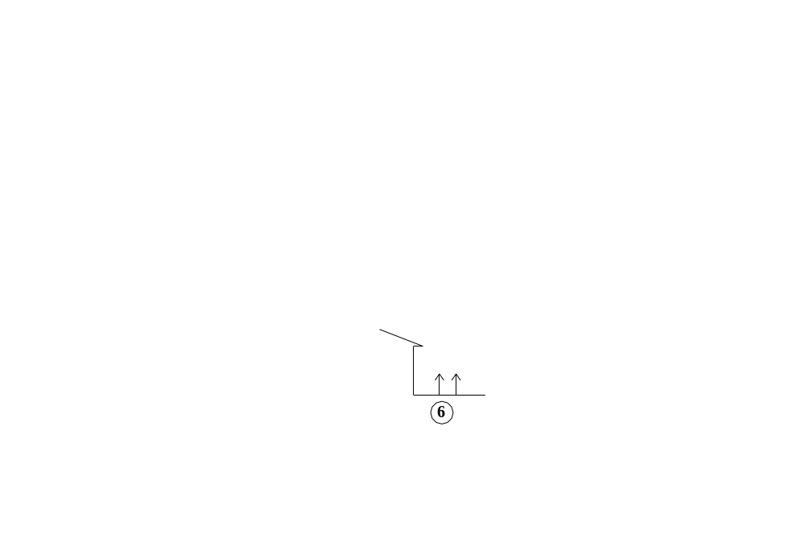
“U”Section, 2 lanes, no tram | “U”Section, 1 lane, no tram
+3/4 dB(A)
“L” Section, 1 lane, with tram | “L” Section, 1 lane, no tram
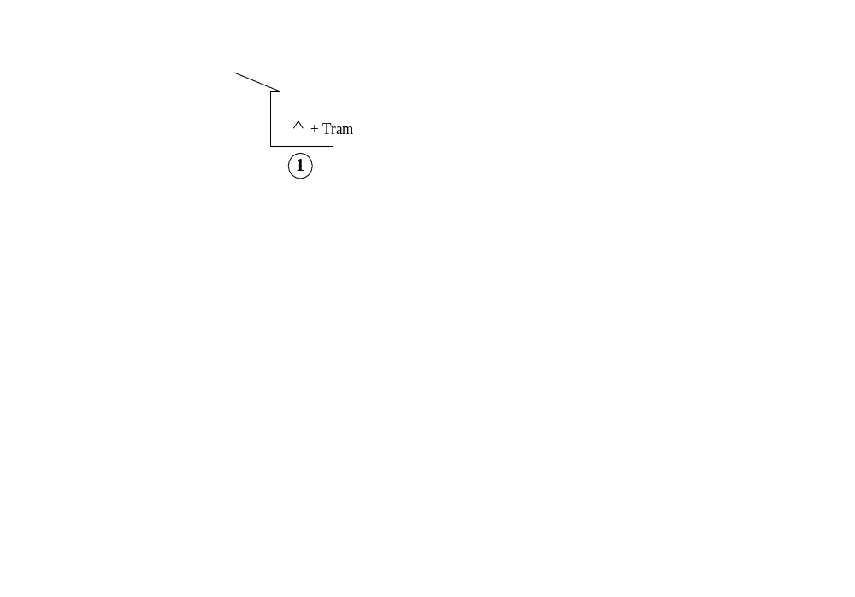
+5/6 dB(A)
Figure 4.1 – Geometrical comparisons between sites

Table 5.1 – ANOVA level of annoyance vs hourly Leq
<Bookmark(9)>
Dep Var: LEQ N: 72  Multiple R: 0.406  Squared multiple R: 0.165 |  |  |  |  |  | 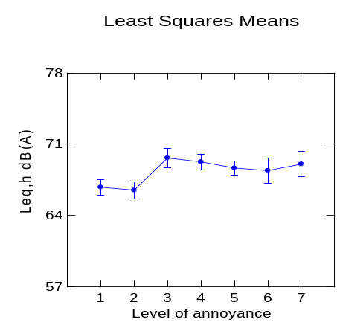
Source | Sum-of-Squares | df | Mean-Square | F-ratio | P
Level of annoyance | 99.112 | 6 | 16.519 | 2.142 | 0.060
Error | 501.285 | 65 | 7.712

Table 5.2 – ANOVA level of annoyance vs hourly Lmax

<Bookmark(8)>
Dep Var: LMAX N: 72  Multiple R: 0.501  Squared multiple R: 0.251 |  |  |  |  |  | 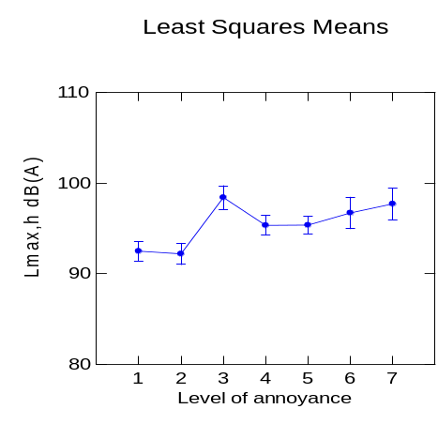
Source | Sum-of-Squares | df | Mean-Square | F-ratio | P
Level of annoyance | 328.486 | 6 | 54.748 | 3.630 | 0.004
Error | 980.454 | 65 | 15.084

Table 5.3 – ANOVA level of annoyance vs hourly Leq
Dep Var: LEQ N: 72  Multiple R: 0.390  Squared multiple R: 0.152 |  |  |  |  |  | 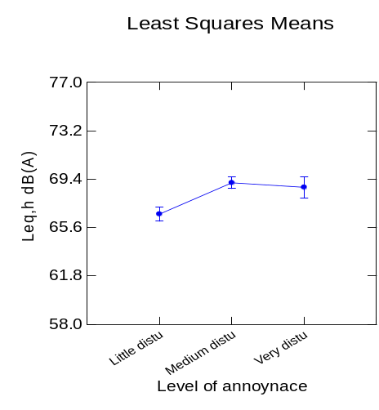
Source | Sum-of-Squares | df | Mean-Square | F-ratio | P
Level of annoyance | 91.462 | 2 | 45.731 | 6.200 | 0.003
Error | 508.934 | 69 | 7.376

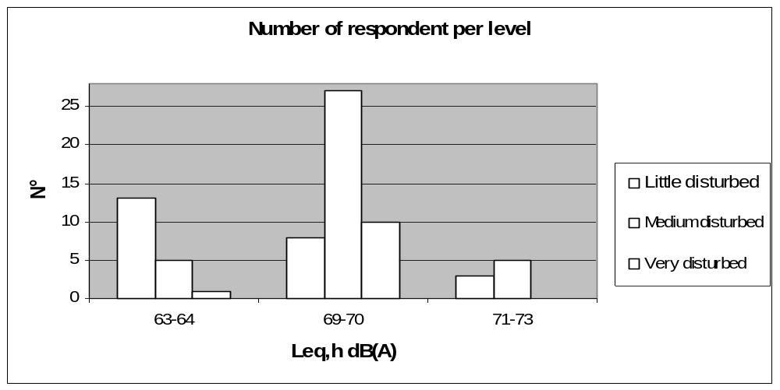

Figure 5.1 – Frequency of respondents

<Bookmark(8)>

Table 5.4 – ANOVA levels of annoyance (3 levels scale) vs hourly L90
Dep Var: L90 N: 72  Multiple R: 0.134  Squared multiple R: 0.018 |  |  |  |  |  | 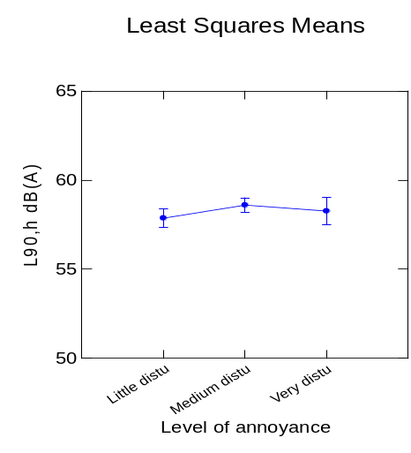
Source | Sum-of-Squares | df | Mean-Square | F-ratio | P
Level of annoyance | 7.791 | 2 | 3.895 | 0.627 | 0.537
Error | 428.929 | 69 | 6.216

Table 5.5 – ANOVA levels of annoyance (3 levels scale) vs hourly L50
Dep Var: L50 N: 72  Multiple R: 0.279  Squared multiple R: 0.078 |  |  |  |  |  | 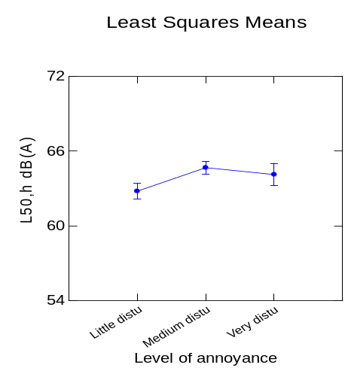
Source | Sum-of-Squares | df | Mean-Square | F-ratio | P
Level of annoyance | 52.170 | 2 | 26.085 | 2.913 | 0.061
Error | 617.847 | 69 | 8.954

Table 5.6 – ANOVA levels of annoyance (3 levels scale) vs hourly Lmax
<Bookmark(10)>
Dep Var: LMAX N: 72  Multiple R: 0.442  Squared multiple R: 0.196 |  |  |  |  |  | 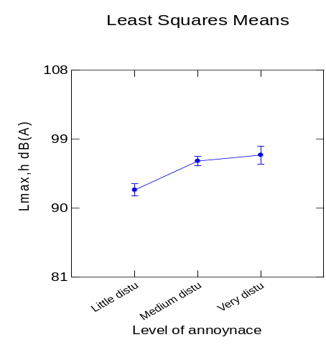
Source | Sum-of-Squares | df | Mean-Square | F-ratio | P
Level of annoyance | 256.171 | 2 | 128.085 | 8.395 | 0.001
Error | 1052.769 | 69 | 15.258

Table 5.7 – ANOVA levels of annoyance (3 levels scale) vs n° of events > 70 dB(A)
Durbin-Watson D Statistic 0.244  First Order Autocorrelation 0.826  Dep Var: V70 N: 72 Multiple R: 0.349 Squared multiple R: 0.122 |  |  |  |  |  | 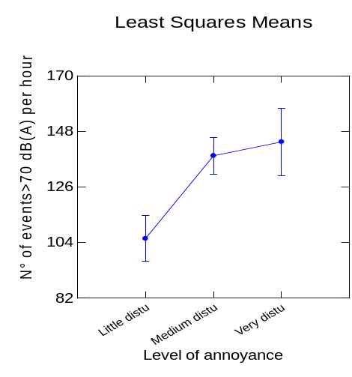
Source | Sum-of-Squares | df | Mean-Square | F-ratio | P
Level of annoyance | 18805 | 2 | 9402.894 | 4.784 | 0.011
Error | 135608 | 69 | 1965.341

