The Impact of High Speed Trains on Socio-Economic Activity

Professor John Preston and Dr Graham Wall, Transportation Research Group, University of Southampton, Highfield, Southampton, SO17 1BJ.
Contacts: J.M.Preston@soton.ac.uk, G.T.Wall@soton.ac.uk
Websites: Transportation Research Group: www.trg.soton.ac.uk, Southampton Railway Systems Research: www.sr2.soton.ac.uk.

To be presented to the 11th World Conference on Transport Research, Berkeley, California, 25th – 28th June 2007.

This paper reports on work undertaken for the South East England Development Agency (SEEDA) to determine the impact of the London-Paris-Brussels-Amsterdam-Cologne high speed rail network on socio-economic development.

A detailed literature review has been undertaken which has covered computable general equilibrium models, accessibility studies and ex-post monitoring studies. This review indicates that there are theoretical reasons to expect high speed rail to have socio-economic benefits over and above those measured in conventional cost-benefit analyses, largely due to the promotion of more competitive land and labour markets and of agglomeration economies. However, at the practical level these net benefits are difficult to measure, as they may be swamped by external factors, although gross effects are easier to discern.

In the empirical part of this paper data on economic activity rates, population changes, planning consents and land values are collated and related to changes in travel patterns and accessibility. Detailed case studies are provided of two types of location in southern England. The first are locations with direct access to long established high speed services for which ex-post analysis is possible. An example is Ashford in Kent. The second are locations where high speed services are being planned, pre-opening impacts are expected and ex-ante analysis can be undertaken. Examples include St Pancras (central London), Stratford (East London) and Ebbsfleet (Kent).

The case studies confirm the results of the literature review namely that the wider economic benefits of high speed rail are difficult to detect, as they are swamped by external factors, but are likely to be larger in more central locations such as St Pancras than more peripheral locations such as Ashford.
1. Introduction

This paper reports on parts of some work in two projects being undertaken by the University of Southampton (and others) for the South East England Development Agency (SEEDA) to determine the impact of the London-Paris-Brussels-Amsterdam-Cologne high speed train (HST) network on socio-economic development. The first called HST Impact, aims to determine the ‘added value’ of two NWE INTERREG IIIB projects – HST Integration (HST4i) and HST Connect. These two projects are valued at €48 million (approximately £32 million) with an ERDF share of €22 million (approximately £15 million). The second, called HST Connect, will develop an HST advice guide, a toolkit on station integration and connectivity and an assessment of new technologies. These projects are due to be completed in June 2008 and February 2007 respectively. This paper therefore reflects work in progress. Some maps showing the stakeholders involved in the two projects are given by Figures 1 and 2.

Work so far by the University of Southampton has involved a literature review, site visits and interviews at four locations, collation of secondary data and an MSc dissertation (Larbie, 2006). This paper summarises this initial work and consists of four further sections. In section 2 a review of the literature is provided which covers computable general equilibrium models, accessibility studies and monitoring studies. This review indicates that there are theoretical reasons to expect high speed rail to have socio-economic benefits over and above those measured in conventional cost-benefit analyses, largely due to the promotion of more competitive land and labour markets and of agglomeration economies. In section 3, a case study of Ashford (Kent) is provided. Data for Ashford on economic activity rates, population changes, planning consents and land values are collated and related to changes in accessibility. In section 4, briefer case studies are presented of three station sites that have yet to have HST services. Services to Ebbsfleet in North Kent and St Pancras (Central London) are due to commence on 14 November 2007, whilst services to Stratford (East London) are expected to commence in late 2009. In section 5, some conclusions are drawn. The Ashford case study confirms the results of the literature review namely that the wider economic benefits of high speed rail can be modest and are therefore difficult to detect, as they are swamped by external factors. However, St Pancras, Stratford and Ebbsfleet are expected to experience major developments, as will Ashford over the next thirty years. It is though likely that much of this development will be redistributive rather than generative, some of it may not happen and the developments that do occur in Ashford, Ebbsfleet and Stratford may be due to Growth Area policies rather than HST investments.

2. Literature Review

Most impact studies suggest that transport investments in advanced economies will result in only modest uplifts in economic performance. For example, the European Commission (1997) estimated that the priority Trans European Networks (TENs - which are dominated by high speed rail schemes) would add 0.25% to European Union GDP and 0.11% to employment over 25 years. Brocker (1999) using a forerunner of the CGEurope model (see below) estimates the maximum impact of TENs in any region to be 3% of GDP.

Additional evidence on the impact of high speed rail investments has come from three main sources. These will be discussed in turn.

2.1. Computable General Equilibrium Models

A computable general equilibrium model called CGEurope has been run to examine the impact of transport infrastructure developments (implementation of projects for the Trans European Network) and for Social Marginal Cost (SMC) pricing policies as part of the IASON (Integrated Appraisal of Spatial economic and Network effects of transport investments and policies) project (Renes et al., 2004). In summary these results suggest that: spatial distribution effects are very moderate; total welfare effects are underestimated by 20% compared to the situation where welfare effects are measured through the cost-benefit analysis (CBA) effects alone; and the effects of transport initiatives tend to be additive

A similar model suite, entitled RAEM, has been used to assess two magnetic levitation rail (Maglev) projects, each with two variants (Oosterhaven and Elhorst, 2003): (1) An inner ring or an outer ring connecting the four largest cities in the Randstad region (Amsterdam, The Hague, Rotterdam and Utrecht), (2) a direct connection between Schiphol Airport and Groningen, either running along the south-east or along the north-west borders of the “Ijsselmeer” lake. Additional benefits result from achieving a better match between labour demand and supply, both through bringing jobs to workers and workers to jobs, as well as productivity benefits when labour demand switches to regions of labour supply shortages and environmental benefits arising from more efficient use of land. The results reflecting these wider benefits in labour and land markets were compared to what the net benefits would have been under perfect competition (standard CBA appraisal). For the urban agglomeration projects the ratio between the two benefit measures is at most 1.2 whilst for the core-periphery projects it is around 1.8. This implies that the true benefits in the urban agglomeration project are some 20% greater than what would have been calculated in a standard CBA, while the true benefits in the core-periphery project is 80% greater than the benefits would have been calculated to in a standard. It should be noted that the Dutch results are based on an empirical analysis (rather than a theoretical model) and take into account not only the product market but also imperfections in the labour and housing markets. The benefits of the urban agglomeration project are constrained by overheating labour and land markets, whilst the benefits of the core-periphery project are enhanced by overcoming such imperfections. In essence, this approach takes into account some features of agglomeration diseconomies.

By contrast, a recent report for the UK Department for Transport on the wider economic benefits of transport infrastructure (DfT, 2005a) has highlighted three source of additional economic benefit:
(i) Agglomeration benefits calculated as the product of the elasticity of productivity with respect to effective density, the change in effective density, GDP and employment.
(ii) Imperfect Competition impact calculated by multiplying the sum of business time savings and reliability improvements by the product of the proportionate price mark up of the imperfect good and its price elasticity.
(iii) A tax wedge calculated as 40% of the GDP of new workers and 30% of the GDP of those working longer hours and those relocating to higher productivity areas.

An empirical application to the proposed East-West Crossrail scheme in London suggests a multiplier of 1.56. However, there may be concerns about double counting, particularly as increased output in an imperfect product market could be viewed as a form of agglomeration benefit.

2.2 Accessibility Approaches

Gutierrez et al. (1996) estimate that HST investments in the European 12 between 1993 and 2010 will increase rail accessibility of major centres by between 20% (Thessaloniki) and 65% (London). However, this will overstate the overall change in accessibility as rail is not, nor will be, a dominant mode on many origin-destination pairs. Vickerman et al. (1999) provide a range of more sophisticated estimates of accessibility changes.

Accessibility changes can be combined with appropriate elasticity measures to estimate the economic impact. Prud’homme and Lee (1999) estimate an elasticity of productivity with respect to accessibility of 0.3, although this may be on the high side as some productivity gains will be reduced by dispersal of activity. Rice and Venables (2004) suggest an elasticity of 0.1. Vickerman (1987) estimated that the maximum increase in accessibility by all modes as a result of the Channel Tunnel was 10%. This would suggest a maximum economic impact of between 1 and 3% of GDP in areas such Nord-Pas de Calais and Kent as a result of the Channel Tunnel.

2.3 Monitoring Studies.

There have been some ex-post evaluation studies, particularly of the TGV Sud-Est (Paris-Lyon), the AVE (Madrid – Seville) and the Japanese Shinkansen (Bonnafous, 1987, de Rus and Inglada, 1997, Banister and Berechman, 2000). Some of the recent evidence is brought together by De Rus and Nash (2006) and Campos et al. (2006), albeit with an emphasis on transport impacts rather the wider economic impacts. Where studies have looked at economic impacts, they have emphasised local and regional impacts and neglected national impacts (for example, van den Berg and Pol, 1998). These monitoring studies show increases in commercial activity and hence land values around some (but by no means all) high speed rail stations. For examples between 1983 and 1990 there was a 43% increase in office space around Lyon Part-Dieu station (250,000 m²). In Japan land values in commercial areas with a Shinkansen station rose by 67% (Nakamura and Ueda, 1989). It should be noted that these measures may reflect displacement of activity from elsewhere and should not be interpreted as being indicative of net growth.

There have been some studies of the extent to which high speed rail can encourage long distance commuting. For example, the Svealand line, opened in 1997, provided a high-speed regional rail link between Ekilstuna and Stockholm. Rail usage has increased by a factor of seven, with rail’s share of the relevant travel market increasing from 6% to 30% (Froidh, 2005). Similarly, there has been substantial growth in commuting from Ciudad Real and Puertollano to Madrid on the AVE. In 1992 Ciudad Real had 18 through trains a day to Madrid. By 2005, this had increased to 47 (Alvarez and Tordesillas, 2005).

There are also examples of ex-ante appraisal. For example Evers et al. (1987) estimate that a high speed rail line between Amsterdam and Hamburg, via Groningen, would increase employment in the northern Netherlands (+0.20%) and northern Germany (+0.37%) but this would be partly offset by losses elsewhere in the study region. Overall a net increase of 19,900 extra jobs was forecast (+0.05%). Martin (1997) estimated that a new high speed rail service between Montreal and Toronto would increase welfare by up to Can$ 1,285 million and GDP by Can$ 539 million (1993 prices). The difference between these two figures is attributed to leisure travel and consumption within the project. The total GDP in this corridor is estimated at Can$165 billion so that the overall uplift represents only around 0.03% of GDP.

  - Conclusions

There is a substantive literature on the impact of transport investments on economic growth. Although this traditionally focused on road investments, the literature on rail in general and high speed rail in particular has been growing (see Givoni, 2006, Mann, 2006). Most economic impact studies of transport investments, such as high speed rail lines, in advanced economies suggest that these will only have modest economic growth impacts, typically less than 1% of GDP overall, but as a high as 3% in the most affected regions. Impacts on net employment are also likely to be modest. Recent work, particularly based on computable general equilibrium models, indicates that conventional approaches may have underestimated some benefits, particularly of reducing the deadweight losses of imperfect competition and through the promotion of scale economies and agglomeration. However, the recommended uplift in benefits (typically between 20% and 80%) is not likely to change the broad conclusion that it will be very difficult to identify an impact of high speed rail investments on GDP. The type of impacts that might be expected would occur over a long time period and would be swamped by the exogenous year on year changes in GDP. To put this into context, historical studies suggest that the introduction of rail technology in the nineteenth century led to uplifts in GDP of 10% to 30%, mainly attributed to the movement of freight (Crafts, 2004, 2005). Incremental improvements to existing passenger services in the early twenty first century may only be expected to provide a fraction of this economic impact. Although the impact of high speed rail on economic growth is likely to be so modest that it will be difficult to measure, monitoring studies of existing high speed services suggest that the impact on patterns of economic activity may be more substantive. In particular, at certain high speed station sites there may be expected to be large increases in commercial activity and commensurate increases in land values. Increases in excess of 50% for both indicators have been observed. However, much of this activity will be transfers from other areas and should not be viewed as a net gain. Moreover, these impacts may only be observed where there are favourable local circumstances and will be by no means uniform across high speed networks.

A recent review of the impact of HST on the wider economy (Givoni, 2006, pp605-606) concludes: The evidence is mixed and there seems to be disagreement on whether the overall impacts, if they exist, are positive or negative. Still the potential for positive economic impacts is an important factor in planning and designing HST lines … , this is probably justified since it seems that it is better to be a node on the HST network than to be bypassed by it.

Similarly, Mann (2006, paras 42 and 44) concludes that: The existing evidence based on the experience of the TGV in France, the availability of modal alternatives, and the UK’s economic geography suggest that the net benefit to the national economy (of an HST Line) in stimulating inter-urban business travel would be relatively modest. … to the extent that there is a case (for an HST line) it would be most likely to reside in freeing up existing/forthcoming capacity constraints on commuter links, particularly into and within London, and by extending the labour market of London and the South East.

3. A Case Study of Ashford (Kent)

In this section we will examine the impact of high speed rail services on the town of Ashford (Kent). Ashford is a medium sized town with a 2001 population (including surrounding districts) of 102,661. However, Ashford has been designated as a growth area for the South East region and its population is expected to double by 2031. This will involve the development of 31,000 homes and 28,000 jobs. Ashford is a historic rail centre, being the hub for five local services (see Figure 3) and it has been a centre for the railway manufacturing and engineering industries. Since 1996 (some two years after the start of Channel Tunnel services), Ashford has been served by Eurostar trains, with a current daily service of six trains to/from Paris and four to Brussels (but six from Brussels). In total this represents 22 trains a day which is a reduction on earlier timetables which provided 30 trains a day (seven to Paris, five to Brussels and nine return trains each). In turn, this is considerably less than the theoretical capacity of four Eurostar trains an hour or the current weekday service from London Waterloo to/from Brussels/Paris of around 45 trains. Our work will be mainly at the meso-level. It will look initially at the impact of high speed services on accessibility. The effects of the improved accessibility will then be examined in terms of the impact on population and employment. Then trends in property prices will be examined.

3.1 Accessibility

As Table 1 illustrates, the opening of Ashford International in 1996 led to a dramatic increase in the accessibility of continental destinations, with an estimated 85% increase. The completion of the first phase of the Channel Tunnel Rail Link (CTRL), completed in September 2003, led to further minor increases in accessibility of 3%.

Table 1: Accessibility Index changes for Ashford
 | Paris | % | Lille | % | Brussels | % | Total | %
Before Channel Tunnel | 21,993 |  | 2,862 |  | 2,356 |  | 27,211
After Channel Tunnel | 40,616 | 84.7 | 5,590 | 95.3 | 4,240 | 80.0 | 50,446 | 85.4
CTRL 1 | 41,712 | 2.7 | 5,795 | 3.7 | 4,360 | 3.0 | 51,867 | 2.8
After CTRL2 (07-09) | 29,090 | -30.3 | 3,612 | -37.7 | 2,951 | -32.3 | 35,653 | -31.3
After CTRL2 (09-) | 35,030 | 20.4 | 4,549 | 25.9 | 3,566 | 20.8 | 43,145 | 21.0
Source: Larbie, 2006 – Table A5.1a.

However, with the completion of CTRL Phase 2 in 2007, Ashford’s Eurostar services will be reduced to three peak trains to Paris and one train to Eurodisney, even though capacity will increase to a theoretical maximum of eight international and eight domestic trains an hour. There will be no direct service to Brussels. Access to international services is assumed to be via Ebbsfleet (see Figures 4 and 5), using conventional rail services up to 2009 and high speed domestic services after 2009. This is estimated as leading to a 31% decrease in accessibility, but with a subsequent accessibility increase as fast services to Ebbsfleet are introduced. However, there is clearly a danger that Ashford will be by-passed by Eurostar in the same way that Dijon was by-passed by TGV Sud-Est and Arras by TGV-Nord (Harman, 2006).

It should be noted that Eurostar services can not be used for travel between Ashford and London. However, with the completion of CTRL2 in 2009 a network of domestic high speed services to London St Pancras will be developed (see Figure 6). Although there remain some uncertainties about the fares that will be charged and the appropriateness of St Pancras as a terminus (existing domestic services run to Charing Cross, London Bridge and Cannon Street), our estimates suggest there will be a large increase in accessibility (see Table 2). These domestic high speed services are expected to increase accessibility between London and Kent by around 20%. However, in the case of Ashford this increase is almost 75%. Moreover, the absolute increase in the Hansen type index (74,382) is in excess of the increase in accessibility to/from Paris (18,809) as a result of Eurostar services by a factor of almost four. Moreover, the current accessibility of London from Ashford is more than double the accessibility of Paris. If cultural barriers are taken into account this might be even greater. For example, Shires found crossing a national border reduced passenger rail demand by around 30% (Shires, 1998), whilst Hay et al. (2004) have illustrated that the border between England and France remains a barrier to the development of integrated housing and labour markets.
Table 2 Before and After domestic high speed service: accessibility for authorities
District or authority | Before: Accessibility , person/£ |  | After: Accessibility , person/£ |  | Access-ibility Change (%)
District or authority | District from London | London from district, | District from London, | London from district, | Access-ibility Change (%)
Dartford | 3,598 | 300,338 | 3,231 | 269,728 | -10.2
Gravesham | 2,336 | 175,014 | 3,067 | 229,801 | +31.3
Medway | 5,882 | 169,089 | 6,168 | 177,307 | +4.8
Swale | 1,850 | 108,039 | 1,795 | 104,858 | -3.0
Thanet | 1,213 | 68,679 | 1,820 | 103,002 | +50.0
Ashford | 1,413 | 98,734 | 2,463 | 172,066 | +74.2
Dover | 1,057 | 72,530 | 1,476 | 101,212 | +39.5
Canterbury | 1,611 | 85,386 | 2,033 | 107,769 | +26.2
Maidstone | 1,935 | 99,862 | 2,981 | 153,874 | +54.1
Total | 20,895 | 1,177,675 | 25,033 | 1,419,622 | +20.5
Source: Larbie, 2006.
  - Population and Employment

Figure 7 shows the historic trends in population in the Ashford District and compares them with South East England (SEEDA) and England. Dummy variable regression analysis suggested that Ashford’s population received an11% uplift in the 1990s compared to the South East as a whole. Figure 8 shows similar trends in employment, with regression analysis suggesting that Ashford’s employment received a 6% uplift in the 1990s compared to the South East. However, these results were not statistically significant.

  - Property Prices

Figure 9 shows the increase in domestic property prices in the Ashford District. It is evident that an increase in prices coincided with the opening of the International station. However, Figure 10 suggests that the increases in Ashford during this period were broadly in line with those of surrounding districts. Regression analysis suggests that since 1996 property prices in Ashford have received an increase over and above the time trend of 26.5%. However, properties in the South East as a whole have received a stimulus of 23.2%. This suggests an additional increase in Ashford of around 2.7%, although this time the estimate is statistically significant.

Some trends for commercial properties are given by Table 3. The main favourable trend is that there has been a drop in vacancy rates in Ashford (from 13% in 1998/9 and 8% in 2004/5). By contrast, vacancy rates elsewhere have increased from 7% to 9%. There has also been a greater growth in the number of new businesses in Ashford than elsewhere, whilst the decline in retail properties with accommodation has been less in Ashford than elsewhere. However, the growth in floorspace and the growth in rateable values has been less than in the South East as a whole or in England. Overall, the growth in occupied floorspace in Ashford has been similar to that of the South East as a whole (8%) and slightly higher then for England (6%).

Table 3: Summary of All Bulk Classes of Commercial Properties: percentage change between 1998/2004.
 | Ashford | SEEDA | England
Number of businesses (count) | 5 | 4 | 2
Area (1,000m square) | 2.3 | 10.8 | 8.6
Rateable value (1,000x£) | 27 | 37 | 41
Rateable value (£/m square) | 24 | 25 | 31
Retail with accommodation (count) | -2 | -11 | -12
Vacancy Rates | -38% | (+)28% | (+)28%

A problem with the data in Table 3 is that they post date the opening of the Channel Tunnel and there is some evidence that there was speculative development in Ashford, particularly in warehousing and distribution floorspace prior to opening (Hay et al., 2004, Figures 45 and 46). Hay et al. also note that some 430,000 m² of land was designated for commercial and industrial development in Ashford between 1991 and 2001 but net completions only amounted to 107,000 m², some 51% of the target. By contrast, there were plans to build 6,800 new dwellings between 1991 and 2001, of which 5,200 were completed (76% of the target).

4. Ebbsfleet, Stratford and St Pancras

The development at Ebbsfleet is likely to dwarf that of Ashford. The station will have 9,000 parking spaces compared to the 2,000 provided at Ashford International, with construction costs estimated at £100 million (compared to £80 million for Ashford). The site is currently brownfield, much of it former chalk quarries. Two major developments are planned. The first, at Ebbsfleet Valley, will involve 790,000 m² of mixed development, including 20,000 new jobs and 3,000 new homes. The second, at Eastern Quarry will involve a mixed development of almost 3 million m², including 10,000 jobs and 7,000 new homes. Adjacent to Eastern Quarry is Bluewater, a large out of town retail and leisure centre, a 153,000 m² development involving 6,500 new jobs. These developments will be linked to each other, Ebbsfleet and the adjacent towns of Dartford and Gravesend by a four route bus rapid transit system marketed as Fastrack. It should be noted that the developments around Ebbsfleet are part of a wider plan to develop Kent Thameside which by 2030 will involve 27,000 more households, 63,000 more people and 45,000 more jobs. The developments in Kent Thameside will be largely funded by the private sector, albeit stimulated by around a £30 million investment in transport infrastructure.

Similarly large developments are planned around the HST station at Stratford. The Stratford City development would involve 1.2 million m², including 4,500 new dwellings and up to 30,000 new jobs. It is unclear how many international services will stop at Stratford. It is understood that LCR are reluctant to stop Eurostar trains as it will add eight minutes to the journey between London and Paris and will involve stopping trains only seven minutes after leaving St Pancras. It is likely that the £210 million station will largely be served by domestic high speed services, although some international services might be provided for the 2012 Olympics (although even here it is likely that the site will served by additional St Pancras - Ebbsfleet shuttle services marketed as Olympic Javelin). A major issue is the link between the Stratford Regional and International services, as the latter is about 0.5 km to the north of the former. As a result the Docklands Light Railway (DLR) will be extended to the International station and this is expected to be completed in 2010 but a planned travelator (costing £25 million) will not now be built. The ‘International’ station will not open until December 2009 when the domestic high speed rolling stock (being built by Hitachi) is ready, even though it could have been opened much earlier. The Stratford Regional station is served by two Underground lines (Central and Jubilee) as well as suburban rail services. It is proposed that the east-west Crossrail will also serve the site.

At King’s Cross - St Pancras, a mixed development of over 740,000 m² is planned, involving around 2,500 new homes and 30,000 new jobs. Transport investments of around £3.3 billion are being undertaken, of which £2.4 billion is being provided by the public sector and Network Rail. King’s Cross - St Pancras is the terminus for a number of suburban rail services, whilst an improved new station on Thameslink services will be provided. In addition, the site is served by six Undergound lines (Circle, Hammersmith and City, Metropolitan, Northern, Piccadilly and Victoria). However, there is not a direct service between Waterloo and the site, although there are tentative plans for a Cross River tram service.

The indicative development impacts at Stratford and St Pancras (which is in the London Borough of Camden) can be judged by Table 4. Between April 2001 and January 2006, retail rents have increased by 42% in Stratford and 53% in Camden (and 38% in adjacent Islington), whilst they have been static (albeit at much higher levels) in the highly prosperous Kensington district.

Table 4: Rental values for shop premises (Type 1) in Stratford Centre, Camden, and Kensington (£/m²/year)
 | Stratford  Centre | Camden | Islington | Kensington
April 2001 | 650 | 1125 | 650 | 6250
October 2001 | 750 | 1200 | 650 | 6250
April 2002 | 850 | 1300 | 650 | 6250
October 2002 | 850 | 1300 | 650 | 6250
April 2003 | 850 | 1400 | 650 | 6250
January 2004 | 925 | 2150 | 650 | 6250
July 2004 | 925 | 1725 | 650 | 6250
January 2005 | 925 | 1725 | 700 | 6250
July 2005 | 925 | 1725 | 900 | 6250
January 2006 | 925 | 1725 | 900 | 6250
Source: Valuation Office Agency (www.voa.gov.uk)

5. Conclusions
There are often political expectations that access to high speed rail services will lead to large economic development impacts. A review of the literature suggests this is rarely the case. This is also confirmed by our case study of Ashford. Although the opening of the International station led to large increases in the accessibility of Paris, Lille and Brussels, these were not centres that Ashford traditionally interacted with. The current international services do not connect Ashford with London. As a result, demand has been relatively low as witnessed by the current low level of service (22 trains per day), which will decrease further next year (to 8 trains per day) with the opening of Ebbsfleet. The opening of Ashford International station has coincided with an 11% increase in population, a 6% increase in employment and a 3% increase in house prices over that of the South East a whole. However, attribution of causation is difficult, particularly given the designation of Ashford as a Growth Area for the South East by the Office of the Deputy Prime Minister (now the Department of Communities and Local Government).

Table 5 suggest that the development impacts so far at Ashford have been relatively modest but development rates over the next 30 years are anticipated to be broadly double those of the last 10 years. Large developments are expected at the three other sites involving almost 4 million m² of commercial development and almost 20,000 new homes and 90,000 new jobs. The Department for Transport estimates that the £5.2 billion investment in CTRL will acts as a catalyst for developments with a post construction value of £8 billion (DfT, 2005b). These investments though are dwarfed by the size of the local economies affected. In 2003, Inner London’s Gross Value Added was £133 billion (or £38,753 per head) whilst that of Kent was £21 billion (or £12,973 per head). Moreover, experience at Ashford suggests that some of these development gains may be slow to materialise, whilst both Stratford and Ebbsfleet are in the Thames Gateway Growth Area so that those developments that do occur will be due to wider planning policies rather than the introduction of HST services.

Table 5: Comparison of Development at Five Sites

 | Commercial  Development m² | Dwellings | Jobs
Ashford 1991-01 P | 430,000 | 6,800 | 10,000 (E)
Ashford 1991-01 A | 107,000 (Net) | 5,200 | 5,000
Ashford 2001-31 | N/A | 32,000 | 28,000
Ebbsfleet | 2,390,000 (E) | 10,000 | 27,000
Stratford | 770,000 | 4,500 | 30,000
St Pancras | 550,000 | 2,500 | 30,000
Total | 3,710,000 | 51,000 | 115,000
P = Planned, A = Actual, N/A = Not Available, E = Authors’ Estimates.

The limited impact of high speed rail services at Ashford should not be a surprise. Ashford is a medium sized market town, not a regional centre on a par with Cologne, Lille, Lyon or Seville. It probably has more in common with other intermediate station on the TGV such Calais Fréthun, Haute Picardie, Le Creusot or Macon Loché. However, the introduction of high speed domestic services could lead it to become a similar commuting centre to Ciudad Real in Spain or Ekilstuna in Sweden. Ebbsfleet cold suffer a similar fate as could Stratford, although the latter could be a destination as well as an origin for trips. St Pancras could be different, resulting in the centre of gravity of London activity moving northwards, and having a similar effect as Lyon Part-Dieu. Strong increases in land values suggest this may already be happening.

References

Alvarez, A.R. and Corando Tordesillas, J.M. (2005) La Movidad de Alta Velocidad eb Estaciones Situadas en Ciudades de Tamano Regueno. Ingeneria y Territorio, 70.

Banister, D. and Berechman, J. (2000) Transport Investment and Economic Development. UCL Press, London.

Bonnafous, A. (1987) The Regional Impact of the TGV. Transportation. 14, 127-137.

Bröcker, J. (1998) Spatial Effects of Transeuropean Networks: preliminary results from a spatial computable general equilibrium analysis. Diskussionsbeiträge aus dem Institut für Wirtschaft und Verkehr, Nr., 4/98, Dresden.
(http://www.tu-dresden.de/vkiwv/VWL/diskp/dskp498.pdf)

Campos, J., de Rus, G. and Barrón, I. (2006) Some Stylized Facts about High Speed Rail Around the World: An empirical approach. Paper presented to the 4th Annual Conference on Railroad Industry Structure, Competition and Ownership. Universidad Carlos III de Madrid.

Crafts, N. (2004) Social savings as a Measure of the Contribution of a New Technology to Economic Growth. London School of Economics, July.

Crafts, N. (2005) What Did Railways Contribute to Nineteenth Century British Economic Growth? London School of Economics, May.

DfT (2005a) Transport, Wider Economic Benefits and Impacts on GDP. DfT, London.

DfT (2005b) Facts and Figures on the CTRL. DfT, London.

De Rus, G. and Inglada, V. (1997) Cost-Benefit Analysis of the High Speed Train in Spain. The Annals of Regional Science, 31.

De Rus, G. and Nash, C. (2006) In What Circumstances is Investment in HSR Worthwhile? Paper presented to the 4th Annual Conference on Railroad Industry Structure, Competition and Ownership. Universidad Carlos III de Madrid.

European Commission (1997) The Likely Macro-economic Benefits and Employment Impacts of Investments in Trans-European Transport Network. Staff Working Paper SEC 97(10). EC, Brussels.

Evers, G.H.M, Van Der Meer, P.H., Oosterhaven, J. and Polak, J.B. (1987) Regional Impacts of New Transport Infrastructure: a multi-sectoral potentials approach. Transportation, 14, 113-126.

Froidh, O. (2005). Market Effects of Regional High-Speed Trains on the Svealand Line. Journal of Transport Geography, 13.

Givoni, M (2006) Development and Impact of Modern High-speed Train: A review. Transport Reviews, 26, 5, 593-611.

Gutierrez, J., Gonzalez, R. and Gomez, G. (1996) The European High-Speed Train Network. Predicted effects on accessibility patterns. Journal of Transport Geography, 4, 4, 227-238.

Harman, R. (2006) High Speed Trains and the Development and Regeneration of Cities. Greenguage 21, London.

Hay, A., Meredith, K. and Vickerman, R. (2004) The Impact of the Channel Tunnel on Kent and Relationships with Nord-Pas de Calais. Final Report. Centre for European, Regional and Transport Economics, University of Kent, Canterbury.

Larbie, A.T. (2006) The Impacts of High Speed Trains in North West Europe: Ashford Case Study. MSc Dissertation, School of Civil Engineering and the Environment, University of Southampton.

Mann, M. (2006) Step Change Transport Improvements: An Assessment of the Potential for ‘Step Change’ Transport Improvement to Generate Wider Economic Benefits. Technical Paper for the Eddington Transport Study. Department for Transport, London.

Martin, F. (1997) Justifying a High-speed Rail project: Social value v regional growth. The Annals of Regional Science, 31, 155-174.

Nakamura, H. and Ueda, T (1989) The Impacts of the Shinkansen on Regional Development. Proceedings of the 5th World Conference on Transport Research, Yokohama.

Oosterhaven, J. and Elhorst, J. P. (2003) Modelling Interactions between the Economy, the Environment and Transportation at the Local and Regional Level, with an Application to Dutch Maglev Projects. Paper presented at the TRIP research conference on the Economic and Environmental Consequences of Regulating Traffic, Copenhagen, February 2003.

Prud’homme, R. and Lee, C.W (199) Size, Sprawl, Speed and the Efficiency of Cities. Urban Studies, 36, 11, 1849-1858.

Renes, G., Schade, W., Burgess, A.W., Tavasszy, L.A. and Rustenburg, M. (2004) Consolidated Results of Case Studies in Transport Project Assessment. IASON (Integrated Appraisal of Spatial economic and Network effects of transport investments and policies) Deliverable 8. Funded by 5th Framework RTD Programme.

Rice, P. and Venables, A. (2004) Spatial Determinants of Productivity: Analysis for the Regions of Great Britain. CEPR Discussion Paper 4527.

Shires, J.D. (1998) Modelling Results for Rail. SORT-IT Deliverable 4, Appendix B. Insitute for Transport Studies, University of Leeds.

Van den Berg, L. and Pol, P. (1998) The European High Speed Train and Urban Development: Experience in Fourteen European Regions. Ashgate, Aldershot.

Vickerman, R.W. (1987) The Channel Tunnel: Consequences for Regional Development and Growth. Regional Studies, 21, 187-197.

Vickerman, R., Spiekermann, K. and Wegener, M. (1999) Accessibility and regional development in Europe, Regional Studies, 33, 1, 1-15

Figure 1 : HST 4 Integration - Strategic Partners

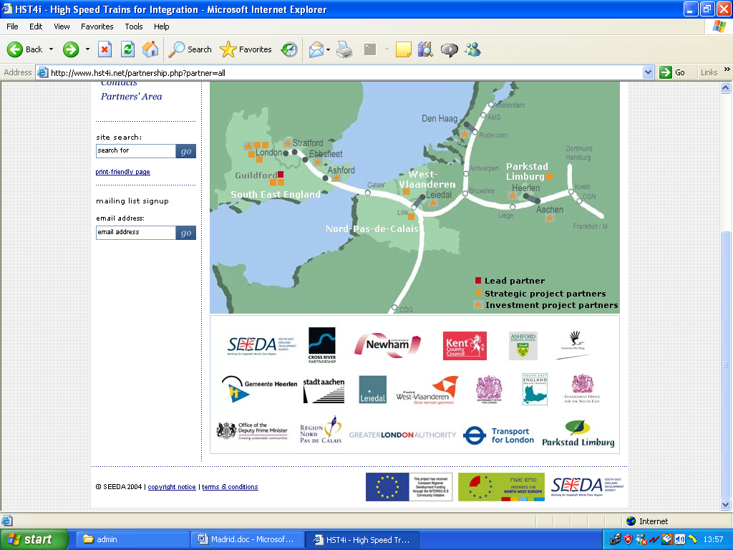
Source: www.hst4i.net
Figure 2: HST Connect Strategic Partners

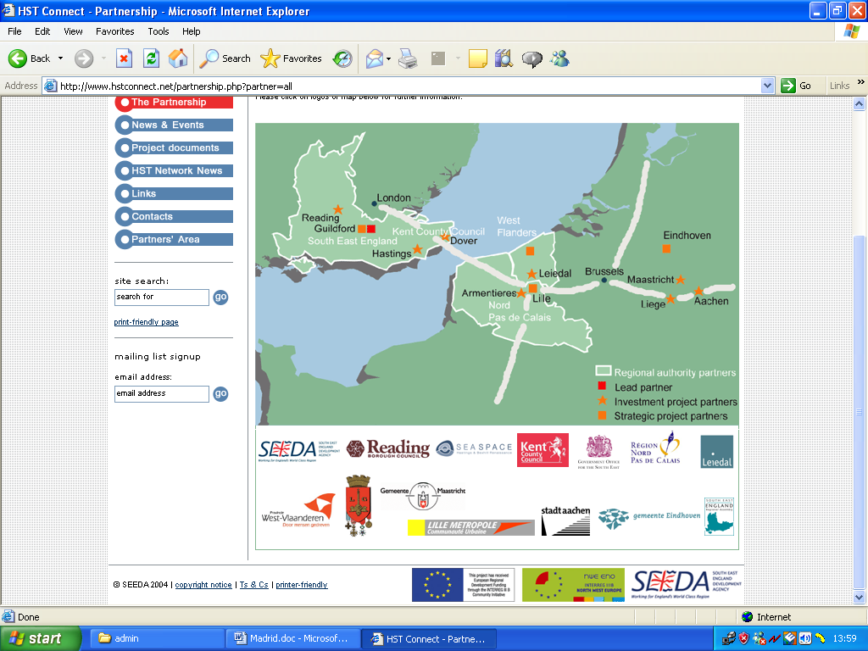
Source: www.hstconnect.net
Figure 3. Ashford’s Rail Network

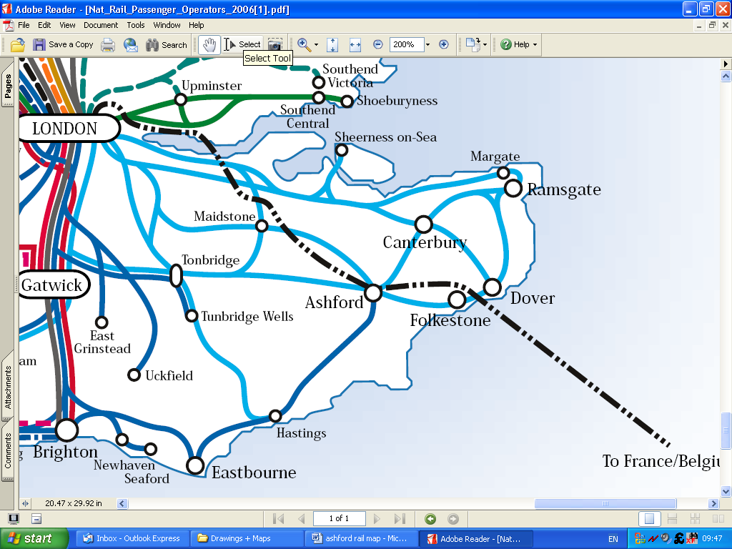
HST: To France &
Belgium

Source: Larbie, 2006.
Figure 4: St Pancras, Ebbsfleet and Stratford Stations

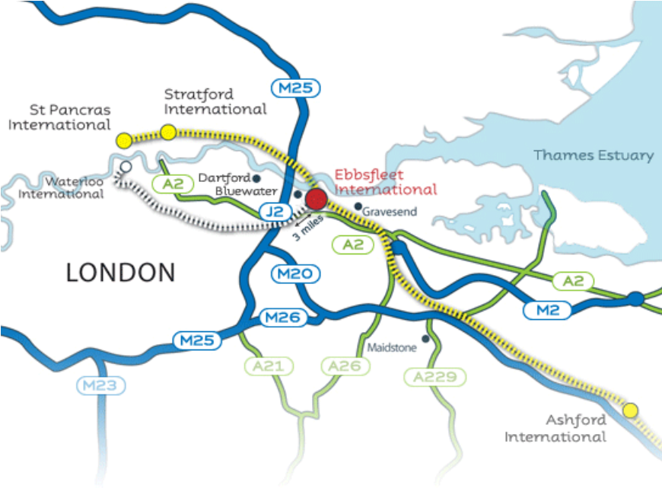

Source: Larbie, 2006
Figure 5: Route map of the CTRL
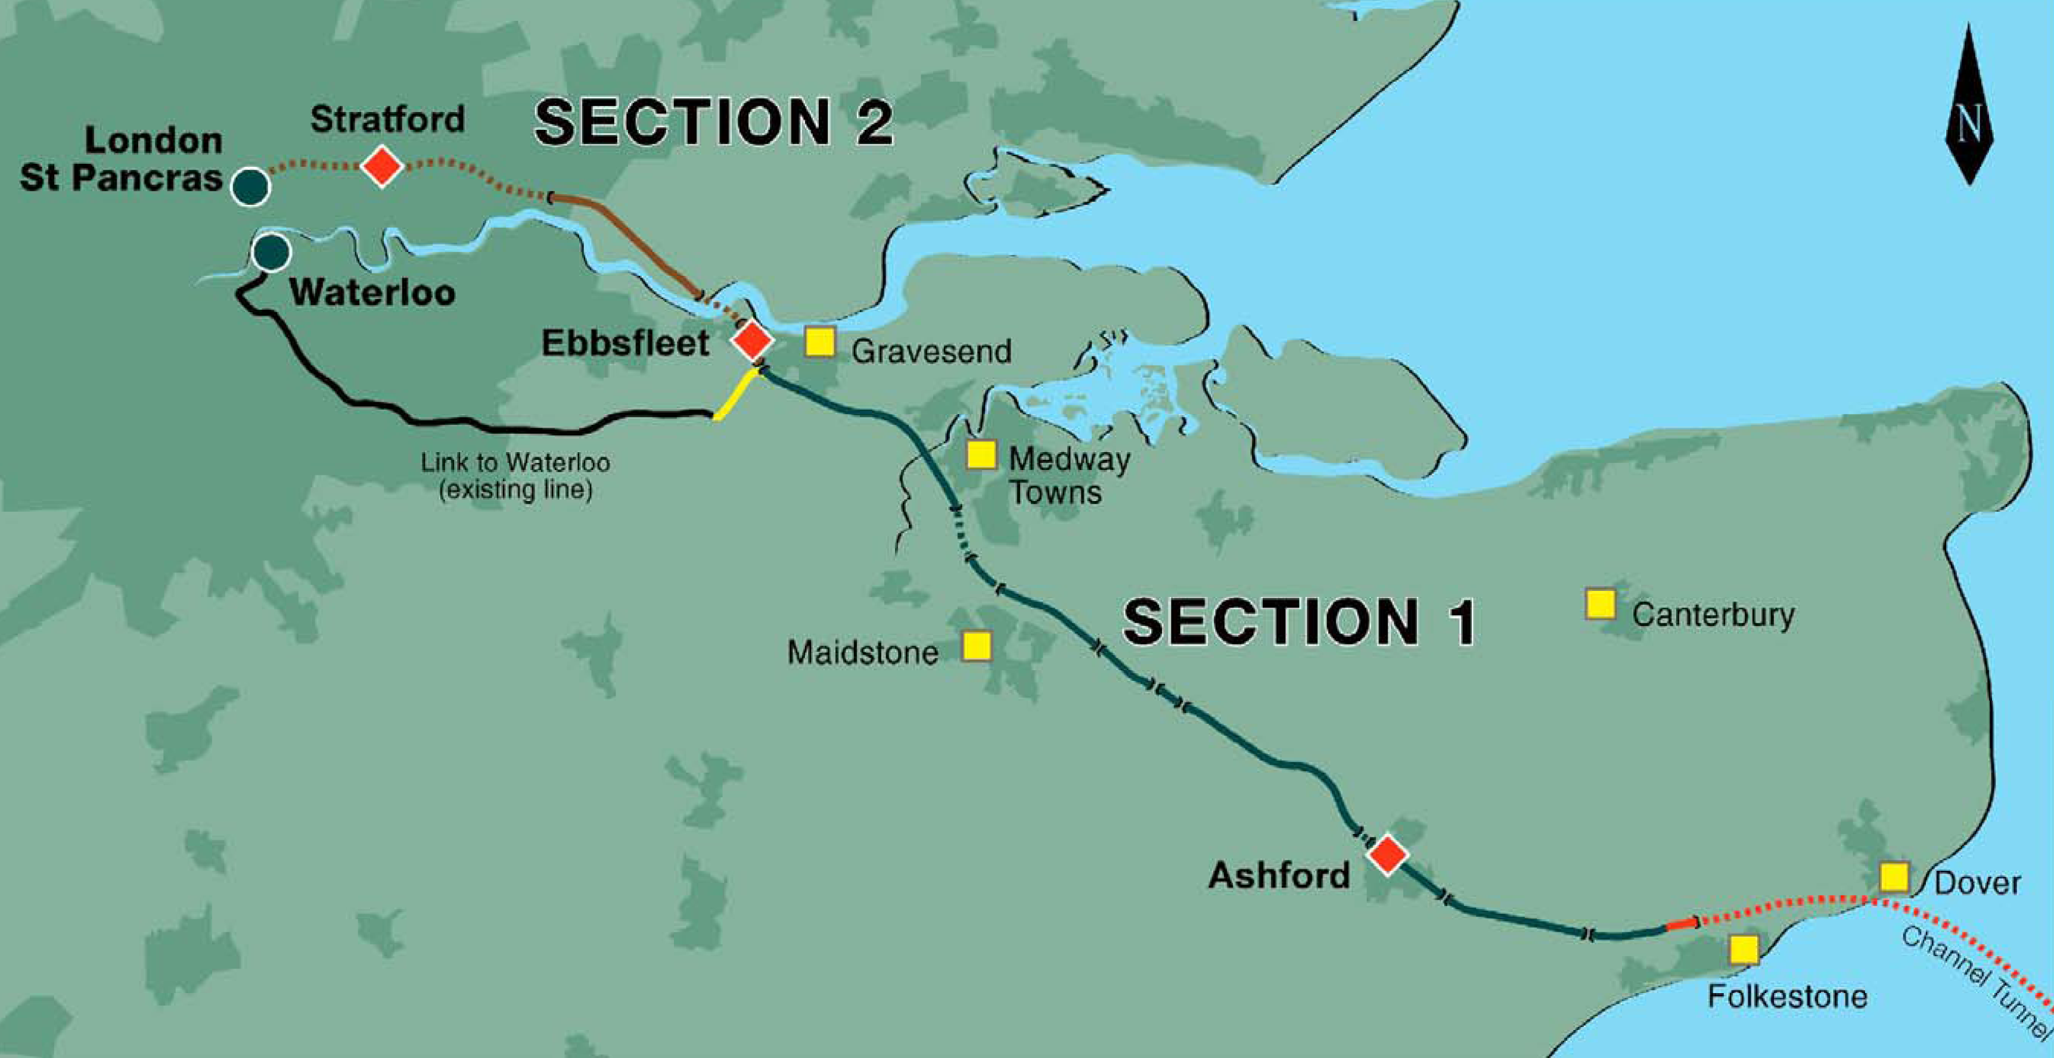

Source: www.lcrhq.co.uk
Figure 6: Domestic High Speed Network

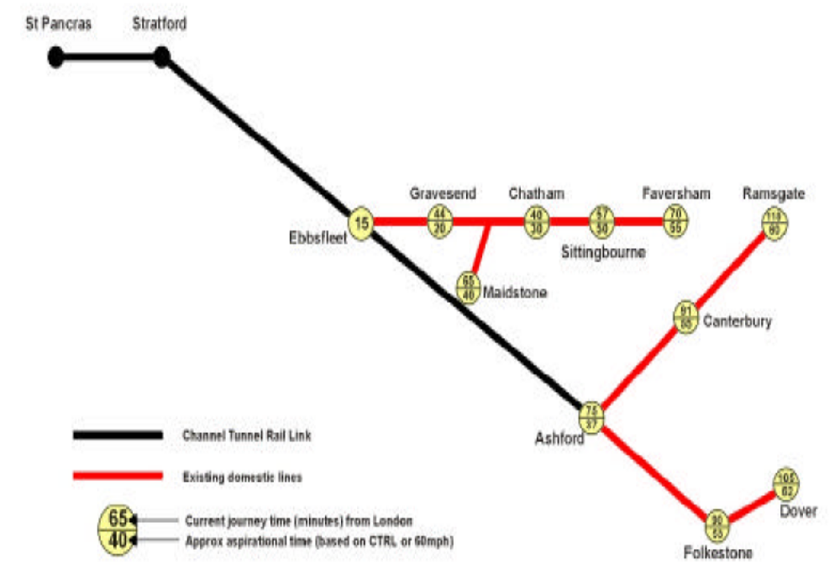
Future Domestic High Speed Train Services

Source: Larbie, 2006
Figure 7: Ashford Population Growth

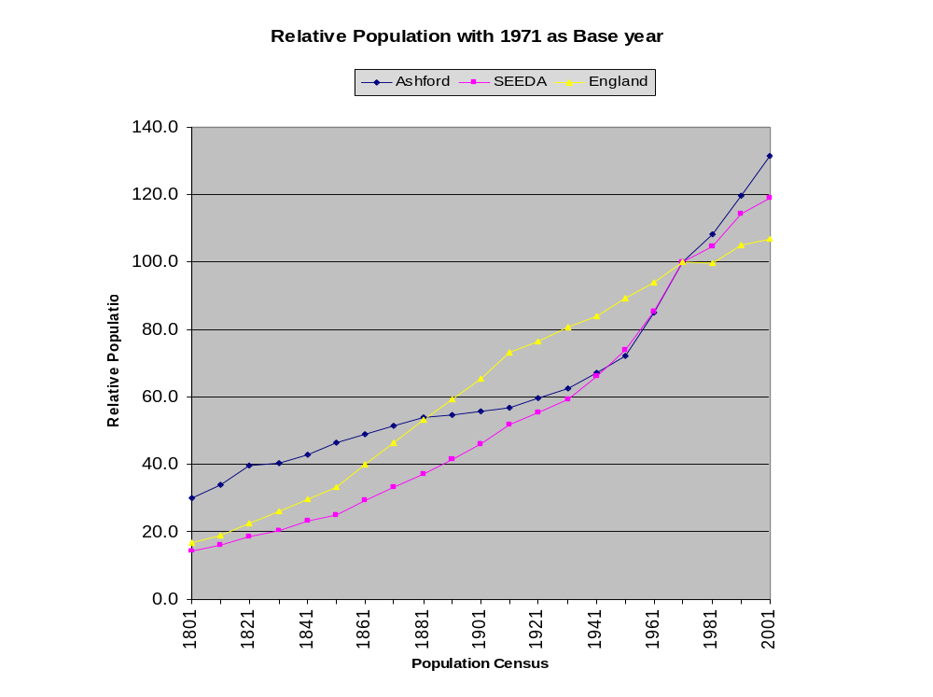
Source: Larbie, 2006
Figure 8: Ashford Employment Growth

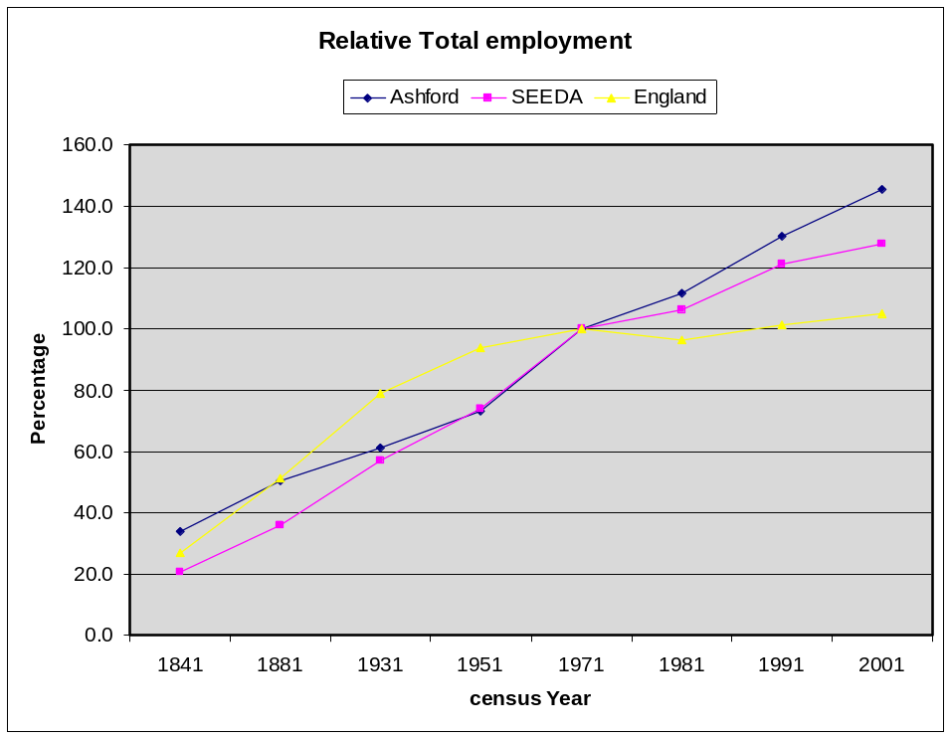

Source: Larbie, 2006
Figure 9: Ashford Trends in Domestic Property Prices

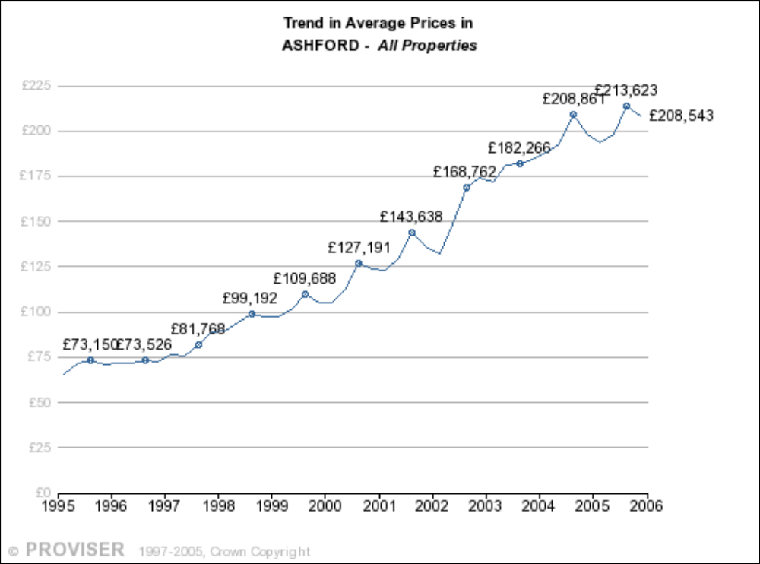

Source: Larbie, 2006
Figure 10: Property Prices in Ashford and Surrounding Authorities

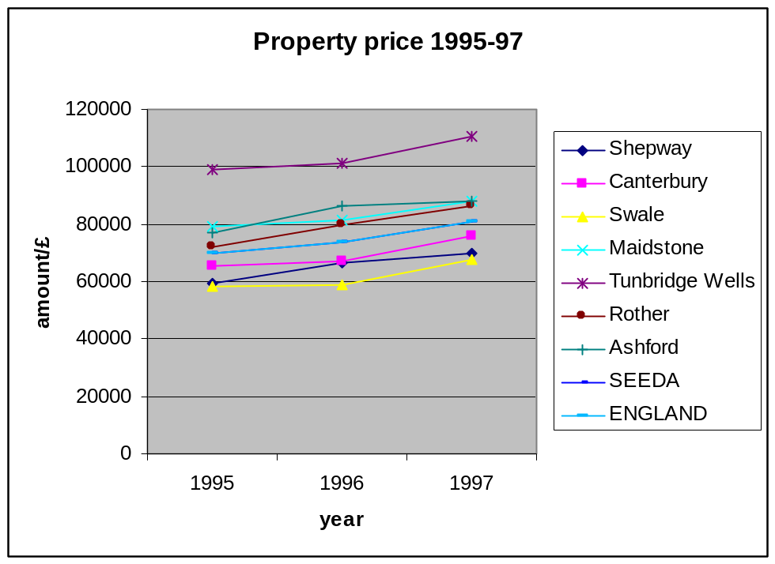

Source: Larbie, 2006

See http://www.hst4i.net/ and http://www.hstconnect.net/

