ANALYSIS OF ROUTINE WEEKLY ACTIVITY/TRAVEL PATTERNS

Matthew J. Roorda
Assistant Professor,
Department of Civil Engineering, University of Toronto
35 St. George Street, Toronto, Ontario, M5S 1A4, Canada
Tel: (+1 416) 978-5976 Fax: (+1 416) 978-5054
Email: roordam@ecf.utoronto.ca

Sheyda Saneinejad
Department of Civil Engineering, University of Toronto
35 St. George Street, Toronto, Ontario, M5S 1A4, Canada

Tel: (+1 416) 223-4899
Email: s.saneinejad@utoronto.ca

Eric J. Miller
Bahen Tanenbaum Professor,
Department of Civil Engineering, University of Toronto
35 St. George Street, Toronto, Ontario, M5S 1A4, Canada
Tel: (+1 416) 978-4076, Fax: (+1 416) 978-5054
Email: miller@ecf.utoronto.ca

Paper submitted to the 11th World Conference on Transportation Research
San Francisco, California, June 24-29 2007.

Abstract
As part of Wave 3 (2005-2006) of the Travel/Activity Panel Survey (TAPS) in Toronto, 300 respondents in 145 households described in some detail their routine weekly activities, including information concerning routine activity episodes’ purposes and usual durations, start times (by day of the week), locations and travel modes. Information concerning the degree of flexibility in these routine episode activities was also collected. This paper first describes the survey instrument used to collect this information. This involved respondents marking on a large sheet of paper their routine activities by time of day and day of the week, using a combination of free-form descriptions and pre-specified symbols. The paper then presents a detailed analysis of the survey data collected. Included in the analysis is a comparison between routine activities as reported prior to the survey week and those activities as they were actually executed, as recorded in a two-day activity diary, which was also part of the Wave 3 survey. This analysis shows that the notion that the “skeleton schedule” consists only of activities that are deterministically defined by their activity type (e.g. “mandatory” activities) and augmented with “flexible” household maintenance and discretionary activities is unfounded. Many exceptions are found to this rule. Men are found to have a greater proportion of routine activities than women, with the exception of weekday work/school activities. The analysis suggests that it may be appropriate to model schedule building in layers, with fully routine non-flexible activities (of all activity types) scheduled first, routine but flexible activities scheduled second, and non-routine activities scheduled last.

Introduction and Background
Most activity-based modeling efforts that attempt in some way to represent the activity scheduling process, involve the assumption that there exists a routine “skeleton” schedule and that other discretionary activities are scheduled around that skeleton. This is the case in the ALBATROSS model (Arentze and Timmermans, 2004), SCHEDULER (Gärling et al., 1989), TASHA (Miller and Roorda 2003, Roorda et al., 2006), and the conceptual framework for activity scheduling developed by Doherty et al. (2002).
Such modelling efforts reflect that an activity pattern is an outcome of an activity scheduling process in which decisions occur across a variety of time scales, rather than a single optimal choice among a series of alternative activity patterns. Behaviourally, this is an attractive approach, because it recognizes that the outcome of a series of decisions may be path dependent, may reflect constraints and opportunities that change over time, and implies that people act both habitually in some circumstances and more spontaneously in others, and do not necessarily re-evaluate and re-optimize previous decisions in response to new opportunities and constraints.
With increased behavioural realism, however, comes increased model complexity and a requirement for more in-depth, demanding surveys to obtain the data necessary for model building. A variety of surveys have been developed to capture the elusive activity scheduling process (Doherty and Miller, 2000; Roorda et al., 2005; Doherty et al., 2004; Ettema et al. 1994; Chen, 2001) but so far have not been used to develop a fully behavioural operational model that incorporates all tenets of activity scheduling.
Two operational activity scheduling models, ALBATROSS and TASHA, make fairly simplistic assumptions about the order of insertion of activities, and the types of activities that form the routine “skeleton” schedule. ALBATROSS assumes that the skeleton consists of all work, drop-off/pick-up of people or goods, medical visits, personal business, sleep and eat activities (Arentze and Timmermans, 2004). The model treats the skeleton schedule as exogenous to the model. TASHA represents the skeleton schedule, by sequentially adding work and school activities to a persons schedule before other activity types (Roorda and Miller, 2003). In both cases, the skeleton is assumed to be a deterministic function of activity type and the activity types that are part of the skeleton schedule are chosen in an ad hoc manner.
Doherty et al. (2002) propose that activities that are included in the skeleton schedule be based on the activity attributes other than activity type, including duration, frequency and indicators of spatial and temporal fixity. The conceptual model proposed by Doherty et al. has not been implemented, although an extensive dataset has been collected (CHASE©) that could potentially be used to build such a model (Doherty et al. 2004; Roorda et al., 2005). The CHASE survey instrument has been one of the best examples to date of an attempt to observe the activity scheduling process was observed over a period over seven days (Doherty and Miller 2000, Doherty et al., 2004). In this computerized survey, respondents were asked to enter all activities that they planned and/or executed, even if those activities were subsequently modified or deleted. The degree of preplanning was queried with each activity addition.
There are a few shortcomings of the CHASE survey if one wishes to develop a complete observation of the routine weekly schedule. First, only activities that are planned to be executed during the week are entered by the respondent. Thus any “routine activities” that, for some reason, are not planned to be done in the week of the survey are not observed. Thus the routine weekly schedule is incomplete. Second, when individuals are asked to describe the planning horizon of the activity “When did you originally plan this activity” the choices available leave some ambiguity about activities that are preplanned but not necessarily routine (for example a wedding) and those preplanned activities that are routine (like regular work hours) (see Doherty, 2005).
The motivation for this study is to better characterize the activities that make up the skeleton schedule by asking a panel of respondents to declare directly the activities that they “normally do every week”. This paper analyzes the results of the survey.
The policy significance of this work is rather indirect, but important nonetheless. Clearly the work can be used as an empirical step toward better modeling of activities and travel, potentially addressing the simplifications made in current operational activity scheduling models. Second, if particular trips are targeted for interventions (e.g. work-based rideshare programs, or flexible work schedules, or school start times) it is important to understand how those activities fit into the larger context of a person’s activity schedule. As pointed out by Doherty et al. (2002), it is likely that because of its long term nature, a person may develop, modify and adjust their routine “skeleton” schedule toward a relatively optimal solution. From that perspective, if we can fully understand how routine activities are organized in time and space, there is potential to successfully offer rational, acceptable alternatives to undesirable travel/activity behaviour (such as long commutes in single occupant vehicles at peak travel times). Because they are repeated activities, the potential benefit of shifting mode to those activities, changing the location of those activities, etc, would be greater than for other activities.
Furthermore, policy aimed at modifying undesirable behaviour for more “spontaneous” trips and activities (such as flexible transit passes) may be ineffective if those spontaneous trips and activities are constrained to “fit” within a skeleton schedule that imposes real limitations on their flexibility.
Clearly, the starting point for a more complete understanding of these issues lies in a thorough investigation and understanding of the attributes of routine schedules, how they relate to the activities that are executed on a particular day. Only armed with this understanding can we fully understand the behavioural underpinnings of a scheduling process that may well be resistant to, or accommodating to policy intervention in unexpected ways.

Data
The Travel Activity Panel Survey (TAPS) is an in-depth longitudinal survey of activity and travel scheduling processes, undertaken on an initial sample of 270 households in Toronto and 250 households in Quebec City, Canada (Roorda et al., 2005, Roorda and Miller, 2004). The TAPS survey consisted of three waves in each of the two geographic locations, each wave using a different survey instrument. Each wave had a core set of data to be collected to allow for comparisons over time. The core data consists of household and person attributes and a minimum two-day executed activity diary. However, each wave emphasized different elements of the activity scheduling process, through the use of different survey instruments for the collection of additional information.
In Toronto, the first wave was conducted between March 2002 and May 2003 using the CHASE© survey instrument (Doherty and Miller, 2000; Doherty et al., 2004). The second wave was a stated adaptation survey, in which respondents were asked to complete a two-day paper-and-pencil activity diary and then to respond via a telephone interview to a series of hypothetical scenarios, in which delays to executed activities, and other perturbations to the respondent’s executed activity schedule were introduced. (see Roorda and Andre, 2006)
The third and final wave of the TAPS survey is the data source analyzed in this paper. The emphasis of this wave of the survey, in addition to completing the core 2-day activity travel diary for the third time, was to determine the panel members’ perceptions of their routine activity schedule. The survey instrument for the third wave of the TAPS survey was a mail-out mail-back paper-and-pencil survey with a follow up computer aided telephone interview (CATI).
The paper and pencil portion of the survey included:
- A two-day diary, shown in Figure 1. This diary was intended to be a memory jogger. The two days of the week were drawn randomly and assigned to each respondent, with the requirement that at least one of the two days be a weekday. Respondents were asked to fill out the basic timing, sequencing and travel information for all activities and trips that they undertook over a 48 hour period. Details about each activity were retrieved during the CATI.
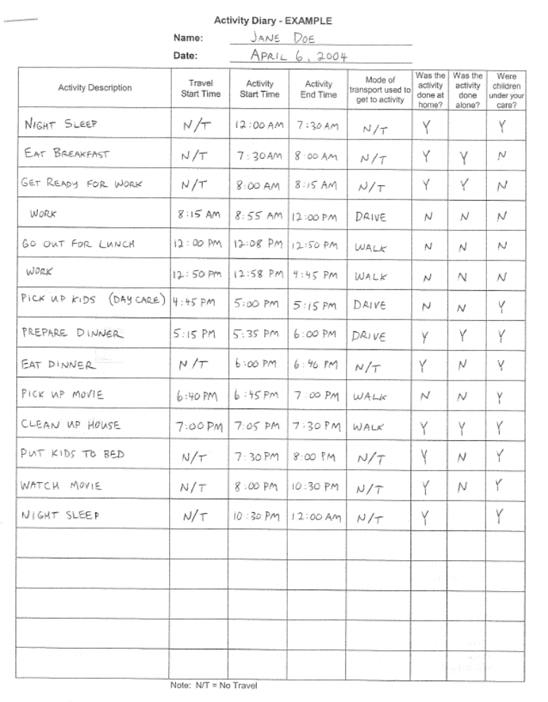
Figure 1 – Two-day activity diary – example

- A seven day “Routine Weekly Schedule” – A large sheet of paper (17”x 22”) was provided for each respondent, as shown in Figure 2. Respondents were asked to enter “only those activities that you normally do every week”. For each activity entered, respondents were asked to note down a description of the activity and its location on the paper. For routine trips, respondents were asked to note down the mode of transportation, the origin, the destination and the approximate travel time. If the start or end time varied by more than fifteen minutes then a “wavy” line was input. Finally, a system of colour-coded symbols (using markers provide in the survey package) were used to allow respondents to indicate the people usually involved in the activity, potential to undertake the activity other locations and other modes that may be available. Instructions provided to survey respondents are shown in Figure 3.
The paper and pencil portion of the survey was returned, coded and a follow-up computer aided telephone interview was conducted. The telephone interview was done to:
- Update residence location, employment and other socio-demographic information about all household members;
- Obtain details about the two-day activity diary. For example, precise activity locations were obtained, and detailed questions were asked about other adults involved and any children under the respondent’s care during the activity;
- Obtain details about each activity in the seven-day routine weekly schedule. Questions about activities entered into the routine weekly schedule were asked with the aid of the computer screen (for the interviewer) shown in Figure 4. Questions included how long the activity had been done routinely, and the potential variation in start time, duration, location, and mode of transportation.
A total of 300 respondents in 145 households responded to the survey out of the 400 respondents and 227 households that had completed the second wave of the TAPS survey, representing a retention rate of 64% (of households).
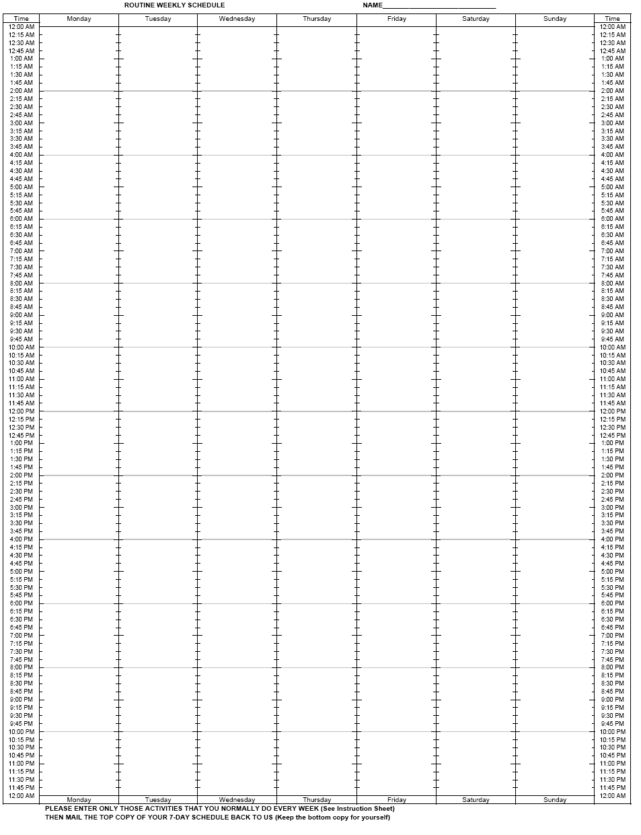
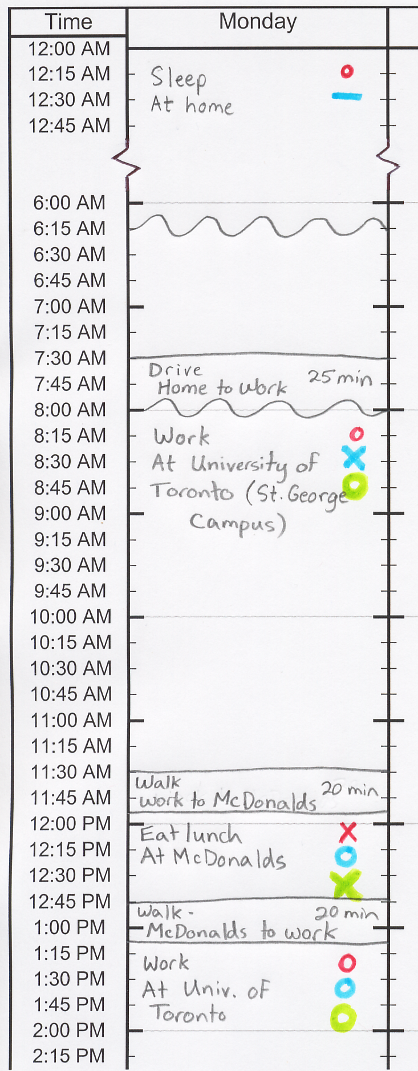
Figure 2 – Routine weekly schedule (with a blow up of a completed portion)

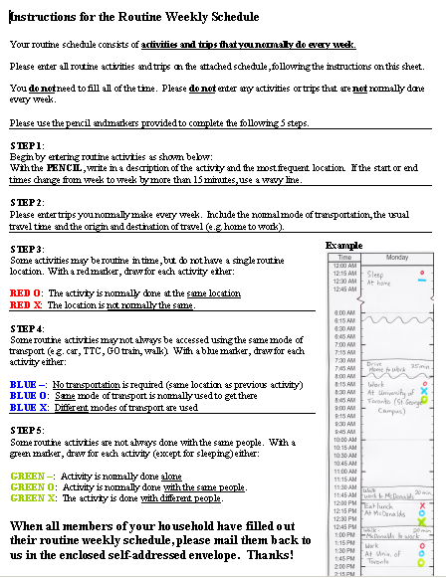
Figure 3 – Instructions for routine weekly schedule (given to respondent)

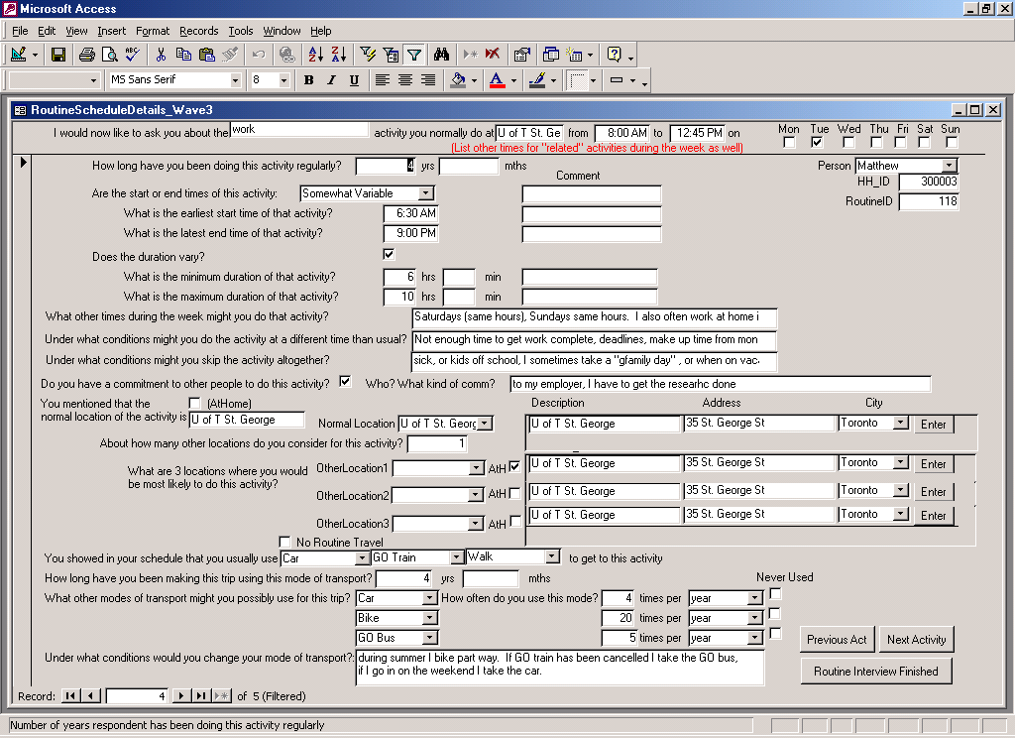
Figure 4 – CATI questions for the routine weekly schedule

Analysis
Comparison of Routine and Executed Schedules
Routine weekly schedules can be compared to executed schedules in many different ways. We begin simply with a comparison of the number of trips by mode, as shown in Figure 5. These diagrams show that less than 50% of auto trips are routine. Similarly, less than 50% of non-motorized trips are routine. On the other hand, almost 95% of transit trips are routine.
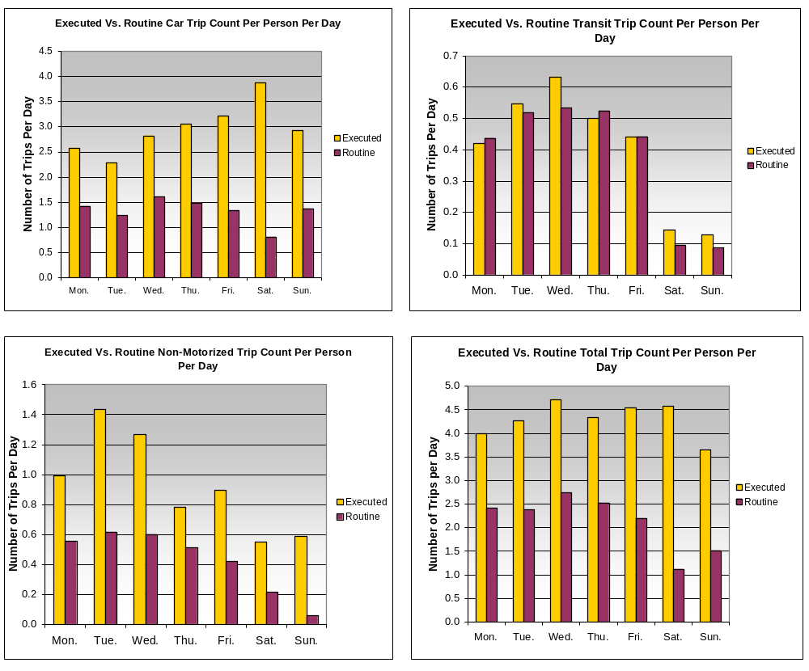
Figure 5 – Executed vs. routine trips per person per day, by mode of transportation

It is also clear that there is significant variation in both the routine and the executed trips by mode across the days of the week. The number of routine car trips remains quite stable throughout the week, but the number of executed car trips increases steadily from Tuesday to Friday. Saturday has by far the fewest routine car trips, yet it is the day that has the highest average number of executed car trips. Clearly, because of its flexibility, the car is the mode of choice for non-routine trips that occur on Fridays, Saturdays and Sundays.
Non-motorized modes are similarly used for non-routine activities, however, these trips appear to be more heavily concentrated on Tuesdays and Wednesdays. The Tuesday-Wednesday peak is also evident for routine non-motorized trips, although this peak is not as pronounced for the executed trips.
Transit usage varies in a different way. On weekends, very few transit trips are present in either the routine or the executed activity schedules. Transit usage, both routine and executed, tends to increase mid-week and to drop off on Mondays and Fridays. On Fridays this is likely due to the greater variety of activities (often done after work) at a more diverse set of locations more easily accessible by car. Mondays are a less eventful day in general with the smallest number of executed trips.
Figure 6 compares the out-of-home activity duration of executed activities and activities that are included in the routine weekly schedule. Approximately 75% of time spent doing out-of-home activities is part of the routine weekly schedule. The proportion is greatest on Mondays and Tuesdays (approximately 85%) followed by Wednesday to Friday (75-80%) and is the least routine on Saturdays (40%) and Sundays (60%). The weekly distribution of routine out-of-home activity duration looks strikingly similar to the weekly distribution of total routine trips by all modes. This indicates that overall the average duration of routine out-of-home activities does not change much through the week or on the weekend. By similar logic, executed activities on weekends appear to be significantly shorter duration than on weekdays.
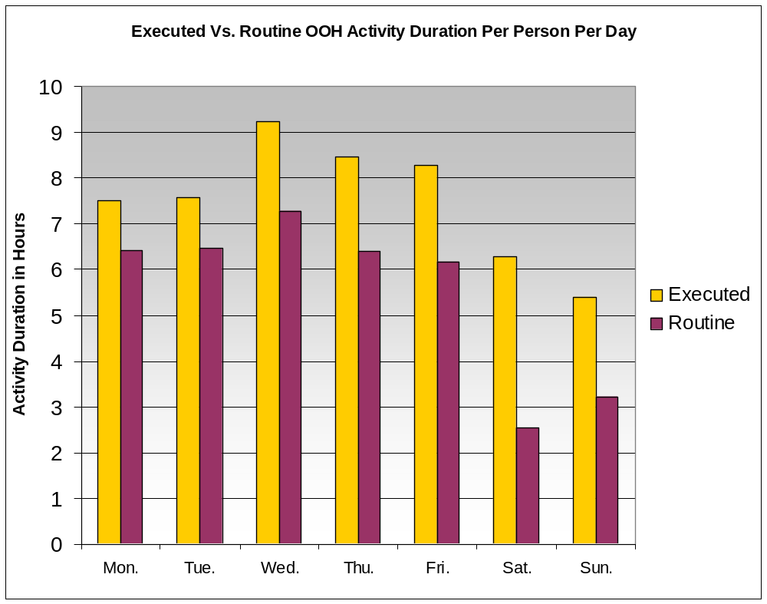
Figure 6 – Executed vs. routine daily out-of-home activity duration

Routine and Executed Differences by Gender and by Activity Type
Comparisons can be made in a multitude of different ways, by cross classifying by person activity household or time of day attributes. Figure 7 shows how the routine and executed schedules, broken down by activity type, can be compared for males and females. In total, men spend a greater amount of time performing out-of-home activities that are routine (on average 5.81 hours per day for men, compared to 5.18 hours per day for women). This pattern is apparent both on weekdays and on weekends.

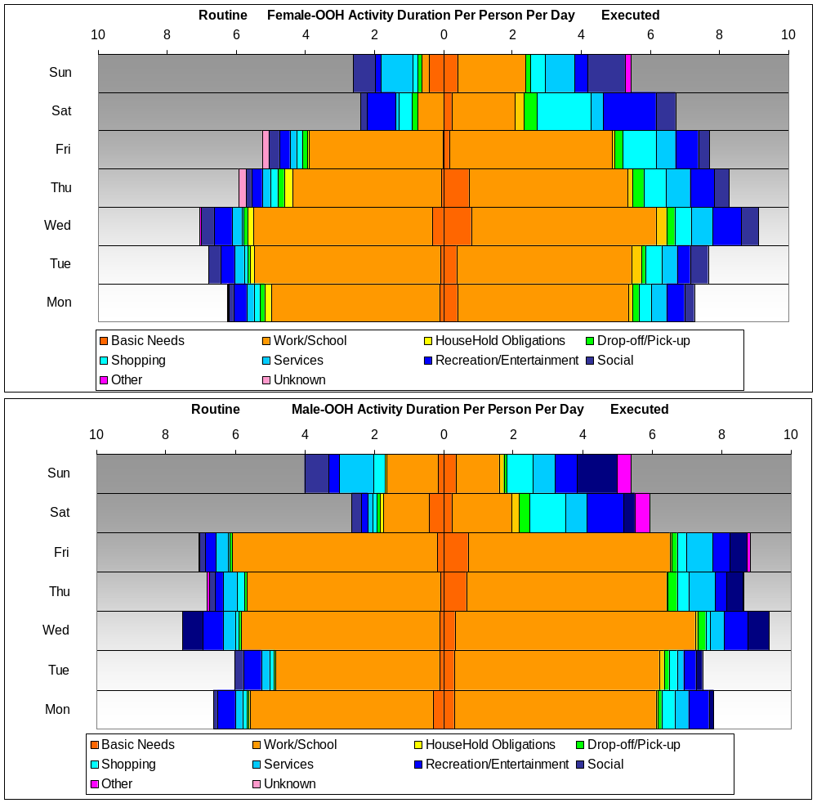
Figure 7 – Comparison of male and female, routine vs. executed out-of-home activity duration by activity Type

However, men spend only slightly more time performing executed activities than women (7.63 hours per day for men, compared with 7.46 hours for women). In fact, women spend more time executing out-of-home activities on weekends than men (5.65 hours per day for men, 6.08 hours per day for women) despite that men have a greater duration of routine activities on the weekends. This results in a ratio of routine to executed out-of-home activity duration that is higher for men (0.76), than for women (0.69).
Why is this the case? Part of the reason is that men have different work habits than women. Over the course of the entire week, men work 16% more than women and on weekdays work 23% more than women. Men worked 10% more hours than they report in their routine weekly schedule, both on weekdays and weekends (on average this amounts to about 35 minutes/day on weekdays and about 5 minutes/day on weekends). Women, on the other hand, spend very little time (about 12 minutes/day) doing non-routine work/school activities during the week. What is intriguing, however, is that women have very little routine work/school activities on the weekend, but are actually observed to work more than men did (1.9 hours/day for women compared to 1.5 hours/day for men). The reason for this pattern is not entirely clear, although it is plausible that a greater number of men are given more flexibility than women (by their families) to work overtime during the week, because they have fewer other responsibilities. On weekends this pattern appears to change. While men schedule routine work on the weekend, women are less likely to do so, but rather engage in out-of-home work activities more sporadically.
There are important differences between men and women in household maintenance activities, including household obligations, drop-off/pickup of people/mail and other items, shopping and services such as banking and medical appointments. Women include more household maintenance activities in their routine weekly schedules than do men (0.73 hours/day for women compared with 0.62 hours/day for men). Men and women, however, routinely spend the same amount of time on weekend days doing household maintenance activities, about 0.9 hours/day.
A much larger difference is seen in the duration of executed household maintenance activities. Women spend 1.67 hours/day on average compared to the average for males of 1.27 over the entire week. Most of the difference occurs on weekdays, where women spend on average 30 minutes more than men executing out-of-home household maintenance activities.
The disparities do not span across all types of household maintenance activity. Men actually spend approximately the same time (about 32 min/day) as women doing out-of-home service activities (which include medical, banking, professional, gas station, etc.) and a greater proportion of this time is routine (71% for men, compared with 54% for women).
Finally, social, recreation and entertainment activities are done for greater periods of time by women (75 minutes/day for women, compared with 65 minutes/day for men), although a greater proportion of social/recreation/entertainment time spent by men is routinely done every week.

Flexibility of routine weekly schedules
As described in Figures 2 and 3, colour coded symbols were used in the routine weekly schedule to determine whether the activities were normally done at the same location, with the same people and by the same mode of transport. As shown in Figure 4, several additional questions were asked about each activity including the flexibility of the start/end times and duration. The intention of these questions was to determine the fixity of routine activities in space, in time, in the mode of transportation used, and in the people with whom the activity is done. Results are shown in Figures 8–11.
As shown in Figure 8, spatial fixity is very strong for most in-home activities and less strong for out-of-home activities. Of a total average of approximately 5.5 in home activities/day, less than 0.1 activities/day normally occur at locations other than home, whereas almost 1/3 of out-of-home activities can occur at more than one location. Of the out-of-home activities, work/school and drop-off/pick-up activities have the least locational flexibility, and other activities, such as shopping, services, social and entertainment have the most spatial flexibility.
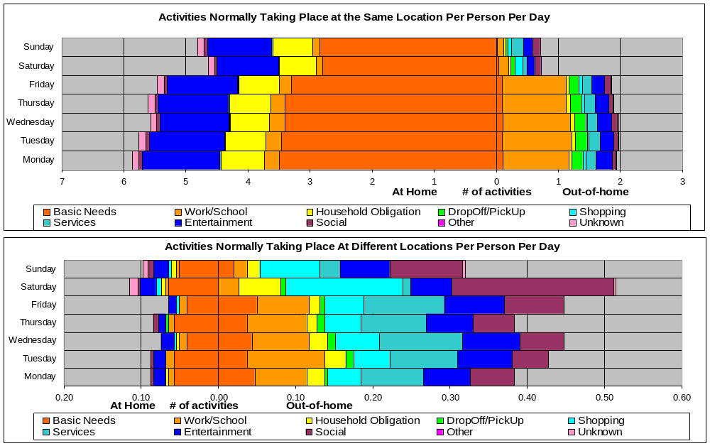
Figure 8 - Spatial fixity for activities done at home versus out-of-home
Figure 9 shows that very little mode flexibility exists. Of approximately 1.8 routine trips per day, an average of only approximately 0.2 trips have flexibility to be accessed by different modes. Social activities have the greatest degree of mode flexibility, especially on Fridays, Saturdays and Sundays.
Temporal flexibility, shown in Figure 10, is relatively small for routine activities. Almost all activities, regardless of type are either “fixed to one or more specific time periods” or are “somewhat variable”, with very few reported as “very variable” or “completely variable”. As expected, work/school and drop-off/pick-up activities have the least variability in time, shopping and social activities have the most flexibility in time, and recreation/entertainment and services fall between. Similar patterns are observed in Figure 11 for flexibility of routine activity duration.

Conclusions
Based on the analysis provided in this paper, we can abandon the conventional notion that there exists a clear cut “skeleton schedule” that consists only of “mandatory” activities of work and school, which is subsequently “filled in” with “household maintenance” and “discretionary” activities that are not routine. Indeed, significant evidence shows that the routine or non-routine nature of activities cannot be defined by activity type alone. Many work/school activities are non-routine in nature, while household maintenance and social/recreation/ entertainment activities are considered by some respondents to be part of their weekly routine.

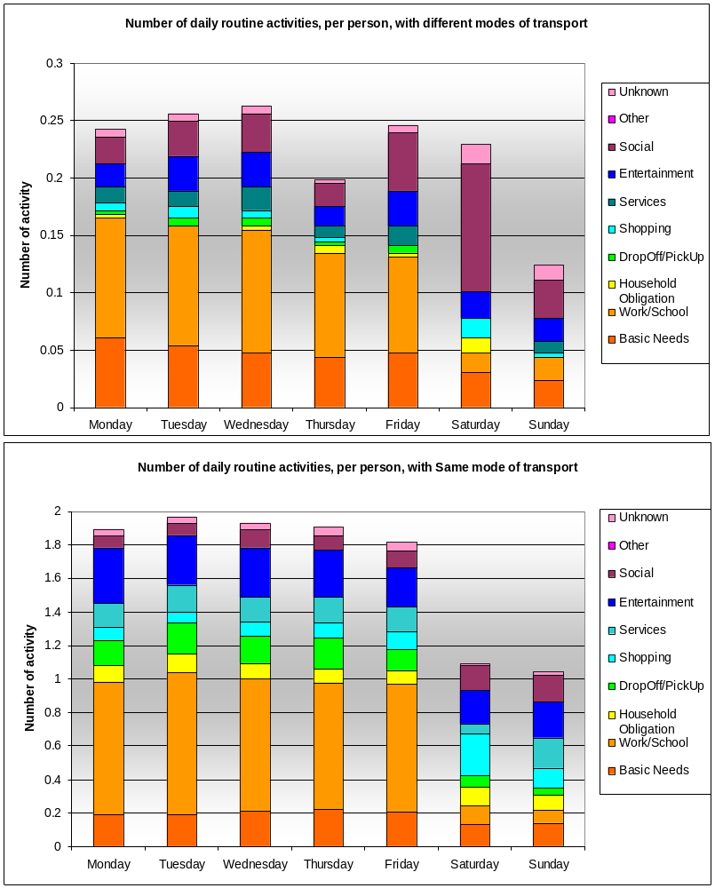
Figure 9 – Mode fixity

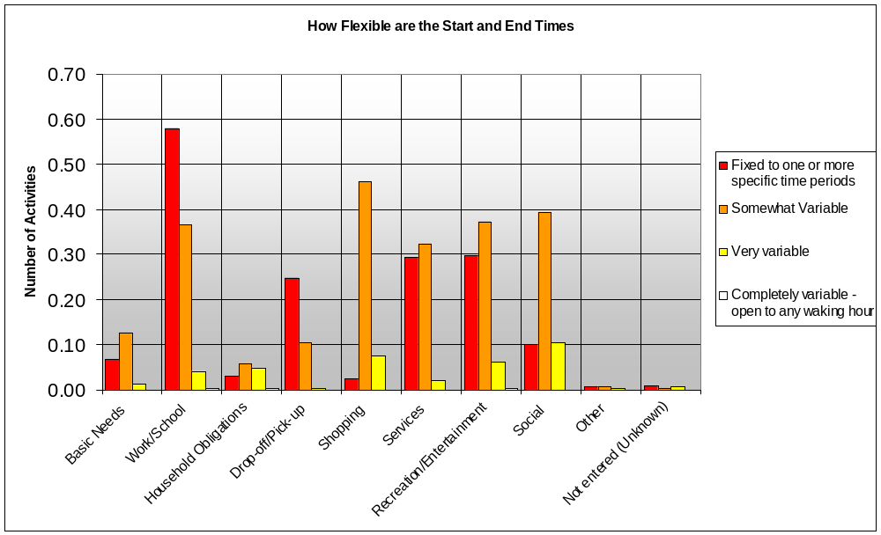
Figure 10 – Temporal flexibility – start/end times

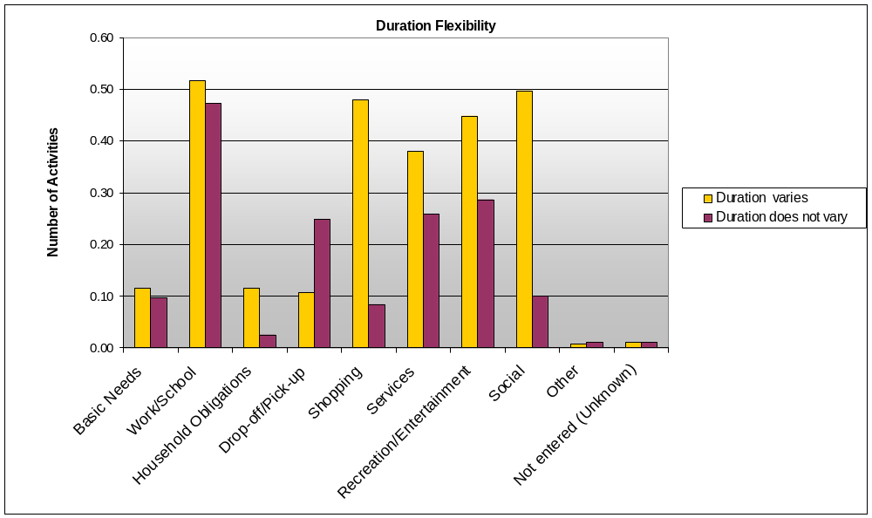
Figure 11 – Temporal flexibility – duration

The analysis of male versus female activity patterns throughout the week provides evidence of greater workforce participation of men and greater participation of women in out-of-home household maintenance and social/recreation/leisure activities. These findings are not new. Indeed, differences in time use by gender have been well documented in numerous studies. The main finding here is that males have a greater proportion of routine activities in their schedules for almost all classes of activities, including work/school activities on the weekend, household maintenance activities and recreation /social /leisure activities. The exception to this general rule is weekday work activities, for which it appears that women have very little flexibility to work beyond their routine work hours, whereas men do.
Our survey also has afforded us the opportunity to assess the extent to which routine activities are fixed in time, space and mode of transportation. We have found that there is really very little flexibility in the choice of mode of transportation to access those activities, with the most notable exception of social activities on the weekend. There is very little flexibility in the location of those routine activities done at home and work/school and drop-off/pick-up activities done out-of-home, compared with other types of activities done out-of-home. Temporal flexibility of routine activities is also relatively small and with the least flexibility associated with work/school and drop-off/pick-up activities.
The analysis suggests two layers of routine activities:
- Those elements of a schedule that are routine and fixed in time space and by mode. This analysis has shown that these are best exemplified by out-of-home work/school and drop-off/pick-up activities on weekdays, and
- Elements of a schedule that are routine, but less fixed in time/space and by mode. This analysis suggests that routine social, recreation/entertainment, shopping services, and household obligations fall into this category more often.
There exists an opportunity to extend this empirical effort to develop a multi-stage model of activity scheduling. Indeed, the analysis presented here lays some of the initial groundwork that could be used for the implementation of the proposed modeling framework proposed by Doherty et al. (2002), or to improve the representation of the routine activity schedule in operational models such as ALBATROSS (Arentze and Timmermans, 2004) or TASHA (Miller and Roorda, 2003).

References
Arentze, T.A. and Timmermans, H.J.P. (2004) ‘A learning based transportation oriented simulation system’, Transportation Research B, 38, pp. 613-633.

Chen, Q. (2001) An Exploration of Activity Scheduling and Rescheduling Processes. PhD Thesis, University of California at Davis.

Doherty, S. T. (2005) ‘How far in advance are activities planned? Measurement challenges and analysis. Transportation Research Record: Journal of the Transportation Research Board, 1926, pp. 41-49.

Doherty, S. T. and Miller, E. J. (2000) ‘A computerized household activity scheduling survey’, Transportation, 27(1), 75-97.

Doherty, S. T., Miller, E. J., Axhausen, K. W. and Gärling, T. (2002) ‘A conceptual model of the weekly household activity-travel scheduling process’, In Travel Behaviour: Patterns, Implications and Modelling. E. Stern, I. Salomon, and P. Bovy (eds).

Doherty, S.T., Nemeth, E., Roorda M.J. and Miller, E.J. (2004) ‘Design and assessment of the Toronto Area Computerized Household Activity Scheduling Survey’, Transportation Research Record, 1894, pp. 140-149.

Ettema, D., Borgers, A. and Timmermans, H. (1994) ‘Using interactive computer experiments for identifying activity scheduling heuristics’, Paper presented at the Seventh International Conference on Travel Behaviour, Santiago, Chile, June.

Gärling, T., Brännäs, K., Garvill, J., Golledge, R. G., Gopal, S., Holm, E. and Lindberg, E. (1989) ‘Household activity scheduling’, In Transport Policy, Management & Technology Towards 2001: Selected Proceedings of the Fifih World Conference on Transport Research, Vol. IV, pp. 235-248, Western Periodicals, Ventura, CA.

Miller, E.J. and Roorda, M.J. (2003) ‘A prototype model of 24-hour household activity scheduling for the Toronto Area’, Transportation Research Record, 1831, pp. 114-121.

Roorda, M.J. and Andre, B.K. (2006), ‘A stated adaptation survey of scheduling responses to delays: empirical and preliminary model results’, Paper presented at the 86th Annual Meeting of the Transportation Research Board Washington, DC, January.

Roorda, M. J., Lee-Gosselin, M., Doherty, S. T., Miller, E.J. and Rondier, P. (2005) ‘Travel/activity panel surveys in the Toronto and Quebec City regions: Comparison of methods and preliminary results’, CD Proceedings of the PROCESSUS Second International Colloquium on the Behavioural Foundations of Integrated Land-use and Transportation Models: Frameworks, Models and Applications. Toronto, June.

Roorda, M.J., and Miller, E.J. (2004) ‘Toronto Activity Panel Survey: demonstrating the benefits of a multiple instrument panel survey’, Paper presented at the Seventh International Conference on Travel Survey Methods. Costa Rica, August.

Roorda, M.J., Miller, E.J. and Habib, K. (2006) ‘Validation of TASHA: A 24-hour activity scheduling microsimulation model. Paper presented at the 86th Annual Meeting of the Transportation Research Board Washington, DC, January.

