A multi-criterion multi-class dynamic transit trip assignment model
S.W.C. FUNG, C.O. TONG* & S.C. WONG
Department of Civil Engineering, The University of Hong Kong, Hong Kong China
(*Author for correspondence, Email: cotong@hku.hk)

Key words: dynamic metro network model, model calibration and validation, multi-class assignment.

Abstract. A dynamic transit trip assignment model developed for the operational planning of an existing metro system has the following salient features:(1) use a schedule-based network formulation to model the movement of trains; (2) use multi-interval assignment (15-minutes duration for each time interval) to predict train loading; (3) assume a multivariable linear path cost model that includes in-vehicle time, waiting time, walking time and line change penalty; (4) divide passengers into different classes based on their route choice preferences; (5) calibrate the model using passenger boarding and alighting flows at station platforms; (6) validate the model using cordon counts. As a case study, the model is applied to the Hong Kong Mass Transit Railway network for a 4-hour period from 6 a.m. to 10 a.m. The input data consists of full sample multi-interval station-to-station O-D trip matrices compiled from data retrieved from ticketing gates. Multi-class assignments for single period and multi-period are implemented and a calibration procedure estimates the proportion of different user classes of travelers to be assigned to the network.

1. Introduction

This paper describes a dynamic transit network model used for the operational planning of an existing metro system, such as for evaluation of proposed new lines, fine-tuning of line schedules, or for management of congestion that is induced by incidents. The salient features of this model are: (1) use a schedule-based network formulation to model the movement of trains; (2) use multi-interval assignment (15-minutes duration for each time interval) to predict train loading; (3) assume a multivariable linear path cost model that includes in-vehicle time, waiting time, walking time and line change penalty; (4) divide passengers into different classes based on their route choice preferences; (5) calibrate the model using passenger boarding and alighting flows at station platforms; (6) validate the model using cordon counts. The main reason of adopting these features is that models for operational planning should achieve a high degree of accuracy and should respond dynamically to changing train schedules and passenger demand patterns. The model is applied to an existing metro network in Hong Kong to illustrate the methods adopted and to demonstrate the “degree of accuracy” that can be achieved.
The subsequent parts of this paper are organized as follows. Section 2 reviews previous research. Section 3 describes the Hong Kong metro network. Section 4 lists out the data collected for model building. Section 5 explains the model assumptions and assignment algorithm. Section 6 describes the data used for model calibration and validation. Section 7 explains the model calibration method. Sections 8 and 9 present the calibration and validation results respectively. Section 10 summarizes the findings of the study.

2. Literature review
A transit network model can either be frequency-based or schedule-based. Frequency-based models assume that transit vehicles for each line operate to a fixed frequency and are commonly used in static assignment models. A good example of frequency-based models is the EMME/2 Standard Transit Assignment (STA) procedure that follows the assignment algorithm described in Spiess and Florian (1989). Schedule-based models assume that transit vehicles operate according to a pre-determined schedule. They allow line frequencies to vary within the analysis period and are commonly used in dynamic assignment models. Examples of schedule-based models are the EMME/2 Deterministic Transit Assignment (DTA) procedure (INRO 2003), the DY-RT model (Nuzzolo and Crisalli 2004) the VISUM model (Freiedrich and Wekech 2004) and the TRANSITNET model (Tong and Wong 1999; Poon et al. 2004)
Most transit networks use a weighted cost function to model passengers’ path choice behavior. This cost function is commonly formulated as a linear combination of different path cost components, such as in-vehicle time, waiting time, fare etc. The relative weights that passengers attach to each component can be estimated by using revealed preference (RP) or stated preference (SP) surveys. Nielsen and Jovicic (1999) and Nielsen (2000) described using a probit-based stochastic schedule-based assignment model to predict the path choices of rail and bus passengers in Copenhagen. Stated preference survey data were used to calibrate the coefficients of the passengers’ utility (cost) functions. Passengers were segmented to 4 classes (commuters, business, education and leisure). The coefficients of the cost functions were assumed to follow truncated normal distributions. However, as there were many coefficients to be calibrated, a large SP data set is required. Additionally, as the assignment procedure requires generating random coefficients using Monte Carlo simulation, it has to be iterated many times in order to obtain a convergent solution. It also did not take into account the possibility that some of the weighting factors may be correlated. For example, a traveler with a high waiting time factor is likely also to have a high line change penalty factor.
The current study proposes a different methodology. Instead of using SP surveys, station in/out counts were used to calibrate the model parameters. Multi-class assignment is used instead of probit-based stochastic assignment.

3. Description of the test network
The Hong Kong Mass Transit Railway Corporation (MTRC) operates the metro system in Hong Kong. It commenced service in October 1979 and carried a total of 876 million passengers in the year 2006. The MTRC network operating in April 2002 (see Figure 1) with the Airport Express Line excluded is used as a test case. It has 43 stations and four lines: (1) Tsuen Wan Line (TWN and TWS), (2) Kwun Tong Line (KTE and KTW), (3) Island Line (ILE and ILW) and (4) Tung Chung Line (TCE and TCW). For the Tung Chung Line, some trains do not run the whole length but only run between Hong Kong Station and Tsing Yi Station. Therefore, for the test network, an additional line, called the Tsing Yi Line (TYE and TYW) is coded to describe the movements of these trains. Since each line operates in both directions, the test network splits each line into 2, and therefore a total of 10 lines are modeled.
[*INSERT FIGURE 1 HERE]

4. Data collected for model building
The time frame for data collection is four weekdays (Thursday, Friday, Monday and Tuesday) during the period from 25 to 30 April 2002. Train schedules were provided by the Planning Department of MTRC, containing the run time for each line segment, vehicle headway and the dwell time at each station specified to the nearest second.
The time that passengers spent walking between station concourses and/or between platforms was determined by survey. The surveys were conducted by carrying out site visits to all MTRC stations during non-peak periods in September 2003. The start/end point of a walk link is assumed to be either at the ticketing gate of a station concourse or the midpoint of a platform. If a station has ticketing gates at several locations, the location with highest passenger flow is assumed.
Station-to-station trip matrices representing the average trip demand for the 4 weekdays in April 2002 were provided by MTRC. There are a total of 20 trip matrices, each representing a 15-minute interval during the morning period from 6 a.m. to 11 a.m.

5. TRANSITNET model
5.1. Network structure
In TRANSITNET, the network model has two types of nodes: zone centriods that represent railway stations and other nodes that represent station platforms. It also has two types of links: walk links that model passengers moving within stations and transit links that model trains moving between stations.
Each transit link models the movements of trains within a transit line segment from the platform of one station to the platform of an adjacent station. If several transit lines share common platforms, then a separate transit link is generated for each line and each line segment. As the model has a discrete time formulation and is schedule-based, information about train departure times at platforms is rounded to the nearest minute and coded into appropriate link description files.
The test network comprises 43 stations and 102 platforms. There are 103 transit links and 244 walk links. The line schedules within the analysis period from 6 a.m. to 11 a.m. are incorporated into the link descriptions. Each train is assumed to have a carrying capacity of 2504 passengers (Each train has 8 cars; each car can accommodate 45 seated, 267 standing passengers and 1 wheelchair space.)
5.2. Assignment algorithms
The assignment algorithm assumes that all travelers have full information about the train schedules, and all trains operate according to these schedules. Congestion effects are not considered and it is assumed that all passengers waiting at the platforms are able to board on the first arrival train. This assumption is justified because the assignment results show that the number of passengers assigned to each train operating within the analysis period is below the train capacity.
The assignment is multi-interval, with 15-minutes being the duration of each interval. Within each time-interval, the station-to-station trip rate is assumed to be constant. A time-dependent optimal path algorithm developed by Tong and Richardson (1984) is used to find the optimal path. The best path for a given O-D pair is dependent on the start time of the trip. Starting from the beginning of the assignment period, various time-dependent best paths are generated. The rate of passenger arrival at the station is calculated from the specified trip matrices. Passengers are assigned onto different paths depending on their time of arrival at the origin station. As the network is schedule-based, the assignment results actually show the number of passengers assigned onto each train.
The criteria for determining the best path is based on the following weighted time function:
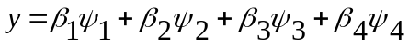 (1)

where:
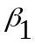= Weight attached to in-vehicle time 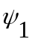
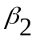= Weight attached to waiting time 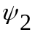
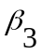= Weight attached to walking time 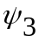
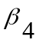= Boarding penalty attached to the number of line changes 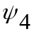

The transit fare is not considered because within the test network, the fare is only dependent on the entrance and exit stations of the path and is independent of the routing of the path used within the network.
Fung et al. (2005) used a similar weighted time function to develop a stochastic assignment model in which the weights , and are assumed to be random variables following gamma type density functions. However, this model is costly to implement because of the need to collect a large SP data set to calibrate the density functions. A less costly procedure used in the current model is to assume that travelers belong to several classes, in which each class has its own set of weights. Then either a single period multi-class or multi-period multi-class assignment can be carried out. In the former, the proportion of each traveler class is assumed to remain constant throughout the whole analysis period. In the latter, the assignment period is subdivided into several time periods, the proportion of each traveler class is assumed to remain constant within each time period.
While a single period multi-class assignment can be performed by repeating the assignment algorithm several times and finding the weighted average of the assignment outputs, a modified assignment algorithm has to be used to perform a multi-period multi-class assignment because of the possibility of passengers from one time period spilling over to the next time period. However, since the network is not congested, the multi-period multi-class assignment problem is still a separable problem. A further assumption is that since the model is applied to a metro network serving the central areas of a small and compact city with mixed land uses, the proportion of each user class will not vary substantially between passengers traveling on different O-D pairs (as defined the origin rail station and the destination rail station).

6. Data used for model calibration and validation

The coefficients of the weighted time function can be estimated by the following methods:
- Revealed Preference (RP) survey on path choice
- Stated Preference (SP) survey on path choice
- Calibration using observed link flows
- Calibration using observed boardings and alightings at platforms.
As path choice surveys have not been conducted in this study, there is a choice of either method (c) or method (d). Method (d) is considered to be better because, as compared to link flows, boardings and alightings provide a larger number of independent data points for calibration. This is illustrated in Figure 2, which shows that a transit line with 3 transit line segments and hence 3 link flow values can provide 6 boardings and alightings counts (there is however 1 reduced degree of freedom for each transit line, because total boardings must equal to total alightings). Furthermore, within a metro system, it is easier to count the numbers of passenger boardings and alightings at platforms compared to counting the number of passengers in a train.
In this study, data on passenger boardings and alightings at all station platforms were provided by the MTRC Operations Department. These are daily 15-minute estimates based on in/out gate transactions and site surveys. This set of data is used for model calibration.
Passenger counts at the cross harbor cordon were conducted by the MTRC Planning Department at successive 15-minute intervals from 7a.m. to 10 a.m. during 25 to 30 April 2002. This is an independent set of data that can be used for model validation. [*INSERT FIGURE 2 HERE]

7. Proposed calibration methodology
7.1. Objectives
As the weights attached to the different components of the weighted time function are not accurately known, the objective is to calibrate these weighting factors using the data available on the number of passenger boardings and alightings at station platforms. Since each class of travelers has its own set of weights, the objectives of model calibration are to find the set of weights for each traveler class as well as the proportion of each traveler class to be assigned to the network during different time periods.
7.2. Model error specification

The multiclass assignment problem requires finding the proportion of each class of traveler to be assigned to the transit network. Let there be a total of classes, with each class denoted by, 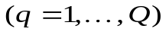and a total of station platforms with each platform denoted as , 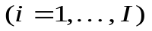. Time is segmented into discrete intervals of 15-minutes duration. Let there be a total of time intervals, with each time interval denoted as ,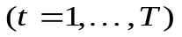. Let 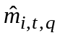 be the modeled number of passenger boardings in platform during time interval if all passengers belong to user class , and let 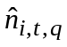 be the modeled number of passenger alightings in platform during time interval if all passengers belong to user class . Let 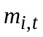 be the observed number of passenger boardings in platform during time interval and let 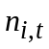 be the observed number of passenger alightings in platform during time interval . Let 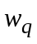 be the proportion of passengers belonging to user class . The Root Mean Square Error (RMSE) for boardings and alightings are defined as:
RMSE (boardings)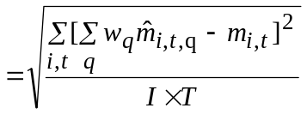 (2a)
RMSE (alightings)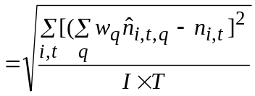 (2b)

7.3. Generation and selection of passenger classes

In the generation of passenger classes, the following assumptions are made:
a) =1
b) 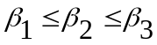
c) 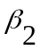 ranges between 1 and 1.5
d) ranges between 1.5 and 2
e) ranges between 1 to 4 minutes
It is a common practice to set the weighting coefficient for in-vehicle time () equal to 1 and less than the weighting coefficients for waiting time () and walking time (). Setting the constraint 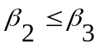 is a reasonable assumption because walking requires more effort compared to waiting. Furthermore, it would prevent generating paths in which passengers prefer to walk too and fro between adjacent station platforms rather than staying at a platform when waiting for a train. The line change penalty coefficient () is always assumed to be positive because passengers would consider line changing as a negative attribute of the trip because of uncertainty concerns. Based on the above assumptions, different sets of weights are generated and tested and the best three are selected for the multi-class assignment problem.
7.4. Single period mult-iclass assignment problem formulation

The single period multi-class assignment problem is to find the values of that minimize the RMSE as defined in Equation (2). This is equivalent to minimizing the following function:
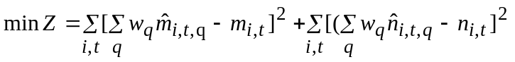 (3)
subject to:
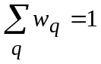 (4)
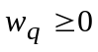 , 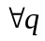 (5)

This minimization problem can be solved by employing a dual quadratic programming algorithm suggested by Goldfarb and Idnani (1983). It started by formulating the problem of minimizing Equation (6):
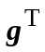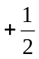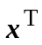H (6)
subject to:

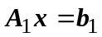 (7)
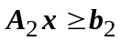 (8)
Where the vectors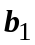, 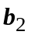, g and the matrices H, 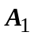, 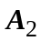 are given and is the solution vector to be found. The next step is to transform the problem specified by Equations (3), (4) and (5) into a form equivalent to those given by Equations (6), (7) and (8).
7.5. Single period multi-class assignment data input

In this problem, we assume a single assignment period and 3 traveler classes (= 3). The assignment period is from 6 a.m. to 10 a.m., giving a total of sixteen 15-minute time intervals (= 16). The test network has a total of one hundred and two station platforms (=102). Therefore I x T = 1632.
Let:
^{T} be the transpose of the solution vector =[x₁, x₂, x₃]
a matrix representing equality constraints specified in Equation (4) =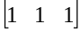
a matrix representing inequality constraints specified in Equation (5) =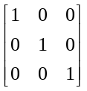
=[1]
^{T} =[0, 0, 0]
g a column vector of length 3
H a 3 by 3 Hessian matrix which has to be positive definite
 a 1632 by 3 boardings matrix with elements
 a 1632 by 3 alightings matrix with elements
observed boardings column vector of length 1632 with elements
observed alightings column vector of length 1632 with elements
Equation (3) can be expressed using matrix and vector notation as:
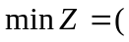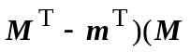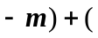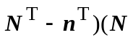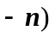 (9)
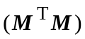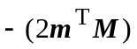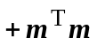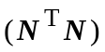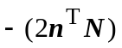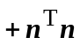

As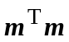, and 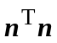 are constant terms independent of , they can be taken out of the equation and the objective function to be minimized becomes:
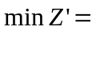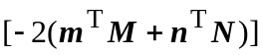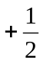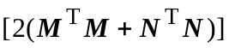 (10)
By setting:
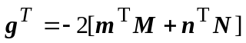 (11)
and
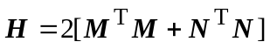 (12)

Equation 10 is in a form equivalent to Equation (6). The problem can then be solved by using any commercially available non-linear optimization subroutine, such as QPROG in the IMSL FORTRAN library developed by Visual Numerics, Inc.
7.6. Multi-period multi-class assignment problem formulation

Let there be a total of  time periods, with each time period denoted by p, 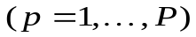, such that each period contains one or more than one class of travelers, each denoted by ,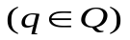. The definition of and is the same as those defined in Section 7.2. However the proportion of passengers in period 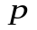 belonging to user class is denoted by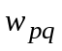. The multi-period multi-class assignment problem is to find the values of that minimize the following:
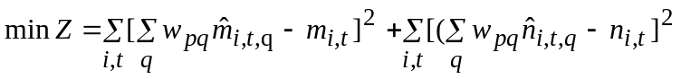 (13)
subject to:
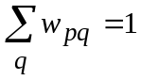,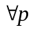 (14)
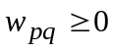 , 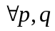 (15)

Since the network is assumed to be uncongested, there is no interaction between different user classes, and therefore the values of and can be obtained by performing a separate trip assignment for each user class by assuming that 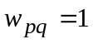and loading the network with the demand matrix for time period .
7.7. Multi-period multi-class assignment data input

For the multi-period problem, we choose three user classes in each time period, giving a total of 3 4 = 12 traveler classes. Therefore we have a solution vector with 12 elements. There are 16 linear constraints including 4 linear equality constraints as specified in Equation (14) and 12 linear inequality constraints as specified in Equation (15).
By employing the same method as explained in Sections 7.4 and 7.5, the solution vector x can be found by using a non-linear optimization subroutine.

8. Calibration results

The calibration results for single period and multi-period multi-class assignment are shown respectively in Tables 1a and 1b. From the tables, it can be seen that the total RMSE for multi-period is 240.59, which is slightly lower than the total RMSE of 243.09 for single period.
[*INSERT TABLE 1a AND 1b HERE]
To illustrate the calibration results, Figure 3 shows the comparison of observed and modeled boardings and alightings for Tsuen Wan Line South for multiperiod multiclass assignment. [*INSERT FIGURE 3 HERE]

9. Model validation

For links in the cross-harbor cordon, the observed link flows are compared with the modeled link flows. The Percent Root Mean Square Error (%RMSE) for link flows is defined as:
%RMSE (link flows) 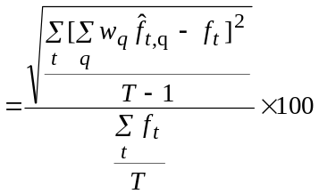 (16)
Where 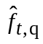is the modeled number of passengers belonging to class q traveling along the link during time interval t,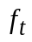is the corresponding observed value and T is the total number of time intervals. (T=12 because there are twelve 15-minute time intervals covering the period from 7 a.m. to 10 a.m.)
The validation results are shown in Tables 2a and 2b for single class (Scenario 1-1.5-1.5-2), in Tables 3a and 3b for single period multi-class and in Tables 4a and 4b for multi-period multi-class. [*INSERT Table 2a, 2b, 3a, 3b, 4a, 4b HERE]. The validation results are further illustrated in Figures 4a and 4b. [*INSERT Figure 4a, 4b HERE]
Table 5 summarizes the validation results for single class, single period and multi-period multi-class assignment. The results show that the %RMSE decreases progressively for single class, single period multi-class and multi-period multi-class. Thus the accuracy of the model increases when the number of user classes increases.
[*INSERT TABLE 5 HERE]
10. Conclusions

Using the Hong Kong MTR network as a case study, this paper has described a procedure for applying a dynamic schedule-based trip assignment model to a high frequency metro system. The numbers of passengers boarding and alighting at all station platforms at 15-minute intervals are used to calibrate the model. Multi-class assignments are implemented based on the calibration results. The observed link counts along a major cordon is used to validated the model. As the results show that the %RMSE based on 15-minute interval link counts decreases as the number of user class increases, this study demonstrates that the proposed multiclass assignment procedure is both feasible and beneficial.
The validation results show that for the cross-harbor cordon, the modeled 15-minute link volume matches the surveyed link counts quite well. A majority of the modeled results has error of less than 30%. Thus the model could be a useful and reliable tool for operational planning, such as planning of line schedules and assessing the impacts of incidents.

Acknowledgements

This study is supported by research grant HKU 7030/02E from the Hong Kong Research Grant Council. The Hong Kong Mass Transit Railway Corporation Limited is gratefully acknowledged for providing data for model building, calibration and validation.

References

Friedrich M. and Wekeck S. (2004). A schedule-based transit assignment model addressing the passengers’ choice among competing connections. In Chapter 9 of Wilson N.H.M and Nuzzolo A. edited Schedule-Based Dynamic Transit Modeling, Theory and Applications, Kluwer Academic Publishers.
Fung S.W.C., Tong C.O. and Wong S.C. (2005). Dynamic transit network assignment using a stochastic generalized cost function. Proceedings of the Tenth International Conference of Hong Kong Society for Transportation Studies. 10 December, Hong Kong, pp 531-538.
Goldfarb, D., and A. Idnani (1983). A numerically stable dual method for solving
strictly convex quadratic programs, Mathematical Programming, 27, 1-33.
INRO (2003), EMME/2 User’s Manual, Release 9.4, INRO Consultants Inc.
Nielson, O.A. and Jovicic G. (1999) A large scale stochastic timetable-based transit assignment model for route and sub-mode choices. 27th Eurpoean Transport Forum (PTRC Annual Meeting), Cambridge, U.K.
Nielson, O.A. (2000) A stochastic transit assignment model considering differences in passengers utility function. Transportation Research, 34B, 377-402.
Nuzzolo, A. and Crisalli Y. (2004) The Schedule-based approach in dynamic transit modelling: a general overview, In Chapter 1 of Wilson N.H.M and Nuzzolo A. edited Schedule-Based Dynamic Transit Modeling, Theory and Applications. Kluwer Academic Publishers.
Poon M.H., Wong S.C. and Tong C.O. (2004) A dynamic schedule-based model
for congested transit networks. Transportation Research, 38B, 343-368.
Spiess H. and Florian M. (1989). Optimal strategies: a new assignment model for transit networks. Transportation Research, 23B: 83-102.
Tong, C.O. and Richardson, A.J. (1984) A computer model for finding the time-dependent minimum path in a transit system with fixed schedules, Journal of Advanced Transportation, 18, 145-161
Tong C.O. and Wong S.C. (1999) A schedule-based time-dependent trip assignment model for transit networks. Journal of Advanced Transportation, 33, 371-388.

Table 1a. The single-period multi-class assignment calibration results.
Time | User Class | Boardings | Alightings | Total | Solution
 | β₁ – β₂ – β₃ – β₄ | RMSE | RMSE | RMSE | Vector
600-1000 | 1-1-1-3 | 126.45 | 122.50 | 248.95 | 0.34
 | 1-1-1.5-2 | 129.59 | 119.48 | 249.07 | 0.00
 | 1-1.5-1.5-2 | 127.34 | 117.16 | 244.50 | 0.67
Weighted |  | 125.92 | 117.18 | 243.09

Table 1b. The multi-period multi-class assignment calibration results.
Time | User Class | Boardings | Alightings | Total | Solution
 | / β₁ – β₂ – β₃ – β₄ | RMSE | RMSE | RMSE | Vector
600-700 | 1-1-1.5-3 | 52.50 | 49.60 | 102.10 | 0.55
 | 1-1-2-1 | 53.95 | 50.34 | 104.30 | 0.28
 | 1-1-1-3 | 56.70 | 50.21 | 106.91 | 0.17
Weighted |  | 51.22 | 47.95 | 99.17
700-800 | 1-1-1.5-2 | 93.49 | 98.99 | 192.48 | 0.52
 | 1-1-1-3 | 97.75 | 102.83 | 200.59 | 0.48
 | 1-1-1.5-1 | 96.79 | 104.00 | 200.78 | 0.00
Weighted |  | 92.42 | 98.29 | 190.71
800-900 | 1-1-1-3 | 183.69 | 172.98 | 356.67 | 0.22
 | 1-1.5-1.5-2 | 186.39 | 163.77 | 350.16 | 0.78
 | 1-1-1.5-2 | 188.79 | 169.21 | 358.00 | 0.00
Weighted |  | 184.48 | 163.63 | 348.11
900-1000 | 1-1.5-1.5-2 | 132.49 | 122.59 | 255.08 | 0.33
 | 1-1.5-1.5-4 | 138.04 | 123.39 | 261.44 | 0.35
 | 1-1.5-1.5-3 | 134.35 | 124.97 | 259.31 | 0.32
Weighted |  | 132.02 | 120.81 | 252.83
Total |  | 125.12 | 115.47 | 240.59

Table 2a. Validation of single class assignment results for the cross-harbor cordon in northbound direction.
Crossing | Western Harbor Crossing (WHC) |  |  |  |  | Central Harbor Crossing (CHC) |  |  | Eastern Harbor Crossing  (EHC)
Time | Observed |  | Modeled |  | Error | Observed | Modeled Error |  | Observed |  | Modeled |  | Error
0700-0715 | 102 | 302 |  | 200(196.08%) |  | 606 | 808 | 202 (33.41%) | 457 | 745 |  | 288 (63.02%)
0715-0730 | 515 | 469 |  | -46 (-8.93%) |  | 830 | 1169 | 339 (40.92%) | 1131 | 1267 |  | 136 (12.02%)
0730-0745 | 643 | 577 |  | -66 (-10.26%) |  | 1142 | 1413 | 271 (23.78%) | 1661 | 1346 |  | -315(-18.96%)
0745-0800 | 847 | 829 |  | -18 (-2.13%) |  | 1670 | 2373 | 703 (42.11%) | 2010 | 1781 |  | -229(-11.39%)
0800-0815 | 1235 | 912 |  | -323 (-26.15%) |  | 2251 | 2796 | 545 (24.21%) | 2483 | 1972 |  | -511(-20.58%)
0815-0830 | 1360 | 1143 |  | -217 (-15.96%) |  | 3429 | 4192 | 763 (22.27%) | 3273 | 2951 |  | -322 (-9.84%)
0830-0845 | 1403 | 1169 |  | -234 (-16.68%) |  | 4584 | 4236 | -348 (-7.60%) | 3969 | 2945 |  | -1024(-25.80%)
0845-0900 | 709 | 845 |  | 136 (19.18%) |  | 4887 | 4856 | -31 (-0.63%) | 2594 | 3131 |  | 537 (20.70%)
0900-0915 | 486 | 509 |  | 23 (4.73%) |  | 4129 | 3376 | -753(-18.23%) | 2312 | 1993 |  | -319(-13.80%)
0915-0930 | 401 | 393 |  | -8 (-2.00%) |  | 3132 | 3094 | -38 (-1.22%) | 1466 | 1668 |  | 202 (13.78%)
0930-0945 | 330 | 339 |  | 9 (2.73%) |  | 2319 | 2411 | 92 (3.97%) | 1179 | 982 |  | -197(-16.71%)
0945-1000 | 326 | 285 |  | -41(-12.58%) |  | 1665 | 2605 | 940 (56.41%) | 911 | 870 |  | -41 (-4.50%)
0700-1000 | 8357 | 7772 |  | -585 (-7.00%) |  | 30643 | 33329 | 2686 (8.77%) | 23446 | 21651 |  |  | -1795 (-7.66%)
%RMSE | 22.66% |  |  |  |  | 21.07% |  |  | 22.56%
%RMSE | 13.71%

Table 2b. Validation of single class assignment results for the cross-harbor cordon in southbound direction.
Crossing | Western Harbor Crossing (WHC) |  |  | Central Harbor Crossing (CHC) |  |  | Eastern Harbor Crossing  (EHC)
Time | Observed Modeled Error |  |  | Observed | Modeled | Error | Observed | Modeled | Error
0700-0715 | 615 | 587 | -28 (-4.55%) | 1790 | 1671 | -119(-6.64%) | 840 | 1376 | 536 (63.81%)
0715-0730 | 965 | 1205 | 240 (24.87%) | 2443 | 2886 | 443(18.12%) | 2036 | 2139 | 103 (5.06%)
0730-0745 | 1640 | 1337 | -303 (-18.48%) | 3457 | 3382 | -75(-2.17%) | 2331 | 2217 | -114 (-4.89%)
0745-0800 | 1355 | 1818 | 463 (34.17%) | 4500 | 4868 | 368 (8.17%) | 3078 | 3159 | 81 (2.63%)
0800-0815 | 2252 | 2490 | 238 (10.57%) | 6497 | 6270 | -227(-3.50%) | 4011 | 4872 | 861 (21.47%)
0815-0830 | 3712 | 2939 | -773 (-20.82%) | 9067 | 9628 | 561 (6.19%) | 5978 | 7120 | 1142 (19.10%)
0830-0845 | 5303 | 3936 | -1367(-25.78%) | 11666 | 10992 | -674(-5.77%) | 7166 | 7836 | 670 (9.35%)
0845-0900 | 4021 | 3929 | -92 (-2.29%) | 12062 | 12651 | 589 (4.88%) | 8113 | 7972 | -141 (-1.74%)
0900-0915 | 2859 | 3254 | 395 (13.82%) | 9405 | 9138 | -267(-2.84%) | 6093 | 5317 | -776(-12.74%)
0915-0930 | 1883 | 2505 | 622 (33.03%) | 7058 | 7611 | 553 (7.84%) | 4525 | 4048 | -477(-10.54%)
0930-0945 | 1335 | 1825 | 490 (36.70%) | 5735 | 5699 | -36(-0.63%) | 3059 | 2337 | -722(-23.60%)
0945-1000 | 1203 | 1270 | 67 (5.57%) | 4457 | 4833 | 376 (8.44%) | 2277 | 2102 | -175 (-7.69%)
0700-1000 | 27143 | 27095 | -48 (-0.18%) | 78137 | 79629 | 1492 (1.91%) | 49507 | 50495 | 988 (2.00%)
%RMSE | 25.58% |  |  | 6.61% |  |  | 15.00%
%RMSE | 7.37%

Table 3a. Validation of single period multi-class assignment results for the cross-harbor cordon in northbound direction.
Crossing | Western Harbor Crossing (WHC) |  |  |  |  | Central Harbor Crossing (CHC) |  |  |  |  | Eastern Harbor Crossing  (EHC)
Time | Observed |  | Modeled |  | Error | Observed |  | Modeled |  | Error | Observed | Modeled | Error
0700-0715 | 102 | 320 |  | 218 (213.73%) |  | 967 | 797 |  | -170(-17.61%) |  | 457 | 737 | 280 (61.27%)
0715-0730 | 515 | 481 |  | -34 (-6.60%) |  | 1212 | 1161 |  | -51 (-4.17%) |  | 1131 | 1263 | 132 (11.67%)
0730-0745 | 643 | 591 |  | -52 (-8.09%) |  | 1647 | 1407 |  | -240(-14.57%) |  | 1661 | 1342 | -319(-19.21%)
0745-0800 | 847 | 838 |  | -9 (-1.06%) |  | 2338 | 2357 |  | 19 (0.83%) |  | 2010 | 1781 | -229(-11.39%)
0800-0815 | 1235 | 938 |  | -297 (-24.05%) |  | 2999 | 2772 |  | -227 (-7.58%) |  | 2483 | 1974 | -509(-20.50%)
0815-0830 | 1360 | 1166 |  | -194 (-14.26%) |  | 3857 | 4160 |  | 303 (7.85%) |  | 3273 | 2957 | -316 (-9.65%)
0830-0845 | 1403 | 1192 |  | -211 (-15.04%) |  | 4366 | 4215 |  | -151 (-3.46%) |  | 3969 | 2950 | -1019(-25.67%)
0845-0900 | 709 | 868 |  | 159 (22.43%) |  | 4115 | 4839 |  | 724 (17.60%) |  | 2594 | 3134 | 540 (20.82%)
0900-0915 | 486 | 517 |  | 31 (6.38%) |  | 3186 | 3365 |  | 179 (5.62%) |  | 2312 | 1996 | -316(-13.67%)
0915-0930 | 401 | 405 |  | 4 (1.00%) |  | 2489 | 3080 |  | 591 (23.76%) |  | 1466 | 1673 | 207 (14.12%)
0930-0945 | 330 | 347 |  | 17 (5.15%) |  | 2222 | 2390 |  | 168 (7.55%) |  | 1179 | 1001 | -178(-15.10%)
0945-1000 | 326 | 289 |  | -37 (-11.35%) |  | 2049 | 2562 |  | 513 (25.01%) |  | 911 | 915 | 4 (0.44%)
0700-1000 | 8357 | 7952 |  | -405 (-4.85%) |  | 30643 | 33105 |  | 2462 (8.03%) |  | 23446 | 21723 | -1723 (-7.35%)
%RMSE | 21.64% |  |  |  |  | 14.23% |  |  |  |  | 22.43%
%RMSE | 11.33%

Table 3b. Validation of single period multi-class assignment results for the cross-harbor cordon in southbound direction.

Crossing | Western Harbor Crossing (WHC) |  |  | Central Harbor Crossing (CHC) |  |  | Eastern Harbor Crossing  (EHC)
Time | Observed Modeled |  | Error | Observed | Modeled | Error | Observed | Modeled | Error
0700-0715 | 615 | 625 | 10 (1.63%) | 1790 | 1643 | -147(-8.21%) | 840 | 1403 | 563 (67.02%)
0715-0730 | 965 | 1258 | 293 (30.36%) | 2443 | 2819 | 376(15.39%) | 2036 | 2152 | 116 (5.70%)
0730-0745 | 1640 | 1420 | -220(-13.41%) | 3457 | 3340 | -117(-3.38%) | 2331 | 2213 | -118 (-5.06%)
0745-0800 | 1355 | 1875 | 520 (38.38%) | 4500 | 4781 | 281 (6.24%) | 3078 | 3183 | 105 (3.41%)
0800-0815 | 2252 | 2599 | 347 (15.41%) | 6497 | 6170 | -327(-5.03%) | 4011 | 4913 | 902 (22.49%)
0815-0830 | 3712 | 3024 | -688(-18.53%) | 9067 | 9507 | 440 (4.85%) | 5978 | 7161 | 1183 (19.79%)
0830-0845 | 5303 | 4088 | -1215(-22.91%) | 11666 | 10835 | -831(-7.12%) | 7166 | 7839 | 673 (9.39%)
0845-0900 | 4021 | 4044 | 23 (0.57%) | 12062 | 12474 | 412 (3.42%) | 8113 | 8004 | -109 (-1.34%)
0900-0915 | 2859 | 3339 | 480 (16.79%) | 9405 | 9019 | -386(-4.10%) | 6093 | 5341 | -752(-12.34%)
0915-0930 | 1883 | 2572 | 689 (36.59%) | 7058 | 7506 | 448 (6.35%) | 4525 | 4072 | -453(-10.01%)
0930-0945 | 1335 | 1885 | 550 (41.20%) | 5735 | 5613 | -122(-2.13%) | 3059 | 2362 | -697(-22.79%)
0945-1000 | 1203 | 1321 | 118 (9.81%) | 4457 | 4755 | 298 (6.69%) | 2277 | 2129 | -148 (-6.50%)
0700-1000 | 27143 | 28050 | 907 (3.34%) | 78137 | 78462 | 325 (0.42%) | 49507 | 50772 | 1265 (2.56%)
%RMSE | 24.93% |  |  | 6.33% |  |  | 15.18%
%RMSE | 7.27%

Table 4a. Validation of multi-period multi-class assignment results for the cross-harbor cordon in northbound direction.
Crossing | Western Harbor Crossing (WHC) |  |  | Central Harbor Crossing  (CHC) |  |  | Eastern Harbor Crossing (EHC)
Time | Observed | Modeled | Error | Observed | Modeled | Error Observed |  | Modeled | Error
0700-0715 | 102 | 338 | 236(231.37%) | 967 | 806 | -161 (-16.68%) | 457 | 726 | 269 (58.86%)
0715-0730 | 515 | 453 | -62 (-12.04%) | 1212 | 1198 | -14 (-1.12%) | 1131 | 1251 | 120 (10.61%)
0730-0745 | 643 | 609 | -34 (-5.29%) | 1647 | 1425 | -222 (-13.48%) | 1661 | 1332 | -329 (-19.81%)
0745-0800 | 847 | 827 | -20 (-2.36%) | 2338 | 2323 | -15 (-0.62%) | 2010 | 1782 | -228 (-11.34%)
0800-0815 | 1235 | 975 | -260 (-21.05%) | 2999 | 2737 | -262 (-8.74%) | 2483 | 1977 | -506 (-20.38%)
0815-0830 | 1360 | 1182 | -178 (-13.09%) | 3857 | 4168 | 311 (8.05%) | 3273 | 2955 | -318 (-9.72%)
0830-0845 | 1403 | 1185 | -218 (-15.54%) | 4366 | 4222 | -144 (-3.30%) | 3969 | 2948 | -1021 (-25.72%)
0845-0900 | 709 | 860 | 151 (21.30%) | 4115 | 4845 | 730 (17.74%) | 2594 | 3133 | 539 (20.78%)
0900-0915 | 486 | 508 | 22 (4.53%) | 3186 | 3375 | 189 (5.93%) | 2312 | 1995 | -317 (-13.71%)
0915-0930 | 401 | 391 | -10 (-2.49%) | 2489 | 3087 | 598 (24.04%) | 1466 | 1678 | 212 (14.46%)
0930-0945 | 330 | 331 | 1 (0.30%) | 2222 | 2390 | 168 (7.55%) | 1179 | 1013 | -166 (-14.08%)
0945-1000 | 326 | 272 | -54 (-16.56%) | 2049 | 2564 | 515 (25.11%) | 911 | 932 | 21 (2.31%)
0700-1000 | 8357 | 7931 | -426 (-5.10%) | 30643 | 33140 | 2497 (8.15%) | 23446 | 21722 | -1724 (-7.35%)
%RMSE | 20.95% |  |  | 14.37% |  |  | 22.42%
%RMSE | 11.33%

Table 4b. Validation of multi-period multi-class assignment results for the cross-harbor cordon in southbound direction.
Crossing | Western Harbor Crossing (WHC) |  |  |  | Central Harbor Crossing (CHC) |  |  | Eastern Harbor Crossing (EHC)
Time | Observed |  | Modeled Error |  | Observed | Modeled | Error | Observed | Modeled | Error
0700-0715 | 615 | 827 |  | 212 (34.47%) | 1790 | 1625 | -165 (-9.22%) | 840 | 1469 | 629 (74.88%)
0715-0730 | 965 | 1277 |  | 312 (32.33%) | 2443 | 2717 | 274(11.22%) | 2036 | 2169 | 133 (6.53%)
0730-0745 | 1640 | 1514 |  | -126 (-7.68%) | 3457 | 3350 | -107 (-3.10%) | 2331 | 2186 | -145 (-6.22%)
0745-0800 | 1355 | 2006 |  | 651 (48.04%) | 4500 | 4743 | 243 (5.40%) | 3078 | 3174 | 96 (3.12%)
0800-0815 | 2252 | 2719 |  | 467 (20.74%) | 6497 | 6159 | -338 (-5.20%) | 4011 | 4909 | 898 (22.39%)
0815-0830 | 3712 | 3561 |  | -151 (-4.07%) | 9067 | 9526 | 459 (5.06%) | 5978 | 7121 | 1143 (19.12%)
0830-0845 | 5303 | 4326 |  | -977 (-18.42%) | 11666 | 10893 | -773 (-6.63%) | 7166 | 7837 | 671 (9.36%)
0845-0900 | 4021 | 4058 |  | 37 (0.92%) | 12062 | 12536 | 474 (3.93%) | 8113 | 7993 | -120 (-1.48%)
0900-0915 | 2859 | 3145 |  | 286 (10.00%) | 9405 | 9042 | -363 (-3.86%) | 6093 | 5343 | -750(-12.31%)
0915-0930 | 1883 | 2346 |  | 463 (24.59%) | 7058 | 7565 | 507 (7.18%) | 4525 | 4144 | -381 (-8.42%)
0930-0945 | 1335 | 1727 |  | 392 (29.36%) | 5735 | 5719 | -16 (-0.28%) | 3059 | 2375 | -684(-22.36%)
0945-1000 | 1203 | 1105 |  | -98 (-8.15%) | 4457 | 4853 | 396 (8.88%) | 2277 | 2136 | -141 (-6.19%)
0700-1000 | 27143 | 28611 |  | 1468 (5.41%) | 78137 | 78728 | 591 (0.76%) | 49507 | 50856 | 1349 (2.72%)
%RMSE | 19.94% |  |  |  | 6.33% |  |  | 15.01%
%RMSE | 6.74%

Table 5. Summary of validation results
Direction | Link |  | Single Class |  | Single Period Multi-class |  | Multi Period Multi-class
 |  |  | Error | %RMSE | Error | %RMSE | Error | %RMSE
Northbound |  | WHC | -7.00% | 22.66% | -4.85% | 21.64% | -5.10% | 20.95%
 |  | CHC | 8.77% | 21.07% | 8.03% | 14.23% | 8.15% | 14.37%
 |  | EHC | -7.66% | 22.56% | -7.35% | 22.43% | -7.35% | 22.42%
Total (North) |  |  | 0.49% | 13.71% | 0.53% | 11.33% | 0.56% | 11.33%
Southbound |  | WHC | -0.18% | 25.58% | 3.34% | 24.93% | 5.41% | 19.94%
 |  | CHC | 1.91% | 6.61% | 0.42% | 6.33% | 0.76% | 6.33%
 |  | EHC | 2.00% | 15.00% | 2.56% | 15.18% | 2.72% | 15.01%
Total (South) |  |  | 1.57% | 7.37% | 1.61% | 7.27% | 2.20% | 6.74%
Total (2-way) |  |  | 1.26% | 6.56% | 1.30% | 6.12% | 1.73% | 5.80%

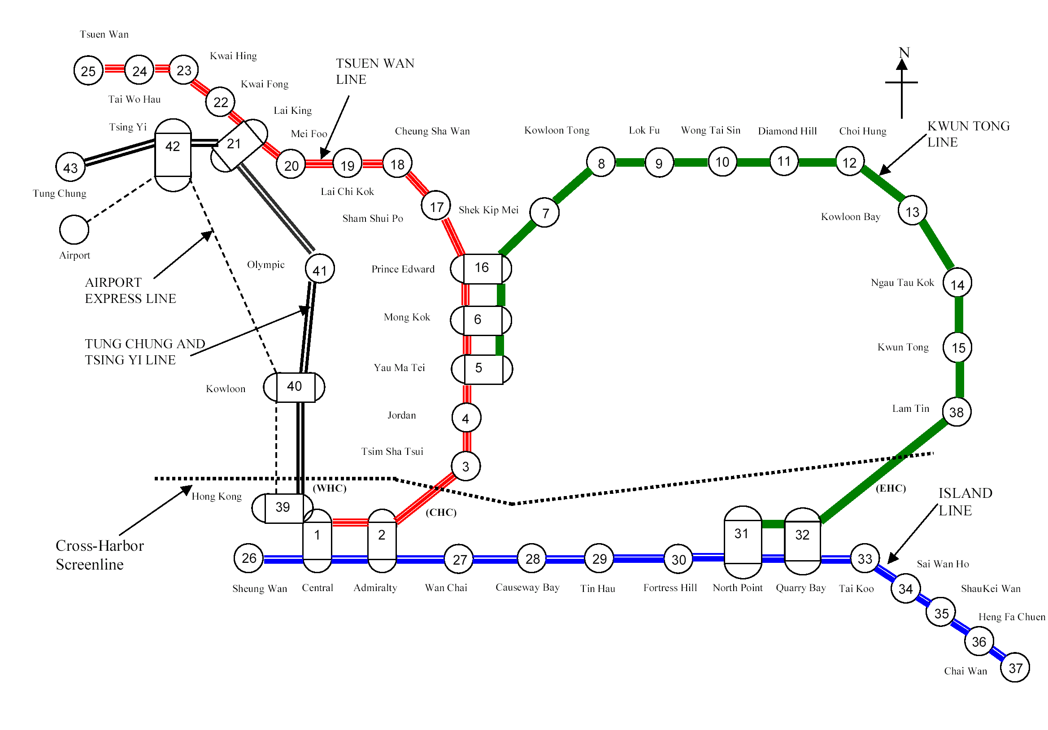
Figure 1. The MTR network operating in April 2002

1
2
3
4
5
6

Figure2. A transit line with 4 platforms and 3 transit line segments providing 6 boardings/alightings counts

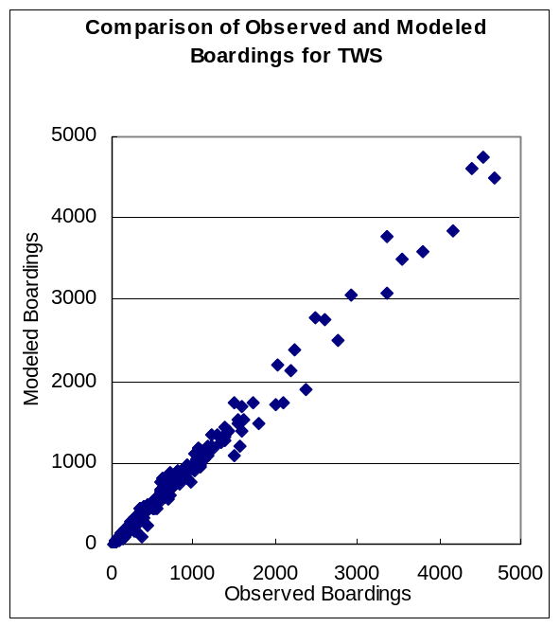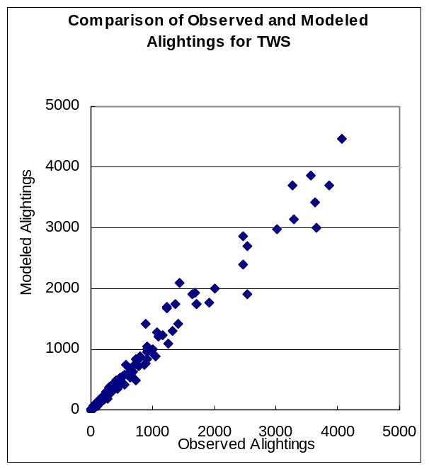
RMSE (Alightings) =171.30
RMSE (Boardings) =108.07
Figure 3. Comparison of observed and modeled boardings and alightings for Tsuen Wan Line south direction
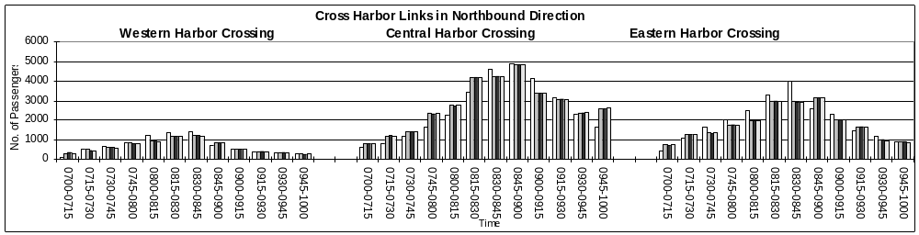
Figure 4a. Validation of cross-harbor link counts in northbound direction
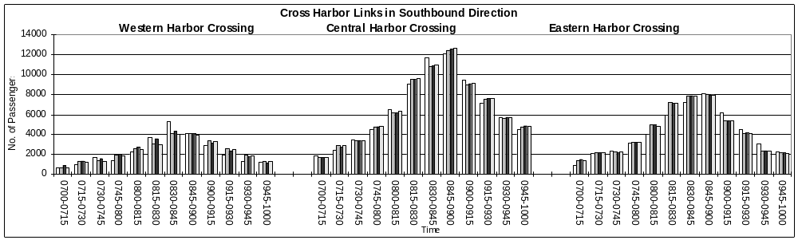
Figure 4b. Validation of cross-harbor link counts in southbound direction
Observed Modeled (Single Period) Modeled (Multi Period) Modeled (Single Class)

