The Impacts of Rainy Weather on Travel Time Variability of Freeway Corridors under Different Traffic Flow Levels

Huizhao Tu, MSc, PhD candidate (corresponding author)
H.Tu@tudelft.nl
Tel. +31 15 2787690
Fax. +31 15 2783179
Transportation and Planning Department
Faculty of Civil Engineering and Geosciences
Delft University of Technology
Stevinweg 1, P.O.Box 5048,
2600 GA Delft, The Netherlands

Dr. Ir. J.W.C. van Lint
Transportation and Planning Department
Faculty of Civil Engineering and Geosciences
Delft University of Technology
H.vanLint@tudelft.nl

Prof. Dr. H.J.van Zuylen
Transportation and Planning Department
Faculty of Civil Engineering and Geosciences
Delft University of Technology
H.J.vanZuylen@tudelft.nl

Word Count
No. of words (main text): 4500
No. of tables: 3*250 =750
No. of figures: 4*250 =1000
Total: 6250

Submitted for the 11th World Conference on Transport Research Society, 24-28 June 2007, Berkeley, USA

Abstract
Travel time variability (unreliability) is determined by the variations both in demand and capacity. One group of factors affecting travel time variability is adverse weather, such as rainy weather. During rain, drivers need to adapt their driving behavior to the prevailing conditions by reducing speeds and increasing the gap distance between vehicles. It is expected that rainy weather conditions also influence travel time variability on freeways. Empirical investigation on the basis of a large database of travel times on various freeways and one year of weather data shows rainy weather conditions, on average, result in around 50% higher travel time variability compared with that under normal weather conditions. It is found that rainy weather conditions have little or no effect on travel time variability below a certain critical transition inflow λ₁, but progressively impacts travel time variability above λ₁. It is also found that rainy weather conditions result in lower critical transition inflows compared with that under normal weather conditions. This might imply that different traffic control strategies and applications should be considered under rainy weather conditions.
Keywords: Travel time variability; Rain; Freeway corridors; Traffic flow; Critical transition inflow; Critical capacity inflow

INTRODUCTION
Travel time reliability has become an important aspect of transportation system performance in several countries over the last two decades. In a recent announcement the Beijing Municipality claims that travel time between hotels and major sports locations of the Beijing Olympic Game 2008 should be within 30 minutes (Beijing Municipality, 2005). Another example is the “Nota Mobility”, a policy document that the Dutch government presented to the parliament in 2005 which outlines targets for the transport policy in the period 2005-2020. Its subtitle “Towards a Reliable and Predictable Accessibility” illustrates the new emphasis that is placed on the concept of travel time reliability (VW, 2005). In this document, some quantitative targets are given, for example that trips longer than 50 km over freeways 95% of the trips should be realized within a 20% margin of median travel time. For shorter trips the target is that 95% of the trips will be realized between the median travel time plus or minus 10 minutes. Clearly, the goals of both the Beijing case and the Dutch case are ambitious, given the current high levels of congestion in both regions and the expected traffic growth.
The travel time reliability of a trip depends on the travel time variability as well as the predictability of the travel time. A trip that shows little variation in travel times is quite reliable. A large variability in travel times is not necessarily a problem, as long as the actual travel time can be well predicted. The reliability is poor when the variability is large and the predictability is small. This results in a major problem in assessing travel time reliability: what is predictable? It is a common concept that travel times are longer on a Monday morning at 8:00AM in comparison to the next morning at 11:00AM. However, the extend of the difference will only be known to those making the trip regularly at different times. Traffic gridlocks due to road accidents will be surprise for all travelers, yet local jams due to events that attract a lot of visitors or road works will be known to some but not to all travelers. In short, travel time reliability implies a degree of predictability but not necessarily complete invariance. Here we ignore the predictability aspect of reliability and suggest that unreliability is directly related to variability. While the definition of travel time reliability is a ongoing issue, we will use the terms travel time variability instead of travel time unreliability (the more travel varies, the less reliable travel times are considered) wherever possible in the reminder of this paper.
Knowledge about which factors affect travel time variability and what their influences are can help improve the travel time reliability. However, unraveling the impact of factors influencing travel time variability is a complex theme. Looking at the causes of travel time (un)reliability (Taylor, 1999, Tu et al., 2006), a rough distinction can be made into two categories: factors causing demand variation and factors causing supply (capacity) variation. Adverse weather, such as rainy weather, is one group of these factors. Prior researches into the effect of rainy weather (one of the adverse weather conditions) on traffic operation roughly address three issues, traffic demand, traffic safety, and capacity. For instance, (Liang et al., 1998) investigated the effects of visibility and other environmental factors on driver speed using multiple regression analysis. They concluded that rainy weather results in speed reduction, which is accompanied by a higher variation in speeds. However, these results pertain to the variance of local travel speed, not in variations in travel times (or journey speeds) of freeway corridors (or on the route level). A short overview of these issues can be found in (Tu et al., 2007a, Maze et al., 2006).
Recently, (Tu et al., 2007a) empirically investigated the impacts of five adverse weather conditions (i.e. rain, ice, storm, fog, and snow) on travel time variability of freeway corridors on the basis of one year of weather data and traffic data. They found that rainy weather conditions on average result in 50% higher travel time variability compared with normal weather conditions. Travel time variability, however, is determined by the variations both in demand and capacity. Weather is likely to play a role in both categories of factors. For example, (Tu et al., 2007a, Maze et al., 2006) noted that depending on the type of traffic (commuter, commercial, long-distance travel, etc.) and the severity of weather, roadway traffic volumes have shown to be less than 5 percent lower during rain conditions and heavy rain (more than 6.4 mm/h) reduce freeway capacity by an average of 14 percent. Therefore, there is a need to deepen the study on the impact of both rainy weather and traffic flow on travel time variability of freeway corridors rather than only focus on the impact of rainy weather.
The following section discusses the way in which travel time variability of a freeway corridor can be explored under both rainy weather conditions and traffic flow, which is followed by a section that illustrates the experimental setup. Then, the next section presents the results and gives a discussion. The last section summarizes the most important conclusions and defines future research.

METHODOLOGY

Travel time variability notions
There are a variety of measures to describe travel time variability. A comprehensive overview can be found in (Lomax et al., 2003), which generally divides the measures into five types, statistical range methods, buffer time methods, tardy-trip measures, probabilistic measures, and skew-width measures. In this paper a statistical range method is used as a measure of travel time variability, more specifically, the difference between the 90th and 10th percentile travel time, as shown in Eq. . The rationale behind it is twofold. Firstly, the more travel time varies, the less reliable it may be considered. Secondly, percentile travel time is a better performance indicator in terms of travel time reliability than standard deviation or variance does (Chen et al., 2003).
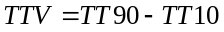
where,
TTV: travel time variability (seconds/km)
TT90: 90th percentile travel time per unit road length (seconds/km)
TT10: 10th percentile travel time per unit road length (seconds/km)

Inflow-percentile travel time functions
The relationship between inflow levels and travel time variability is analyzed by prior research (Tu et al., 2007b, Tu et al., 2006). In these papers the beginning of freeway corridors are chosen far way (at least 1.5 kilometers) from the potential bottleneck (e.g. on-ramp area, lane discontinuous, etc.) to avoid the effect of the spillback queue on the start cross-sections. Thus, the inflow exclusively denotes vehicles entering the studied freeway corridor. Flows on off and on ramps are not included as explanatory variables because these data were not sufficiently available. On a basis of large empirical dataset, they found that travel time variability is determined by two critical inflows (critical transition inflow λ₁ and critical capacity inflow λ₂) and concluded that capacity variations have more impacts on travel time variability than the variations of traffic flow do. The quantitative results in (Tu et al., 2007b) are obtained by fitting a modified BPR (Bureau of Public Roads) function, in which there are two critical inflows lower than capacity. The proposed inflow-travel time continuous function is as follows:
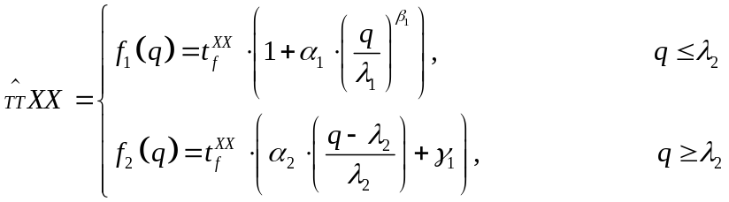
subject to,
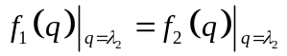
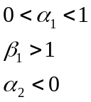
and by Eq. ,
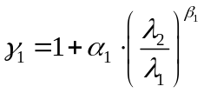
in which 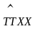, XX is the 10th, 50th or 90th percentile of travel time, λ₁ is the critical transition inflow, λ₂ is the critical capacity inflow, and α_{i} and β_{i} are parameters governing the shape of the relationship, which (like λ₁ and λ₂ ) need to be estimated from data. Note that our primary interest is not to derive an alternative BPR function (although this is a useful side effect), but to gain more insights into the inflow – travel time variability relationship, and particularly whether these critical inflow levels explain its behaviour. All parameters can be determined by fitting the estimated travel time to the observed travel time TT by minimizing the squared errors, as shown in Eq.. The Least Square Error Method, minimize the error between estimated travel times and empirical travel times, is used to estimate the parameters.
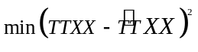

Hypothesis about travel time variability
Rainy weather reduces the friction on the road surface and hence longer braking distance. Furthermore, visibility diminishes because of the reflection on wet surface (Eisenberg, 2004). The rainy weather conditions therefore result in lower capacity and speed reduction compare with that under normal weather conditions. Furthermore, rainy weather conditions lead to higher accident risk (Zhang and Rakha, 2005) and hence reduce the capacity. In this context, traffic phase transition (from free-flow to congested flow) may more easily occur under rainy weather conditions than normal weather conditions. Figure 1 shows the congested probability function as a function of inflow on the A12 freeway of the whole year of 2004. Here the congested probability is the number of traffic states which are in congested traffic situation over the total number of traffic for a specific inflow level and traffic flows below 70km/h are defined as congested traffic flow. As can be seen in Figure 1, the congested probability under rainy weather conditions is higher than that under normal weather conditions. Thus, rainy weather conditions induce more traffic breakdown. Consequently, in this paper, below hypothesis will be investigated on a basis of a large of empirical dataset from inductive loop detectors:
- Since rainy weather conditions induce more traffic breakdown, the travel times under rainy weather conditions become more unstable compared with under normal weather conditions and hence resulting in the lower value of both critical transition inflow λ₁ and critical capacity inflow λ₂

Experimental Setup
Data Collection
In order to investigate the impact of rainy weather conditions on travel time reliability of freeway corridors, detailed traffic and weather data were collected. The traffic data are obtained from Regiolab-Delft (Van Zuylen and Muller, 2002, Muller et al., 2005), in which detailed real-time traffic data are collected from a network of freeways, provincial roads and an urban network in the South-west of the Netherlands, as shown in Figure 2. The weather data are collected from weather stations of the Dutch Meteorological Institute KNMI.
The traffic monitoring system of the study area in Regiolab-Delft is installed with dual loop detectors situated every 400-500 meters along the freeway that collect traffic data (volume and speed) aggregated for every 1-minute time interval. The raw data used in this study consists of 10-minute aggregate speed and flow observations, measured between 6:00AM and 20:00PM in the whole year of 2004.
Rainy weather conditions are investigated due to the fact that the data under the other adverse weather conditions are not sufficiently available for analysis. Note that only the presence of the rainy weather is studied in this paper. That is, rainy weather conditions indicate that rain is occurring, but the severity of rain has not been reported. Of course, information concerning extra variables, like the quantity or duration of snowfall would have been desirable. Since the measurements took places each hour during one year, each station disposes of 8760 observations per variable. The weather data used in this study consists of the whole year of 2004 measurements.

Extraction of Travel Time on freeway routes
Six routes (freeway corridors) are selected from Regiolab-Delft, as shown in Table 1. The routes are on average (approximately) 13.5 km long, ranging from 9.7 km to 17.3 km. As the Regiolab-Delft does not directly measure travel time data on the freeway routes, travel times were estimated with the ‘Piecewise Linear Speed Based’ (PLSB) trajectory algorithm (Van Lint and Van der Zijpp, 2003) for every departure time period of 10 minutes. This PLSB method reconstructs vehicle trajectories and hence mean travel times based on time series of speed and volume measurements on consecutive detector locations along a route. The characteristics of the PLSB method is the fact that trajectories are constructed based on the assumption of piecewise linear (and continuous at section boundaries) vehicle speeds rather than piecewise constant (and discontinuous at section boundaries) speeds. During each such departure period a record is stored with the mean travel time per unit length for vehicles departing in this period and inflow in vehicles per hour per lane during that period. Given dense enough detector spacing – about 2 dual loop detectors per kilometer – the resulting travel time estimates compared with the travel times data from floating cars are almost unbiased and the residual errors exhibit small variance (in the order of 5%). The travel time used in this paper is concerned with the route-level dynamic estimated mean travel time on 10-minute aggregate.

Integration of Weather and Traffic Data
Prior research (Smith and Ulmer, 2003) concluded that time intervals between 10 and 15 minutes are appropriate to compute flow rates for an hour. This research assumed a 10-minute time interval for weather and traffic data. Thus, weather data from Rotterdam weather station and traffic data were combined using constraints of date, hour, and 10-minute intervals since the studied freeways are close to the Rotterdam weather station.

Statistical significance
Finally, all results will be tested for their statistical significance by means of Z-statistic.
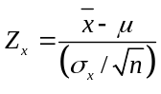
where,
: mean value of travel times under rainy weather conditions
μ: mean value of travel times under normal weather conditions
σ_{x}: standard deviation of travel times under rainy weather conditions
: the number of samples of travel times under rainy weather conditions

RESULTS AND DISCUSSION
After the data was collected and processed, a total of 11380 10-minute travel time/weather records were available for each of the six routes. The results of this research are presented in rainy weather conditions. The rainy weather conditions were compared against normal weather conditions, which are defined as no rain, no snow, no ice, no fog and no storm. The database contained 5055 records under normal weather conditions and 6375 records under rain conditions.

Rain impact under whole inflow range
The traffic data were divided into two categories (0, under normal weather conditions, and 1, under rainy weather conditions) for the analysis of the impacts of rainy weather conditions on travel time variability.
Table 2 and Figure 3 show that the differences in TT10th and TT50th (median travel time) between normal weather and rain conditions are not large, only increasing less than 1% and 3%, respectively. However, it can also be seen that under rain conditions TT90th increases by 10%-23%, whereas TTV increases by 49%-88%. In this case, Z score is -3 if the significance level is 1.35‰ in the Z-statistic. The results are statistically significant (Z-statistic of -110, -129, -98, -85, -151, and -137 for all six routes).

Rain impact under different inflow levels
The empirical data on the route level shows there are two critical inflows in the inflow-TTV relationship, in line with the findings in a prior study (Tu et al., 2007b). When inflow is below the critical transition inflow (CTFλ₁), the sensitivity of TTV for variations in inflow is small. In the case that inflow is above critical capacity inflow (CCFλ₂), both the sensitivity of variations of inflow and variations of capacity on the TTV have significant influence. In case inflow is between CTFλ₁ and CCFλ₂, the sensitivity of variations of inflow on the TTV becomes significant. Figure 4 illustrates the TTV as a function of inflow levels under both normal weather and rain conditions for six routes. As can be seen in Figure 4 there are some interesting findings related to the inflow-TTV relationship.

- Under both normal weather and rainy weather conditions, the critical inflows CTFλ₁ and CCFλ₂ for 90th percentile travel time can be identified. Table 3 shows the estimated critical inflows parameters for TT90th;
- Both the CTFλ₁ and CCFλ₂ values under rainy weather conditions are lower than or the same as that under normal weather conditions;
- In case inflow is below CTF λ₁ under both rainy weather and normal weather conditions, TTV does not vary with the varied inflow. The rainy weather does not increase TTV compared with that under normal weather conditions;
- In case inflow is above CTFλ₁, TTV under both rainy weather and normal weather conditions sharply increase. TTV under rainy weather conditions is greater than that under normal weather conditions.

On average, Table 2 shows that rainy weather has a slight influence on TT10th and TT50th increasing by 1% and 2%, respectively; while the rainy weather has significant impacts on TT90th and TTV increasing up to 23% and 88% the ones for normal weather conditions, respectively. Statistically analysis shows that rain (Z-statistics of -118) statistically significant has effect on TTV. In conclusion, rainy weather conditions indeed have negative impacts on TTV of freeway corridors based on the empirical data analysis.

Discussion
Since the travel time in this paper is the 10-minute aggregate mean travel time, we do not address the heterogeneity of driver behaviors. Note that the numbers of ramps (on-ramp, off-ramp, and weaving section (weaving section: two ramps – one on-ramp and one off-ramp) per ten kilometers on the routes are ranging from 4.1 to 8.5. The ramps are the potential bottlenecks in the routes. In this sense, travelers under both normal weather conditions and rainy weather conditions experienced unexpected delays due to recurrent and non-recurrent congestions in the bottlenecks.
In case of low flow (below CTF λ₁) and rain conditions, drivers still have enough space and time to regain acceptable traffic situation (e.g. fluent traffic) after a disturbance of the flow and the effect of the rain weather conditions, hence TTV is still low. However, rainy weather conditions results in lower CTFλ₁. That is, the traffic under rainy weather conditions becomes unstable even in a lower traffic demand (inflow) than that under normal weather conditions.
Situations with high inflow and rainy weather conditions lead to a wider travel time distribution. This might indicate that rain results not only in a reduction of capacity, but also leads to higher capacity variations for a given inflow level above the critical inflow. Based on the preliminary results, some traffic controls, advisory and road treatment strategies may be used to reduce the travel time variability of freeway corridors if the data of inflow and rainy weather conditions are available for given freeway corridors.

CONCLUSIONS AND FUTURE WORK
This paper has presented an empirical investigation of the impacts of rainy weather conditions on travel time variability of freeway corridors. The main hypothesis we tested was that rainy weather leads to higher travel time variability at lower inflow (demand) levels.
An empirical study, based on six freeway corridors, one year of traffic data and weather data, illustrates below interesting findings:

- Rainy weather conditions clearly have negative effects on the travel time variability of freeway corridors. Travel times are less reliable under rainy weather conditions than that under normal weather conditions;
- Statistical analysis shows that rain has significant effect on travel time variability.
- Rain weather conditions have little or no effect on travel time variability below critical transition inflow λ₁. But have positive impact on travel time variability above λ₁.
- Both the CTFλ₁ and CCFλ₂ under rainy weather conditions are lower than or the same as under normal weather conditions. That is, rainy weather conditions make the travel time less reliable than under normal weather conditions, especially at higher inflow levels.
- Besides an overall increase in travel time variability indeed also critical inflows decrease under rainy weather conditions, with – in this case – around 10% for CTFλ₁ and 5% for CCFλ₂.

With respect to the implications of the study for practice, this might imply that different traffic control strategies and applications should be considered under different weather conditions. For instance, the control parameters of ramp metering and advisory speeds should be adapted to the rainy weather conditions.
In this paper, only the presence of rainy weather conditions on travel time variability is investigated. The intensities of rain, for example, may have impacts on travel time variability. Moreover, this paper covers just two of the many potential causes for travel time unreliability. The combination of inflow, weather and other factors such as road geometry, road works, dynamic traffic control, traffic accidents, etcetera, will be subjects for further research.

ACKNOWLEDGEMENT
This study is supported by the Transport Research Centre Delft and the TRANSUMO/ATMO (www.atmo.tudelft.nl) research program in the Netherlands. The contents of this paper reflect the views of the authors who are responsible for the facts and the accuracy of the data presented herein. The authors thank AVV, the Transport Research Centre of Dutch Ministry of Transport, Public Works and Water management for providing the traffic and weather data.

REFERENCES

Figures and Tables

Table 1 Description of freeway routes
Code | Freeway | N.of ramps* per ten kilometers | Route length (m) | Route mark
1201 | A12 | 4.1 | 17280 | (8980**-26260)
2001 | A20 | 6.7 | 10500 | (37805- 48305)
1211 | A12 | 7.1 | 15520 | (25395- 9875)
2011 | A20 | 7.0 | 17215 | (48195- 30980)
1301 | A13 | 8.5 | 10590 | ( 5910 - 16500)
1501 | A15 | 7.2 | 9725 | (50335- 60060)
*: ramps include on-ramp, off-ramp and weaving sections. One weaving section is two ramps (one on-ramp and one off-ramp)
**: Loop detectors location

Table 2 Travel time variability due to rainy weather on seven routes

Travel time (seconds/km) |  | route1201 | route1211 | route1301 | route1501 | route2001 | route2011 | average
TT10th** | normal | 31.3 | 31.3 | 32.8 | 32.4 | 30.9 | 31.4 | 31.7
TT10th** | rain | 31.6 | 31.7 | 33.0 | 32.4 | 31.0 | 31.9 | 31.9
TT10th** |  | 1% | 1% | 0% | 0% | 0% | 1% | 1%
TT50th | normal | 33.1 | 33.5 | 35.0 | 34.8 | 32.8 | 33.6 | 33.8
TT50th | rain | 33.7 | 34.5 | 35.6 | 35.3 | 33.5 | 34.4 | 34.5
TT50th |  | 2% | 3% | 2% | 1% | 2% | 2% | 2%
TT90th | normal | 38.2 | 41.8 | 60.4 | 39.7 | 40.0 | 46.3 | 44.4
TT90th | rain | 44.5 | 47.7 | 74.1 | 43.6 | 44.9 | 54.0 | 51.5
TT90th |  | 17% | 14% | 23% | 10% | 12% | 17% | 15%
TTV*** | normal | 6.9 | 10.4 | 27.6 | 7.3 | 9.2 | 14.9 | 12.7
TTV*** | rain | 13.0 | 15.9 | 41.1 | 11.2 | 13.9 | 22.2 | 19.6
TTV*** |  | 88% | 53% | 49% | 53% | 52% | 49% | 57%
Z-statistic |  | -110 | -129 | -98 | -85 | -151 | -137 | -118

* : This value is defined as the ratio of the difference between percentile travel time or travel time variability (TTV) under adverse weather and under normal conditions over normal weather conditions.
** : TTXX, percentile travel time (i.e. 10th, 50th (median) and 90th percentile travel time)
*** : TTV, travel time variability

Table 3 Estimated critical inflow parameters for TT90
λ* value  (veh/h/ln) |  | Route1201 | Route2001 | Route2011 | Route1211 | route1501 | Route1301
λ₁ | Rain | 1320 | 1260 | 960 | 960 | 780 | 780
λ₁ | Normal | 1380 | 1260 | 1080 | 960 | 960 | 1020
λ₂ | Rain | 1680 | 1440 | 1380 | 1320 | 1320 | 1260
λ₂ | Normal | 1800 | 1500 | 1500 | 1320 | 1320 | 1320

* : λ₁ denotes critical transition inflow while λ₂ denotes critical capacity inflow;

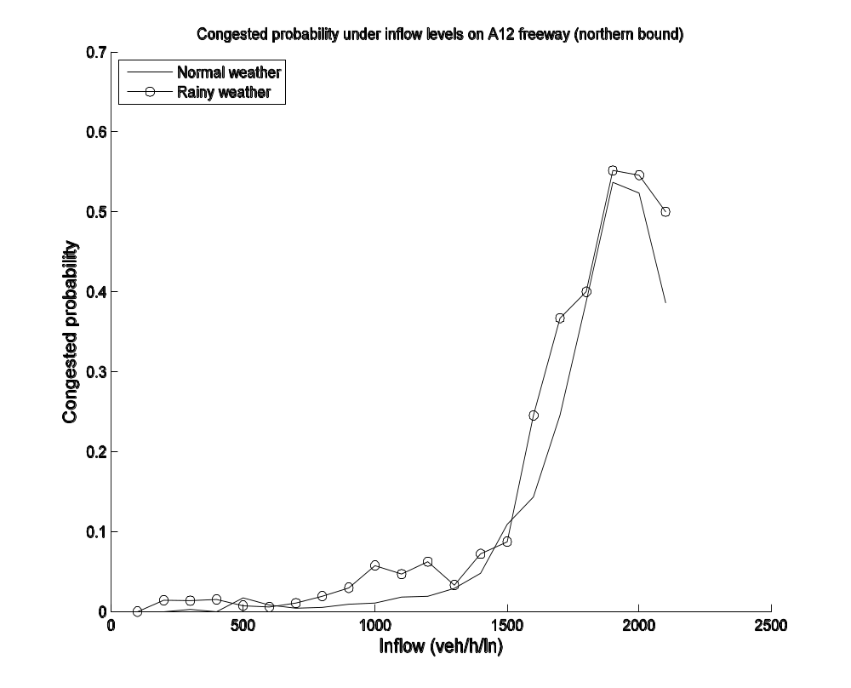
Figure 1 Congested probability (the number of traffic state which is under congested situation, travel speed below 70km/h, over the total number of traffic for a specific inflow level) as a function of inflow on A12 freeway northern bound in the year of 2004. The traffic data are collected from inductive loop detectors in the Regiolab-Delft traffic monitoring system (Van Zuylen and Muller, 2002, Muller et al., 2005) on 10-minute aggregate.

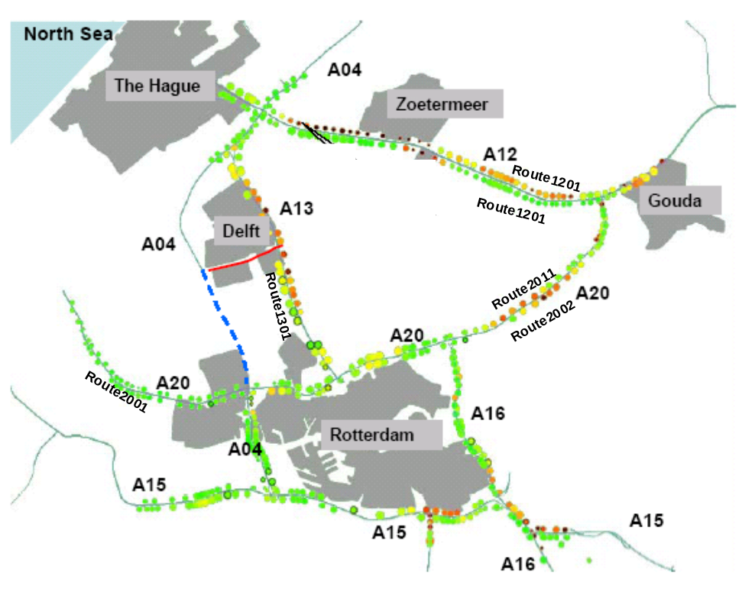
Figure 2 Regiolab-Delft Traffic Monitoring System

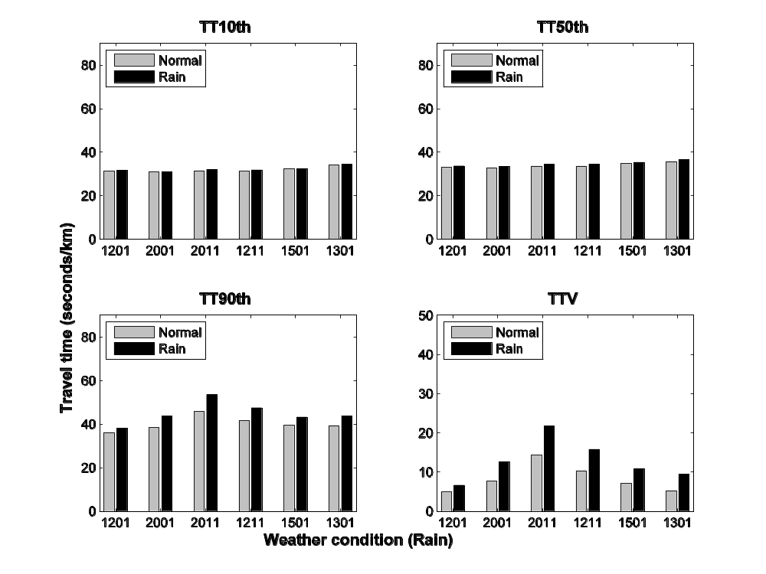
Figure 3 Percentile travel time and travel time variability under both normal weather and rainy weather conditions

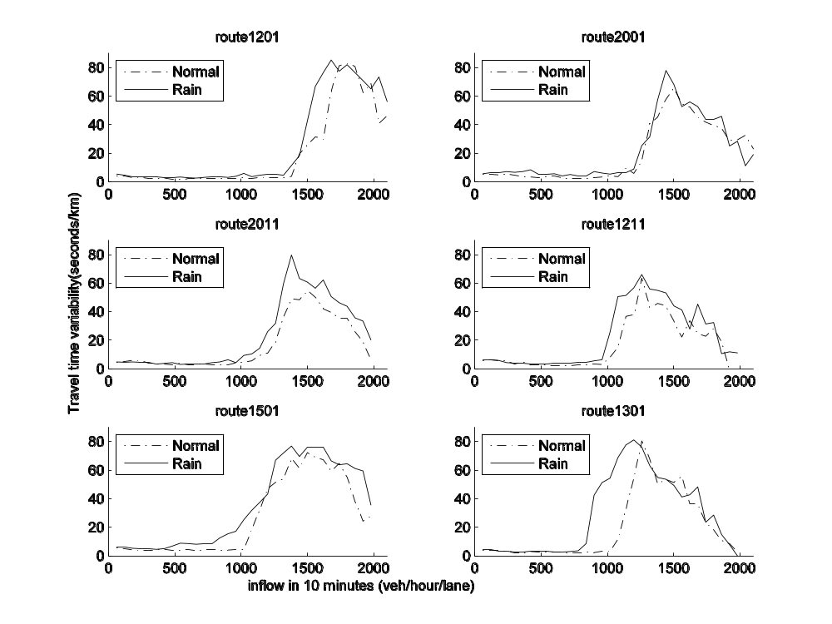
Figure 4 Travel time variability (TT90th minus TT10th) as a function of inflow level under both normal weather and rainy weather conditions. Inflow levels are discrete increasing binned in multiples of 60 veh/hour/lane.

