URBAN MOBILITY MANAGEMENT: WHAT ABOUT DISTRIBUTION OF URBAN GOODS?

Rosário Macário

Asisstant Professor

CESUR, Instituto Superior Técnico, Lisbon Technical University

Consultant

TIS.PT, Consultores em Transportes, Inovação e Sistemas, s.a.

Luis N Filipe
Engineer, MSc. Student and grantholder
CESUR, Instituto Superior Técnico, Lisbon Technical University

Paulo Martins
Engineer
ISEL, Instituto Superior de Engenharia de Lisboa

Vasco Reis
Engineer, PhD. Student and grantholder
CESUR, Instituto Superior Técnico, Lisbon Technical University
Urban Mobility Management: what about distribution of urban goods?

Rosário Macário ^{1, 3}
rosariomacario@civil.ist.utl.pt

Luis N Filipe ¹
Paulo Martins ²
Vasco Reis ¹

¹ CESUR, Instituto Superior Técnico, Lisbon Technical University
² ISEL, Instituto Superior de Engenharia de Lisboa
³ TIS.PT, Consultores em Transportes, Inovação e Sistemas, s.a.

Introduction

This paper reports the preliminary results of an on-going project funded by the Portuguese National Science Foundation at the IST – Lisbon Technical University, designated LOGURB – Optimization of Logistic Systems for Goods Distribution in Urban Settlements, and aims to serve as a discussion draft for the concepts proposed herewith that will be duly tested in the framework of the research project. The final results of this research will be presented at a later stage.
The work being done analyses the impacts Urban Logistics have in other urban uses, and proposes a model of distribution model based on the introduction of a set of new solutions for urban goods distribution. For this, the project will define “Logistic Profiles”, which are the logistic characteristics of homogenised groups, defined by the features of territory, and by the specific needs of the goods and the agents. This concept will allow the definition of a conceptual organizational model, which quality will then be evaluated and validated. Based on these analyses, the work will produce guidelines for a master plan in Urban Logistics.
The practical approach of this work will be done based on the analysis of the Urban Logistic activity in a specific area inside the city of Lisbon (“Bairro de Alvalade”).

Background
In this work, we have adopted the Urban Logistics definition presented by the Urban Freight Logistics Working Group of OECD (OECD, 2003), according to which Urban Logistics is “the delivery of consumer goods (not only by retail, but also by other sectors such as manufacturing) in city and suburban areas, including the reverse flow of used goods in terms of clean waste.”
From this definition, it is clear to see that Urban Logistics plays an important role when it comes to urban competitiveness, since it is strictly connected to the economic activities inside a city – we can easily understand that economic transactions are not possible without urban logistics.
However, the distribution of goods within urban settlements has been placing ever increasing constraints to other urban users. This results from a number of reasons, strictly related to the new trends in urban living, which demand ever faster and cheaper logistic solutions. In the European context, the main driving forces for this increase are (EC, 2002):
- High-profile consumer demands, which lead to flexibility in the production and distribution of goods (faster deliveries and smaller parcels);
- Internationalisation, which leads to the concentration of production and distribution centres in small areas, making it necessary for the products to travel higher distances in order to reach their final destinations;
- Outsourcing of non-core activities, with companies subcontracting specialized partners for some (or all) logistic activities, increasing the efficiency and reducing the costs of distribution;
- Supply chain integration, mainly driven by retailers, who try to maximize their transport and warehousing capacities.
- Information technology advancement, which reinforce the collaboration between agents of the distribution chain, accounting for the appearance of innovative services
The most significant constraints caused by urban logistics are the pollution associated with the transportation, the use of infrastructures built for other needs (roads, parking lots), and the congestion sometimes caused by the space occupied by loading and unloading activities. These constraints place at risk the three pillars of urban sustainability – environmental, economic and social sustainability.
Despite the importance and increasing intensity of these problems in large and medium size cities, local authorities have always denied urban logistics the attention it needs, leaving it to second plan in what urban and transport planning is concerned. This negligence has a twofold justification: lack of knowledge on the appropriate instruments to solve the problems; and, awareness of the difficulty to achieve stakeholders acceptability to any type of solution that limits their freedom for unlimited use of urban space.
Notwithstanding the problems it causes, urban logistics activities are also victims of a series of problems which affect the other “urban users”, namely the congestion on city centres caused by heavy traffic and the lack of urban space for the deployment of its activities.

State of the Art – implemented solutions and modelling in Urban Logistics
Within the complex and problematic background presented above, it is important that some actions are taken, in order to reduce the impacts of the distribution of goods inside cities, yet keeping it in pace with the city needs. In other words, this means rationalizing the distribution process (from the economic, spatial and temporal perspectives), reducing the flow of goods yet keeping the adequate level of distribution to satisfy consumer’s needs.
As a way to achieve this, various solutions have been pointed out in several European cities. These solutions are not only aimed at the transport activity, but to the organization of the whole logistic chain. On some cases, the implemented solutions were adopted as “stand alone” solutions, focused on a specific case or problem; on some other examples, combined solutions were applied, i.e., several measures were implemented in a combined form, as part of a broad political strategy for urban logistics.

Generally, the different authors try to group the adopted solutions in accordance to different criteria (Muñuzuri et. al, 2005; Melo, S., 2003; EC et al, 2002). In the scope of this work, the measures identified on the literature review were grouped according to the focus of their application. This systematization can be found in Table 1, where they were placed according to the degree of intervention needed for their implementation (from "soft" to “hard” measures):

Table 1 – Measures implemented to solve the urban logistics problems
Type of Measure | Examples
Legislative and organizational measures | Cooperative logistic systems, encouraging night deliveries, public-private partnerships, intermediate delivery depots.
Access restriction measures | Access restrictions according to vehicle characteristics (weight or volume), conditioning access to pedestrian areas, urban tolls, periodic restrictions.
Territorial management measures | Creation of loading and unloading areas, of load transfers, and mini logistic platforms.
Technological measures | GPS, track and tracing systems, route planning software, intelligent transport systems, adoption of non polluting vehicles and vehicles adapted to urban characteristics (size and propulsion).
Infrastructural measures | Construction of urban distribution centres, and peripheral storing facilities, use of urban rail for freight (freight trams), underground freight solutions.

Some of the measures identified are very ambitious, but others lack the needed coherence and fail to achieve the goals for which they were designed. This happens for a number of reasons, like the relative novelty of the introduction of this subject on the urban management agenda, and also the lack of knowledge about the implementation processes involved in urban logistics and hence on the appropriate way to tackle the collateral problems accruing from these processes. Another very important matter relates with the difficulties associated to modelling of urban logistics, given its fragmented character largely caused by the fact that a significant amount of transport is done on private basis. It is worth noting that in all experiences reported the main difficulty in handling urban logistics lies in understanding the associated origin-destination matrix.

Good planning solutions need good planning tools, i.e. modelling tools capable of “predicting” the evolution of future needs and guide intervention to implement enhancing solutions. However, the state of development in modelling of urban logistics, is currently rather poor, particularly when compared to the modelling of urban passenger transport, or even with the freight transport at the interurban level (i.e., regional, national or international levels).

Several aspects may be pointed out as a cause of this “modelling failure”, namely the recent nature of the problems associated to the urban logistic activities, the inherent complexity to the urban logistic processes, the unfamiliarity of the decision making process of the involved agents, the inexistence of base theory, and also the inexistence of complete and liable statistical data.

The models developed so far can be grouped into different categories (Russo, F. and Comi, A., 2004): gravitational models, similar to the ones used in the passenger transport, input-ouput models, and models of spatial price balance. The simulation models of transport demand can also be classified in function of the unit of analysis - disaggregated models (focused on the individual actions of each logistic agent) and aggregated models (focused on a group of agents or population).

The development of simulation models allowed, in turn, the development of tools to support the decision process in the logistic activity. The most applied of these tools are:

- FRETURB, developed for the LET (Laboratoire d'Economie des Transports) of Lyon (France), and conceived to analyze and to evaluate scenarios. It calculates the number of vehicles attracted by one given region, in function of its logistic needs, and also allows the computation of the road network and parking lots usage. This tool was applied, among others, to the city of Lyon (Ambrosini, C. et al, 2004).
- WIVER, developed for the IVU Traffic Technologies GAC and PTV GAC. It allows the calculation of the expected traffic (trips generated by different types of economic agents) in an urban area, based on behavioural data. It also allows the segmenting of the traffic generated by type of economic activity and by type of vehicle. It offers great flexibility in the zoning of the urban area, and its results can be differentiated by type of business, type of vehicle and period of the day. From its various practical applications, the ones to the cities of Berlin and Rome in the scope of the European project “REFORM” (European Commission, 1998) may be highlighted;
- VISEVA, developed for the Technische Universität Dresden and PTV GAC, over the previous (WIVER) tool, by adding to it the systems dynamics theory. Besides offering all the functionalities of WIVER, it also calculates the trips, in a disaggregated manner, for origin-destination pairs or alternatively for homogenous groups or even according to the behaviour of the agents. It considers the multiple traffic flows simultaneously and calculates the modal distribution. This tool was applied to several regions, e.g. Chemnitz, Stuttgard, and Freiburg (Lohse D. et al, 2004);
- NATRA, developed for the region of Stockholm (Sweden), based on an extensive survey to the urban logistics on the area;
- GOODTRIP, developed for the Technische Universiteit Delft; it calculates the product flows, the traffic generated by these flows, and the respective impacts. It allows the evaluation of the different phases and stages of the process of urban freight distribution, as well as the evaluation of different scenarios. As output, it gives the travel distance, the load factor in the different logistic chains, emitted gases and the energy consumed. It was applied to the city of Groningen (Boerkamps, J. and van Binsbergen) with the objective of analyzing the impacts of the different types of urban distribution systems.

Scope of this work
Departing from the state of the art review presented, and which was carried on the initial stages of the project, it is the goal of this work to find a better overall solution for the Urban Logistics, which shall consider all the agents involved and be made up of different measures. For this, a “3-step approach” methodology was outlined. This methodology is strongly based on empirical data, and therefore an area inside the city of Lisbon was identified according to its logistic needs and urban characteristics.

The first step of the methodology comprises the definition of “Logistic Profiles”, which will be explained in detail bellow. A survey of the logistic activities in the study area was performed, in order to define the Logistic Profiles of a set of the most representative commercial sectors (textiles, restaurants and small markets).

The second step encompasses the evaluation of logistic solutions based on different criteria in terms of their suitability for serving the Logistic Profiles. This will allow us to choose the best solution(s) for each Logistic Profile and locate them accordingly.

The third and final step consists in modelling the impacts that will occur if the proposed solution is implemented. This means estimating the aggregate costs and benefits of such implementation.

The methodology synthesized above will allow the definition of a conceptual organizational model, which quality will then be evaluated and validated. Based on these analyses, the work will produce guidelines for a master plan in Urban Logistics.

The “Logistic Profile” Concept

The first step to be accomplished during the present work is to test the validity of the "Logistic Profile" concept, which we intend will be an important tool for the Urban Logistic management and a key-element in the conception of an Urban Logistic Master Plan.

This concept is based on the hypothesis that it is possible to define, for some well-defined areas inside a city, more or less homogenous groups of logistic needs, based on three key points: the urban characteristics of the area, the necessities of the logistic agents, and the characteristics of the products they transact. The Logistic Profile of a given urban area is thus defined by the interaction of these three key aspects.

In the areas of the city in which it is possible to define a Logistic Profile, it will then be possible to adjust urban logistic services which will optimize the consumption of the involved public and private resources (space, vehicles, etc.), in function of the needs of the different market segments. As a point of departure, the following logistic services are considered:

- Creation of hierarchic freight terminals inside the urban territory, their location and size is to be planned in function of the different Logistic Profiles of the urban micro-zones. These terminals have their own micro distribution networks that can be composed of electric bicycles or similar services ;
- Collective and regular services often using the facilities offered by the regular public transport in its ours of no operation (e.g. light rail transit and underground);
- Services "on demand " (including services "on-call" and "charter" services);
- Self services (e.g. postal safe deposit boxes);
- Cooperative services like car pooling and car sharing

To each of these services a different business model is required but in most cases the possibility of being offered by private initiative seems to be possible, despite the very likely need of a leveraging process that may require public funds.

The outset of the urban logistic system consists in defining and determining the levels of service in the different terminals, as well as its main characteristics in terms of localization, operation and capacity. From the conceptual point of view, this system of logistic distribution is assumed to be a network of services and infrastructures, in which the nodes are the terminals (distribution centres) and the links are the transport services between them. The first and last level nodes are, respectively, the origin and the destination of the goods.

For the definition of the services and services’ combinations, it is necessary to consider the specificities of the freight transport inside the urban space, which are:
- Frequency of delivery;
- Load factor of the vehicles;
- Restrictions of hourly and weekly periods of delivery;
- Parking needs for loading and unloading of commodities.

These characteristics are largely determined by the specifications associated to each type of good and, consequently, to certain commercial activities. The good performance of the urban logistic system is as much dependent on the service as on the background network since it requires an adequate dimensioning of nodes and links, as a way of optimizing the displacements required to serve the different demand segments, allowing this way the reduction of mobility associated to the satisfaction of urban logistic needs.

The main characteristic of urban logistic system is its high number of stakeholders and the heterogeneity of their needs that forces a very thin segmentation of services often going below the minimum scale for economic feasibility. Consequently for an adequate balance the organization of the urban logistic system should meet the following requirements, which are partially conflicting, as drivers of this optimization process:
- To reduce the direct costs of the agents, both wholesale and retail commerce, as well as of the small industry, or at least do not aggravate their perceived costs (objective of the private agents);
- To reduce the traffic congestion, the environmental impacts and the security risks normally increased by the presence of freight vehicles in the urban road and street network (objectives of the public authorities);
- To increase the quality of urban life through a diversified offer of goods and services which minimize the time spent and global costs (private and public) in supplying families and businesses (objective of the citizens and the local societies).

It is worth stressing that the high costs imposed to a city by the process of urban distribution are identified already for some years. In 1998 the (EC, COST 321, 1998) reported that the freight distribution was responsible for 10 to 15% of the motorized movements inside urban areas, and for 40% of the energy consumption and vehicle emissions; this report also identified that, from all the movements of goods observed in some cities, from 25% to 60% of the movements were inner movements (with an origin and destination inside the city), and the entrance, exit or crossing movements would go from 15% to 30%.

Despite the desirable result being the reduction of the needed motorized movements, it is not only the network optimization that leads to the final solution for urban logistics. It is also necessary to articulate the following areas of intervention, to get consistent guidelines for the creation of an Urban Logistics Master Plan, at the same time allowing the aforementioned requirements:
- Legal and regulation framework for offered services;
- Regulation of motorized vehicles access and temporary urban space occupancy, for loading and unloading activities;
- Road infrastructures with appropriate loading/unloading bays for the activities served by those bays;
- Logistic infrastructures and information systems which support the goods distribution;
- Regulation of security requirements for the transport and handling of goods;
- Incorporation of the needs and specificities of urban logistics in the urban planning activity, joining the environmental and the urban planning sectors;
- Energy policies aimed at the optimization of the urban logistic system fostering the utilization of non-polluting modes in the inner city short-range distribution services that represent a significant part of the urban logistics movements

The setting for the envisaged model
The neighbourhood chosen as study area for this project is a multifunctional neighbourhood in the city of Lisbon, known as “Bairro de Alvalade”. This area, which planning started in the 1930’s, is one of the first and most interesting experiences concerning urban planning in the city of Lisbon.

Figure 1 shows the “Bairro de Alvalade” and its location within the city of Lisbon.

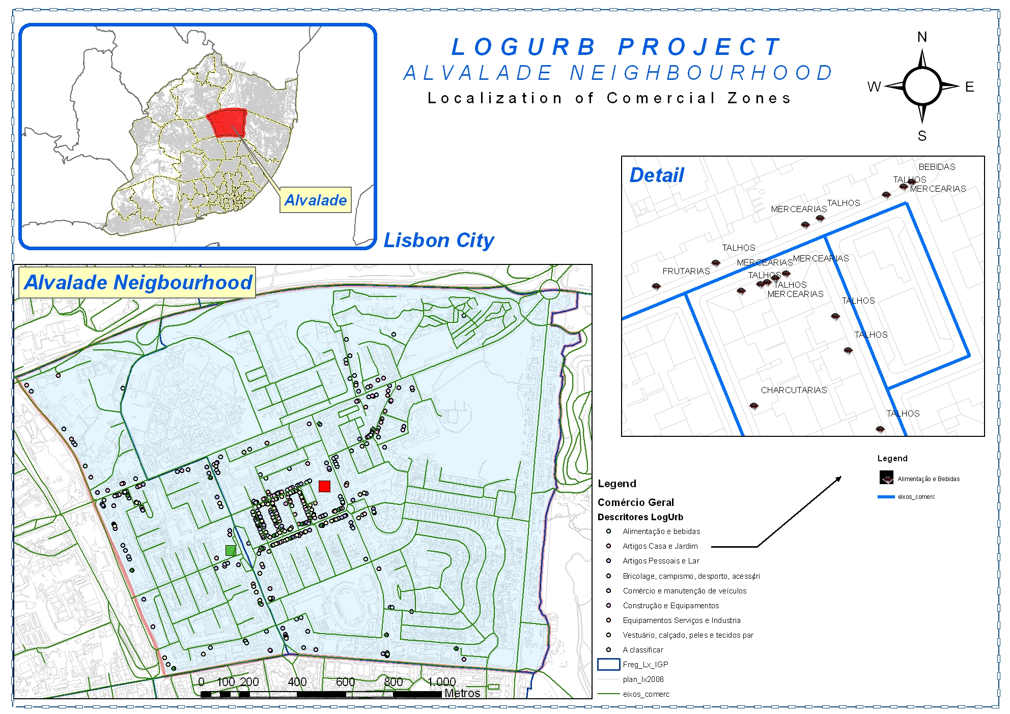
Figure 1: Location of the Study Area (Bairro de Alvalade)

“Bairro de Alvalade” is a central and consolidated residential area, which simultaneously offers many and diversified services. It has very intensive commercial streets, which mix traditional and modern shops, some warehouses and many restaurants and cafés. The clients of these facilities are not only the residents in the neighbourhood, but also the employees who work in the area.

The complexity and diversity found on the commercial tissue of “Bairro de Alvalade” lead us to think that it might be a very demanding area in logistic terms, and also that it must have a number of situations which might be representative of what happens in the whole city. On the other hand, being a planned neighbourhood, it hasn’t the urban complexity found on the older parts of the city (very narrow, steep and winding streets) which could represent additional complexity that is not representative of the whole city.

In order to briefly characterize the logistic activity on this neighbourhood, a direct observation survey was done on its main avenue (Avenida da Igreja), in which a majority of the shops is located. This was done by observing, for a whole week, the delivery of goods to three kinds of shops: home textiles, clothing and shoes shops, restaurants & cafes, and markets & small food shops. These clusters of activity were chose again due to its capacity to represent a large part of the logistic movements.

This data was then analysed concerning deliveries per day/time period, per type of product and per type of shop. The graphics on figures 2 to 5 show the main results of these analyses.

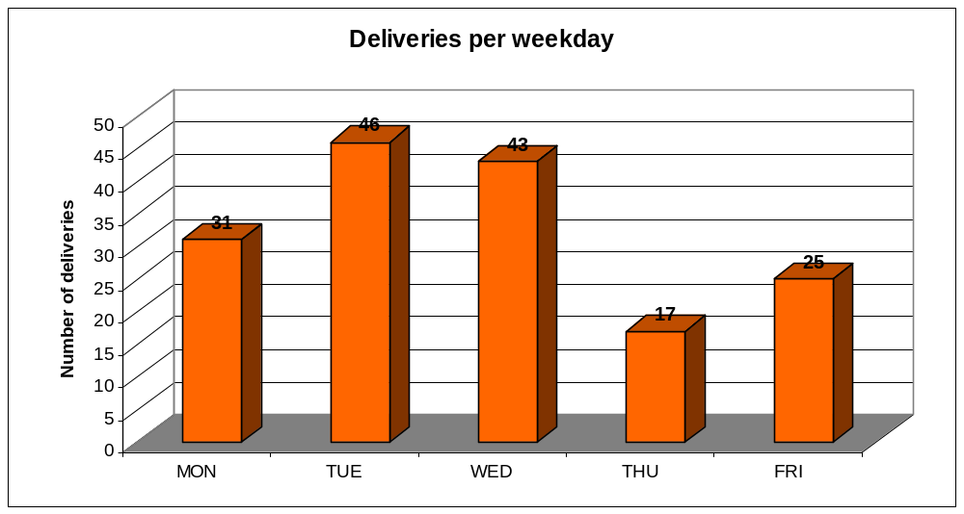
Figure 2: Deliveries per weekday

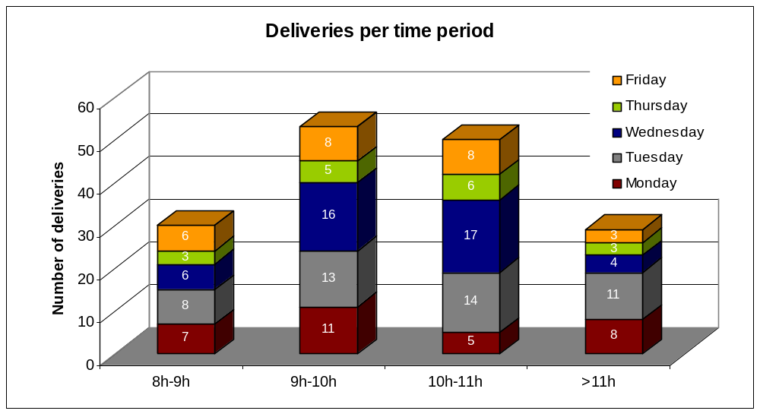
Figure 3: Deliveries per time period

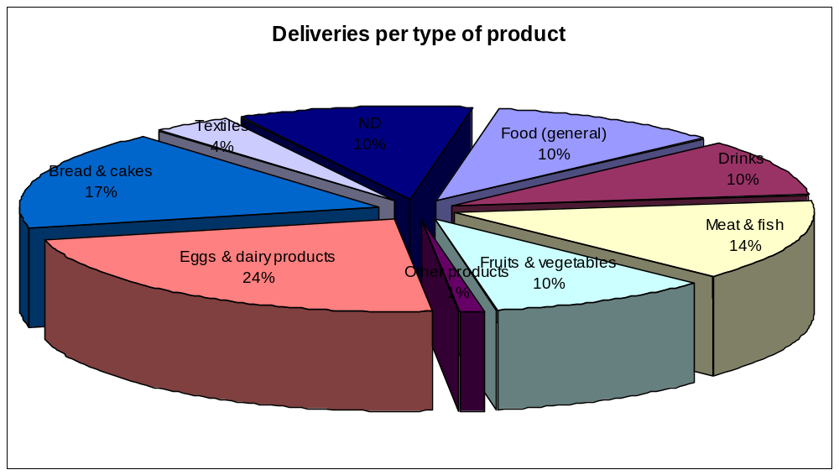
Figure 4: Deliveries per type of product

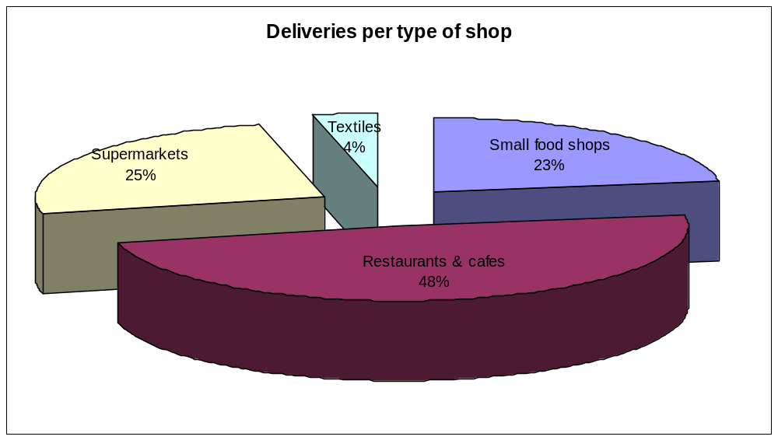
Figure 5: Deliveries per type of shop

One big problem in the whole city of Lisbon is the use of the traffic lanes for loading and unloading activities due to the lack of appropriate bays. This causes congestion, problems to other road users, as it obstructs the normal traffic flows, and even difficulties and risks in the loading and unloading tasks. Therefore, it was also analysed the duration and the place in which these tasks were undertaken. The results are shown on Table 1.
Table 1. Number of deliveries according to the parking of the vehicles
Place of parking during loading and unloading activities | Number | % | Average parking time (seconds)
Parking lot / appropriate delivery places | 50 | 31% | 15
Traffic lane | 112 | 69% | 12
Total | 162 | 100% | 13

The analysis clearly reveals that shops that deal with food, drinks or related products are highly demanding activities in terms of delivery, and seem to be the ones causing the most problems within urban logistics. However it was not possible to distinguish which of the following two factors justifies this position: the type of business, that is small shops and storing facilities, which implies a high rotation of stocks; to the specificities of the products, most of them are perishable products and cannot be stored for long periods. A more detailed survey is needed to understand the contribution of the different attributes of the business to the stress of the urban logistic function.

Concerning the loading and unloading activities, it was confirmed that these pose a major problem to the city traffic flows, since most of them are done using the traffic lanes.

The proposed management model consists in a network of urban terminals and complimentary services (which might be used or not with the terminals), each of them focused on a different Logistic Profile. The background rational is that each profile has a best matching service, which will be defined taking into account the profile needs and characteristics (in terms of delivery frequency needs, product specific needs, and so on). The different services will have to be implemented in an integrated way, since they are part of a package which shall not be deployed partially without the risk of loosing its effectiveness. The types of solutions being currently evaluated, which later will be the focus of a more detailed specification, are the following ones:
- Self-servicing deposit freight boxes;
- Electric motorbikes for delivery of small parcels
- Electric trolleys
- On call services
- Regular distribution vans from the terminal
- Car pooling
- Car sharing
- Public transport for freight delivery (tram and underground)

This approach will be tested on the study area, for which the location of an urban terminal will be devised and the implementation of the different services evaluated. This valuation will test the new situation against the present one, considering costs and benefits obtained confronting the business as usual scenario with the hypothetical scenario where these services are implemented.

After testing these solutions, it will be possible to enunciate guidelines to be adopted to the whole city, in the form of an Urban Logistics Plan, which should be used as a tool when planning new investments (or changes in the existing ones) that deal with freight delivery inside the city.. By adopting these guidelines incremental improvements are envisaged in the old area and a new approach based on this concepts can be though for the new areas.

Model test and validation
The goal of the modelling carried out on this project is to analyse and measure the potential efficiency gains obtained from implementing the different urban logistic solutions presented above. It is also an essay for the development of modelling procedures using a GIS tool – in this case, the ArcGIS 9.1 with Network Analyst software, from ESRI – which allows the combination of transport modelling and networking with the representation of the city organization.

The modelling work was done over a geographic information library consisting of:
- the main urban roads in the Metropolitan Area of Lisbon, and representing the network of the sub-urban area;
- the complete road and street network for the city, and
- a very detailed network for the study area, with all the details for streets and direction of traffic flows, traffic signs.
- Parking areas and access restrictions, pedestrian and bus networks, and commerce facilities were also modelled as part of the city model. The last elements were very useful to define conflict areas and pressure points in the urban tissue of Bairro de Alvalade.

Despite the object of analysis (Bairro de Alvalade) being just a neighbourhood, it was necessary to consider also, in the model, the interaction of its street network with its network of access (i.e. the roads which give access to its neighbouring areas). A road network efficiency ranking was done for the different solutions (or models), as well as other relational (non-physical) aspects integrated in the management of a logistic chain.

Since the work is being done on a very small scale, the inclusion of other elements of the supply chain (the actors) would be extremely interesting; however, this proved to be very difficult, as the resources used in the survey were limited. On the other hand, modelling the non-physical links and nodes of the logistical chain is very demanding, and therefore some simplifications were made, which however did not jeopardise the main results concerning the social e organizational gains.

In terms of road network efficiency, the results achieved so far are very encouraging, showing high physical network efficiency gains (in the study area as well as within the access paths) accruing from some of the solutions tested in the study area. However, these gains should be confronted with the overall efficiency of the freight distribution model. This means that the economic gains achieved with the road network reorganization must be compared with the losses for some of the actors inside the Logistic Chain – using a private cost approach – and compared with the gains (and eventual losses) for the citizens, namely for the residents and workers and the society as a whole.

The modelling work is currently underway, and by the time it finishes we expect to have a quantification of the net benefits obtained with the implementation of the solutions proposed.

Conclusions
The main preliminary conclusion to be drawn from this study is that no single solution can be adopted for the urban logistics problem. Different from the logistic of passenger the freight as a much more fragmented demand which requires the concerted offer of different services that should complement each other in satisfying the different requirements of the stakeholders of an urban area. The preliminary results obtained seem to validate the relevance of the departure thesis that a market segmented approach with the mix of services presented herewith should solve the large majority of existing logistic profiles.

One of the barriers to a greater improvement is the fact that some of the deliveries carried out are done by the shopkeepers (who are also the shop owners) using their private cars and no record of these movements is available. It is expected that these elements will not join the solutions pointed out, unless there is some kind of regulation or price mechanism forcing them to do so. Otherwise, the “private” option will remain cheaper and therefore unchangeable.

In addition, some difficulties were found to establish the setting for the proposed management model largely related with the lake of existing information regarding the movement of freight in urban areas. As already referred this is not independent from the fact that a considerable amount of movements is ensured either by private consumers or by semi-private operations, that is the typical self-handling of freight for the small shopkeeper.

Considerable room for innovation has been found in two particular fields of interventions that revealed to be fundamental for the development of a management model for the logistic of urban freight. These are: modelling tools that encompass this fragmented reality; and, a client resource management (CRM) tool to enable and effective network management

Just like urban mobility system in it whole also the sub-sector of urban logistics requires to be planned and monitored against the performance of the system, of the networks and of the services.

Bibliographic References
Ambrosini, C., Routhier, J. and Toilier, F. (2004) How do work urban policies on the urban goods transport flows?, Proceedings 10th World Conference on Transport Research, Istanbul, Turkey, 4-8 July 2004.
Boerkamps, J. and van Binsbergen, A. (1999) GoodTrip - A New Approach for Modelling and Evaluation of Urban Goods Distribution, Proceedings 2nd KFB-Research Conference, Lund, Sweden, 7-8 June, 1999
EC, 2002. “City Freight – Inter- and Intra- City Freight Distribution Networks – Work Package 1: Final report – Comparative Survey on urban freight, logistics and land use planning systems in Europe”
Lohse, D., Glücker, C., and Teichert, H. (2004). A demand model for urban commercial transport, Proceedings 2nd International Symposium Networks for Mobility 2004, Stuttgart, 29 September - 1 October, 2004.
Melo, S. (2003) Uma Logística Colaborativa para a Cidade (MSc. Thesis), Departamento de Engenharia Civil da Universidade do Porto, Porto
Muñuzuri, J., Larrañeta, L., Onieve, L. and Cortés, P. (2005). Solutions applicable by local administrations for urban logistics improvement, Cities, 22 (1)
OECD (2003) Delivering the Goods - 21st Century Challenges to Urban Goods Transport, OECD Publications, Paris
Russo, F. and Comi, A. (2004) A state of the art on urban distribution at European Scale, Proceedings 8th Conference on Mobility Management, Lyon, France, 5 - 7 May, 2004.

The work on this project is due to finish by the end of March 2007. Therefore, by the time this paper is presented, this information will be outdated.

