Topic Area:
B4 Urban Goods Movement

Abstract Number:
1116

Authors:
Francesco Russo and Antonio Comi

Title:
A model system to simulate urban freight choices

Abstract:
In order to describe the freight trip chain in urban and metropolitan areas, a model system is proposed. It allows to join end-consumers (assumed to be families) and retailer choices.
In the last years, in Italy, a specific study has been developed to define, specify and calibrate a multi-step model to analyze urban freight transport and logistics. The proposed model system considers two levels: models that concern calculation of the demand by freight type, by o-d consumption pair and d-w restocking pair starting from socioeconomic data; models that concern determination of the service, used vehicle, time as well as the route chosen for restocking sales outlets; the freight transport multi-step model used concerns a medium-size city and considers a disaggregated approach for each decisional level.

Keywords:
Urban goods movements, freight demand models

Topic Area Code: B4
A MODEL SYSTEM TO SIMULATE URBAN FREIGHT CHOICES

Francesco Russo
Department of Computer Science, Mathematics, Electronics and Transportation, Mediterranea University of Reggio Calabria, Italy
Feo di Vito, 89060 Reggio Calabria (Italy)
Tel: +39 0965 875 232
Fax: +39 0965 875 214
e-mail francesco.russo@unirc.it

Antonio Comi
Department of Civil Engineering, Tor Vergata University of Rome, Italy
Via del Politecnico 1, 00133 Rome (Italy)
Tel: +39 06 7259 7059
Fax: +39 06 7259 7060
e-mail comi@ing.uniroma2.it

Introduction

From different analysis carried out in many countries around the world it emerged that the main component of freight transport, in tonnage terms, is done in metropolitan and urban areas. In fact, for example in Italy from statistics carried out by the Ministry of Transport (2003) it emerged that about the 50% of tonnage is moved in a range of 50 kms, similar percentages are relived in other European States.
Different measures have been implemented in several European countries at urban and metropolitan level for urban freight transport management, but often have proved ineffective. In recent years a large European project (BESTUFS, 2000) has recognized the different measures implemented and the connected results. From this project it emerges that forecast action which was developed to estimate the results of the implementing measures had a higher rate of failure than success. Then, now, it is considered crucial to have mathematical models to support the measures before to implement. So, it is necessary to have models for the design, valuation and control of urban freight transport systems, thus simulating with the use of models what the system state will be once the new scheme/practice is adopted.
In literature there are a few studies treating urban freight transport and the urban freight models have mainly developed to simulate some aspects of the restocking process and not starting from the need of end-consumer which causes the goods movements in these areas. So, it is difficult that these models can be used (and usable) to forecast the impacts and to simulate the effects of transportation measures.

The problem

In Europe, as several surveys have shown (CERTU, 1998; COST 321, 1998, Gerardin et alii, 2000), the main components (about 64%) of urban freight transport are represented by foodstuff and household articles. Moreover, from other road surveys (Russo et alii, 2002) it emerged that some foodstuffs for daily consumption are purchased by end-consumers in their zone of residence. From the data issued by the Italian Institute of Statistics, freight transport by short-haul accounts for about 50% by tonnage of all freight transport in Italy (Table 1).

The paper, starting from an analysis of the existing studies, relative to political freight measure implemented at urban scale and main works on urban and metropolitan freight transport, has the following objectives:
- identification of freight trips in urban and metropolitan areas and relative decision-makers;
- proposal of an integrated modelling system that allows linkage between final consumer choices and restocking choices made by retailers within the urban or metropolitan area.

Table 1 - Road freight transport in Italy (CNT, 2003)
Class of length | Quantity (tonnage) | Quantity (%)
to 50 km | 604,286,577 | 50.05
51 - 100 km | 197,723,113 | 16.38
101 - 150 km | 107,554,735 | 8.91
151 - 200 km | 79,418,064 | 6.58
201 - 300 km | 97,608,064 | 8.09
301 – 400 km | 49,518,682 | 4.10
401 – 500 km | 23,242,078 | 1.93
over 500 km | 47,917,434 | 3.97
Total | 1,207,268,747 | 100.00

State of the art

Freight measures at urban scale

An initial list of measures related to urban freight transport was given by COST 321 (1998). The identified measures are about 60 and are classified in 8 different classes. COST 321 provided quantitative results on the impact of measures and estimated effects in projects and case studies.
In 2000, the European Commission established a thematic network on Best Urban Freight Solutions (BESTUFS) with a 4-year duration. BESTUFS aims to identify and disseminate best practices with respect to urban freight transport. The BESTUFS project can be seen as a follow-up and continuation of the COST 321 project (Ruesch and Glucker, 2000; Wild, 2003).
The investigation of tools and policies for urban goods distribution in some European cities was also done with another European project called City Ports and concluded in 2005. This project has been devoted to outline a general method to address city logistics problems within a comprehensive framework where policies are defined after local analysis, ranking of critical issues, design and evaluation of specific solutions, and through the involvement of the various stakeholders.
To analyse the effects of policy measures and company initiatives for sustainable urban distribution, in England a project entitled “Modelling policy measures and company initiatives for sustainable urban distribution” was developed (Allen et alii, 2003). The main aim of the project has been to investigate the extent to which policy measures and company initiatives are likely to result in changes in patterns of goods flows and goods vehicle activity in different types of urban distribution operations.
The previous studies that analysed the measures implemented in urban area gave a list and did not consider the possibility to classify them in function of some characteristics, e.g. who takes the decisions (public agencies, etc.) or who has to abide by them (community, retailers, carriers, etc.). So trying to find a classification that allows to consider it and from the study of urban contexts at world scale, the main measures adopted in the urban areas can be classified into four classes:
- infrastructure (nodal, that considers the use of some logistic nodes to optimize the freight distribution in metropolitan/urban area; linear, e.g. the use of a urban transportation subnetwork only for freight vehicles; surface, e.g. areas for loading and unloading operations);
- equipment, this class includes measures on unit of transport, load and handling (on weights, space and emissions), and vehicles (electric vehicles, methane vehicles, metropolitan railways, tram, etc.);
- governance (access time, heavy vehicles network, road-pricing, maximum parking time, maximum occupied surface and specific permission).
- telematics or Intelligent Transportation System (traffic information, freight capacity exchange system, route optimisation services, vehicle maintenance management system, other information services through internet access, centralised route planning);

Urban freight models

In addition to papers proposing methods of analysis for urban goods movements, there are works that propose some classifications according to some criteria. For example, Ogden (1992) proposes a classification according to the reference unit of quantities moved (commodity-based) or freight vehicles by which transport is effected (truck-based); Regan and Garrido (2000) propose a classification with two classes: gravity models, in which a model structure similar to those used for passengers is proposed and macro-economic models, in which there are models known as spatial price equilibrium models, that simulate the production and consumption of each zone and each economic sector through demand and supply curves as functions of prices, and intersectorial models originate from an explicit representation of interdependence between the different sectors of economy to simulate the quantity of goods produced and exchanged between different zones (they simulate the level, quantity, and spatial distribution of goods traded between various zones and ultimately produce Origin-Destination matrixes). Finally, Ambrosini and Routhier (2001) examine the various analytical methods developed in various countries, grouping them by the country in which they were proposed and applied.

Studies on urban and metropolitan freight transport can be classified according to their main elements, namely:
- modelling structure,
- unit of reference,
- distribution channel,
- level of aggregation,
- basic assumptions,
- integration with passenger models.

The first category (modelling structure) concerns whether or not the main characteristics are treated progressively. It is thus possible to identify partial share models (multi-step models) and joint/direct models. In partial share models a progressive split among the different steps is made, each model of a sequence being treated/solved independently; in joint/direct models the main characteristics are treated simultaneously (all in one). One of the first partial share models was proposed by Hutchinson (1974); examples of both partial share and joint/direct are given by Ogden (1992), Harris and Liu (1998) and Taniguchi et alii (2001). Within the joint/direct class the models treat all segments of goods movements (from estimation of quantities to paths used by vehicles) or only some segments. In this respect, it is possible to have full or partial models. Within joint/direct models, in recent years other types of models have been developed to determine the optimal size and location and to analyse the effects and impacts of Urban Distribution Centres (UDCs). Analyses of Urban Distribution Centres can be classified according to topics studied in depth namely location and optimal size (Taniguchi et alii, 1999a and Crainic et alii, 2004), scheduling and routing (Thompson and Taniguchi, 1999; Taniguchi et alii, 1999b; Ando and Taniguchi, 2006).

The second element of classification concerns the unit of reference. The models can be defined as commodity-based, if the unit of reference is the quantity moved: these models are based upon the notion that the freight system is essentially concerned with the movement of goods, not of vehicles, and the movements of goods are modelled directly; commodity-based models receive as input socio-economic data and give as output commodity quantity flows that can be converted into truck flows by vehicle loading models (Ogden, 1992). If the unit of reference is the freight vehicle, the models are termed truck-based: models that focus on truck movements and estimate them directly. The input of truck-based models is the same as the first (commodity-based) but it gives truck freight flows directly as output (Ogden, 1992; Holguin-Veras and Thorson, 2000; Holguin-Veras, 2002; Munuzuri et alii, 2003). Within the first and the second classes different structures have been developed. In general, we can say that the commodity flows can represent the actual demand, while the vehicle trips can represent the logistic decisions. Recently, other researchers have proposed to use as unit of reference the delivery/collection in order to reduce the complessity to convert the quantities to vehicles (Nuzzolo et alii, 2006).

The third classification element concerns the distribution channel. This can be characterized by pull or push movements. A pull movement is defined as that movement determined by the last ring of the logistic chain, and the push movement is that determined by the first ring of the logistic chain. In both the freight from the producer arrives to the end-consumer after transhipping through one or more dealers (for example wholesaler and/or retailer). In this case different distribution channels can be defined according to the freight type, number and type of agents/dealers; in this case there are physical relations among the freight actors and in many cases the decision-maker moves together with the freight. If, the freight moves alone and during the distribution process there are no physical relations, another distribution channel may be identified, called e-commerce. In this channel there can be no physical relations among the actors and it is generic with respect to the freight. In literature there are papers that focus on the effect of e-commerce and its effects on urban freight distribution, such as Visser et alii, 2001, Thompson et alii, 2001; Taniguchi and Kakimoto, 2003; Taniguchi and Hata, 2004 and Stumm and Bollo, 2004.

A fourth element regards the aggregation level of data, to be used both for the specification and calibration of the model and for its application. In general, the available data can be aggregated in several ways; often, the use of aggregate models is imposed by the available data which are seldom disaggregate. In this regard, there are aggregate and disaggregate models if the model variables entail aggregate (such as individual companies or individual shipments) or disaggregate units (such as all the companies of certain category and/or economic sector). The first aggregate model was proposed by Hutchinson (1974), but recent urban freight research has promoted a disaggregated model (Russo and Comi, 2002; Matsumoto et alii, 2005).

A fifth element concerns the basic assumptions that support the model, whether they represent user behaviour or whether they are only statistical relations. Thus there are descriptive models (empirical relations between freight demand and variables of the economic and transportation system), and behavioural models, in which there are explicit hypotheses on the actor involved in the choices.

The last classification element can be considered the level of integration with passenger models: there are models that treat freight mobility starting from end-consumer needs (example of a joint/direct model: Oppenheim, 1994; example of a partial share model: Russo and Comi, 2002), that can be final or intermediate, and hence from demand to purchase by end-consumers within the urban area, and models that treat freight mobility independently of others. In this respect, models may be integrated or non-integrated.

Referring to the elements explained above, a possible classification of the main urban freight mobility models is reported in Table 2.

From the analysis of urban freight models developed (last column of Table 2) it is possible to see that many of them are not integrated with the models that simulate other components of urban mobility: they are not used (or usable) to forecast the impacts of implementing traffic and transportation measures at urban scale. These models have been developed to simulate some aspects of the restocking process and do not start from the end-consumer. Hence it is difficult to consider the connection between these urban models (developed mainly for logistic trips) and end-consumer models (that are those developed for traditional passenger mobility) and to analyse the complexity of urban transport systems with all components that make up urban mobility.
Starting from the results of the previous analysis, in the following section the general structure of freight transport in urban and metropolitan areas is analysed and the main objectives of this study are discussed. In section 3, some conclusions are treated.

Table 2 – Main models for urban goods movements
Reference | Year | Modelling  Structure | Reference unit | Distribution channel | Aggregation level | Basic Assumption | Integration
Hutchinson | 1974 | PS | V | T | A | S | N
………
Ogden | 1992 | PS | Q/V | T | D | S | N
Oppenheim | 1994 | FS | Q | T | D | B | Y
Harris and Liu | 1998 | FS | Q | T | A | S | N
Taniguchi et alii | 1999b | FS | V | T | A | B | N
Taniguchi et alii | 2001 | PS | Q/V | E | A | B | N
Visser et alii | 2001 | FS | V | E | D | B | N
Thompson et alii | 2001 | FS | V | E | A | B | N
Holguin-Veras | 2002 | PS | V | T | A | S | N
Russo and Comi | 2002 | PS | Q/V | T | D | B | Y
Munuzuri et alii | 2003 | FS | V | T | A | S | N
Taniguchi and Kakimoto | 2003 | PS | V | E | D | B | N
Taniguchi and Hata | 2004 | FS | V | E | D | B | N
Stumm and Bollo | 2004 | FS | V | E | D | S | N
Crainic et alii | 2004 | FS | V | T | D | B | N
Matsumoto et alii | 2005 | PS | Q/V | T | D | B | N
Ando and Taniguchi | 2006 | PS | V | T | D | B | N
Russ et alii | 2006 | FS | V | T | D | S | N
Nuzzolo et alii | 2006 | FS | Q/F/V | T | A | S | N
PS=partial share; FS=joint/direct; V=vehicle; Q=quantity; F=delivery; T=one or more dealers; E=e-commerce; A=aggregate; D=disaggregate; B=behavioural; S=descriptive; N=not integrated; Y=integrated

General pattern

The modelling system that is presented below seeks to identify all components of urban freight transport. First the definitions and notations are given and then the proposed modelling system is described.

Definitions and notations

The geographical area containing the transport system to be analysed could be expressed by means of a graph G = (N, L), where N is the set of internal and external nodes and L the set of pairs of nodes belonging to N called links. It is useful to divide the geographical area into traffic zones and approximate all points of beginning and end of trips in each zone with one point (centroid). The internal centroid set is {c} = C ⊆ N; the external centroids set is {z} ⊂ N and {c} ∩ {z} = ∅.
Among internal and external centroids four different sets are defined:

{o}, {d}, {w}, {z}

with:
- {o} ⊆ C, set of internal zone centroids in which the end-consumer consumes the goods and the residences and services (offices) are located; in these zones the freight is used/consumed;
- {d} ⊆ C, set of internal zone centroids in which the end-consumer purchases the goods and the retailer sells; the shops are located in these zones;
- {w} = W ⊆ C, set of internal zone centroids in which the retailer purchases some goods sold in his/her shops;
- {z} = Z, set of zone centroids outside the study area where the retailer can purchase the complementary goods sold in his/her shops.

In general, residences (zone o), shops (zone d) and acquisition zone (zone w) can be located in the same urban zone and the existing relations can be expressed as follows:

{o} ∩ {d} ≠ ∅; {o} ∩ {w} ≠ ∅; {d} ∩ {w} ≠ ∅

In the set of possible relations among the zones reported above, two relations can be identified at urban scale: attraction and acquisition. Attraction regards the connection between zone d in which the freight is bought by the end-consumer and zone o where the freight is consumed (o-d). The attraction regards end-consumer movements. Acquisition regards the connection between zone w/z where the retailer takes the freight and the zone d where he/she sells it (d-w/z). The end-consumer movement is described by attraction; the restocking of shops in zone d is described by acquisition and it is a component of logistic movements that brings the freight from producer to retailer.

In the same way, two different main trip types, in the urban area, and relative decision-makers can be identified: end-consumer trips, which are made by the end-consumer (customer) travelling from residence/consumption zone to others; logistic trips, which allow freight to arrive at markets or directly at the end-consumer. In end-consumer trips, it may be hypothesized that the decision-maker is the end-consumer; in logistic trips several decision-makers can be considered.
In the case of end-consumer (customer) trips two main sub-classes can be considered: private and business trips. For each, different kinds of purchase are possible (Figure 1):
- end-consumer buys from a retailer (d);
- end-consumer buys from a wholesaler or a producer within the study area (w⊆ C); this is the case in which the end-consumer purchases and carriers (from w) deliver the freight to zone o;
- end-consumer buys directly from the producer or a wholesaler in a zone outside the study area (z⊄ C).

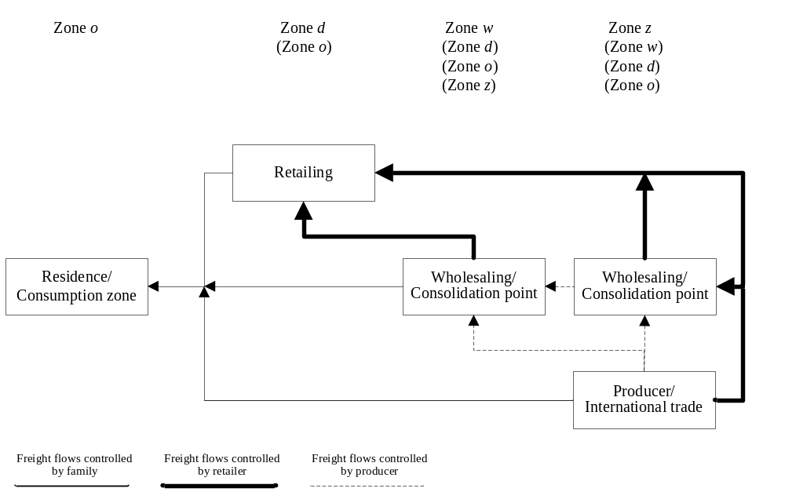
Figure 1 - Graph of freight distribution channels

For private end-consumer trips, the decision-maker can be assumed to be the family, (F); for business end-consumer trips, he/she can be assumed to be the business customer (B).
In the case of logistic trips, the main freight purchase modes are: from producers (firms) and from wholesalers (warehouses). There are different decision-makers for different choice levels as evidenced, in depth, in the literature (Holguin-Veras, 2002; Ghiani and Musmanno, 2000 and references cited therein).

To analyse the restocking process it is necessary to investigate the distribution strategy/mode. The distribution mode consists of the selection of a set of distribution channels. Each channel is characterized by a number and type of intermediaries present between the producer and customer. It is necessary to distinguish the case in which the customer is the end-consumer from the case in which he/she is the business customer. Business customer can be end-consumer or intermediate consumer who use the freight to produce other goods or services. Within the class of intermediate business customers, two groups may be considered: seller to private customers and business/public customers. In the section below, if the business customer uses the goods, he/she is considered an end-consumer and, as stated above, is called a business end-consumer (B); if he/she is an intermediate business customer and sells to private customers (end-consumers), he/she is assumed to be a retailer.

Proposed modelling system

As stated above, a specific work was developed to define the main model structure to analyze urban freight transport and logistics. The decision-maker involved in the o-d process is considered the end-consumer, E (F∪B). For d-w, several decision-makers can be considered who choose how and from where freight must arrive in zone d. This is investigated below. From the analysis carried out in different areas, it emerged that the main component of urban freight transport is given by the movement of some freight types in which restocking is done by retailer inside the study area. Hence, within acquisition below, we focus on the case in which restocking is done directly by retailer, r, who is also the decision-maker. In other words the pull movements of freight are considered, while the push movements are only recalled (Russo and Cartenì, 2004). Freight type is identified by s.
The pull movement is defined as that movement determined by the last trip of the logistic chain (end-consumer); the push movement is that determined by the first trip of logistic chain (producer).
Specific models can be then specified and calibrated for private end-consumer trips in which the decision-maker is the family (o⇔ d) and for logistic trips in which the decision-maker can be assumed to be the retailer (d⇔ w, he/she buys directly from a zone inside the study area).
The proposed modelling system was developed on two levels:
- models that concern calculation of the demand by freight type, by o-d consumption pair and d-W/Z restocking pair starting from socio-economic data;
- models that concern determination of the service, vehicle and time used as well as the path chosen for restocking sales outlets; the used freight transport multi-step model concerns a medium-size city and considers a disaggregated approach for each decisional level.

Commodity level
- Attraction macro-model; this model refers to end-consumer quantities; it has as input general socio-economic data (residents, number of employees, etc.) and gives as output the freight quantity required by them (demand in freight quantity for each od pair);
- Acquisition macro-model; this model concerns logistics trips from the retailer’s standpoint; in the literature several types of models have been developed and different decision-makers can be considered for each choice level; this model receives as input the freight quantity needed in each traffic zone d by the retailer and, in analysing the restocking process, it gives the quantity that is acquired inside (macro-area W) or outside (macro-area Z) the study area (demand in freight quantity for each macro-area).

Vehicle level
- Service macro-model; the model receives as input the demand in quantity for a macro-area and gives as output quantity, zone and vehicles needed for restocking;
- Path macro-model; the model receives as input the demand in vehicles and gives as output the departure/arrival time and path used; it can be both static and dynamic; several models can be used to evaluate the probability of choosing the desired departure/arrival time and each path, considering within them the existence of a supply chain (Russo et alii, 2005).

A specific case is investigated below, focusing on the case in which the end-consumer is a private user, the decision-maker can be considered the family and purchases in a shop (retailer, zone d) and the retailer stocks up directly from a warehouse within the study area (zone w∈W). Starting from the results obtained from surveys carried out and recalled below, the models within the second level investigated in the paper are based on the hypothesis that the retailer is the decision-maker of the restocking process, he/she purchases in the study area (W = {w}), the restocking trip is a round trip (one origin, w, and one destination, d) and he transports a quantity of freight equal to the capacity of his/her vehicle.
Figure 2 reports the modelling structure for each level. The general structure of the modelling system and an example of it is given in the following.

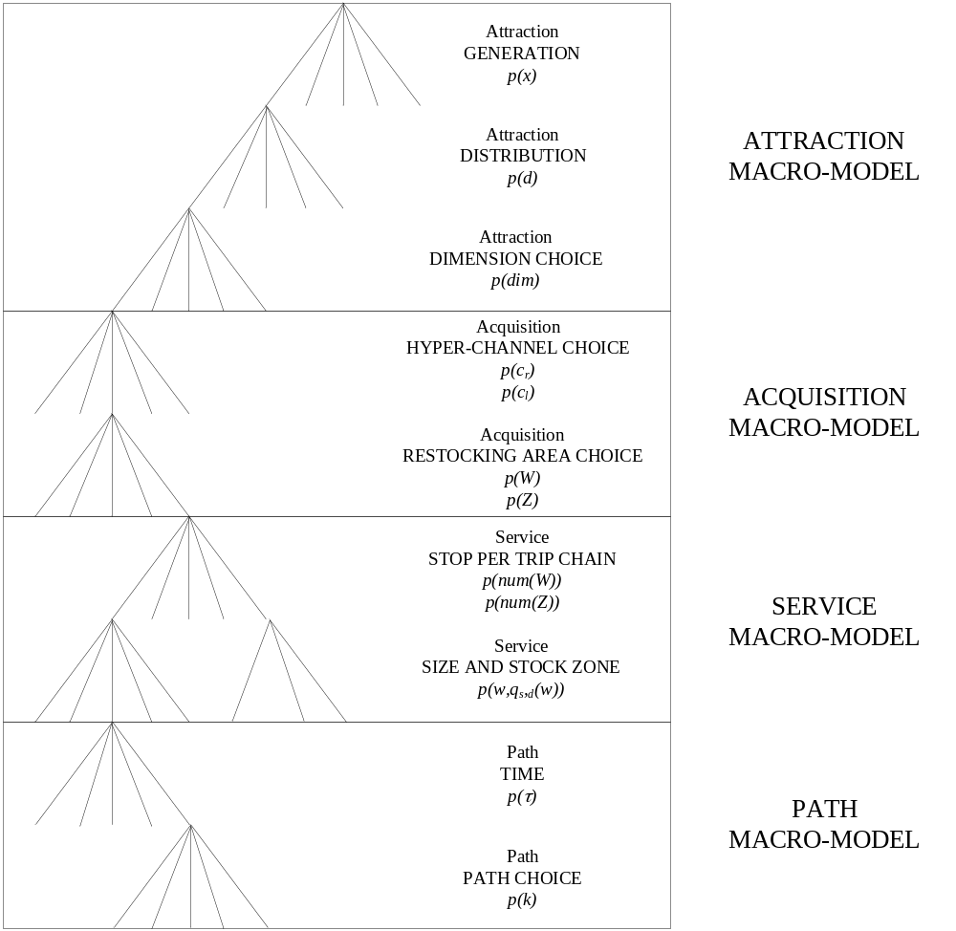
Figure 2 - Modelling System Structure

Attraction macro-model

The freight that is transported every day in an urban centre may be grouped into various categories. In literature there are several classifications, albeit developed mainly for logistic trips. As stated below, the attraction model concerns end-consumers. Hence the classification that gave the best results, in Italy, in simulating end-consumer trips at urban scale is that reported in Cascetta (2001) and Russo (2005). This macro-segmentation of trip types provides two macro-classes:
- shopping for durable and
- shopping for non-durable goods.

The attraction macro-model consists of a set of elementary models that allow us to calculate, as final output, the freight quantities (disaggregated by freight type) that are consumed in zone o, purchased and thus required in d. In this approach, defined as trip-based, the models allow the o-d matrices in trips to be calculated, whether round trip or trip chaining (Russo and Comi, 2003).
For estimating the quantity of goods attracted by each zone (o) the decision-maker in question is the end-consumer (E=F ∪ B). According to population or office or employment data in each zone, the number of trips undertaken from/to each zone of study area may be estimated. Thus each trip can be converted into quantities classified in a homogeneous type s, using some specific models. The quantities purchased may be estimated from the data relative to families and shopping trips undertaken and goods classification.

The first two models that allow us to estimate the trips for shopping (both for durable and no-durable goods) are generation and distribution models.
The generation model gives the probability p(x/os), for end-consumer E conditional upon having o as zone of residence and purchasing freight of type s, of undertaking x trips in a set time with x equal to 0, 1, …, n.
The distribution model gives the probability p(d/os) of trips being undertaken by end-consumer E going to destination d conditional upon leaving from o for purchases of type s.
These two elementary models allow us to obtain the O/D matrices in terms of trips done by users to buy some freight (products). In these models the considered decision-maker is the end-consumer E (Russo and Comi, 2006).
In this approach, the generation and distribution models are those that traditionally allow trips to be calculated. In literature there are several models available, such as descriptive or behavioural both for round trip and trip chaining (Ben-Akiva and Lerman, 1985, Ortuzar and Willumsen, 1994; Cascetta, 2001). While all are usable, the difficulties in employing them could lie in the complexity of the following model to convert trips into quantities and simulate the choice of shop type (retail shop, store, etc.).

To convert the trips in quantity, a dimension choice model is used. This model allows us to give a quantity dimension (dim) to each shopping trip. It gives the probability p(dim/dos) that a trip concludes with a purchase of dimension dim (0, dim₁, dim₂, …., dim_{n}), conditional upon undertaking a trip from zone o to zone d for a purchase of type s.

Finally, we can calculate the quantity required from each traffic zone d. But it is important to consider that the quantity, required by end-consumers and estimated with the models proposed above, is a component of total freight attracted by zone d. In fact, in general, the quantity required by purchasers in zone d is given by the sum of two terms: one calculated with previous models, 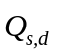, and another, also bought/sold in d, given by the demand of end-consumers living/working in zone z, outside the study area, 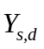:
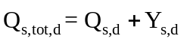

Acquisition macro-model

In general, the acquisition macro-model informs us whether the freight for restocking arrives from inside or outside the study area. Using the previous models, the quantities of freight, disaggregated in different types s, required in each traffic zone d are estimated.
As stated in the first part of this section, the freight leaves from producers to end-consumers and different distribution channels are used; the model gives the used distribution channel and gives from where (inside or outside the study area) the freight for restocking arrives in zone d.

When the large distribution strategy provides for the existence of wholesalers, a hyper-channels can be identified for freight distribution between wholesalers and retailers. Two main hyper-channels may be defined:
- hyper-channel r (c_{r}); it includes all distribution channels in which the decision-maker can be considered the retailer who chooses how, where and when to go to acquire the freight for restocking d;
- hyper-channel l (c_{l}); it includes the other distribution channels in which the decision-maker cannot be considered the retailer and in which many different decision-makers can be considered; in this case the retailer suffers the choice of other subjects involved who choose how and from where the freight must be delivered and can give some identifications regarding the delivery time.

The acquisition macro-model, thus, consists of two different models:
- hyper-channel choice model; the probability of choosing hyper-channel c to bring freight of type s for restocking zone d is estimated; from the previous macro-model (attraction macro-model) the quantity 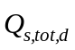 is obtained; hence with this model the freight quantity of type s arriving in zone d using a certain distribution hyper-channel can be estimated;
- restocking area choice model; the probability that a retailer takes the freight sold in his/her shop using a certain hyper-channel and arriving from inside (W) or outside the study area (Z) is estimated; the set of zones inside and outside the study area is called A={W} ∪ {Z}.

Based on these clear-cut choices the retailer can choose how the freight should be delivered. Thus the decision-maker in the case of c_{r} is the retailer, but not in the case of c_{l}, where the retailer deals with an agent or other subjects and he/she does not know how and from which zone the freight reaches his/her shop.

The freight quantity of type s, 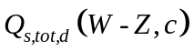, arriving in zone d from macro-area W or Z using channel c, can be calculated starting from knowledge of as follows:

where
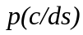 is the hyper-channel choice model that allows us to estimate the probability that the freight of type s attracted arrives to zone d with hyper-channel c;
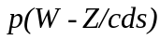 is the restocking area choice model that gives the probability of receiving freight of type s from macro-area W or Z conditional upon having selling zone d with hyper-channel c.

Service macro-model

The service macro-model allows us to analyse the restocking trip. As stated above, the macro-model consists of two elementary models: the stops per trip chain and the size and stock zone models. The former model estimates the number of stops made per trip in macro-area W or Z. In particular, it is possible to simulate how many warehouses are reached for each restocking trip. The second model is a joint model that calculates the size and zone of each warehouse stop.
In the following the attention is referred to analyze what happens when the decision-maker of restocking process is the retailer r under the assumption that he chooses the restocking macro-area W (the extension of macro-area Z is rather easy)

The stops per trip chain model gives the percentage of having num(W) stops and can be expressed as:

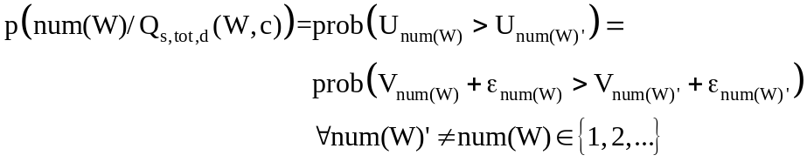
where
W is the set of zones inside the study area,
num(W) is the number of stops per trip in macro-area W.

The second model is the size and stock zone model. The freight quantity that is acquired from macro-zone W can be obtained in different stops done in a zone w. This model identifies the shipment size and the elementary zone (w) from where each sub-quantity, q_{s,d} (w), is acquired. It treats the choice of size and stock zone jointly; each alternative is defined by (w, q_{s,d} (w)):

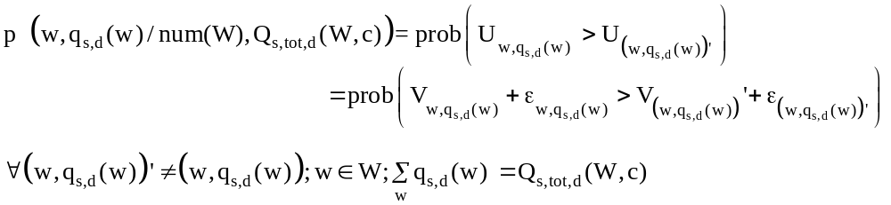

As stated above, and as demonstrated from surveys carried out in some Italian urban and metropolitan areas, it emerged that 48% of restocking is done using distribution channels in which the decision-maker is the retailer and in 46% it is effected from warehouses located inside the study area. Furthermore, in the case of self-restocking 90% of retailers supplies from one traffic zone (one or more warehouses located in the same place), and 83% of them uses their own vehicles with a load capacity less than 10 m³.

Below, we focus on freight 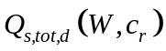 when the retailer is the decision-maker.
In fact, referring to data obtained from surveys, this macro-model was specified for the case in which the retailer is the decision-maker of restocking and he/she undertakes a round trip (base model). In this case, the choice set of the previous model consists of two alternatives:

Round trip (num(W)=1) = rt
Trip chain (num(W)>1) = tc

If 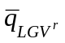 is the loading capacity of vehicle type 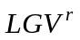, we assume, (as it is emerged from some surveys) that the vehicle reaches the zone d loaded at capacity, loaded quantity 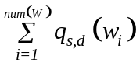, after num(W) stops:

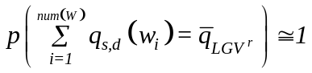.

The probability, 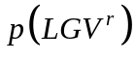, that a retailer owns an vehicle can be expressed as:

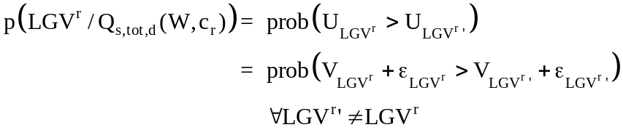

with , vehicle type with capacity .

Finally, it is possible to estimate the number of vehicles used to transport the freight s from w to d as follows:

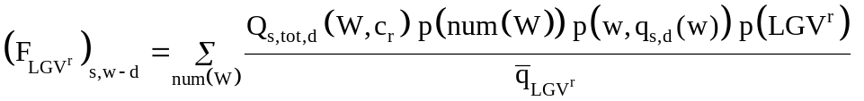

where
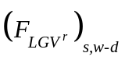 is the flow of vehicles from w to d for restocking freight of type s.

Path macro-model

Obtained with the previous models the matrices for each vehicle type and for each w-d pair, the last step is to estimate the network flows. Before, the time in which the trip is made is to calculate, after the path used from d to w and from w to d is to define. Hence in the path macro-model there are two elementary models: time and path model.

The first model is used to calculate the target time of each restocking trip and can be formalized as:

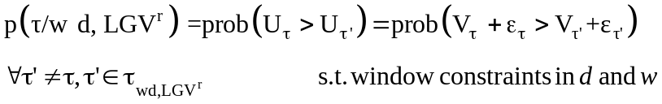

where
τ = Desired Departure/Arrival time from/to zone d and from/to zone w.

The path model that allows us to calculate the probability of using each network path, k_{i}, from each w_{i} to each w_{j} (until w_{j} is egual to d) can be expressed as:

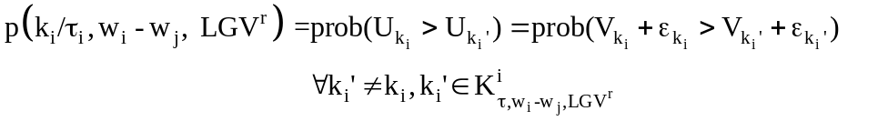

End-consumer and freight flows

The modeling system described in the previous paragraphs allow to estimate the freight flows in terms of both freight and end-consumer trips.
Regards end-consumer flows, one of the outputs of attraction macro-model is the o-d matrices in trips for purchases.
The average number of trips for purchases of freight of type s from zone o to zone d can be expresses as:

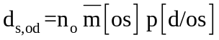

with
n_{o} is the number of end-consumer (E) of zone o;
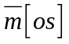 the average number of trips undertaken by each end-consumer from o for purchasing freight of type s, that can be evaluated as:

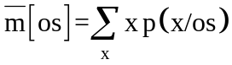
where 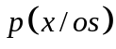 is the probability described in the par. 2.3;
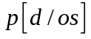 is the probability of trips being undertaken by end-consumer going from o to d for purchasing freight of type s; it is also described in par. 2.3.

Obtained, in this way, the o-d matrices in terms of end-consumer trips, it is possible to use modal split and assignment models present in the literature (Cascetta, 2001) to obtain the passenger flows on the network.
In fact, it is possible to recall some definitions, assumptions and basic equations on transportation demand and supply models; let:
f be the link flow vector, with entries f_{l} (flow on link l);
Δ be the link-path incidence matrix;
h be the vector of path flows;
c be the link cost vector;
g the vector of total path costs that is given by the sum of additive path costs (g^{ADD}) and non additive path costs (g^{NA}).
In the case of congested networks, link costs depend on link flows through the following cost functions:
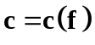

In the case of passengers, the relationship between link flows and path flows is expressed by the following equations:

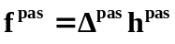.

From the models reported in the par. 2.3 the passenger demand for purchases is obtained, and it can be described by demand vector d^{pass}, whose components are the demand values 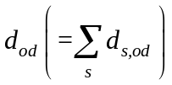 for each od pair, and P^{pass} is the path choice probabilities matrix, with a column for each od pair and a row for each path k (Cascetta, 2001, and Ortuzar and Willumsen, 1994); the relationship among path flows, path choice probabilities and demand flows is given by:

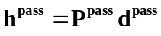

Regards the freight, the average flow of vehicle from w_{i} to w_{j} for restocking freight of type s that uses the path k with a target time τ can be evaluated as:

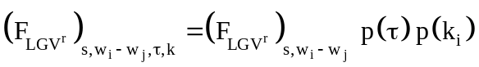
where
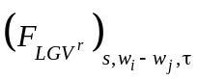 is the flow of vehicles from w_{i} to w_{j} for restocking freight of type s;
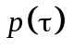 is the probability that the restocking trips has the target time τ;
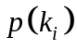 is the probability to use the path k_{i} to go from w_{i} to w_{j} (until w_{j} is egual to d).

As obtained for passengers, it is possible to express the relationship among path flows, path choice probabilities and demand flows in aggregate form as:

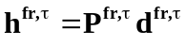

where
h^{fr,τ} is the vector of path freight flows, whose components are the vehicle flows 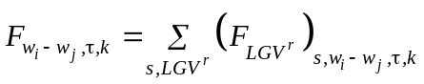;
P^{fr,τ} is the path choice probabilities matrix, whose components are 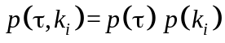; each terms was detailed in par. 2.6;
d^{fr,τ} is the demand vector, whose components are the 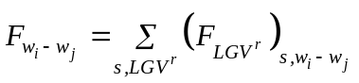.

Conclusions

In the paper a state-of-the-art model on urban goods movements was proposed and a possible classification reported. An identification of the freight trip chain in urban and metropolitan areas was discussed, and a model system to link end-consumers (assumed as families) and retailer choices was proposed. We focused on defining the structure of last choices made by private end-consumers (families) and service end-consumers (e.g. banks and offices) and retailers of last restocking. For these movements a sequence of behavioural models were formalized. The model system has an integrated structure with passenger modeling systems and so may be a useful tool for calculating the main components of vehicle flows resulting from freight transport in urban and metropolitan areas. In fact, starting from the evaluation of freight requested by end-consumers within a urban or metropolitan area, the proposed modeling system allows to link the two type of choices (end-consumer and retailer) and to evaluate the two type of flows (end-consumer and restocking) which use the same road network.
This paper is an outline of the modeling system developed by the authors in the last 4 years, and as said before, each proposed model was specified and calibrated in different contexts (both in towns and in medium-size cities) and the main results are detailed in different papers.

References

Allen, G., Tanner, G., Browne, M., Anderson, S., Christodoulou, G. and Jones, P. (2003). Modelling policy measures and company initiatives for sustainable urban distribution. Transport Studies Group, University of Westminster, http://www.wmin.ac.uk/transport/
Ambrosini, C. and Routhier, J. (2001). Objectives, methods and results of surveys carried out in the field of urban freight transport: a international comparison. In Proceedings of 9th World Conference on Transport Research, Seoul, South Korea.
Ando, N. and Taniguchi, E. (2006). An Experimental study on the performance of probabilistic vehicle routing and scheduling with ITS. In Recent Advances in City Logistics - Proceedings of the 4th International Conference on City Logistics edited by Thompson, R. G. and Taniguchi, E., Elsevier Ltd., United Kingdom, 2006.
Ben-Akiva, M. and Lerman, S. R. (1985). Discrete Choice Analysis: Theory and Application to Travel Demand, The MIT Press, Cambridge.
BESTUFS (2000). Best Urban Freight Solution, www.bestufs.net.
Cascetta, E. (2001). Transportation Systems Engineering: Theory and Methods, Kluwer Academic Press.
CERTU (1998). Plans de Déplacements urbains. Guide Méthodologique. Ministère de l’Equipement, des Transports et du Logement.
CNT (2003). Conto Nazionale delle Infrastrutture e dei Trasporti (CNIT) – Anno 2003– con elementi informativi per l’anno 2004. Ministero delle Infrastrutture e dei Trasporti, Rome, Italy.
COST 321 (1998). Urban goods transport, Final report of the action. Transport Research, European Commission Directorate General Transport, Belgium.
Crainic, T. G., Ricciardi, N. and Storchi, G. (2004). Advanced freight transportation systems for congested urban areas. In Transportation Research Part C 12, Elsevier Science.
Gerardin, B., Patier, D., Routheir, J. L. and Segalou, E. (2000). Diagnostic du Transport de Marchandises dans une agglomération. Programme National Marchandises en Ville, www.transports-marchandises-en-ville.org.
Ghiani, G. and Musmanno, R. (2000). Modelli e metodi per l’organizzazione dei sistemi logistici, Pitagora Editrice, Bologna, Italy.
Harris, R. I. and Liu, A. (1998). Input-output modelling of the urban and regional economy: the importance of external trade. In Regional Studies, 32 (9).
Holguin-Veras, J. and Thorson, E. (2000). An investigation of the relationships between the trip length distributions in commodity-based and trip-based freight demand modeling, In Proceedings of 79th Transportation Research Record, Washington, USA.
Holguín-Veras, J. (2002). Revealed Preference Analysis of the Commercial Vehicle Choice Process. In Journal of Transportation Engineering, Vol. 128 (4), American Society of Civil Engineers.
Hutchinson, B. G. (1974). Principles of urban transport systems planning. McGraw-Hill Book company, USA.
Matsumoto, S., Sano, K. and Wisetjindawat, W. (2005). Supply chain simulation for modeling the interactions in freight movement. In Journal of the Eastern Asia Society for Transportation Studies, Vol. 6.
Munuzuri, J., Larraneta, J., Onieva, L. and Cortes, P. (2003). Estimation of an origin-destination matrix for urban freight transport. Application to the city of Seville. In Logistics Systems for Sustainable Cities - Proceedings of 3^{trd} Conference on City Logistics eds E. Taniguchi and R. G. Thompson, Elsevier.
Nuzzolo, A., Crisalli, U. and Comi, A. (2006). A modelling system for urban freight movements. In Proceedings of 11th International Conference of Hong Kong Society for Transportation Studies - Sustainable Transportation, Hong Kong, China.
Ogden, K. W. (1992). Urban Goods Movement. Ashgate, Hants, England.
Oppenheim, N. (1994). Urban Travel Demand Modeling. John Wiley & Son, New York.
Ortuzar, J. de D. and Willumsen, L. G. (1994). Modelling Transport, J. Wiley & Sons.
Regan, A. C. and Garrido, R. A. (2000). Modeling Freight Demand and Shipper Behaviour: State of the Art, Future Directions. In Preprints of IATBR, Sydney.
Ruesh, M. and Glucker, C. (2000). Best Practice Handbook 1, Project funded by the European Community under the ‘Competitive and Sustainable Growth’ Programme, www.bestufs.net.
Russ, F. B., Yamada, T., Castro, J. and Ito, T. (2006). Modelling multimodal freight transport: impacts of network improvement in urban areas on inter-regional freight transport. In Recent Advances in City Logistics - Proceedings of the 4th International Conference on City Logistics edited by Thompson, R. G. and Taniguchi, E., Elsevier Ltd., United Kingdom, 2006.
Russo, F. (2005). Sistemi di trasporto merci - approcci quantitativi per il supporto alle decisioni di pianificazione strategica tattica ed operativa a scala nazionale, Franco Angeli, Milan, Italy.
Russo, F. and Cartenì, A. (2004). A tour-based model for the simulation of freight distribution. In Proceedings of European Transport Conference - PTRC 2004, Strasbourg, France.
Russo, F. and Comi, A. (2002). A general multi-step model for urban freight movements. In Proceedings of European Transport Conference - PTRC 2002, London, England.
Russo, F. and Comi, A. (2003). Urban freight movements: quantity attraction and distribution models. In Sustainable Planning & Development eds E. Beriatos, C. A. Brebbia, H. Coccossis and A. Kungolos, WIT Press.
Russo, F. and Comi, A. (2006). Demand models for city logistics: a state of the art and a proposed integrated system. In Recent Advances in City Logistics - Proceedings of the 4th International Conference on City Logistics edited by Thompson, R. G. and Taniguchi, E., Elsevier Ltd., United Kingdom, 2006.
Russo, F., Cartisano, A. G. and Comi, A. (2002). Modelli per l’analisi degli anelli finali della distribuzione delle merci. In Modelli e metodi dell’Ingegneria del traffico eds G. E. Cantarella and F. Russo, Franco Angeli, Milan, Italy.
Russo, F., Comi, A. and Vitetta, A. (2005). Calibration of generalized cost models for road freight vehicles within an intermodal chain: an experimental application in Italy. In Proceedings of European Transport Conference - PTRC 2005, Strasbourg, France.
Stumm, M. and Bollo, D. (2004). E-commerce and end delivery issues. In Logistics systems for sustainable cities eds. E. Taniguchi and R. G. Thompson, Elsevier.
Taniguchi, E. and Hata, K. (2004). An evaluation methodology for urban freight policy measures with effects of e-commerce. In Proceedings 10th World Conference on Transport Research, Istanbul, Turkey.
Taniguchi, E. and Kakimoto, T. (2003). Effects of e-commerce on urban distribution and the environment. In Journal of Eastern Asia Society for Transportation Studies.
Taniguchi, E., Noritake, M., Yamada, T. and Izumitani, T. (1999a). Optimal size and location planning of public logistics terminals. In Transportation Research Part E 35, Elsevier Science.
Taniguchi, E., Yamada, T. and Tamagawa, D. (1999b). Probabilistic vehicle routing and scheduling on variable travel times with dynamic traffic simulation. In Proceedings of 1st International Conference on City Logistics, Cairns, Australia.
Taniguchi, E., Thompson, R. G., Yamada, T. And van Duin, R. (2001). City Logistics – network modelling and intelligent transport systems. Pergamon.
Thompson, R. and Taniguchi, E. (1999). Routing of Commercial Vehicles Using Stochastic Programming. In Proceedings of 1st International Conference on City Logistics, Cairns, Australia.
Thompson, R. G., Chiang, C. and Jeevapatsa, M. (2001). Modelling the effects of e-commerce. In City logistics II eds. E. Taniguchi and R. G. Thompson, Kyoto, Japan.
Visser, J., Nemoto, T. and Boerkamps, J. (2001). E-commerce and city logistics. In City logistics II eds. E. Taniguchi and R. G. Thompson, Kyoto, Japan.
Wild, D. (2003). The BESTUFS project. In Proceedings of 4th BESTUFS Conference, Praha, Czech Republic.

