WCTRS Research Newsletter
 | World  Conference on  Transport  Research  Society | SECRETARIAT OFFICE OF THE WCTRS  Institute for Transport Studies  The University of Leeds  Leeds, LS2 9JT England  Email: wctrs@leeds.ac.uk  Website: www.wctrs-society.com

February 25, 2021 | Volume 1, Issue 1
In This Issue  - Message from the President of the WCTRS  - Message from the Scientific Committee Chairman  - About WCTRS-Y initiative from Prof. Laetitia Dablanc  - Article on the education and license on supply chain management task force  - Article on the subway benchmarking task force  Useful Information and links  1. The Call for Applications to the WCTRS Young Researcher's Initiative  Deadline: February 28, 2021  For details, visit: link  2. Asian Transport Outlook Webinar  On: March 9, 2021  For details, visit: link  3. Joint online workshop of SIG F1 and AUM group on Impact of “COVID-19 on transport and spatial development: an international perspective”  On: February 25 and March 11, 2021  For details, visit: link  4. Lee Schipper Memorial Scholarship for “Sustainable Transport and Energy Efficiency”  Deadline: March 15, 2021  For details, visit: link  5. Antwerp Rail School, 2021  On: March 22 – 26, 2021  For full program, visit: link  For registration, visit: link  6. SIG G1 Governance and Decision-Making webinar on “Cab aggregators in India – a regulatory dilemma”  On: March 26, 2021  For details, visit: link  WCTRS society journals  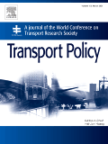  Transport Policy  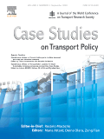  Case Studies in Transport Policy  WCTRS and Elsevier Transportation Book Series  For details, visit: link  Find us on  Visit us on  https://www.wctrs-society.com/  https://wctr2022.ca/  Email to us at  Editorial team of WCTRS Research Newsletter  Editor  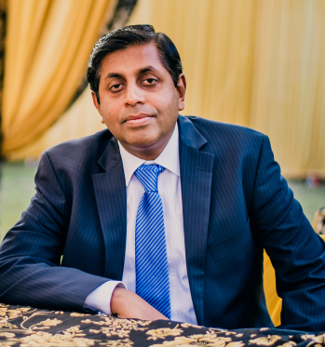  Prof. Dr. Ashish Verma  IISc Sustainable Transportation Lab (IST Lab), IISc Bangalore, India  ashishv@iisc.ac.in  Assistant editor  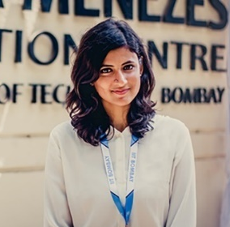  H. Gayathri  Research Scholar, IST Lab, IISc Bangalore, India  gayathrih@iisc.ac.in | Message from Prof. Tae Hoon OUM, President of the WCTRS  Greeting! I hope all of you are doing well and staying Covid-19 Safe in this rather difficult and strange period of time in our history!  Since the WCTRS is the largest International academic society in transport field, I thought it is a good idea to have an organized/regular newsletter focusing on research and related issues. For some time, we have been searching for a qualified newsletter editor who is willing to take up this important task for our Society’s common good.  Fortunately, as Professor Ashish Verma’s second 3-year term as the Transport Policy’s Special Issue editor has just ended, I was able to persuade Ashish to take up this important responsibility as the WCTRS Newsletter editor. Ashish’s Newsletter work will be assisted well by Ms. H. Gayathri. Gayathri also assisted Ashish in WCTRS 2019 who was the Vice-chair (Conference) of the Scientific Committee.  Since we have 30+ Special Interest Group Chairs/Co-chairs/Vice Chairs, nine topic area managers, many colleagues committed to the newly elevated CARs (Country and Regional Representatives) Council, Covid-19 Task Force, WCTRS Montreal World Conference organization, WCTRS-Chartered Education-Licence Task Force programs, WCTRS Subway and Urban Railway Efficiency Performance Benchmarking Task Force, very active WCTRS-Y programs, a large number of international partner organizations, Transport Policy and Case Studies in Transport Policy journals, these are numerous sources of the information and news that Ashish and Gayathri can tap to generate and organize the rich WCTRS newsletters. Since the WCTRS society is a largely volunteer organization, we decided to start with ‘monthly’ newsletter.  To make this new initiative to succeed, it is very important for all of us in the WCTR Society to alert newsworthy items to Ashish (ashishv@iisc.ac.in) and Gayathri (gayathrih@iisc.ac.in). Furthermore, please be generous in allocating your time when Ashish or Gayathri approach your unit to seek newsworthy materials.  Thank you very much for your special attention and cooperation.  Prof. Tae Hoon OUM, President of the WCTRS  University of British Columbia  Message from Prof. Lori TAVASSZY, Scientific Committee Chairman of the WCTRS  It is my great pleasure and honor to help launch the new research newsletter of the WCTRS with a short note. As you will know, our core research network connects more than 1000 scholars from over 60 countries worldwide – together they are organized in 30 Special Interest Groups across all fields of transport research. This newsletter will be a key outlet for the research highlights emerging from within these groups, around and between the tri annual WCTRS conferences.  We are living in challenging and interesting times as researchers. The unfortunate pandemic that has engulfed the world in 2020 has created many new needs that required our attention. We are proud to report that the WCTRS was the first network to organize a global conference about transport topics emerging during the Covid-19 pandemic, ranging from the impacts of social distancing on travel to the resilience of supply chains. During five conference days, more than 60 contributions were discussed by more than 500 attendants. Prof. Yoshi Hayashi and Dr. Junyi Zhang have led this excellent and remarkable initiative. The Covid-19 task force will continue to bring together researchers and support the necessary publications to make new knowledge widely accessible.  Currently, we are midway between two conferences. After the immense success of the WCTR2019 in Mumbai, we are preparing for the upcoming event in Montreal in 2022. The considerable uncertainties around free and easy travel mark this WCTR occasion as one without precedent. Decisions are being prepared concerning the timing and nature of the event. We have observed that digital facilities increase the accessibility of conferences for those with a low budget across multiple time zones. However, we also feel that classical conferences' atmosphere cannot be easily replaced by online attendance. We will communicate soon how WCTR2022 will be organized.  Looking at the fallout of the WCTR2019 in Mumbai, we can report new successes. As in previous years, our Scientific Committee has consolidated the strongest contributions and has prepared their publication. Selected proceedings containing 293 papers are now available in Transport Research Procedia. Besides, 20 special issues have been created in various journals in our field, including the WCTRS' home journals Transport Policy and Case Studies in Transport Policy. Furthermore, the WCTRS-Elsevier book series has presented five new volumes since the conference.  Our service to the scientific community includes further highlights worth mentioning. The WCTRS has launched two intercontinental taskforces: one aimed at Global Urban Transport Efficiency Benchmarking and a second at a Transport and Supply Chain Management Analyst licensing program. These will report their results as they emerge during the coming year. The journals of the Society have reached new heights. Transport Policy has welcomed its new Editor-in-Chief, Prof Hai-Jun Huang. We thank Prof. Tae Oum for his service to the journal, allowing it to reach its latest impact factor of 3.382. Case Studies in Transport Policy remains under the leadership of Prof. Rosário Macário and has seen the number of submissions rise by 60% compared to the previous year. Last but not least, we have installed new Special Interest Groups in the areas of High-Speed Rail, Infrastructure, and Supply Chain Management. We invite scholars on these topics to join and help build our community.  Altogether we find that the WCTRS is in strong shape. I am extremely proud of our scientific committee and grateful to the many loyal individual members of our Special Interest Groups, who have helped secure these tangible achievements during the past years. We look forward to continuing to report on new achievements in the upcoming newsletters.  Lóri Tavasszy, Scientific Committee Chair  TU Delft  About WCTRS-Y initiative by Prof. Laetitia Dablanc  The Young Researchers' Initiative (https://www.wctrs-society.com/wctrs-y-initiative/) provides opportunities for young members of the Society to gain experience in academic activities, develop their professional profiles and skills, network with established transport researchers and practitioners, and become familiar with the workings of WCTRS. It was first run as part of WCTR-13 in Rio de Janeiro in 2013 and is now beginning the fourth edition. 'Young members' are defined as members of the Society who will be below 35 years old on the first day of the WCTR-16 Montreal (July 24, 2022).  The initiative was established to encourage young members to enhance their capabilities and become acquainted with the Society's activities. The objective is to prepare a new generation of young colleagues who will gradually take the lead. WCTRS-Y covers three activities. The first one is the organization of a one-day conference, which will be held on July 24, 2022, on the first day of the World Conference on Transport Research in Montreal. Organizers will be selected from applicants in the current application process (deadline February 28, 2021). About 10 to 15 papers and posters from young members will be presented and discussed. A final roundtable with an extensive Q&A session will be organized to discuss career challenges and objectives with senior academics. The second activity of the WCTRS-Y is the allocation of Ph.D. grants to inspire Ph.D. students and young doctors to produce innovative transport research. Five grants will be distributed (applications close on February 28, 2021). All five recipients will present their papers during a special session at WCTR Montreal. The third WCTRS-Y activity is around the development of social media, newsletters, and online facilities for young members to facilitate the exchange of knowledge, discuss transport research, and share grants and positions' opportunities.  In Mumbai in 2019, more than 200 young members participated in the Young conference on the first day of WCTR, a record. They particularly enjoyed the Q&A session with senior academics, who provided tips for the job. Nevertheless, the initiative does not stop at this one-day event: young members who participated or received grants networked together and networked with senior members. They felt included in the international transport research community. We encourage you to participate in the current edition of the Young Initiative.  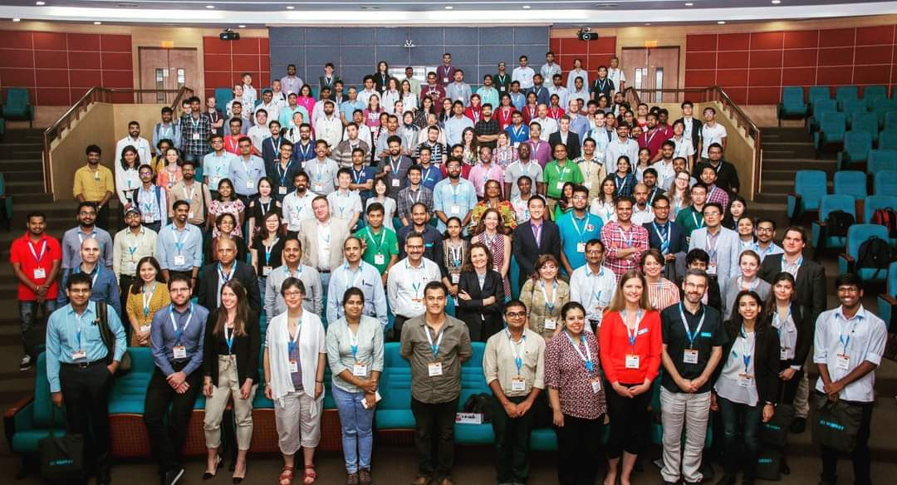  WCTRS-Y at Mumbai Conference  Prof. Laetitia Dablanc, WCTRS-Y leader  Director of Research at University Gustave Eiffel  WCTRS- Chartered Education - License task force  Prof. Martin Dresner Prof. Aseem Kinra Prof. Yafeng Yin The WCTRS is in the process of rolling out two licensing programs for analysts in supply chain management and transport. The first two cohorts of students are planned for September 2021. The programs are geared to advanced undergraduates and recent graduates who want to pursue careers in supply chain management or transportation. The programs will be administered through a partnership with Beijing Jiaotong University (BJTU). BJTU is ranked number 1 in Transportation Science and Technology in the Shanghai ranking of the world’s top academic programs and will serve as the anchor university for the licensing programs. As anchor university, BJTU will administer two capstone courses in each of the specialty areas. These courses will be delivered online, in English, by top academics in the field. In a survey delivered to students around the world, there was an overwhelming desire to participate in a licensing program designed to further their careers. Given the worldwide reputation of the WCTRS, it was felt that no other organization is in a better position to oversee the programs.  Two esteemed faculty members led committees that determined the content of the capstone courses. Prof. Yafeng Yin from the University of Michigan oversaw the Transport Analyst licensing program, while Prof. Aseem Kinra from the University of Bremen oversaw the development of the Supply Chain Management licensing program. Both individuals were aided by teams of academics from around the world. Vice Dean and Professor Guowei Hua led the effort from BJTU. The entire endeavor has been overseen by WCTRS President, Prof. Tae H. Oum. Brief descriptions are provided for each of the programs, below:  Supply Chain Management Analyst Program:  Following consultations with colleagues and course curricula from different countries and regions, the education task force proposed a list of approximately 30 topics to be covered under four different modules: an introductory module that sets the scene with the key definitions and interconnections to areas such as Production, Transportation, and Physical Distribution; two core modules, one on supply chain operations and the other on controlling, performance and other supply chain management techniques; and finally a concluding module that shall deal with newer perspectives such as global supply chains, supply chain digitalization, resilience and sustainability. The WCTRS plans to initiate this licensing program to educate and set standards for high-level SCM analysts. As the WCTRS is the only transport research/academic organization encompassing virtually all major countries and universities of the world, it has the expertise and credibility to formulate this type of education/training and licensing program.  Transport Analyst Program:  The task force has developed a list of suggested topics to be covered by two capstone courses offered in the WCTRS Chartered Transport Analyst License Program. The suggested topics include the paradigm of transportation systems analysis, introduction to optimization, demand, supply and competition, mode-specific considerations, transportation regulation and ownership, project evaluation, decision analysis and capstone project. These topics aim to help students develop a “systems perspective” necessary for intelligent planning and management of transportation systems, explore a set of quantitative tools of great value to transportation analysts and decision makers and foster a critical perspective of the limitations of these tools when applied to the field of transportation systems analysis. These topics integrate basic concepts and tools of transportation systems analysis, including those of microeconomics, optimization, project evaluation and decision making, into transport planning and management.  Prof. Martin Dresner, University of Maryland, Prof. Aseem Kinra, University of Bremen & Prof. Yafeng Yin, University of Michigan  (On behalf of all the task force members)  Subway and Urban Railway Efficiency Performance Benchmarking task force  Urban rail transit system (URTS) efficiency benchmarking study compares the productivity and operation efficiency worldwide. With economic development, China has conducted the largest scale URTS planning and construction. The total length has now reached 6434 km. We have collected the information for 37 cities in China, including network size, investment, energy consumption, employee, ticket revenue, and passenger. The first try of VARIABLE FACTOR  PRODUCTIVITY (VFP) was analyzed for the 37 systems. More data is expected for Europe and other regions for further comparison.  Prof. Haixiao Pan, Tonji University  (On behalf of all the task force members)
WCTRS Research Newsletter
President  Tae OUM (University of British Columbia, CANADA)  Secretary General  Greg MARSDEN (Leeds, ENGLAND)  Secretary  Emma PICKERING (Leeds, ENGLAND) | Chair Scientific Committee  Lori TAVASSZY (TU Delft, NETHERLANDS)  Chair Editorial Board "Transport Policy"  Hai-Jun HUANG (Beihang University, CHINA)  Chair Editorial Board "Case Studies on Transport Policy"  Rosário MACÁRIO (Lisbon, PORTUGAL)  16th Conference Director  Catherine MORENCY (Ecole Polytechnic, Montreal, CANADA)

February 25, 2021 | Volume 1, Issue 1

