Tongji-WCTRS World Transport Research Center was established
On the afternoon of April 19, 2019, the founding ceremony of Tongji-WCTRS World Transport Research Center was successfully held at College of Transportation Engineering, Tongji University.
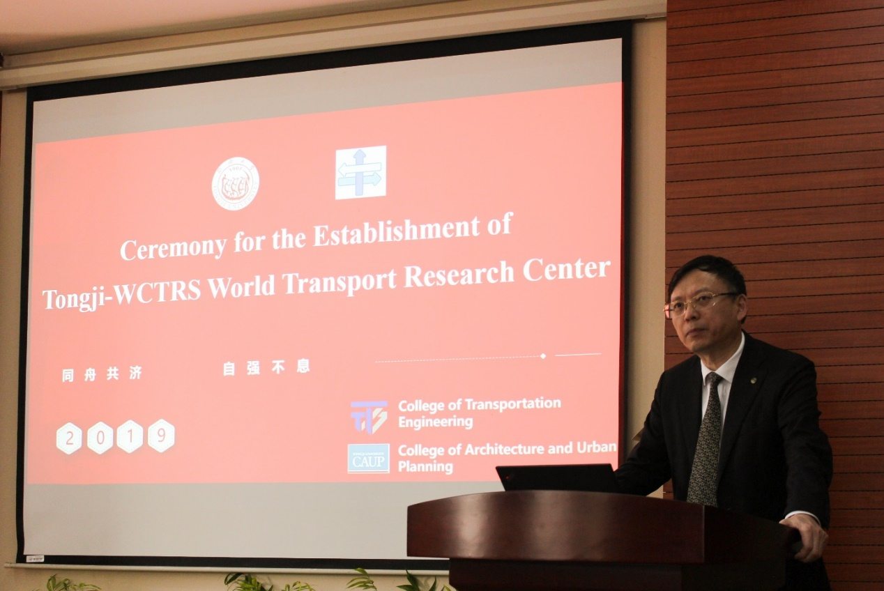
Professor Ma Wanjing,vice Dean of Transportation Engineering, presided over the inauguration ceremony of the Center, and Professor Fang Shouen, Secretary of the Party Committee of the University, delivered a congratulatory message for the establishment of the Center, hoping to cultivate students with international vision and cross-cultural exchanges by relying on the Tongji-WCTRS World Transport Research Center, innovate the post-doctoral training mode, establish a post-doctoral training mechanism of linkage at home and abroad, and improve the quality of post-doctoral training. Actively carry out international cooperation in scientific research, and carefully build the international conference brand of Tongji-WCTRS World Transport Research Center.
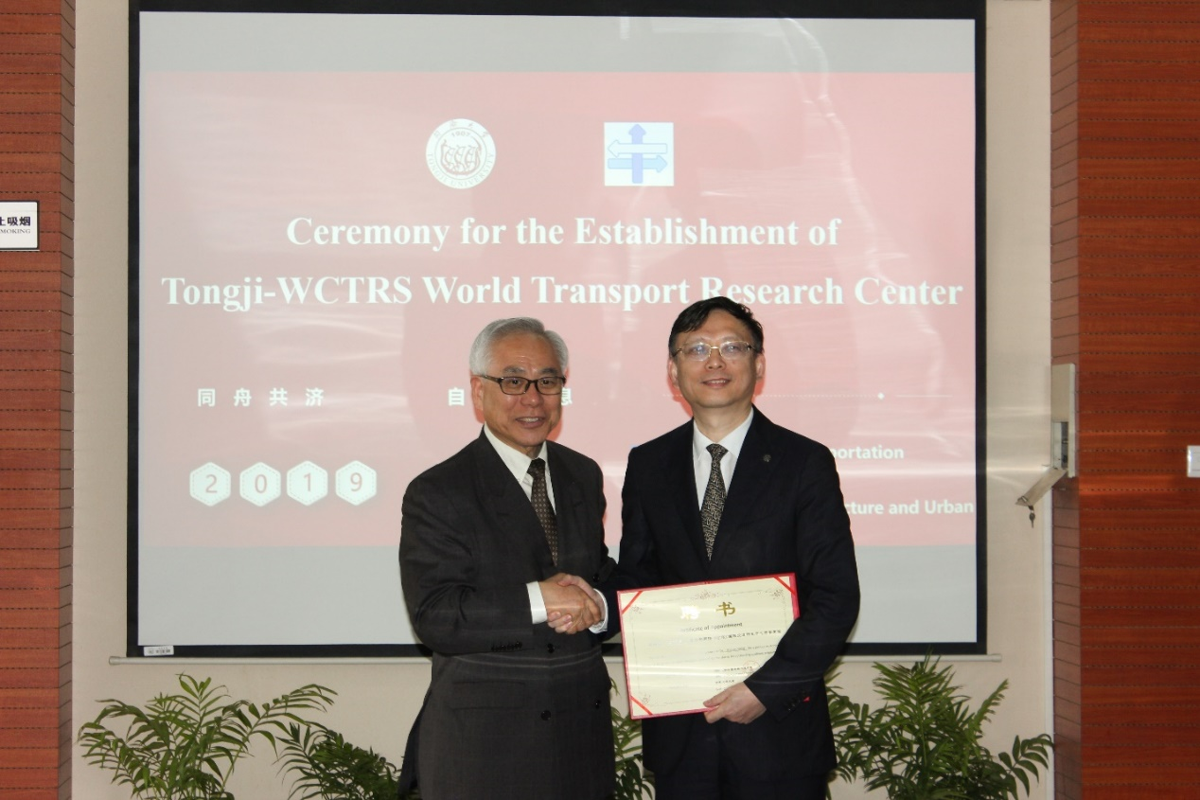
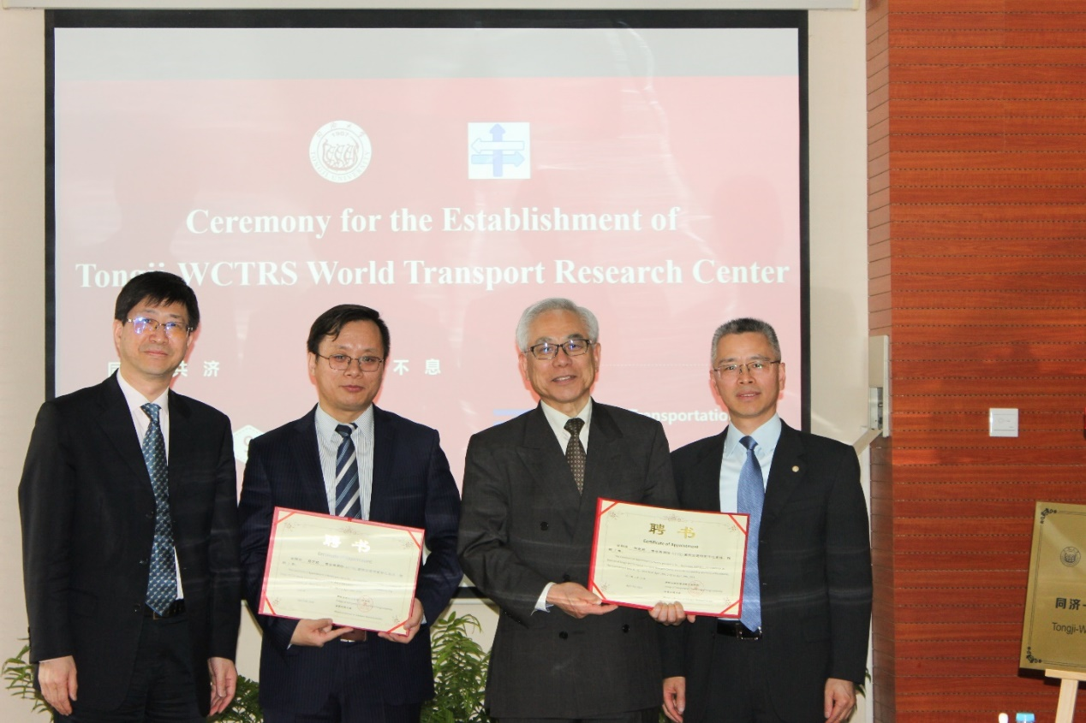
Professor Yoshitsugu Hayashi, President of the World Transport Congress and member of the Rome Club, introduced the history, development, partners, objectives, members and internal structure of the Tongji-WCTRS World Transport Research Center. Professor Tae Oum, Editor-in-Chief of Transport Policy, University of British Columbia, introduced the future direction of WCTRS, research topics and the work of the Center. Professor Ling Jianmin, Dean of Transportation Engineering College, once again congratulated the establishment of the Center. Professor Fang Shouen is the honorary chairman of the center. Professor Yoshitsugu Hayashi and Professor Ma Wanjing are the co-chairmen, Professor Luo Xiao is the Secretary and Professor Wan Xiaohua is the secretary.

