3rd Tongji-WCTRS SIG F3 Seminar on “Smart city, smart transport and Quality of Life”

On April 20, 2019, the seminar "Smart City, Smart Transport, Quality Life" jointly organized by the Organizing Committee of the World Transport Research Conference and Tongji University was successfully held in Conference Room C401 of the China-France Center of Tongji University. The conference focused on the theme of "Better mobility and quality of life", which was divided into three sub-forums: keynote speeches, challenges of urban planning and social impact, better mobility and quality of life. The purpose of the conference was to promote in-depth exchanges and discussions between academia and industry in the areas of smart cities, smart transportation and quality of life. The Conference triggered heated discussions among participants.
The seminar was opened by Professor Luo Xiao, School of Transportation Engineering, Tongji University. The seminar was chaired by Professor Pan Tsunami, Professor Luo Xiao and Professor Yoshitsugu Hayashi, President of the World Conference on Transportation Research, Professor Tae Hoon Oum of British Columbia University, Professor Bao Cunkuan of Fudan University, Professor Cheng Yiheng and Susu H.NOUSALA, School of Design and Creativity, Tongji University, Professor Li Ye, Professor Ye Jianhong, Professor Kang Qi, School of Electronic and Information Engineering, etc. participated in the seminar.
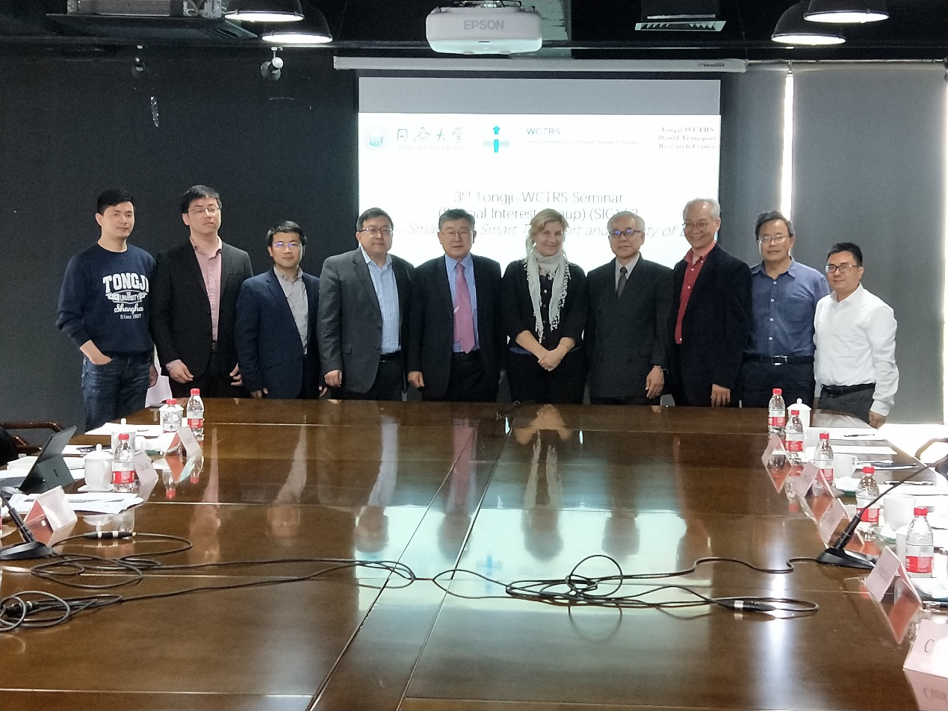
During the seminar, participants conducted in-depth exchanges and discussions on the current academic research progress and the specific application of the industry, including the urban planning approach towards quality of life under Sustainable development, the impact of China's air policy liberalization on the changes in relations between China and its Asian neighbours, the value of one ton of carbon dioxide, and the difference analysis of the impact of rail transit accessibility on housing prices, setting up rules for development, the importance of complex social adaptation system, transfer learning based on ecological laws: a machine learning method to weaken supervision, Shanghai population dynamic monitoring and quality of life assessment, the impact of electric vehicle sharing on urban traffic, etc.

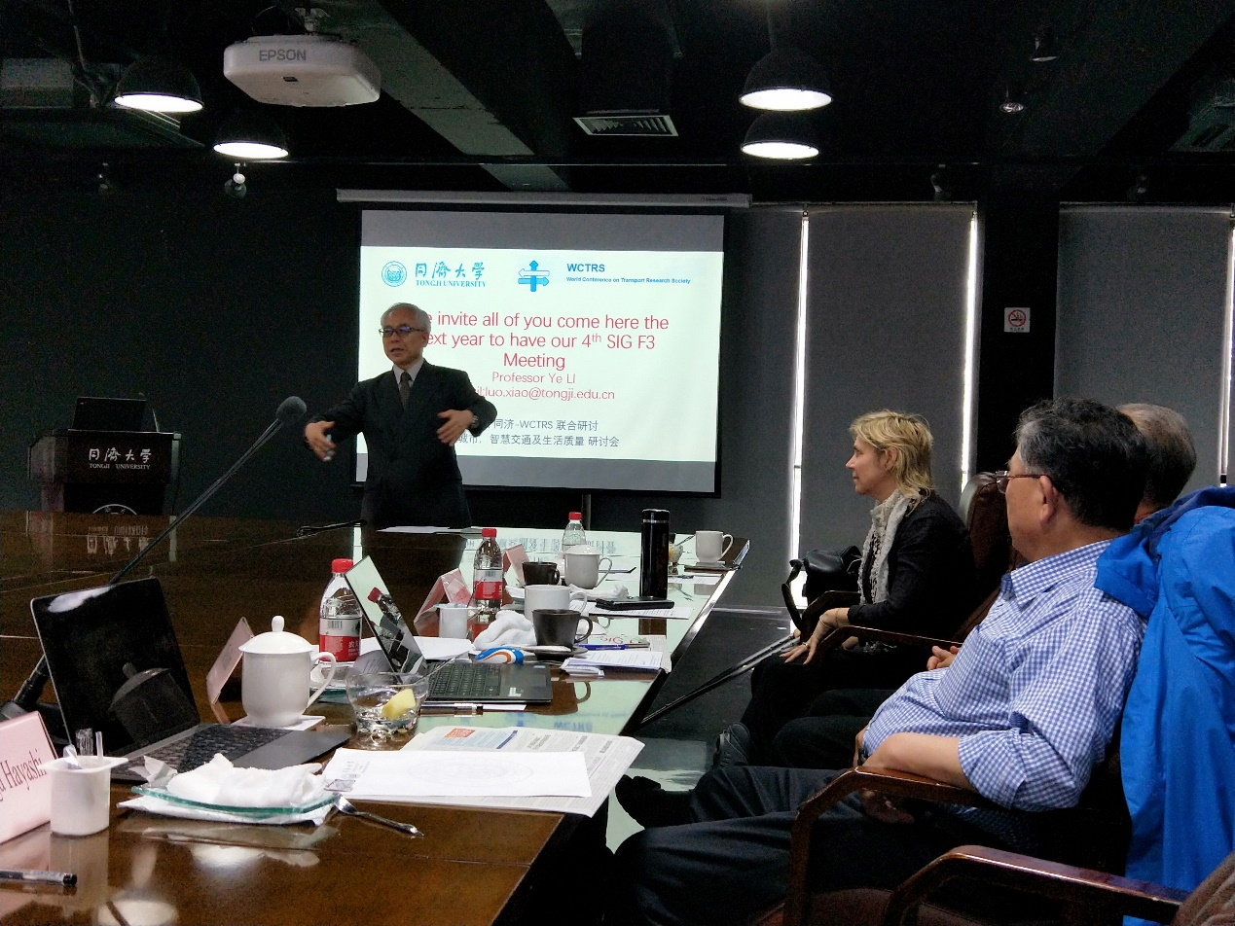
At the end of the discussion, Professor Yoshitsugu Hayashi and Professor Li Ye summarized the seminar, fully affirmed the achievements of the seminar, placed great expectations on the future development of smart cities and smart transportation systems, and sincerely invited participants to reunite next year. After the meeting, the participants visited the School of Design and Creativity of Tongji University.

