LIVABLE CITY SPACES: The Tokyo Street Space from a Spatio-Historical Perspective

Iderlina Mateo-Babiano¹⁾ and Hitoshi Ieda, Dr. Eng.²⁾

- PhD Candidate, Transport Research and Infrastructure Planning (TRIP) Laboratory
Civil Engineering Department, School of Engineering, University of Tokyo, Tokyo, Japan
Phone: +81.80.3210.3077
Email: ibmateo@yahoo.com or derlie@gmail.com
Lecturer, College of Architecture and Applied Sciences, Eastern Visayas State University, Tacloban City, Leyte, Philippines

2) Professor, Transport Research and Infrastructure Planning Laboratory
Civil Engineering Department, School of Engineering, University of Tokyo, Tokyo, Japan
Phone: +81.3.5841.1270
Fax: +81.3.5841.8506
Email: ieda@civil.t.u-tokyo.ac.jp

Abstract. Technological innovation in the field of transport has aimed to encourage safer and more efficient travel. In some instances however efficiency does not translate to better quality-of-life. With the drive towards sustainability, livable community spaces are said to contribute more to better life quality. Furthermore, streets that developed not only as access routes but as centers of exchange contributed largely towards sustainable mobility. Thus, a city’s history provides insightful knowledge on achieving city livability and sustainable mobility. The study focus is Edo (former name of Tokyo) during the Edo period (1603-1868) given its historical precondition. The paper is concept-driven by making reference to Edo’s spatio-historical street development, with particular focus on its structural and functional dimension, so as to establish a “space not only for access but as lived space” and define workable concepts towards an effective street design. The research will draw on historical survey of urban spaces, visual analysis of pictorial presentations and analysis of existing literature. This research aims to strengthen the importance of gaining in-depth understanding of a city’s historical past as potential methodology in sustainable transport planning.

- INTRODUCTION

  - Background

Mobility had been closely related with technological innovation. The latter’s objective was to find ways and means to achieve safer and more efficient travel by widening highways and enhancing vehicle functionality. However, the twenty-first century saw the advancement of a knowledge-based society which instilled understanding that efficiency does not always translate to better quality-of-life. Intangible attributes such as having a stress-free life, security, enjoyment, happiness and self-expression were few characteristics which led to the pursuit of a more sustainable lifestyle. As the city is premised to house various unsustainable practices, it was but natural that studies concentrate on how to make these cities more effective. However, the concept of sustainability had been vague and defining a sustainable city model was as ambiguous. This necessitated establishing goals towards achieving sustainability. According to Pacione (1997), an ideal sustainable community possessed environmental integrity, economic vitality and social well-being. Livability usually referred to a city’s built environment and how it contributed in the improvement of the people’s quality-of-life. Walkable streets encouraged interaction which translated into community livability (Litman, 2003). Furthermore, Alexander (1965) and Gehl’s (1987) empirical studies showed the intrinsic relationship between street pattern complexity and increased level of city livability. High occurrence of interaction and amount of activities within city streets determined street vitality. From a historical perspective, streets developed not only as access routes but as centers of exchange. This practice exemplified sustainable mobility wherein the focus was not only on locomotion but for other non-walking activities. However, with the increasing number of vehicle traffic, street vitality had significantly declined. This displaced activities held in community common spaces to the periphery and largely contributed to inner city decay.

The premise is that examining a city’s socio-cultural roots will provide insightful knowledge on achieving city livability. Asian cities serve as cradle of diverse traditions and home to strong indigenous knowledge. This knowledge serve as window to better understand the current social and morphological state of the city, and more specifically of its streets. Indigenous knowledge is inherent and handed down from one generation to another. Often, these traits and values are not apparent and dismissed as common practice. However when manifested collectively in a single common space becomes obvious and contributes to the creation of a distinctly local culture. It is also important to note that in the field of the social sciences ‘culture’ has evolved from bearing exclusive reference to high art to the consideration of intangible assets such as values and traditions, to popular culture as well as the taken for granted culture of the everyday.

At this point there is a need to establish a common definition for streets as opposed to roads. While roads refer solely to accessibility function, streets, on the other hand, are considered more dynamic and holistic since it integrates other dimensions such as physical, functional and social. The study will focus specifically on the spatio-historical spaces that served as venues for both distribution and communication in Edo (Tokyo), Japan. Edo refers to the period from 1603 to 1868, the seat of the Shogun government and the capital of Japan (presently, Tokyo) during the said period.

The aim is to conduct a case study of Edo so as to provide a historical view on everyday life and livable spaces. Edo period is a suitable case in examining Tokyo’s indigenous knowledge and practices given its historical precondition. This includes, but not limited to, an imposed seclusion policy which limited foreign contact during the 250 year-period, a long period of peace which gave rise to a distinctive merchant culture as opposed to the high culture present in Kyoto, formation of a stable central government, general prosperity of the era, and increased literacy which also gave rise to an extensive publishing industry. Thus, this era embodied a period of cultural nationalism wherein Japanese art and culture were allowed to reach its peak of development.

A number of researches focused on Japan’s sustainable practices. As an example, Ishikawa’s e-articles (2000) posted on the Japan Echo website discussed various sustainable practices and indigenous knowledge during the Edo period. Some examples include: the effective night soil collection system which provided valuable information towards the present waste management practice, unpaved roads which were very common during the period were rationalized to be more effective since compared to paved stones, sprinkled water did not dry up easily and lessened the road temperature by 10Cº resulting in cooler air temperature, preference towards the use of wood and soil although this contributed to the spread of fire commonly referred to as ‘flowers of Edo’, lessened the heat of tropical nights given that wood absorbed heat at a slower rate than stone. These indigenous practices, technically simple and largely founded on common sense, had recently been experiencing a renaissance by providing alternative solutions. Moreover, learning about these concepts and ideas may provide insightful knowledge that will help better the present urban system.

  - Objectives
The paper’s aim is to examine indigenous knowledge on Edo’s urban spaces focusing mainly on its streets. Discourse will focus on the structural and functional dimension of Edo streets to be able to establish the idea of ‘streets as lived space’. Finally, it will build on this knowledge to develop workable concepts towards improving contemporary street design and achieve a more effective pedestrian environment.

  - Methodological Process
The research process is founded on socio-cultural study which presupposes that culture does not only entail traditional ‘high’ arts but refers to the general mass culture. It focuses on the way-of-life and how meanings and values are expressed in art and learning as well as in institutions and ordinary behavior (Williams, 1961). The thrust is the analysis of socio-cultural phenomena by conducting historical survey of urban spaces as represented in historical visual data such as pictorial representations (i.e. meisho-zue or ukiyo-e) and analysis of existing literature with the assumption that these materials reflect the everyday lives of Japanese in the Edo period. It is hoped that this research would strengthen the importance of gaining in-depth understanding of a city’s historical past as potential methodology in sustainable transport planning.

- EDO’S FOREST-BASED ECOSYSTEM AS BASIS OF STRUCTURAL AND FUNCTIONAL DIMENSIONS

The ecology-culture-behavior paradigm serves as an appropriate starting point for this undertaking. Theories in psychology and philosophy have pointed out the interactive and dialectical role played by man (pedestrian) and their relationship with their physical and cultural context (street environment and culture) (Berry et al, 2002). In order to understand the meaning of any utterance it is important to understand the cultural context in which this occurs (Malinowski, 1923). The physical and cultural contexts are part and parcel of the broader ecological context. It is within this latter locus that man and environment interact to form macro-level relationships and is reflected in the socio-cultural value system. This is further reflected at the micro-level in the behavior of street users referring to both observable behavior (i.e. actions, interactions) and inferred characteristics (i.e. motives, abilities, traits and attitudes).

The close interrelationship between geographic makeup and way-of-life is an important topic to consider especially when one wants to refer to a society’s socio-cultural roots. Japan is located within the ring-of-fire, thus, is prone to frequent force majeure. Thus, the physical rebuilding after each calamity resulted in fewer tangible artifacts. The country has a mild climate with four seasons. Its ecology features a forest ecosystem with land geography of undulating terrain, rolling hills and mountain ranges. Japan has a forest cover rate of 67 percent (about 25 million hectares of forests) thus, is considered as one of the most densely forested countries in the world (Japan FAO Association, 1997). In such an environment, a forest-based culture is formed. The physical manifestations of a forest-based culture include auditory cacophony, visual diversity, restrictive horizon view giving an impression of compactness, sufficient food and shelter needs encouraging subsistence lifestyle, abundant flora and fauna, organic configuration of elements as well as dynamic and metabolic lifestyle.

  - Structural Dimension: Morphology of Edo Streets
Edo is located on the Kanto plain on the pacific side of central Honshu. Edo period Japan consisted of more than 200 jokamachi (castle towns) spread within the archipelago. Edo castle served as the main castle town and administrative core of the Shogun government. The castle took on the geographic center. The area surrounding the castle was subdivided into two main regions, the Yamanote and Shitamachi. Yamanote was located within the Musashino plateau while the Shitamachi in the east was two to three meters below sea level, therefore prone to flooding. The former was inhabited by the upper vassals (daimyo), nobility and warrior class as well as served as the location of temples and shrines while the latter a flat area reclaimed from the bay served as the domain of the chonin, a term that generally referred to merchants, artisans, servants and laborers (Cybriwsky, 1998). The chonin served and worked for the nobility and warrior class and lived together in districts partitioned according to their trades. Edo’s centrality was due primarily to the imposition of sankin kotai (system of alternate attendance) which required vassals to alternately move and dwell in Edo and his hometown for a certain period of time.

Numerous regulations introduced by the sixteenth century ruler Toyotomi Hideyoshi influenced Edo’s physical road network. Edo exhibited a coherent road structure wherein the combination of organic and grid layout could be found intrinsically integrated within its urban network. The street layout of Edo had been highly influenced by the topography of the area. The vassal dwellings within the Yamanote were developed on protruding uplands or on independent island-like hills resulting in an organic road network closely adapting to the natural setting. The Shitamachi, typical of most machi or castle town districts, was located in a relatively flat terrain. The area’s layout followed a regular grid pattern. Also, the practice of view planning was employed in the orientation of Edo’s streets. Edo’s city grid was structured in such a way that major thoroughfares were purposely orientated towards natural vistas such as the two mountain ranges of Mount Fuji and Mount Tsukuba (Horton, 1985). This was evidenced by the numerous ukiyo-e depicting street scenes with natural features as background (Shelton, 1999). Furthermore, this exemplified the close connection between the natural environment and the Japanese psyche. However, the present thrust on high rise developments neglected this historical statute such that natural elements can hardly be discerned from the viewpoint of the person on the street. Figure 1 depicts an ukiyo-e of Suruga-cho which is oriented towards Mount Fuji while figure 2 shows the same street at present with high rise structures obstructing the view.

Moreover, the preference towards narrow streets within a mixed use context was already realized in the Edo period. Road widths were basically adopted from Kyoto standards which inhabitants perceived to be spacious. They complained that wide streets were not conducive for businesses as its tendency is to distance potential customers from storefronts and thus, would contribute to economic retardation (Naito, 2003). Narrow streets were preferred over large roads during the Edo era. Especially across mountainous terrain, the roads would become narrower and more difficult, although well-engineered. Narrow and hooked shape roads restricted freedom of movement and limited rebellion and armed attack from its constituents. Basically, narrow Edo period roads were suited for foot and horse traffic. Only in some occasion would one encounter oxen-drawn carriages. These were utilized in festivals for wheeled carts drawn by a group of men or used to transport heavy loads (Dunn, 1972). At present, Japanese streets are considered a problem because of their narrowness. Similar concerns are being echoed in old historic districts in developing countries. However, the realization of physical limitations as well as the quality of the place should be considered in coordination with planned street improvements. Various studies empirically showed that narrow street widths are safer. As street width widens, accidents per mile increase exponentially.

During the Edo period, inter-city movement was highly restricted. The sankin kotai system was the highest form of mobility accorded only to vassals but also diminished their income by about 70 to 80 percent (Japan an Illustrated Encyclopedia, 1993). The system impelled the construction of a systematic network of connected roads and highways known as the gokaido. The gokaido initiated from Nihonbashi in Edo which was built on Torichosuji Avenue and intersected with Edo’s central Honcho district. The Nihonbashi served as an important landmark from the Edo period being the point of origin of the five major highways fanning outwards to connect the city with the rest of the country. The five great highroads officially designated in 1604 were as follows: Tokaido ran west along the Pacific to Kyoto, the Nakasendo ran north then west, Koshudochu ran northwest through Koshu (Yamanashi prefecture) and Nikkodochu forked off from Oshudochu to Nikko (Naito, 2003). Main roads were often marked by rows of trees planted close together on both sides, either tall cedars or pine trees. The purpose was to define the road and prevent travelers from wandering off. Also, this provided shade from the sun and shelter from rain and snow (Dunn, 1972). Typical highways were subdivided into stages of post towns or shukubamachi wherein provisions for road-side rest areas (michi-no-eki) and facilities for long distance travelers at various stages of their trip were present. This included facilities for resting, eating and the like so as to make travel more comfortable and convenient. Also, at each post station horses and porters were available to be engaged for the next stage. Various post towns or shukubamachi cropped up along the gokaido road network. This provided access, intercity travel and improved sending of information. This can be considered as the forerunner of transit-oriented developments (TODs). The michi-no-eki concept is currently being revived to aid in the revitalization and socioeconomic growth of surrounding rural areas within Japan (Yokota, 2003). The intercity highways and its post stations became the subject of various art prints and pictorial representations during the Edo period such as Hiroshige’s ukiyo-e. Figure 3 illustrates a typical post station wherein individuals that arrived were either on foot, horse or palanquin (kago). The post station also served as wayside teahouse for the weary travelers.

The intersection became the most important location within the street network. As proof, it commanded the highest land value, provided venue for important public functions and became the preferred location of trading since its strategic location enabled the capture of more street users. Even at present, it is the locus of the informal economy because of its wider capture of potential customers and the point of transfer for individuals using public transport. The most common transport mode was by walking. Other modes of transport were by palanquin and, by the end of the period, the jinrikisha, a man-pulled passenger vehicle, were introduced (Matsumoto, 2004). This encouraged not only walking but the emergence of non-movement activities. As such the street environment was conducive to walking as it did not provide conflict or threat towards pedestrians. Furthermore, there was deliberate absence of sidewalks as this was a Western invention. In the West, sidewalks were introduced to create spatial segregation and ensure pedestrian safety from fast moving chariots. Also, paved streets were uncommon since stone or pebbled roads absorbed heat. Given the humid summers in Japan, it was necessary to limit heat adsorption. Thus, the preferred building material was wood and although this needs further proof, Ishikawa (2000) supposed that the unpaved roads within Japan’s big cities during the Edo period was not due to lack of technology but more on the need to ease the tropical heat and provide comfort towards Edo residents.

The road system during the Edo period was publicly-owned which dictated the shape and size of the present city structure. Even so, the Edo streets were considered to support a collection of vital and dynamic living spaces and served multi-purpose functions. Since there was no equivalent in the East of the West’s urban park, the only expansive spaces available to the people were the shrine and temple grounds. Thus, the streets became the contextual substitute to the West’s urban square (Kurokawa, 1988). The street functioned as a place for access, social gathering and an extension of living space (Sato, 1992). This implied that the distinct relationship within urban spaces was more of a western-dictated concept and was markedly absent in the Japanese urban space (Kurokawa, 1988).

  - Functional Dimension: Edo Streets as a Case Study For Livable Spaces
From a forest ecosystem-based viewpoint, the Japanese urban system reflected a strong causal relation between the physical landscape and the social attribute of its inhabitants. The following paragraphs discuss the attributes of the forest and how its sociological manifestation is reflected in the urban space.

The forest contains auditory and visual diversity due to the presence of numerous flora and fauna that co-exist harmoniously. This is manifested in the need for sensory satisfaction. Thus, the Japanese devotes much time and effort towards creating proper organization of their living space to be perceived by all their senses (Hall, 1968). This also translates into a heterogeneous and mixed use quality of the Japanese urban space. The Japanese space may be described as flexible as it can house diverse activities temporally distributed throughout the day. The Japanese concept of space takes on a vertical dimension and is time-dependent wherein an event is dictated to happen based on the time of the day almost independent of the space. Time acts as the interval or the ma between two functions. Ma is defined as the basic building block of the Japanese spatial experience but is fundamentally different from the notion of the Western three-dimensional geometrical space. The latter was a western construct that had no Japanese word equivalent before the Meiji era (post-Edo period). Thus, the word kukan was introduced during the influx of western influence in order to describe such concept (Inoue, 1985). It is defined to be the temporal interval between two different phenomena, between two contradictory elements, between dimensions of varying natures (Kurokawa, 1988) or between two discrete events. This is best illustrated in the Japanese interior, in which rooms are given a suffix of ma primarily in recognition of their being perceived as essentially intervals between distinct physical events (Nute 1999). In theoretical terms, ma takes on a vertical dimension of an intangible, in-between connector between activities (nodes), and may also be analogous to the concept of non-movement space wherein it acts as the interval between two acts of movement. Kurokawa (1988) introduced the Architecture of the street concept where he described the street as a continuous space which is in constant dialogue with the buildings that face it on both sides and unfolds through time. He aptly describes the spatial experience as follows:
“….in the morning one experiences the bustle in the milk stand and the newspaper kiosk, (during midday) little local parks become gathering places of housewives and children, in the evening restaurants are the focus of activity and late at night the bars suddenly grow lively. It becomes an extension of private space, community space, a point of social contact.”

The diverse and organic spatial quality of the Japanese space is one of its unique characters which one could not encounter in most parts of Europe or in the United States. The diversity comes from the influence of the forest environment wherein the cacophony of sounds, sights, smell, taste and touch can only be experienced simultaneously within the traditional Japanese street space. External factors have influenced change on an inhabitants’ way-of-life or behavior. However, it has been shown that even if morphology changes, the core of ones social structure and values remains the same. This is reflected in the Asian street space and how its inhabitants utilize this given space – not only as an access path but an extension of living space, integrator space, and recreational space reflecting the sociological roots of Asians which is based on the forest. The Japanese street space, served various purposes: a) as eating area, wherein the popularity of some foods increased especially when served along the yatai street stalls; b) as market place and street bazaar. Street stalls or rotenshō were set up to sell miscellaneous articles for daily use usually on busy street corners. These merchants utilized semi-fixed stalls. Variations included the yomise, stalls which appear only in the evenings and have regular locations, and stalls that open only on festival or feast days at shrines and temples; c) street vendors or gyōshōnin were almost always present peddling along the streets. In the Edo period (1600-1868), the Ōmi (now Shiga Prefecture) peddlers were so successful that they soon established large shops in Edo (now Tokyo), Osaka, Kyoto, and other cities. Many peddlers could be distinguished by their cries. In recent years, however, most peddlers of wares such as baked sweet potatoes (yakiimo) use microphones or recordings; d) as a place of entertainment or daidōgei which resulted from ancient court and religious functions that reached its peak of popularity with the growth of cities during the Edo period. Around 300 different types of street entertainers were active during the Edo period. This included street corner sumo which is considered one of the few occupations suitable for a samurai. This led numerous ronin (masterless samurai) into practice. At present, Asian street life is described as extremely active as it serves as venue of everyday activities often reflecting the dynamic outdoor life enjoyed by Asians. It is common to find a variety of eating stalls, vehicle repair facilities, street vendors and parked vehicles as well as people waiting for buses and other transport modes along the street (Preiser and Ostroff, 2001). The Nihonbashi, aside from being the point of origin of the five intercity highways, also served as a social space. The foot of the bridge also served as a market venue. Figure 4 is an ukiyo-e of the foot of Nihonbashi. It provided a glimpse of early morning activities in this sakariba.

In the forest, the restrictive horizon view due to the presence of trees has encouraged a human scale development and a compact quality urban space. Within the city, Edo structures in both the Yamanote and Shitamachi areas consisted of 2-storey wooden buildings. Only the presence of temples broke the almost uniform skyline as well as the corner structures within the machi were allowed to be constructed up to three levels. Another regulation required that machiya houses be oriented towards a common linear street across the community core. The pedestrian scale urban form furthermore encouraged social cohesion (Kurokawa, 1988) within the community.

A forest environment-based culture encourages harmonious co-existence of all creatures and elements, advances healthy respect towards other beings, promotes a sense of equality and encourages a ‘build with nature’ edict. Social spaces were as necessary in Edo as private spaces. The Shitamachi was subdivided into various village-sized units (machi) mainly inhabited by dwellers belonging to similar craft or occupation. Streets did not delineate the machi but rather the single side of four separate machi facing each other defined the two intersecting streets which became the focal point of the machi (Kurokawa, 1988). The four lots at the intersection commanded the highest land value. The back of the machiya are nagaya or small rowhouses which was rented out to day laborers. These were accessed through narrow alleys. At the center, a common space for residential utilitarian purposes was located. This served as communal space for the residents and venue for social interaction. This configuration is still present within contemporary Tokyo (Shelton, 1999). Figure 5 portrays a plan view of the nagaya. Figure 6 is a visual representation of the nagaya area which illustrated the daily scene in the communal space. Typically, a machiya aligned along the periphery with its façade facing the street while the back towards the inner core. Nagaya row houses were built attached to the back of the machiya. These nagaya were rented out to blue collar workers. A single alley ran towards the center from the main gate (kido) and provided access to the common space.

Also, a favorite pastime during the Edo period was visiting koshikake jaya or teahouses. To while away time, it was common for people to seat on outside benches either for tea or to have a meal along clusters of chaya making these establishments ubiquitous on the streets. Street restaurants and food stalls cropped up in almost every city district in Edo and its main streets. Matsumoto (2004) supposed that Edo citizens who visited Atagoyama Hill must have admired the scenic beauty while sipping green tea. Asians, in general, are social individuals. Usually they do not go out alone, and prefer to do activities together and exhibit collective behavior. Same goes with the Japanese. Common spaces encouraged socialization of its users, thus should be one of the main considerations at the outset of street space design. In the Edo period, the creation of social spaces encouraged spontaneous contacts among street users as well as assisted in the integration of elements on both sides of the streets.

Socialization also resulted in safe and secure streets. Jane Jacobs (1961) introduced the concept of ‘eyes on the street’ wherein she reiterated that the presence of other people polices community public spaces. The streets of Edo were always peopled. The setting up of the pre-modern equivalent of the police box (jishin ban’ya) functioned to keep an eye out for criminal activities, as well as to ensure proper working condition of utilities (i.e. no water pipes were leaking) and that streets were kept clear especially at night. In addition, city authorities made use of the outcaste who lived within the city to keep streets free from dead animals, to handle corpses, perform tasks ordinary residents would not touch, and report on anything suspicious they found on their rounds. These enabled authorities to have tighter control over the enormous population of the city (Hanley, 1997) and also accorded accountability and responsibility to a population considered as a burden to society.

The forest ecosystem also rationalizes the higher tolerance towards density of a forest-based society. Tolerance towards density while it may differ from person to person is a culturally-specific character of the Asian pedestrian. In Edo alone, population was pegged at around 1.4 million during the early Edo period (Kato, 2000) which increased to about 5 million (16 percent of the total) by the end of the 19th century (Sorensen, 2002). Edo occupied 52-65 square kilometers. The densely inhabited Shitamachi with 1700 wards (cho) had little open space and the population density far exceeded 100,000 inhabitants per square mile (Japan An Illustrated Encyclopedia, 1993). Edo’s population level was at par with Western cities within the same time period, however, with higher density. This physical condition allowed the high level of socialization as well as high tolerance level towards crowding. This encouraged a different type of sensory adaptation to indicate division among activities or the means to define public from private sphere. Instead of physical division, they employed sensory division (i.e. sense of hearing, sight).

Furthermore, there was perceived lack of physical order which was reflected in the organic pattern of the Japanese urban space. The forest provides ample supply of basic needs such as food and shelter which translates into a high survival potential. Hawkers and vendors’ presence within Edo’s streets was a reflection of the subsistence lifestyle its inhabitants thoroughly enjoyed.

One of the most important manifestations which illustrated the interrelatedness of the natural environment and the Japanese psyche is in the existence of the Shinto belief system. This was theorized to have evolved from a forest ecosystem (Suzuki, 1978). Shinto is characterized by the veneration of ones ancestors and nature spirits, and is practiced through various rituals and elaborate celebrations. During the Edo period, these were manifested in two forms: the commonality of small shrines or spirit houses fronting dwellings and along streets which indicated that streets served as a ritual place for religious exercise, and the celebration of festivals or matsuri on almost a daily basis. These were modest functions participated by a few villagers venerating a shrine. Both are still being observed at present. During such occasions streets are often closed off furthering the culturally-sensitivity of Japanese streets. They would gather for offering of sacred sake as a means of achieving religious enlightenment (Yanagita, 1956). This, however, is in sharp contrast to the flashy and highly animated contemporary affairs.

  - The Role of Edo’s Socio-cultural history in advancing Asian Transport Planning

The present policy and practice in the field of transport and pedestrian facility provision in most developing Asian cities often mimicked Western models resulting in unfit urban spaces. This strategy failed to address problems that are uniquely experienced within the Asian region and further overshadowed the need to conserve the innate Asian heritage (Mateo-Babiano and Ieda, 2005).

It has been shown in the preceding section that street design process should be highly sensitive towards socio-cultural needs. Samadhi (2001) prescribed the need to reconnect proposals with their cultural context to ensure a broader respect for local powers and cultural diversity. This required the identification of local histories as prerequisites in achieving a more effective street space thereby contributing towards a sustainability-oriented mobility culture. In Japan’s case, the Edo experience had been invoked to increase understanding of Japanese mobility and spatial use. Preliminary insights are discussed in the following paragraphs.

Indigenous knowledge gained suggests that glocalization may be able to help pave way towards a more sustainability-oriented mobility culture by encouraging a broader respect for local powers and cultural diversity. Glocalization makes reference to the need to understand local culture as a prerequisite in determining a more effective street space. Design process should require the identification of local histories and how this could provide multitude of insights in the field of pedestrian space research.

Culture dictates spatial use and formation. There is a need to understand the Edo pedestrian and determine the socio-cultural value system which indirectly defines street culture in order to spatially express localism and cultural diversity. Thus, the role of street users is central in the planning and design of effective pedestrian spaces. Being the end user of the said space, it is necessary to understand pedestrian behavior from a socio-cultural viewpoint given that pedestrian behavior is not just a function of the physical environment but is also dictated by culture (Rapoport in Moudon, 1987).

Traditional treatment of oriental space is concerned not only with people’s movement but also with non-movement activities. A pedestrian’s need for non-movement cannot be discounted as it has been shown that in the Asian space such activities proliferate. The presence of a diverse group of street users contributes to street liveliness. Asian pedestrians do not differentiate between public and private space using a communal space as an extension of living area, a venue for commerce and exchange and a place to socialize. Streets are not necessarily just for walking. And since there is a direct correlation between walking and non-movement spaces as areas that attract high pedestrian volume usually has a greater tendency for non-movement activities. As such, the opportunity to increase sidewalk sustainability requires the reconsideration of non-movement activities in the design of such space.

The temporally-dictated space use in Asian streets requires a sidewalk flexible enough to accommodate various activities which are conducted at different times of the day. Morning activities differ from afternoon activities but are accommodated in one single space. For example, the tofu vendor who sells his products in the mornings and stations himself in front of the community commercial center may occupy the same space which in the late afternoon serve as neighborhood playground for the children and could be the venue of musical performances in the evenings. This reflects the vertical quality of Asian space that has to be taken into consideration when designing sidewalks. This may imply the need for a smaller physical space provision which can accommodate a multitude of activities.

Through time, a society is exposed to a variety of external factors that may influence its inhabitants’ way-of-life. However, it has been shown that even if morphology changes, the core of ones social structure and values remains the same. This is reflected in the Asian street space and how its inhabitants utilize this given space – not only as an access path but an extension of living space, integrator space, and recreational space to its inhabitants. This reflects the sociological roots of Asians. A space should encourage spontaneous contacts rather than limit it and integrate the elements on both sides of the streets rather than separate it.

The seemingly disorganized spatial quality of Asian space is one of its unique characters which could not be encountered in most part of Europe and in the US. The diversity comes from the influence of the forest environment wherein the cacophony of sounds, sights, smell, taste and touch can only be experienced simultaneously within the Asian street space. The apparent disarray of the Asian street pattern actually contains a measurable hidden order. The presence of vendors also contributes to this quality. The food variety sold along the street brings forth a combination of visual, olfactory and gustatory sensations which compel passersby to taste its flavors. This adds interest to the Asian street space. However, this paper does not encourage sidewalk vending rather it advocates a compromise between vending and regulating so as to define locations most appropriate for such activities as well as improving the esthetic quality of their presence. In some instances, the presence of informal economy agglomerations is necessary as they contribute greatly towards pedestrian comfort and convenience. Generally, these are found near activity generators such as school entrances, in front of shops and stores, churches, shopping malls, access towards train stations and at intersections. This provides them assurance of steady flow of customers. The type of economic activity is dependent on the activity generator, usually complementing such enterprise.

Policies in managing the intersections should focus on defining and regulating the activities it should carry as well as increasing its external physical area to accommodate various activities – both movement and non-movement. Potential treatments include: curb bulb-outs, chokers or neckdowns, or curb extensions placed at intersections which narrow the street to provide visual distinction and reduce pedestrian crossing distance.

The ambiguousness of spatial use in the given study areas may be explained by the concept of blurred boundaries. Street space is said to be perceived by Asians as part of the inside, thus, one could not discern where the physical boundary of the private space ends and where the public sphere begins. Private activities which may only be performed inside the boundary of the so-called dwelling unit (private sphere) may actually be discerned within the outside space (public sphere) when observing the Asian space. The boundary becomes blurred from external individuals because its concept is purely psychological and may be understood only by a community with a given shared values. The latter is determined by the similarity in socio-cultural upbringing its inhabitants are exposed to. As such, the concept of a space bubble may differ between individuals belonging to different communities with different shared values. It may however be similar with individuals belonging to similar cultural upbringing. As an example, individuals in Southeast Asian cities share a common socio-cultural roots, thus, may reflect similar shared values.

There is an ongoing perception associating walking as a mode utilized by the low income, poor and underprivileged group. Furthermore, owning a car becomes a status symbol, thus, most people aspire to own one. This contemporary mentality fed by western-dictated ads contributes further to the degradation of walking. However, there is a need to change this perception. Currently, there are various advocacy groups promoting walking (and other NMTs) as an alternative mode as it contributes to a clean, healthy and sustainable lifestyle.

- CONCLUSION

It is premised that improving street space design and provision will increase the satisfaction of its current users and will also encourage its use. The concept of need-satisfaction refers to the hierarchical pedestrian needs (Mateo-Babiano and Ieda, 2005a) that when provided would increase the level of satisfaction of pedestrians. By doing so, this would encourage participation and loyalty of pedestrians as reflected in the frequency of use and the level of participation in the given space. The paper discussed, from a historical perspective, the socio-cultural roots of the Japanese street space initially discussing the development of its urban web and donning on an extensive discussion of Edo’s livable spaces. Further discussion centered on the structural and functional dimension of its urban spaces, specifically on its streets, while at the same time establishing its influence on the current street space and its users. These socio-cultural issues provided useful insights that can be translated into workable and feasible design recommendations to be evaluated and assessed further so as to contribute towards livable street spaces.
- REFERENCES

Alexander, C. (1965) ‘A city is not a tree’, Architectural Forum 122 (1): pp. 58-61 and (2): pp.58-62. Reprinted in Design After Modernism, Thackara J. (ed.). Thames and Hudson: London. 1988.
Berry, J.W. et al (2002) Cross-cultural Psychology: Research and Applications, second edition. Cambridge: University Press.
Cybriwsky, R. (1998) Tokyo: The Shogun’s City at the Twenty-First Century, John Wiley & Sons, New York.
Dunn, C.J. (1972) Everyday Life in Traditional Japan, Charles E. Tuttle Co., Tokyo.
Gehl, J. (1987) Life Between Buildings: Using Public Space. Van Nostrand Reinhold Co., Inc., New York.
Hall, E.T. (1968) The Hidden Dimension, Doubleday, New York.
Hanley, S.B. (1997) Everyday Things in Premodern Japan, University of California Press, Berkeley.
Horton, HM (1985) (translated, adapted and introduced) What is Japanese Architecture?, originally in Japanese, Nihon kenchiku no katachi: seikatsu to kenchiku-zokei, Nishi, K. and Hozumi, K. (1983), Tokyo, New York and San Francisco: Kodansha Intl Ltd.
Http://mcel.pacificu.edu/as/students/sumo/sumo_site/edo1.html
Http://www.city.minato.tokyo.jp/e/minato/mm020701/07_11.html
Inoue, M. (1985) ‘The Preeminence of Material Objects’, in Space in Japanese Architecture, Weatherhill, Tokyo. Original publication in Japanese Nihon Kenchiku no Kukan. Tokyo: Kajima Institute. 1969.
Ishikawa, E. (2000) ‘The Edo Period had an Ecological Society (1603-1867)’ [online]. Originally in Japanese O-edo Ecology Jijo (2000), Kodansha Publishing Company, Tokyo. Available from: http://www.japanfs.org/en/column/ishikawa.html [Accessed 01 December 2004].
Jacobs, J. (1961) The Death and Life of Great American Cities, Random House, New York.
Japan An Illustrated Encyclopedia (1993) Kodansha Ltd., Tokyo.
Japan FAO Association (1997) Forests and forestry in Japan, Tokyo. Website at http://www.fire.uni-freiburg.de/iffn/country/jap/jap_1.htm [28 November 2006].
Kato, K. (2000) Edo in the seventeenth century: aspects of urban development in a segregated society. Urban History, Vol. 27, No. 2. Cambridge University Press, United Kingdom
Kurokawa, K. (1988) Rediscovering Japanese Space. John Weatherhill, New York and Tokyo.
Litman, T.A. (2003) The Economic Value of Walkability [online]. Victoria Transport Policy Institute website. Available from: <http://www.vtpi.org> [Accessed 12 March 2003].
Malinowski B (1923) 'The problem of Meaning in Primitive languages’ supplement to CK Ogden and IA Richards The Meaning of Meaning. London: Routledge and Kegan Paul.
Mateo-Babiano, I. and Ieda, H. (2005a). Theoretical discourse on sustainable space design: towards creating and Sustaining Effective Sidewalks. Special Issue on Space Design in Business Strategy and Environment Journal.
Mateo-Babiano, I. and Ieda, H. (2005b) Street Space Renaissance: A Spatio-Historical Survey of Two Asian Cities. Journal of the Eastern Asian Society for Transportation Studies.
Matsumoto, T. (2004) Time Travel Minato City 100 to 150 years ago: Atagoyama Hills [online]. Available from: <http://www.city.minato.tokyo.jp/e/minato/mm020701/07_11.html> [Accessed 08 June 2004].
Naito, A. (2003). Edo, The City that Became Tokyo: An Illustrated History. Kodansha International: Tokyo.
Nute, K. (1999) ‘Ma and the Japanese Sense of Place Revisited: by Way of Cyberspace’, in Challenging New Technologies to Fulfill the Human Spirit. Online proceedings of the Third International Symposium on Asia Pacific Architecture. http://web1.arch.hawaii.edu/events/EW99/pdfs/nute.pdf [12 May 2003]
Pacione, M. (1997) Britain's Cities, Geographies of Division in Urban Britain, Routledge, London.
Preiser. W. and Ostroff E. (2001) Universal Design Handbook. McGraw-Hill Professional.
Rapoport, A. (1987) Pedestrian Street Use: Culture and Perception. Public Streets for Public Use. (edited by) Anne Vernez Moudon.Van Nostrand Reinhold Co. Inc. U.S.A. p. 82- 92.
Samadhi TN (2001) The Urban Design of a Balinese Town: Placemaking Issues in the Balinese Urban Setting. Habitat International 25. p. 559-575. 2001 Elsevier Science Ltd. All rights reserved. View website at www.elsevier.com/locate/habitatint.
Sato, M. (1992) Community Design Elements of Modern Environmental Landscape and Signage. Graphic-sha, Tokyo.
Shelton, B (1999) Learning from the Japanese City: West Meets East in Urban Design, Spon/Routledge, London/New York.
Sorensen, A. (2002) The Making of Urban Japan Cities and Planning From Edo to the 21st Century, Nissan Institute/Routledge Japanese Studies Series, Routledge, London, New York.
Suzuki, H. 1978. Shinrin no Shiko, Sabaku no Shiko (Ideas of the Forest, Ideas of the Desert). NHK Books, Tokyo. Thinking in a Forest, Thinking in a Desert
Yanagita K. (1956) The Japanese Festival. Tokyo: Kadokawa Bunko. White series No. 83, Kadokawa Shoten. (originally in Japanese: Nihon no Matsuri).
Yokota, T., Scurfield, R., Kawabata, Y. and Bhandari, A.S. (2003) Guidelines for Michi-no-Eki (Road-side Rest Area) in Developing Countries. Interim Report.

CAPTION TO ILLUSTRATIONS

Figure 1. This is an ukiyo-e which depicted the significance of the natural environment in street planning. This illustrated Suruga-cho oriented towards Mount Fuji.

Figure 2. This is the same street at present wherein the high-rise structures at the background have obstructed the view of Mount Fuji.

Figure 3. An ukiyo-e of the post station the fief of Kumagaya-Jiro Naozane who served under Minamoto Yoritomo (1147-1199), the first Minamoto Shogun, where the name of the post town came from him. This served as a post station as well as a wayside teahouse for the weary traveler. Interesting to note was the presence of a shrine at the right side of the picture with a stone figure and candle.

Figure 4. This is a scene of the foot of Nihonbashi depiction of the sakariba at sunrise. There is a diverse crowd which includes two women, fish sellers, man with a pole, people with umbrella, and two persons pushing a cart carrying large bundles of goods. Nihonbashi also served as starting point of the gokaido highway and from which distances all over Japan are measured from.

Figure 5. This represents a vicinity plan of the nagaya area which was located at the back of the machiya. A single alley provides access from the main gate towards the community common space where the well and latrine are located

Figure 6. This illustration depicted the typical day-to-day scene within the nagaya.

ILLUSTRATIONS

FIGURE 1

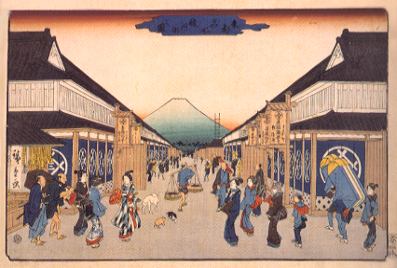

FIGURE 2

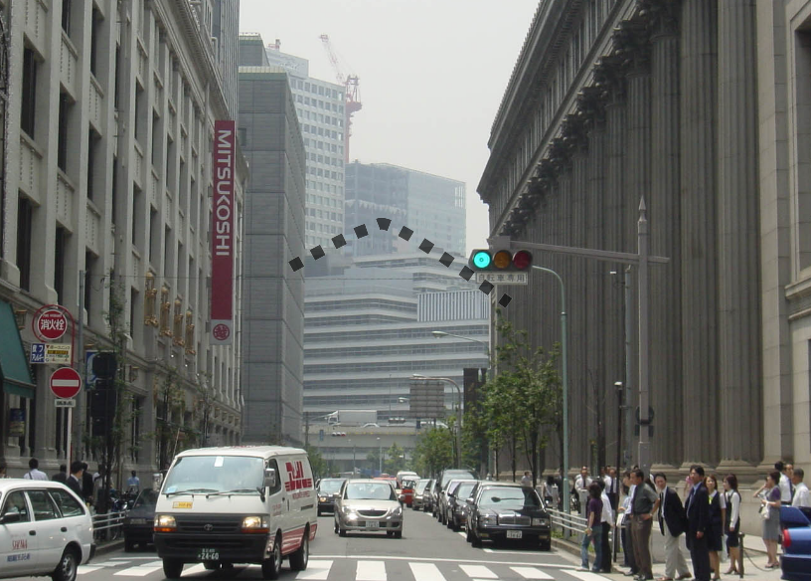

FIGURE 3

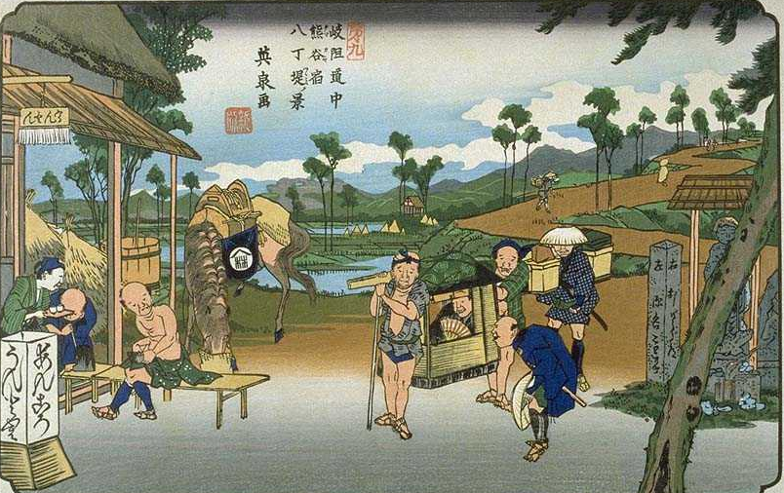

FIGURE 4

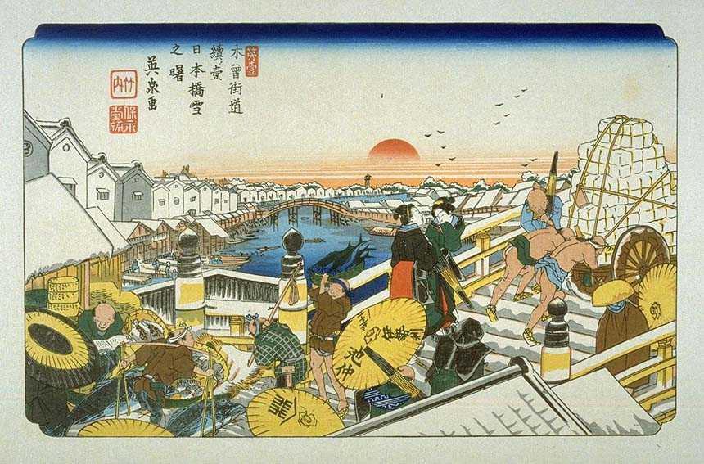

FIGURE 5

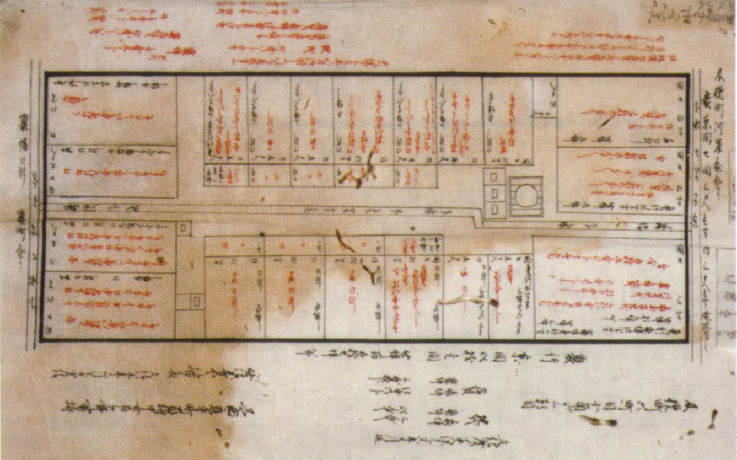

FIGURE 6

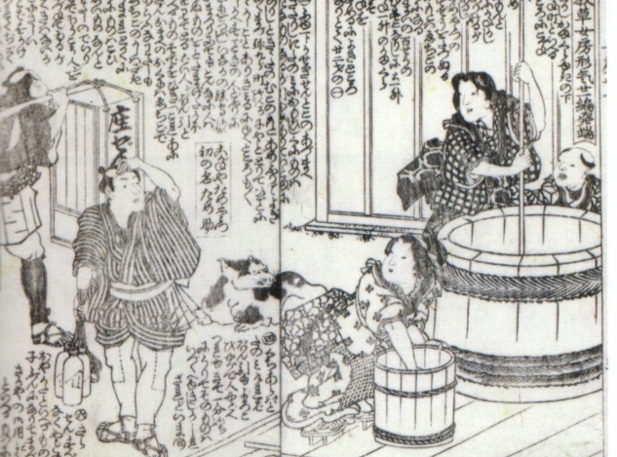

which meant ‘to be in the presence of and to render service to a Shinto deity’

