Transport and access of poor populations to education in Cape Town and Conakry

Dr. Roger Behrens*, Dr. Lourdes Diaz-Olvera** (corresponding author), Dr. Didier Plat** and Dr. Pascal Pochet**

* Department of Civil Engineering, University of Cape Town, Private Bag X3, Rondebosch, 7701, South Africa. Email: Roger.Behrens@uct.ac.za
** Laboratoire d'Economie des Transports, ENTPE-Université Lumière Lyon 2-CNRS, rue Maurice Audin, 69518, Vaulx-en-Velin Cedex, France. Email: diaz@entpe.fr; plat@entpe.fr; pochet@entpe.fr

Abstract

Strategies to eliminate poverty in Sub-Saharan Africa will need to incorporate measures to improve access to education systems. Schooling rates remain low in most countries. Factors hindering access to education need to be identified, and mitigating strategies developed. This paper explores access to education in Sub-Saharan cities from a transportation perspective. It compares two cities (Cape Town and Conakry) in two contrasting contexts. The cities are found to share high scholar dependency on walking amongst middle- and low-income bands, long travel times, broadly similar trip timing profiles, and an absence of cycling. Notwithstanding institutional constraints, some school travel planning interventions implemented elsewhere might hold promise in Africa on the grounds that they are implemented at relatively low cost and do not appear to rely greatly on public sector expertise, facilitation or funding, particularly measures focusing on improving low- or no-cost non-motorised transportation conditions for scholars.

1. Introduction

Most economists regard schooling as an essential investment in human capital (see, for instance, Bommier and Shapiro, 2001). From a household perspective, this investment is expected to improve income-generating potential in the future. From a societal perspective, the development of schooling systems and a rise in the educational status of populations as a whole are seen to improve labour productivity and economic performance, and in societies with gender disparities, offer a means of elevating the status of women. In Sub-Saharan African countries, improved education systems, and improved access to these systems, will have to form a central component of any strategy to eliminate poverty.

These countries have to provide schooling for a rapidly increasing number of children. In 2000, half of their populations were estimated to be under 18 years of age (Tabutin and Schoumaker, 2004). At the instigation of international funding agencies, school provision has diversified in recent years (Lange, 2002). Private schools (both non-denominational and denominational), and to a lesser extent community schools, have emerged in competition with public schools, resulting in what Solaux and Suchaut (2002) have called a “creeping privatisation”. This has increased the number of available places offered to children, but the high costs of these private and community schools have dissuaded many households from educating their children, particularly girls (Glick and Sahn, 1997; Bennell, 2002). This reticence to invest in education can also be explained by a perceived deterioration in the return on investment in education, due to a reduction of employment opportunities in the public, as well as the formal private, sectors. Thus, in spite of recent progress in school provision, schooling rates still remain low in a number of countries and significant progress towards the objective of universal primary education by 2015 set in the Millennium Development Goals pursued by the United Nations, has not been made (Bennell, 2002; Sahn and Stifel, 2003). It is clearly, therefore, of great importance to identify what factors hinder access to education in these countries, and what mitigating strategies can be pursued.

This paper explores the hitherto under explored field of access to education from a transportation perspective. In addition to an undersupply of schools, African cities are characterised by low rates of private car ownership, and limited public transport provision. Daily trips by children to schools are, therefore, often long and arduous (Diaz Olvera et al., 2005). The physical difficulty of accessing schools is a factor mentioned frequently in analyses of enrolment, grade repetition and completion rates nationally, and in rural contexts more specifically. Little research has been undertaken of the effects of school accessibility in urban areas, and even less in specific cities.

To improve current knowledge of scholar transport problems in African cities, this paper compares two contrasting African contexts (South Africa and Guinea), and more particularly, two major cities in these countries, Cape Town and Conakry, where household travel surveys were conducted in 2001 and 2003, respectively (Behrens, 2002; Sitrass, 2004). In the Cape Town survey, the sample was stratified into three equally sized (high, middle and low) combined household (gross) income bands. The sample of households was also clustered into selected transport zones of the metropolitan area (two zones for each income band) on the basis of ease of access to commercial and employment opportunities (see Behrens, 2004a for a fuller explanation of survey method). In the Conakry survey, the urban area was demarcated according to various indicators concerning living standards, availability of urban facilities and infrastructure, and accessibility. A sample of households was then clustered in 30 zones selected on the grounds that they contained large numbers of poor households. In Cape Town, 204 households and 678 persons were surveyed; in Conakry, 627 households and 2,073 persons over the age of 10 were surveyed. The surveyed period in both cases was the day before interviews.

The paper is divided into four sections. The next section describes the case study cities and their education system. Section 3 discusses the findings of the travel surveys administered in these two contexts in the light of household income categories and age of scholars. Section 4 concludes with a discussion on the policy implications of the survey findings with respect to the development of mitigating strategies.

2. Case studies

Guinea, which is only slightly urbanized, appears among the least developed countries, ranked 156th out of 177 in 2003 according to the United Nations Development Programme’s Human Development Index. With regard to education, its performance is lower than that of the Sub-Saharan Africa average (see table 1). Ranked 120th, South Africa’s situation is more favourable, but life expectancy is low and there is an imbalance between economic and education indicators, which are nevertheless higher than those of the other countries in the region.

→ insert Table 1 here

2.1 The case of Cape Town

Cape Town is a medium-sized city, with an ethnically diverse population currently estimated at 3.2 million. The economy has tended to perform better than other South African cities in the past decade, recording a mean annual growth rate of 2.5% for the period 1996-2000 (vs. a national growth rate of 2.1%). Formal activity and employment remain concentrated on a few historical corridors structured by the main roads and a suburban railway network, but a number of new secondary centres are gradually emerging. Unemployment remains an important problem, with some 18% of the economically active population unemployed and some 22% employed in the ‘informal sector’. The impoverishment of some groups of the population has induced a growth of criminality and associated societal problems, many of which are experienced in schools. Since the 1980s, the proportion of informal housing has increased. Relative to other African contexts, the access of the poor to urban facilities and opportunities is constrained more by affordability, than by low levels of service provision (Wilkinson, 2000).

Cape Town’s transport system is notable for its dualistic mode of operation in terms of the supply of services to two clearly distinguishable and roughly equally sized passenger market segments (Behrens and Wilkinson, 2003). The first segment cannot afford the costs associated with vehicle ownership and are therefore captive to whatever public transport services are provided, and to walking. The second segment has higher incomes and, while presented with a choice of modes, use their cars extensively. By South African standards the city has an extensive fixed road and rail infrastructure. The rail network is essentially radial, with multiple branch lines radiating from the city centre. Radial freeways also emanate from the city centre, overlapping an irregular grid of primary and secondary arterials (Figure 1). The public transport vehicle fleet and rolling stock is comprised of trains, scheduled buses, and partially regulated 15-seater paratransit minibus-taxis.
→ insert Figure 1 here

With regard to the South African education system, school life spans 13 years or grades, from grade 0, otherwise known as grade R or ‘reception year’, through to grade 12 or ‘matric’ – the year of matriculation. The matric pass rate, which was as low as 40% in the late 1990s, has improved in recent years, reaching 68.3% in 2005, but concerns around the quality of education remain.

South Africa has 12.3 million scholars, some 386,600 teachers and 26,292 schools (including 1,098 registered independent or private schools). In government-funded public schools, the average ratio of scholars to teachers is 32.6 to one, while private schools generally have one teacher for every 17.5 scholars. Of all schools, roughly 6,000 are high schools (grade 7 to grade 12) and the rest primary (grade 0 to grade 6). By law, education is compulsory from age 7 (grade 1) to age 15, or the completion of grade 9. While policies have been developed to assist poor households afford schooling costs, affordability remains a problem (International Marketing Council of South Africa website).

The national Department of Education is responsible for education across the country as a whole, while each of the nine provinces has its own education department. The central government provides a national framework for school policy, but administrative responsibility lies with the provinces. Power is further devolved to grassroots level via elected school governing bodies, which have a significant influence in the administration of their schools. Some provincial governments contract bus operators to provide school bus services, but this practice is not widespread.

2.2 The case of Conakry

Conakry, the capital of Guinea, with a population of approximately 1.3 million inhabitants in 2002, is the home of more than half of the national urban population. It has an unusual linear configuration, due to geographical conditions. The city currently extends for more than 30 kilometres on a south-western/north-eastern axis, with a width of only 2 to 6 kilometres in the narrowest areas (see figure 2). A rapid increase in population has resulted in densification of older districts, as well as the appearance of non-serviced new residential areas increasingly further away from the Point of Kaloum, where the administrative and business centre, the port, the main markets and the main bus station are located. Poverty affects more than 50% of inhabitants and is spread across the whole city. Furthermore, 38% of the 100 city districts are extremely poor, according to the Survey on Poverty in Conakry (Unicef and Governorship of Conakry, 1999).

→ insert Figure 2 here

Residential location choices are severely constrained by the low level of household incomes. Consequently, accessibility to urban services, and in particular to schools, has an insignificant influence on residential location. Only 1% of homeowners and 4% of tenants declare that locating closer to schools was a reason for their last house move.

Daily travel conditions are very difficult. Despite the relatively low number of private motor vehicles, radial arterials are heavily congested by the concentration of vehicles on the small number of roads and the disorganized operating conditions of the paratransit minibuses (“magbanas”) and shared taxis. Feeder roads are seldom paved, especially in the peripheral areas, and to reach a paved road, one has to walk on average 18 minutes in the outer districts as opposed to only 5 minutes in the centre. Due to affordability constraints of households and the penetration and frequency deficiencies of the public transport services provided, walking is by far the most common mode of transport (75% of trips of all lengths).

With regard to the education sector, the Guinean government, shortly after independence, pursued a number of policies to improve the education system as a way of addressing poverty and achieving national development. Despite some early improvements, the situation in the education sector deteriorated gradually. Since the mid-1980s, however, various programmes have been implemented to slowly reverse this trend. The enrolment rate for primary education is currently 85%, and inequalities between boys and girls have been reduced.

The opening up of private sector schools was authorized in the 1990s and their number has grown rapidly in recent years – in 2003 the ratio of public to private primary schools in Conakry was 1:5 (Bceom-Group Huit, 2003) and this imbalance is more acute in the districts further away from the central area (see figure 3). In some areas, the only available schools are privately funded.

→ insert Figure 3 here

Education in public schools is supposedly free but given the low resources of public institutions, households face a number of expenses. In 1999, according to the EDSG-II data, the schooling of a child in a public primary school involved an annual expenditure of FG 43,000, compared to FG 156,000 in a private school. These figures include items such as the purchase of books, supplies, and uniforms; transport, meals, and possible private lessons. They should be viewed in the context of an annual median income of those in employment at that time of FG 480,000 and therefore they show evidence of the greater strain on the budgets of poor households imposed by the limited financial resources in the education sector and the scarcity of public schools.

The education system in Guinea consists of six years of primary schooling, four years of lower secondary schooling, and three years of upper secondary schooling. Due to a number of cultural and socio-economic factors and deficiencies in education provision, delayed primary school enrolment, interruption and grade repetition are common in Conakry. Consequently, some students are withdrawn from school prematurely, while for others school life lengthens. Both situations are clearly observable in the 2003 survey. For instance, 73% of scholars aged 11-14 and 25% of scholars aged 15-18 are still in primary school. Among those aged 19-22, 33% are still in lower secondary school, 58% in upper secondary school and only 8% in tertiary education. Due to this age distribution, it is appropriate to include the 19-22 age group in scholar travel studies.

Of the sample population aged 6 to 22 years, 73% are in education. As highlighted by the sizeable literature on education in Sub-Saharan Africa, the proportion of children in education varies considerably according to the combination of three factors: age, gender and household income level (i.e. schooling rates decrease with increasing age and with decreasing household income, and girls are less frequently enrolled than boys). For young children (6-10 years), the differences in school enrolment according to these factors are small, but deepening gaps appear in older groups, particularly amongst children of 15 years or more. Even though gender enrolment disparities decline with household income, female schooling rates are low (see table 2). Among girls of 15-18 years from middle- and low-income households, half of them are in education and this proportion drops to around 30% for those aged 19-22 years. For girls from high-income households, these figures are higher, 60% and 42%, respectively, but still significantly lower than for boys.

→ insert Table 2 here

Boys are thus the majority among scholars (57%) for all income groups. Forty-seven percent of all scholars aged 6 to 22 are in primary education, 22% in lower secondary school, 20% in upper secondary school, and only 11% in tertiary education. The proportion of scholars in employment increases with age, especially among the poor - 16% of poor scholars aged 19-22 stated that they work (11% in the middle income households, and only 3% in the higher income households). Owing to the fact that the average size of households grows with decreasing household income level, the proportion of scholars from low-income households is higher (36%) than that of the other income groups (34% from the middle-income households, and 30% from the high-income households).

3. Scholar travel behaviour in Cape Town and Conakry

A number of surveys have been administered in Cape Town that provide data on scholar travel behaviour. This section therefore supplements the 2001 survey data mentioned earlier, with more recent data sources, some of which are from national surveys. With regard to Conakry, according to the household survey methodology, data on travel occurring on the day before the interview were collected only for individuals aged 11 and over. Consequently, the findings on Conakry scholars’ daily travel presented in this section relate only to the population aged 11-22.

3.1 Trip generation

Approximately 35% of Cape Town’s currently estimated 3 million population are children aged 18 years or less, and 25% are children of a school-going age. Crude estimations suggest that children aged 18 years or less account for around 30% of all daily trips (Behrens, 2004b). Data on trip generation suggest, as is the case for all age groups combined, that child trip generation (for all trip purposes) increases with household income (see figure 4). Amongst middle- and low-income households, older children (of 6-18 years) generate more trips than younger children (of 0-5 years). The inverse however appears to be the case amongst high-income households where young children undertake more trips – this is probably because of the greater coupling of infants to parents.

→ insert Figure 4 here

On average, scholars from Conakry travel as much as the total population sample, aged 11 and over (3.9 trips on average per weekday vs. 3.7 trips respectively) and the impact of household income on trip generation is lesser than in Cape Town. Figure 5 which illustrates the breakdown of scholars according to age and household income, shows that three groups of students have higher trip generation rates: the 15-18 age group from high-and middle-income households because they make more trips related to education, and the 19-22 age group from poor households, because they travel more for household maintenance activities (shopping, fetching water, etc.) and for work.

→ insert Figure 5 here

3.2 Trip purpose

Table 3 illustrates data on trip purposes amongst children of different age groups within different household income bands from Cape Town. The data indicate that, other than trips to home (from all out-of-home activities), the most common trip purpose amongst children from all household income bands and age group categories is education, followed by trips to social and recreational activities. While there are some variations in this pattern across age and income categories, there would appear to be a general consistency in the distribution of child trip purposes. The most notable differences perhaps being the greater proportion of shopping trips amongst high-income children, and the amount of serve passenger trips amongst high-income pre-school children (again presumably the result of greater trip coupling with parents responsible for transporting older siblings).

→ insert Table 3 here

Like in Cape Town, education, social and leisure activities are the major trip purposes in scholar travel in Conakry. They concern 38% and 30% of trips, respectively, while the remaining trips are mostly related to shopping and personal business. In contrast, this activity purpose distribution varies differently according to age and household income from the Cape Town case (see table 4). For all income groups, school is the major activity generating travel for the youngest, and its share in daily travel decreases with age. Conversely, social activities increase with age and they generate more travel for older scholars. Also, the analysis of the impact of income shows specific travel patterns of low-income scholars, through all age groups. On the one hand, they travel less to school, and on the other, they travel more for shopping and personal business, which contribute to the reproduction of the household. One trip out of four is undertaken for these activities.

→ insert Table 4 here

3.3 Trip timing

Figure 6 illustrates data on scholar trip timing by trip purpose in Cape Town. It suggests that children have a relatively simple trip timing profile, comprised of a spiked peak in trip departures to educational activities between 07h00 and 08h00 in the morning, followed by a more evenly distributed afternoon peak in trip departures to home stretching between 12h00 and 17h00 associated with varying school closing times for pre-, junior and senior schoolchildren.

→ insert Figure 6 here

In Conakry, journeys to and from school are concentrated in shorter time periods (see figure 7). Most trips to school also occur between 07h00 and 08h00. Older students, who typically have longer distances to travel to school, leave home earlier than younger students (between 07h00 and 07h30). The midday peak period stretches between 12h00 and 14h30 and it is largely associated with trips back home, given that 85% of the students attend school only in the morning. After 15h00 the share of education trips is very small.

→ insert Figure 7 here

3.4 Modal split

Travel surveys undertaken between 1999 and 2003 in 21 schools located in three heavily contrasting districts of Cape Town study school trip mode use (Behrens and Phillips, 2004). They show that scholars in lower income residential areas (Khayelitsha, serving a largely ‘Black’ low-income population, and Mitchells Plain, serving a largely middle- and low-income ‘Coloured’ population) are heavily reliant on walking as their primary mode of travel to school; minibuses and taxis come in second place. In contrast, most scholars in higher income areas (Blaauwberg, serving a largely high- and middle-income ‘White’ population) travel to school by car and walking is the second most important mode.

A similar pattern is observed in data from the 2003 National Household Travel Survey, which include urban and rural areas. For 93% of the poorest households, with an income less than R500 per month, walking is the main mode of transport to educational institutions. Among the most well-off households, with a monthly income higher than R16000, this figure drops to only 11% and the car is the main mode of transport for 75% of households.

Table 5 extends the scope of analysis to include child trips undertaken for all purposes in Cape Town. The table illustrates main mode use amongst children of different age groups within different household income bands. Two clear patterns can be observed from these data. The first is that walking increases as the main mode of travel, across all age groups, with declining household income. The second is that, amongst children in middle- and low-income household bands, the use of public transport modes increases with age. The former is clearly the result of lower household private mobility, while the latter presumably reflects greater independent child mobility and location of educational institutions further away from home.

→ insert Table 5 here

Analysis of the modal split of education trips in Conakry shows that, likewise in Cape Town, younger scholars walk more than the older scholars and the poor more than the wealthy. On average, three quarters of trips are made on foot, but the proportion varies markedly with age (92%, 74% and 40%, respectively for the three age groups considered), and declines sharply with increasing household income level (see table 6). The use of mechanised modes of transport, mainly public transport, for journeys to and from school becomes most frequent for students aged over 18, with the exception of those from low-income households for whom walking remains the main travel mode.

→ insert Table 6 here

Gender plays an important role in education trip modal splits (see table 7). Girls are less dependent than boys on walking as the main mode of transport to and from school, whatever their age, and especially from 15 years and older. There are no survey data to explain this particular trend in the mode use distribution, but at least two possible explanations can be advanced. On the one hand, the older the girl, the greater the perceived risks attached to school travel (e.g. road safety or assault), which might dissuade parents from allowing their daughters to walk. On the other hand, travel on foot might be perceived to be arduous, particularly if journeys are long, and it may be socially more acceptable for boys to walk than for girls.

→ insert Table 7 here

3.5 Trip duration

National data presented in figure 8 illustrate a surprisingly consistent mean travel time to school by all modes in urban and rural areas, with travel time declining slightly amongst wealthier households in metropolitan cities. Figure 9, however, illustrates that in relation to walking trips to school in metropolitan cities, mean walking time is 50% higher for the poorest households and the range of travel times also tends to be greater amongst these households, i.e. from 10 to 50 minutes, while for the wealthiest households it varies from 5 to 30 minutes.

→ insert Figure 8 here

→ insert Figure 9 here

Given the importance of walking amongst scholars, figure 10 presents National Household Travel Survey findings in urban and rural areas with respect to mean main mode walking times to education institutions disaggregated by household income and age. The figure illustrates a clear pattern of increasing walking times with decreasing household income (as already observed for metropolitan areas), and indicates older scholars walk for longer times than younger scholars.

→ insert Figure 10 here

On average, a trip between home and school takes 26 minutes in Conakry, which is similar to the mean value in South African urban areas. As in all world education systems, the higher the school in the education hierarchy, the fewer the facilities available, and the greater the average distance to school. This explains the increase with age in trip duration, for all travel modes, as has been observed above particularly for walking trips in South Africa. The mean walking trip duration is 17 minutes for the 11-14 age group, 21 minutes for the 15-18 age group, and 24 minutes for the 19-22 age group. The same trend is observed for mean durations for public transport trips: 42 minutes, 49 minutes and 55 minutes, respectively.

The impact of household income on trip duration in Conakry is not as clear cut as that of age of scholars and patterns are more pronounced for public transport travel, i.e. decreasing household income implies increasing trip duration. Trips to school in public transport for scholars aged 11-18 from high-income households take a little more than half an hour, while trip duration is nearly twice this for scholars from middle-income households and from low-income households in the 15-18 age group.

With nearly 4 trips per day, scholars’ average daily travel time budgets in Conakry are high: 61 minutes for the 11-14 age group, 81 minutes for the 15-18 age group and 101 minutes for the 19-22 age group. Owing to the structure of activity schedules, school trips represent more than half of the daily budget for scholars aged up to 18, and the share decreases for older students. Given that low-income scholars aged 15 and over travel less for school and use public transport less, their travel time budget is lower, by approximately 20% relative to scholars from the other income groups.

3.5 Transport expenditure

According to the 2003 Conakry survey, scholars travelling to school by public transport spend on average GF 527 per day. Assuming that a child attends school 20 days a month, the cost of school travel for one child rises to 26% of the median income for the population in employment. This cost is considerable and compounds the already high cost of schooling, particularly in private institutions, and even most so as it is common for households to include several children of school-going age. Household income is thus a determining factor, not only in the decision to educate children and the choice of the school, but also in how children travel to school, particularly to schools located far from the home.

3.6 Road crash causalities

Road traffic crashes in Cape Town are a problem of almost crisis proportions. Of the 689 people killed in road crashes in 2004, an alarming 60% were pedestrians (see figure 11). Even more alarming perhaps is the proportion of child pedestrian fatalities. The anatomical and physiological differences between paediatric and other road crash victims, particularly the height of head, chest and abdomen relative to the point of impact with the colliding vehicle, make children particularly at risk. It is not surprising then that data from 1997 and 1999 indicate around 19-33% of pedestrian fatalities are children aged 12 years or less, and 24-43% are children aged 17 years or less (see figure 12). The available data indicate around 31-38% of pedestrian injuries are children aged 12 years or less, and 41%-52% are children aged 17 years or less. These figures are disproportionate with the city population’s age distribution – 1996 national census data indicate that 25% of the population are 12 years old or less, and 34% are 17 years old or less. These data suggest that the 6-12 age group is particularly vulnerable, and even most so as a significant proportion of scholars from middle- and low-income households walk to and from school.

→ insert Figure 11 here

→ insert Figure 12 here

4. Conclusion: possible mitigating strategies

Differences in survey method and instrument prevent precise comparisons of scholar travel behaviour in the two city contexts, and even crude comparisons are not possible with regard to travel expenditure and crash rates, because the Cape Town data do not include the former and the latter are not collated in Conakry. Nevertheless some differences between, and similarities in, the two contexts can be observed. The main differences take the form of significantly higher car passenger use amongst the higher income band in Cape Town, and higher public transport use in the higher income band in Conakry (despite Cape Town’s more extensive scheduled public transport system). The main similarities take the form of an unsurprising high dependency on walking amongst middle- and low-income bands, long travel times, broadly similar trip timing profiles, and an absence of cycling.

Survey data in Conakry suggest that in the case of scholars for whom public transport use is necessary for school trips, transport expenditure imposes a greater strain on household budget. In low-income settings, as is the case in most Sub-Saharan African countries, travel conditions can therefore weigh heavily on schooling and more specially on completion of primary school and the continuation of education. Even though gender disparities have been reduced, they have not been removed and the share of girls in education decreases sharply with age and increasing level of education. Constraints in school travel expenditure for girls are then added to other cultural and economic factors that hinder their education.

If education goals are to be fulfilled, provision of schools is not enough – the affordability of schools and quality of education are primary factors, but accessibility is also essential, like for other urban facilities. The above findings on travel to school show evidence of travel conditions and of a number of difficulties which scholars face, such as long trips to and from school on foot, high transport expenditure, and road insecurity, particularly for scholars from poor households. However, available survey data in both case studies cannot furnish an accurate measure of the influence of accessibility to educational institutions on schooling rates. Further research work on this area is therefore necessary.

With regard to the scholar transport problems of poor, unsafe and inequitable access prevalent in these contexts, particularly amongst poorer groups, how might they be addressed by mitigating strategies? A review of scholar transport policies and strategies in other parts of the world, suggests that some interventions implemented elsewhere might hold promise on the grounds that they are relatively low-cost and do not appear to rely greatly on public sector expertise, facilitation or funding. A significant development in scholar travel internationally has been the emergence of school travel planning practices, labelled differently in various parts of the world (e.g. ‘safe routes to schools’ in the United Kingdom and United States, ‘travelwise to schools’ in New Zealand, ‘travelsmart to school’ in Australia). A school travel plan essentially assembles a co-ordinated package of measures to improve scholar road safety, ease traffic congestion and encourage scholars and parents to consider walking and cycling to school as an alternative travel mode. Such measures might include the establishment of lift clubs, walking buses, scholar crossing patrols, the provision of cycle parking, pedestrian crossing facilities, etc. The travel plan is typically drawn up through a consultative planning process involving teachers, parents, pupils, local authority representatives and local community groups.

Some school travel planning measures will have greater prospects of success in Cape Town, where municipal budgets and private car use is higher. So, for instance, staggered school start times might be investigated as a means of peak spreading, and ‘school zones’ could be delimited, within which surrounding networks are subjected to special traffic claming and management retrofits.

Other strategies have prospects in both contexts. Perhaps most importantly, given the heavy reliance on low- or no-cost non-motorised transportation in both cities, strategies aimed at facilitating improved conditions for walking and cycling to school, such as ‘walking buses’ and ‘cycle trains’, hold the greatest promise. A ‘walking bus’ is an organised walking group of usually younger children led by adults. The benefits of the ‘bus’ include improved safety and security. The latter of particular importance for girls, and potentially a factor in persuading parents in Conakry not to terminate their daughters’ education prematurely. Parents wait at a series of ‘bus stops’ along identified routes for parent volunteers to pick-up or drop-off their children on their way to or from school. ‘Cycle trains’ operate on essentially the same principles, and could be facilitated by the low-cost bicycle distribution non-governmental organisations already operating in Sub-Saharan Africa (e.g. ICE, BEN, ITPD, FABIO). The implementation of ‘cycle trains’ in under serviced districts, however, could be difficult owing to the lack of infrastructures for cycling.

In instances where distances are too great for non-motorised travel, affordable public transport services will be required. This could take the form of contracted subsidised school bus services, negotiated arrangements with paratransit operators, or use of appropriately scheduled public transport services if they exist. Given the current state of roads and of public transport services and financial constraints, the prospect for any of these options in Conakry is limited. Despite current institutional constraints, however, there does appear to be at least some scope for improving scholar travel conditions in Sub-Saharan contexts.

References

Bceom- Group Huit. (2003) Etude de faisabilité d’un programme prioritaire d’aménagement des quartiers sous-équipés de Conakry. Rapport de phase 1. Rapport pour la Direction Nationale de l’Aménagement du Territoire et de l’Urbanisme, Ministère de l’Urbanisme et de l’Habitat de la République de Guinée, 196 p.
Behrens R and Phillips B. (2004) Findings of learner travel surveys in Cape Town, and the prospects of establishing a longitudinal learner travel database, 23rd Southern African Transport Conference: Getting Recognition for the Importance of Transport, Pretoria.
Behrens R and Wilkinson P. (2003) Metropolitan transport planning in Cape Town, South Africa: a critical assessment of key difficulties”, Working Paper No. 5, Urban Transport Research Group, University of Cape Town.
Behrens R. (2004a) Understanding travel needs of the poor: towards improved travel analysis practices in South Africa, Transport Reviews, 24(3), pp317-336.
Behrens R. (2004b) Child and learner travel in Cape Town: Problems and prospects, Urban Forum, 15(3), pp254-278.
Bennell P. (2002) Hitting the target: Doubling Primary School Enrolments in Sub-Saharan Africa by 2015, World Development, 30(7), pp1179-1194.
Bommier A. and Lambert S. (2000) Education Demand and Age at School Enrolment in Tanzania, The Journal of Human Resources, 35(1), pp177-203.
Bommier A. and Shapiro D. (2001) Introduction à l’approche économique de la demande d’éducation, in Pilon M., Yaro Y. (dir.), La demande d’éducation en Afrique. Etat des connaissances et perspectives de recherche, UEPA, Dakar, 49-62 (Coll. Réseau sur la famille et la scolarisation en Afrique, n° 1).
Canagarajah S. and Coulombe H. (1998) Child Labor and Schooling in Ghana, World Bank, Washington DC, 44 p. (Policy Research WP n° 1844).
City of Cape Town. (2000) Cape Metropolitan Area: Traffic accident statistics 1999” Directorate Transportation and Traffic, City of Cape Town.
Diaz Olvera L., Plat D. and Pochet P. (2005) Les quartiers sans la ville ? Accès aux services, transport et ségrégation urbaine en Afrique Subsaharienne, in Buisson M.-A., Mignot D. (éds), Concentration économique et ségrégation spatiale, Ed. de Boeck,, Bruxelles, 245-261.
DoT (2005) National household travel survey 2003: Technical Report, Department of Transport, Pretoria.
Glick P. and Sahn D. E. (1997) Gender and Education Impacts on Employment and Earnings in West Africa: Evidence from Guinea, Economic Development and Cultural Change, 45(4), pp793-823.
Grootaert C. (1998) Child labor in Côte d’Ivoire: incidence and determinants, World Bank, Washington DC, 80 p. (World Bank Policy Research WP n° 1905).
International Marketing Council of South Africa website, http://www.southafrica.info, accessed on 29/11/2006
Kane L. (2006) Transport problems associated with poverty in South Africa, National Household Travel Survey Seminar: Understanding travel habits and transport conditions in Southern Africa, Pretoria.
Kobiané J.-F. (2002) De la campagne à la ville, constances et différences dans les déterminants de la scolarisation des enfants au Burkina Faso, Conference « La recherche face aux défis de l’éducation au Burkina Faso », INSS/CNRST-IRD-AREB, Ouagadougou, 19-22 novembre, 18 p.
Lange M.-F. (2002) Politiques publiques d’éducation, in Lévy M. (dir.), Comment réduire pauvreté et inégalité : pour une méthodologie des politiques publiques, IRD-Karthala, Paris, p. 37-59.
Nielsen H. S. (1998) Child Labor and School Attendance : Two Joint Decisions, Aarhus, CLS (Centre for Labour Market and Social Research), 32 p. (Working Paper 98-15).
Pooley C. G., Turnbull J. and Adams A. (2005) A Mobile Century? Changes in Everyday Mobility in Great-Britain in the Twentieth Century, Aldershot, Ashgate, 251 p.
Sahn D. E. and Stifel D. C. (2003) Progress Toward the Millennium Development Goal in Africa, World Development, 31(1), pp23-52.
Sitrass. (2004) Pauvreté et mobilité urbaine à Conakry. Rapport Final, Lyon-Arcueil, 154 p. (Research report for the World Bank - SSATP), (http://www4.worldbank.org/afr/ssatp/Resources/PapersNotes/Conakry.pdf).
Solaux G. and Suchaut B. (2002) La privatisation « rampante » des systèmes éducatifs d’Afrique sub-saharienne, Communication au colloque ARES « Les voies de scolarisation alternative en Afrique sub-saharienne », Strasbourg, 22 mai, 17 p.
Tabutin D. and Schoumaker B. (2004). La démographie de l’Afrique au sud du Sahara des années 1950 aux années 2000. Synthèse des changements et bilan statistique, Population, 59(3-4), pp521-622.
UNDP. (2005) Human Development Report 2005, New York, UNDP, 372 p.
Unicef and Governorship of Conakry. (1999) Élaboration d’une cartographie de la pauvreté urbaine de la ville de Conakry, Conakry, 54 p.
Wilkinson P. (2000) City profile: Cape Town, Cities, 17(3), pp 195–205.
Zoungrana C. M., Tokindang J., Marcoux R. and Konaté M. (1998) La trajectoire scolaire des filles à Bamako. Un parcours semé d’embûches, in Lange M.-F. (dir.), L’école et les filles en Afrique. Scolarisation sous conditions, Karthala, Paris, 167-196.

Table 1. Human Development Indexes for Guinea and South Africa (2003)
 | Guinea | South Africa | Sub-Saharan Africa
Human development index (HDI) value | 0.466 | 0.658 | 0.515
Life expectancy at birth (years) | 53.7 | 48.4 | 46.1
Adult literacy rate (% ages 15 and above) | 41 | 82.4 | 61.3
Combined gross enrolment ratio for primary, secondary and tertiary schools (%) | 41 | 78 | 50
GDP per capita (PPP US$) | 2,097 | 10,346 | 1,856
Life expectancy index | 0.48 | 0.39 | 0.35
Education index | 0.41 | 0.81 | 0.56
GDP index | 0.51 | 0.77 | 0.63
Source: UNDP, 2005

Table 2. Percentage of boys and girls in education by age and household income in Conakry*
 |  | Boys | Girls
6-10 years | high-income | 90 | 83
6-10 years | middle-income | 83 | 78
6-10 years | low-income | 82 | 81
11-14 years | high-income | 91 | 87
11-14 years | middle-income | 89 | 78
11-14 years | low-income | 89 | 79
15-18 years | high-income | 76 | 60
15-18 years | middle-income | 79 | 51
15-18 years | low-income | 74 | 49
19-22 years | high-income | 60 | 42
19-22 years | middle-income | 58 | 29
19-22 years | low-income | 54 | 30
All | high-income | 82 | 70
All | middle-income | 79 | 64
All | low-income | 77 | 66
* Let us consider the first line, for example. Amongst children aged 6-10 years from high-income households, 90% of boys and 83% of girls are in education.
Source: Data from the 2003 Poverty and Urban Mobility Household Survey
Table 3. Percentage child trip destination activity purpose* by age and household income in Cape Town
 |  | work | education | shopping | business | social | pers. bus. | recr. | serve pass. | home
pre-school children  (0-5 yrs) | high-income | 0 | 22 | 3 | 0 | 16 | 3 | 5 | 14 | 38
pre-school children  (0-5 yrs) | middle-income | 0 | 20 | 0 | 0 | 25 | 0 | 10 | 0 | 45
pre-school children  (0-5 yrs) | low-income | 0 | 25 | 0 | 0 | 0 | 6 | 19 | 0 | 50
junior school children  (6-12 yrs) | high-income | 3 | 26 | 3 | 0 | 10 | 6 | 13 | 0 | 39
junior school children  (6-12 yrs) | middle-income | 1 | 24 | 3 | 0 | 6 | 0 | 18 | 2 | 46
junior school children  (6-12 yrs) | low-income | 2 | 29 | 0 | 0 | 11 | 2 | 11 | 0 | 45
senior school children  (13-18 yrs) | high-income | 0 | 38 | 9 | 0 | 6 | 0 | 3 | 0 | 44
senior school children  (13-18 yrs) | middle-income | 1 | 17 | 4 | 0 | 19 | 0 | 13 | 1 | 45
senior school children  (13-18 yrs) | low-income | 0 | 33 | 3 | 0 | 15 | 3 | 0 | 0 | 48
* work= trips to the site of a person’s place of employment or income generation, educ.= trips to education activities, shop.= trips to retail establishments irrespective of whether a purchase is actually made, bus.= trips undertaken during working hours for business purposes, social= trips to social activities (e.g. visiting family and friends), pers. Bus.= trips to personal business activities (e.g. to health and dental care facilities, welfare offices, police stations, possible employers, etc.), rec.= trips to recreational activities (e.g. cinemas, restaurants, sports facilities, etc.), serve pass.= trips undertaken for the purpose of transporting someone else to or from an activity site, home= trips to a place of residence.
Source: Data from the 2000-2001 Household Travel Survey (Behrens, 2004b)

Table 4. Trip-purpose distribution for scholars by age and household income in Conakry (%)
 |  | Work | Education | Shopping | Social | P. Business | Recreation | Serve Pass. | Other
11-14 yrs | high-income | 4 | 46 | 7 | 15 | 6 | 15 | 7 | 0
11-14 yrs | middle-income | 0 | 44 | 9 | 21 | 11 | 13 | 2 | 0
11-14 yrs | low-Income | 1 | 41 | 11 | 14 | 14 | 16 | 2 | 0
15-18 yrs | high-income | 0 | 41 | 14 | 21 | 10 | 13 | 2 | 0
15-18 yrs | middle-income | 2 | 38 | 8 | 24 | 13 | 11 | 4 | 1
15-18 yrs | low-Income | 2 | 35 | 16 | 24 | 8 | 14 | 1 | 0
19-22 yrs | high-income | 0 | 33 | 14 | 36 | 4 | 9 | 4 | 0
19-22 yrs | middle-income | 0 | 28 | 6 | 43 | 16 | 6 | 2 | 0
19-22 yrs | low-income | 3 | 28 | 10 | 30 | 14 | 11 | 4 | 0
Source: Data from the 2003 Poverty and Urban Mobility Household Survey
Table 5. Percentage child main mode use for all trips by age and household income in Cape Town
 |  | walk | Public transport | car passenger | other
pre-school children  (0-5 yrs) | high-income | 0 | 0 | 97 | 3
pre-school children  (0-5 yrs) | middle-income | 35 | 0 | 65 | 0
pre-school children  (0-5 yrs) | low-income | 88 | 12 | 0 | 0
junior school children  (6-12 yrs) | high-income | 10 | 0 | 90 | 0
junior school children  (6-12 yrs) | middle-income | 75 | 6 | 19 | 0
junior school children  (6-12 yrs) | low-income | 69 | 31 | 0 | 0
senior school children  (13-18 yrs) | high-income | 9 | 3 | 88 | 0
senior school children  (13-18 yrs) | middle-income | 60 | 16 | 24 | 0
senior school children  (13-18 yrs) | low-income | 67 | 28 | 5 | 0
Source: Data from the 2000-2001 Household Travel Survey (Behrens, 2004b)
Table 6. Modal splits for education trips by age and household income in Conakry (%)
 |  | Walk | Public Transport | Private Vehicle
11-14 years | high-income | 79 | 21 | 0
11-14 years | middle-income | 96 | 4 | 0
11-14 years | low-Income | 97 | 3 | 0
15-18 years | high-income | 67 | 33 | 0
15-18 years | middle-income | 76 | 24 | 0
15-18 years | low-Income | 78 | 22 | 0
19-22 years | high-income | 25 | 70 | 5
19-22 years | middle-income | 40 | 60 | 0
19-22 years | low-Income | 58 | 42 | 0
All | high-income | 62 | 37 | 1
All | middle-income | 82 | 18 | 0
All | low-Income | 84 | 16 | 0
Source: Data from the 2003 Poverty and Urban Mobility Household Survey
Table 7. Modal split for education trips by age and gender in Conakry (%)*
 | Walk | Public Transport | Private Vehicle
11-14 years | 92 | 8 | 0
Boys | 94 | 6 | 0
Girls | 89 | 11 | 0
15-18 years | 74 | 26 | 0
Boys | 79 | 21 | 0
Girls | 65 | 35 | 0
19-22 years | 40 | 58 | 2
Boys | 46 | 51 | 3
Girls | 28 | 72 | 0
All | 77 | 23 | 0
Boys | 80 | 19 | 1
Girls | 71 | 29 | 0
* Let us consider the first and second lines, for example. Amongst children aged 11-14 years, 92% of education trips are made on foot and 8% by public transport. For boys of the same group of age, these figures are respectively 94% and 6%.
Source: Data from the 2003 Poverty and Urban Mobility Household Survey

Figure 1. Cape Town

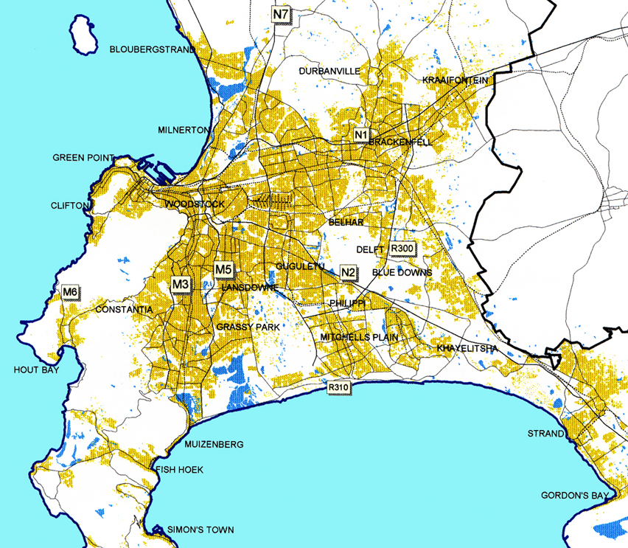
Source: City of Cape Town
Figure 2. Conakry

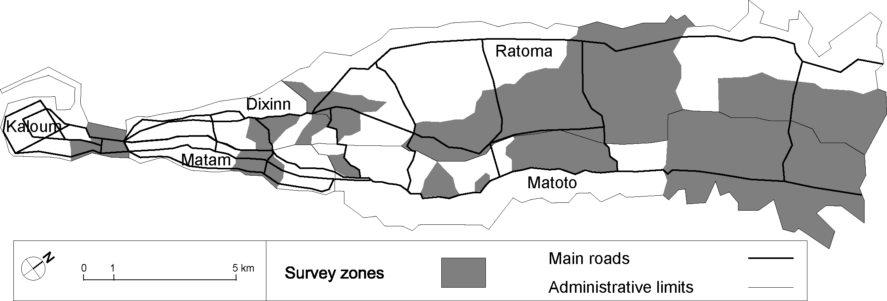
Source: Map elaborated with Philcarto - http://perso.club-internet.fr/philgeo
Figure 3. Number of public and private primary schools by district in Conakry (2003)

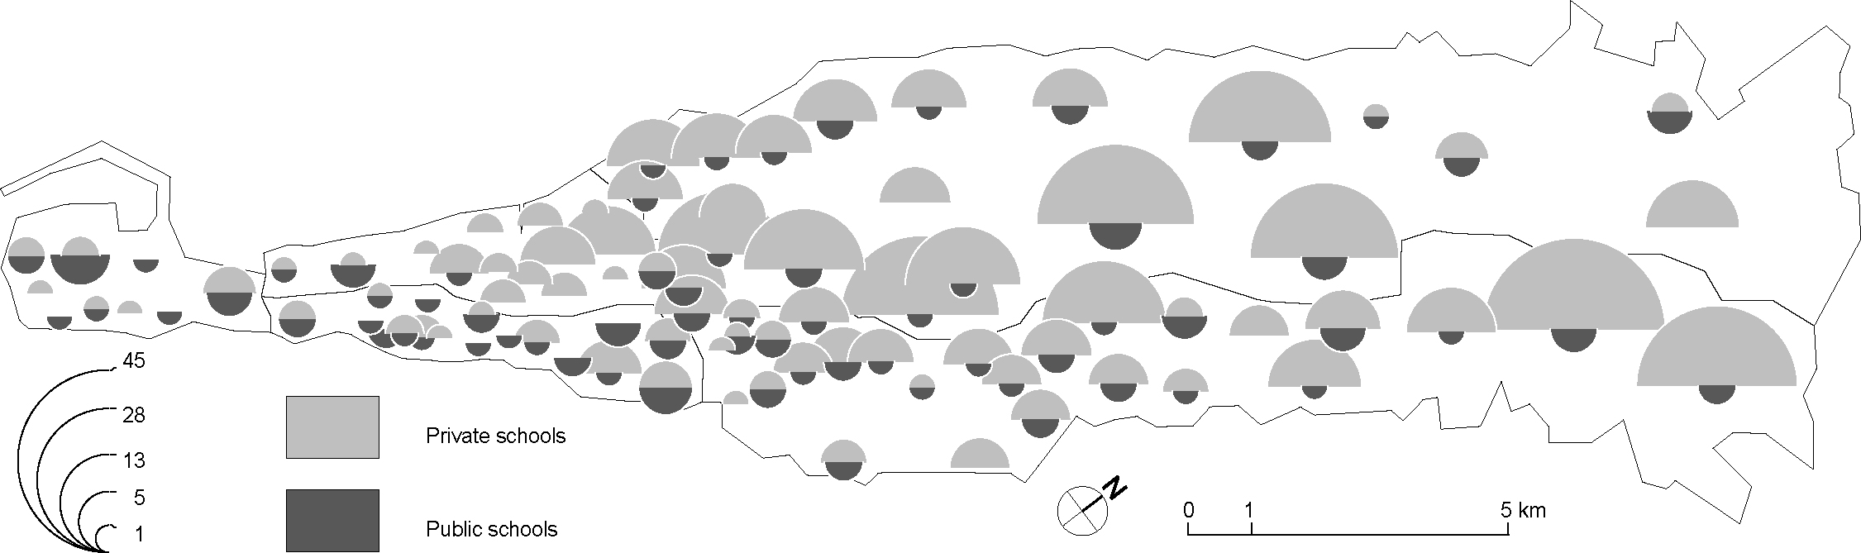

Source: Map elaborated with Philcarto - http://perso.club-internet.fr/philgeo
Figure 4. Child trip generation by age and household income in Cape Town
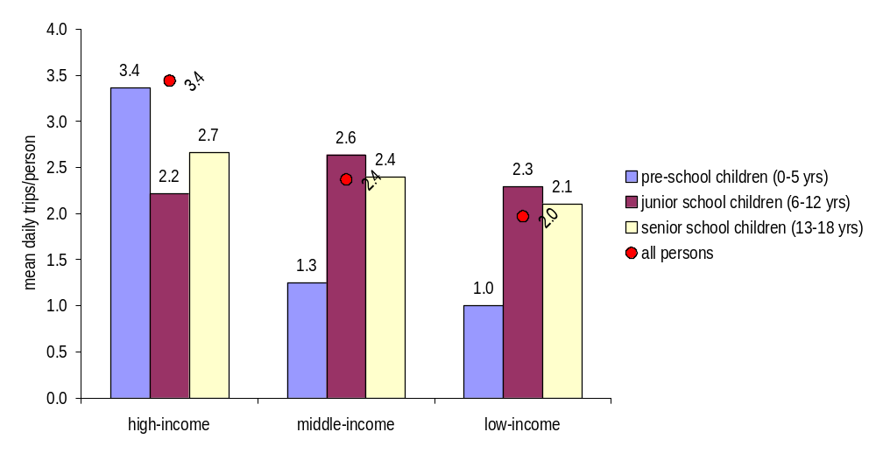
Source: Data from the 2000-2001 Household Travel Survey (Behrens, 2004b)
Figure 5. Mean trip generation, by age and household income in Conakry
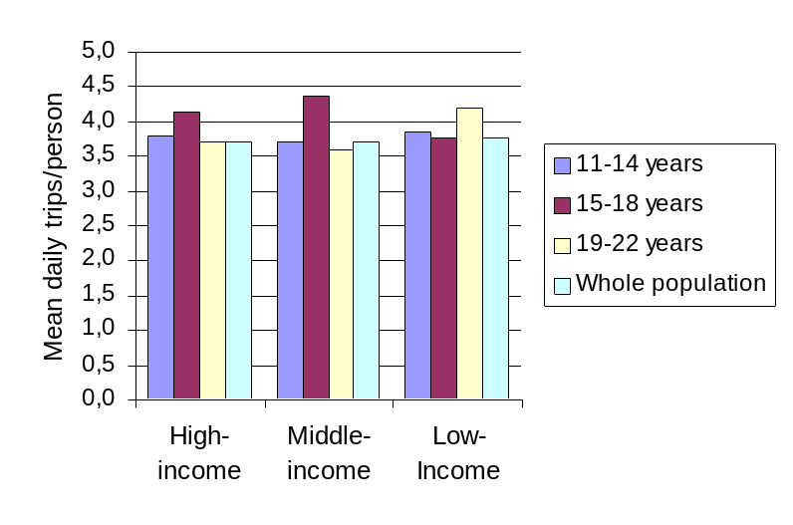
Source: Data from the 2003 Poverty and Urban Mobility Household Survey
Figure 6. Weekday child (0-18 years) trip timing by destination activity purpose in Cape Town
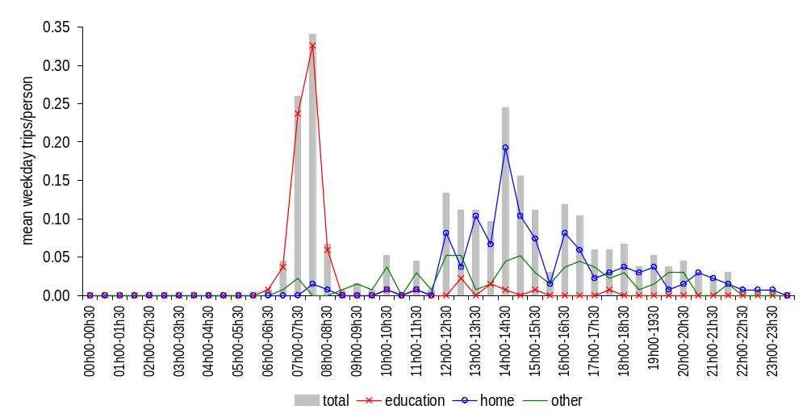
Source: Data from the 2000-2001 Household Travel Survey (Behrens, 2004b)
Figure 7. Percentage of weekday scholar (11-22 years) trip timing for education and other activity purposes in Conakry
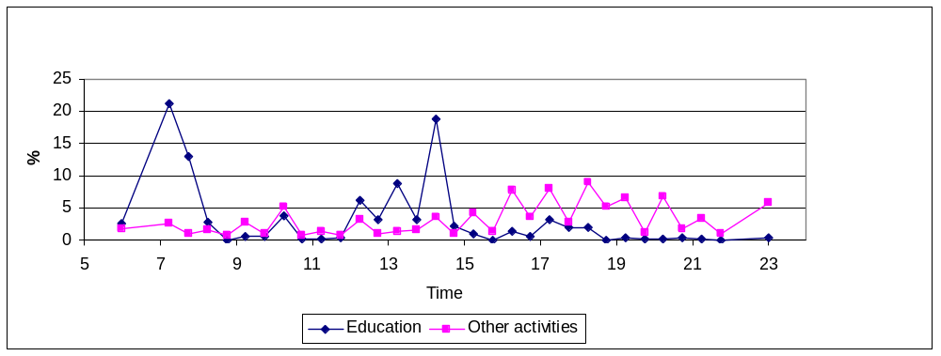
Source: Data from the 2003 Poverty and Urban Mobility Household Survey
Figure 8. Mean travel time to school by quintile and settlement type in South Africa
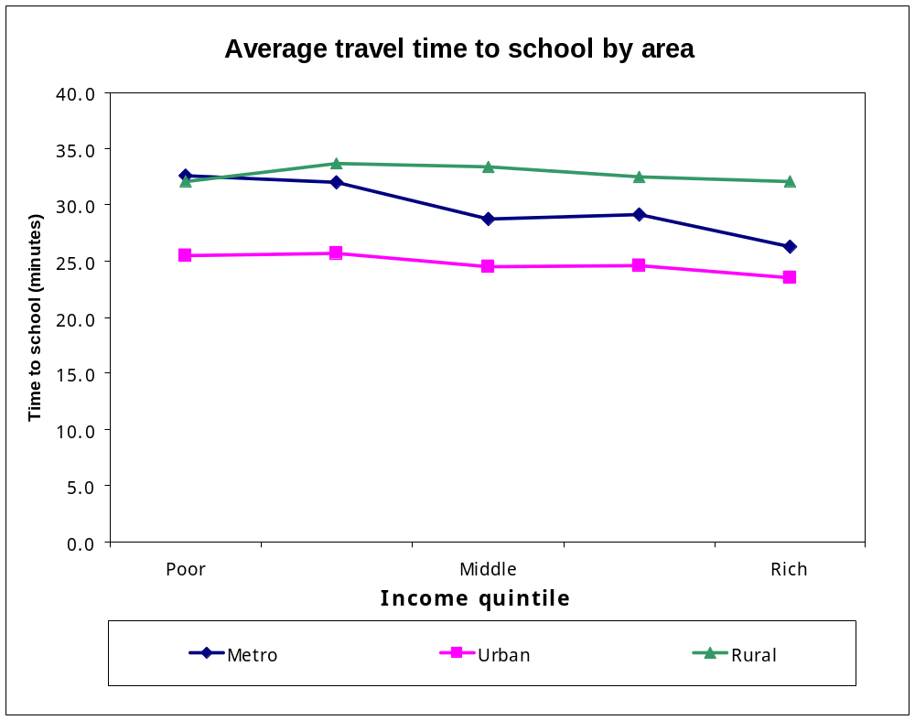
Source: Data from the 2003 South African National Household Travel Survey (Kane, 2006)
Figure 9. Mean and standard deviation walk time to school by quintile in South Africa metropolitan areas
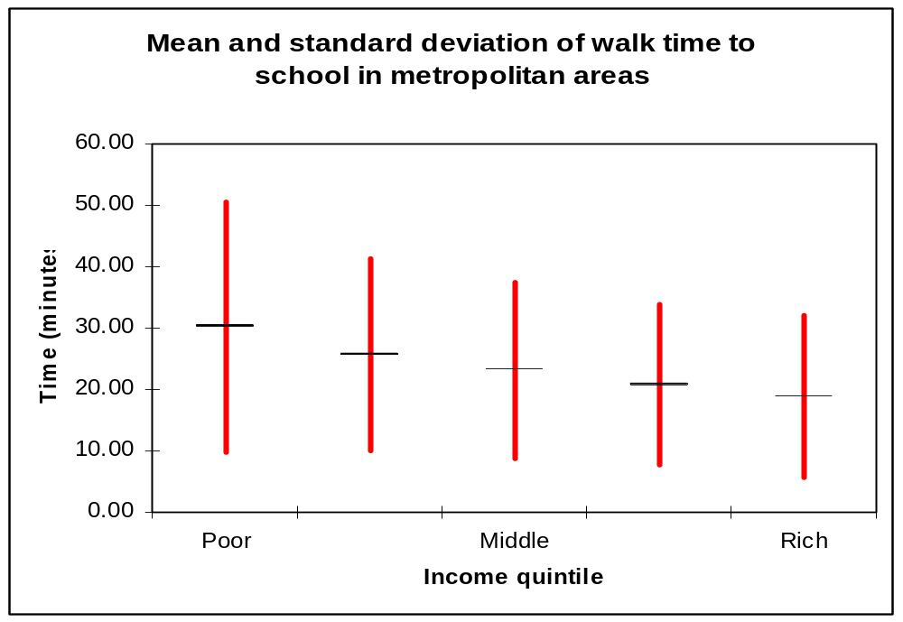
Source: Data from the 2003 South African National Household Travel Survey (Kane, 2006)
Figure 10. Mean main mode walking travel time (in minutes) to educational institutions, by household income and age in South Africa

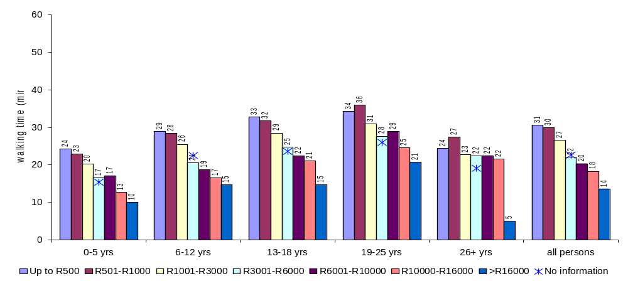
Source: Data from the 2003 South African National Household Travel Survey
Figure 11. Number of fatalities and fatal road crashes in Cape Town: 1997-2004
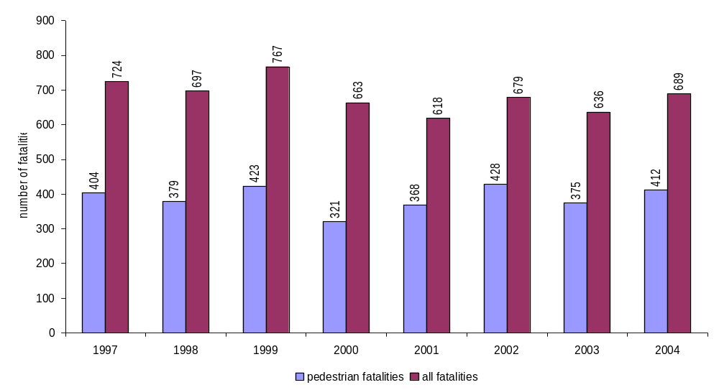
Source: City of Cape Town
Figure 12. Pedestrian road crash fatalities and injuries by age in Cape Town: 1997-1999
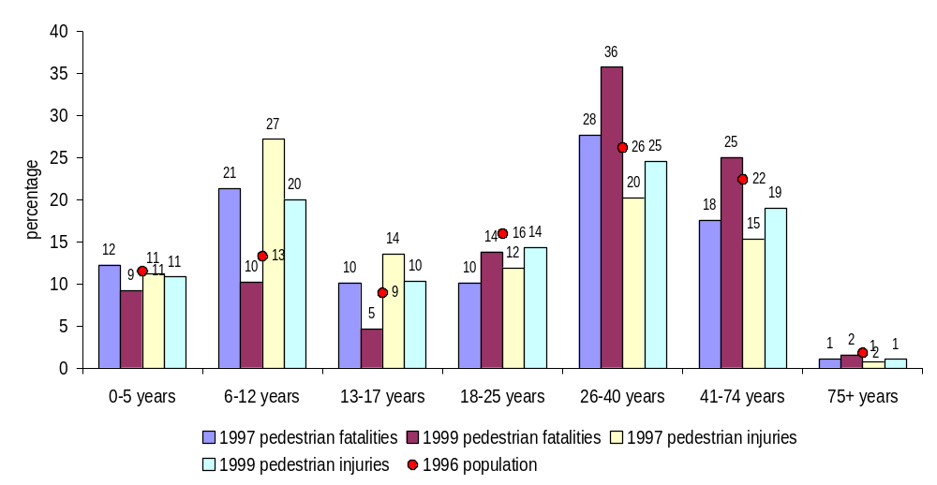
Note: These data include both serious and slight injuries. Serious injuries are defined as including fractures, crushings, concussion, internal injuries, severe cuts and lacerations, severe shock requiring medical treatment, and any other injuries which necessitate hospitalisation or confinement to bed. Slight injuries include cuts and bruises, sprains and light shock not requiring hospitalisation. A fatal injury is defined as an injury that causes death, either immediately or within seven days of the crash.
Source: City of Cape Town, 2000
Footnotes:

The results of the few studies that have been undertaken are inconsistent. Grootaert (1998) in Ivory Coast and Nielsen (1998) in Ghana, for instance, did not find travel distance to be a problem, Kobiané (2002) found only a minor impact of distance in urban Burkina Faso, while Bommier and Lambert (2000) found a significant distance effect in urban Tanzania. For Canagarajah and Coulombe (1998) distance is not a factor in Accra, while in Ouagadougou Kaboré and Pilon (2003) argue that a lack of schools in peripheral districts and associated long travel distances dissuades parents from sending their children to school. Zoungrana et al. (1998), on the other hand, found that long distances to school in Bamako are the third most significant cause of non-enrolment of girls.
The average size for high-income households is 9 persons, 10 persons for middle-income households and 11 persons for low-income households.
Data on school travel expenditure is not available in the case of Cape Town.
Data on road safety with regard to school-going children is not available for Conakry.
Negotiated arrangements with paratransit operators have proved problematic in some cases. In Dar es Salam for instance, authorities tried to impose a half price fare for scholars travelling on 'dala dala' minibuses. Because operators were not adequately compensated for fare losses, scholars were frequently ejected from the vehicles in favour of full fare passengers, and subjected to abuse by conductors and drivers.

