

Workplace Journey Planners

Identifying access options to employment opportunities

Kathryn A Cooper
Renfrewshire Council

The World Conference on Transport Research Society April 2007

Abstract

Workplace Journey Planners

This initiative developed materials to assist Jobcentre Plus staff to identify employment opportunities for their clients in locations that would otherwise have been discounted on the basis of being perceived as inaccessible by public transport due to lack of awareness resulting in employers being more able to retain staff long term. Initial evaluation and feedback on the success of this initiative is very positive.

INTRODUCTION

Overview

Increasing congestion on the Scottish road network and its causes and effects are similar to those being faced in many parts of the world and these are generally well documented. The significance of this problem is illustrated by the increase in the percentage of those commuting to work by car which has risen from 21% in 1966 to 68% in 2001 (General Register Office for Scotland, 2001).

The above statistic was confirmed by the Scottish Household Survey (Scottish Executive, 2005) which also showed that car use was linked to increased affluence in that 38% drive to work from households with an income of up to £10,000, rising to 77% for commuters from households earning more than £40,000 which also has implications for travel patterns.

In addition, it is well known that increased levels of vehicle-use have been shown to have an adverse effect on the environment and people’s health.

The need to balance the pressure for increased car use with the need to ensure free movement of freight around the country to maintain Scotland’s economic competitiveness are also detailed in the Freight Action Plan for Scotland (Scottish Executive, 2006).

This therefore presents a dilemma. A buoyant economy leads to increased affluence, increasing car ownership and usage, leading to congestion which adversely affects the economy and the health of the population.

Travel planning in the UK

Benefits associated with lower traffic growth such as environmental benefits through reduced carbon emissions and health improvements associated with higher levels of walking and cycling have been recognised for some time.

Travel planning is one method of addressing some of the difficulties faced by today’s businesses. It should be recognised that although travel planning in one form or another has been around for many years the concept started to gain a profile during the 1990s’ in particular when it was identified by the UK Government as a potential method of reducing the rate of traffic growth such that demand was managed without the need for major capital investment in increased road space. It was also identified that benefits to the economy could be realised through more efficient business practices (DETR, 2000).

Scottish Executive (StepChange Initiative)

More recently (2003), the Scottish Executive also introduced a pilot study for the ‘Stepchange’ initiative under the control of a Steering Group comprising members from the Scottish Executive and three Local Authorities (Councils). The Scottish Institute of Sustainable Technology (SisTech) provided independent evaluation and overall management of this initiative. Project management was carried out by transportation consultants, with funding being made available by the Scottish Executive to engage a small team in the field (Stepchange project team) to serve the three pilot areas. In addition, a marketing company was engaged to raise the profile of the initiative.

The purpose of this project was to support, encourage and accelerate modal shift from car to public transport, walking and cycling, by promoting methods that would allow people to change their travel behaviour. Renfrewshire was one of three pilot areas in Scotland chosen to support this study. In Renfrewshire the pilot project was to focus on travel behaviour change in a selection of workplaces, although involvement with schools and local communities was also undertaken.
A LOCAL CONTEXT

Renfrewshire

Renfrewshire lies in the central belt of Scotland on the western edge of the Glasgow conurbation with an estimated mid-year population of 170,000 (Renfrewshire Council, 2006), making it the 9th largest local authority (out of 32) in Scotland. (Appendix A).

Renfrewshire’s eastern section contains a number of towns which form an integral part of the conurbation with Paisley at the centre. Paisley’s population is approximately 75,000. Other towns in the area include Renfrew (20,000), Erskine / Inchinnan (18,000), Johnstone (16,000) and Linwood (9,000). The remainder of Renfrewshire is predominantly rural with a number of smaller outlying settlements which tend to have a large proportion of commuter residents.

Employment

In 2001, the economically active population of Renfrewshire was estimated to be 115,000 representing the 4th largest in the Glasgow and Clyde Valley Structure Plan Area after Glasgow and North and South Lanarkshire.

Following large reductions during the recession of the 1980s, employment in Renfrewshire has stabilised during the last 15 years, with a shift away from manufacturing to service industries. Car ownership is relatively low compared to the national average, although over half of Renfrewshire’s households have access to a car.

Economic Development

In terms of economic pressures in Renfrewshire, inward investment is a key priority for Renfrewshire (Renfrewshire Council, 2006) and it is recognised that the location of new businesses and changing business locations can lead to alterations in people’s travel patterns and their choice of travel mode. The impact of these factors can in turn have a significant impact on the efficiency of business operation that can subsequently cause employers a variety of problems such as, ‘wild’ (uncontrolled) on-site parking, high staff turnover and poor time-keeping all of which lead to disruption of productivity.

As part of the effort to assist people back into employment the Council’s Economic Development Department manage the Sustainable Jobs and Transport Initiative (formally, the Innovative Transport Fund). In essence, this provides funding to unemployed individuals re-entering employment to ensure that they can access their new workplace for a transitional period (one month), until they receive their first pay from their employer.

Travel planning in Renfrewshire

In 2003, using funding provided by Renfrewshire Council to promote sustainable development, the decision was taken to recruit a Transportation Officer to work on all aspects of travel planning within the authority area. This post was located within the Planning and Transport Department whose responsibilities include issues relating to town planning, roads and economic development. One of the major objectives was identified as helping people access and keep employment by:

- Improving accessibility between areas of high unemployment and areas with existing employment opportunities by promoting better public transport together with targeted infrastructure improvements;

- Ensuring that development of new employment opportunities were located to be accessible to areas of high unemployment; and

- Reducing traffic levels through increased car sharing, walking and cycling to major employment nodes.

The vision set out for Renfrewshire in the current Local Transport Strategy is:

‘that people can improve their health and travel to where they want to get to within a set timescale using all modes including walking, cycling, public transport or their car for essential trips; business can operate effectively and efficiently creating prosperity and job opportunities; visitors are attracted to enjoy the tourism facilities; and all this is accommodated without compromising our future environment and at best value to the council.’ (Renfrewshire Council, 2006)

To achieve this, the Strategy sets out five key objectives:

- Regenerate the economy wherever possible;

- Extend opportunities for all by:
  - combating poverty and promoting equality including supporting behavioural change;
  - encouraging healthier lifestyles;
  - encouraging a choice of transport options, and
  - improving access for all, including the mobility impaired;

- Ensure a healthy and sustainable environment;

- Improve community safety and security, both real and perceived, and increase connectivity between settlements and services; and

- Encourage integration between services and adopt an integrated approach by public bodies whilst achieving best value.

Engaging in aspects of travel planning in Renfrewshire

It was decided that the Council’s new Transportation Officer (Travel Planning), would initially concentrate on those developers with a condition on their planning consent to develop a travel plan and additionally to forge links with the business community, especially existing large companies in an attempt to address area-wide issues. Particular employment locations were identified within which to target travel planning initiatives.
METHOD (DATA COLLECTION)

Problems identified by employers

Following a substantial number of meetings with leading businesses and a number of their staff, problems of staff retention faced by businesses in out of town employment locations were identified as a major issue both from the employer and employee perspective, in particular, in terms of staff retention following the removal of financial incentives after the initial period of employment.

Employees reported a struggle to continue with employment due to unsustainable travel costs or perceived lack of available public transport to meet the needs of shift patterns and a lack of information on public transport availability. It was clear that the businesses and people’s job prospects in certain parts of Renfrewshire were being adversely affected.

Problems identified by Economic Development Initiative

The above finding was confirmed during interviews with the Council’s Economic Development Division during which it was reported that a large number of individuals receiving financial incentives in their initial period of employment were using taxis to reach their place of employment for the first month and then immediately resigning from the post as they couldn’t afford to maintain this means of travel.

After cross-referencing this information with that received from employer interviews it was identified that one of the locations was the same as where employers had raised the issue of staff turnover being due to a lack of public transport. The location in question was Inchinnan Business Park which comprises an office and industrial use business park located in a semi-rural part of Renfrewshire with limited public transport links.

The Council’s Transportation Officer therefore identified this issue as a subject for further investigation.

Jobcentre Plus

A similar issue was also raised with Renfrewshire’s Director of Planning and Transport by the Business Development Manager of Jobcentre Plus, a Government agency supporting people of working age from welfare into work, and helping employers to fill their vacancies.

The main issue identified by Jobcentre Plus was their clients’ difficulty in re-engaging in employment, particularly following a period of long-term
Unemployment, when confidence can often be severely affected. Amongst the barriers put forward by clients to taking up available employment was ‘the lack of transport links’, often cited as the ‘main’ reason.

Scottish Enterprise Renfrewshire (SER)

These findings were further confirmed through discussions with Scottish Enterprise Renfrewshire, an economic development agency funded by the Scottish Executive, who had engaged a Travel Plan Coordinator to look specifically at the issues at Inchinnan Business Park in detail and to work in close collaboration with the Council’s Transportation Officer (Travel Planning) on these issues.

DEVELOPING A SOLUTION

A co-ordinated approach

Discussions by Renfrewshire Council with the various employers, Jobcentre Plus and the other bodies outlined above, concerning the difficulties of staff recruitment and retention in terms of transportation links had shown that a lack of possession of current public transport information formed the root of much of the problem.

Identified barriers to employment

The stated barriers to employment identified were that:

- traditional style timetabling information was often found to be too complicated to understand;

- there was an assumption that there wasn’t any public transport when employment locations were ‘out of town’;

- some people had no access to the internet;

- there was a lack of knowledge of how to go about finding out the information;

- people had concerns over whether services ran at times that would suit particular shifts;

- there was a lack of awareness surrounding where interchanges were possible to connect to services; and

- the cost associated with travel was often unknown.

Identifying the study area

It was proposed that a set of workplace journey planners be developed by the Stepchange project team under the guidance of Renfrewshire’s Transportation Officer and Scottish Enterprise Renfrewshire’s Inchinnan Business Park Coordinator.

These were to form a pilot scheme for use by Jobcentre Plus staff as a means of assisting companies and potential employees to address some of the travel information difficulties and were to be applied in locations identified by Jobcentre Plus as experiencing difficulties in maintaining employment for the above reasons.

The scheme would allow potential employees to know from the outset if travel by public transport to a certain employment centre was a viable option. This would also avoid drawing unnecessarily on the Innovative Transport Fund, if the individual had no means of accessing the location after the fund period had been exhausted and it was hoped reduce further difficulties on the employer’s part in terms of recruitment.

The idea behind this pilot was not to replace traditional comprehensive timetable information, rather to provide individuals with a visually pleasing and informative guide to enable them to get to a work destination by public transport. Where appropriate, journey planners could be used in conjunction with traditional timetables.

For this concept to be successful the development of the journey planners had to be practical and affordable. It was not envisaged that information would be developed on an individual basis, rather to provide public transport information covering the main routes from central transport locations to particular centres of employment. Thorough research of journey plan travel information was essential to ensure the journey planners were accurate and up-to-date.

Review of previous initiatives

A review was undertaken to establish previously developed initiatives to assist the public with travel to work around the UK. From this research, it was established that the majority of other resources available at that time were internet based and designed to provide information for individual journeys between major transport interchanges and did not specifically address the issue of travel to employment centres (For example, see www.traveline.org.uk). Clearly, such resources also do not cater for those without access to a computer or the internet.

Materials

A journey planner leaflet format was designed and produced showing a simple map on the front with the journey origin and one on the back showing the destination. These encompassed coloured symbols to illustrate bus stop locations, for passengers to board and alight on both outward and return journeys (Appendix B).

In addition, shift pattern information collected from local employers was used to allow travel link information to be provided as close as possible to those times. Travel service information was then gathered and matched to the various shift patterns. This information was detailed on the centre pages of the journey planners set out separately in terms of shift starting / finishing times, detailing the operator and service number, together with when the service departs from the origin and arrives at its destination.

Journey planners also contained information relating to fare information for the cost of travel at these times. The printed information is identified as being correct at the particular date it was printed. Contact points for further or updated travel information were also included.

Further consultation

A variety of public transport operators and Strathclyde Passenger Transport (SPT) were contacted to seek a technical evaluation of the product prior to it going into circulation. In addition, a sample study was undertaken using members of the public to see if any useful modifications could be identified through the feedback. Both of these exercises proved useful with slight modifications being suggested that brought further clarity to the plans. In addition, both SPT and the major bus operator in Renfrewshire offered to check any future or updated leaflets to ensure accuracy of information.

Initially journey planners were trialled covering the following areas:

- Paisley Town Centre to Inchinnan Business Park;

- Renfrew Town Centre to Inchinnan Business Park;

- Paisley Town Centre to Braehead Shopping Centre;

- Paisley Town Centre to Phoenix Retail Park; and

- Paisley Town Centre to Hillington Industrial Estate (train).

Training of Jobcentre Plus staff

A short training course in how to use the informational leaflets was given to Jobcentre Plus employees who, in turn provided guidance to their branch advisors. The leaflets were not to be placed on any sort of dispenser but were used in a controlled way and kept by the advisors as a discussion point on travel options for specific jobs. Once it had been established that a client was interested in taking up the particular appointment the journey planner was given to them for their future use. Branch advisors would gather information for feedback whenever possible.

If the pilot proved to be a success consideration was to be given to updating journey planners at regular intervals or potentially rolling the scheme out to include other areas.

Results/Evaluation

It was crucial that feedback was received on the success or otherwise of the journey planners, as the product had to be of practical value to the user to make it worthwhile.

Towards the end of 2004, following the pilot exercise of the journey planners undertaken in Paisley and Renfrew jobcentres, a feedback session was held with employees from these jobcentres and the manager from Jobcentre Plus at their head office.

There was consensus that the journey planners had proved to be a useful tool during the pilot period as they had been used in a controlled way and were considered to be simple enough to be easy to use, but still contained the relevant information to allow users to make their journey. Fare information was considered to be a beneficial inclusion.

Clients were enthusiastic about the availability of information relevant to particular work patterns and Jobcentre Plus advisors found the journey planners beneficial in breaking down barriers to ‘selling’ jobs in certain areas.

The major public transport operator in the area had recently started to provide updated information independently to the jobcentres. This was helpful for use in conjunction with the journey planners, and fitted in with the original intention of the project, i.e. journey planners in combination with conventional timetables.

Jobcentre Plus management fully supported continuing and extending the development and use of journey planners in Renfrewshire and ultimately beyond. They would like to see further development of journey planners to encompass other locations such as journeys from the town of Johnstone, and are also interested in extending to other work destinations within their operational area beyond Renfrewshire.

Clearly there was a desire to continue using and developing journey planners. In addition to the above, interest had been shown in utilising journey planners by other organisations such as local businesses, Economic Development (for inward investment purposes), recruitment agencies and Argyll and Clyde Health Board. This interest demonstrated the potential for journey planners to go further than the initial purpose of assisting unemployed people accessing jobs.

Further Development

The pilot was funded through the Stepchange project and although Renfrewshire Council remained on the Steering Group there was no funding for further work during the remainder of that financial year which raised the question as to how journey planners could be taken forward in Renfrewshire as resources would be required for further research, development and printing.

An Officer was identified within the Council who could commit some of their working time to the development of journey planners. Renfrewshire negotiated a rate for the Stepchange project team to provide training in the required skills for this staff member.

In Spring 2005, through their development of the on-line site ‘Transport Direct’, the Government’s site containing a searchable public-transport route-finder database, the Scottish Executive provided an unexpected means of allowing Renfrewshire Council to continue and develop journey planners further. A one-off funding opportunity was being offered to Councils to help to promote ‘Transport Direct’ across council areas. As contact points were already included in the journey planner information this provided the possibility of extending the plans to additional areas that had been identified as necessary during the feedback session whilst publicising ‘Transport Direct’ as a useful tool. Through the above, the journey planners were updated and new ones developed as considered appropriate and identified by Jobcentre Plus and progressed on this basis.

CONCLUSION

Difficulties encountered

The main difficulties with taking the project forward were the continuity of staff and the issue of funding. One aspect of this was the necessity to update the information at regular intervals. This was discussed with Strathclyde Passenger Transport, who indicated that quarterly intervals were a minimum to ensure the information remained current. Meetings continued to take place on a quarterly basis between Jobcentre Plus and the Council’s Transportation Officer.

Next Steps

It is intended that once the current round of journey planners are in circulation a formal evaluation will be undertaken that will guide the future of this simple, yet innovative project.

Despite the difficulties that have been encountered with taking this project forward, the enthusiasm that partners, Jobcentre Plus, businesses and clients have all shown towards the concept has been very encouraging and has given the impetus to continue to strive to provide journey planners as a means of helping people access employment. The funding and resources required to undertake such an initiative are minimal in comparison to many projects that try to bring changes to people’s travel choices and it is believed that journey planners have the potential to make a long-term difference in bringing about behavioural change.

REFERENCES

DETR (2000): Developing an effective travel plan

General Register Office for Scotland (2001): Scotland’s Census 2001

Renfrewshire Council (2006): Local Transport Strategy

Scottish Executive (2005): Scottish Household Survey (undertaken by TNS Social and MORI Scotland on behalf of the Scottish Executive

Scottish Executive (2006): The Freight Action Plan for Scotland, Preparing For Tomorrow, Delivering Today: Freight

APPENDICES

APPENDIX A

Location Map

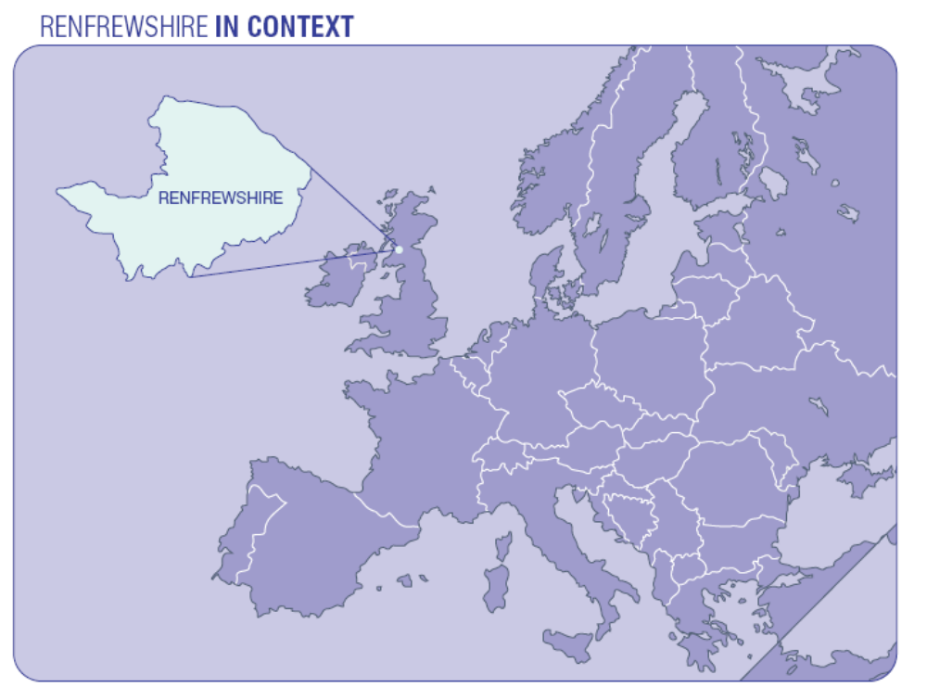

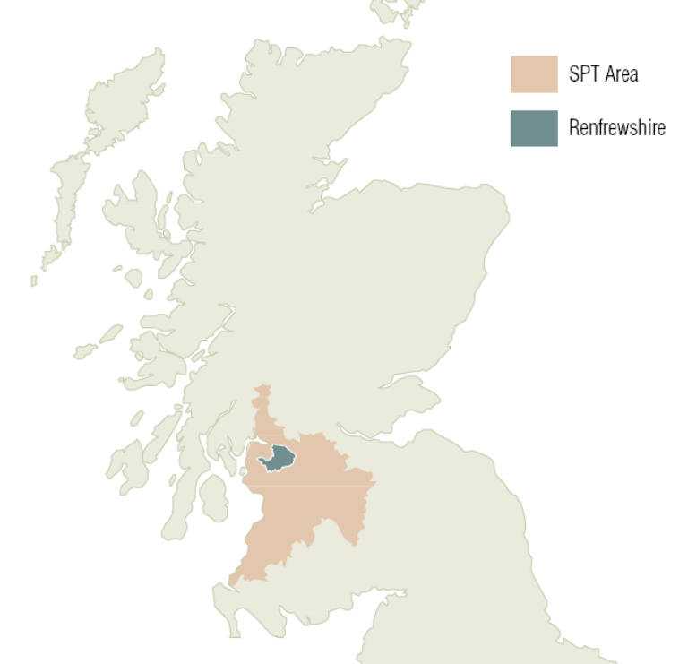
Appendix B

Example Journey Planner (Inchinnan Business Park)



