SIMULATING INTERACTIONS BETWEEN
LAND USE, TRANSPORT AND ENVIRONMENT

Rolf Moeckel*, Björn Schwarze*, Klaus Spiekermann**, Michael Wegener**

*Institute of Spatial Planning, University of Dortmund (IRPUD)
**Spiekermann & Wegener, Urban and Regional Research (S&W)

ABSTRACT

The project ILUMASS (Integrated Land-Use Modelling and Transport System Simulation) embedded a microscopic dynamic simulation model of urban traffic flows into a comprehensive model system incorporating both changes of land use and the resulting changes in transport demand as well as their environmental impacts. The land use modelling is entirely microscopic and includes models of demographic development, residential location, firm life cycles, business relocation and construction of dwellings and non-residential floorspace. To test the land use model the very detailed transport and environment models were temporarily replaced by an aggregate transport model and less detailed environmental impact models. The paper outlines the land use submodels and their integration into the ILUMASS model and presents selected scenario results and concludes with a discussion of the advantages and limits of microsimulation.

1. INTRODUCTION

Rising energy prices and growing evidence of the role of greenhouse gas emissions for climate change have renewed the awareness of experts and policy makers for environmental issues. However, despite advances in resource efficiency and pollution control, continued growth in affluence leads to ever longer travel distances, energy consumption and greenhouse gas emissions. This has renewed the interest in integrated models of urban land use and transport. There is growing consensus that the negative environmental impacts of transport cannot be reduced by transport policies alone, but that they have to be complemented by measures to reduce the need for mobility by promoting higher-density, mixed-use urban forms more suitable for public transport.

Urban modellers, have for a long time ignored ecological aspects of the processes simulated in their models and have only recently been prompted to redirect their attention from economic to environmental impacts of land use and transport policies. Existing land-use transport (LT) models are being augmented by environmental submodels to become land-use transport environment (LTE) models. However, today there exist no full-scale urban LTE models. The first pioneering efforts of extending LT models to LTE models have concentrated on environmental impacts of land use and transport and have ignored the opposite direction, the impact of environmental variables on land use and transport decisions. However, the quality of the environment of urban locations strongly affects their attractiveness in the eyes of investors, firms and households.

Paper for presentation at the 11th WCTR, UC Berkeley, 24-28 June 2007.
The project ILUMASS (Integrated Land-Use Modelling and Transport System Simulation) embedded a microscopic dynamic simulation model of urban traffic flows into a comprehensive model system incorporating both changes of land use and the resulting changes in transport demand as well as their environmental impacts. The land use model of ILUMASS includes submodels of demographic development, residential location, firm life cycles, business relocation and construction of dwellings and non-residential floorspace. The transport part of ILUMASS simulates travel and goods movements based on household activity patterns and the resulting mobility behaviour of household members and a microscopic dynamic simulation of travel flows. The environment model of ILUMASS calculates the environmental impacts of simulated transport flows, such as greenhouse gas emissions, air pollution and traffic noise. The three models are linked by feedbacks as locations decisions of developers, households and firms are co-determined by the accessibility provided by the transport system and environmental quality calculated in the environment model.

The ILUMASS model differs from other models of urban land use and transport that both urban land use and transport are modelled microscopically. Microsimulation is already common in the simulation of traffic flows, but it is still in its research phase in travel demand modelling and even more so in land-use modelling (Wegener, 2004; Strauch et al., 2005). With its microscopic perspective ILUMASS is one of several similar microsimulation projects in North America and Europe, such as ILUTE (Miller, 2001; Miller et al., 2004), UrbanSim (Waddell et al., 2003), TLUMIP (Weidner et al., 2006), ALBATROSS (Arentze and Timmermans, 2000; 2004), SIMDELTA (Feldman et al., 2005), PUMA (Ettema and Timmermans, 2006) and IRPUD (Wegener, 1998; Spiekermann and Wegener, 2007).

The paper outlines the land use submodels of the ILUMASS project and their integration into the ILUMASS model and presents selected scenario results and concludes with a discussion of the advantages and limits of microsimulation.

2. THE ILUMASS PROJECT

The project ILUMASS (Integrated Land-Use Modelling And Transportation System Simulation) was conducted in 2002-2006 by a group of institutes of the universities of Aachen, Bamberg, Dortmund, Cologne, and Wuppertal under the co-ordination of the Transport Research Institute of the German Aerospace Center (DLR) under a grant by the German Federal Ministry of Education and Research (Beckmann et al., 2007). The project extended an existing microscopic activity-based travel model by equally microscopic models of urban land use and the urban environment. The combined ILUMASS model so consisted of three main models. Figure 1 shows the three models with the land-use model highlighted and with greater detail:
- The land-use components are based on the land-use model developed at the Institute of Spatial Planning of the University of Dortmund (IRPUD). The macroscopic land use submodels of the IRPUD model (Wegener, 1998) were rewritten in microscopic form and then used within ILUMASS. The microscopic land use models simulate demographic and household development, the development of businesses, the location of private and public buildings and the mobility of firms, labour and households.

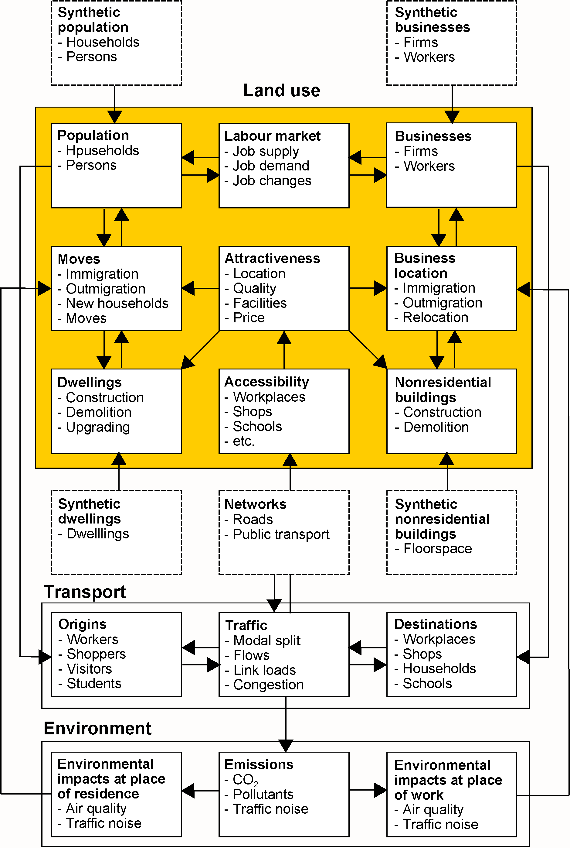
Figure 1. The land use submodels in the ILUMASS model

- The transport parts of ILUMASS simulates the daily activities of people and, based on this, the demand for travel between different parts of the city at different times of the day, and the demand for freight travel and the resulting traffic by a very detailed agent- and activity-based travel model.
- The environmental components of ILUMASS forecast the emissions of CO₂ and other greenhouse gases, the emission and distribution of air pollutants (NO_{x} and particulate matter), boundary layer effects (smog), traffic noise and the barrier effects of transport corridors.
The three models of land use, transport and environment are linked by the following main interactions:
- The locations of households, persons and firms and workplaces are the locations of activities and hence origins and destinations of trips in the transport model.
- The accessibility provided by the transport model, together with other location factors, determines the location decisions of developers, households and firms.
- The traffic flows on the links of the transport network lead to environmental impacts, such as greenhouse gas emissions, air pollution, traffic noise and loss of open space.
- The environmental impacts, in particular traffic noise, air pollution and access to open space, co-determine the location decisions of developers, households and firms.

In this way the full feedback between the three subsystems land use, transport and environment are implemented in the model: Households and persons, firms and workers, cars and commercial vehicles and residential and non-residential buildings are aged and undergo changes by transitions or choice decisions. For each year the distributions of households, persons and firms are passed to the travel and freight transport models. Traffic flows, link loads and travel times and costs are fed back to the land use model, in which they affect the location decisions of developers, households and firms, and serve as input to the environment model which calculates the environmental impacts of transport and land use. These in turn are fed back to the land use model and affect the location decisions of developers, households and firms.

The study area of the model is the urban region of Dortmund in Germany with a population of 2.6 million in Dortmund (pop. 590,000) and 25 surrounding municipalities (see Figure 6). The regions is part of the polycentric Ruhr area and, besides Dortmund, includes four other major cities, Bochum (pop. 390,000), Hagen (pop. 200,000), Hamm (pop. 190,000) and Herne (pop. 170,000). The study region is divided into 246 zones. However, the spatial resolution of 246 zones is not sufficient for the microsimulation of transport, land use and environmental impacts. The study region is therefore further subdivided into about 207,000 raster cells of 100 by 100 m size. These raster cells serve as addresses for activities, residential and nonresidential buildings and environmental impacts. The base year of the simulations was set to the year 2000 and the simulation horizon to the year 2030, with simulation periods of one year duration.

The ILUMASS model and its submodels are described in detail in the ILUMASS Final Report (Beckmann et al., 2007).

3. SYNTHETIC MICRO DATA

Microsimulation models require micro data. However, the collection of micro data, i.e. data that can be associated with single buildings, households or firms is in most countries neither allowed nor desirable for privacy reasons. The ILUMASS model therefore works with 'synthetic' micro data disaggregated from generally accessible aggregate data using iterative proportional adjustment or Monte Carlo sampling such that the synthetic micro data are statistically consistent with the aggregate input data.
The synthetic population consists of individual households and household members. Each household has certain characteristics such as size, income, number of cars and address (dwelling). Each person is represented by characteristics such as age, sex, nationality and employment. These agents engage in activities during a day: they go to work, shop, visit friends or attend school. They select a transport mode and so generate traffic. Households move into or out of or within the region and so affect land use.

The synthetic businesses are described by their industry, number of employees, number of vehicles and microlocation (raster cell). Public facilities are special cases of businesses. They include institutions like kindergartens, schools, universities or museums. Businesses affect land use by their establishment, relocation or closure and affect transport by the person and goods movements they generate.

Residential buildings and floorspace of non-residential buildings are characterised by building type, size, quality, tenure and price. Every dwelling has a microlocation (raster cell). Non-residential floorspace is distinguished by industrial, retail, office, and public use. Raster cells are used as addresses for the microsimulation.

Geographic information system techniques were used for the disaggregation of zonal data to raster cells. To spatially disaggregate zonal data within a zone the land-use distribution within the zone was taken into account, i.e. it was assumed that there are areas of different density in the zone. The spatial disaggregation of zonal data consists of three steps: the generation of a raster representation of land use, the assignment of probabilities to land-use categories and the allocation of dwellings and non-residential buildings to raster cells (Spiekermann and Wegener 1999, 2000).

4. MICROSIMULATION MODULES

In this section the most important six submodels of the ILUMASS land use model are briefly presented: the submodels modelling population, firms, residential mobility, business location/relocation and residential and nonresidential buildings.

4.1 Population

The population model simulates the development of persons and households. In each year all persons get one year older and, depending on their age and sex, have a certain probability to die. Couples move together and establish a new household, households become smaller as persons die, children leave or partners separate. Women give birth to children depending on their ethnic background and age and whether they live together with a partner or not. Young people move together and establish non-standard households. In the population submodel also changes in employment are modelled. Depending on their age, persons are assigned to educational facilities, such as kindergartens, elementary or secondary schools or universities. Workers change the place of work, become unemployed or retire, and their income is adjusted accordingly. Unemployed people try to find a new job. Car ownership is modelled as a function of the mobility budget of the household. Figure 2 shows the possible events occurring to a person.

Figure 2. Microsimulation of persons and households
Start
End
Another person?
Yes
No
Select a person
Demographic events
- Ageing
- Death
- Birth
- Marriage/cohabitation
- Divorce/separation
- Persons leave household
- Persons move together
Economic events
- Education
- Place of work
- Employment status
- Income
- Mobility budget of household
Update lists
- Persons
- Households
- Dwellings
- Firms

4.2 Firms

Like persons and households, also firm lifecycles are modelled by microsimulation of foundation, growth and eventual relocation, decline and closure. The simulation of firms provides information for the forecast of employment, the demand for land and the demand for freight and business trips and their environmental impacts. The simulation of firms consist of two parts, firm lifecycles and firm location. The simulation of firm lifecycles is, in analogy to demography, also called firmography. Firmography includes the simulation of new establishments, growth, decline and closure of firms. Firmographic events are modelled by transition probabilities subject to exogenously provided economic structural change and business cycles. Firmographic events may lead to relocations of firms. (see below).

4.3 Residential mobility

The residential mobility submodel models location and housing decisions of households who move into the region (immigration), move out of the region (outmigration), move into a dwelling for the first time (starter households), or have a dwelling and move into another dwelling (moves). The submodel is based on a similar submodel of the IRPUD model, which was designed as a microsimulation model already before ILUMASS (Wegener, 1986). Moves are modelled as Monte Carlo simulation of transaction of households and landlords on the regional housing market. A market transaction is every successful operation by which a household moves into or out of a dwelling or both. The attractiveness of a dwelling for a household is a weighted aggregate of the attractiveness of its location, its quality and its rent or price in relation to the household's housing budget. A move can be effected in two ways: a household looks for a dwelling (housing demand) or a landlord looks for a tenant or buyer (housing supply). In the first case the household first selects a zone and then a vacant dwelling in the zone. If the offered dwelling promises a significant improvement of its housing satisfaction compared to its present dwelling, the household accepts the dwelling. Otherwise it continues its search until it find a suitable dwelling or abandons the search until the next year. In the second case the landlord looks for a household, if necessary in several attempts. Figure 3 shows the steps of the two search processes.

Start
End

Another
dwelling?
Yes

No

Select dwelling
- Area
- Type
Select household
- Immigration
- New household, forced move
- Move
Accept?
No

No
Update lists
- Households:
- with dwelling
- without dwelling
- Dwellings
- occupied
- vacant

1-5

Housing supply
Yes

Start
End

Another
household?
Yes

No

Select household
- Outmigration
- Immigration
- New household, forced move
- Move
Select dwelling
- Area
- Type
Accept?
No

No
1-5

6
Yes

Housing demand
Update lists
- Households:
- with dwelling
- without dwelling
- Dwellings
- occupied
- vacant
6

Figure 3. Microsimulation of residential mobility
4.4 Firm location/relocation

The second part of the simulation of firms simulates location or relocation decisions of firms as logit choice models. All firms are tested in random order whether they are satisfied with their present location. A new firm, which still has no location, or a firm which is dissatisfied with its present location examines up to ten alternative locations with respect to accessibility, size, price, quality and image. The firm selects one of the examined locations if it offers a significant improvement of locational satisfaction. Otherwise the firm keeps its present location and may start a new search in the subsequent year. Figure 4 shows the steps of the location/relocation process.
Start
End
Another
firm?
Yes
No
Select a firm
Select alternative location
Accept?
No
No
1-10
11
Yes
Update lists
- Firms
- Nonresidential floorspace
- Persons
Check satisfaction with present location
Satisfied?
No
Yes

Figure 4. Microsimulation of location/relocation of firms

4.5 Residential buildings

The residential development submodel simulates investment decisions of private developers to demolish, upgrade or build residential buildings for rent or sale as a function of supply and demand on the housing market and profitability expectations. The residential developments model proceeds in three phases. In the exploration phases supply and demand are assessed. If the developer believes that positive returns can be achieved by upgrading or new construction, investments projects are planned. In the decision phase these projects are executed in random order. For each project, a zone and a microlocation (raster cell) are selected among the land zoned for residential use in the municipal land use plans subject to location criteria, such as accessibility, neighbourhood facilities, environmental quality and land price. In the implementation phase the projects are executed. Demolition of dwellings creates households without dwellings, which will have to find housing in the subsequent year. Land used for new buildings is designated immediately as built-up land, but the new dwellings enter the housing market as vacant dwellings for rent or sale in the residential mobility submodel only after their completion one year later to take account of construction time. Figure 5 shows the three phases of the development process.
Start
Another
project?
End
No
Update lists
- Persons
Households
Dwellings
Land use
Select zone and microlocation

Select type and number
of dwellings

Upgrading
Expected demand
- Demolition
Upgrading
Construction
Select zone and microlocation
Select type and number
of dwellings
Demolition and resulting moves
Select zone and microlocation

Select type and number
of dwellings

Construction
Yes
Select project
- Demolition
Upgrading
Construction

Figure 5. Microsimulation of housing projects

4.6 Nonresidential buildings

Firms select locations on agricultural, industrial or commercial land. Agricultural firms require agricultural land; all other industries require floorspace in industrial, retail or office buildings. As floorspace demand per worker continues to increase, there is in each year demand for new floorspace. The model of nonresidential development examines the demand for floorspace in each zone and develops new floorspace in zones in which the vacancy rate is low. Floorspace development is constrained by land use restrictions in the municipal land use plans. Within a zone at first microlocations (raster cells) close to exiting firms are developed before isolated locations. Newly developed land is immediately designated as built-up land, but the new floorspace is offered on the market only one year later to take account of construction time.

5. THE REDUCED ILUMASS MODEL

When the microscopic land use submodels described in the previous section were linked with the very detailed travel, freight transport and environmental submodels, it turned out that the computing times of the integrated model were so long that in the limited time frame of the ILUMASS project only few complete test runs until the simulation horizon of 2030 were possible (Beckmann et al., 2007). Therefore, for testing the land use submodels, the detailed transport and environment simulations were temporarily replaced by the aggregate transport model of the IRPUD model (Wegener, 1998) and the environmental impact models developed in the EU projects SPARTACUS and PROPOLIS (Lautso et al., 2004):
- The transport model calculates work, shopping, service and education trips for four socio-economic groups and three modes walking/cycling, public transport and car/motorcycle. The model determines user-optimum set of flows where car ownership, trip rates, modal split and route choice are in equilibrium subject to congestion in the network. The transport submodel proceeds in eight steps: trip generation, car ownership, network analysis, trip utilities, trip distribution, modal split, trip assignment and capacity restraint. Network capacity-flow equilibrium is approached by adjusting in each iteration car ownership, trip rates, travel flows and link loads.
- The environmental impact model consists of four submodels: The emission submodel uses emission functions to calculate CO₂ and air pollutant emissions from modal traffic flows. The air pollution and exposure submodel applies a Gaussian air dispersion model to the emissions to calculate air quality at the places of residence of the population. The noise submodel calculates noise generation at sources and noise propagation to residential locations. The environmental quality submodel calculates a land fragmentation index as contiguous open space undisturbed by traffic noise. The accessibility to open space submodel calculates a potential indicator in which the attraction term is open space and the impedance is walking distance (Spiekermann, 2003).

This fast-running combination of models with different degrees of substantive, spatial and temporal resolution allowed a greater number of test runs and scenario simulations. Figures 6 to 15 show screenshots of the animated user interface indicating the progress of the simulation in each year during a model run.
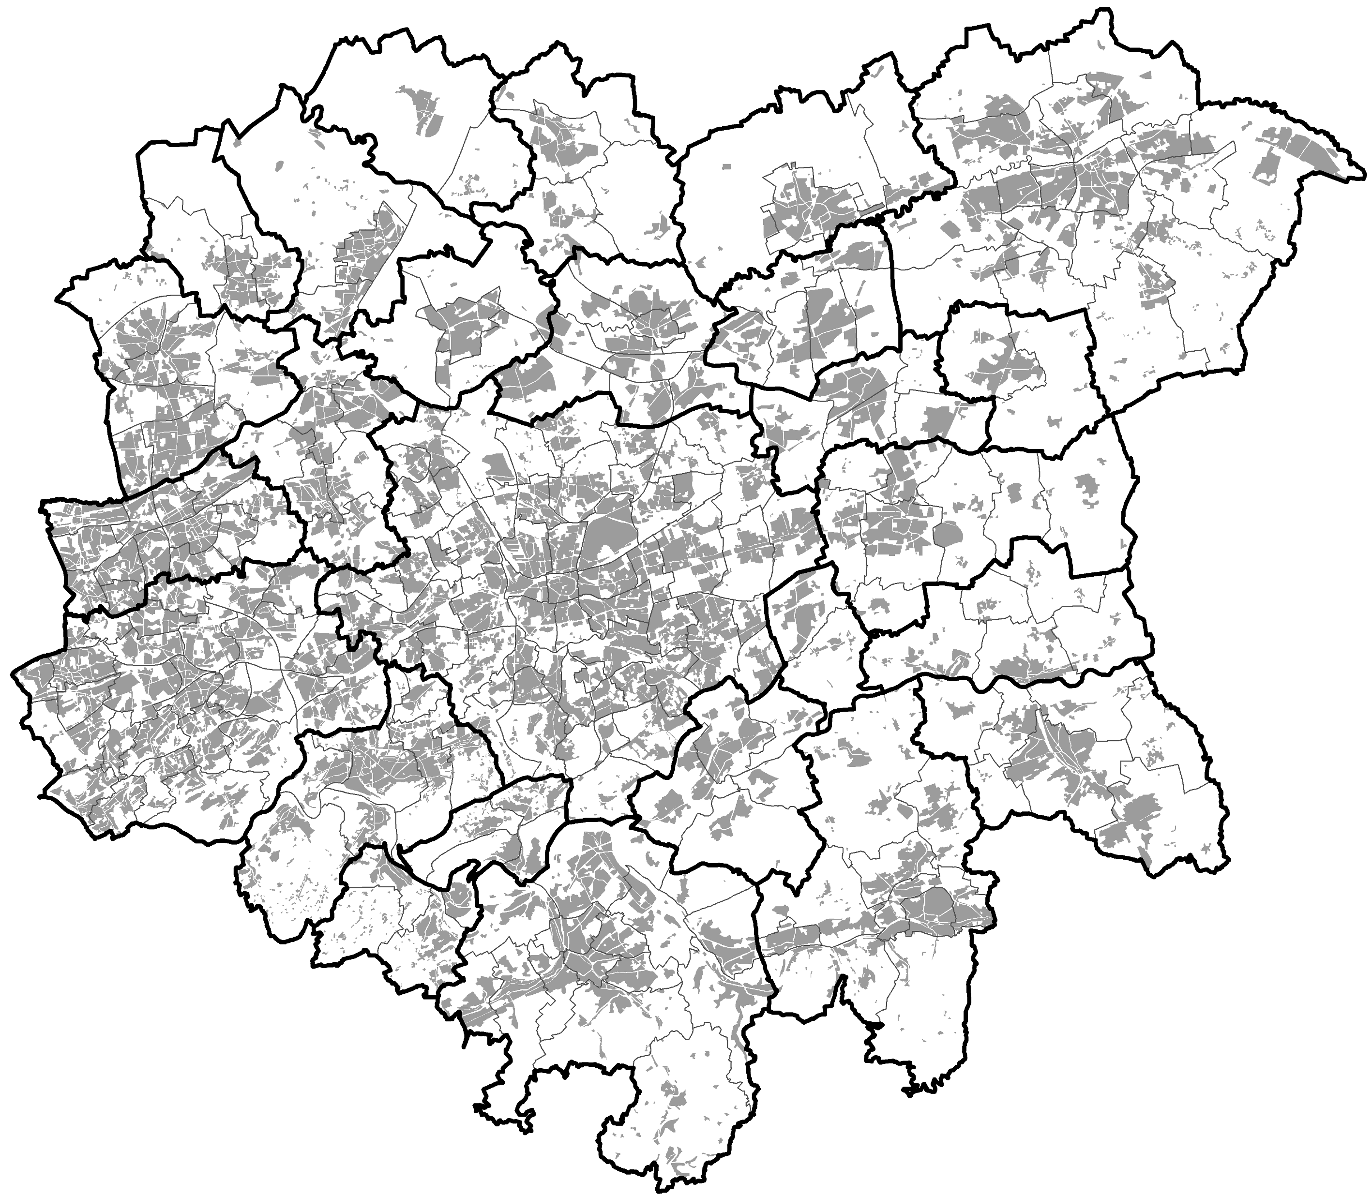
Built-up area
Municipalities
Zones
Study area
Dortmund
Hagen
Bochum
Hamm
0
10 km
5
Herne
Figure 6. Study area with municipalities, zones and built-up area

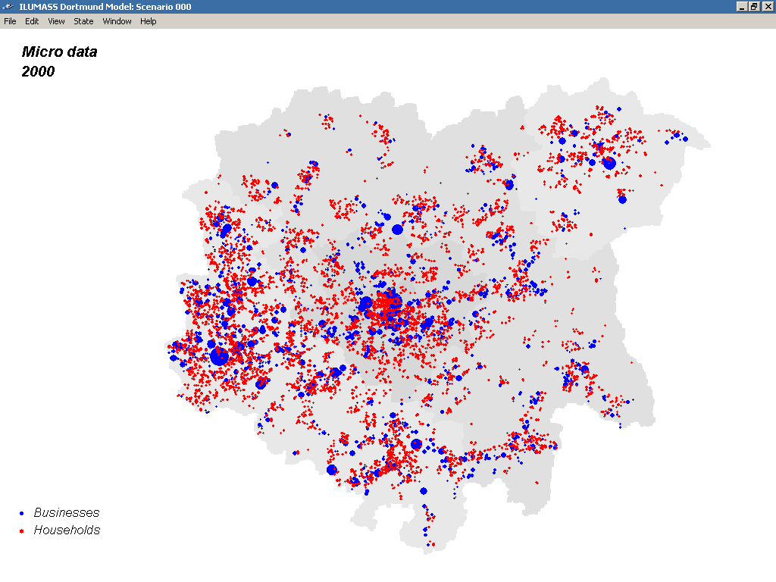

Figure 7. Synthetic micro data: businesses and households

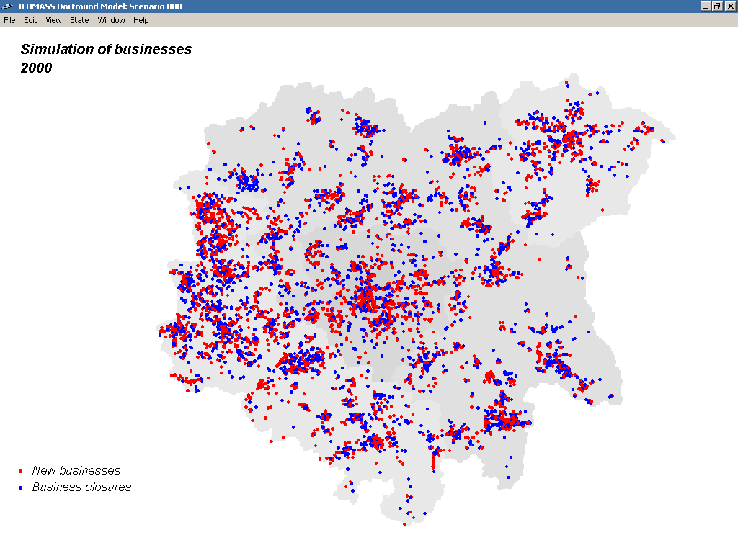
Figure 8. Simulation of businesses: new businesses and business closures

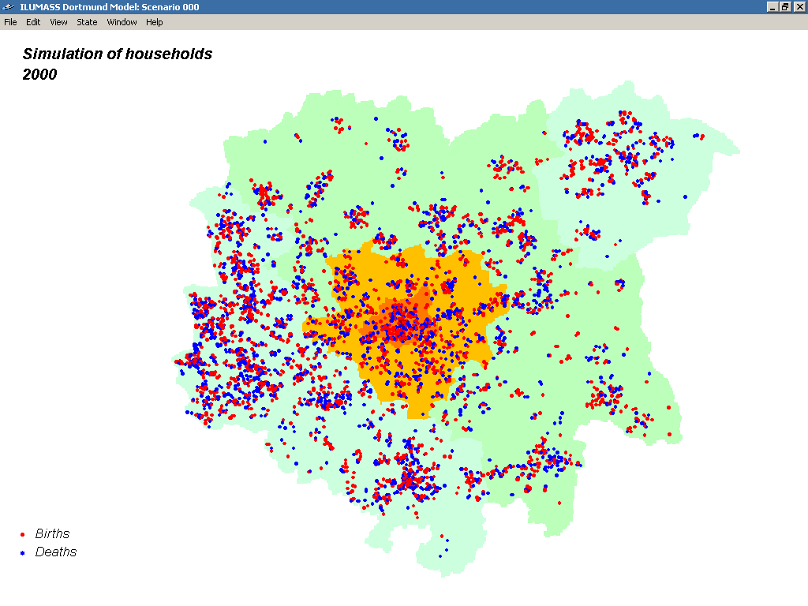

Figure 9. Simulation of households: births and deaths

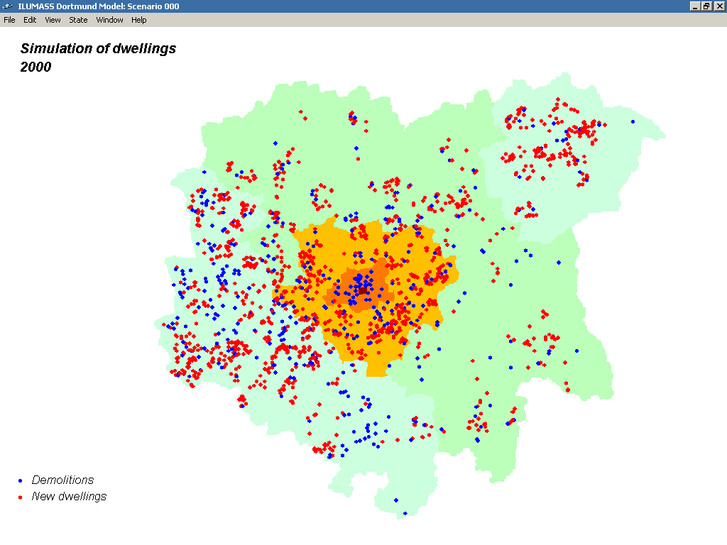
Figure 10. Simulation of dwellings: demolitions and new dwellings

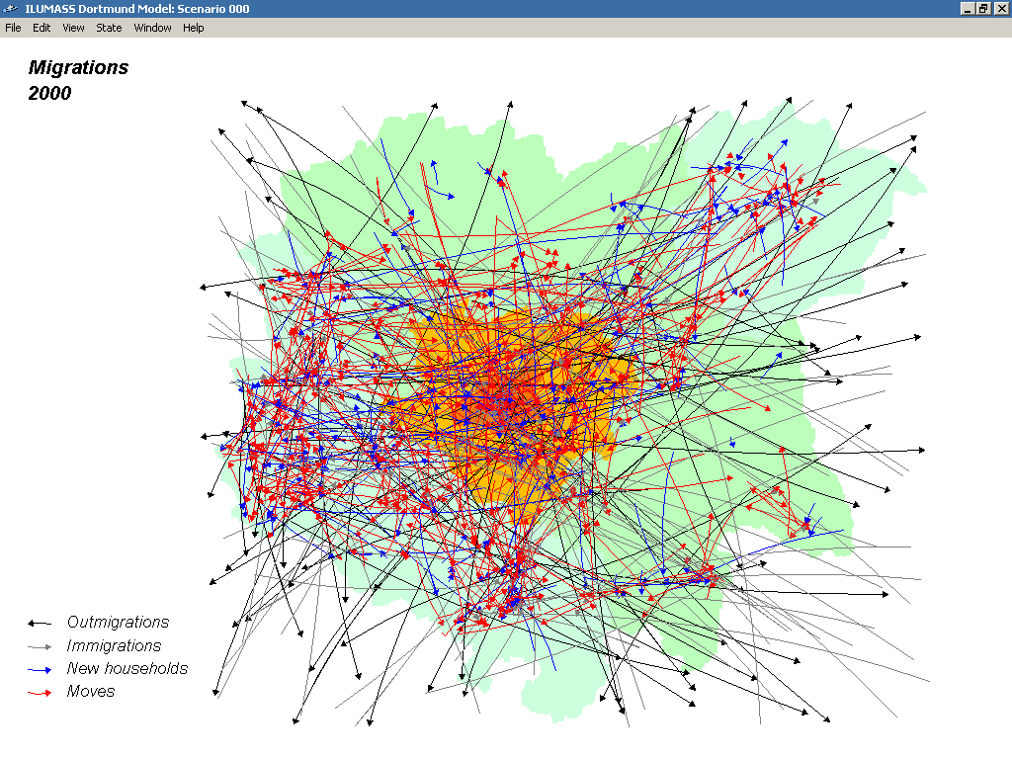

Figure 11. Migrations: outmigrations. immigrations, new households, moves

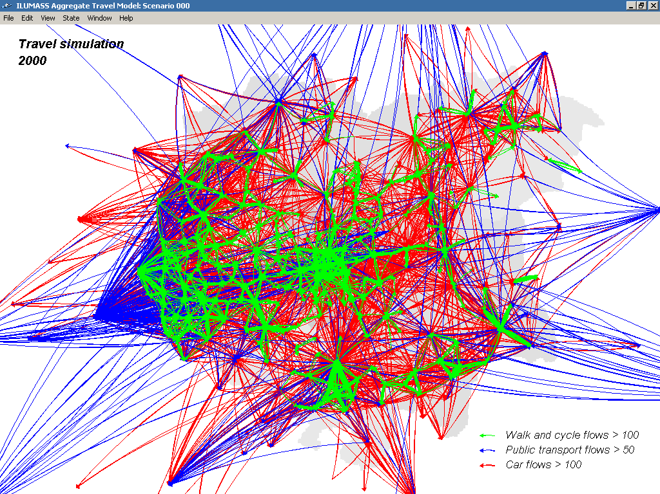
Figure 12. Travel simulation: traffic flows by mode

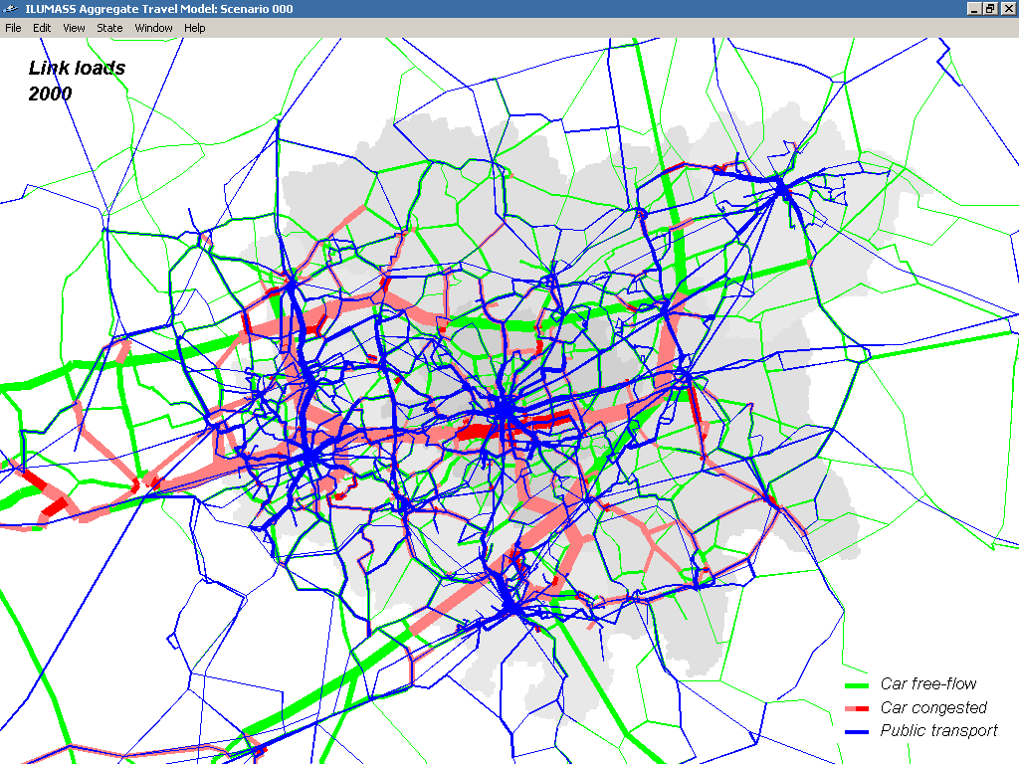

Figure 13. Travel simulation: link loads by mode

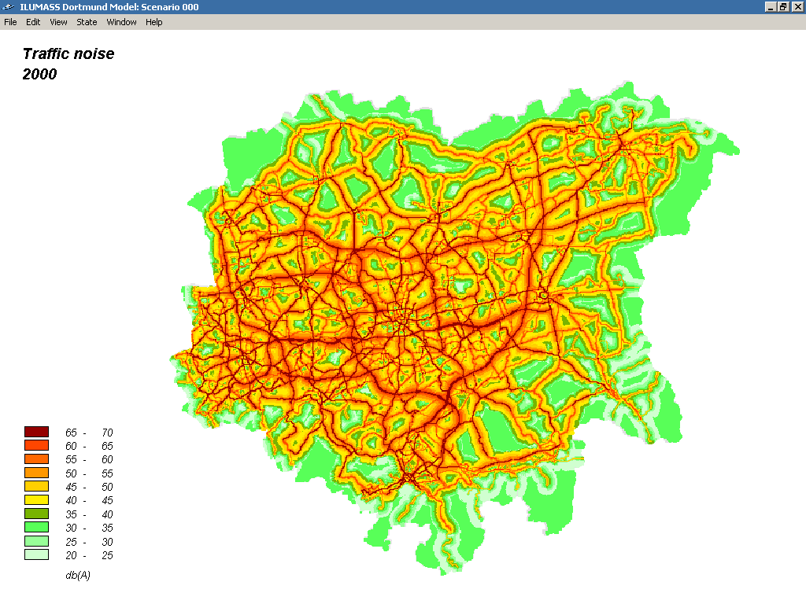Figure 14. Environmental impacts: traffic noise

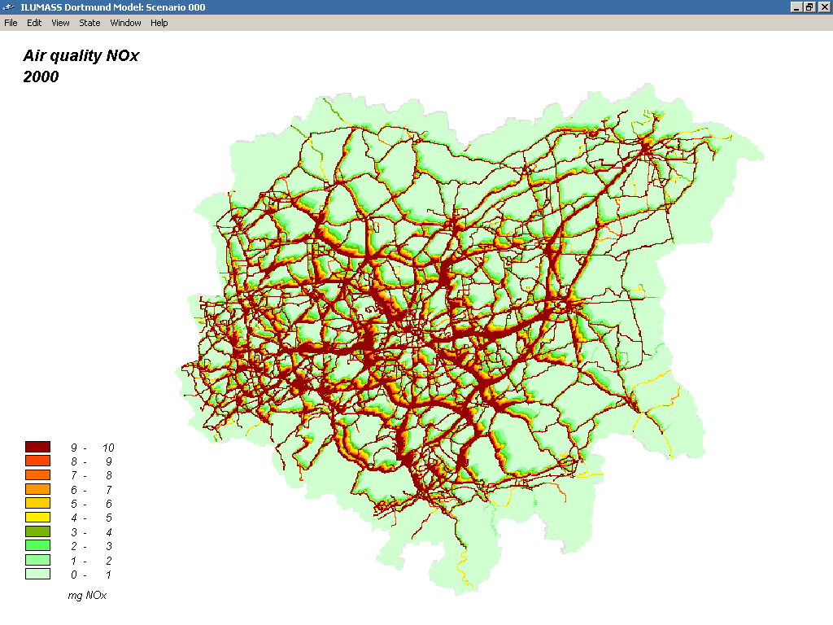

Figure 15. Environmental impacts: air quality NO_{x}
6. FIRST RESULTS

The reduced ILUMASS model was used to examine a number of land use, transport and fiscal policies and policy combinations.

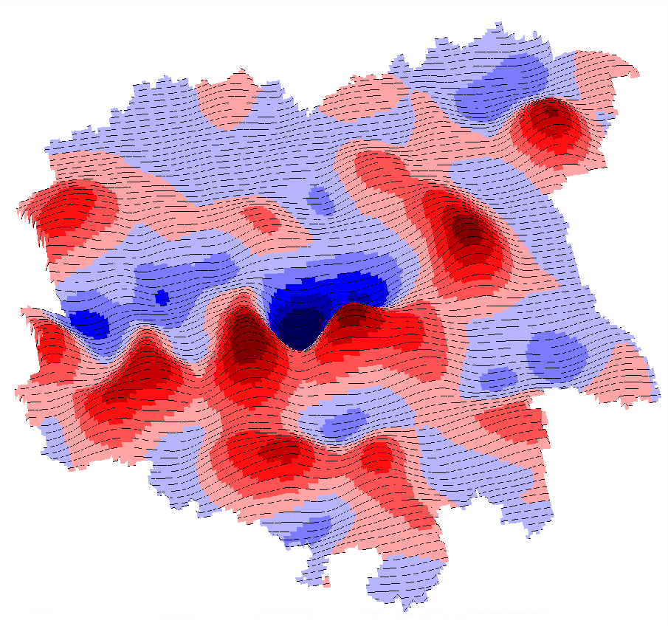
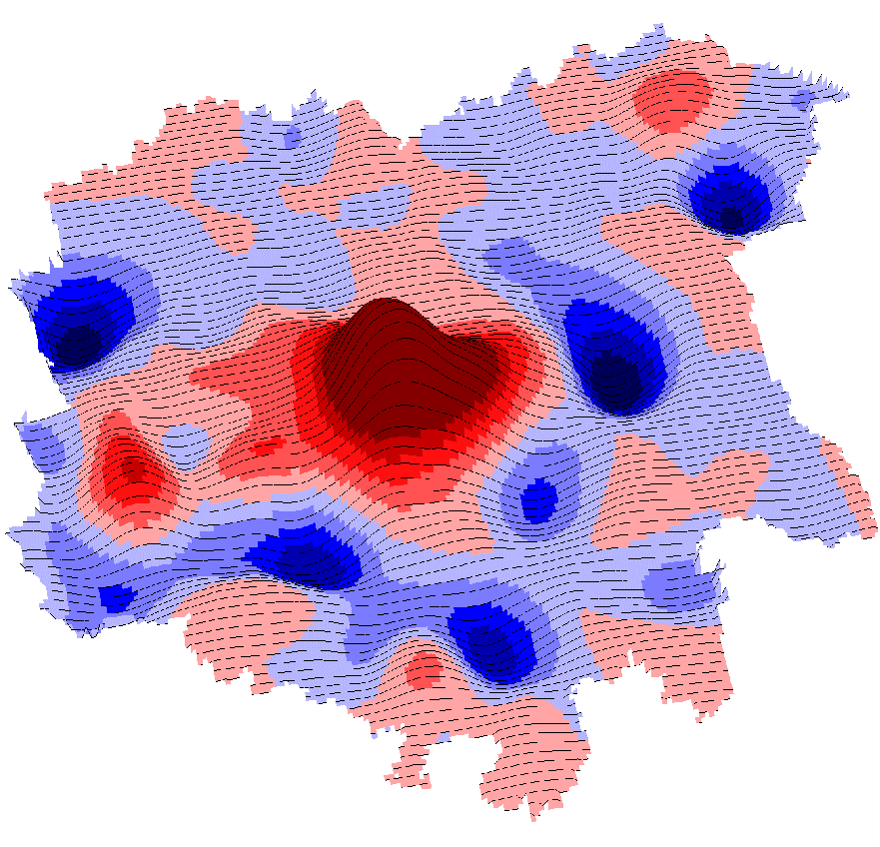
As an example for the use of the reduced model, the impacts of a land use planning on the spatial distribution of workplaces in the urban region were examined in a study on business location (Moeckel, 2006). First a base scenario of the expected development between 2000 and 2030 was run. In the base scenario no planning policies working against current trends in land use development were implemented. Then a scenario representing a strict anti-sprawl policy as an attempt to return to higher-density mixed-use urban forms ("compact city") was run. In the compact-city scenario only the city of Dortmund is allowed to offer new land for commercial or industrial development; all other municipalities can only develop already designated land. Figure 16 shows the changes in the distribution of workplaces as three-dimensional surfaces:

Figure 16. Changes of workplaces in the Dortmund urban region 2000-2030 in the base scenario (left) and differences between the base scenario and the compact-city scenario in the year 2030 (right) (Moeckel, 2006)

The left-hand surface in Figure 16 shows the change of the number of workplaces in the raster cells of the urban area in the base scenario between 2000 and 2030: red indicates growth in workplaces and blue indicates decline. It can be seen that the general trend of suburbanisation of workplaces continues. In particular the city centre of Dortmund loses jobs, but also most other larger cities in the urban area. The right-hand side of Figure 16 shows the results of the compact-city scenario as difference in workplaces between the policy scenario and the base scenario in the year 2030. Red indicates that a raster cell has more workplaces in the compact-city scenario than in the base scenario in 2030; blue indicates that it has less. During the thirty years simulated Dortmund gains a significant number of workplaces at the expense of the other municipalities.
The results of these and other policy scenarios showed that restrictions on land use development and transport reduce urban sprawl, road congestion and environmental emissions. Offering more sustainable options (pull measures) is less effective than restricting unsustainable behaviour (push measures), and integrated strategies are more effective than isolated measures. These results call for a strong system of regional planning.

7. CONCLUSIONS

The ILUMASS project demonstrated that a fully microscopic model of urban land use, transport and environment (LTE) is feasible. The land use components were tested with the transport and environmental components of the integrated ILUMASS model. In parallel, a reduced model consisting of the microscopic land use components and simpler transport and environmental models was compiled and applied to the simulation of a number of land use and transport policies.

All planned functions of the land use parts of the ILUMASS were implemented and tested. For the following functions, however, further improvements and extensions are desirable: in the population submodel emergent new life styles and household types and car ownership as a function of household income, residential location and level of service of public transport, in the residential buildings submodel amalgamation and change of use of dwellings and in both the residential and nonresidential buildings submodels the response of land and house prices and rents to changes in supply and demand.

A comprehensive evaluation of integrated microsimulation models for urban land use, transport and environment planning leads to a differentiated assessment of their advantages and limitations. Without doubt, microsimulation models of urban land use, transport and environment are an important step towards fully integrated, behavioural and policy-sensitive urban models. Only with microsimulation models it is possible to anticipate future developments in life styles, work patterns and mobility. Only with microsimulation models it is possible to anticipate the likely effects of innovative planning policies in the fields of travel demand management and organisation. Only with microsimulation models it is possible to model the environmental impacts and feedbacks of land use and transport policies with the necessary spatial resolution.

However, microsimulation models are no universal solution. There are ultimate limits to increasing the substantive, spatial and temporal resolution of behavioural models:
- There are theoretical limits when further disaggregation brings no additional information or the number of processes simulated is too small to yield reliable results due to stochastic variation.
- There are empirical limits when the marginal costs of obtaining micro data are larger than their added value.
- There are practical limits when the computing time of the models exceeds the duration of the modelled processes.
- There are, finally, ethical limits to the collection of data about private lives only for purposes of research.
These considerations lead to a reassessment of the hypothesis that eventually all spatial modelling will be microscopic and agent-based. This hypothesis was expressed by the authors in the adaptation of a diagram of the evolution of urban models by Miller et al. (1998). In the extended diagram (Moeckel et al., 2003) all trends pointed towards greater disaggregation until the ultimate, microscopic model in the lower right-hand corner of the diagram was reached.

From today's perspective, this view of microsimulation may have been too enthusiastic. Until further evidence a question mark in the lower right-hand corner of the diagram may be more appropriate (Figure 17). A more robust hypothesis seems to be that for every modelling problem there is an optimum level of substantive, spatial and temporal resolution. If this more cautious hypothesis is correct, future urban models will be multi-level in substance, space and time. The challenge would then be to develop a theory of balanced multi-level spatial models which are, to quote Albert Einstein, as simple as possible – but no simpler.
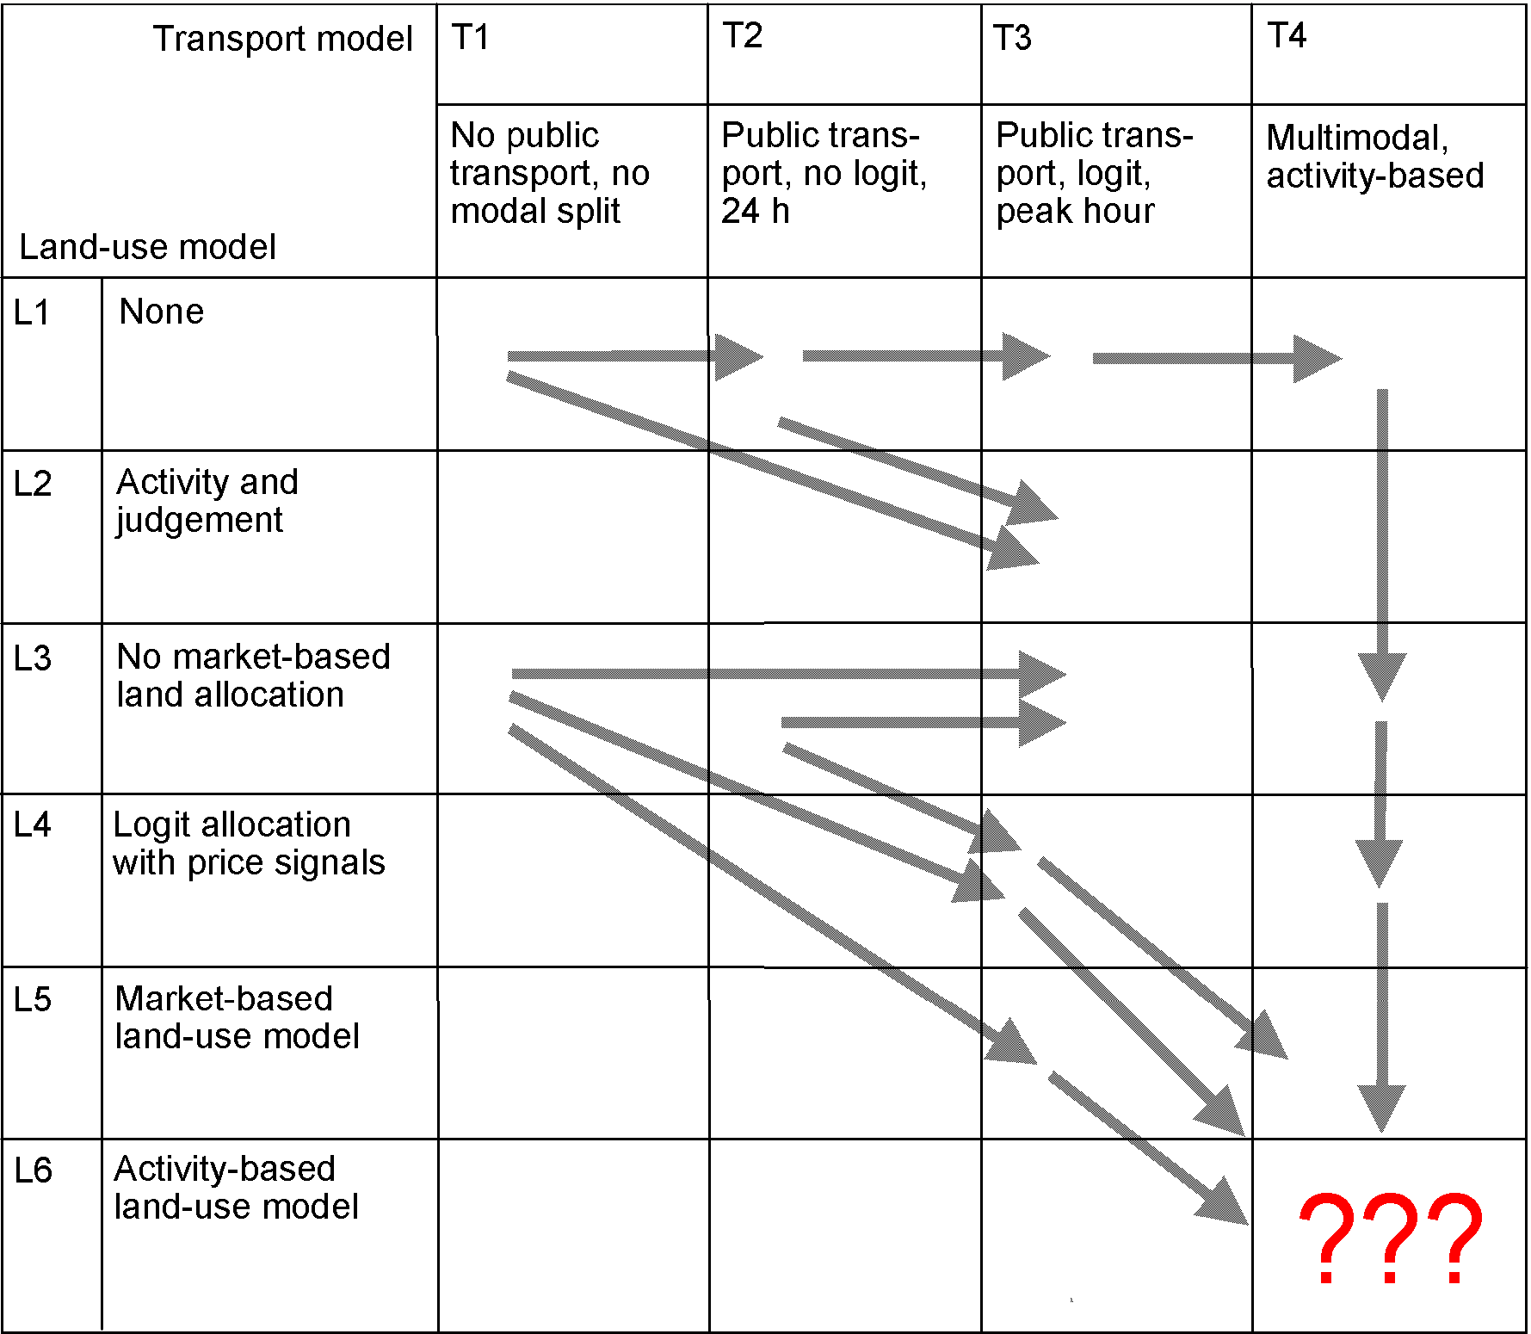

Figure 17. Evolution of urban land-use transport models (adapted from Miller et al. 1998)

ACKNOWLEDGEMENTS

The authors wish to thank their ILUMASS colleagues for the privilege to report on the common project work: Klaus J. Beckmann, Heike Mühlhans and Guido Rindsfüser of the Technical University of Aachen, Ulrike Brüggemann and Harald Schaub of the University of Bamberg, Jürgen Gräfe and Rainer Schrader of the University of Cologne, Felix Huber and Hans Meiners of the University of Wuppertal and Peter Mieth, Michael Spahn, Dirk Strauch and Peter Wagner of the German Aerospace Center Berlin. Detailed information about their work will be contained in the forthcoming Final Report of ILUMASS (Beckmann et al., 2007).
REFERENCES

Arentze, T., Timmermans, H. J. P. (2000) ALBATROSS – a Learning Based Transportation Oriented Simulation System, European Institute for Retailing and Services Studies (EIRASS), Eindhoven.

Arentze, T., Timmermans, H.J.P. (2004) 'A learning based transportation oriented simulation system', Transportation Research Part B, 38(7), pp. 613-633.

Beckmann, K.J., Brüggemann, U., Huber, F., Meiners, H., Mieth, P., Moeckel, R., Mühlhans, H., Schaub, H., Schrader, R., Schwarze, B., Strauch, D., Spahn, M., Wagner, P., Wegener, M. (2007) ILUMASS – Integrated Land-Use Modelling and Transportation System Simulation, Final Report, German Aeorospace Center (DLR), Berlin.

Ettema, D., Timmermans, H. (2006) 'Multi-agent modelling of urban systems: a progress report of PUMA System', in Stadt Region Land 81, Institut für Stadtbauwesen und Stadtverkehr, RWTH Aachen, pp. 165-171.

Feldman, O., Simmonds, D., Ballas, D., Clarke, G., Gibson, P., Jin, J., Stillwell, J. (2005) 'A spatial microsimulation approach to land-use modelling'. Paper presented at CUPUM 2006, London, 29 June - 1 July 2006.

Lautso, K., Spiekermann, K., Wegener, M., Sheppard, I., Steadman, P. Martino, A., Domingo, R., Gayda, S. (2004) PROPOLIS. Planning and Research of Policies for Land Use and Transport for Increasing Urban Sustainability, Final Report, LT Consultants, Helsinki. http://www.wspgroup.fi/lt/propolis/ (Access 26.04.2007).

Miller, E.J. (2001) Integrated Land Use, Transportation, Environment (ILUTE) Modelling System. http://www.civ.utoronto.ca/sect/traeng/ilute/ilute_the_model.htm (Access 26.04.2007).

Miller, E.J., Hunt, H.D., Abraham, J.E., Salvini, P.A. (2004) 'Microsimulating urban systems', Computers, Environment and Urban Systems 28, pp. 9-44.

Miller, E.J., Kriger, D.S., Hunt, J.D., Badoe, D.A. (1998) Integrated Urban Models for Simulation of Transit and Land use Policies, Final Report, TCRP Project H-12, Joint Program of Transportation, University of Toronto.

Moeckel, R. (2006) Business Location Decisions and Urban Sprawl: A Microsimulation of Business Relocation and Firmography, Doctoral Dissertation, Department of Spatial Planning, University of Dortmund.

Moeckel, R., Spiekermann, K., Schürmann, C., Wegener, M. (2003) 'Microsimulation of land use', International Journal of Urban Sciences 7(1), pp. 14-31.

Spiekermann, K. (2003) The PROPOLIS Raster Module, Deliverable D 4 of the 5th RTD Framework Programme project PROPOLIS, Institute of Spatial Planning, University of Dortmund.

Spiekermann, K., Wegener, M. (1999) 'Disaggregate environmental modules for modelling sustainable urban development', in Rizzi, P. (ed) Computers in Urban Planning and Urban Management on the Edge of the Millennium, F. Angeli, Milano.

Spiekermann, K., Wegener, M. (2000) 'Freedom from the tyranny of zones: towards new GIS-based models', in Fotheringham, A.S., Wegener, M. (eds) Spatial Models and GIS: New Potential and New Models, Taylor & Francis, London, pp. 45-61.

Spiekermann, K., Wegener, M. (2007) 'Environmental feedback in urban models', Forthcoming in International Journal of Sustainable Transport.

Strauch, D., Moeckel, R., Wegener, M., Gräfe, J., Mühlhans, H., Rindsfüser, G., Beckmann, K.J. (2005) 'Linking transport and land use planning', in Atkinson, P., Foody, G., Darby, S., Wu, F. (eds) GeoDynamics. CRC Press, Boca Raton, pp. 295-311.

Waddell, P., Borning, A., Noth, M., Freier, N., Becke, M. Ulfarsson, G. (2003) 'Microsimulation of urban development and location choices: design and implementation of UrbanSim', Networks and Spatial Economics 3(1), pp. 43-67. http://www.urbansim.org/ papers/UrbanSim_NSE_Paper.pdf (Access 26.04.2007).

Wegener, M. (1986) 'The Dortmund housing market model: a Monte Carlo simulation of a regional housing market', in Stahl, K. (ed) Microeconomic Models of Housing Markets, Lecture Notes in Economics and Mathematical Systems 239, Springer Verlag, Berlin/Heidelberg/New York, pp. 144-191.

Wegener, M. (1998) The IRPUD Model: Overview. http://www.raumplanung.uni-dortmund.de/irpud/pro/mod/mod_e.htm (Access 26.04.2007).

Wegener, M. (2004) 'Overview of land use transport models', in Hensher, D., Button, K.J., Haynes, K.E., Stopher, P.R. (eds) Handbook in Transport, Vol. 5, Transport, Geography and Spatial Systems, Pergamon/Elsevier, Oxford, pp. 127-146.

Weidner, T., Donnelly, R., Freedman, J., Abraham, J.E., Hunt, J.D. (2006) 'TLUMIP – transport land use model in Portland – current state', in Stadt Region Land 81, Institut für Stadtbauwesen und Stadtverkehr, RWTH Aachen, pp. 91-102.

