FRONT COVER

How to design effective road pricing cordons

Dr Simon Shepherd
Prof. Anthony May
Mr. Andrew Koh

Institute for Transport Studies, University of Leeds, UK.

Corresponding author
S.P.Shepherd@its.leeds.ac.uk

How to design effective road pricing cordons

Simon Shepherd, Anthony May and Andrew Koh.

Institute for Transport Studies, University of Leeds, UK.

Abstract
This paper describes three approaches to cordon location design, a judgemental approach, an optimisation approach based on Genetic Algorithms and a short-cut approach which lies between the two. The GA optimal single cordon generated benefits 80% higher than the best judgmental cordon for a simplified network of Edinburgh. The short cut approach was developed from an observation that charging on only a few of the highest marginal cost links could result in a high proportion of the system optimum or first best benefits. Initial results for Edinburgh and York have shown that the approach can double benefits compared to a judgemental cordon and more impressively achieve 93% of the GA optimal cordon benefits with only a few model runs in the case of Edinburgh.

Introduction
In Europe and Asia, most proposals for urban road pricing involve the use of cordon or area charging, in which one or more boundaries are drawn, with charges to cross the boundary (using cordon schemes as in Singapore and Stockholm) or to drive within it (using area schemes as in London). Despite over 40 years’ research into such schemes, there is little technical advice on where best to place such boundaries. Most designs are based on a mix of professional and political judgment, with little or no assessment of whether alternative locations would be more effective.

In practice, the performance of any road pricing cordon or boundary will be affected by the combined effects of a reduction in traffic entering the area and an increase in traffic bypassing it. While congestion will be reduced within the area, it might well be aggravated outside it. Since these conflicting impacts will depend on both the topology of the road network and the pattern of demand for its use, it is difficult to offer general advice on cordon location. All that is known is that the benefits of road pricing, usually measured in terms of welfare economic impacts, are critically dependent on the choice of cordon (May et al, 2002).

This paper discusses three broad approaches to cordon design. The first is a brief review of judgemental designs and our understanding of the approaches which professionals adopt to cordon design. It then reports on two promising methods which have been developed to improve the design process. The first of these uses an application of genetic algorithms to represent design options and to highlight those which are most effective. The second provides a short cut method which is analytically less complex and involves the planner directly in the design process. Both have been shown to provide two- to three-fold improvements in performance over judgmental designs. They are not, however, intended to supplant the need for professional and political judgment; rather they are offered as design tools which will help to focus such judgment on those designs which are likely to be technically the most effective.
While many of the principles considered will apply to area charging, the analysis has focused on cordon schemes, which are more common and also simpler to analyse.

Past approaches to cordon design - Evidence from model-based studies

Between 1992 and 1995, consultants conducted, for the UK Department of Transport, one of the most comprehensive studies ever undertaken of the potential for road pricing, and the relative performance of a range of road pricing designs (Richards et al, 1996). The study illustrates well the flexibility of cordon charging and the extent to which design options influence scheme performance. It demonstrated that, while the concept of cordon pricing is simple, its application offers a wide range of options. Those tested in the study (Figure 1) included a single cordon around Central London (the innermost ring in Figure 1); a second and third cordon in Inner London; the addition of radial screen lines to charge orbital movements; charges either inbound, outbound or both; charges varying by time of day; for the more complex schemes, variations in the ratio of charges between cordons; and, for all of these, variations in the level of charge. In all, some 45 separate options were tested.

[insert Figure 1 about here]

Figure 2 summarises the impact of 19 options, representing six charging structures and four charge levels, on social welfare benefit. A simple, single cordon around Central London performed least well, and reached an optimum level of performance at around £5 per crossing. This is broadly representative of the scheme subsequently implemented (TfL, 2006). A second cordon in Inner London added around 50% to the social welfare benefits, before taking account of the additional operating costs. Bi-directional charging on these cordons increased the benefits further, and produced results which were similar to those from three cordons with inbound charges. The best performing option, with three cordons and four screen lines and bi-directional charging, had benefits at the levels of charge shown of up to three times greater than those from the single cordon. Moreover, there was clear evidence that benefits would have been even higher at higher levels of charge (May, Coombe and Travers, 1996). Even allowing for the higher cost of operation, this most complex scheme had a net benefit three to four times greater than the simple single Central London cordon (Richards et al, 1996).
[insert Figure 2 around here]
The reasons for these differences can be traced back to three principal causes. Firstly, a single cordon intercepts fewer journeys, and thus excludes many which contribute significantly to congestion. Secondly, it imposes the same charge on all journeys which cross it, thus over-restraining short journeys and under-charging long ones. It is the over-restraint of some journeys which leads to the economic benefit falling at higher charges. Thirdly, and most importantly, it allows many journeys to escape the charge by rerouting around the cordon. The worst congestion in a city is often to be found just outside the central area, and the impact of a single cordon will be to relieve this congestion to the extent that radial journeys are reduced, but to aggravate it through traffic diversion. The more complex schemes, and particularly the screen lines, avoid this, and hence increase the benefits from congestion relief.

Optimal cordon design based on Genetic Algorithms
As discussed in the previous section, design of charging cordon schemes has primarily relied on professional judgment, which may well fail to identify the best performing scheme. This section presents a computational method based on the concept of Genetic Algorithms (GA) for directly optimising the charging cordon design so as to maximise the scheme benefits. It summarises the method, named GA-AS, as developed in Sumalee (2004a).

The problem of charging cordon design is very complex, since it involves an interaction between the scheme design by the planner and the possible responses of travellers. The problem can be categorised as a Mathematical Program with Equilibrium Constraint (MPEC), which is one of the most challenging optimisation problems. In addition, the topological requirement for the charged links to form a closed cordon imposes further complexity. This combination precludes the application of a conventional gradient-based optimisation algorithm.

Instead, the concept of Genetic Algorithms (GA) has been adopted. The basic idea of the GA approach is to code the decision variables of the problem as a finite string, called a ‘chromosome’, and calculate the fitness (objective function value) of each string. Chromosomes with a high fitness level have a higher probability of survival. The surviving chromosomes then reproduce and form the chromosomes for the next generation through the ‘crossover’ and ‘mutation’ operators.

In this framework, the travellers’ responses to the scheme have been calculated by SATURN (Van Vliet 1982), which is a steady-state equilibrium assignment model that predicts route choice and traffic flows on a road network, based on the generalised costs of travel, and takes account of delays due to capacity constraints. The model used is a single user class private traffic model for the peak period. Thus in response to tolling we represent route choice on the network, while all other responses such as mode choice, time period choice, distribution and generation are accounted for via an elastic demand approach implemented within SATURN (Hall et al, 1992). Thus in response to a toll users either pay the toll, re-route and avoid payment (if possible) or are priced off the network to another mode, time period or are assumed not to travel. The output from SATURN gives the equilibrium flows, which can then be used to evaluate the performance of different scheme designs. The GA will act as a planner in this framework to improve the scheme designs so as to maximise a given objective. In what follows we employ the traditional economic objective of maximising social welfare defined using the “Marshallian measure” as follows:
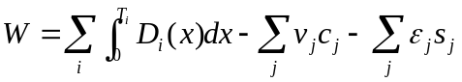 (1)
where i and j denote the index of OD pair i and link j; T_{i}, v_{j}, c_{j}, and s_{j} represent the travel demand, link flow, travel time, and cost of implementing a toll point respectively. ε_{j} is 1 if link j is tolled, and 0 otherwise. D_{i} is the inverse demand function. The first and second terms are the consumer surplus and consumer cost (excluding tolls) respectively. The net of these two values is the social welfare (or social surplus). The third term is the cost of the road pricing scheme. The net benefits are calculated by deducting an hourly equivalent capital and operating cost per toll point from the gross welfare benefits.

For the optimal cordon problems discussed in this paper, each chromosome in GA represents a uniform charge level for a specific charging cordon. Thus, to apply GA to the charging cordon design problem, we need to develop a chromosome scheme which represents a closed cordon and preserves its formation, even after the genetic operators (i.e. mutation and crossover) are applied. Based on Sumalee (2004a), the concept of a “branch-tree” was used to encode a closed cordon into a chromosome format. The “branch-tree” is simply a mathematical representation of the links which form a closed cordon. The crossover operation is defined as an exchange between a valid pair of sub-branches from mated chromosomes which will automatically ensure the formation of a charging cordon for the new chromosome. The mutation is based on the branching in and branching out operations as applied to a branch-tree to reduce or widen the coverage of a particular part of that cordon. The detail of the branch-tree structure and its associated crossover and mutation operators can be found in Sumalee (2004b). The method developed is named GA-AS. The algorithm is also able to optimise the location of a double cordon scheme. For the purposes of this paper it is sufficient that the reader views the GA process as some sort of heuristic search process which gradually improves the performance of the cordon by varying both the location of toll points and the uniform charge around the cordon.

Tests with the Edinburgh network
GA-AS was tested with a SATURN model of the Edinburgh road network with the objective of maximising the social welfare benefit. The following tests were conducted:
- Optimise uniform tolls for three pre-specified judgmental single cordon schemes (see Figure 3)
- Optimise the location of a closed charging cordon with a uniform toll (OPC)
- Optimise the uniform toll for the 15 links with highest marginal social cost (top-15)
- Optimise the location of double charging cordons with uniform tolls (D-OPC)

The summary of the test results is shown in Table 1. The tests were conducted with a SATURN model operating in “buffer” mode which represents delays on links rather than at junctions. This simplification was adopted to enable the method to be tested reliably. The values of time and vehicle running cost adopted were 7.63 and 5.27 pence per minute respectively with a generalised cost elasticity of -0.57; all these values were based on earlier research. The operating and implementation cost of a toll point were assumed to be £100 per peak hour, based on earlier analysis for London.

[take in Table 1 about here]

From test (i), out of the three judgmental cordons as defined in Figure 3, the Inner2 cordon performs best with a net social welfare improvement of £3.99k per peak hour. In earlier research, an incomplete judgmental outer cordon had been identified with a somewhat higher net benefit of £4.57k per peak hour. This has not been used for comparison, since the focus of GA-AS is on complete cordons.

In test (ii), GA-AS found an optimal charging cordon (named OPC) as shown in Figure 4. OPC is larger than either of the inner judgmental cordons and extends further to the west where congestion is more serious. The net benefit generated by OPC is £7.21k per peak hour which is 80% higher than the benefit produced by the Inner2 cordon and over three times the benefit of the other two judgmental cordons. This result clearly indicates the potential loss of scheme benefit by relying on professional judgment.

For the third test, the marginal cost tolls for all links in the network were calculated by running the system optimum assignment (Sheffi 1985). We then selected the 15 links with the highest level of marginal cost toll (see Figure 5). This combination of tolled links was used as an approximation to the best combination of tolled links in the network. The Top-15 charging system (with an optimal uniform toll of £0.75) generated a net benefit of £9.21k per peak hour which is around 30% higher than that generated by the OPC cordon. Furthermore with variable charges taken directly from the system optimal tolls applied the benefits were even greater being some 149% greater than OPC. Thus the requirement for a continuous cordon may itself be a serious constraint on optimal design as is the constraint for uniform charges; however, such isolated charging points with variable charges may be particularly difficult to explain to users.

GA-AS was used in the fourth test to find an optimal double-cordon scheme (D-OPC) (Figure 6). The inner cordon is slightly wider than the City Council’s proposal, but the outer cordon is very different, crossing the outer ring road in two locations to charge approach corridors contributing to congestion. The optimal uniform toll found for D-OPC is £1.25. The benefit generated by D-OPC is £15.28k per peak hour which is more than double of the benefit from the OPC.

[take in Figures 3-6 about here]

A short cut method based on select link analysis
While the Genetic Algorithm approach described above has been shown to be capable of generating significantly improved cordon designs, it is analytically complex, and has yet to be tested on the road networks of other cities or with other models. The UK Department for Transport was interested in providing guidance to local authorities on road pricing design (DfT, 2006), and commissioned work on a short cut method which could be applied more rapidly on a wider range of network models. The aim of the short-cut approach was to improve on the judgmental designs by using some theoretical modelling whilst reducing the number of simulations required by the GA based approach. As such it was not designed to find an optimal closed cordon design but it was expected to improve performance over the judgmental approach.

As mentioned above the previous work on the GA approach had included as a benchmark the system optimal or “first best” solution whereby all links were tolled to give the system optimal or maximum welfare gain (Sheffi, 1985), (consistent with the formulation in equation (1) above without implementation costs). It was this which led to the Top-15 test in Table 1 which, as we have seen, out-performed the optimal cordon by 149% and achieved over 50% of the first best solution (Table 2).

Further investigations showed that the percentage of first best benefits achieved versus the number of links tolled at the system optimal level (added in order of decreasing charges) formed a curve as shown in Figure 7. The form of the curve shows how benefits increase as we add more tolled links until finally we reach the first best condition. In theory there would be an optimal set of toll points and charge levels for each point on the curve i.e. solving the second-best toll problem in terms of tolls levels and location for a given number of chargeable links. Our previous research applied two different approaches to solve this problem (Shepherd and Sumalee (2004)), the first based on the concept of location indices following Verhoef (2002) and the second using a genetic algorithm approach similar to the above. The methods had limited success despite being applied to a relatively small network. In some respects this type of analysis is similar to that of Hearn and Yildirim (2002), Yildirim and Hearn (2005) who present different first best toll sets which result in system optimal flows but which have some secondary objective such as minimising the number of toll booths or minimising the maximum toll level on a given link.

Similar curves were also found for networks of Cambridge, Leeds and York which have many more links and many more origin-destination pairs than the Edinburgh network discussed here. So whilst we have not conducted an optimisation for each point on the curve we would suggest that the use of marginal cost tolls applied in descending order of magnitude gives a reasonable starting point for suggesting locations of beneficial toll points and a reasonable benchmark to give an idea of an upper bound on potential benefits from tolling a given number of links.

These curves have proved useful in defining how many links (the top X links) should be used in the design process. The number of links used should be manageable whilst still achieving a significant proportion of the first best benefits. In general less than 10% of the links are required to achieve around 60-70% of the first best benefits.

[take in Figure 7 about here]

As these limited point charges on the highest charged links from the system optimum could out-perform the closed cordons it was thought that using these links may prove beneficial in designing a new closed cordon. Figure 5 shows the position of the top fifteen “highest tolled” links for the Edinburgh network. As can be imagined it would be difficult to find a closed cordon which is not unduly complex which passes through all these links. However, it was realised that it was not essential to include the top links in the cordon; instead the cordon charge should be imposed on the principal path flows through these high cost links. The higher the proportion of high cost flows covered by the cordon the higher the potential benefits of that cordon location. This led to the idea of using a select link analysis to aid the cordon design process.

Select link analysis (SLA) is available in many commercial packages such as EMME/2 (INRO, 1999) or TRANPLAN (Caliper Corp, 2004) and is an easy to use option within SATURN. Basically select link analysis shows the paths used by all flows through a set of links. First a select link analysis is performed for the top X links (in this case 15, as shown in Figure 8). Next the path information is used to aid in the design of a new cordon on screen, trying to capture as much of the flow from the SLA as possible. A further select link analysis is performed on the new cordon and this is cross-matched with the top X links to determine the proportion of flow covered. Cordons with a high proportion of flow covered are taken to the next stage which is to run the simulation for various charge levels to optimise the uniform charge around the cordon.

This heuristic process can be summarised as follows:-

- Compute the system optimum and calculate first-best benefits.
- Sort the system optimal charges in descending order and apply those charges using an increasing number of links, creating a graph of relative benefits versus number of links charged.
- Use the graph from Step 2 to select a sub-set of Top X links and produce a visual output of these links.
- Carry out a select link analysis with these links to show, using bandwidths, where the flows come from/go to through these top X links.
- Draw a cordon or set of cordons either on-line or off-line which “catch” a high proportion of the flows from the top X links.
- Optimise the charge level for the cordon by plotting benefits for a set of uniform charge levels.
- Repeat 5-7 until a satisfactory cordon design is achieved.

An example of the single cordon produced by the above approach is shown in Figure 9. As shown in Table 2, this single SLA cordon achieved 93% of the gross benefits from the GA optimised single cordon OPC. Thus the method has delivered gains in welfare which are comparable to those produced by a much more time consuming and complex approach.

[take in Figures 8 and 9 and Table 2 about here]

Transfer to larger networks
In order to prove the above method which was developed for a relatively small network the approach was applied to networks of Cambridge, Leeds and York. Here we shall present the results for the York network in buffer form.

The York network has 219 zones, 894 nodes and 2832 assignment links. In the previous Edinburgh network there were only 89 links and it was found that the highest 15 tolled links could produce over 50% of the system optimal benefits. The first issue for transferability of the approach was to investigate how many links should be used to help define the cordon. The system optimal (first best) tolls were ordered by charge level and benefits were calculated for various sets of top X charged links ranging from 5 links to the full set. Figure 10 shows how the benefit varies as a percentage of first best (with all links tolled) versus the percentage of links actually tolled (applying the original system optimal tolls in descending order of magnitude).

[take in figure 10 about here]

From the figure it can be seen that 90% of first best benefits can be achieved by charging just over 20% of all links. The figure shows that even with only the top 5 links charged that 15% of the first best benefits can be achieved. These top 5 links were all located on the outer ring-road, and as we assume York would not be charging on the ring-road in all which follows a closed cordon would not be able to use these top 5 links. In selecting the number of links to be used in the SLA to aid cordon design two factors were considered, the first being the proportion of first best benefits achieved and the second being the number of links (which should not be too many to handle). With these two factors in mind the top 95 links were selected as these were shown to achieve 66% of first best benefits and formed a natural cut off with a minimum toll level of 100 seconds. Figure 11 shows the select link analysis for the top 95 links (highlighted). The select link analysis highlights these links and the paths of all flows going through the selected links. It was found that this type of numerical output was difficult to read so the information was presented in bandwidth form with the minimum value shown being 500 PCUs/hr which cuts out low flow links. This bandwidth diagram was later used to help design the cordon locations, the aim being to maximise the SLA flows from the top 95 links covered by the closed cordon. The basis of the SLA approach is that if most of these high cost flows can be charged at some point on the trip then a high level of benefits should be possible. As with Edinburgh a few judgemental cordons were tested to compare against the SLA approach. One tight inner cordon and a natural outer cordon just inside the ring-road were tested along with a double cordon made up from inner plus outer cordons (See figure 12).

[take in figures 11- 13 about here]

In all cases the cordon charges were uniform around the cordon and optimised by plotting a set of discrete values (25 pence intervals).

Figure 13 shows the screen shot from SATURN when defining the first SLA cordon using the information from the top 95 links to guide the design through the high flow links from figure 11 above. Note that the design does not go out to the ring-road in the North and West avoiding the small bandwidth areas from figure 11.

Comparing benefits across the cordons
Table 3 summarises the optimal tolls and benefits for the judgmental cordons, two SLA designed cordons, and compares to the top 95 links and first best tolls. As with Edinburgh the judgemental designs based on tight inner cordons and outer cordons which lie just inside the outer ring-road can only achieve between 9% and 15% of the first best benefits. The double cordon increases benefits to 24% of first best (almost perfectly additive).

Using the SLA approach increases the possible benefits significantly with SLA3 achieving 33.7% of first best (this is higher than that achieved with GA in the Edinburgh network (22.9% of first best)). As we have no GA solution to compare against we can only compare against typical designs (inner and outer) and the benefit from the top 95 links. SLA can more than double the benefit compared to the outer cordon and it achieves 50% of the top 95 benefits with only 30 links charged. It also improves upon the double cordon design.

The proportion of top 95 SLA flows covered is a reasonable indicator of expected benefits but the outer cordon seems to be out of line with this result. Whilst the ratio may not be a perfect indicator of performance the information from the top 95 SLA using a bandwidth approach obviously aided the cordon design.

[take in table 3 about here]

In summary there are two simple methods to improve cordon design. The first is to optimise the uniform charge level around any cordon design – as the plots above show the benefits can change significantly with charge levels. However perhaps more important is the issue of cordon location. Here we have shown that using the SLA approach can double the benefits of a pure judgmental design by using information about the marginal costs or system optimal tolls and the paths of flows passing through a set of high cost links.

The SLA approach has at least two advantages over a GA optimal approach. The first is that it only takes a few SATURN runs to determine the design and charge level compared to many hundreds of runs required for GA. The second is that it allows the user to limit the design process and visualise the cordon location – making use of local knowledge which cannot be incorporated easily into a GA approach.

Conclusions and future developments

The research described above has led to a GA method which can identify the theoretically best performing cordon for a specified objective in a given city. Such cordons can double or treble the benefits of a cordon located solely on the basis of professional judgment. However, it must be emphasised that these theoretical techniques are not a replacement for professional and political judgment. Instead, they should be used to identify cordons which are worthy of consideration. Where these cordons are found wanting on political grounds, the method can be used to identify constrained optimal designs, or as a benchmark to estimate the benefit lost by adopting a more politically acceptable design.

At present, this GA method has still to be tested on a wider set of networks and models, and is too complex to be easily transferred into practice. As an alternative a short cut SLA method has been developed, which has been shown to identify cordons which achieve a large proportion of the benefits of an optimal cordon. The method is much easier to use, and has the advantage of involving the planner directly in the cordon design process. It has highlighted some weaknesses in current practice in network modelling which need to be remedied if these models are to be used successfully in road pricing design.

Both of these methods are being developed further. Future work on the SLA method will look at alternative measures for selecting the “high cost” links. This will help get around the problem of solving the system optimum in a SATURN simulation network, where due to the approach used there is no analytical solution. Work to date has shown that a simple measure of “total delay” on a link is a good proxy for the high cost links as defined by the highest system optimal tolls for the Edinburgh network. Further work is required to prove this concept for other networks such as York, Leeds and Cambridge. If successful, this approach will be applied to simulation networks to improve cordon designs. However, it will no longer be possible to calculate the first-best benchmark.

Both the SLA and GA approaches need to be enhanced to take into account multiple user classes and multiple time periods. This will enable them to be tested on realistic networks in the UK and elsewhere. In the meantime we continue our research into optimal tolling, extending the work to consider both tolling and investment in capacity. The theoretical approach is based around the work of Lawphongpanich and Hearn, (2004), which uses a constraint cutting algorithm to solve the second-best optimal toll problem for a given set of links. This method has been selected as it avoids the pitfalls of other methods reported in Shepherd and Sumalee (2004) whereby a change in path set causes a discontinuity which disturbs the optimisation procedure. Whilst this approach is being adopted to solve the joint second-best problem of investment in capacity and charge levels for predefined links it will not be able to solve the cordon location problem. For this we intend to extend the GA approach to include capacity investments under typical planning constraints.

Acknowledgements
The work presented here was funded by the UK Engineering and Physical Sciences Research Council (EPSRC) and the DfT. The authors would like to acknowledge the contribution of Dr Agachai Sumalee who developed the GA approach described above as part of his PhD thesis at the University of Leeds. We would also like to stress that all network results and cordon designs are not part of any study by York or Edinburgh and that as such all results are purely hypothetical in nature.

References
Caliper Corp (2004) TRANPLAN Overview Caliper Corp: Newton, Massachusetts
Deb, K., Agrawal, S., Pratap, A. & Meyarivan, T. (2000) A fast elitist non-dominated sorting genetic algorithm for multi-objective optimization: NSGA-II. Proceedings of the Parallel Problem Solving from Nature VI (PPSN-VI)
Department for Transport (2006) Designing efficient local road pricing schemes. TAG Unit 3.12.1 (draft). London, DfT.
Hall, M.D., Fashole-Luke, T., van Vliet, D. and Watling, D.P. (1992) Demand responsive assignment in SATURN. Proceedings of 20th Summer Annual Meeting, Seminar E, PTRC, London.
Hearn D.W. and Yildrim M. B. (2002) A Toll Pricing Framework for Traffic Assignment Problems with Elastic Demand. M. Gendreau M and Marcotte P (Eds.) Current Trends in Transportation and Network Analysis: Papers in honour of Michael Florian, Applied Optimization: Volume 63 Kluwer, Dordrecht, 135-145
INRO (1999) EMME/2 User’s Manual INRO, Montreal
Lawphongpanich, S. and Hearn, D. W. (2004) “An MPEC Approach to Second-Best Toll Pricing”, Mathematical Programming B, 101(1).
May, A.D., Coombe, D. and Travers, T., 1996. The London Congestion Charging Research Programme: 5 Assessment of the impacts. Traffic Engineering and Control 37(6), 403-409
May A D, Liu R, Shepherd S P and Sumalee, A, 2002. The impact of cordon design on the performance of road pricing schemes. Transport Policy 9.
Richards, M., Gilliam C., and Larkinson J., 1996. The London Congestion Charging Research Programme: 6.The findings. Traffic Engineering and Control 37(7/8), 436-440
Richardson, J.T., Palmer, M.R., Liepins, G. & Hilliard, M. (1989) Some Guidelines for Genetic Algorithms with Penalty Functions. Proceeding of the 3rd International Conference on Genetic Algorithms, eds J Schaffer, Morgan Kaufmann, CA, USA.
Sheffi, Y. (1985) Urban Transportation Networks: Equilibrium Analysis with Mathematical Programming Methods, Prentice-Hall, Inc, Englewood Cliffs, New Jersey.
Shepherd, S.P., May, A.D. and Milne, D.S., 2001. The design of optimal road pricing cordons. Proc. of the 9th World Conference on Transport Research, Seoul, Korea.
Shepherd, S.P. and Sumalee A. (2004). “A genetic based algorithm based approach to optimal toll level and location problems”. Networks and Spatial Economics, 4.
Shepherd, S.P., Koh, A., and May, A D. (2006) Investigating a Select Link Analysis approach to cordon design : Executive Summary. Report to Department for Transport (June 2006) Unpublished.
Sumalee A., 2001. Analysing the design criteria of charging cordons. ITS Working paper no. 560. Institute for Transport Studies, University of Leeds
Sumalee, A. (2004a) Optimal Road User Charging Cordon Design: A Heuristic Optimisation Approach, Computer-Aided Civil and Infrastructure Engineering 19, pp. 377-392.
Sumalee, A. (2004b), Optimal Road Pricing Scheme Design, PhD Thesis, University of Leeds.
Transport for London, 2006. Central London congestion charging: impacts monitoring. London, TfL.
Van Vliet, D. (1982) SATURN - a modern assignment model, Traffic Engineering and Control 23, pp. 578-581.
Wardrop, J. (1952) Some theoretical aspects of road traffic research, Proc. of the Institution of Civil Engineers 1, pp. 325-362.
Yildrim M. B. and Hearn D.W. (2005), A first best toll pricing framework for variable demand traffic assignment problems, Transportation Research, 39B(8), 659-678.

Charging  regime | Optimal toll | No. of toll points | Gross Social welfare benefit (£k/hour) | Net Social welfare benefit (£k/hour) | % of benefit compared to OPC
Inner1 cordon | £0.50 | 9 | 3.00 | 2.10 | -71%
Inner2 cordon | £0.75 | 7 | 4.69 | 3.99 | -45%
Outer cordon | £0.75 | 20 | 3.96 | 1.96 | -73%
Top-15 | £0.75 | 15 | 10.71 | 9.21 | +28%
Top-15 | Varied | 15 | 19.46 | 17.96 | +149%
OPC | £1.50 | 13 | 8.51 | 7.21 | -
D-OPC | £1.25 | 38 | 19.08 | 15.28 | +112%

Table1: Comparison of the performance of different charging regimes for the Edinburgh network

Cordon | Optimal toll | Cost of implementation /operation per peak hour (£k) | Gross total benefit per peak hour (£k) | % of gross total benefit compared to first-best | Net benefit per peak hour (£k) | Flow crossing top 15 links | Proportion of total flow on top 15 links | Proportion of top 15 gross benefits
Top 15 links | £0.75 | 1.50 | 10.71 | 28.8% | 9.21 | 66759 | 100% | 100%
Top 15 links | Varied | 1.50 | 19.46 | 52.3% | 17.96 | 66759 | 100% | 100%
OPC | £1.50 | 1.30 | 8.51 | 22.9% | 7.21 | 34389 | 51.5% | 43.7%
SLA-single | £0.75 | 1.60 | 7.94 | 21.3% | 6.34 | 51278 | 76.7% | 40.8%
First-best condition | NA | 35.00∗ | 37.19 | 100.0% | 2.19∗ | ALL | 100% | N/A

Table 2: Relative performance of OPC and SLA cordons
* notional figures based on 350 links being charged

Cordon | Optimal charge  (£) | Gross benefits (£/peak hour) | % top 95 SLA flow covered | % first best benefits
Inner | £0.75 | £1671 | 22% | 9.8%
Outer | £0.75 | £2519 | 49% | 14.7%
Double | £0.75 | £4104 | 60% | 24.0%
SLA1 | £1.25 | £4,989 | 43% | 29.1%
SLA3 | £1.00 | £5,770 | 59% | 33.7%
Top 95 | Varied all>12pence | £11,302 | 100% | 66.1%
First best (all links) | Varied  1– 86 pence | £17,125 | N/A | 100%
Table 3 : Summary of optimal tolls and benefits (York).

Figure 1: The design of London congestion charging scheme with three cordons and screenlines. Source: May et al (1996).

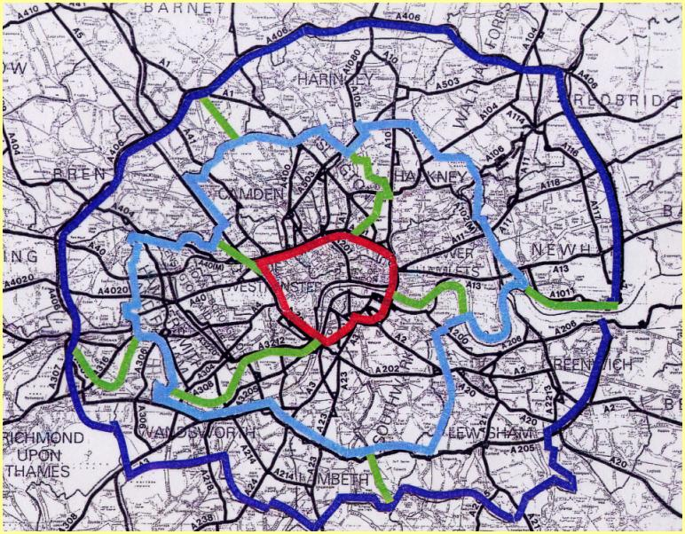

Figure 2: 1991 Central and inner bi-directional cordon charging for different charging structures: Economic benefits (£M per annum). Source: May et al (1996).

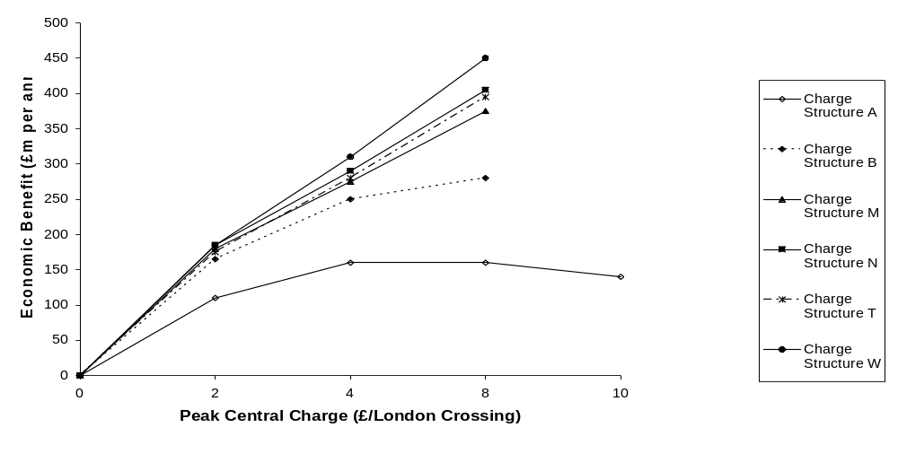

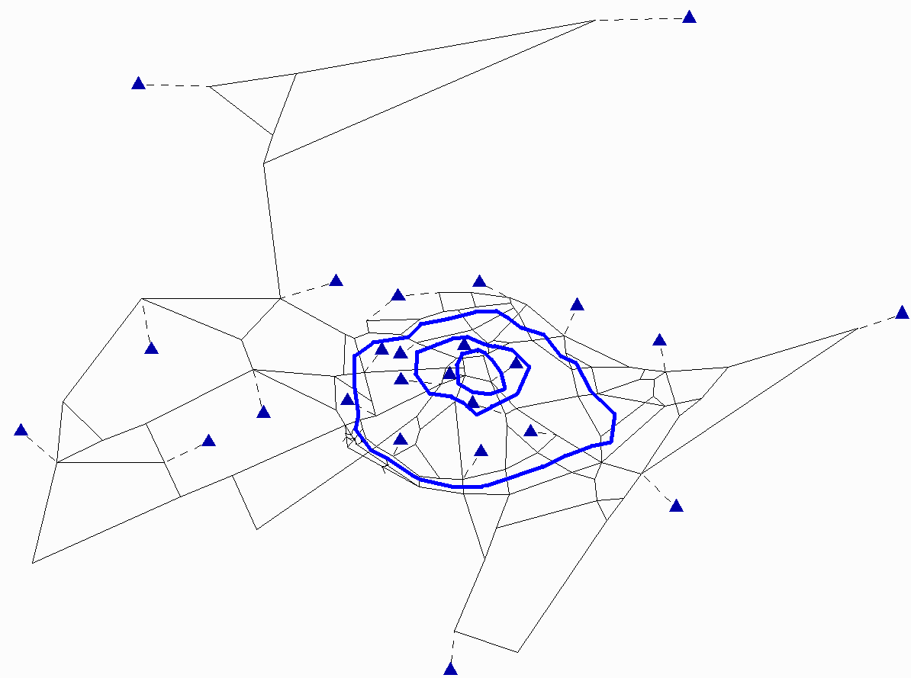
Outer cordon
Inner1 cordon
Inner2 cordon

Figure 3: Edinburgh network with three judgmental cordons
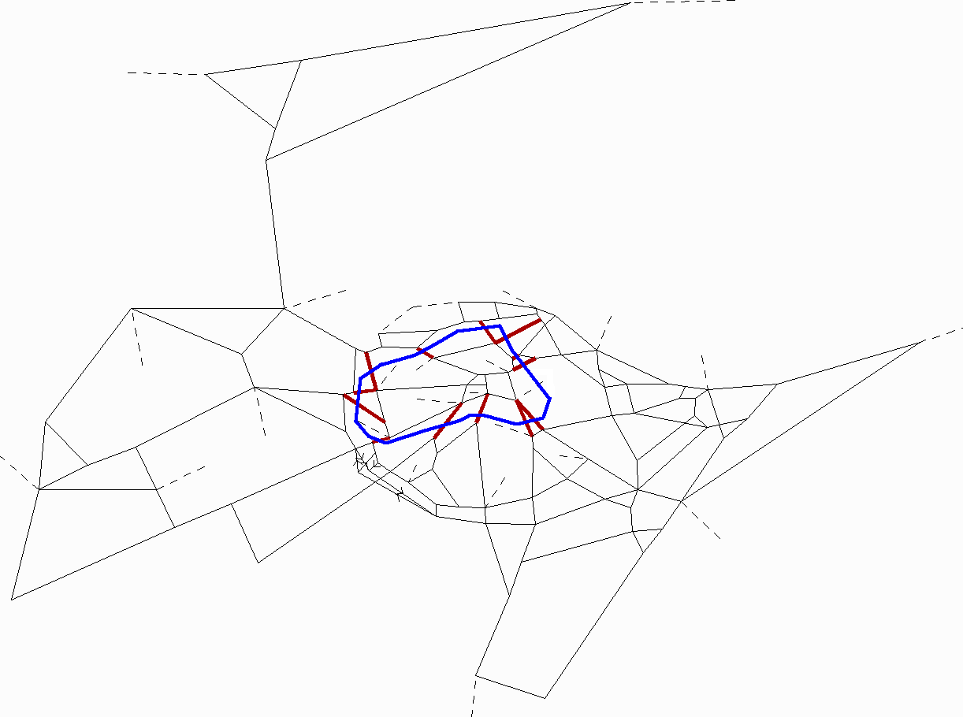

Figure 4: Location of the optimal cordon OPC

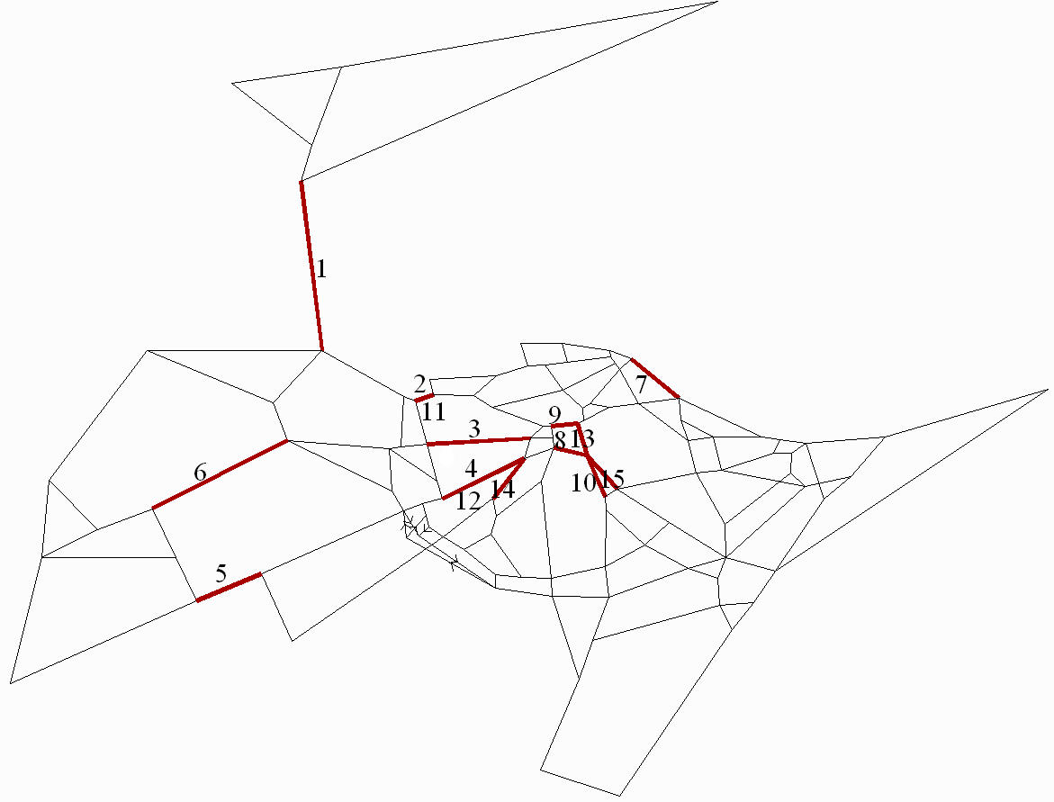
Figure 5: Locations of the Top-15 links with the highest marginal costs, numbered in rank order

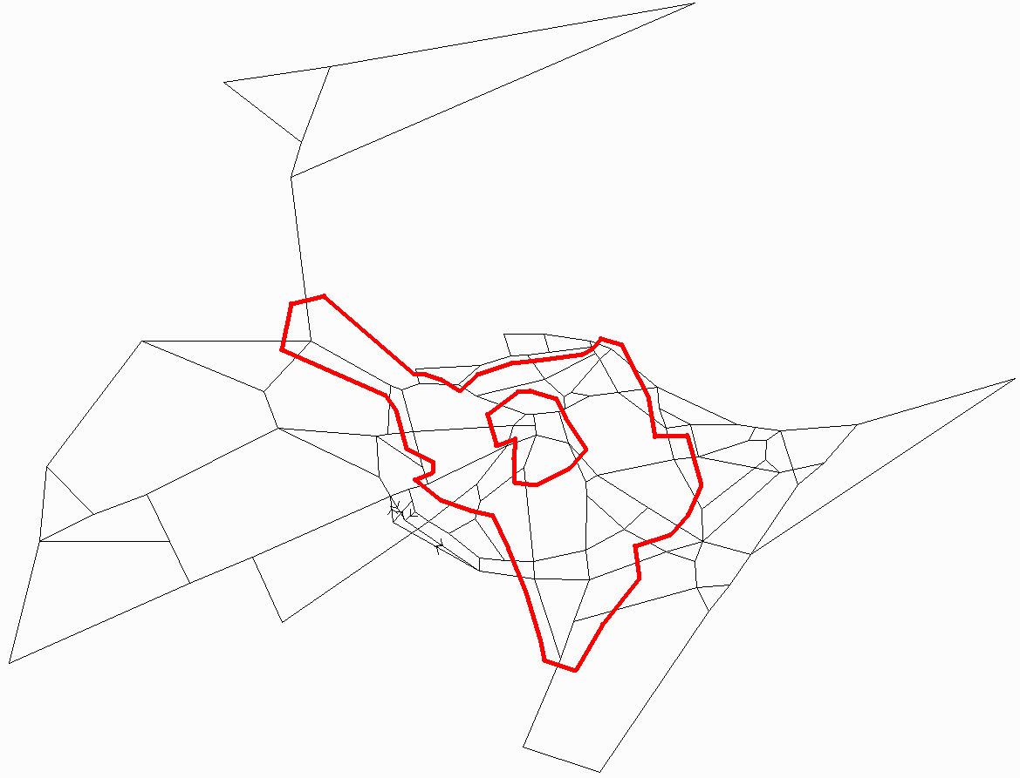
Figure 6: Location of the optimal double cordon D-OPC

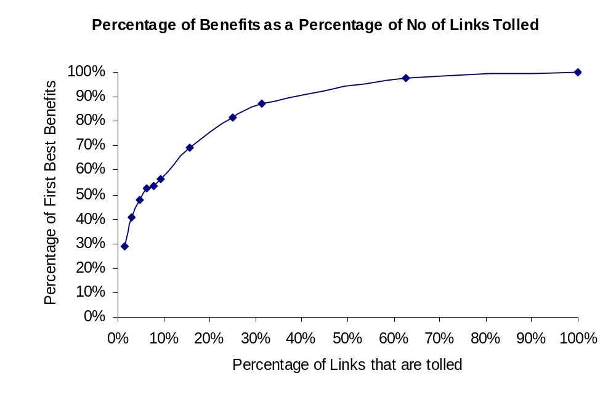
Figure 7: Percentage of first best benefits versus percentage of links tolled – Edinburgh

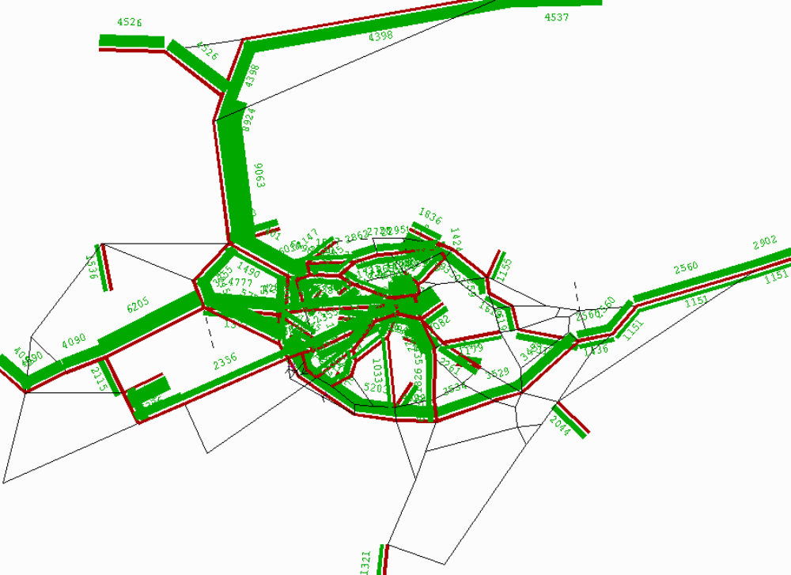
Figure 8: Top 15 links and bandwidth from Select Link Analysis in SATURN

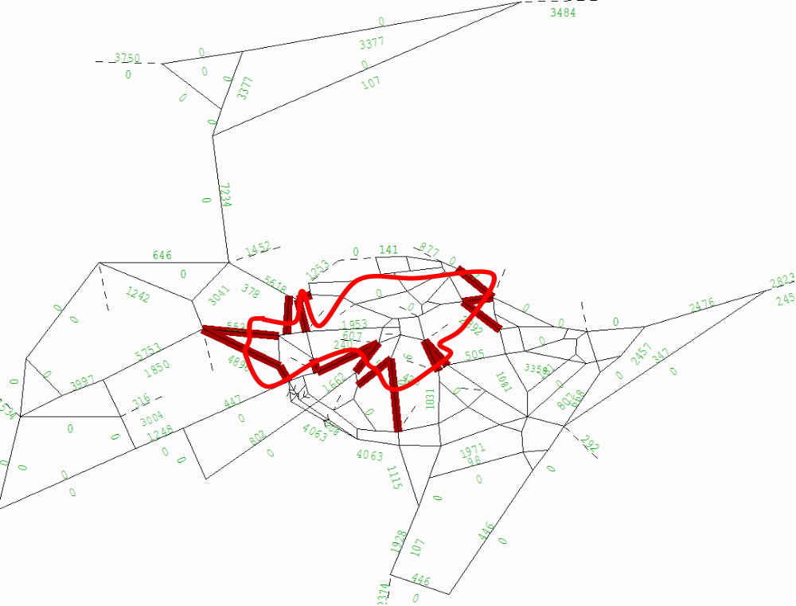

Figure 9: Single cordon developed using the SLA approach
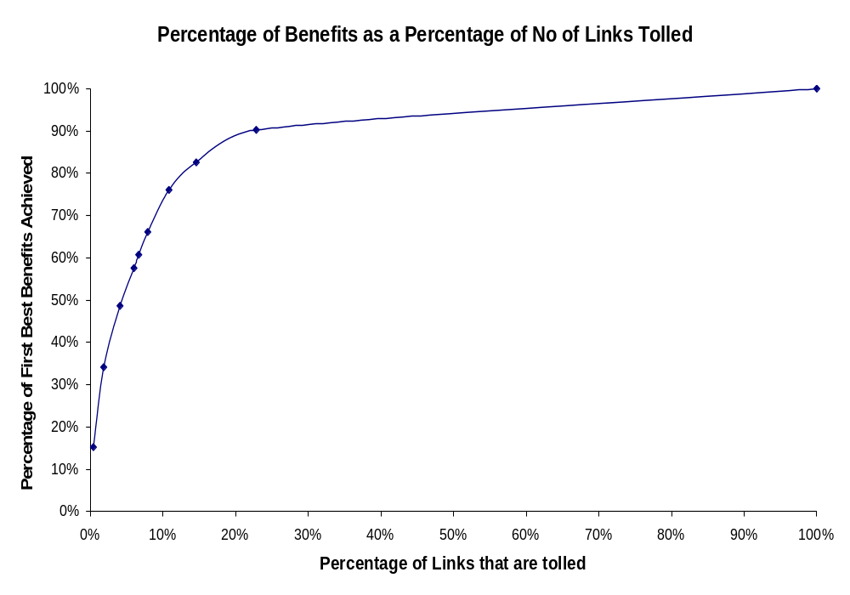

Figure 10 : Variation of benefit with percentage of system optimal tolls applied – York buffer network.
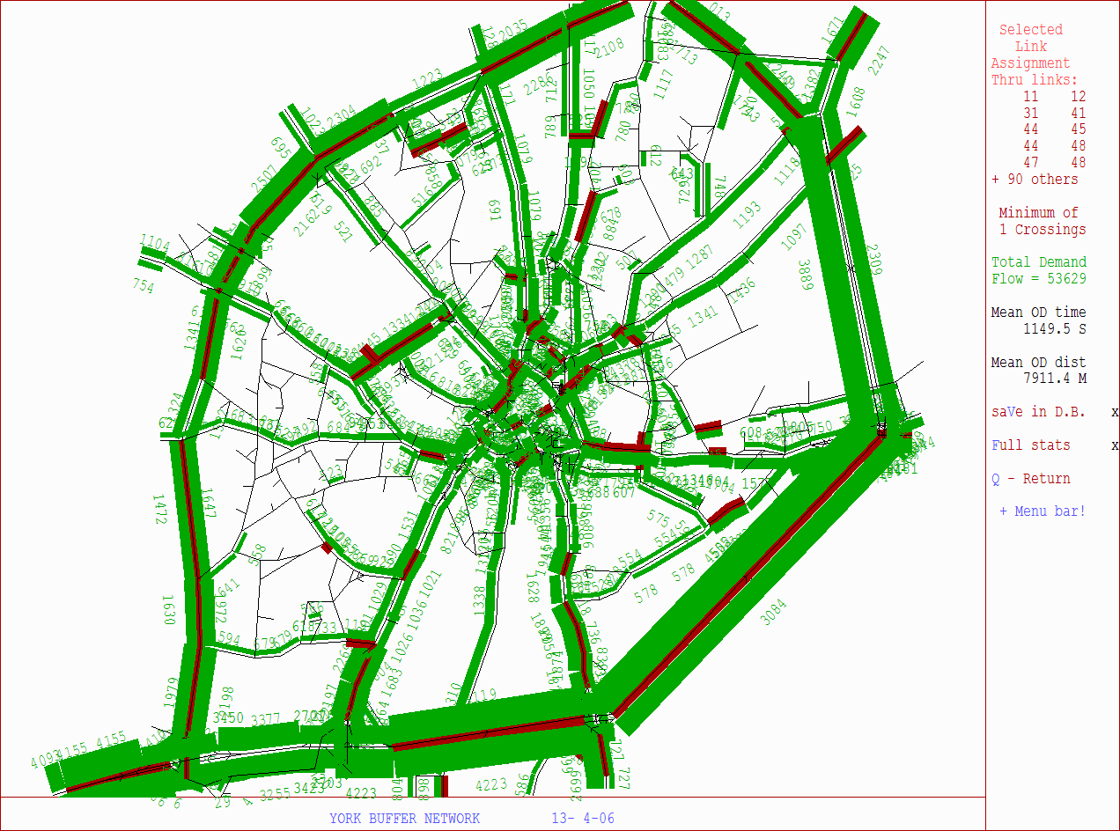
Figure 11 : SLA for top 95 links with bandwidth display (min value 500 PCUs/hr).
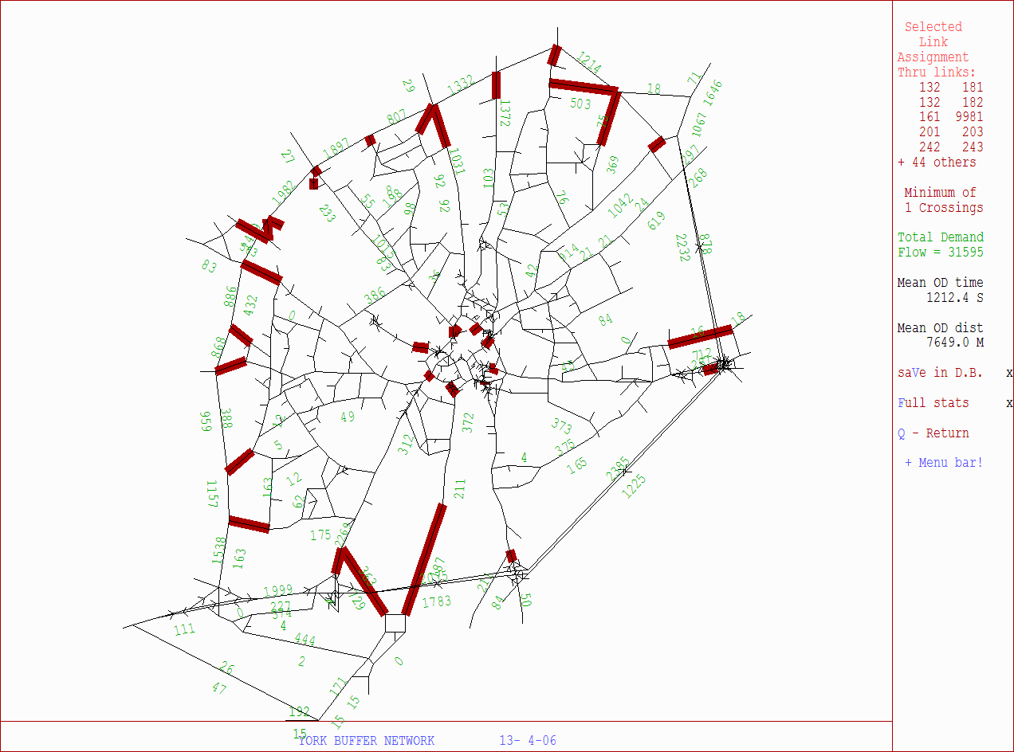

Figure 12 : York Judgmental cordons.
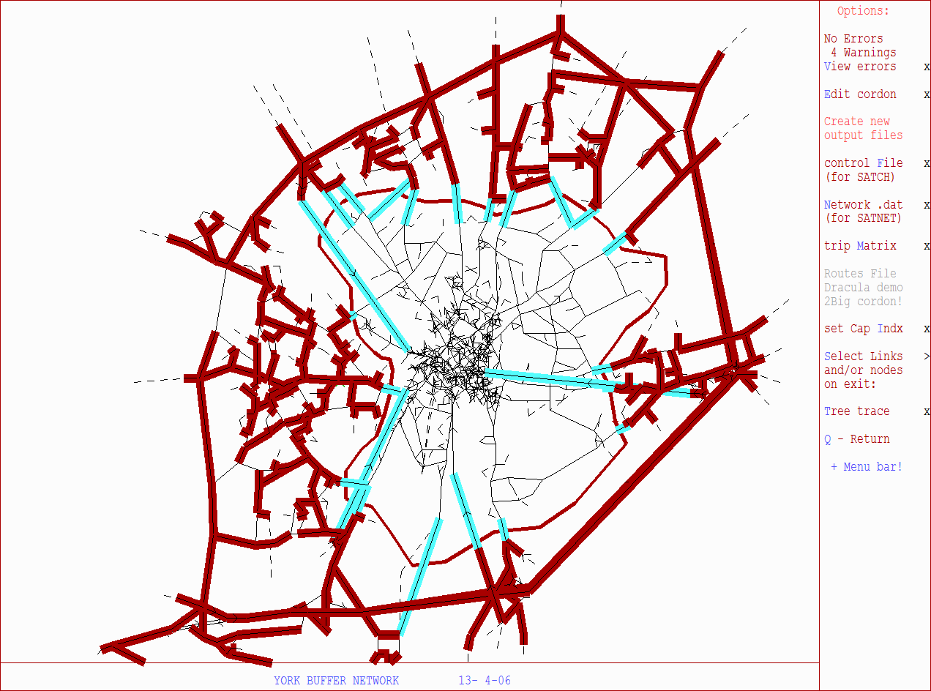

Figure 13 : SLA process to design cordon SLA1 in SATURN

