WCTR 2007 - June 24-28 - University of California, Berkeley:
Track E2 - Transportation Performance Measurement

Improving urban transport performances by tendering lots : an econometric estimation of natural monopoly frontiers

William ROY & Yves CROISSANT

Laboratoire d’Économie des Transports (LET)
Université Lumière Lyon 2

November 2006 – revised April 2007

Abstract: Recently, some cities decided to divide their transport network into several attractive and accessible parts (this procedure is called allotment) in order to reduce urban transit costs. Gains obtained by introducing more competition for the market should be compared with costs associated with cutting the network into several parts, and this question is crucially linked to the measure of returns to scale. In this paper, we estimate a translog cost function on a panel of French urban transit networks. Our main conclusion is that scale economies are exhausted for a production of about 7.5 millions vehicles-kilometres per year (corresponding to urban areas of about 200,000 inhabitants). Therefore, in terms of scale economies, allotment would reduce costs of public transport services for the seven biggest cities of our sample.
Keywords: cost function, return to scale, public transport, allotment
Abbreviated title: Reducing cost of urban public transports by tendering lots?

Introduction
In order to provide their public transport services, 90% of the French local transport authorities are using calls for tender for more than 20 years. And those urban authorities are free to decide how to organise and contract out public transport services. But while an increasing number of European cities work with more than one operator (London, Stockholm, Helsinki…), none of the French transport authority moved to this form of governance, that is called allotment. Typically, public transports in cities like Lyon, Lille, Toulouse or Bordeaux are only operated by one single private operator.
However, during the last few years, the concentration of the industry has reduced the number of potential bidders: the three main companies hold now a 75% market share. And as a consequence or not, urban public transport costs increased dramatically during the same period. One of the possibilities in favour of competitive pressures (including benchmarking) and cost reducing is to divide networks into attractive and accessible parts. It is this governance scheme that we want to analyse with this contribution.

An allotment will probably increase transaction costs and reduce market power of local monopolies. But it has also consequences on cost minimisation process. Unit production costs depends on technological returns to scale. So before studying the other aspects, we will consider that an allotment could be desirable if it is not disconnected from the industry natural monopoly frontiers.
Technologically, an industry is said to be a natural monopoly if, over any relevant vector of outputs Y_{k}, the cost function C(Y) is subadditive:
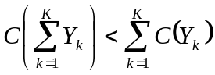
So in order to handle the question of urban transport natural monopoly frontiers, the central point deals with the industry cost function structure. The literature contains many single-product estimations for transport industry (Braeutingam 1999, Pels & Rietveld 2000). Some contributions are unavoidable, particularly about railways and airways (Caves, Christensen & Swanson 1980 et 1981, Caves, Christensen & Tretheway 1984), and a large number of econometric estimations have been realised on urban transport samples (Karlaftis 2001, De Borger, Kersterns & Costa 2002).
This paper studies the operating costs of the French urban public transport networks. A translog cost function is estimated with a 1995-2002 panel data. As a result, we measure several significant diseconomies of scale in the production of vehicles-kilometres. So, the classical argument of a local natural monopoly seems to be limited, valid only for a production under 8 millions kilometres a year.

We will first (section 2) come back to the essential lessons on returns to scale provided in the literature applied to urban public transport industry. We will then present in section 3 the translog cost function that will be estimated. In section 4, we discuss the econometric methodology chosen, particularly the advantages of panel data. The data are presented in section 5. The results of panel estimations are discussed in section 6.

Optimal size : literature review about the single-product
Empirical analysis considering an unique output are limited to study the heterogenous production of public urban transport services. However, this kind of econometric studies have some recurrent results that are an important basis in order to understand cost formation and cost functions. Indeed, the literature contains lessons on scale economies in the industry that should not be ignored.

Definition of optimal size
In the single-product case, returns to scale are generally defined by the ratio between average cost and marginal cost, that is the inverse cost elasticity of production (ε_{Y}):
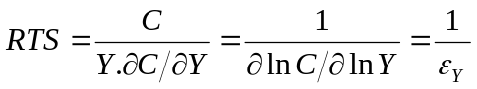
Consequences are the followings :
- If RTS < 1: decreasing returns to scale, diseconomies of scale
- If RTS = 1 : constants returns to scale
- If RTS > 1: increasing returns to scale, economies of scale

In addition, economies of scale in railway industry are classically decomposed into returns to density and returns to size (Keeler 1974, Caves Christensen & Tretheway 1984). Returns to density (RTD) measure the evolution of costs when the level of production change, given a constant network of infrastructures. Returns to size (RTS) measure the evolution of costs when a network is enlarging, given traffic constant per lane. In this objective, returns to density do not include the variation of the length of lines (LL):
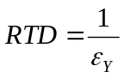
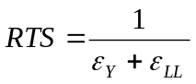
Some urban transport studies include this decomposition (Fazioli, Filippini & Prioni 1993, Levaggi 1994, Matas & Raymond 1998, Gagnepain 1998, Jha & Singh 2001, Karlaftis & McCarthy 2002, Filippini & Prioni 2003), but it is not clearly relevant. Indeed, infrastructure costs are specific only for some modes (subway, tramway, trolleys…), not for buses. And those costs are not supported by the operators (at least in the French urban transport industry). Moreover, the hypothesis of a constant level of infrastructure is only valid in a short term. So we think that this decomposition is not that helpful in our context.

Returns to scale and output measurement
The literature review presented in Table 1 show substantial differences between the numerous estimations realised. This diversity is in particular due to the variety of methodologies used by authors, and to the different samples considered. Yet, two results seem to be stable.
First, level of returns to scale depends on the output selected. Berechman & Guiliano (1984) observed diseconomies in terms of vehicles-kilometres; while considering receipts per passenger they noticed economies of scale. This result is confirmed in Karlaftis, McCarthy & Sinha (1999a) study, who estimated returns to size and density by passengers and vehicles-miles. So it seems to be higher returns to scale with a demand-oriented outputs (trips, journeys, receipts pere passenger or passenger-kilometres) than with supply-oriented outputs (vehicles-kilmetres or seats-kilometres).
Second, in most of the cases, returns to scale decrease with total production (Viton 1981, Button & O’Donnell 1985, Thiry & Lawarree 1987, Filippini Maggi & Prioni 1992, Fazioli Filippini & Prioni 1993, Matas & Raymond 1998, Karlaftis McCarthy & Sinha 1999a, Jha & Singh 2001), mainly when it deals with supply oriented output. So generally returns to scale are increasing, except for some studies from the 1980’s: Williams & Dalal (1981) and Obeng (1984,1985).

<Insert Table 1 here>

In total, one of the most essential facts in order to discuss returns to scale levels is the choice of output. Some authors argue that demand-related indicators (e.g. passenger-km or number of passengers) are more relevant than pure supply indicators (e.g. vehicle-km or seat km) because they take into account the economic motivation for providing services. Ignoring demand may lead to consider that the most efficient operators are those whose buses are empty.
Vehicles-kilometres operators seem to have smaller optimal sizes than demand-oriented output producers do. So in terms of passengers, networks need to be more integrated, but vehicles-kilometres operation should be done by smaller companies. This may explains why some European cities like Helsinki, London or Stockholm have adopted an institutional scheme with an organising authority controlling all the demand side, while several operators run vehicles on the lots (after a call for tender).

As a conclusion of this literature review, two main points have been identified about returns to scale in the urban transport industry. On the one hand, the optimal size in terms of “demand side output” has a weak probability to be smaller than the whole urban area size. On the other hand, returns to scale in terms of vehicle-kilometres (“supply side output”) production has a quite high probability to do not imply a natural monopoly. So we will concentrate our investigations in measuring the optimal size in terms of vehicle-kilometres.

The translog total cost function
Standard microeconomics defines cost function as the minimal cost for each production level, given relative factor prices and technology:
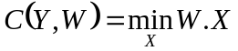 under constraint 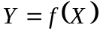
where C(.) represents the cost function, Y is the vector of outputs levels, W is the vector of input prices, X is the vector of input quantities and f(.) is the production function.

This function has the following properties:
- Monotonicity: Cost function is non-decreasing in prices (positive gradient).
- Homogeneity: For a given output, if all the input prices increase in the same proportion, total costs increase by this proportion.
- Concavity: The hessian matrix is negative semidefinite

Cost structure analysis requires a flexible functional form, minimising a priori restrictions and in particular unconstrained in terms of returns to scale and elasticity of substitution (Berndt & Khaled 1979). Christensen & Green (1976), in their study applied to electricity production, have for instance shown the translog cost function ability to treat in a relevant way the question of scale economies.
The translog cost function had been used in the large majority of studies (see Table 1) needing a flexible cost function.

A translog cost function is defined by:
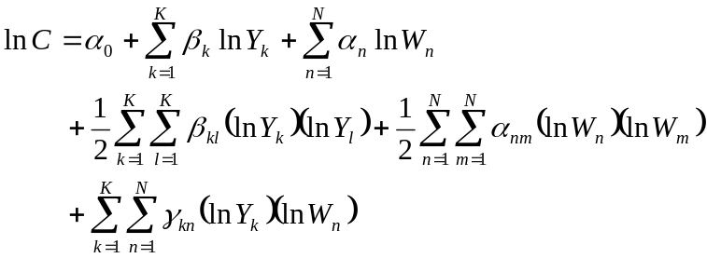
where C represents total costs, Y the vector K outputs and W the vector N input prices.

Two more a priori conditions are assumed:
- the matrix of coefficients is symmetric: (Young theorem) : 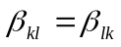 et 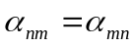
- homogeneity of degree 1 in price implies the following conditions (Euler theorem) : 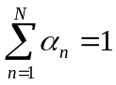 ; 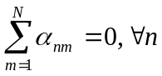 ; 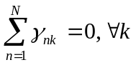

Elasticities of scale ε_{Yk} for each output are:
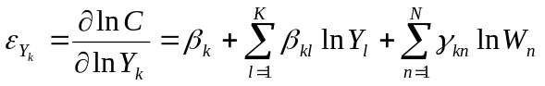
In addition, from a translog cost function, it is easy to determine the demands of input. The Shephard lemma implies equality between each input cost share (S_{n}) and the partial logarithmic derivation of cost in its input price:
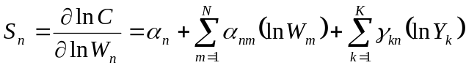 with W_{n} > 0
The simultaneous estimation of cost shares and the cost function increases the number of degrees of freedom, and to improve the quality of the estimators. Parameters of the n-1 cost share equations are estimated simultaneously (Christensen & Green 1976) by Zellner (1962) method (or SURE: Seemingly Unrelated Regressions).

At last, many studies used variable cost functions which consider a fixed input, typically the fleet size. But despite its apparent pertinence, this choice implies serious difficulties. And those difficulties conducted us to reject this approach. Indeed, most of variable cost estimations conduct to a positive effect of fleet variable on cost (Viton 1981, Levaggi 1994, Kumbhakar & Bhattacharyya 1996, Karlaftis & McCarthy 2002, Fraquelli Piacenza & Abrate 2004, Piacenza 2006), which is clearly unrealistic. It means that buying more vehicles conduct to more variable costs! Credible results (a negative effect) are rare (Obeng 1985, Gagnepain 1998), so the literature leads to consider that variable cost function estimations including fleet size have a bias.
The bias seems to come from a misunderstanding about the production capacity choice. Urban transports require different levels of production during the day. And the volume of vehicles is decided in order to have a sufficient capacity during peak hours. As a consequence, “These proxy-variables for the capital stock reflect maximum available production capacity at one particular point in time and, therefore, are generally highly correlated with output increasing" (Filippini 1996). So if a network manager decides an increase in its peak-base ratio (with a constant amount of kilometres produced), both variable costs and fleet will increase. It is probably the effect measured by the fleet coefficient, but this is not what the variable cost function model assumes.

As a conclusion, total cost function seems to be better appropriate to study urban transport industry. The use of a variable cost function with fleet as proxy for capital raises more questions than it solves. Moreover, in the French case, investments (including buses) are directly granted by local governments. Operators produce a service by using public capital. As a consequence, their capital cost share in under 1%. So, it is more adapted to run a total cost function in that case, which include indeed a very small amount of capital.

Econometric models and methods
Translog cost functions have been generally used for urban transport estimations (see Table 1). Since the very often quoted paper of Viton (1981), econometric methods and models became more refined. On the one hand, specifications estimated are less and less restrictives : linear, Cobb-Douglas then translog. And on the other hand, data are more and more available. It allows to go beyond time series analysis or cross-section studies. As a result, standards are clearly oriented to flexible functions (typically translog) estimations on panel data (Thiry & Lawarree 1987, Kumbhakar & Bhattacharyya 1996, Matas & Raymond 1998, Karlaftis McCarthy & Sinha 1999a, Filippini & Prioni 2003).
Time series models reduce the analysis to a particular network, or imply a macro aggregation. Time series estimations had been historically used during the 1980’s, according to macroeconomic data (Berechman 1983, De borger 1984) or local ones (Berechman & Guiliano 1984, Androkopoulos & al 1992). In the urban transport case, time series are standing a relatively small variance and are very sensible to local determinants.
Cross-section estimations give a really more interesting perspective of production structure. The joint study of firms with different sizes is more able than time series analysis to improve our understanding of scale economies. In return, cross-section analysis assume that firms have access to the same technology, produce the same type of services and are facing the same environment, which is sometimes a strong hypothesis and can be ease by using control variables that limit effects of non relevant heterogeneity:
- Average commercial speed : Viton 1992, Levaggi 1994, De Rus & Nombela 1997, Gagnepain 1998, Fraquelli Piacenza & Abrate 2004, Piacenza 2005
- Load factor for a demand-oriented output: Levaggi 1994, Kumbhakar & Battacharyya 1996, Jha & Singht 2001
- Number of stops: Filippini, Maggi & Prioni 1992, Filippini & Prioni 2003
- Urban constraints (density, centrality…): Levaggi 1994, Dalen & Gomez-Lobo 2003
- Institutional or organisational design (ownership, contract) : Kumbhakar & Battacharyya 1996, De Rus & Nombela 1997, Gagnepain 1998, Dalen & Gomez-Lobo 2003, Filippini & Prioni 2003, Piacenza 2005
- Peak-base ratio: Button & O’Donnell 1985, Viton 1992, Karlaftis McCarthy & Sinha 1999a.

Estimations on panel data tend to stand out, thanks to their double individual and time dimensions. Panel models gather individual effects (for each network) in a specific term. So estimated coefficients are free of individual effects. And moreover, panel data allow us to take into account the influence of unobservable information. The additional hypothesis we need to assume is that unobservable characteristics of networks are constant during the time period considered. In our sample considering urban area, it is quite realistic to assume that some local components (geography, housing, urban structure…) are constants in a short run. So panel data estimations have attractive properties and are quite adapted to the urban problematic.

Data
We used an unbalanced panel data of 959 observations on 141 French urban transport networks, for the years 1995 to 2002. This data set was gathered thanks to the annual surveys conducted by the Centre d’Etude et de Recherche du Transport Urbain (CERTU), a ministerial agency.
For a purpose of homogeneity, we have excluded non-urban traffics, and the small networks (under 30,000 inhabitants) that are assumed to have a different production function. In addition, several observations (network-year) were discarded because some data were missing or were suspected to be wrong after a careful scanning of the data. This database is the biggest and the most updated on the French urban public transport system. Its physical and institutional variables were used in a recent paper (Roy & Yvrande-Billon 2007). Since, we did collect and treat accounting data.

Prices and costs
In this data base, private firms itemised their costs, at least between labour and puchases. It is not individual input factor costs as we would have like to treat : labour, fuel, material, maintenance and administrative costs. But this is nevertheless better than lump-sum costs that are reported for instance the National Transit Database in the US.
Labour is the main input factor of the operators. Its price W_{L} is obtained by dividing annual labour expenses by the number of equivalent full time employees. So labour price W_{L} is actually an average cost of labour for each network, ignoring the differences of wage structure.
The others expenses considered are dealing with energy and maintenance. Price of energy and maintenance W_{A} is the ratio between the total amount of purchases (including taxes) and the total number of kilometres covered by the vehicles of the network during the year.
We are not considering any price of capital, and cost of capital (typically amortisation and depreciation expenses) is not added to the cost variable C. Mainly, this kind of data is not properly filled out. And moreover, buses are generally owned by the organising authority. At last, we assume that capital cost is the same everywhere in France, and by the way it will not explain differences in costs.
In total, costs considered are only operating costs (€ 2002) in their main dimensions: labour, energy and maintenance. Table 2 shows the 959 observations panel we use. Around 50% of firms operating costs are between 1.5 millions € and 10 millions €. The last quartile is very large, as it includes networks with more than 100 millions € of expenses: Lille, Marseille (> 130 millions €) and Lyon (> 220 millions €). The mean price of labour is 33 400 € and the mean purchases price is 0.69 €.

<Insert here Table 2>

Output : vehicles-kilometres
The definition of outputs had been largely debated in transportation literature as explained earlier. The output we retain in this paper is supply-orientated; it is the number of vehicle-kilometres. The main argument explaining our choice is that demand-related output will certainly conduct to a larger natural monopoly as we explained it in section 2.2 .
Km includes different kind of vehicles-kilometres. Some of them, KmL, are realised by different light rail transit (LRT) systems, mainly subway and tramway. We also distinguish in Table 2 kilometres produced with short buses or microbuses (KmP), and articulated buses (KmBA). Table 2 show that only a few number of networks use the whole diversity of vehicles. Close to 50% of networks declare to do not operate articulated buses or small buses. Figure 1 shows the "gross" cost function extracted from the data.

<Insert here Figure 1 >

Data used are not perfect, but the sample is large and quite complete. They will allow us to estimate returns to scale in the French urban transport industry, according to the advanced standards of a translog function on panel data.

Estimation results

Global comments
The fixed effects model we estimate at the mean values is the following translog cost function:
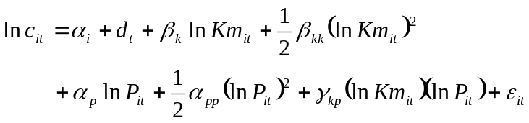
where α_{i}’s and d_{t}’s represent the individual and time effects,
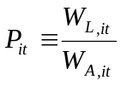 and 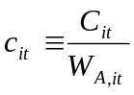 (price homogeneity condition),
and ε_{it} is a stochastic disturbance independent and identically distributed IID(0, σ_{ε}²).

In parallel to this fixed effect model (Within), we show in Table 3 the resultats of the two classical alternative models: a random effect model (Random) and a model without individual effect (Pooling). The Pooling model is a cross-section estimation with time dummy variables. The Random model have less parameters (and more degree of freedom) as the α_{i} are assumed random:
- Pooling: 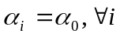
- Random: 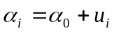, with 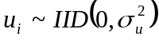

<Insert here Table 3>

Econometric standard tests of comparison between the models are presented in Table 4.
First, a Fisher test concludes that the Within model should be preferred to the Pooling model (without fixed effects). A Fisher test is also used to test three other specifications that are rejected compare to the Within. In addition, the Lagrange multiplier test proposed by Breusch & Pagan (1980) show that Random model is econometrically more relevant than the Pooling one. So the presence of firms individual effects is attested by the Fisher and Breush & Pagan tests.
Second, the Hausman (1978) test comparing the closeness of the Within and the Random coefficients is rejected, which is meaning that individual effects are correlated with at least one of the explanatory variable. We will come back to this result, which requires more comments.

<Insert here Table 4>

In addition, some restrictions have been tested: homotheticity, homogeneity in production, elasticity of substitution equal to one and Cobb-Douglas function. According to a Wald test, all these restrictions are rejected.

So according to these tests, the existence of specific effects seems credible and correlated to explanatory variable. The translog specification also appears to be econometrically robust.

Input price coefficients
The first order price coefficients α_{p} are quite stable for the three models, but are not exactly conform to the value we were expected, which is the cost share of labour (see Table 5) at the mean point. It is the most problematic point associated with input prices.

<Insert here Table 5>

The simultaneous estimation of the cost function and the labour cost share according to the SURE method is clearly correcting results in accordance with the previous remark. Table 6 shows that the first order coefficient reach approximately the labour cost share, and the cross coefficient γ_{kp} become positive. The second order coefficient α_{pp} is almost the same in both estimations.

<Insert here Table 6 >

Secondly, we have to control the concavity in price of the cost function. This condition is verified if the second order derivative matrix is negative semidefinite. According to price homogeneity condition, we face indeed to an only price ratio P, which imply the simple following condition:
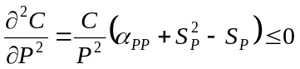 with 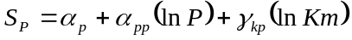
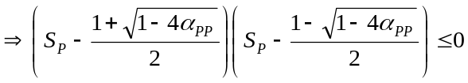
This condition impose α_{pp} to be inferior to ¼. The second order coefficients (α_{pp}), as measured in Table 4 and Table 6, are always less than 0.18. For α_{pp}=0.18, this condition is verified for labour cost shares between 0.235 and 0.764.

Output coefficients
In this paper, we are mainly interested in output coefficients. The first order coefficient corresponds to cost elasticity of production (ε_{Y}) at the mean level of output. We notice mainly that this cost elasticity is very weaker in the Within model than in the Random model (from 0.718 to 1.059 in Table 4). Consequences in terms of returns to scale are by the way completely opposed. Figure 2 shows returns to scale estimated by the two translog models, and defined by:
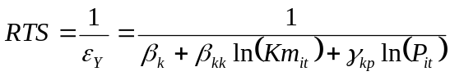

<Insert here Figure 2 >

Returns to scale are increasing and always higher than 1 for the Within model. They are decreasing and become inferior to 1 after approximately 1 millions vehicles-kilometres per year for the Random model.

Figure 3 describes marginal cost and average cost curves for the two models. The Within model corresponds to an average cost curve continuously decreasing, while the Random model implies a minimum average cost when returns to scale become lower than one. The Within model concludes to a natural monopoly as marginal cost are never increasing on the sample range. But it is unconvincing that the cost of a new kilometre in under 2 € in a large network. Indeed, as noticed by Thiry & Lawarree (1987), fixed effects are probably include a part of the size effect.

<Insert here Figure 3 >

As a consequence, the Within model seems to be questioned. In fact, the difference in results between the Within model and the Random model is explained by the strong correlation between individual effects and Km as illustrated in Figure 4. The Random model ignores this correlation, which leads to an inconsistent estimator (see for example Verbeek 2005, p.351). And according to the previous Hausman test and Figure 4, individual effects are correlated with outputs.

<Insert here Figure 4>

Yet, “unfortunately, applied researchers have interpreted a rejection as an adoption of the fixed effect model and nonrejection as an adoption of the random effect model” (Baltagi, 2005, p.19). Indeed, the two models do not have the same significance. The Within estimates a scale elasticity, given a value of α_{i}. Conversely, the Random effect approach is not conditional upon the individual α_{i}’s but integrates them. So the two model have just a different meaning. The appropriate interpretation is that the Within model measures a β_{k} conditional upon the values for α_{i}. β_{k} is the best value to explain ln c_{it}, ceteris paribus (including α_{i}). The Random model measures β_{k} while α_{i} is not constant, so its impact is included in the coefficient. Finally, if we estimate (by OLS) a function explaining the fixed effects α_{i}’s from the Within model (represented in Figure 4) with the individual means of Km and their squared, we obtain the following coefficients at the mean values:
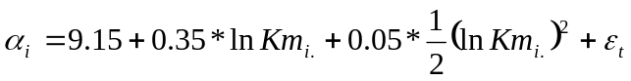
Those coefficients are clearly representing the differences between the Within and the Random ones (α₀, β_{k} and β_{kk}) from Table 3. The intercept is the α₀ of the Random model. The sum of 0.718 and 0.35 is close to 1.059. And the sum of –0.03 (non-significant) and 0.05 is not far from 0.0499.

As a conclusion, the Within and Random models explain differently the data. The Within model is probably more useful in order to discuss small variations in the short run, while the Random model is considering a heavier production modification (where α_{i} varies). Our problematic of allotment will conduct us to prefer the Random model. And in addition we are not very interested in the particular values of α_{i}. However, the random estimation we obtained is not consistent given the correlation between the individual effects and the explanatory variables Km and Km². The next model we are proposing is including instrumental variables, according to Hausman & Taylor (1981). It is a consistent Random model.

A random with instrumental variables model
For practical reasons, the HT (Hausman & Taylor) model is estimated for a balanced panel. This panel gathers the 78 networks from the global unbalanced panel, with the condition that we have data every year from 1995 to 2002 (624 observations). Instrumental variables used are the deviation from individual means for every variable, and individual means only for exogenous variable that are: 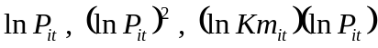 and year dummies.
Results are presented in Table 7. Estimations of the Within’ and Random’ models with the balanced panel show results very close from Table 3 ones. So we will not do more comments on them. They will be a benchmark in order to discuss the model HT results, which globally have an intermediate position.

<Insert here Table 7 >

In particular, returns to scale deal with β_{k} and β_{kk} coefficients. Those coefficients have to be interpreted as the Random model ones. The HT model leads to increasing returns to scale at the mean point (1/0,9413), and RTS are increasing at a 0.0855 rate. Compared to the Within’ model, which consider returns to scale given an α_{i}, the β_{k} is significantly higher (Hausman test is rejected). This level is also inferior to the β_{k} obtained by the Random’ model. So the HT model have the double advantage to be econometrically and economically consistent (it has the same interpretation than the Random).
Returns to scale of the model HT and their consequences on cost curves are summarised in Figure 5. Returns to scale become inferior to one for a production level around 7.5 millions vehicles-kilometres per year, which is correspond to the optimal size revealed by the model. This result is credible, and is approximately the production of cities like Reims, Saint-Etienne, Caen or Rennes. It also corresponds to one half of the production of Strasbourg, Nantes, Toulouse or Bordeaux, one third of the production of Lille or Marseille, and one sixth of the production of Lyon.

<Insert here Figure 5 >

At last, about time effects, the HT model estimates, as the others, a global increase of unit cost (with constant production and price ratio). The productivity falls by 1.88% between 1995 and 1999 and speeds up its decline the year after: 2.5% (4.38%-1.88%) between 1998 and 1999, 1.97% (6.35%-4.38%) between 1999 and 2001, and 0.66% (6.35%-7.01%) between 2001 and 2002.

Conclusion
In order to study the opportunity of urban public transport allotment, the aims of this paper was to evaluate the natural monopoly frontiers in this industry in France. According to a review of literature that mainly shows that a supply-oriented output was more appropriate to fragment networks, we estimated a translog cost function.
Within and random model were estimated on a large panel of French data. It shows that the random model was more appropriate but needed the complement of instrumental variables to be consistent.
In this later case, the optimal size measured for the sample is 7.5 millions of vehicles-kilometres. This result is quite consistent with the literature review, and will for instance imply to do three different calls for tender for Marseille or Lille, in accordance to what is implemented in London or Stockholm.
However, this study is restricted to the production side, and other determinants like transaction, and information costs and benefits are not taken into account. Further researches into those directions should give us a clearer idea of what is desirable. We are also investigate the field of multiproduct cost functions in order to find more detailed results.
References
Andrikoupolos A.A., Loizidis J. & Prodromidis K.P. (1992), ‘Technological Change and Scale Economies in Urban Transportation’, International Journal of Transport Economics, 19, pp.127-147.
Baltagi B.H. (2005), Econometric Analysis of Panel Data, John Wiley & Sons, 3rd edition.
Berechman J. & Giuliano G. (1984), ‘Analysis of the Cost Structure of an Urban Bus Transit Property’, Transportation Research Part B, 18(4), pp.273-287.
Berechman J. (1983), ‘Costs, Economies of Scale and Factor Demand in Bus Transport’, Journal of Transport Economics and Policy, 17(1), pp.7-24.
Berechman J. (1987), ‘Cost Structure and Production Technology in Transit: An Application to Israeli Bus Transit Sector’, Regional Science and Urban Economics, 17(4), pp. 519-534.
Berndt E.R. & Khaled M.S. (1979), ‘Parametric Productivity Measurement and Choice among Flexible Functional Forms’, Journal of Political Economy, 87(6), pp.1220-1245.
Braeutingam R.R. (1999), ‘Learning about Transport Costs’ In Gómez-Ibáñez &. Tye (Eds), Essays in Transportation Economics and Policy: A Handbook in Honor of John R. Meyer, Clifford Winston, http://brookings.nap.edu/books/0815731817/html/index.html
Breush T.S. & Pagan A.R. (1980), ‘The Lagrange multiplier test and its applications to model specifications in econometrics’, Review of Economic Studies, 47, pp. 239-253.
Button K. & O’Donnell K.H. (1985), ‘An Examination of the Cost Structures Associated with Providing Urban Bus Services’, Scottish Journal of Political Economy, 32, , pp. 67-81.
Caves D.W. Christensen L.R. & Tretheway M.W. (1984), ‘Economies of Density versus Economies of Scale : Why Trunk and Local Service Airline Costs Differ’, RAND Journal of Economics, 15(4), pp. 471-48
Caves D.W., Christensen L.R. & Swanson J.A. (1980), ‘Productivity in U.S. Railroads, 1951-74’, Bell Journal of Economics,11(1), pp.166-181.
Caves D.W., Christensen L.R. & Swanson J.A. (1981), ‘Productivity Growth, Scale Economies, and Capacity Utilization in U.S. Railroads, 1955-74’, American Economic Review, 71, pp.994-1002.
Christensen L.R. & Green W.H. (1976), ‘Economies of Scale in U.S. Electricity Power Generation’, Journal of Political Economic, 84(4), pp.655-676.
Croissant Y. (2005), ‘plm: Linear models for panel data’, R package, version 0.1-2, http://www.R-project.org
Dalen D. M. & Gomez-Lobo A. (2003), ‘Yardsticks on the road: Regulatory contracts and cost efficiency in the Norwegian bus industry’, Transportation, 30, pp.371-386.
De Borger B. (1984), ‘Cost and Productivity in Regional Bus Transportation: The Belgium Case’, Journal of Industrial Economics, 33(1), pp. 37-54.
De Borger B., Kerstens K. & Costa A. (2002), ‘Public transit performance: what does one learn from frontier studies’, Transport Reviews, 22(1), pp.1-38.
De Rus G. & Nombela G. (1997), ‘Privatisation of Urban Bus Services in Spain’, Journal of Transport Economics and Policy, 31(1), pp. 115-129.
Delhausse B., Perelman S. & Thiry B. (1992), ‘Substituabilité partielle des facteurs et efficacité-coût : l’exemple des transports urbains et vicinal belges’, Econome et Prévision, 32, pp.105-115.
Fazioli R., Filippini M. and Prioni P. (1993), ‘Cost Structure and Efficiency of Local Public Transport: The Case of Emilia Romagna Bus Companies’, International Journal of Transport Economics, 20, pp. 305-324.
Filippini M. & Prioni P. (2003), ‘The influence of Ownership on the Cost of Bus Service Provision in Switzerland. An Empirical Illustration’, Applied Economics, 35(3), pp.683-690.
Filippini M. (1996), ‘Economies of Scale and Utilization in the Swiss Electric Power Distribution Industry’, Applied Economics, 28(5), pp. 543-550.
Filippini M., Maggi R. & Prioni P. (1992), ‘Inefficiency in a Regulated Industry: The Case of the Swiss Regional Bus Companies’, Annals of Public and Cooperative Economics, 63, pp. 437-455.
Fraquelli G., Piacenza M. & Abrate G. (2004), ‘Regulating Public Transit Networks: How Do Urban-Intercity Diversification and Speed-up Measures Affect Firms’ Cost Performance ?’, Annals of Public and Cooperative Economics, 75(2), pp. 193-225. http://www.hermesricerche.it/elements/wp02-1.pdf
Gagnepain P. (1998), ‘Structures productives de l’industrie du transport urbain et effets des schémas réglementaires’, Economie et Prévision, 135(4), pp.95-107.
Guilkey D.K., Lovell C.A.K. & Sickles R.C. (1983), ‘A Comparison of the Performance of Three Flexible Functional Forms’, International Economic Review, 24(3), pp. 591-616.
Hamann J.D. & Henningsen A. (2005), ‘systemfit : Simultaneous Equation Estimation Package’, R package, version 0.7-6, http://www.r-project.org, http://www.forestinformatics.com, http://www.arne-henningsen.de
Hausman G. (1978), ‘Specification tests in econometrics’, Econometrica, 46, pp. 1251-1271.
Hausman J.A. & Taylor W.E. (1981), ‘Panel data and unobservable individual effects’, Econometrica, 49, pp. 1377-1398.
Jha R. & Singh S.K. (2001), ‘Small Is Efficient : A Frontier Approach to Cost Inefficiencies in Indian State Road Transport Undertakings’, International Journal of Transport Economics, 28(1), pp.95-114.
Karlaftis M.G. & McCarthy P. (2002), ‘Cost structures of public transit systems : a panel data analysis’, Transportation Research Part E, 38, pp.1-18.
Karlaftis M.G. (2001), ‘Reviewing methods and findings for the supply of bus transit services’, International Journal of Transport Economics, 28(2), pp.147-177.
Karlaftis M.G., McCarthy P.S. & Sinha K.C. (1999a), ‘System Size and Cost Structure of Transit Industry’, Journal of Transportation Engineering, 125(3), pp.208-215.
Karlaftis M.G., McCarthy P.S. & Sinha K.C. (1999b), ‘The Structure of Public Transit Costs in the Presence of Multiple Serial Correlation’, Journal of Transportation and Statistics, 2(2), pp.113-121.
Keeler T. (1974), ‘Railroad Costs, Returns to Scale, and Excess Capacity’, Review of Economics and Statistics ,56(2) , pp.201-208.
Kumbhakar S.C. & Bhattacharyya A. (1996), ‘Productivity Growth in Passenger-Bus Transportation: A Heteroskedastic Error Component Model with Unbalanced Panel Data’, Empirical Economics, 21(4), pp.557-573.
Levaggi R. (1994), ‘Parametric and Non-Parametric Approach to Efficiency: The Case of Urban Transport in Italy’, Studi Economici, 49(53), pp. 67-88.
Matas A. & Raymond J-L. (1998), ‘Technical characteristics and efficiency of urban bus companies: The case of Spain’, Transportation, 25, pp.243-263.
Obeng K. (1984), ‘The Economics of Bus Transit Operation’, Logistics and Transportation Review, 20(1), pp.45-65.
Obeng K. (1985), ‘Bus Transit Cost, Productivity and Factor Substitution’, Journal of Transport Economics and Policy, 19(2), pp. 183-203.
Pels E. & Rietveld P. (2000), ‘Cost functions in transport’, In Hensher & Button (Eds), Handbook of Transport Modelling, Oxford : Pergamon, pp.321-333.
Piacenza M. & Vannoni D. (2004), ‘Choosing among Alternative Cost Function Specifications: An Application to Italian Multi-utilities’, Economics Letters, 82(3), pp.415-422. http://www.hermesricerche.it/elements/wp03-4.pdf
Piacenza M. (2006) ‘Regulatory Contracts and Cost Efficiency: Stochastic Frontier Evidence from the Italian Local Public Transport’, Journal of Productivity Analysis, 25(3), pp. 257-277. http://www.hermesricerche.it/elements/wp02-2.pdf
R Development Core Team (2005), R : A language and environment for statistical computing, R Foundation for Statistical Computing : Vienna (Austria), ISBN 3-900051-07-0, http://www.R-project.org.
Roy W. & Yvrande-Billon A. (2007), ‘Ownership, Contractual Practices and Technical Efficiency: The Case of Urban Public Transport in France’, Journal of Transport Economics and Policy, forthcoming. http://halshs.archives-ouvertes.fr/halshs-00107375
Swamy P.A.V.B. & Arora S.S. (1972), ‘The exact finite sample properties of the estimators of coefficients in the error components regression models’, Econometrica, 40, pp.261-275.
Thiry B. & Lawarree J. (1987), ‘Productivité, coût et caractéristiques technologiques des sociétés belges de transport urbain’, Annales de l’économie publique, sociale et coopérative, 4, pp. 368-396.
Verbeek M. (2005), A Guide to Modern Econometrics, John Wiley & Sons, 2nd edition.
Viton P. (1992), ‘Consolidations of scale and scope in urban transit’, Regional Science and Urban Economics, 22, pp.25-49.
Viton P.A. (1981), ‘A Translog cost function for urban bus transport’, Journal of Industrial Economics, 29(3), pp.287-304.
Williams L. & Dalal A. (1981), ‘Estimation of the Elasticity of Factor Substitution in Urban Bus Transportation : A Cost Function Approach’, Journal of Regional Science, 21, pp. 263-275.
Zellner A. (1962), ‘An Efficient Method of Estimating Seemingly Unrelated Regressions and Test for Aggregation Bias’, Journal of the American Statistical Association, 58(2), pp.348-368.

Table 1 : Cost function (single output) estimation: a survey
Authors | Models estimated | Data | Outputs  (average) [range] | Main results  (average) [range]
Viton (1981)  Journal of Industrial Economics | Translog  Variable cost  SURE  Cross-section | 54 operators  1975  USA  Urban + periphery | Vehicles-miles  (11.73 millions)  [ 0.168 to 88.5]  + fleet | RTD^{CT} = (1.78) [1.67 to 1.93]  RTD^{LT} = [1.16 (small) to 0.87 (big)]  ϑ_{LF} = [0.22 to 0.56]  η_{Lw} = [-0.03 to -0.19]  η_{Fe} = [-0.19 to -0.57]
Williams & Dalal (1981)  Journal of Regional Science | Translog  Total cost  SURE  Cross-section | 20 operators publics  1976  Illinois  USA  Bus | Vehicles-miles  Small and medium networks : < 4 millions | RTS [0.60 (small) to 2 (medium)]  ϑ_{LF} = [ns to 0.060]  ϑ_{LM} = [-2.02 to –2.07]  ϑ_{KM} = [2.03 to 2.26]  ϑ_{LK} = ϑ_{MF} = ϑ_{FK} = ns
Berechman (1983)  Journal of Transport Economics and Policy | Translog  Total cost  SURE  Time series | Quarterly national data  1972-1979  Israel  Urban et inter-urban | Gross receipt (millions of shekels 1969)  [69.7 to 103] | RTS^{LT} = (1.85)  ϑ_{LK} = [-0.024 to -0.214]  η_{Lw} = [-0.007 to -0.046]  η_{Kr} = [-0.432 to -0.451]  η_{Lr} = [-0.015 to -0.157]  η_{Kw} = [-0.008 to -0.056]
De Borger (1984)  Journal of Industrial Economics | Translog  Variable cost  SURE  Time series | Annual data  1951-1979  Belgium  SNCV : regional buses | Seats-kilometres | RTD^{CT} = [0.34 to 5.29]  ϑ_{LF} = [0.316 to 0.703]  η_{Lw} = [-0.135 to -0.023]  η_{Fe} = [-0.568 to -0.293]
Berechman & Giuliano (1984)  Transportation Research Part B | Translog  Total cost  SURE  Time series | Quarterly data  1972-1979  San Francisco USA | Vehicles-miles  then receipt per passenger  800 bus | RTS^{V-M} = (0.696)  RTS^{R/P} = (1.22)  ϑ_{LF} = [-0.03 to 0.11]  η_{Lw} = [-0.002 to –0.04]  η_{Fe} = [-0.05 to -0.12]
Button & O’Donnell (1985)  Scottish Journal of Political Economy | Translog  Total cost  SURE  Cross-section | 44 networks  1979-1980  United-Kingdom  44 districts | receipt per passenger  + peak/base ratio and density | RTS = [0.9 (big) to 1.4 (small)]  ϑ_{LK} = (0.305)  ϑ_{LM} = (0.657)  ϑ_{MK} = (-0.339)  Weak price elasticities
Obeng (1985)  Journal of Transport Economics and Policy | Translog  Variable cost  Cross-section | 62 operators  1982  USA  Urban + periphery | Passengers-miles  Firms from 25 to 600 vehicles | RTS^{CT} =[0.75 (small) to 4.17 big)]  RTS^{LT} = [0.55 to 0.72]  ϑ_{LK} = [0.497 to 0.708]  η_{Lw} = [-0.164 to –0.218]  η_{Fe} = [-0.441 to –0.474]  η_{Le} = [-0.087 to –0.328]  η_{Fw} = [-0.379 to –0.46]
Berechman (1987)  Regional Science and Urban Economics | Translog  Total cost  ML  Time series | Quarterly national data  1972-1981  Israel  Urban, suburban et inter-urban buses | Vehicles-kilometres  (93.9 millions in 1972)  Journeys  (7.93 millions in 1972) | RTS^{VK} = [1.7 to 2]  RTS^{Jou} = [1.2 to 2.86]  ϑ_{LF} = [-1.6 to ns] ϑ_{MK} = [ -0.80 to ns]  ϑ_{LK} = [ ns to 0.32] ; ϑ_{MF} = [ 0.39 to 0.76] ; ϑ_{ML} = [ -0.25 to 0.25]  ϑ_{FK} = [ 0.26 to 0.91]
Thiry & Lawarree (1987)  Annales de l’économie publique, sociale et coopérative | Translog  Variable cost  SURE  Panel | 5 operators  1962-1986  Belgium  Bus, tramway, subway and trolley | Seats-kilometres  (5 034 to 0.310 millions in 1986) | RTS^{LT} = RTS^{CT} = [0.89to 4]  ϑ_{LF} = [0.57to 0.67]  η_{Lw} = [-0.03 to –0.06]  η_{Fe} = [-0.50 to –0.61]
Andrikopoulos, Loizidis & Prodromidis (1992)  International Journal of Transport Economics | Translog  Total cost  SURE  Time series | Annual data  1960-1986  Athens  Subway, bus et rail separately | Passengers  De 95 (1960) to 104 (1986) millions | RTS^{Sub} = RTS^{rail} = (0.41)  RTS^{bus} = (0.68)  ϑ_{EK} = [0.99 to 1.5]  η_{Lw} = [0 to –0.21]  η_{Fe} = [-0.26 to –0.46]  η_{Kr} = [0 to –1.15]
Delausse, Perelman & Thiry (1992)  Economie et Prévision | Cobb-Douglas Variable cost  SURE  Panel | 13 operators (all)  1978-1987  Belgium  Urban, SNCV et regions | Seats-kilometres and Passengers | RTS^{P} = 0.685  Weak complementary between labour and fuel
Filippini, Maggi & Prioni (1992)  Annals of Public and Cooperative Economics | Translog  Total cost  SURE  Cross-section + trend | 62 operators  1986-1989  Switzerland  bus | Seats-kilometres  (7.3 millions)  + number of stops  Passengers-kilometres  (2.1 millions)  + number of stops | RTS^{SKO} = (1.16)  [1.50 (small) to 1.00 (big)]  RTD^{SKO} = ( 1.45)  [1.78 (small) to 1.28 (big)]  RTS^{PK} = (1.24) ; RTD^{PK} = (2.19)
Fazioli, Filippini & Prioni (1993)  International Journal of Transport Economics | Translog  Total cost  SURE  Cross-section + trend | 40 operators  1986-1990  Emilia Romagna (Italy)  Bus | Seats-kilometres  (18.4 millions)  + length of lines (34 kilometres) | RTD^{LT} = [2.47 (big) to 2.64 (small)]  RTS^{LT} = [1.68 (big) to 2.11 (small)]
Levaggi (1994)  Studi Economici | Translog  Variable cost  SURE  Cross-section | 55 operators  1989  Italy  Bus | Passengers-kilometres  + length of network, density, average speed and load factor | RTS^{CT} = (0.92) ; RTD^{CT} = ( 0.89)  RTS^{LT} = (1.43) ; RTD^{LT} = (1.38)  ϑ_{LF} = (-0.30)  Cost-elasticity to speed : -0.017
Kumbhakar & Bhattacharyya (1996)  Empirical Economics | Translog  Variable cost  TFP  SURE  Panel (random) | 31 operators publics  1983-1987  India  Bus | Passengers- kilometres  + fleet use, load factor and ownership | RTD = (2.38)
De Rus & Nombela (1997)  Journal of Transport Economics and Policy | Translog  Total cost  ML  Cross-section | 35 operators  1992  Spain  Bus | Vehicles-kilometres (3 304 thousand)  + average speed (12.5 km/h) et ownership (12 publicly owned) | RTS = 1  Weak ϑ’s  η_{Lw} = (-0.235)  η_{Fe} = (0.091)
Matas & Raymond (1998)  Transportation | Translog  Total cost  OLS  Panel (random) | 9 networks  1983-1995  Spain  Mains cities | vehicles-kilometres  (22.723 millions)  + length of network  (377 kms) | RTD = 2  RTS^{CT} = [0.91(big) to 2.25 (small)]  RTS^{LT} = [0.70(big) to 1.29(small)]
Gagnepain (1998)  Economie et Prévision | Translog  Variable cost  ML  Cross-section + trend | 60 operators  1985-1993  France  Urban and periphery (without Lyon, Paris and Marseille, > 100 000 inhabitants) | vehicles-kilometres  (5.4 millions)  + average commercial speed (16.7 km/h), length of network and type of contract | RTD^{CT} = 2.60; RTD^{LT} = 0.87  RTS^{CT} = 2.42; RTS^{LT} = 0.80  η_{Lw} = (-0.015)  η_{Fe} = (-0.134)  η_{Le} = (0.149)  η_{Fw} = (0.149)  Cost-elasticity to speed:(-0.13)
Karlaftis, McCarthy & Sinha (1999a)  Journal of Transportation Engineering | Translog  Variable cost SURE  Cross-section + trend | 18 networks  1983-1994  Indiana (USA)  Fixed-route systems | Vehicles-miles (0.73 millions) [2.9 to 0.155]  +age fleet, ratio peak/base et Saturday  Passengers  +age fleet, ratio peak/base et Saturday | RTS^{V-M} = [> 1 (small) to < 1 (big)]  RTD^{V-M} =[> 1 (small) to < 1 (big)]  ϑ_{LF} = [0.197 to 0.222]  η_{Lw} = (-0.08)  η_{Fe} = [-0.447 to –0.418]  RTD^{pass} > 1
Karlaftis, McCarthy & Sinha (1999b)  Journal of Transportation and Statistics | Translog  Variable cost  ML  Monthly series | 60 observations  1991-1995  Indianapolis (USA) | Vehicles-miles | RTS = (1.05)  RTD = (1.75)
Jha & Singh (2001)  International Journal of Transport Economics | Translog  Total cost  SFA  ML  Cross-section + trend | 9 operators publics  1983-1997  India  Bus | Passagers-kms,  + length of lines, load factor and rate of bus use | 10 billions passengers-kms  RTS^{small} = (1.036)  27 billions de passengers-kms  RTS^{medium} = (0.898)  50 billions de passengers-kms  RTS^{big} = (0.799)
Karlaftis & McCarthy (2002)  Transportation Research Part E | Translog  Variable cost  Cluster  SURE  Cross-section + trend | 256 networks  1986-1994  USA  Urban + periphery | Vehicles-miles (5.1 millions) [67.8 to 0.408]  + length of network | RTS^{CT} = (1.28) [0.99 to 11]  RTD^{CT} = (1.33) [0.99 to 20]  ϑ_{LF} = (-0.55) [0.63 to –0.53]  η_{Lw} = (-0.17) [-0.16 to –0.24]  η_{Fe} = (-0.45) [-0.45 to –0.17]
Filippini & Prioni (2003)  Applied Economics | Translog  Total cost  SURE et ML Panel + trend | 34 operators  1991-1995  Switzerland  Regional buses | Bus-kms (421 000)  + length of lines  Seats-kilometres  (29 millions)  + number of stops and ownership | RTS^{BKO} = 1.04 – RTS^{PKO} = 1.17  RTD^{BKO} = 1.37 – RTD^{PKO} = 1.97  ϑ_{LF} = (0.007)  ϑ_{LK} = (2.52 – 2.65)
Dalen & Gómez- Lobo (2003)  Transportation | Cobb-Douglas  Total cost  SFA  ML  Panel + trend | 142 operators  1987-1997  Norway  Bus | Urban vehicles-kms and inter-urban vehicles-kms  + density, centrality et industry index | RTD_{k}^{CT}= 1.038  RTD higher with inter-urban traffic.  Cost-complementarity: 0.013
Fraquelli, Piacenza & Abrate (2004)  Annals of Public and Cooperative Economics | Translog  Variable cost  SURE  Cross-section | 45 operators  1996-1998  Italy  Urban (without Rome, Milan and Naples), inter-urban and regional railways | Seats *vehicles-kms  (437 709 millions)  [36 to 8 156 709]  + commercial average speed (23.12 km/h)  [13km/h to 45km/h] et type of service | RTD^{CT} = 2.09  RTD^{LT} = 1.85  M_{LF} = [0.30 to 0.35]  η_{Lw} = (-0.11)  η_{Fe} = (-0.32)  Cost-elasticity to speed:(-0.22)
Piacenza (2006)  Journal of Productivity Analysis | Translog  Variable cost  SFA  ML  Cross-section + trend | 45 operators  1993-1999  Italy  Urban, inter-urban and regional railways | Seats *vehicles-kms  (542 216 millions)  + average commercial speed (23.3 km/h)  [13 km/h to 45.5 km/h], type of service et type of contract | RTD^{CT} = 1.89  RTD^{LT} = 1.83  Some restrictions accepted  Cost-elasticity to speed: (-0.18)
Quantities: L = labour, F = fuel, M = maintenance et K = capital ; Prices: w = travail, e = fuel et r = capital ; ϑ Allen’s elasticity of substitution ; M Morishima’s elasticity of substitution ; η price-elasticity of input demand ; SFA : Stochastic Frontier Analysis ; TFP : Total Factor Productivity Analysis ; SURE : Seemingly Unrelated Regressions ; ML : Maximum Likelihood
Table 2 : Descriptive statistics
Variables | Min. | 1st Quartile | Median | Mean | 3rd Quartile | Max.
C : operating costs (€2002) | 404 000 | 1 461 000 | 3 480 000 | 12 430 000 | 10 810 000 | 226 100 000
W_{L} : labour price (€2002) | 19 900 | 30 400 | 33 600 | 33 400 | 36 700 | 48 700
W_{A} : purchases (energy and material) price (€2002) | 0,274 | 0,549 | 0,660 | 0,692 | 0,774 | 2,08
Km : vehicles-kilometres  of which | 206 000 | 619 600 | 1 320 000 | 3 434 000 | 4 005 000 | 45 390 000
- KmL : Light Rail Transit systems | 0 | 0 | 0 | 219500 | 0 | 10 950 000
- KmBA : articulated buses | 0 | 0 | 0 | 487 800 | 393 500 | 6 745 000
- KmP : microbus and short buses | 0 | 0 | 42 750 | 134 400 | 162 200 | 1 612 000
Table 3 : Translog cost function estimation results
 | Within |  | Random |  | Pooling
 | Coef | P(>|t|) | Coef | P(>|t|) | Coef | P(>|t|)
α₀ |  |  | 9.125 | *** | 9.179 | ***
β_{k} | 0.7184 | *** | 1.0595 | *** | 1.0680 | ***
β_{kk} | -0.0323 | 0.13 | 0.0499 | *** | 0.0149 | **
α_{p} | 0.5700 | *** | 0.5467 | *** | 0.5203 | ***
α_{pp} | 0.1749 | *** | 0.1716 | *** | 0.0414 | 0.50
γ_{kp} | -0.0215 | * | -0.0223 | * | -0.0334 | **
d₁₉₉₆ | 0.02% | 0.97 | -0.66% | 0.25 | -0.53% | 0.72
d₁₉₉₇ | 0.85% | 0.12 | 0.17% | 0.78 | -0.14% | 0.92
d₁₉₉₈ | 1.50% | ** | 0.29% | 0.62 | -0.33% | 0.82
d₁₉₉₉ | 4.16% | *** | 2.29% | *** | 1.16% | 0.42
d₂₀₀₀ | 5.21% | *** | 2.83% | *** | 1.98% | 0.17
d₂₀₀₁ | 7.16% | *** | 4.57% | *** | 4.49% | **
d₂₀₀₂ | 8.38% | *** | 5.18% | *** | 4.89% | ***
ssr | 1.316 |  | 1.778 |  | 11.582
df | 806 |  | 946 |  | 946
Probabilities: 0 '***' , 0.001 '**', 0.01 '*' and 0.05 '.'
Table 4 : Usual tests for individual and time effects
Type of test | H₀ | Q | Threshold | Critical probability | Decision
Fisher | 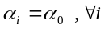 | 45.63 | F_{5%}(140,806) = 1.227 | 0 | Reject Pooling model
Fisher | 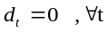 | 43.21 | F_{5%}(7,806) = 2.021 | 0 | Reject Within model without time effects
Fisher | 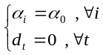 | 45.02 | F_{5%}(147,806) = 1.222 | 0 | Reject Within model without fixed effects
Breush-Pagan | 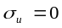 | 4561.8 | χ²_{5%}(1) = 3.84 | 0 | Reject Pooling model
Hausman | 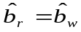 | 151.17 | χ²_{5%}(5) = 11.07 | 0 | Reject Random model

Table 5 : Input share of operating costs
 | Minimum | 1st Quartile | Median | Mean | 3rd Quartile | Maximum
Labour share | 49.35 % | 72.60 % | 75.80 % | 74.95 % | 78.31 % | 88.45 %
Purchase share | 11.55 % | 21.69 % | 24.20 % | 25.05 % | 27.40 % | 50.65 %

Table 6 : Simultaneous estimation (SURE) of cost function and labour cost share
 | Pooling_{s} |  | Within_{s}
 | Coef | P(>|t|) | Coef | P(>|t|)
α₀ | 9.225 | ***
β_{k} | 1.0810 | *** | 0.6848 | ***
β_{kk} | 0.0171 | *** | -0.0218 | 0.30
α_{p} | 0.7689 | *** | 0.7571 | ***
α_{pp} | 0.1778 | *** | 0.1424 | ***
γ_{kp} | 0.0186 | *** | 0.0177 | ***
d₁₉₉₆ | 0.72% | 0.44 | 1.26% | .
d₁₉₉₇ | 0.55% | 0.56 | 2.03% | ***
d₁₉₉₈ | 0.46% | 0.62 | 2.67% | ***
d₁₉₉₉ | 1.24% | 0.18 | 5.84% | ***
d₂₀₀₀ | 2.21% | * | 8.45% | ***
d₂₀₀₁ | 2.64% | ** | 10.26% | ***
d₂₀₀₂ | 2.66% | ** | 11.32% | ***
ssr | 15.025 |  | 1.663
df | 946 |  | 806
Prob: 0 '***' , 0.001 '**', 0.01 '*' and 0.05 '.'

Table 7 : Hausman & Taylor model estimation
 | Within’ |  | Random’ |  | HT
 | Coef | P(>|t|) | Coef | P(>|t|) | Coef | P(>|t|)
α₀ |  |  | 9.136 | *** | 9.042 | ***
β_{k} | 0.7487 | *** | 1.0598 | *** | 0.9413 | ***
β_{kk} | -0.0085 | 0.72 | 0.0513 | *** | 0.0855 | ***
α_{p} | 0.5947 | *** | 0.5674 | *** | 0.5773 | ***
α_{pp} | 0.3001 | *** | 0.2906 | *** | 0.2912 | ***
γ_{kp} | -0.0005 | 0.96 | 0.0019 | 0.86 | -0.0040 | 0.75
d₁₉₉₆ | 0.38% | 0.51 | -0.41% | 0.49 | -0.03% | 0.95
d₁₉₉₇ | 1.32% | * | 0.55% | 0.37 | 0.97% | 0.17
d₁₉₉₈ | 2.47% | *** | 1.26% | * | 1.88% | **
d₁₉₉₉ | 5.24% | *** | 3.41% | *** | 4.38% | ***
d₂₀₀₀ | 5.43% | *** | 3.03% | *** | 4.28% | ***
d₂₀₀₁ | 7.61% | *** | 4.98% | *** | 6.35% | ***
d₂₀₀₂ | 8.58% | *** | 5.39% | *** | 7.01% | ***
ssr | 0.6584 |  | 0.8629 |  | 1.1398
df | 534 |  | 611 |  | 610
Probabilities: 0 '***' , 0.001 '**', 0.01 '*' et 0.05 '.'

Figure 1 : Structure of the panel
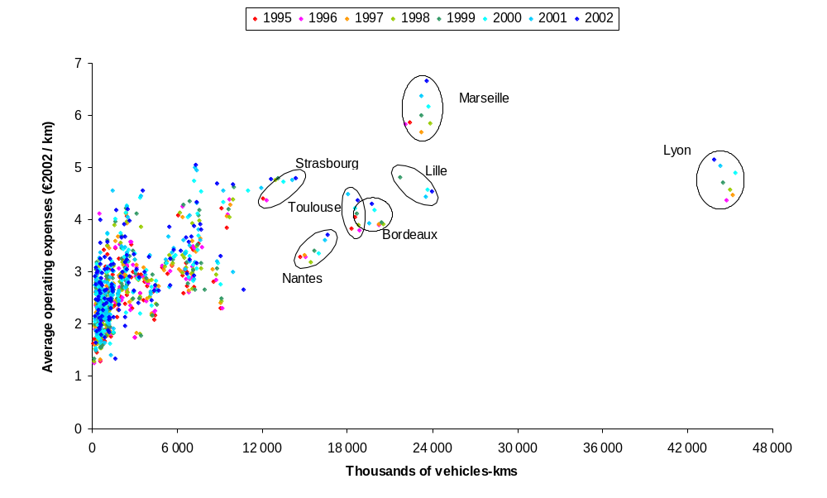

Figure 2 : Returns to scale according to Table 4
a) Within model  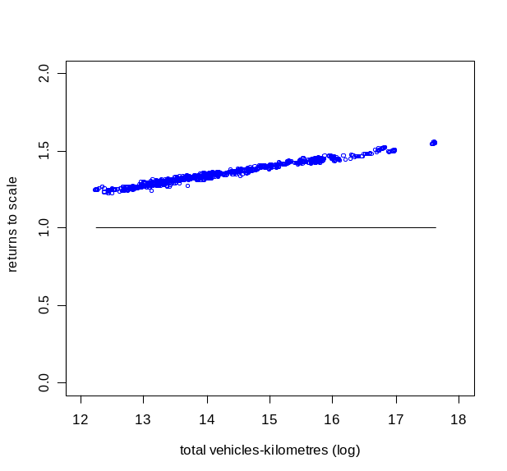 | b) Random model  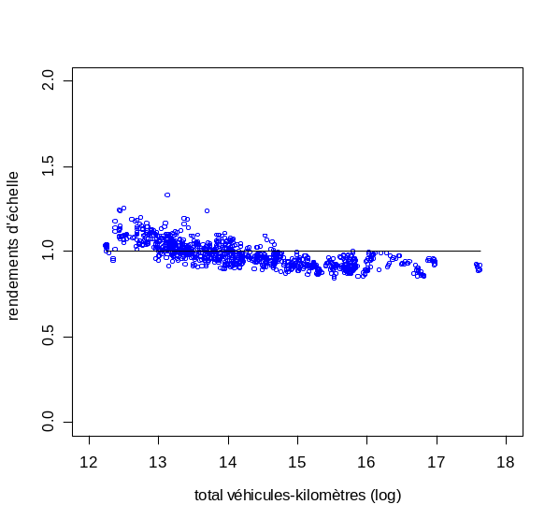

Figure 3 : Average (red) and marginal (green) cost functions at the input mean point.
a) Within Model  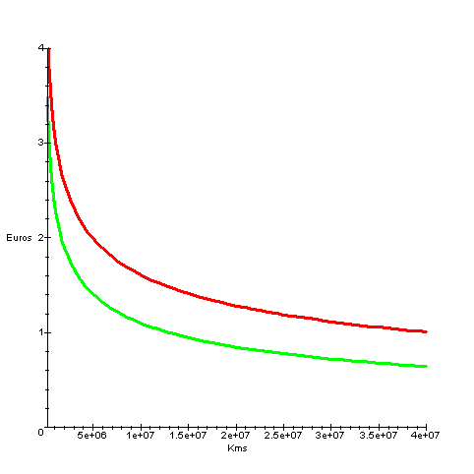 | b) Random Model  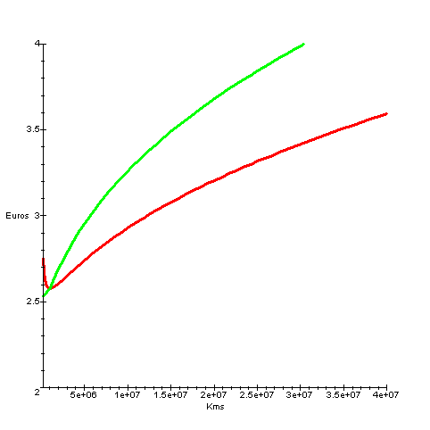

Figure 4 : Individual effects in the Within model
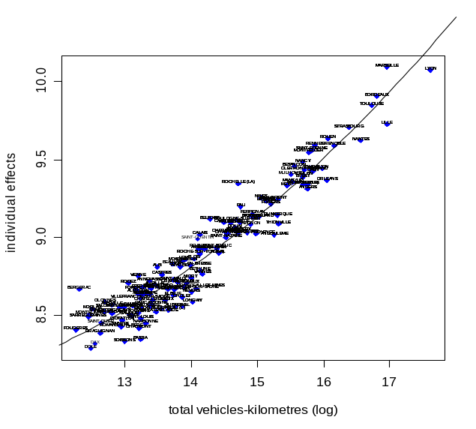 | 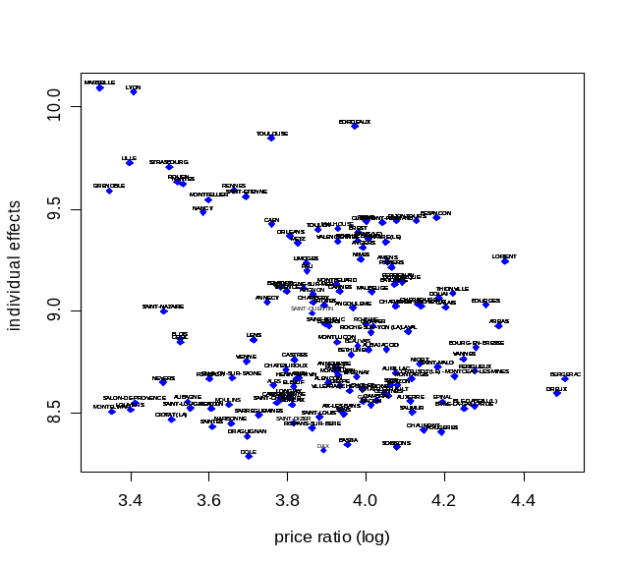
Figure 5 : Returns to scale and cost curves with the HT model
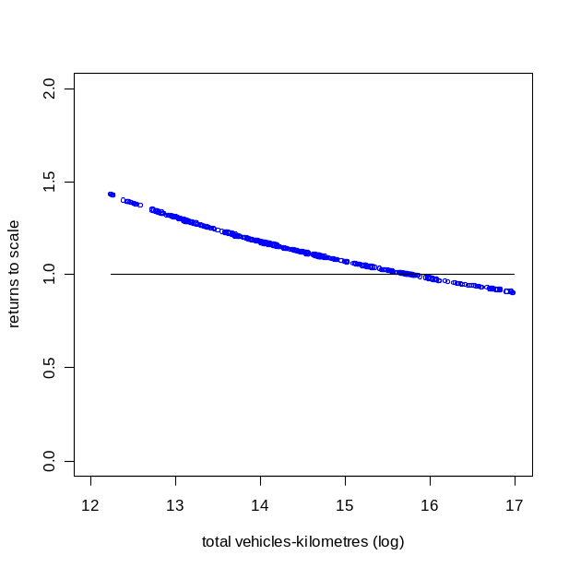 | 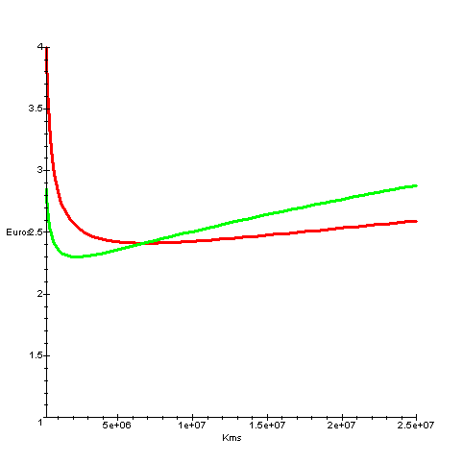

william.roy@let.ish-lyon.cnrs.fr William ROY / LET-ISH / 14 avenue Berthelot / 69363 LYON Cedex 07 / FRANCE Tel : +33 (0)4 72 72 64 44 / Fax : +33 (0)4 72 72 64 48
Allotment consists of a fragmentation of the unique call for tender into several ones.
This research has been partly supported by the PREDIT (http://www.predit.prd.fr), and is part of a research program that also discuss the other aspects and consequences of allotment.
A next paper will discuss the more complete but also more complex multiproduct case
Returns to scale are measured in some paper by :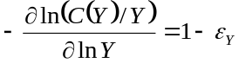
The transcendental logarithmic cost function had been introduced by Berndt, Christensen, Jorgensen & Lau. Guilkey, Lovell & Sickles (1983) demonstrated the reliability of the translog, compared to some other flexible functional forms, by a Monte Carlo simulation. However, the translog is still a second order approximation which could be generalised (Piacenza & Vannoni 2004)
Results are asymptotically equivalent to the maximum likelihood estimator.
For instance, the firm that operate Lyon’s network (buses, subway and tramway) has a positive working capital (inventories – reveivables + payables), no financial debt and about 3 M€ of equity. Returns on equity ratio was between 5% and 25% the last few years, which means a capital cost under 0.5% of the sum of labor, energy and maintenance cost (about 260 M€). On the other side, asset amortization is always under 1% of this amount.
A screaming of the data sample (Williams & Dalal 1981), or a cluster design (Karlaftis & McCarthy 2002) can also be used
Data on Paris region are not available and included
Including temporary work, excluding subcontracting personnel, and with no distinction between driving labour and non-driving labour.
All the estimations are realised thanks to the package plm (Croissant 2005) from R software (R Development Core Team 2005).
According to the Swamy & Arora (1972) transformation method
According to Zellner (1962) method, and thanks to the R package “systemfit” (Hamann & Henningsen 2005)
Returns to scale are recalculated when they are defined by 1-ε_{Y} , instead of 1/ε_{Y} .
Results close to Obeng (1984) ones.

