Paper submitted to the 11th World Conference on Transportation Research

Track D4 – Data collection methods

Imputation techniques for missing fields and implausible values in public transit smart card data

Ka Kee Alfred CHU (corresponding author)
Ph.D. candidate, Department of Civil Engineering,
École Polytechnique de Montréal
P.O. Box 6079, Station Centre-ville, Montréal, Québec, Canada. H3C 3A7
Email: ka-kee.chu@polymtl.ca
Telephone: +1-514-340-4711 ext 4157

Robert CHAPLEAU
Professor of Transportation Planning, Department of Civil Engineering

École Polytechnique de Montréal
P.O. Box 6079, Station Centre-ville, Montréal, Québec, Canada. H3C 3A7
Email: rchapleau@polymtl.ca
Telephone: +1-514-340-4711 ext 4809
Fax: +1-514-340-5763

Imputation techniques for missing fields and implausible values in public transit smart card data

Ka Kee Alfred CHU
Ph.D. candidate, Department of Civil Engineering,
École Polytechnique de Montréal

Robert CHAPLEAU
Professor of Transportation Planning, Department of Civil Engineering

École Polytechnique de Montréal

Abstract
This paper proposes a methodology to improve the quality of archived public transit smart card data. Using rules to verify the spatial-temporal constraints of objects in a public transit network, the procedure identifies erroneous, suspect and irrelevant data and imputes plausible values based on two concepts: the regularity in public transit operations and the regularity in cardholders’ historic travel patterns. Applied to one month of transactions, most of the lost information is recovered and the spatial-temporal movements of the objects are re-established. The methodology can be generalized for use in other datasets.
Keywords: smart card, public transit, imputation, data quality, data mining

Acknowledgements
We would like to thank Georges O. Gratton, the general manager of the STO for providing the dataset; Guillaume Bisaillon and Daniel Piché of the MADITUC Group for their contributions in data processing and analysis and Le Fonds québécois de la recherche sur la nature et les technologies for supporting the research.

1. Introduction
The advent of automated data-acquiring systems in nearly all domains has created a data explosion. Compounded by the ease and cheap cost of digital storage, large amounts of data can be archived. In the domain of transportation, a medium-sized public transit corporation can generate upward of 35,000 transactions in a regular weekday with an automated fare collection (AFC) system. While the system fulfills all the needs of fare collection, secondary benefits are difficult to come by since raw data from automated sources are far from flawless. They usually represent a chaotic system that renders the knowledge generation process more complex (see Olsen, 1999).

This seemingly vast and formidable source of information cannot achieve the anticipated secondary benefits without extensive off-line processing. Erroneous values caused by human intervention, equipment or automated processes must be identified. With proper automated validation and imputation techniques, these data, which contain an unprecedented level of detail, can be extremely useful for planning purposes, especially for systems also equipped with automatic vehicle location (AVL).

The long term goal of this research is to build a high-resolution transit demand model for systems equipped with AFC and AVL capabilities. This paper presents a methodology which detects errors and suspect values based on spatial-temporal constraints and imputes values by taking advantage of two public transit concepts: the regularity in transit operations and the regularity in individual travel patterns. Although the procedure described in this paper is applied to data from a specific system, these concepts are generic enough to be partially or entirely implemented in other AFC systems with or without AVL. The paper starts with a literature review which provides a brief background in this area of research. It is followed by a description of data sources and the methodology used to detect errors and suspect values. Details of the imputation techniques are explained followed by results, discussion, and conclusions.

2. Literature review
There are numerous studies discussing the use of AFC data for planning purposes. In general, the data sources can be categorized by two characteristics. The first concerns the location of the transactions. They can either be recorded at a fixed and known location, such as a train station, or at a variable position, such as a bus en route, where the position can only be known with the presence of AVL. In the latter case, the movement of a vehicle makes the location information more susceptible to error. The other characteristic of the data depends on the fare structure. Some fare structures require the user to perform a transaction at both ends of the trip (entry and exit), while others require the user to perform only once, usually at entry. In this second case, an extra procedure is required to impute the stop or station used at the other trip end.

Navick and Furth (2002 use location-stamped farebox data from buses in Los Angeles to estimate alighting patterns, based on the assumption of origin-destination symmetry. Due to the aggregate nature of the data, only travel patterns on a single bus line can be obtained. Barry et al. (2002) use automated fare system data from New York to estimate origin-destination matrices in the subway system. Assuming that an individual starts a trip at the station where the previous trip ends and returns to the entry station of the first trip in the last trip of the day, the alighting station can be deduced. Zhao (2004), using data from the smart card AFC system in Chicago, infers the destination station for individual trips and models the path choice in rail-to-rail sequences. Trépanier et al. (2007), assuming that an individual alights at a downstream stop closest to the next boarding stop, derives the alighting stop from bus trips using smart card transaction data from a transit agency which operates in the National Capital Region of Canada. Morency et al. (2006), with the data from the same smart card system, aims to understand activity pattern of cardholders using data mining techniques. Although the authors of the previous studies make valuable contributions to AFC data analysis, most of the research fails to properly address the issue of data accuracy. The studies engage directly in analysis while ignoring potential errors, with the exception of Trépanier et al. (2007), who explicitly acknowledge that “the data must be thoroughly validated and corrected prior to the estimation process”.

Bagchi and White (2005) analyze two random samples of validated smart card data from the United Kingdom. However, details of the validation process are not described. Examining bus boarding data from a magnetic strip card system in a mid-size European city, Hofmann and O’Mahony identify transfer journeys using an iterative classification algorithm (2005a) and analyze the effects of adverse weather on bus performance (2005b). They recognized the presence of corrupted data and removed erroneous values from the analyses. Tseytin et al. (2006), meanwhile, use a market basket data mining technique to trace the same individual using different magnetic strip cards over a period of time.

Okamura et al. (2004) attempted to use magnetic card transaction data from Hiroshima to analyze transfer behaviour and to classify passengers into clusters. The authors provide statistics on missing data: on one day in October 2000, 14.1% of 23,589 samples contain missing data. Although they acknowledge transport planners’ interests in data accuracy, they concluded that there is no need to be concerned about the missing data in that specific dataset. Utsunomiya et al. (2006) explore the potential of smart card transaction data from Chicago to improve transit planning. More specifically, they discuss the walk access distance of individuals to bus stops and train stations as well as the regularity of their travel patterns. They recognize that errors in the data are one of the difficulties encountered in the analysis and identify two types of errors: missing transactions and incorrect bus routes. Missing transactions can be due to equipment malfunction, boarding without transacting, or simply a change in travel behaviour. The incorrect bus route error occurs because the bus driver fails to set the route correctly. This is a well-documented problem with AFC data. When dealing with electronic registering fareboxes, drivers “must enter specific codes at the beginning of their shifts and at the start of each new trip to tie fares to specific blocks and trips” (Boyle, 1998, p.12). The same procedure is required for certain AFC systems with AVL. In transit agencies surveyed by Furth et al. (2006), up to 40% of AVL data are rejected because they could not be matched to a route. In response, the authors mentioned that some transit agencies have developed in-house processing techniques to improve AVL data usability. Utsunomiya et al. (2006) proposed using AVL data in conjunction with AFC route information and examining users’ typical and variable travel patterns as remedies for this issue.

Without a proper validation and imputation methodology, the strategy that researchers can follow is either to include all data in the analyses or to leave out erroneous and suspect data, hoping that the large amount of data will mask the errors or the loss of data will not seriously influence the results. However, errors can significantly influence and disrupt the results of analyses. Error in one transaction can even propagate into other transactions, amplifying its effect, as shown in the case of imputing alighting location of a trip, which depends on the next transaction of the same cardholder.

3. Identification of erroneous and suspect values

3.1 Data source
The transaction data used in this study come from the smart card AFC system of the Société de Transport de l’Outaouais (STO), a public transit agency which operates in the National Capital Region of Canada, with Ottawa and Gatineau (previously known as Hull) being the two major cities. All of the regular transit vehicles (about 240 buses) are equipped with a smart card reader, an on-board computer and an AVL system using GPS receivers. The system was first implemented in 2001. The database has been compiled a posteriori and contains all transactions performed in February 2005. The original database totals 763,570 boarding transactions from 21,813 different cards. Figure 1 shows the daily distribution of the transactions. More than 80% of passengers pay their fare using a card. Two distinctive features of this AFC system are that complete and continuous boarding records are captured and each card is individually identified with a photo and is limited to one user. This provides totally disaggregate transactional data, which is an important pre-requisite of activity-based travel demand modeling.
Figure 1. Smart card transactions in February 2005 showing the respective number of validated and flagged transactions.

3.2 Transaction generation
The AFC system is entry-only, meaning that passengers pay when they enter the system. In the garage, drivers start a vehicle block by taking possession of a bus, which has the up-to-date operational data stored in the on-board computer. The drivers identify themselves using the vehicle block number. This operation is sometimes referred to in the literature as sign-in or log-on. All the runs associated with that specific block are automatically retrieved and drivers initialize the start of each run (including deadheading runs) by pressing a key. When a smart card is placed against the reader during a boarding, a transaction is automatically generated.

Each transaction bears information on various objects: the card number and its fare type; the vehicle number; the transaction time; the boarding stop number; the run information (route number, direction and scheduled departure time); driver number; vehicle block number and other operational data. The current stop number is identified and updated by on-board software which takes into account the route information initialized by the driver and matches the GPS coordinates to the closest downstream stop. Potential errors occur when stops of an incorrect route are used to match the GPS coordinates. In other words, if the route information in the on-board computer does not match the actual route, the computer will search for a match to the GPS coordinates in the wrong stop database. This can result in a considerable discrepancy in location. Stops located upstream are not searched in order to preserve the sequential nature of the route. The location information is only registered when there is a transaction using smart card. Transactions are stored on-board until the vehicles return to the garage and transfer the data to the server via infrared. The boarding sequence of a bus is conserved while the raw coordinates are discarded en route. In a study on enriching trip information gathered by GPS, Wolf et al. (2004) concluded that such storage processes are “suboptimal for all subsequent analysis”.

3.3 Rule-based processing
With a background on how the transactions are generated, one can begin to understand how the data become susceptible to errors since many attributes in a transaction can be affected by human intervention. In the methodology presented here, the spatial-temporal constraints of the objects and operational constraints are used to generate rules that detect irrelevant, erroneous and suspect values in the transactions. A transaction is flagged as irrelevant if it does not constitute part of the scheduled service. A transaction is considered erroneous when one of the values is not consistent with the concept of a public transit service. A transaction is suspect when the vehicle in question appears to defy the spatial-temporal logic of a public transit service.

The first step in this methodology is to filter all irrelevant transactions, which should not be considered as regular transactions under any circumstances. This includes transactions which contain invalid vehicle numbers, invalid vehicle block numbers and non-regular service, such as transactions recorded during maintenance and special events.

Table 1 shows an excerpt of the database, with relevant fields only, to illustrate a run that is not correctly initialized. The driver initialized a deadheading run 900-0-0625 (short for route 900, direction 0, scheduled departure time 6:25am) but failed to initialize the service run (83-0-0648) before the first three transactions occurred. The boarding stops in the first 3 transactions are incorrect since they are attributed to a deadheading run. To translate this situation into an error-detection rule, all route numbers containing 900 have to be identified as errors because, by definition, that there can be no boarding in a non-service or interlined run.
[Table 1]

A run suggested by the vehicle block number entered by the driver contains a scheduled departure time. Some transactions are characterized by a “0000” departure time, which may indicate human intervention. In this case, the departure time and perhaps other fields are missing elements that need to be imputed. More generally, any transaction with a departure time that is inconsistent with the known service revealed by the vehicle blocks can be flagged as an erroneous transaction. In the algorithm, all transactions with departure time “0000” are considered as erroneous (Table 2).
[Table 2]
When a driver fails to initialize a service run following another service run, the transactions of the following run are tied to route and stop information of the previous run as shown in Table 3. Assuming that the previous run ends at the last stop, all transactions that have the last stop of the previous run as boarding stops have to be identified as errors because, by definition, there should be no boarding at the end of the line. If analysis is performed on the raw data, the number of boardings would be abnormally high for first service run while it would be abnormally low, or completely absent, for the following run. A large temporal gap between 2 successive transactions, usually result of the absence of boarding at the end of the line and the layover and/or deadheading time, can be used to identify a run that has not been properly initialized. Moreover, the temporal gap between a transaction and its corresponding departure time usually lies within the planned duration of the run. Although it is theoretically possible that the transaction time lies outside the planned run duration due to traffic congestion or other unforeseeable incidents, such transactions, as well as subsequent transactions in the same run, are considered suspect.
[Table 3]
An excessively long dwell time at a stop (apart from certain locations, such as the departure terminus, short-run departure terminus, and important transfer points) defies spatial-temporal logic. Therefore, consecutive transactions recorded at one stop over a long time period are suspected of being tied to an incorrect boarding stop. Table 4 illustrates that there are 47 transactions spanning 49 minutes at the same boarding stop, which is the 68th out of 74 stops of route 60, direction 0. Translating the situation into a rule, a vehicle in a service run cannot spend more than a certain amount of time at the same stop. However, the amount can vary according to the type of stop and type of route. For example, routes picking up students after class usually have a long dwell time at the school. This rule also captures situations that might be a software or hardware problem. All the transactions on vehicle 9401 have boarding stops fixed at the departure terminus for the whole day regardless route information, as illustrated in Table 5. This suggests a GPS failure.
[Table 4]
[Table 5]

The last type of suspect value is characterized by an inconsistent sequence of boarding stops within the same run as illustrated in Table 6. In this example, the spatial-temporal logic of a bus route is violated, and the on-board software should not allow a return to an upstream boarding stop. Stop 1019 represents the third stop of the route. However, it is repeated after the 52nd stop (2604). This type of error can be identified by checking if the sequence of stops within a run is respected. Since stop order is relative, a forward and a backward detection are necessary to identify all suspect values.
[Table 6]

Table 7 summarizes the results of rule-based processing. 115,650 irrelevant, erroneous and suspect transactions are identified, representing 15.15% of all transactions in the database. As shown in the table, many transactions are captured by more than one rule. The error detection procedure represents a good use of the information contained the database, the system mechanism and public transit concepts. Further data validation would require external information not available in the database.
[Table 7]

4. Imputation of erroneous and suspect values
Erroneous and suspect transactions seriously damage the integrity of data. The main goal of imputing a most likely value in a transactional database is to improve data accuracy and quality. Therefore, an imputation is considered successful if the lost information can be recovered and the spatial-temporal movement of the objects re-established. Two transportation concepts are used in the establishment of the methodology. The first is the regularity in public transit operations and the second is the regularity in historic travel patterns of individual cardholders. Each concept alone proves to be useful for imputation, but the results improve when imputed values are cross-validated using both concepts, compensating for the shortcomings of each method. More specifically, the regularity in operations can include exceptions due to unforeseen circumstances and erroneous data in the planned operations, whereas some cardholders’ historic transactions do not exhibit a pattern or regularity. Given that the data will be used to model transit travel patterns, two attributes closely tied to planning are subject to imputation: the run information and the boarding stop.

4.1 Imputation of run by regularity in public transit operations
In the public transit domain, the planning of fixed-schedule bus service starts with a route geometry and a vehicle trip file containing all the required runs. The runs are then assigned to a vehicle in order to construct vehicle blocks (also known as vehicle tours), which minimize deadheading, a non-productive movement of a vehicle to and from a revenue service. These blocks are carried out repeatedly for several days or months until the timetable is changed. Please refer to Ceder (2001) for a more complete description on public transit scheduling. Under normal circumstances, each vehicle block is performed by one bus on a given day. If the transactions coming from a particular bus contain the correct block number or information on at least one correct run, it is possible to identify the subset of planned runs that the particular bus should have carried out by referring to the planned vehicle block. Since the vehicle number and transaction time are not susceptible to human intervention and are assumed to be faultless, erroneous and suspect transactions are matched against the subset of planned runs by comparing the transaction time and scheduled departure time in order to determine the most likely run.

4.2 Deriving operation dictionaries
Information on planned operations can either be obtained from the transit agency or, alternatively, be derived from smart card data following an informational approach. Although not all planned service runs appear in the transaction records everyday (which is exactly the reason why imputation is needed), the complete service can be derived by integrating knowledge accumulated from a number of days. This assumes that a longer period yields a more complete knowledge of the operations because the probability of missing a run diminishes as the number of days increases. Using transactions from February 2005 (each day of the week occurs four times), an operation dictionary which includes vehicle block numbers, their associated runs and the vehicle that carried out the block on a given day is reconstructed. This operation dictionary forms the basis for imputing run information. If the operations vary according to day of the week, imputation may require more than one dictionary. For the STO, the timetable is based on an average weekday. The vehicle blocks are almost the same for all weekdays although there are a few additional trips in Tuesdays, Thursdays and Fridays. Imputation for Saturdays and Sundays requires two extra dictionaries.

4.3 Enriching the operation dictionaries
During the imputation process, the transaction time is compared with the departure time of the runs in a vehicle block. This would work perfectly if users only start boarding after the departure time. In reality, often at the departure terminus, drivers allow users to board the vehicle several minutes before the scheduled departure. This is especially true for runs preceded by a layover time or deadheading run. The beginning-of-line and the end-of-line therefore have to be redefined, spawning the need to enrich the operational dictionary.

First, the dictionary can be enriched by including non-service run information. Transactions with deadheading run information, which are initially regarded as errors caused by human intervention, become a new source of information. With a valid block number and departure time, they provide information on operations within vehicle blocks even when the vehicle is not in service. Second, by sorting the departure times within a block, the planned duration or maximum length of each run can be derived. Third, since not all service runs are separated by a non-service run, it is useful to know when the last boarding of a run occurs in order to get an estimated length of a run. This information is derived by examining the validated transactions. All these enrichments contribute to better assignment of erroneous or suspect transactions to the most probable run. Table 8 shows a typical vehicle block taken from the enriched operation dictionary and Figure 2 illustrates transactions tied to this specific block for the whole month. Data for February 15th and 22nd might be tied incorrectly to another vehicle block or the data might have been lost, or they are yet to be transferred to the server. Transactions made in the same minute have been offset by 10 seconds to facilitate visualization because the temporal resolution of the system is 1 minute. The bus number indicates which vehicle has carried out the block. This example visually demonstrates the procedures of error detection and imputation by regularity of the transit operation.
[Table 8]

Figure 2. Transactions associated with vehicle block 140 for 20 weekdays.

4.4 Imputation of run by users’ historic travel patterns
Concurrently, information can also be imputed by studying the recurrent activity pattern of an individual in space and time, as proposed by Chapin (1974). The smart card AFC system stores all boarding transactions of travelers who use a smart card as their mode of payment. Since each card represents a unique cardholder, a cardholder’s historic boarding records - a month-long period in this case - are therefore captured by the system. It should be noted that at no point during this analysis can a card can be tied to any personal or confidential information which could identify the cardholder. According to the theory of activity-based travel demand modeling, travel is considered a derived demand arising from the need or desire to participate in an activity, which is in turn characterized by its location in space and time. Space-wise, the majority of travelers have a pre-defined set of locations where they visit, such as their home, workplace or a shopping center. Also, activities take place at a certain moment in time. The recurrence and fixity of these two elements in a traveler’s activity schedule, whether daily, weekly or for an even longer period, constitute a travel pattern and this pattern is imprinted in their boarding records. Since most of the cardholders are frequent travelers as confirmed by the monthly median number of transactions of 34 for each card, mining the historic travel patterns of these cardholders can reveal route (run) and boarding stop regularities. Figure 3 illustrates all transactions made with a typical card in February 2005. Each transaction is represented by a point indicating the date and time it took place. Different symbols denote different routes as recorded in the transaction. A filled point implies that the transaction is valid whereas a hollow point suggests that it is a transaction that needs imputation. The number above or below the point indicates the boarding location by stop order of the route. 0 represents the departure terminus.
Figure 3. The transaction history of a card in the month of February 2005.

4.5 Data mining using the Bayesian approach
In the field of statistics, there are two approaches to probability, namely the frequentist or classical approach and the Bayesian approach. Given a distribution, the frequentist approach assumes that parameters are fixed and the randomness lies in the data, while the Bayesian approach considers the parameters as random variables and uses the observed data to provide information on the parameters. In addition, one of the applications of data mining is data cleaning (Witten and Frank, 1999), which is usually defined as the process of modifying the form or content, such as filling in missing values and correcting erroneous data, in order to improve the accuracy of the data. These tools are used in the study to improve the quality of the transaction data.

According to data mining literature, the imputation of run or boarding stop information can be viewed as a classification problem, since both the run and boarding stop values constitute categorical or discrete classes. The goal of the Bayesian classification performed in the research is to learn the distributions of instances from validated transactions and to predict the most likely class for each of the flagged transactions. For each transaction, the conditional probability for each class can be calculated based on other explanatory variables using the boarding records of a card. The class with the highest probability is retained. The simple implementation and the strong interpretability of the Bayesian classifier merit its choice.

The imputation of run information with users’ historic travel patterns draws on the day-of-the-week (weekdays, Saturday or Sunday) and transaction time as explanatory variables. An algorithm looks for the most frequent run that a user takes at about the same time on other days. Only transactions made within plus or minus 5-minute window are considered. The imputed run is filtered by the subset of runs in the associated vehicle block using the operation dictionary. This means that predictions are removed if they do not belong to the runs in the vehicle block determined by the regularity in operations. Since a run can often be imputed by multiple users’ historic travel patterns, all the imputed run information on a given vehicle at a particular time period must have the same value. The most likely run for a set of transactions, therefore, is the run most often used by the majority of cardholders in the set.

The results based on the regularity in public transit operations and on the regularity in users’ historic travel pattern are combined. Filters are applied to remove imputed values that are inconsistent with the public transit service and concepts.

4.6 Imputation of boarding stop
Using the same regularity in users’ historic travel patterns, it is possible to impute boarding stops since activity not only recurs in time, but also in space. Upon the imputation of run information, boarding stop probabilities can be computed by following a similar Bayesian approach, using boarding stop as the class and run information (route, direction and scheduled departure time) as the explanatory variables. An algorithm looks for the most frequently used stop where a user boards when he/she takes this specific run on other days. In cases where the run is taken only once, the condition can be relaxed to include transactions on the same route (same route and direction but not the same scheduled departure time).

Since the imputed value of one transaction can be in conflict with the imputed value of another transaction, the imputed boarding stops need to be filtered to ensure the bus object respects the spatial-temporal constraints: the order of boarding stops must follow the sequence of transactions and the speed of the bus must be reasonable. The filter prioritizes stops that are imputed with run information (as opposed to route information only). It also identifies imputed stop values that are incompatible with the preceding and following transactions. Several iterations of filtering may be required. For transactions without an imputed value or with an imputed value discarded due to conflict, a linear interpolation and extrapolation with time and distance is done. The distance comes from a linear-referenced database of the routes in the transit network. Since the temporal resolution of the system is one minute and the distance between bus stops is generally small, the imputed boarding stop may be different from the actual stop used by the cardholder. The difference, however, should be small and acceptable. Although more sophisticated methods can be derived, linear interpolation and extrapolation are often sufficient to improve the quality of the data for planning purposes. A simplified flowchart (figure 4) summarizes the imputation technique presented in this paper.
Figure 4. Flowchart illustrating the steps in the imputation process.

5. Results and discussion

5.1 Analysis of results
A typical weekday containing about 35,000 transactions can be processed automatically in less than 10 minutes by an ordinary desktop computer. For instance, on February 10, there are 38,502 transactions in total, of which 6,032 (15.7%) are flagged as irrelevant, erroneous or suspect. There are 4 irrelevant transactions that are not included in the imputation process. Run information for 5,311 out of 6,028 transactions are successfully imputed, which translates to a success rate of 88.1%. Transactions without imputed values are isolated cases and are removed from the analysis. After the procedure, 37,781 of 38,502 (98.1%) transactions are considered as valid, against 84.3% in the raw data.

Figure 5 shows three time-space diagrams of all the active bus objects on February 10. Each line represents an individual run. The vertical axis indicates the linear distance of a run and the horizontal axis indicates the time elapsed since the scheduled departure time. The raw transactions (5a) contain many inconsistencies, such as vertical lines indicating the vehicle is stationary and downward lines indicating the vehicle is moving in the wrong direction. Transactions excluding all flagged records (5b) and transactions after the imputation process (5c) are significantly cleaner. It is possible that the imputed transactions may still contain a few minor errors.
Figure 5. Three time-space diagrams of all runs in February 10 showing raw transactions (a in red), non-flagged transactions (b in blue) and transactions after imputation (c in green).

Although there is no guarantee that all the imputations are correct and reflect the reality exactly, the procedure recovers most unknown values and to re-establishes the spatial-temporal movement of objects. In addition, the filtering of the imputed values assures that the retained values satisfy the spatial-temporal constraints of the bus objects and are therefore coherent as a whole. Figure 6 is a 3D visualization that illustrates the spatial-temporal dimensions of the 4 boarding transactions made by a cardholder on February 10, 2005. The thick lines show the spatial-temporal movement of the cardholder before imputation. The numbers beside the dots are the known boarding stops and the derived alighting stops. The bus routes (route 60 and 76) and the street network are given as reference. The accompanying table includes the original data. The route taken and the boarding stop are flagged as erroneous in trip 2 because the transaction was assigned to a non-service run. Consequently, besides knowing that the user alights at a stop downstream, it is impossible to derive the alighting stop for trip 1 as there is no information for trip 2.
Figure 6. A 3-dimensional time-space diagram showing the temporal movement of the object cardholder before the imputation process.

In contrast, figure 7 illustrates the same 4 transactions after the imputation process described in previous sections. Route 900-0-0638 in the second transaction is replaced by the imputed value 76-1-0705. Although the transaction time of 07:02 constitutes an early boarding, it is normal to occur at a departure terminus. According to the historic travel patterns of the card (43 transactions in February), 10 of 10 transactions on route 76-1 are made at stop 3002, and all of them made between 07:01 to 07:06. Therefore, there is a strong likelihood that this particular transaction is made at stop 3002 on route 76-1. With this additional information, subsequent imputation of boarding stop and alighting stop of the previous transaction is achievable.
Figure 7. A 3-dimensional time-space diagram showing the re-established temporal movement of the object cardholder after the imputation process.

It is important to note that the loss of information is not necessarily limited to the record itself (loss of route and boarding stop information in the transaction record). The information loss propagates into the previous transaction of the card. Without the correct route and boarding stop in trip 2, the alighting stop of trip 1 cannot be derived. In this example, not only is the apparently lost information completely recovered, but the spatial-temporal movement of the objects is also re-established. The example illustrates that, without proper processing, a database with 10% of records containing errors can potentially affect 20% of the records. The goal of minimizing the loss of information by improving data accuracy is achieved through the automated process described above.

5.2 The relative efficacy of the two concepts
In order to measure the relative efficacy and the contribution of the two concepts used in imputation, statistics which compare the retained imputed values and the imputed values by each concept are helpful. Out of 6,028 flagged transactions on February 10, the retained run information of 3,160 transactions, or 52.4%, is the same as the values imputed by regularity in cardholders’ historic travel patterns. 46 transactions (0.8%) display different values and run information of 2,822 transactions (46.8%) cannot be imputed or have been filtered out. The statistics confirm the strength of this concept which can constitute a reliable source of information. It must be noted that certain types of cardholders, as revealed by the fare type, can display a more regular travel pattern. Therefore, this concept may be more reliable for routes serving these specific niches.

The other concept, based on the regularity in operations, successfully imputes a value for 5,732 (95.1%) of the 6,028 retained runs. For 101 runs (1.7%), it imputes an inconsistent value and for 195 runs (3.2%), no value is imputed. The statistics suggests that the regularity in operations is significantly more reliable than the regularity in users’ travel patterns in imputing run information. However, by incorporating the latter, the number of incorrect and unsuccessful imputations can be substantially reduced. Meanwhile, the regularity in users’ historic travel patterns represents a reliable concept for the imputation of boarding stop. This concept successfully imputes a boarding stop for 4,036 out of 5,311 retained boarding stops which constitutes a success rate of 76.0%.

6. Conclusions
Although there is no perfect solution to recover all the irrelevant, erroneous and suspect data, nor guarantee that the imputed and validated data represent the actual reality, the paper suggests an alternative approach to the existing practice regarding AFC data analysis for planning purposes. With relatively simple procedures, the imputation method significantly reduces the number of problematic transactions which would otherwise be completely left out or left unaltered in analyses, influencing results. Furthermore, the amount and type of erroneous transaction records provide valuable information on system performance. Improvements, such as automating the processes which require human intervention or driver training, can be evaluated by monitoring the errors. One advantage of personalized smart card data is that it conserves the transaction history of the card. However, this benefit can easily be lost if some of the information is missing or erroneous. As illustrated above, the loss of information can propagate to other transactions as observed in the inference of alighting stops from boarding data.

While the study aims to improve data accuracy data from a specific system, this paper presented a general procedure which can be adapted to different systems, which are believed to have similar concerns regarding data accuracy. Data-specific procedure and adjustments are not described in details as they are less relevant to researchers with different datasets. The imputed values, especially the boarding stops imputed based on interpolation or extrapolation, contain uncertainties. However, they are acceptable as the difference in distance should be minor and the imputation percentage is small compared to the whole dataset. The strength of this model is that apart from the transaction records and the network information (route and geographic coordinates of stops), no other external information is required. The informational approach employed in the model uses only knowledge generated by actual transactions and the imputation results preserve the internal consistency of the data. The method demonstrated here is not definitive and continual learning and adjustments are needed to further improve the effectiveness and efficiency of the techniques. This paper paves the way for Chapleau and Chu (2007) which discusses the use of validated and imputed smart card AFC data to model the movements and demand within a transit network.

References
Barry, J.J., Newhouser, R., Rahbee A. and Sayeda S. (2002) ‘Origin and destination estimation in New York City with Automated Fare System Data’, Transportation Research Record, 1817, pp. 183-187.

Bagchi, M. and White, P.R. (2005) ‘The Potential of Public Transport Smart Card Data’, Transport Policy, 12, pp. 464-474.

Boyle, D.K. (1998). TCRP Synthesis of Transit Practice 29: Passenger Counting Technologies and Procedures, TRB, Washington D.C.

Ceder, A. (2001) ‘Public Transport Scheduling’, in K. J. Button and D. A. Hensher (eds) Handbook of Transport Systems and Traffic Control, Elsevier Science, pp. 539-558.

Chapin, F.S. (1974). Human Activity Patterns in the City: Things People Do in Time and in Space, Wiley, New York.

Chapleau, R. and Chu K.K. (2007) ‘Modeling Transit Travel Patterns from Location-stamped Smart Card Data Using a Disaggregate Approach’. Paper submitted to the 11th World Conference on Transportation Research, Berkeley, CA.

Furth, P.G., Hemily, B., Muller, T.H.J. and Strathman, J.G. (2006) TCRP Report 113: Using Archived AVL-APC Data to Improve Transit Performance and Management, TRB, Washington D.C.

Hofmann M. and O'Mahony, M. (2005a) ‘Transfer Journey Identification and Analyses from Electronic Fare Collection Data’, Proceedings of the 8th International IEEE Conference on Intelligent Transportation Systems, Vienna, Austria.

Hofmann M. and O'Mahony, M. (2005b) ‘The Impact of Adverse Weather Conditions on Urban Bus Performance Measures’, Proceedings of the 8th International IEEE Conference on Intelligent Transportation Systems, Vienna, Austria.

Morency, C., Trépanier, M. and Agard, B. (2006) ‘Contributions des données de cartes à puces à la compréhension des rythmes d’activités en transport’. Paper presented at the 41e congrès annuel de l’Association Québécoise du Transport et des Routes, Québec, Canada.

Navick, D.S. and Furth P.G. (2004) ‘Estimating Passenger Miles, Origin-Destination Patterns, and Loads with Location-Stamped Farebox Data’, Transportation Research Record, 1799, pp. 107-113.

Olsen Jr., D.R. (1999) ‘Interacting in Chaos’, Interactions, 6(5), pp.42-54.

Okamura, T., Zhang J. and Akimasa F. (2004) ‘Finding Behavioral Rules of Urban Public Transport Passengers by Using Boarding Records of Integrated Stored Fare Card System’, Proceedings of the 10th World Conference on Transportation Research, Istanbul, Turkey.

Trépanier, M., Tranchant, N. and Chapleau R. (2007). ‘Individual Trip Destination Estimation in a Transit Smart Card Automated Fare Collection System’, Journal of Intelligent Transportation Systems: Technology, Planning and Operations, 11(1), pp.1-14.

Tseytin, G., Hofmann, M. and O'Mahony, M., Lyons, D. (2006) ‘Tracing Individual Public Transport Customers from an Anonymous Transaction Database’, Journal of Public Transportation, 9(4), pp. 47-60.

Utsunomiya, M., Attanucci, J. and Wilson, N. (2006) ‘Potential Uses of Transit Smart Card Registration and Transaction Data to Improve Transit Planning’. Paper presented at the 2006 TRB Annual Meeting, Washington D.C.

Witten, I.H. and Frank E. (1999) Data Mining: Practical machine learning tools and techniques with JAVA implementations, Morgan Kaufmann Publishers, San Francisco.

Wolf, J., Schönfelder, S., Samaga U., Oliveira, M. and Axhausen, K.W. (2004) ‘Eighty weeks of Global Positioning System Traces: Approaches to Enriching Trip Information’, Transportation Research Record, 1870, pp. 46-54.

Zhao, J. (2004) The Planning and Analysis Implications of Automated Data Collection Systems: Rail Transit OD Matrix Inference and Path Choice Modeling Examples. Master’s Thesis, Massachusetts Institute of Technology, Cambridge MA.
Table 1. Transactions illustrating a case where a driver failed to initialize a service run after a deadheading run. Route number 900 always associates with dummy boarding stops 1 or 2.
Record ID¹ | Card Number¹ | Fare Type | Date | Transaction Type¹ | Transaction Time¹ | Vehicle Blcok Number | Route Number | Direction | Departure time¹ | Boarding Stop | Bus Number | Driver Number | Event Sequence Number¹
23080308 | 1454633320 | 2 | Feb 10 | 1 | 0650 | 207 | 900 | 0 | 0625 | 1 | 9217 | 3283 | 5
23080309 | 2187852747 | 2 | Feb 10 | 1 | 0650 | 207 | 900 | 0 | 0625 | 1 | 9217 | 3283 | 6
23080310 | 2173486001 | 16 | Feb 10 | 1 | 0651 | 207 | 900 | 0 | 0625 | 1 | 9217 | 3283 | 7
23080311 | 1381629131 | 2 | Feb 10 | 1 | 0653 | 207 | 83 | 0 | 0648 | 4406 | 9217 | 3283 | 12
23080312 | 3325226344 | 2 | Feb 10 | 1 | 0653 | 207 | 83 | 0 | 0648 | 4406 | 9217 | 3283 | 13
¹Record ID is a unique identifier. Each card number represents a smart card. Transaction type 1 is a first boarding while 3 is a transfer boarding defined by the system. Times are in “hhmm” format. Event sequence number increases by one for each event in the system, including transaction.
Table 2. Transactions with missing departure time as indicated by “0000”.
Record ID | Card Number | Fare Type | Date | Transaction Type | Transaction Time | Vehicle Blcok Number | Route Number | Direction | Departure time | Boarding Stop | Bus Number | Driver Number | Event Sequence Number
23126308 | 2730621387 | 1 | Feb 10 | 1 | 1650 | 503 | 39 | 1 | 0000 | 2610 | 8505 | 568 | 7
23126309 | 33999041 | 1 | Feb 10 | 1 | 1650 | 503 | 39 | 1 | 0000 | 2610 | 8505 | 568 | 8
23126310 | 3068145281 | 37 | Feb 10 | 1 | 1703 | 503 | 39 | 1 | 0000 | 2547 | 8505 | 568 | 26
23126311 | 1180472426 | 37 | Feb 10 | 1 | 1703 | 503 | 39 | 1 | 0000 | 2547 | 8505 | 568 | 27
23126312 | 374796392 | 1 | Feb 10 | 1 | 1704 | 503 | 39 | 1 | 0000 | 2540 | 8505 | 568 | 29
Table 3. Transactions illustrating a case where the driver fails to initialize a service run after another service run. Boarding stop 2008 is the arrival terminus of route 31 direction 1.
Record ID | Card Number | Fare Type | Date | Transaction Type | Transaction Time | Vehicle Blcok Number | Route Number | Direction | Departure time | Boarding Stop | Bus Number | Driver Number | Event Sequence Number
23081150 | 383864696 | 38 | Feb 10 | 3 | 0921 | 181 | 31 | 1 | 0852 | 2424 | 9122 | 3342 | 334
23081151 | 3602471840 | 38 | Feb 10 | 3 | 0921 | 181 | 31 | 1 | 0852 | 2424 | 9122 | 3342 | 335
23081152 | 106782112 | 1 | Feb 10 | 1 | 0951 | 181 | 31 | 1 | 0852 | 2008 | 9122 | 3342 | 358
23081153 | 35846603 | 15 | Feb 10 | 3 | 0952 | 181 | 31 | 1 | 0852 | 2008 | 9122 | 3342 | 359
23081154 | 1381497547 | 1 | Feb 10 | 1 | 0954 | 181 | 31 | 1 | 0852 | 2008 | 9122 | 3342 | 360
Table 4. Transactions illustrating a case where the dwell time at boarding stop 5006 (68th of 74 stop) reaches 49 minutes.
Record ID | Card Number | Fare Type | Date | Transaction Type | Transaction Time | Vehicle Blcok Number | Route Number | Direction | Departure time | Boarding Stop | Bus Number | Driver Number | Event Sequence Number
23102647 | 845316033 | 1 | Feb 10 | 3 | 0830 | 147 | 60 | 0 | 0820 | 5006 | 9506 | 3332 | 176
23102648 | 3330703001 | 15 | Feb 10 | 3 | 0831 | 147 | 60 | 0 | 0820 | 5006 | 9506 | 3332 | 177
… | … | … | … | … | … | … | … | … | … | … | … | … | …
23102693 | 1449361817 | 1 | Feb 10 | 1 | 0919 | 147 | 60 | 0 | 0820 | 5006 | 9506 | 3332 | 222
23102694 | 918350952 | 34 | Feb 10 | 1 | 0919 | 147 | 60 | 0 | 0820 | 5006 | 9506 | 3332 | 223
Table 5. Transactions illustrating a case where the boarding stop is always tied to the departure terminus of the route, indicating a malfunction on software or equipment.
Record ID | Card Number | Fare Type | Date | Transaction Type | Transaction Time | Vehicle Blcok Number | Route Number | Direction | Departure time | Boarding Stop | Bus Number | Driver Number | Event Sequence Number
23105317 | 2801434009 | 3 | Feb 10 | 1 | 0631 | 239 | 900 | 1 | 0000 | 2 | 9401 | 3374 | 5
23105318 | 3533243585 | 15 | Feb 10 | 1 | 0701 | 236 | 48 | 0 | 0655 | 1339 | 9401 | 3374 | 11
23105319 | 3792566987 | 1 | Feb 10 | 1 | 0701 | 236 | 48 | 0 | 0655 | 1339 | 9401 | 3374 | 12
… | … | … | … | … | … | … | … | … | … | … | … | … | …
23105562 | 4139422058 | 38 | Feb 10 | 1 | 2027 | 424 | 439 | 0 | 2003 | 2151 | 9401 | 3352 | 290
Table 6. Transactions illustrating the order of stops within a run is not respected.
Record ID | Card Number | Fare Type | Date | Transaction Type | Transaction Time | Vehicle Blcok Number | Route Number | Direction | Departure time | Boarding Stop | Bus Number | Driver Number | Event Sequence Number
23094597 | 2251784345 | 1 | Feb 10 | 1 | 0730 | 274 | 46 | 0 | 0728 | 1019 | 9408 | 3207 | 11
23094598 | 1991257473 | 1 | Feb 10 | 1 | 0731 | 274 | 46 | 0 | 0728 | 1002 | 9408 | 3207 | 15
… | … | … | … | … | … | … | … | … | … | … | … | … | …
23094630 | 3070177153 | 1 | Feb 10 | 1 | 0807 | 274 | 46 | 0 | 0728 | 2604 | 9408 | 3207 | 93
23094631 | 373658474 | 1 | Feb 10 | 1 | 0913 | 274 | 46 | 0 | 0728 | 1019 | 9408 | 3207 | 129

Table 7. Distribution of transactions by flag type for the month of February 2005. The same transaction can be flagged more than once by different rules.
Flag type | Rule | Transaction count
Irrelevant | Invalid vehicle number | 2
Irrelevant | Invalid block number | 376
Irrelevant | Special run | 577
Erroneous | Boarding during deadheading | 25,897
Erroneous | Missing departure time | 15,108
Erroneous | Boarding at arrival terminus | 25,212
Suspect | Excessive dwell time | 84,320
Suspect | Excessive run time | 24,004
Suspect | Excessive gap time | 17,368
Suspect | Inconsistent sequence of boarding stop | 8,224
Flagged total | All rules combined | 115,650 (15.15%)
No flag (Validated) |  | 647,920 (84.85%)
Grand total |  | 763,570 (100%)

Table 8. A typical vehicle block for a weekday derived from transactions taken from the enriched operations dictionary.
Vehicle Block Number | Route Number | Direction | Departure Time¹ | Type of Run | Days Present (Out of 20) | Number of Transactions | Number of Validated Transactions | Latest Transaction Time¹ | Redefined Beginning-of-Line¹ | Redefined End-of-Line¹
140 | 42 | 1 | 0600 | Service | 18 | 80 | 80 | 0636 | 0546 | 0655
140 | 900 | 0 | 0655 | Non-service | 1 | 52 | 0 | - | - | -
140 | 45 | 0 | 0706 | Service | 17 | 567 | 567 | 0751 | 0656 | 0755
140 | 30 | 1 | 0810 | Service | 17 | 99 | 72 | 0836 | 0756 | 0845
140 | 39 | 0 | 0900 | Service | 17 | 380 | 380 | 0948 | 0846 | 1003
¹All times in “hhmm” format.

List of figures
Figure 1. Smart card transactions in February 2005 showing the respective number of validated and flagged transactions.
Figure 2. Transactions associated with vehicle block 140 for 20 weekdays.
Figure 3. The transaction history of a card in the month of February 2005.
Figure 4. Flowchart illustrating the steps in the imputation process.
Figure 5. Three time-space diagrams of all runs in February 10 showing raw transactions (a in red), non-flagged transactions (b in blue) and transactions after imputation (c in green).
Figure 6. A 3-dimensional time-space diagram showing the temporal movement of the object cardholder before the imputation process.
Figure 7. A 3-dimensional time-space diagram showing the re-established temporal movement of the object cardholder after the imputation process.
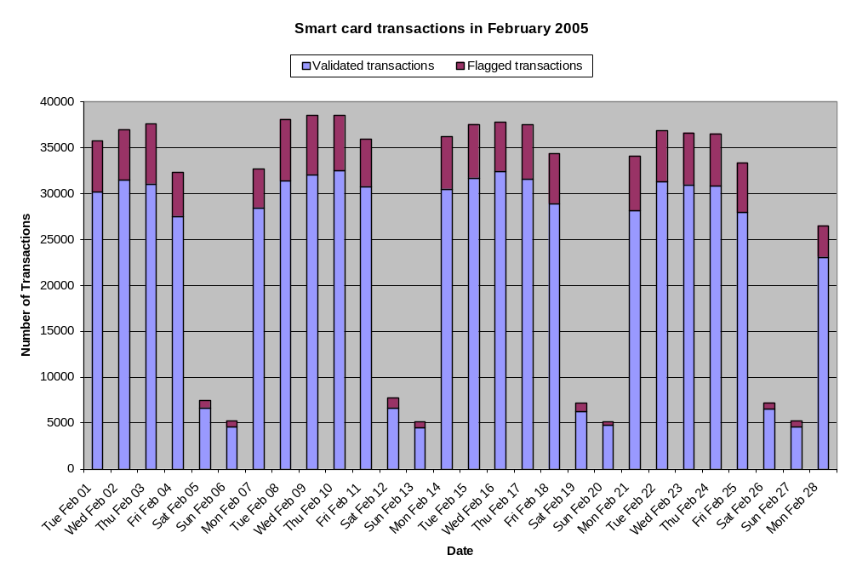
Figure 1.
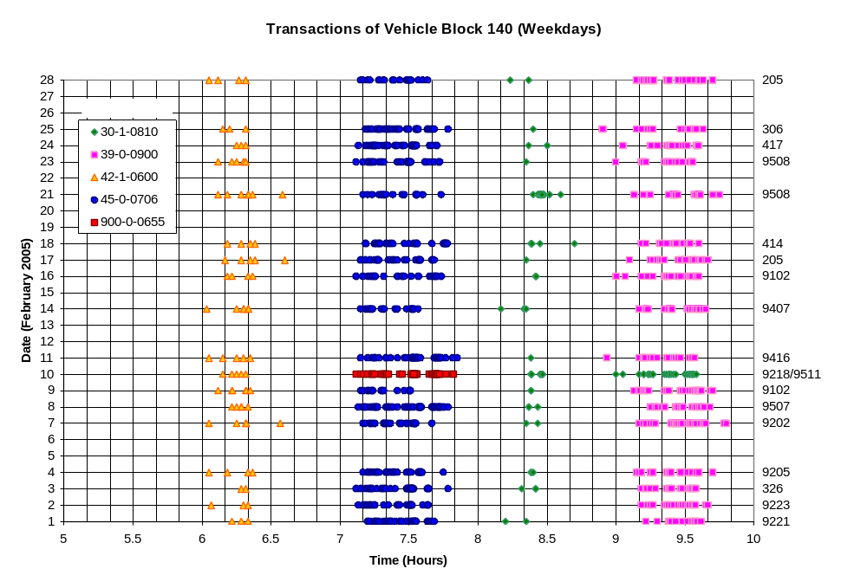
Figure 2.
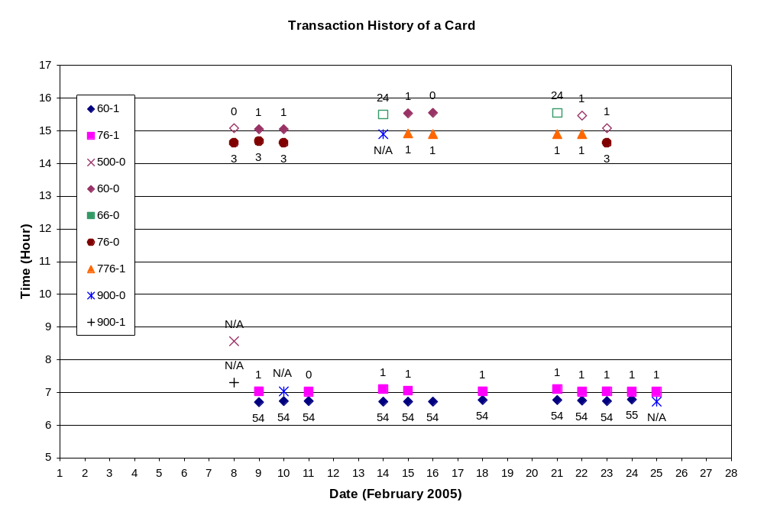
Figure 3.
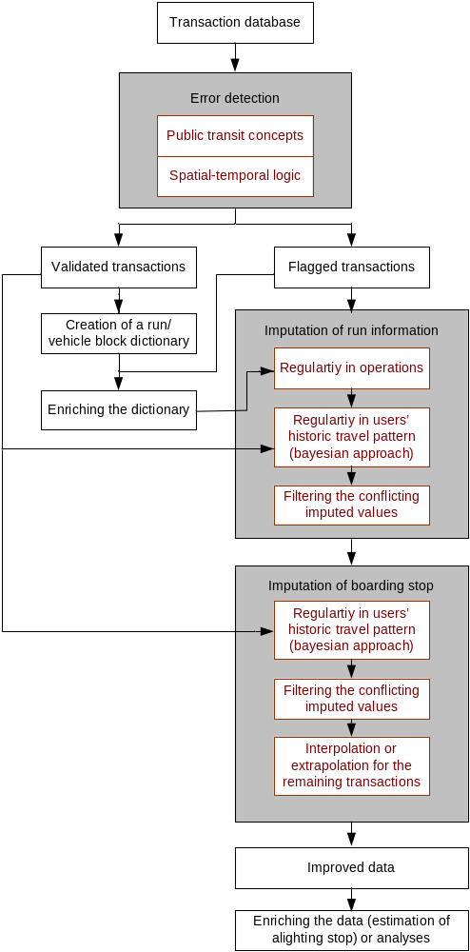
Figure 4.
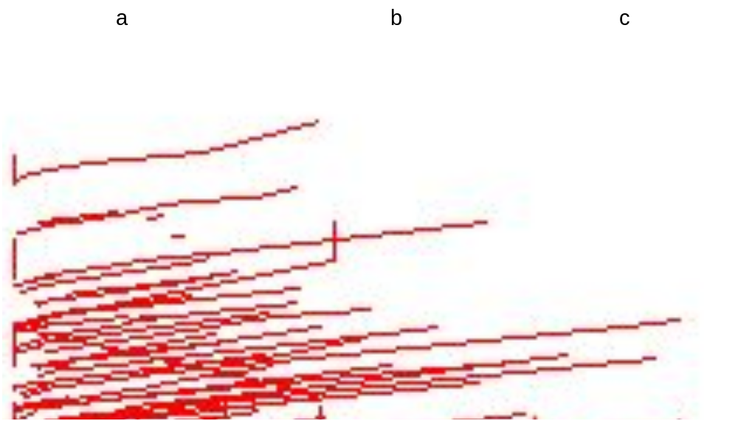
Figure 5.
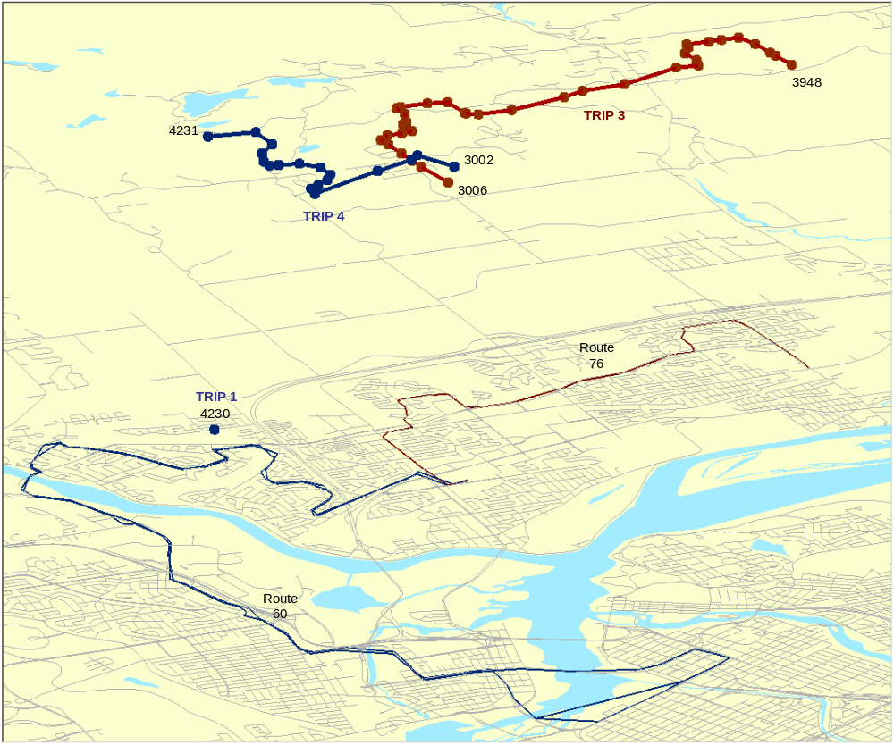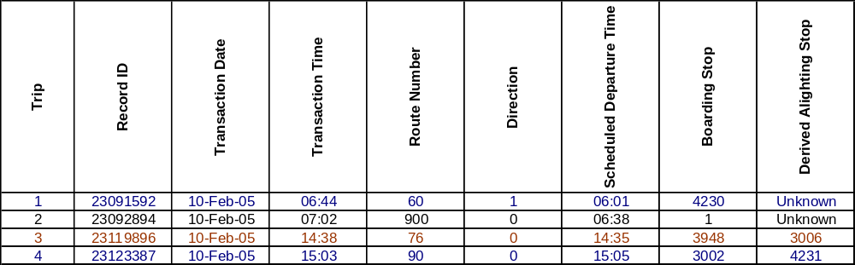
Figure 6.
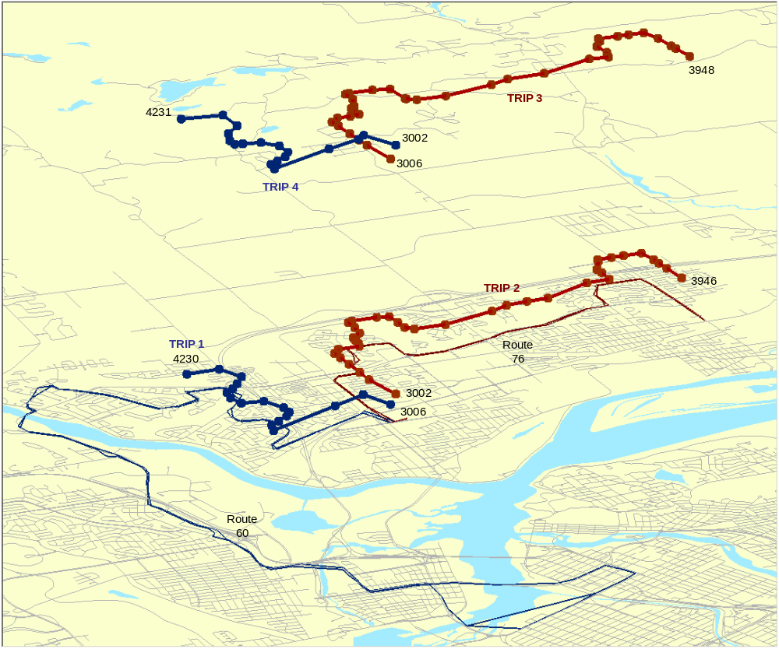
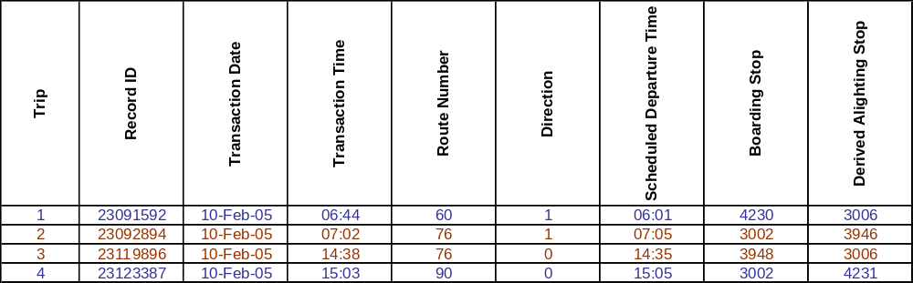 Figure 7.

