Development of Road Flooding Simulation and Animated

Traffic Simulation under the Heavy Rainfall Disaster

Jun SAKAMOTO
Engineer, CTI Engineering Co., Ltd.
3-21-1 Nihombashi Hama-cho Chuo-ku, Tokyo, 103-8430, Japan
E-mail: j-sakamoto@ctie.co.jp / Fax: +81-52-735-5492

Motohiro FUJITA
Professor, Graduate School of Engineering, Nagoya Institute of Technology
Gokiso-cho, Showa-ku, Nagoya, Aichi, 466-8555, Japan
E-mail: fujita@doboku2.ace.nitech.ac.jp / Fax: +81-52-735-5492

Jun MITAMURA
Researcher, Regional Futures Research Center
5-11 Kasuga-cho, Otsu-city, Shiga, 520-0055, Japan
E-mail: mitamura@issr-kyoto.or.jp / Fax: +81-77-522-6231

and

Koji SUZUKI
Assistant Professor, Graduate School of Engineering, Nagoya Institute of Technology
Gokiso-cho, Showa-ku, Nagoya, Aichi, 466-8555, Japan
E-mail: suzuki@ace.nitech.ac.jp / Fax: +81-52-735-7962

Abstract
Concentrated downpour might cause heavy traffic congestion and damage traffic network in a large city. In this paper, we developed the animated traffic simulations and 3D traffic simulation with GIS for analyzing the road traffic situation under the downpour disaster based on the data of travel survey and tachometer from Sept.11 to 12, 2000 in the Tokai region, Japan. As a result, it was revealed that the characteristic of flood situation by downpour is depended on the geographic characteristics around the area, and chronic traffic jams had continued until midnight over the areas which were affected by the downpour.

Key Words: Road condition analysis, Elevation analysis, Animated traffic simulation, 3D traffic simulation, GIS, travel survey

Topic Area: 3D Applied Geographical Information Systems

1. INTRODUCTION

Concentrated downpour might cause traffic congestion and change traffic network. Tokai downpour which had occurred from September 11 to 12, 2000 caused severe damage to Nagoya city’s traffic network, and highlighted the problem that traffic measures for prevention of traffic confusion under downpour is not yet sufficient. With these points as background, for developing traffic measures which is impervious to downpour, it is important to analyze the impact of the downpour on road traffic situation and to reflect the result in the traffic measures.
There are several aspects for researches on Tokai downpour disaster. Tominaga et al. (2001) and Ota et al. (2001) analyzed the problem of the areas where were affected by severe flood and proposed the measures of flood damage prevention in the future. These studies analyzed the affection of Tokai downpour in the urban area, but weren’t focused on road traffic network. Katada et al. (2001) focused on the behaviors of residents whose houses were flooded by the Tokai downpour, and analyzed the relationship between the envisioned flood damage in the future and the residents’ behaviors in those days, but the study didn’t analyze the relationship between the downpour and the rush-hour traffic jam.
In this paper, we focus on the Tokai downpour which is one of the heaviest floods in an urban area, and try to analyze the relationship between the flood damage and the affection of the damage on drivers based on the questionnaire survey which are conducted to the drivers who had driven under the downpour and to clarify road traffic situation on GIS by using the consciousness survey. Therefore, this study aims at providing the fundamental data for considering traffic measures under downpour.

2. OUTLINE

2.1 Outline of Tokai downpour
Tokai downpour which had occurred in Nagoya city on September 11 and 12, 2000 caused serious damage to the area. Figure 1 shows hourly rainfall and total rainfall observed by Nagoya observatory that indicates unprecedented amount of rainfall “93mm” for from 18:01 to 19:00 during rush hours of going home in the downpour. In this disaster, rivers overflowed in some districts and the number of flooded houses was about 4,000 in the west area of Nagoya city and Nishi-biwajima town (now, Kiyosu city), and about 2,800 in Nonami district. When it comes to transportation network around the rush hour for going home, the almost all mass transits such as subway and railway lines stopped running one after another and urban express highway was also closed, as a result, the problems affected many office workers going home.

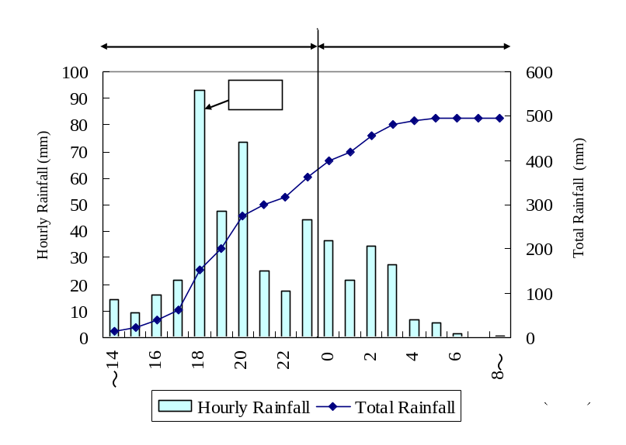

Figure 1 Rainfall variability under Tokai downpour

2.2 Outline of survey
We conducted questionnaire survey to the residents of Nagoya city, the residents of adjoining cities of Nagoya city, and taxi drivers. Table 1 shows the outline of the survey, and Figure 2 shows the questionnaire contents. In each survey, questions are about the personal attributes, activity on the day, car travel route and road condition. Drivers’ respondents were requested to draw his/her car travel route on a map following the example in Figure 3 and specify the impassable points that drivers gave up passing and the sections covered with rainwater, wherever applicable. Additionally taxi drivers’ respondents were requested to offer their tachometers that have been recorded the driving speed per minute along their travel routes under the downpour.

Table 1 Outline of survey
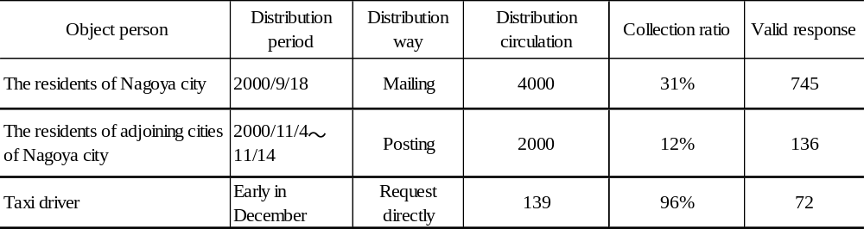

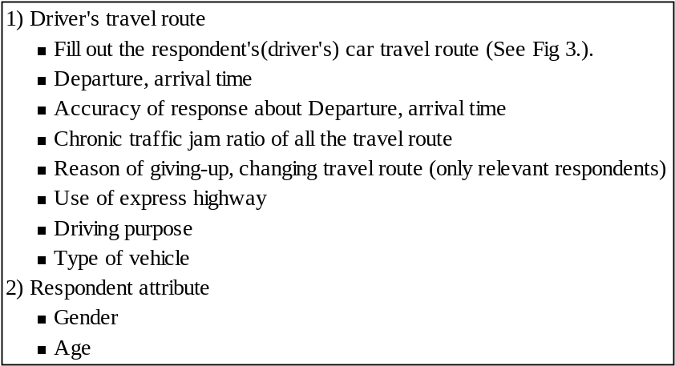

Figure 2 Questionnaire content

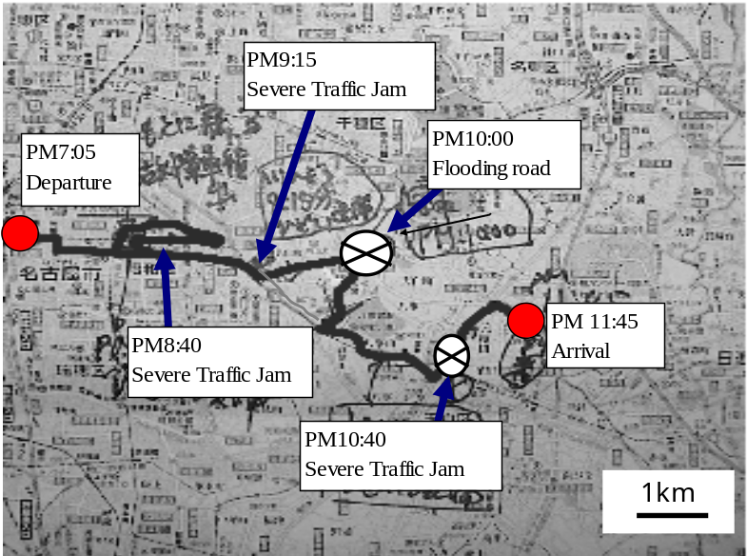

Figure 3 Example of filling out car travel route, etc

Table 2 Attribute of respondents
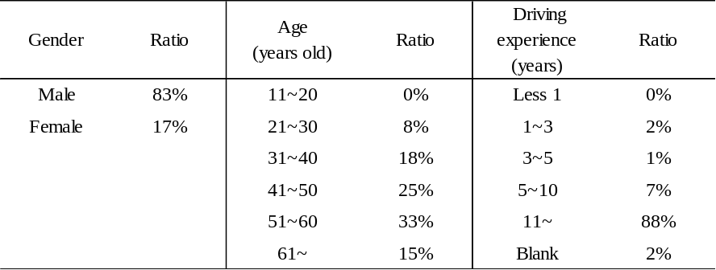

Table 2 shows the attribute of respondents. Most of respondents are male, between 40 and 60 years old, and over 10 years of driving experience. Figure 4 shows the accuracy of respondents’ memories about their departure time, arrival time, and car travel route. In each survey, the rate of the respondents who replied “remember exactly” or “remember almost exactly” is over 90%. Since we conducted the survey immediately after Tokai downpour, it can be considered that the travel time and travel route obtained by the survey are reliable for analysis. Figure 5 shows the driving purpose during the disaster. The rate of the respondents who replied “Go home”, “Go work” is higher than others. The reason of the results is considered that Tokai downpour happened the period of going home, and the hourly rainfall of 18:00 (September 11) was 93 mm. Figure 6 shows driver’s consciousnesses about traffic jam under the downpour. It implies that many drivers who drove at that time were involved in severe traffic jam.

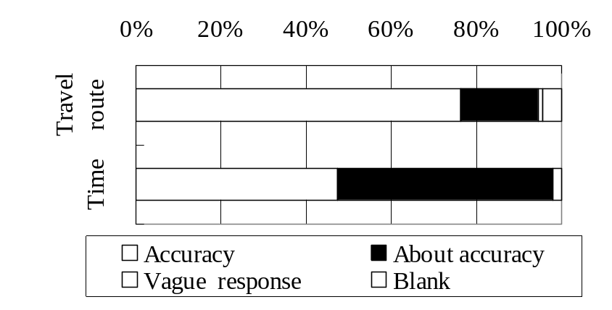

Figure 4 Accuracy of response [N= 745]

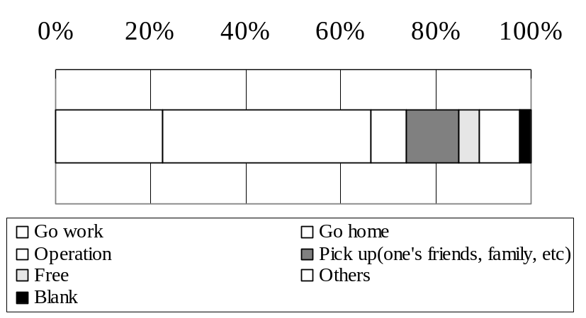

Figure 5 Driving purpose

[N= 745]

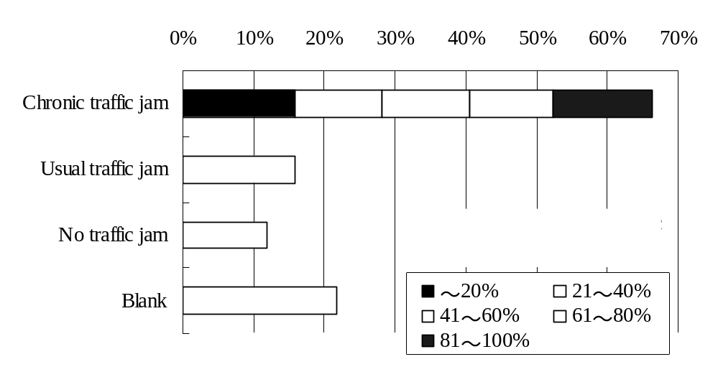

Figure 6 Driver’s consciousnesses about traffic jam under the downpour [N=745]

3. ANALYSIS ON ROAD TRAFFIC SITUATION UNDER TOKAI DOWNPOUR

In this chapter, we reproduce flood points and impassable points on map by using GIS and analyze the downpour impact on road traffic situation. The flood point means the road situation that although road surface is covered by water, vehicles can slowly go through. The impassable point means the road situation that it is impossible for almost the vehicles to go through due to the covered water. These definitions are explicitly stated in the questionnaire. The appearance of flood points and impassable points depends on not only geographical conditions but also road structure and the height of vehicle. Therefore, these points are not always correspondent with the flooded house area. In addition, the meaning of geographical conditions is mainly geographical gradient and the topographic requirements in surrounding area in this study.

3.1 Geographical and temporal variation of flood and impassable points
Figure 7 is Nagoya city area map and Figure 8 is a contour map of Nagoya city. The elevation is divided into hilly area (Moriyama, Chikusa, Meito, Tenpaku, and Midori wards, hereinafter called “East area”), highland (Naka, Higashi, Showa, Mizuho wards and one of the Minami, Atsuta wards , hereinafter called “Central area”), and alluvial area (Kita, Nishi, Nakamura, Nakagawa, Minato wards and one of the Atsuta, Minami wards ,hereinafter called “North, West, South area”). East area is the landscape of gentle hills. Central area is flat highland. North, West, and South area is alluvial area, and the place of the least elevation is -1.76 meters from sea-level (one of the place of Minato ward).
Figure 9 shows temporal variation of rainfall under Tokai downpour. From 17:00 to 18:59, rainfall peak is shifting from west to east. From 18:00 to 20:59, rainfall amount is more than 30-50mm/h in almost the city area. From 21:00, the rainfall in many places weakens except southeast area.
Figure 10 shows the temporal variation of flood and impassable points under Tokai downpour. The initiation time for these points was obtained based on questionnaire data. When the initiation time is unknown from the data, the time is estimated by the departure and arrival time for each travel route data. For this analysis, we adopt general driver’s respondents (The residents of Nagoya city and adjoining cities of Nagoya).
From 18:00 to 20:59 as shown in Figure 10, the downpour spreaded to almost every region of the city. It is shown that there were many flood and impassable points not only at lowland areas but also at highland areas. From 21:00 to 22:59, downpour relatively relented, but there were still many flood and impassable points. Comparing with the figure of 18:00-20:59, these points decreased in highland areas. From 23:00, the points at highland areas were decreasing again, however these points at lowland areas were increasing.
According to the results, it is revealed that these points at highland areas such as these points decreased relatively quickly, on the other hand, these points at lowland areas increased, because it was affected by not only the impact of the downpour in the region but also the impact of flooding from highland areas even after downpour relented.

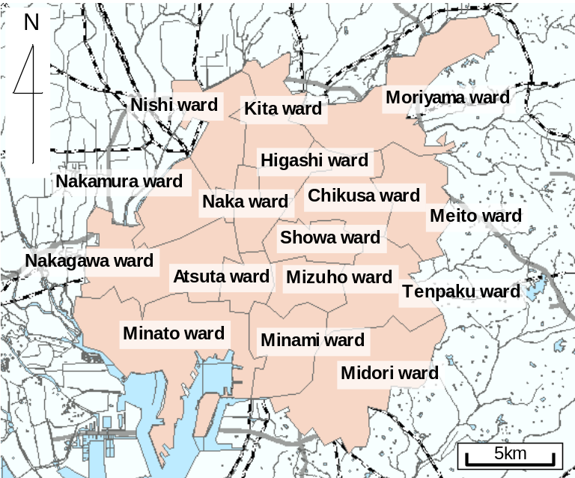

Figure 7 Nagoya city area map

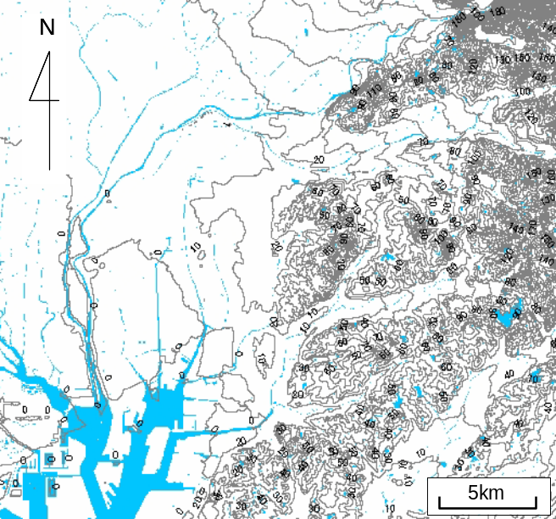

Figure 8 Nagoya city contour map
(This contour is tens of meters, and the values on the figure show elevation.)

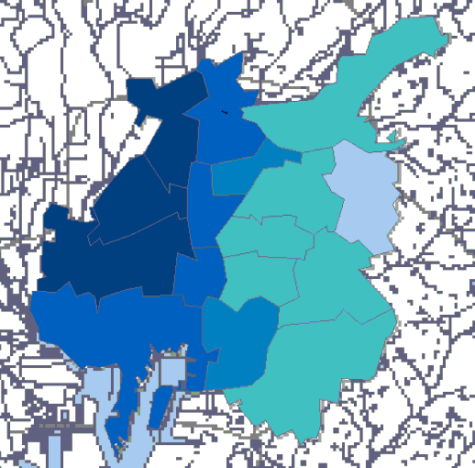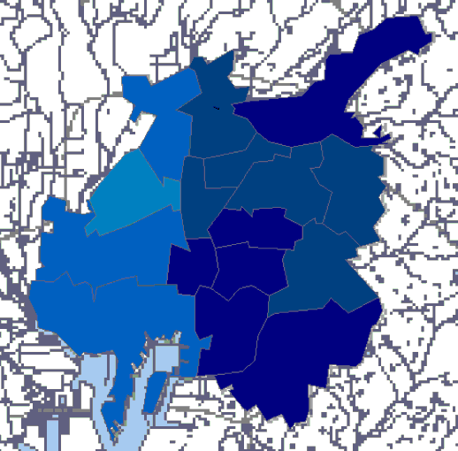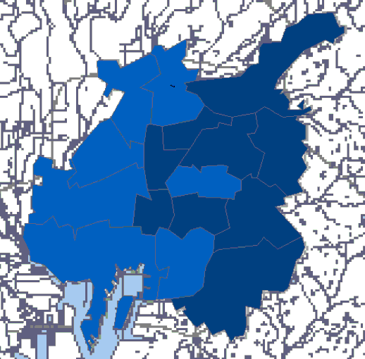
Fig.9-1 17:00-17:59 Fig.9-2 18:00-18:59 Fig.9-3 19:00-19:59

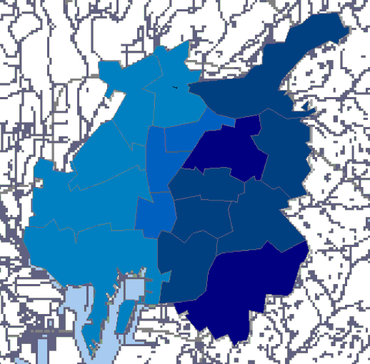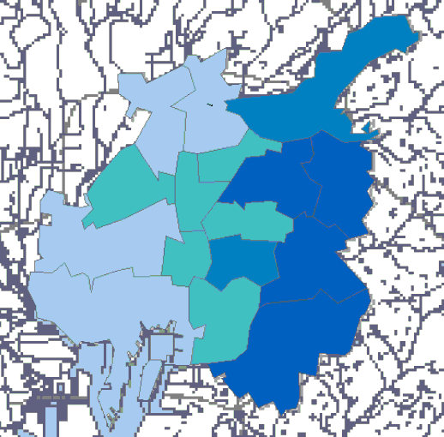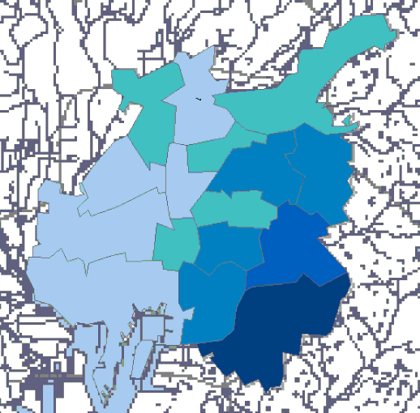
Fig.9-4 20:00-20:59 Fig.9-5 21:00-21:59 Fig.9-6 22:00-22:59

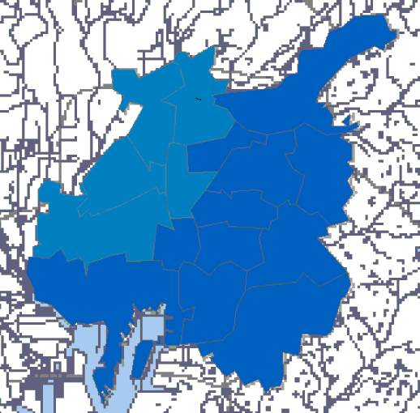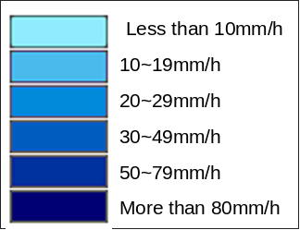
Fig.9-7 23:00-23:59 Fig.9-8 Explanatory note

Figure 9 Temporal alteration of rainfall under Tokai downpour (9/11, 2000)

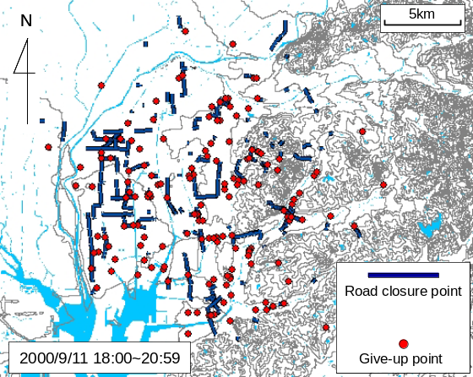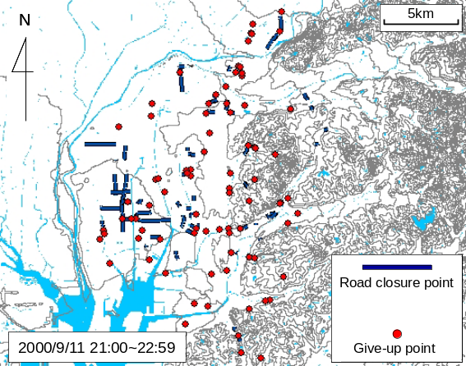
Fig.10-1 18:00-20:59 Fig.10-2 21:00-22:59

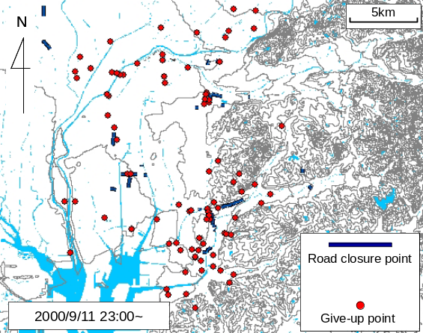

Fig.10-3 18:00-20:59

Figure 10 Temporal alteration of Flood, Give-up point under Tokai downpour (9/11, 2000)

3.2 Analysis on the geographic characteristics about flood and impassable points
We discuss the geographic characteristics which are tendency to be affected by downpour based on the data of road flood and impassable points in greater details in this section. In order to understand the problems more clearly, we classify the various conditions into three patterns based on the geographic conditions relative to downpour with the detailed contour maps, which are measured in 50 centimeters as shown in Figure 13.
Three geographies, which are tendency to be affected by the downpour, are shown in Figure 11. The disaster areas that are classified in the Figure, “(a)-1~(a)-5”, “(b)-1~(b)-2”, and “(c)” are correspondent to the geography images in Figure 12 and the detailed contour map (Contour is 50 centimeter interval in Figure 13). The characteristics of these geographies are expressed as follows.

(1) Lowland area that is surrounded on three sides by highland areas
These areas depend on the degree of slope from highland area to lowland area. In the area “(a)-1”, since the slope from highland to lowland area is gradual, there are many flood points, but there are a few impassable points. On the other hand, in the areas such as “(a)-2~ (a)-5”, the slope from highland to lowland area is steep, there are many impassable points.

(2) Closed lowland area (that is surrounded by highland areas in all directions)
In the areas “(b)-1~ (b)-2”, there are many road closure points and most of the areas are below sea level area. Therefore, these areas had been affected by flood for many hours. Since the slope is steeper and amount of rainfall is higher as compared with “(b)-1”, the area “(b)-2” was involved in serious damage more than another one.

(3) Lowland area that is surrounded by highland areas and confluence of rivers
The area “(c)” had been affected by flood for many hours. This reason is that rainwater drainage became impossible with elevation of water surface, and the flood was collected from highland areas to the area “(c)” of lowland.
It is revealed that there are several relationships between “temporal variation of rainfall and characteristic of geography” and “occurrence of flood and impassable points”.

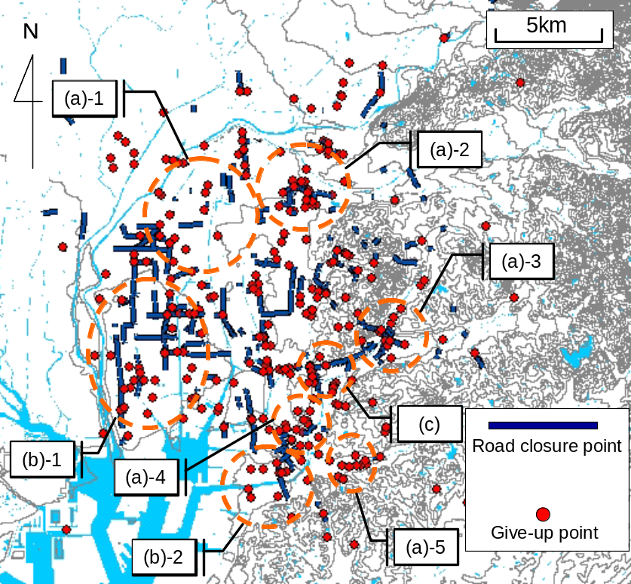

Figure 11 Classification of disaster area

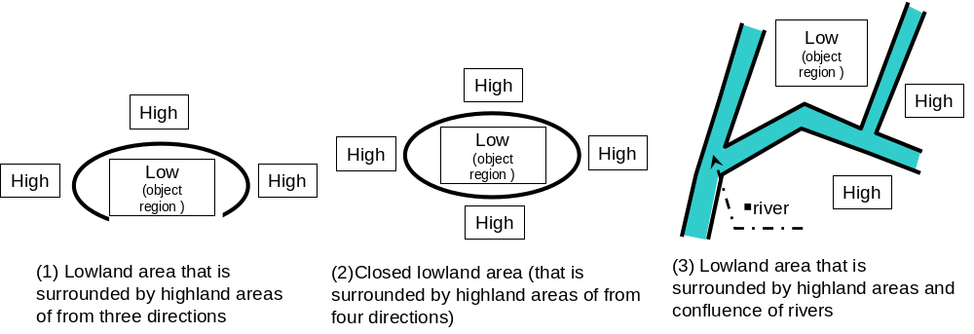

Figure 12 Geographic characteristics of the above areas

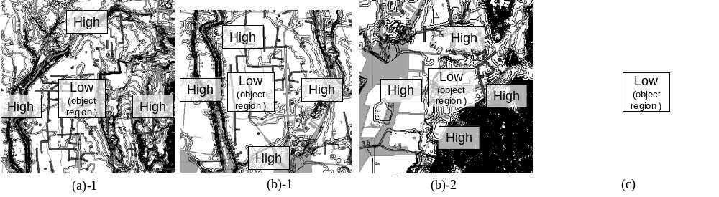

Figure 13 Contour maps of the above areas

4. ANALYSIS ON ROAD TRAFFIC SITUATIONS BY ANIMATED TRAFFIC SIMULATION
As the result of Chapter 2, it is revealed that severe traffic jams happened during Tokai downpour. In this Chapter and the next one, we simulate the traffic situation by using GIS on the basis of the same questionnaire results in order to analyze the situations more concretely.

4.1 Development of animated traffic simulation
We develop “animated traffic simulation” in order to analyze the impact of Tokai downpour on traffic situation. Animated traffic simulation is the system that draws the fluctuating traffic situations under downpour as an animation per minute by GIS. Figure 14 shows the flow diagram of the system. The process of “Calculate driving speed from input data” is as follows: For using the general driver’s questionnaire data from the residents of Nagoya city and the adjoining cities, we calculate the average driving speed of from origin to destination by using questionnaire result only. On the contrary, for treating taxi driver’s data, we calculate real-time driving speed per minute by using both questionnaires and tachometers recorded by taxi drivers. In other words, real-time driving speed of taxi driver’s data can simulate traffic situations more detail and correctly.
We use ArcGIS Tracking Analyst for developing the animated simulation. Tracking analyst is the system that can analyze time series data containing time, position, and attribution effectively on GIS map. Therefore, we develop the time series variation of traffic situation under Tokai downpour by using the software. In this simulation, a link is a part of travel route that a driver moves from origin to destination, from departure time with the calculated driving speed mentioned above. Figure 15 is the example of the moving link. In the left graphic of the figure the links 1~3 progress along each direction of arrow. As shown in the right graphic that draws the situation after 5 minutes from the left graphic situation, the links 1~3 move along each direction and each changed length of link is different.
The method of moving a link on the GIS application is as follows: A link has the length as a part of the travel route that a questionnaire respondent drove under the downpour. A link is still divided into many short segments. When a link moves on the GIS, the rear segments of link are vanished and the front segments of link are appeared simultaneously along the travel route. The GIS application can control the displayed time of segments as a function of track control. Therefore, we can move the links from origin to destination realistically by using the function.
Additionally, the reason that each extended length of link is different (See Fig 15) is that the moving distance of links with high speed are normally longer per minute than the ones of low speed. Therefore, this normal type of animated method would emphasize the traffic links with high speed stronger than the ones with low speed. However, since this study aims to express the severe traffic congestion under the downpour and simulate realistic traffic situation, the low speed travel link should be emphasized at least in the same intensity as the high speed travel link.
Consequently, we modified the above normal type of animated method by using the function on GIS so that the links for each travel route have almost the same length in spite of the speed of links (After reviewing, we adopt 4km as a constant length.).

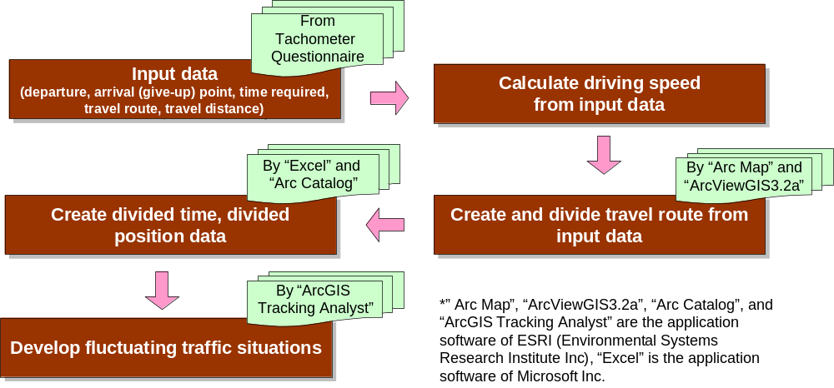

Figure 14 Flow diagram of animated traffic simulation

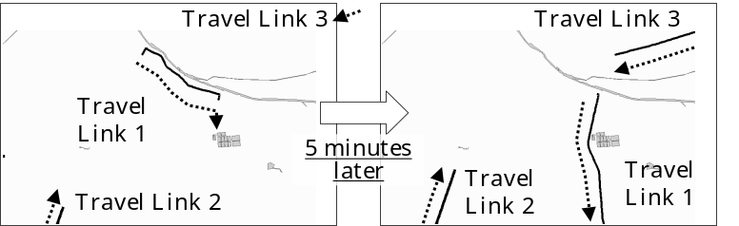

Figure 15 Example of the traffic behavior of animated traffic simulation

4.2 Analysis on road traffic situations under Tokai downpour by animated traffic simulation
As mentioned above, many drivers who had driven under the downpour have been involved in chronic traffic jam. Therefore, we analyze the road traffic situations under Tokai downpour more concretely by using the animated traffic simulation.
Figure 16 shows the time-cross sectional figures of animated traffic simulation at 19:00, 21:00, and 23:00 on 9/11, 2000. Explanatory note is the relationship of driving speeds and displayed link colors as follows: 1) Less than 4km/h (Red), 2) 4~8km/h (Brown), 3) 8~12km/h (Yellow), 4) 12~16km/h (Blue), 5) More than 16km/h (Green). When links with different speed colors overlap, the link with the lowest speed is put on the front of the link colors because of drawing the severe affection on network realistically.
From the traffic situation at 19:00 of the figure, it can be seen that chronic traffic jam happens in many regions of the city, especially, the roads less than 8km/h speed (Brown or Red line) are found largely in the areas of from west to central areas. It is attributed that the center of downpour was around the west area at this time. As a result, east area was not affected so much by the downpour.
From the traffic situation at 21:00, it can be seen that chronic traffic jam occurs at almost every region of the city. The temporal variability of from 19:00 to 21:00 would be attributed that many drivers who had driven at that time couldn’t avoid the impassable points.
From the traffic situation at 23:00, it can be seen that chronic traffic jam relieves at several areas except ones of north and south areas, because the downpour was weakening. From the temporal variability of from 21:00 to 23:00, especially in west area many travel routes recovered more than 12km/h speed.
Therefore, by using this animated traffic simulator we can reproduce more noticeable traffic situation that chronic traffic jams happened and calmed down during the heavy downpour than the existence research. Especially, it is visually revealed that the traffic jams under the downpour were affected by the temporal alteration and geographical condition.

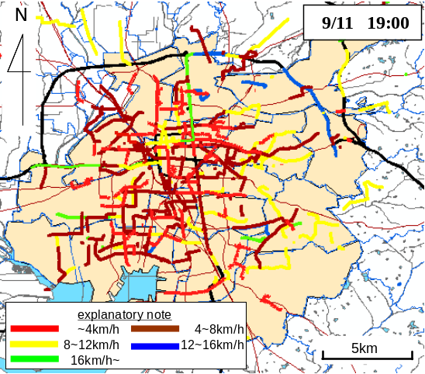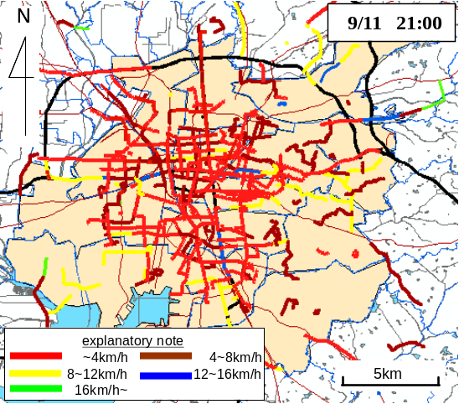
Fig.16-1 19:00 Fig.16-2 21:00

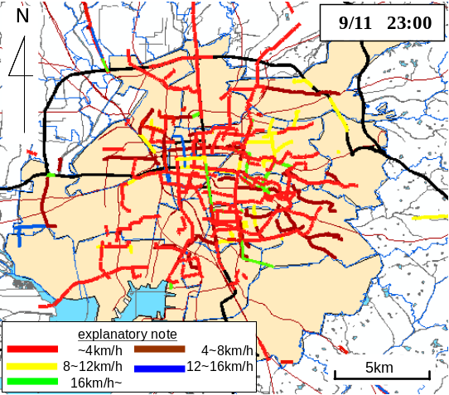

Fig.16-3 23:00

Figure 16 Traffic situations under Tokai downpour by animated traffic simulation

5. ANALYSIS ON ROAD TRAFFIC SITUATIONS BY 3D TRAFFIC SIMULATION

Although we developed the animated traffic simulation in 2-Dimensions in Chapter 4, the expression capability of the 2D animated traffic simulation still has some limitation such as coloration patterns when we need to analyze the multiple attribute data simultaneously. Therefore, we try to analyze traffic situations under downpour more detail by developing a 3D traffic simulation. This simulation is not animated traffic simulation but hourly traffic simulation because the 3D animated traffic simulation requires a lot of memory and high performance of CPU for the computer applied.

5.1 Development of 3D traffic simulation
3D traffic simulation is the system that draws colored and 3-dimensioned travel routes of drivers by using GIS (ArcGIS 3D analyst and ArcScene). Figure 17 shows the flow diagram of the system.
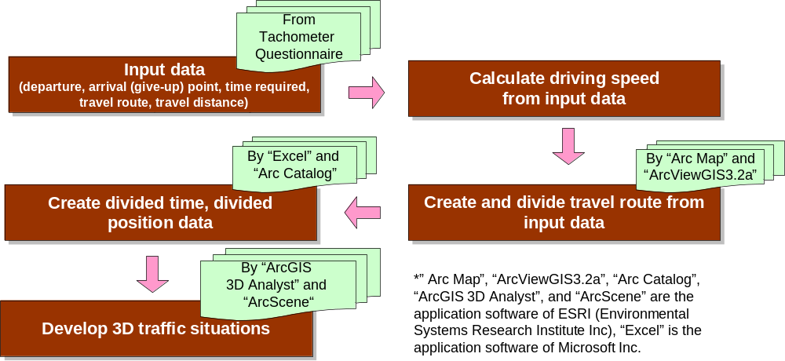

Figure 17 Flow diagram of 3D traffic simulation

5.2 Analysis on road traffic situations under Tokai downpour by 3D traffic simulation
Figure 18 shows the 3D traffic simulations at 18:01~19:00, 19:01~20:00, 20:01~21:00, 21:01~22:00, and 22:01~23:00. In this study, only taxi drivers’ data are applied to 3D image and the other data are applied to 2D image. The reason that the 3D image data are limited is that if all data are applied to 3D image, it becomes impossible to analyze and distinguish the temporal change of traffic jam due to too many 3D data. The vertical axis of 3D image in the figure 18 is set to travel time per kilometer (min/km) in order to clearly express severe congestion areas. Additionally, the explanatory note is the relationship of driving speeds and displayed link colors as follows: 1) 15min/km~ (Red), 2) 7.5~15min/km (Violet), 3) 4~7.5min/km (Blue), 4) ~4min/km (Green).
From the traffic situation about 19:01~20:00 in the figure, it can be seen that severe traffic jam with 15 minutes per kilometer caused around the north area. From the figure of 19:01~20:00, the degree of traffic jam became worse to more than 60 minutes per kilometer and the jam links increased. Then it is clarified that road traffic was paralyzed especially around the north area. However, in these time periods, it can be also seen that the other area caused severe congestion due to many links displayed with red color.
From the figure of 22:01~23:00, although the severe traffic jam around north area decreased, several links in south area caused the severe traffic jam with more than 60 minutes per kilometer due to the lowland of south area. Since these results would be consistent with the situation analyzed by the 2D animated simulations in the previous chapter, it is noted that we can still understand the traffic jam level in each area more concretely by using 3D traffic simulation.

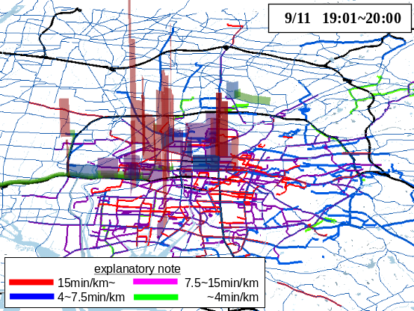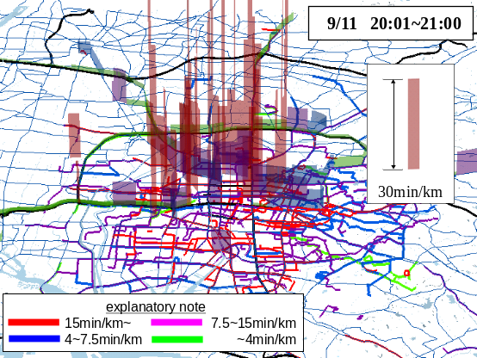
Fig.18-1 19:01~20:00 Fig.18-2 20:01~21:00

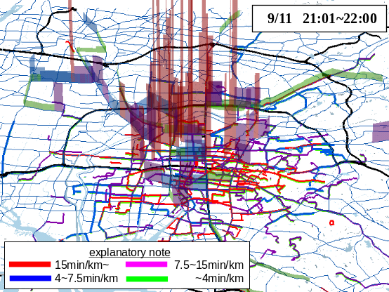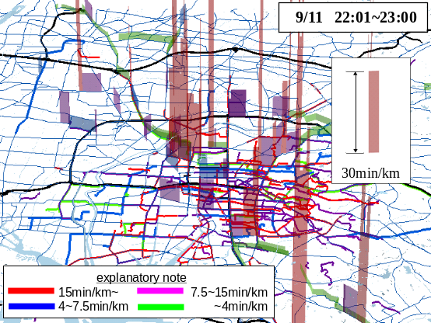
Fig.18-3 21:01~22:00 Fig.18-4 22:01~23:00

Figure 18 Traffic situations under Tokai downpour by 3D traffic simulation

6. CONCLUSION

In this paper, we aim to provide the fundamental data for examining the way of traffic network under downpour, and develop the road condition analysis, elevation analysis, animated traffic simulations, and 3D traffic simulation with GIS under Tokai downpour by travel survey and tachometer of the drivers who had driven under the downpour, from 9.11 to 9.12, 2000. The conclusions of this paper can be summarized as below:
- Reproducing flood points and impassable points on map by using GIS and analyzing the downpour impact on road traffic situation, it is revealed that there were many flood and impassable points not only at lowland areas but also at highland areas for the hours of that the downpour spread to almost every region of the city, and after them, these points at highland areas decreased, however the points at lowland areas were increasing.
- Analyzing on the geographic characteristics about flood and impassable points, it is revealed that there are several relationships between “temporal variation of rainfall and characteristic of geography” and “occurrence of flood and impassable points”.

- Analyzing the road traffic situations by animated traffic simulation, it is revealed that the chronic traffic jam had continued till all hours of the night.
- Analyzing on road traffic situations under Tokai downpour by 3D traffic simulation, we can simulate the traffic jam level in each area more concretely.
The issues of this study are to provide the impact of a downpour on road traffic situation more clearly, and to reflect as a future role of disaster planning. And from the viewpoint of the amount of data and quality of information, it is necessary to improve the way of analyzing traffic situations under downpour by utilizing ITS techniques.

References
Akihiro TOMINAGA, Kenjiro SHO, 2001. PROBLEMS OF TENPAKU-RIVER FLOOD IN TOKAI HEAVY RAIN ON SEPTEMBER 2000, ADVANCES IN RIVER ENGINEERING, No.7, 47-52, JSCE. (In Japanese)
Ota Yuji, Tachikawa Yasuto, Takara Kaoru, 2001. Tokai Heavy Rainfall Disaster, urban flooding, Nonami district, Tenpaku river, Goshita river, Fuji river, PROCEEDINGS OF ANNUAL CONFERENCE OF THE JAPAN SOCIETY OF CIVIL ENGINEERS, No.56, 442-443, JSCE. (In Japanese)
Toshitaka KATADA, Makoto KODAMA, 2000. Changes of inhabitant's estimate of flood damage and its effect on the action accompanied by development of a flood disaster in heavy rainfall disaster in Tokai District in 2000, PROCEEDINGS OF INFRASTRUCTURE PLANNING, No.24-2, 929-932, JSCE. (In Japanese)
Jun SAKAMOTO, Motohiro FUJITA, Keitaro FUJIMOTO, and Koji SUZUKI., 2004. Development of Animated Traffic Simulation Systems Using Travel Route Survey and Tachometer Data and its Application to the Heavy Rainfall Disaster, The infrastructure planning committee, No.30(CD-ROM), JSCE. (In Japanese)
Motohiro FUJITA, Jun MITAMURA., 2004. Analysis on road traffic situation of travel times and routes of cars under the downpour disaster in TOKAI area, Journal of JSCE, No.751/IV-62, 127-137, JSCE. (In Japanese)

City of Nagoya; http://www.city.nagoya.jp/global/en/

