Accessibility and transport policy : the case of the Strasbourg tram-line A
Aurélie MERCIER*, Nicolas Ovtracht**
Laboratoire d'Economie des Transports
(CNRS, Université Lyon 2, ENTPE)

30 Avril 2007
Ground address: LET, ISH, 14 av Berthelot, 69363 Lyon, France.
* PhD Student, email: aurelie.mercier@let.ish-lyon.cnrs.fr
** Design engineer (CNRS), mail: nicolas.ovtracht@let.ish-lyon.cnrs.fr

Abstract
This paper compares job-access levels by cars and public transports on the Strasbourg area. A gravity accessibility index based on job density and generalised costs is coupled to a GIS representing car and public transport networks to measure accessibility. Results underline a job-access level often higher by cars than by public transports, in spite of a car-restriction policy in the centre. Nevertheless job-access cartographic representation highlights the importance of some public transports high-speed lines to compete with cars. Whatever the mode considered, the most accessible zones are located in the centre.

Introduction
Since the 19th century European cities have never stopped growing outward. The dense and intensive cities have been transformed into multipolar cities. Jobs and population are therefore located in different suburban areas. These new urban forms generate a spatial mismatch phenomenon and its corollary a travel demand increase. Note that a decrease of generalized travel costs rather than a lifestyle evolution has mainly impacted the urban spread. Consequently there is a vicious circle between urban spread, generalized travel costs and car travel demand. Both massive motorization and high-speed road constructions have allowed reaching more and more locations. Jobs located in suburbs can easily be accessible by car and distance is no more considered as a frontier. Distances are no more spatial but temporal. Yet spatial mismatch can be overcome.
Nevertheless suburbanisation and car travel demand made cities be confronted with congestion and pollution. Regarding these problems the speed issue has to be addressed. How to reduce automobile use without restricting individual utility? How to overcome spatial mismatch without car intensive use? Are time earnings compatible with a car-restricting policy? Are public transports able to provide an access level equal to the car one? Literature on congestion issue highlights that traffic fluidity is higher when speeds are homogenous than high. Downs and Thomson (1962, 1977) have proved that car and public transports generalized travel costs tend to balance in dense urban areas. Mogridge (1997) adds that an increase of roads make congestion decrease but only at short term. In long term a balance between speeds of different modes is observed.
Following these comments, transport policies develop public transports to the detriment of cars. In France many cities have developed a public transport oriented policy with tram lines implementation. This tram network is often inside town-center but in some cases it also links suburbs to center. Strasbourg is one of the main examples. The policy implemented in Strasbourg has made public transport predominant in central area with the implementation of a first tram-line in 1994 (other tram-lines have been implemented in 1998). It aims at increasing accessibility by public transports in order to avoid car travels in town center.
This paper seeks to compare job-access levels by cars and public transports after the first tram line implementation in 1994. This research based on a GIS-analysis has a double objective. First, it constitutes an application of a gravity-based indicator. It develops job-access measures considering a fine zonal grid and a differentiation between mode users. The second objective is to test the two different alternatives proposed by policymakers to workers located in Strasbourg : car travel versus public transport travel. Transport policy is based both on higher access-levels for public transport and a car-restriction in town-center. But is the first tram line really sufficient to made public transports competitive with car?
Therefore the paper is organized in four sections. An introduction of the research constitutes the first section. The second section justifies the choice of Strasbourg as a case study. It insists on daily and residential mobility and on transport policy specificities. The third section explains the choice of a gravity accessibility measure. It also presents GIS implementation and hypothesis on data modeling. The fourth section reports the main job-access results.

study area
The city of Strasbourg, located near the German border (see Figure 1) is the French 7th City. Its population is estimated at 264 115 inhabitants (1999 Census) located on 78 square kilometers. Strasbourg is built according to a center-periphery model with an inner core of 11 square kilometers, represented in maps by the tram line station “Homme de Fer”, and suburbs.
There are two reasons for selecting Strasbourg (and its adjacent city Illkirch-Graffestaden). The first is that Strasbourg is one of the first French cities which introduced a tram line in 1994. The second is that the transport policy is public transport-oriented.

Spatial distribution of population and jobs
Figure 4 represents the density of population and jobs. It shows a spatial pattern of population and a pattern of jobs almost similar. To be more accurate, the population mainly resides both in central and in eastern zones while jobs are concentrated in the inner core. Indeed 24.5% of jobs but only 9% of population are located in the Centre area. Nevertheless job density sharply drops when moving away from central zones to suburbs. Spatial distribution of population is the result of the city transformations and housing policies. Job distribution is mainly linked to the weight of the tertiary sector mainly centralized within the inner core. Industrial activity areas are nevertheless located in the eastern zone of Strasbourg.

A public transport-oriented policy
The policy in favor of public transports has been implemented since the nineties to revitalize the city core. The opening of the first tram line in 1994 can be seen as the symbol of this policy. The first section of tram line A, represents 80% of the actual line length (the second section was implemented in 1998). It crosses the city from north to south on 9.6 km and links 18 stations (see Figure 3). The tram serves facilities (hospital, railway station, commercial center, and tourist places…) with an operating speed of 20 km/h.
Concurrently to the implementation of the tram, the bus network has been improved with the creation of new bypass lines, the extension of existing lines and an improvement of frequencies. This reorganization allowed an increase of 20% of kilometer bus between 1992 and 1995.
The development of public transports has been reinforced by a policy restricting the importance of cars in the city center. The first measures to limit cars in the city center were applied in the nineties with the end of the transit traffic. The traffic has been therefore limited on roads bypassing the city center. These restriction measures have been implemented with a new parking policy.

Mobility behaviors
Changes on transport policy impacted on mobility behaviors, and especially on transport modes used. According to a study published by the Urban Agency of Strasbourg (ADEUS), the number of trips made by inhabitants of Strasbourg metropolis is the highest of French ones. The average number of trips is 4.53 per day in 1997. Approximately 50% of trips are made by cars and 10% by public transports. Nevertheless numbers of trips made by public transport modes increased between 1988 and 1997. This increase is mainly due to inhabitants located in the centre area or near the tram line. Due to the tram line implementation, between 1994 and 1995, the use of public transports increased of 28 %.

Measuring gravity accessibility using GIS methods and tools

The choice of a gravity accessibility measure
The concept of accessibility is used in many studies and “it is best described from a variety of angles” (Stalinov, 2003). Accessibility is generally defined as a measure of spatial separation of human activities denoting the ease with which activities (opportunities) can be reached from a given location using a particular transport system (Morris and al., 1979). Consequently, this concept combines transportation system, land use, temporal constraint and sometimes individual behavior. Referring to these components many accessibility indicators are mentioned in literature. As suggested by Primerano (2003), an indicator classification can separate indicators based on “supply approach” and indicators based on “behavioral approach”. On “supply approach” accessibility is linked to the transportation system and distribution of opportunities on space. This approach is mainly composed of isochronic measures and potential accessibility measures. On “behavioral approach” accessibility depends on transport, opportunity supply and individual characteristics. This approach mainly refers to measures from space-time geography and from utility theory (utility-based accessibility measures).
The choice of an accessibility measure depends on the case study objective. Here the objective is to analyse job accessibility for different modes and for different periods of the day, following a tram line implementation. We do not analyse accessibility from the viewpoint of individuals organising their activity programmes considering different constraints (transport, time or activity constraints for example). We adopt the viewpoint of a land-planner who aims at improving the public transport network performance, given housing and job location.
Given our objective and the modest data requirement we focus on “supply approach”. Gravity accessibility measures are used.
Hansen introduced potential accessibility measures in 1959. He considers accessibility “as the potential of opportunities for interaction” and not only a “measure of the intensity of the possibility of interaction”. In his definition Hansen underlines “the ability and the desire of people and firms to overcome spatial separation”. The potential accessibility can be described as:
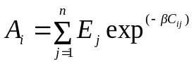 Where :
Ej denotes the mass of opportunities at location j
Cij denotes the travel cost (or generalised cost) between i and j
 denotes a travel cost coefficient
n denotes the number of locations
Therefore, accessibility depends both on transportation system and land use pattern. This gravity indicator highlights the relation between opportunities available to consumers in zone j, considered as the trip's “pull” factor and the travel cost (or generalised cost), to reach this zone j, seen as the trip's “deterent” factor. Potential accessibility measures can be used for different types of opportunities i-e jobs, inhabitants, services, and recreational facilities… Whatever the type of opportunity considered, potential accessibility can be interpreted as “the range of choice offered by the land-use transport system in the form of a sum of potential destinations” (Koenig 1980 in Geurs and Ritsema, 2001).
Literature on accessibility underlines three main failures for the potential accessibility measures: the strong influence of the distance decay function on the weighting for internal accessibility, the non-integration of individual characteristics, and the non-integration of competition effects. These main failures are overcome in our case study as follows:
- The distance decay function tends to give an important weight on internal accessibility, mainly for zones with a high level of opportunities. Consequently we use an area division into small zones of 250 meters by 250 meters. The choice of a potential accessibility based on an exponential decay function is mainly justified by the gravity law of distribution (Koenig, 1980) and the short distance interactions in an urban context (Fotheringham and O’Kelly, 1989),
- The problem of the non-integration of individual characteristics is solved using a semidisaggregated analysis according to mode users: cars users are considered separately from public transport ones.
- Potential accessibility measures do not integrate competition effects. While supply is included into gravity accessibility measure, demand is not. Nevertheless such a model with competition effects provides results not easily interpretable.

GIS implementation
Job accessibility is computed following the gravity accessibility formula for both road users and public transport users in peak and off-peak periods. Four accessibility measures are therefore implemented using a Geographic Information System.
Gravity accessibility computation can be divided into three steps. The first one permits to model the transport network. Then generalized travel cost has to be determined for both car and public transport users and for the two periods considered. In a third step the number of opportunities has to be integrated to compute gravity accessibility.

Transport network modelling
The GIS has been developed using the MapInfo software and its extension RouteFinder to perform accessibility computations. It is composed by two main transport networks and two other layers representing different area divisions:
- The road network was generated from a screen digitalisation of street paper-map (scale 1/13000) representing the whole study area roads.
- The public transport network has been produced by digitising each bus-line from a street paper map dated 1997 and avoiding the overlapping of bus-lines when it is not necessary. Some data attributes were added to complete this network (seeFigure 3).
- A layer dividing the study area in 250m * 250 m zones was created to improve accessibility calculations
- A layer representing Iris 2000 areas (polygons) was added. For each Iris 2000 area (an Iris 2000 area corresponds to an area of 1,800 to 5,000 inhabitants), the French Institute of Statistics (INSEE) has collected (census from 1990 and 1999) statistical data on population, housing, and employment.

Generalized travel cost computation
Generalized travel cost is given by:
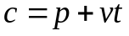 Where: c denotes generalized travel cost
p denotes the monetary cost
t denotes the travel time
v denotes the value of time

Monetary cost computation
Monetary costs are computed weighting travel distance by the cost price of one kilometre for travels by cars (i-e € 0.32 per Km). The cost corresponds to car purchase, maintenance costs, financial and fuel taxes. Travel distance is computed using a shortest path algorithm (A* algorithm).
Public transport monetary cost does not depend on travel distance. It is based on bus ticket price fixed to € 1.07 (value 1999). However public transport travel distance is computed to determine travel time.

Travel time computations
Travel time has been computed separately for public transports and cars both for peak and off-peak periods. To obtain travel time from travel distance, a speed limit is assigned for each network section. An access time to the network, as the crow flies, corresponding to a speed limit of 5 km/h for car network and 3.5 km/h for public transport network is considered. Total travel time is transformed into monetary units considering a value of €0.12 per minute.
Hypothesis on car speeds:
Car speed mainly depends on road categories, peak or off-peak periods. Speed data used in this study have been provided by the French transport department. They are summed in Table 1.
Hypothesis on public transport speeds:
Public transport speeds and frequencies have been constructed using bus-line timetables. The separation between peak and off-peak periods has been made considering that peak-hour speed is the max speed in the day while the peak-hour frequency corresponds to the lower waiting time between two buses in the day. Conversely for off-peak hour speed and frequency. Public transport speeds and frequencies are summed up in Table 2. The average speed amounts to 19.3 km/h in peak hours and to 14.6 km/h in off-peak hours. As a comparison element, the daily commercial speed computed by the public transport company in Strasbourg amounts to 16.4 km/h in 1995 (our network corresponds to the 1997 scheme).

Integration of job data
As said previously, job location at the Iris2000 scale has been integrated in the GIS. Number of jobs has been computed using both the number of wage-earner from SIREN data (published by INSEE) for establishments with more 1 salaried employee and the number of establishment with 0 salaried employee.
The number of jobs has to be weighted by a parameter  determining the effect of distance on accessibility values. The value of  corresponds to the propensity for individuals to perform a long trip. The value of  is often determined by the travel behaviour model on the area studied but in our case study we consider a value of 0.156 obtained for such a model in Lyon. At the end of these three steps, we obtain the accessibility from a zone i to a zone j: this is a relative accessibility. To obtain an integral accessibility measure from a zone i, these relative accessibility results have to be summed up.

Analysis of accessibility results
Figure 5 is divided into two parts representing respectively accessibility to jobs in peak and in off-peak periods. It visualizes accessibility from a zone i (supposed to be a residential zone) to the whole study area zones (supposed to be employment zones). For each period, accessibility for public transport and car users is illustrated (maps (a), (d) and (b), (c)). As a comparison, these four maps use the same equal interval classification. Moreover in order to improve the understanding, a comparison map represents the accessibility variation between car and public transports (maps (c) and (f)).
Average and median job-access values by modes, periods and urban zones are reported in Table 3. These values are not weighted by the number of inhabitants or the number of jobs. Note that the “Center” zone corresponds to the central area illustrated on Figure 1. Also note that job-access values have been computed using a model. Therefore they depend on the quality of data sources.

General comments
Job-access level varies according to the distance from the center: accessibility is higher in central area than in suburbs. Figure 5 clearly highlights the different job-access levels whatever the mode and the period. As presented in Table 3, average job-access in Center is estimated to be 50% (respectively 40%) as high as in Suburbs in peak period (respectively in off-peak period).
To explain this result, the concentration of jobs may be put forward. As shown in Figure 4, job density (per Km²) is the highest in central area. Therefore, referring to section 2.1 and the spatial distribution of jobs and population, inhabitants tend to be located where the job-access level is the highest.
Even if job-access is the highest in central area, note a distortion of the most accessible area perimeter down the south. The center area symbolized by the tram line station “Homme de Fer” is not the central point of the most accessible area perimeter. The central point is more down the south. This observation can be explained by the main urban network and by commercial areas located on the south.
Figure 5 shows a great difference in job-access between peak and off-peak period. Job-access levels are always higher in off-peak period than in peak period. For example, average job-access increases of 20% from peak to off-peak period considering cars and 12% considering public transports. To take congestion charges into account a speed limitation has been introduced in peak period both for cars and public transports. These changes in job-access values are illustrated in maps (a) and (b) by a narrowing of the circle of the most accessible areas.

A job-accessibility generally higher by cars than public transports
When the job-access level is compared between cars and public transports, it is often higher for the private mode than for the public one. This disparity is explained by a travel speed higher by cars than by public transports. Contrary to public transport users, car users don’t have connections and waiting time.
As said previously, for both cars and public transports, job-access decreases from the centre but some particularities are peculiar to each mode. Accessibility by car is represented by circles that are concentric to the town center. This structure is due to the dense road network allowing a homogenization of car travel time.
In spite of a car-restriction policy in the town centre, job-access from central area is clearly better than the access-job from suburbs (average accessibility from centre is 50% as high as from suburbs). Nevertheless congestion charges generated by a car restriction policy impact on car access-level in peak-period. Between off-peak and peak period, average job-access level decreases by 16%.

Public transports sometimes competitive
For some areas, accessibility is higher by public transports than by cars (areas located in the south-west or in north-east of the study area). For them, the bus network is efficient with cut bus-line or high-speed lines. They are directly linked to the town centre. At the same time, motorways do not cross these zones.
Representation of job-access levels by public transports differs from the one of cars. The concentric circle structure gives way to a structure like the “fingers of a glove” underlying impacts of public transport network on job-access level. Areas where job-access values by public transport are the highest are those where public transport network is the more dense, i-e central areas. The structure representing “ fingers of a glove” can be justified by public transport lines characterized by high commercial speeds and frequencies. The Tram line A, the bus lines 4 and 72, for example, have commercial speed superior than 17 km/h. Also note the impact of cut bus-lines like the n°65 (south-west of the study area) or like the n°7 (north-west of the study area). Due to their route in not very dense periurban zones, their commercial speed higher than 20 km/h permits to link “rapidly” the tram line and central jobs. The low job accessibility level of south-east and north-east zones is linked to the absence of public transport network because of forests and a port activity zone.
If job-access level remains higher by cars than public transport (considering average for “Center+Suburbs”) the “peak period scenario” tends to balance access-level between both modes. The tram line speed does not change with congestion and allows to compensate for the bus speed decrease. While the job-access variation between cars and public transport amounts to 24% in off-peak period (in favour of cars), it is estimated to 16% in peak period.
To sum up, job accessibility level is higher by cars for most of central zones, for zones located near motorways (and particularly interchanges) and for zones without public transport network. Conversely, job-access level is higher by public transports in peripheral zones located in the south-west or in the north. This result highlights the impacts of high-speed bus line or tram line to connect suburbs to central zones. Nevertheless it underlines the weakness of some travel speed used in this study. Indeed the result is based on travel speeds sometimes higher for bus than for cars while the two types of vehicles are expected to use the same route. To accept this difference, we have to make the hypothesis that these bus lines are exclusive.

Conclusion
This paper compares both job accessibility for car and public transport users on Strasbourg area. Firstly it permits to apply gravity-based indicators for the two modes considering a fine zonal grid. Secondly it tests two of the various transport mode alternatives proposed to workers living in Strasbourg. The choice of Strasbourg is mainly link both to its transport policy in favor of public modes and data requirements. During the nineties a tram line has been implemented in central zone and in the same time the importance of cars has been restricted. From this research three main results can be drawn:
- Job accessibility is often higher by cars than by public transports, in spite of car restriction policy in the centre. The tram-line associated to fast cut-bus lines are not sufficient to compete with car speeds and a dense road urban network. Nevertheless due to some efficient bus lines, public transports can reveal competitive in some suburbs.
- Whatever the mode considered, the most accessible zones are located in the centre. This result indicates that central zones offer a number of jobs higher than suburbs and that central zones are served by a dense transport network.
- Cartographic representation of job-access varies according to the mode. While accessibility by car is represented by a concentric circle structure, accessibility by public transport is represented by a “finger of a glove” structure. This structure highlights the impact of some public transport lines with high commercial speeds and high frequencies.
These job-access results have not to be interpreted as a transport policy failure. The car restrictive policy implemented in Strasbourg in the nineties is based on a car speed limit in the town centre, on an increase of paying car parks on central streets, and on a development of public transports. Among these measures, only the car speed limit and therefore the speed homogenisation with public transports is integrated in our GIS.
Therefore for future research many improvement have to be integrated. Beyond the integration of parking monetary costs, an important work will be made integrated a 4-stage model. Such a model will allow determining more precisely length trips and therefore accessibility measures.

References
Burrough, P.A., McDonnell, R.A. (1998) ‘Principals of Geographical Information Systems’, Oxford University Press.
Bordin P. (2002) ‘SIG : concepts, outils et données’, Lavoisier, Paris.
Commissariat Général du Plan (2001) ‘Transports : choix des investissements et coût des nuisances’. Rapport du groupe présidé par Marcel Boiteux, La Documentation française, Paris.
Communauté Urbaine de Strasbourg, ADEUS (2000) ‘Plan de déplacements urbains’.
Communauté Urbaine de Strasbourg, ADEUS (2003), ‘Rapport annuel de l’observatoire des effets du tramway :2001’.
Centre d’Etudes sur les Réseaux, les Transports, l’Urbanisme et les constructions publiques (2006) ‘Calculs d’accessibilité. Impact des spécifications du réseau routier sur les calculs d’accessibilité. Données sources méthodes.’
Crozet Y. (2005) ‘Le temps et les transports de voyageurs’, in 127ème table ronde de la CEMT, Le temps et les transports, Editions de l’OCDE, Paris.
Fotheringham A.S. and O’Kelly M.E. (1989), Spatial Interaction Models: Formulations and Applications, Kluwer Academic Publishers, Dordrecht, Boston, London, 1989.
Downs A. (2004), ‘Why traffic congestion is here to stay…and will get worse’, Access, 25, pp.19-25
Geurs K., Ritsema Van Eck J. (2001), Accessibility measures : review and applications. Evaluation of accessibility impacts of land-use transport scenarios, and related socio-economics impacts; RIVM report 408505 006, june 2001, Bilthoven, pays-bas.
Hansen, W.G. (1959) ‘How accessibility shapes land-use’, Journal of the American Institute of Planners, 25, pp. 73-76
Jemelin, C., Kauffman, V., Barbey, J ., Klein, T., Pini, G. (2005) ‘Politiques de transport et inégalités sociales d’accès. Analyse comparative d’enquêtes-ménages déplacements françaises et suisses.’ Rapport intermédiaire PREDIT 3.
Johannsson, B., Klaesson, J., Olsson M. (2002) ‘Time distance and labour market integration’, Papers in Regional Science, 81-3, pp. 305-327
Koenig, J.G. (1974) ‘Théorie économique de l'accessibilité urbaine’, Revue Economique, XXV-2, pp. 275-297
Koenig, J.G. (1980) ‘Indicators of urban accessibility : theory and application’, Transportation, 9, pp. 145-172
Kwan M.P. (1998) ‘Space-Time and Integral measures of Individual accessibility : A Comparative Analysis Using a Point-based Framework’, Geographical Analysis, 30-3, pp.191-216
Masson, S. (2000) ‘Les interactions entre système de transport et systèmes de localisation en milieu urbain et leur modélisation’. Thèse pour le doctorat de Sciences Economiques, Mention Economie des Transports, Université Lumière Lyon 2, Lyon.
Mogridge M.J.H. (1985) ‘Transport, land use and energy interaction’, Urban Studies, 22-6, pp. 481-492.
Morris, J.M., Dumble, P.L. and Wigan, M.R. (1979), ‘Accessibility indicators for transport planning’, Transportation Research-A, 13A, pp. 91-109
Pirie, G.H. (1979), ‘Measuring accessibility : a review and proposal’, Environment and Planning A, 11, pp. 299-312
Primerano, F. (2003) ’Towards a Policy-Sensitive Accessibility Measure’. Paper presented at the 26th Australian Transport Research Forum, Wellington, October 2003
Stalinov, K. (2003) ‘Accessibility and Land Use : The Case of Suburban Seattle, 1960-1990’, Regional Studies, 37.8, pp. 783-794
Thomson, J. M. (1977) ‘Great Cities and their Traffic’, Gollancz, London.
Varlet, J. (2004) ‘L’enclavement fonctionnel urbain’. Paper presented at the Conference ‘Mobilité/Territoire : penser la ville sans borne’, Paris, June 2004.
Wiel M. (1999) La transition urbaine ou le passage de la ville pédestre à la ville motorisée, Pierre Mardaga Ed., Liège.

Appendix: Assumption and supplementary data

Car speeds
Car speed value are presented in Table 1 (Certu, 2006, p 15)

Public transport speeds
<Table 2 here>
Tables
Table 1 : Car speeds
Road categories | Direction | Off-peak hour speed (km/h) | Peak hour speed (km/h)
Motorways ; highways | One-way street | 65 | 35
Main urban network | Two-way street | 30 | 16
Urban streets | Two-way street | 25 | 14
Other streets | Two-way street | 20 | 16

Table 2 : Public transport speeds
Lines | Peak hour  frequencies  (in minutes) | Off-peak hour  frequencies  (in minutes) | Peak hour speed (km/h) | Off-peak hour  speed (km/h)
Line 1 | 4 | 60 | 11 | 15.5
Line 21 | 12 | 120 | 12 | 17
Line 3 | 8 | 27 | 14.5 | 23
Line 23 | 6 | 42 | 14 | 19
Line 4 | 10 | 70 | 13.5 | 17
Line 14 | 5 | 26 | 12 | 15
Line 24 | 6 | 60 | 11.5 | 16
Line 50 | 15 | 45 | 14 | 17.5
Line 6 | 5 | 29 | 13.5 | 18.5
Line 66 | 17 | 54 | 16.5 | 22
Line 7 | 7 | 30 | 15.5 | 20
Line 9 | 4 | 32 | 16.5 | 22
Line 10 | 6 | 30 | 11.5 | 17
Line 20 | 5 | 59 | 12.5 | 19
Line 30 | 3 | 31 | 13 | 16.5
Line 72 | 10 | 60 | 14 | 18.5
Line 2 | 6 | 37 | 15.5 | 18.5
Line 15 | 5 | 53 | 17.5 | 26
Line 40 | 10 | 39 | 18 | 24
Line 61 | 10 | 30 | 14 | 19
Line 63 | 19 | 40 | 21.5 | 27.5
Line 65 | 12 | 60 | 23 | 25.5
Tram A | 4 | 15 | 19.5 | 21.5
Table 3 : Average and median job-access values per zone
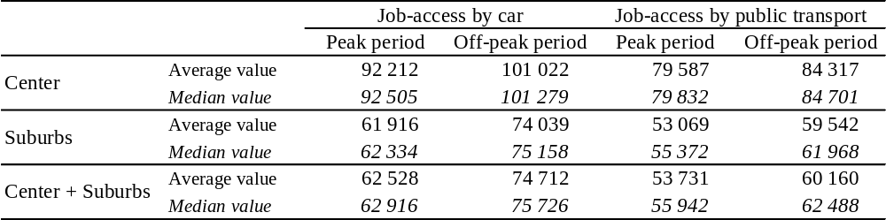
Illustrations
Figure 1 : Case study area
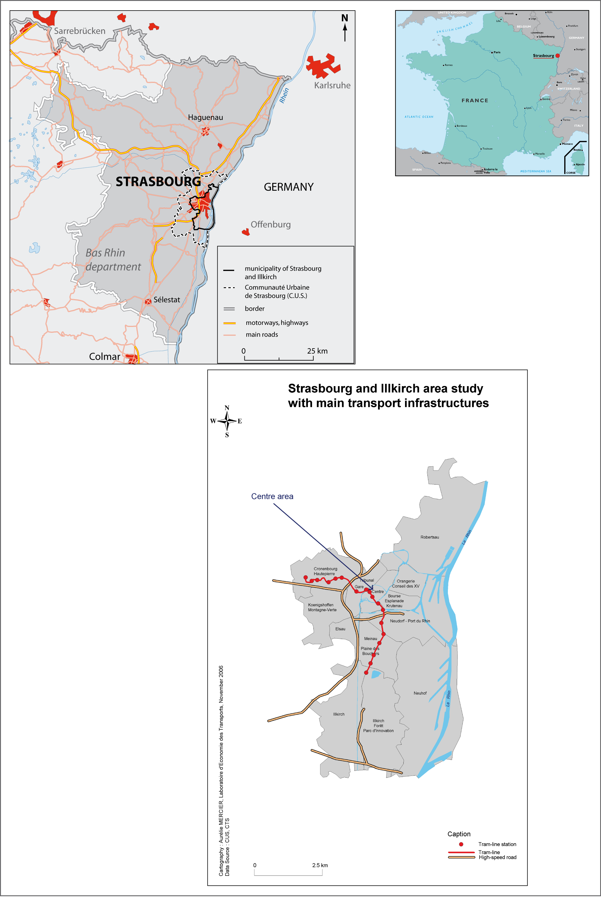
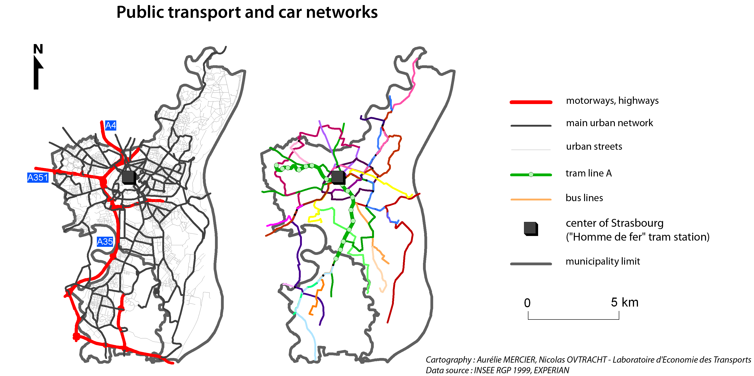
Figure 2 : Public transport and car networks

Figure 3 :Car and public transport layers
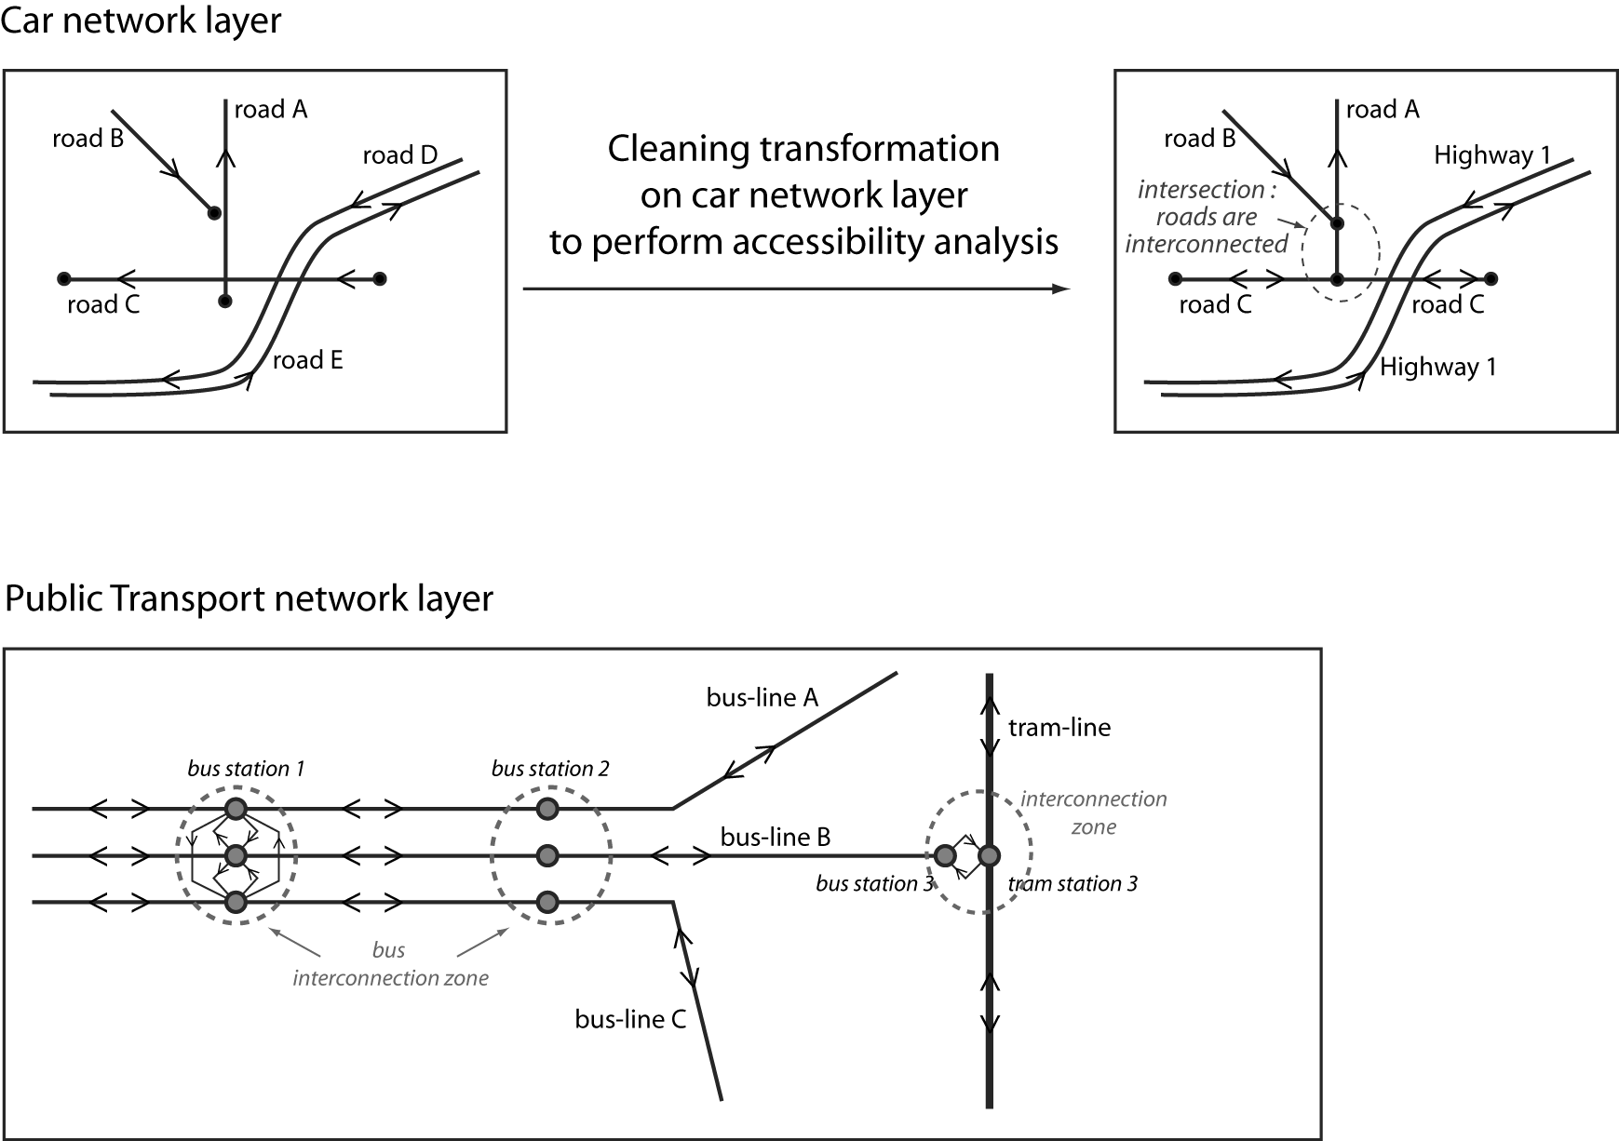
Figure 4 : Spatial distribution of population and jobs
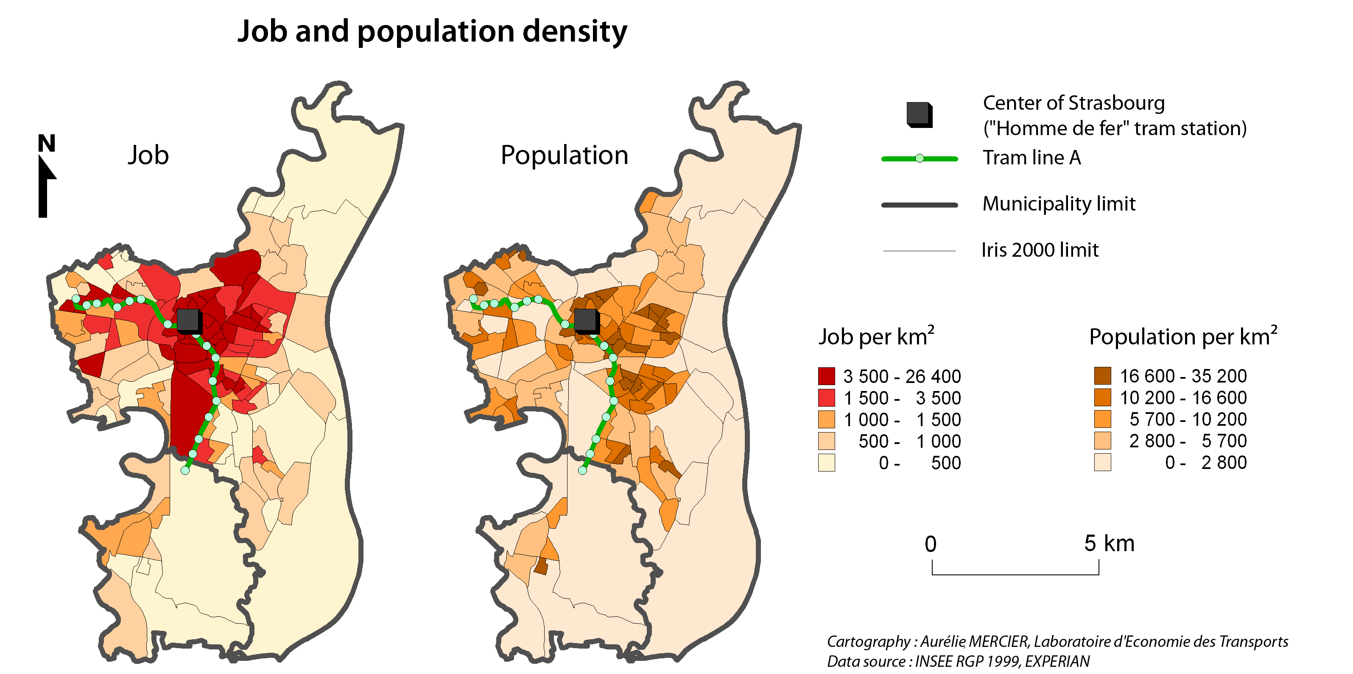

Figure 5: Job accessibility by cars and public transports


