Multi-directional pedestrian flow model based on empirical data
Miho ASANO, D. Eng.
Visiting Researcher, INRETS MSIS
2, Avenue du Général Malleret-Joinville, 94114 Arcueil, FRANCE
TEL: +33 1 47 40 70 23, FAX: +33 1 45 47 56 06
E-mail: miho_asano@yahoo.co.jp

Masao KUWAHARA, PhD
Professor, Institute of Industrial Science, University of Tokyo
Cw-504, 4-6-1 Komaba, Meguro-ku, Tokyo, 153-8505, JAPAN
TEL: +81-3-5452-6419, FAX: +81-3-5452-6420
E-mail: kuwahara@iis.u-tokyo.ac.jp

Shinji TANAKA, D. Eng.
Assistant Professor, Institute of Industrial Science, University of Tokyo
Cw-504, 4-6-1 Komaba, Meguro-ku, Tokyo, 153-8505, JAPAN
TEL: +81-3-5452-6419, FAX: +81-3-5452-6420
E-mail: stanaka@iis.u-tokyo.ac.jp

ABSTRACT

This research aims at finding characteristics of multi-directional pedestrian traffic flows based on empirical data. Recently, several pedestrian models are proposed to evaluate congestion in normal and/or evacuation situations. However, not many models are validated using observed data and even important characteristic of flow is still unknown. This research has conducted an experiment to find characteristics of congestion phenomena and microscopic behaviors of pedestrians depending on one-direction and bi-directional flow. A microscopic simulation model based on pedestrian behavior observed in the experiment is proposed. The model is tested and has shown that it represents basic characteristics of pedestrian flows.

Keywords: Pedestrian flow, Experimental data analysis, Pedestrian simulation modeling

INTRODUCTION

This paper proposes a pedestrian simulation model for multi-directional flow based on empirical data. Recently importance of walking as a trip mode and as a transfer mode between other modes has been reviewed and policies to improve pedestrian mobility are being proposed. In order to evaluate different scenarios of proposed policies, proper indices for pedestrian transport are required. For example, Highway Capacity Manual (2000) mentions some basic density-based indicators of level of service for pedestrians. However, there are still many discussions about indices for pedestrian flow. Most of these indicators could be applied only to one-directional flow, although pedestrian flow has complication such as effects of multi-directional flow or heterogeneity of pedestrians’ characteristics which should affect on flow characteristics and LOS.

One of the largest problems to find effects of such kind of complexity is limitation of number of observations. Pedestrian flow has more degree of freedom as compared to vehicle traffic flow. This means more data is required to find macroscopic phenomena of pedestrian flow than vehicle traffic. However, observed data of pedestrian flow is still limited as compared to vehicle traffic because of difficulty of observation. In the vehicle traffic, there is huge number of data detected by several different sensing technologies such as detectors or probe cars and used for analysis, while there are still very few for detection of pedestrians. In this paper, an experiment has been conducted to observe pedestrians’ behavior in congested conditions. Several different conditions such as different angles of crossings, amount of flows are tested and measured.

Moreover, even though the macroscopic phenomena of pedestrian flow are observed, there may be still more discussions for applying it to actual walking spaces. Pedestrian simulation modeling is a powerful tool for examining complicated flow conditions. That is why this paper also analyzes on the microscopic behavior of pedestrians. Based on the experimental data analysis, microscopic simulation for representing more general application is proposed. Most of the existing model decides behavior of pedestrian just based on the current speed and position of surrounding pedestrians, while the actual pedestrian considers the near future conditions of others. The proposed microscopic model includes anticipatory behavior of surrounding pedestrians. This behavior represents more efficient walking behavior as actual pedestrians.

State of arts of pedestrian flow analysis is summarized in the next chapter. Overviews of the experiment are explained in the third chapter. Then basic analysis of one-directional flow and bi-directional flow will be shown. Findings of pedestrian behavior in bi-directional flow are utilized in developing a micro-simulation. Following chapter explains concepts of the proposed model and examines its performance. Finally, conclusion and future issues will be shown in the last chapter.

STATE OF ARTS OF PEDESTRIAN FLOW ANALYSIS

Macroscopic characteristics of pedestrian flow

Basic characteristics of pedestrian flow have been discussed in the similar concepts of vehicle traffic in existing papers. Speed-flow-density relationship in one-directional flow is measured by several researchers in different conditions (for example, Older 1968, Navin and Wheeler 1969, Fruin 1971, Lam et al. 1995).

In addition to one-direction flow analysis, there are some observations in bi-directional flow. Algadhi and Mahmassani (1990) have estimated speed-density conditions in severe congested condition with bi-directional flow in Makkah. About capacity of pedestrian flow in bi-directional flow, Naka (1978) concludes that there is no large difference between one-directional and bi-directional flows because of phenomena of striping shape in bi-directional flow. According to Naka, the equilibrium condition of bi-directional flow is the case when two different directional flows make stripe so that they do not disturb movements of each other. In this condition, theoretically effects of bi-directional flow on capacity could be neglected. However, the actual flow is not always as rational as this assumption. Lam et al. (1995) calculates capacities of bi-directional flow depending on flow ratio of each direction in sidewalks. Their findings that capacity changes due to flow ratio of directions do mean an effect of mixture of directional flows. Further observations in multi-directional flow as general conditions should be still needed.

Simulations for multi-directional flow evaluation

Simulation approach for representing pedestrian flow is currently getting more and more popular. Cellular Automata model (Blue and Adler 2000, Burstedde et al. 2001, Kuepfel 2003 etc.) divides walking area into grids and set each grid to different attributes such as obstacles, walkable spaces or pedestrians. Pedestrians move from one cell to others in each time step. Because of discrete representation of walking space, Cellular Automata has difficulty in representation of capacity in different crossing angles especially with diagonal flows. Moreover, cellular automata is a rule-based model and rule sets can be more complicated to manage different conditions.

Some simulation models are able to deal with continuity of directions. Social Force model by Helbing (1995) gives “forces” between pedestrians to take distance from others and calculates acceleration of each pedestrian by mechanics equations. However, force-based model is not based on actual decision making process of pedestrians. Utility maximization model which is proposed by Hoogendoorn (2004) assumes that optimal velocities are decided by linear summation of cost for several elements of walking behaviors, such as proximity cost to other pedestrians, cost of changing directions and so on. Model of Teknomo (2006) is also based on physical representation of forces. Antonini et al. (2006) proposes a discrete choice model based on actual observed data but mainly for uncongested conditions.

Despite there are several models proposed, they does not include the prediction of other pedestrians’ behaviors in decision making process. Actual pedestrians may choose their speed and direction by anticipating positions of other people in few seconds later in order to avoid collisions. For example, suppose a pedestrian is trying to avoid another pedestrian getting across in front of him/her. He/she has some number of choices, such as reducing the speed to wait for other’s crossing, change his/her direction, and these alternatives are chosen from when he/she recognize that they have possibility of collision. Without anticipation, pedestrians can not choose their decision before they have severe conflict conditions. This may affect on the effectiveness of pedestrian flow especially in multi-directional flow with frequent conflicts.

Requirement in observation and simulation development

There are still not many observed data to find pedestrian flow characteristics in general conditions. This research conducts an experiment to know the basic phenomena of pedestrian congestions in different settings. About experimental data analysis, Daamen and Hoogendoorn (2003) have had an experiment to get congestion phenomena in several different flow conditions. Especially they analyze bottleneck capacity in the narrow corridors with this detailed observation data. Experiment in this paper is more focusing on mixture of directional flows.

In addition to understanding actual congestion phenomena, modeling of pedestrian behavior is also important. This paper discusses pedestrian simulation model based on the microscopic behavior of observed data, dealing with anticipatory behavior as explained in the previous section.

OUTLINES OF THE EXPERIMENT

This research has conducted an experiment to obtain pedestrian behaviors in congested conditions. Aim of the experiment is to get individual behavior of pedestrians and macroscopic indicators such as average speeds and densities in different flow conditions. It can be assumed that there are two different stages of pedestrian behavior when they face congestion. One is route choice or path choice to avoid congestion area itself and the other one is to avoid collision and try to pass efficiently in the congested area. The experiment does not focus on route choices but collision avoidance when pedestrians are forced to walk in congested places.

Advantages of experiments as compared to on-site observation can be summarized as follows.
- Input data such as demand rate, crossing angles can be freely set by analysts.
- Subject people could be same people in different conditions. Difference of attributes of pedestrians could be neglected.
- Environment of ideal condition for observation is available.

On the other hand, possible disadvantages are as follows. These factors should be considered in the analysis of experimental data.
- Subject people may get stressed because of experimental conditions and may not walk as they walk in usual conditions.
- Subject people may get tired or bored after long-time experiment. Their behavior may change from beginning of the experiment and the end of the experiment.

The experiment was held on 23rd of May, 2006 at Komaba research campus of University of Tokyo. The number of experimental subjects was 94 (17 of them were female). The subjects are divided into two or more groups and instructed to walk in the experimental area. The experimental area is surrounded by partitions as in Figure 1. Two patterns of inflow into the area are tested; controlled inflow and uncontrolled inflow. The controlled inflow scenario instructs the subjects to enter the experiment area following the sign-guides. On the other hand, with the uncontrolled inflow scenario, the subjects are allowed to enter the area freely without any instruction. Various ratios of flows from different directions are also tested as shown in Table 1. Crossing angle in Table 1 means the angle of direction between one flow and the other flow as in Figure 1. To collect the data, movements of pedestrians inside of the experimental area are taken by video camera as in Figure 2 and their trajectories are tracked by using an image processing technique. An example of trajectories observed in bi-directional flow (opposed flow) is shown in Figure 3. In the following chapter, analysis on one-directional and bi-directional flow, especially 90 degrees crossing is mainly discussed.

MACROSCOPIC ANALYSIS OF ONE-/BI- DIRECTIONAL PEDESTRIAN FLOW

Used data for directional flow analysis

Basic characteristics of pedestrian flow are firstly investigated. Two scenarios in Table 1 are conducted in the experiment as one-directional flow. However these scenarios are measured without bottleneck section and only the conditions under capacity levels are measured. On the other hand, congested conditions in one-directional flow are measured at upstream of crossing points in experiment of bi-directional crossing flow. Therefore, pedestrian flows in following conditions are utilized for one-directional flow analysis.
- all the subjects in scenarios of one-directional flow
- pedestrians in upstream points of crossing area in scenarios of crossing flow

Headway-speed relationships

Headway-speed relationship of one-directional flow is measured. Headway of pedestrians in this paper is defined as length between front side of subject pedestrian and front side of leader pedestrian as shown in Figure 4. Shape of pedestrians is assumed as a circle with radius of 30cm. Leader pedestrian is the nearest pedestrian among who are in front of subject pedestrian and in the width of 30cm.

Figure 5 shows headway-speed relationship in one-directional flow. This figure shows that average speed of pedestrians will decrease rapidly when headway is less than 1m. If it is not so much congested and headway is more than 1.5-2m, then headway does not affect on speeds of subject pedestrians.

Figure 6 shows the headway-speed relationship in bi-directional flow with crossing angles of 90 degrees and flow ratio of 50:50. Again the average speed tends to decrease in small headways. However, this tendency is not statistically significant.

Speed-density relationships in different crossing angles

Speed-density relationship at crossing point in bi-directional flow is shown in Figure 7. Exponential fitting function is used for each data of directional flow. The fitting function is as follows.

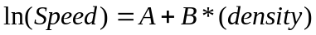 (1)

Table 2 shows the estimated parameters and confidence intervals of each parameter. Parameter B, difference of slopes of the functions, is not significantly different in different crossing angles. However, parameter A has significant difference between some cases, such as between 0, 45 and 90 degrees. The crossing angles of 0 and 180 degrees, or 45 and 135 degrees do not have differences in parameters.
This result shows that different crossing angles give effects on speed of each pedestrian. According to regression parameters, only the interrupt differs between each other. That means even in case of lower flow level speed of the pedestrians are affected in the crossing angles.

MICROSCOPIC BEHAVIOR ANALYSIS IN BI-DIRECTIONAL FLOW

Not only macroscopic relationships, but also microscopic behaviors are important to be analyzed in order to find congestion mechanisms. In this chapter, more detailed individual behavior is discussed.
図８、９の縦軸の意味を説明した方がよい。
Speed distribution of pedestrians

Figure 8 shows speed of each pedestrian at each time at crossing area in bi-directional flow with different crossing angles. Each data in figure 8 corresponds to average speed which each pedestrian inside of the crossing area has taken in certain one second. Figure 9 shows direction of velocities of each pedestrian in every second obtained by whole experiments. Speed and direction of each pedestrian in each second during whole experiments are collected and used as the population data. ‘Appearance’ in vertical access of Figure 8 and 9 means number of data among this population data.

This shows that there are not frequent directional changes rather than acceleration and deceleration. Maximum range of direction change was about 45 degrees in the experiment. This may be because the experiment is carried out in the narrow corridors with width of 3m and pedestrians did not have enough space to change directions drastically.

Behavior of changing directions

Figure 10 shows trajectories of pedestrians in bi-directional flow with crossing angle of 90 degrees. In this Figure, pedestrians only in the observed area of Figure 11 are plotted. Since the shape of the observed area in Figure 11 is a band, pedestrians may appear or disappear not only at their origins and destinations but in the middle of the walking area because of their movement to lateral direction. Direction 1 and 2 in Figure 10 indicates trajectories of pedestrians in each direction in Figure 11. Pedestrians in direction 2 crosses flow of direction 1 at crossing area of Figure 11. As in the Figure 10, pedestrians in direction 1 avoid pedestrians in direction 2 by either decelerating their speed or changing directions.

Figure 12 shows trajectories of some pedestrians in the same experiment of Figure 10. Pedestrian A avoids pedestrian B and C by changing directions in Figure 12-a and by decelerating in Figure 12-b. Pedestrian A in Figure 12-a changes direction to left at t = 5. In this time, pedestrian B and C are still in the left hand side of pedestrian A. However, they passed the conflict point before pedestrian A reaches. As a result, pedestrian A could pass through the conflict point without hitting the other pedestrians. Pedestrian A in Figure 12-b also starts decelerating at t=13. At this time, pedestrian B has already passed conflict point of pedestrian A and B, and pedestrian C has not yet arrived at the conflict point with pedestrian A. In this case, pedestrian A gave way to pedestrian C to avoid collision.

In these cases, pedestrian A tries to avoid collision with other pedestrians anticipating their position at near future, not considering current position. This behavior makes more effective flow and may affects on the capacity of bi-directional flow.

MICROSCOPIC PEDESTRIAN FLOW MODELING BASED ON BEHAVIOR ANALYSIS

In previous chapters, the headway-speed relationship and microscopic behavior of pedestrians have been discussed. However, it is still difficult to evaluate capacities especially in the application stage with complicated shape of geometries. Measurement of capacities is impossible before operation and so some simulation model is required to evaluate performance of the places.

The results of speed-headway relationship in the experiment show that the direction of movement affects on speed of each pedestrian, not just based on headways. Microscopic behavior of pedestrians in crossing section shows that the anticipatory behavior of pedestrians can be an important factor. This chapter explains a model for microscopic pedestrian behavior taking into account of the anticipation of other people’s movements.

Basic assumption of the model

The proposed model is an agent-based model which calculates velocity of each pedestrian in each time updating interval. Principles of walking behavior assumed in this model are summarized as follows:
- Pedestrians try to minimize travel time to reach their destination.
- Pedestrians avoid collision with walls and other pedestrians (as restrictions of movements)
First principle is simplified in this paper that pedestrians try to maximize walking distance toward destination in limited time T.

This model considers anticipations of movements of neighbor pedestrians for the latter principle and decides optimum velocities taking into considerations of conditions several seconds ahead from current time. Anticipatory behavior in the model has these two assumptions.
- Surrounding pedestrians take same speed and direction from current simulation time to anticipation time.
方向も変化させるのでは？
- Subject pedestrians will keep taking certain directions during anticipatory period but may change speeds.
Subject pedestrians evaluate their walking distance under these assumptions. Because they decided their velocity in each time step which is smaller than anticipatory period, they may change their direction as a result of whole simulation. Shapes of pedestrian are assumed as circles with radius of r.

Suppose a pedestrian i who has a desired velocity vector V_{fi} is walking at time t with velocity of V_{i}(t). Range of velocities which pedestrian i is possible to take is represented as sector form with maximum speed and change of directions, as shown in Figure 13. Desired speed |V_{fi}| is equal to their maximum speed, which means pedestrians do not avoid others by increase their speed. Basically pedestrians have to decide walking speed and direction at the same time though vehicles do not need to decide directions and this makes search of optimal values more complicated. In this paper, choice set of optimal direction is discretized into certain numbers of 10 to 20 in order to reduce calculation time. Searching step of optimum velocity is as follows.
V_{f}にもiのサフィックスを付ける
- Evaluate maximum walking distance from current time t to t + T in given direction and find optimum speed.
- Compare maximum walking distance obtained by 1) for each direction and find optimum direction which maximizes walking distance within time T.

Pedestrian i decides his/her own velocities considering surrounding obstacles. He/she detects walls and other pedestrians as obstacles if they are in his/her ‘search area’ as in Figure 14. Search area is also set as sector form with radius of R and angle of 2ψ.

Each subject pedestrian predicts positions of surrounding pedestrians from current time t to t + T. There are several different ways of anticipation but moving average of the surrounding pedestrians is used in this paper. Predicted positions of surrounding pedestrian j are written using average velocity of them in latest time.
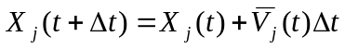 (1)
Where 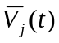 is the average speed of pedestrian j from time t – Δs to t. Δs is a period in which the average speed is taken.

Choice of walking speed of pedestrians in given walking direction

As the first step of velocity optimization, the model evaluates maximum walking distance from current time t to t + T in given direction. Let’s assume that walking direction of subject pedestrian is given to be θ. If there are no obstacles around subject pedestrians, they can walk in their desired speed during current time t to t + T in order to maximize walking distance in this period. However, because of surrounding pedestrians or walls, subject pedestrian is forced to reduce his/her speed to avoid these obstacles.

For the calculation of maximum distance, let’s introduce walking zones where are occupied by each pedestrian at any time between t and t + T in case that they walk with speed of |V_{fi}| for subject and with for surrounding pedestrians as in Figure 15. If walking zones of surrounding pedestrians are crossing with that of subject pedestrian, there are possibilities for them to collide with subject pedestrian. If subject pedestrian and surrounding pedestrian pass the crossing area of zones as in Figure 15 at the same time, only way for subject pedestrian to avoid collision is to change his/her speed due to the assumption that they can choose fixed direction θ during T. Therefore, the optimal walking strategy under θ is to maximize the walking distance with constraint that the subject cannot pass through the conflict area.

Let us call just upstream position from crossing area in zone of pedestrian i as A_{i}, and downstream position adjacent to crossing area in zone of pedestrian i as D_{i}. The time Ta_{i} for pedestrian i to pass A_{i} is calculated as follows.
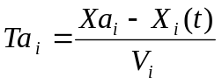 (2)
Where Xa_{i} is position vector of A_{i}. V_{i} is velocity of pedestrian i during prediction time period. If pedestrian i is subject pedestrian, his/her speed is set as free-flow speed |V_{fi}|.
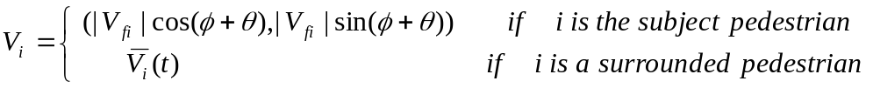 (3)
Where φ is degree from base direction x to desired direction of i as in Figure 16.

Figure 17 indicates a trajectory of the subject pedestrian i. Colored area is a period that the crossing area of Figure 15 is occupied by surrounding pedestrian j. If pedestrian i continues to walk in his/her desired speed as dotted line, i and j will make a collision. This trajectory of pedestrian i should be modified from dotted line to solid line so that the subject pedestrian does not pass the colored area. Distance L_{i}(t+T,θ) reached at time t + T in solid line is the maximum possible distance when subject pedestrian takes this direction.

Choice of optimum walking directions and speeds

L_{i}(t+T,θ) is calculated for each possible directions θ among choice sets shown in Figure 13. The subject pedestrian chooses the maximum of L_{i}(t+T,θ) so that he/she can reach as close as possible within the anticipation time period.
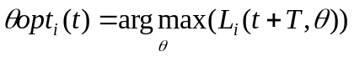 (4)

Under the given direction θopt, speed of subject pedestrian is selected. Here we assume a rule that pedestrians minimize the frequency of changing their speeds. Under this rule, the speed profile of subject pedestrian is uniformly decided as slope of solid line in Figure 17.

COMPARISON BETWEEN SIMULATION RESULTS AND OBSERVED DATA

The performances of the proposed model have been compared with the observed data. Parameters are shown in the table 3 and are selected mainly based on existing analysis. Two different types of tests are conducted. First is that pedestrians are generated as same time and position as the experiment, and the proposed model starts to be applied to only one pedestrian among them at arbitrary time. The second test is that the model is applied to all the pedestrians who are generated as same as the experiment.

Figure 18 shows comparison of speed to destination between observed and simulation data in the first examination just after the model is started. Because of the setting of desired speed V_{fi} as 1.36 m/s in simulation, speeds in simulation results are less than or equal to this value. This graph shows the velocities of simulation output have good correlation with observed data.

Figure 19 shows trajectories of bi-directional flows in the second test of the simulation. In this simulation, generation time of each pedestrians are set as the same as the experimental data shown in Figure 10. Similar to Figure 10, speed reduction and changing directions of pedestrians in direction 1 due to existence of pedestrians in direction 2 are observed.

Figure 20 shows strip shapes in bi-directional flow. It is said that pedestrians in bi-directional flow make strip-shaped groups to avoid conflicts to the other flow. Both observation data in this study and simulation data shows strip shapes of diagonal directions.

CONCLUSIONS

This paper has analyzed some basic phenomena of pedestrian flow and behavior of each pedestrian, and proposed a pedestrian simulation model. The model could represent basic flow characteristics of pedestrian flows in one-directional flow and bi-directional flows. As farther research, more detailed flow analysis from experimental data is required including flow-density relationships, effects of mixture flow in desired speed. Most of people in experimental data were students, but in the actual situation people have different walking purposes and variation of the attributes becomes huge. That leads us to do farther observation with people in different ages or different purposes.

About the proposed simulation model, verification in several different flow conditions which are not shown in this paper is required. This model only calculates velocities of pedestrians in given desired directions and does not include upper level decision making such as route choice model. Development of combined model with route choice is also a future work.

ACKNOWLEDGEMENT

This research is supported by Research Fellowships of the Japan Society for the Promotion of Science for Young Scientists.

REFERENCES

Algadhi, S. A. H. and Mahmassani. H. S. (1990). "Modelling crowd behavior and movement: application to Makkah pilgrimage." Transportation and Traffic Theory, pp. 59-78.
Antonini, G., Bierlaire, M. and Weber, M. (2006). “Discrete choice models of pedestrian walking behavior.” Transportation Research Part B 40(8), p.p. 667-687.
Blue, V. J. and Adler, J. L. (2000). “Modeling Four-Directional Pedestrian Movements.” Transportation Research Record 1710, pp. 20-26.
Burstedde, C., et al. (2001) “Simulation of pedestrian dynamics using a two-dimensional cellular automaton.” Physica A 295, pp. 507-525.
Daamen, W. and Hoogendoorn, S. P. (2003) “Experimental research of pedestrian walking behavior.” Transportation Research Record. 1828, pp. 20-30.
Fruin, J. J. (1971). "Designing for pedestrians: A level of service concept." Highway Research Record 355, pp. 1-15.
Helbing, D. and Molnar, P. (1995) “Social force model for pedestrian dynamics.” Physical Review E, 51(5), pp. 4282-4286.
Highway Capacity Manual 2000, Transportaion Research Board.
Hoogendoorn, S. P. (2004) “Pedestrian flow modeling by adaptive control.” Proceedings of Transportation Research Board Annual Meeting.
Kluepfel, H. L. (2003). “A Cellular automaton model for crowd movement and egress simulation”, Ph.D. dissertation, Falkutaet 4, Universitaet Duisburg-Essen
Lam, W. H. K., et al. (1995). "Pedestrian flow characteristics in Hong Kong." Transportation Research Record 1487, pp. 56-62.
Lam, W. H. K., et al. (2003). “A generalised function for modeling bi-directional flow effects on indoor walkways in Hong Kong.” Transportation Research Part A, 37, pp. 789–810.
Naka, Y. (1978) “Research on conflict passenger flow at railway stations”, Railway Research Report 1079. (written in Japanese)
Navin, F. P. D. and Wheeler, R. J. (1969). "Pedestrian flow characteristics." Traffic Engineering 39(4), pp. 30-36.
Older, S. J. (1968). "Movement of pedestrians on footways in shopping streets." Traffic Engineering and Control 13, pp. 160-163.
Teknomo, K. (2006) “Application of microscopic pedestrian simulation model”, Transportation Research Part F: Psychology and Behaviour, Vol 9, pp. 15-27

Table 1: Settings of experiments

Crossing angle (degree) | Total demand  （people / min / m） | Flow ratio of each direction
0 | 30，max
90 | 30，60，max | 50:50，75:25，88:12
180 | 30，60，max | 50:50，75:25，88:12
45 | 60，max | 50:50，88:12
135 | 60，max | 50:50，88:12
0,90,180（3 - direction） | 60, max | 35:35:30
0 (with different desired speeds） | 30，60 | (fast walkers：slow walkers) = 75:25，25:75
* “max” of demand means that the case without instruction of guidance to enter.

Table 2: Confidence interval of estimated parameters in speed-density relationship
Crossing angle (degree) | Parameter A |  | Parameter B
Crossing angle (degree) | Coefficient (t-value) | Confidence interval (95%) | Coefficient (t-value) | Confidence interval (95%)
0 | 0.520 (44.2) | 0.023 | -0.330 (-12.6) | 0.052
45 | 0.308 (8.9) | 0.069 | -0.315 (-11.2) | 0.056
90 | 0.429 (23.7) | 0.036 | -0.339 (-16.6) | 0.040
135 | 0.285 (13.1) | 0.043 | -0.324 (-19.4) | 0.033
180 | 0.521 (44.4) | 0.023 | -0.381 (-26.6) | 0.028

Table 3: Parameter sets of the simulation
Parameter | Value
Desired speed V_{f} | Normal distribution of average 1.36m/s, standard deviation 0.2m/s
Radius of pedestrian body r | 0.2m
Search window size for surrounding pedestrians R, Ψ | R = 5m, Ψ = 60deg
Prediction period T | 2 sec
Time step Δt | 0.2 sec
Time period to evaluate surrounding pedestrians’ speed Δs | 1 sec

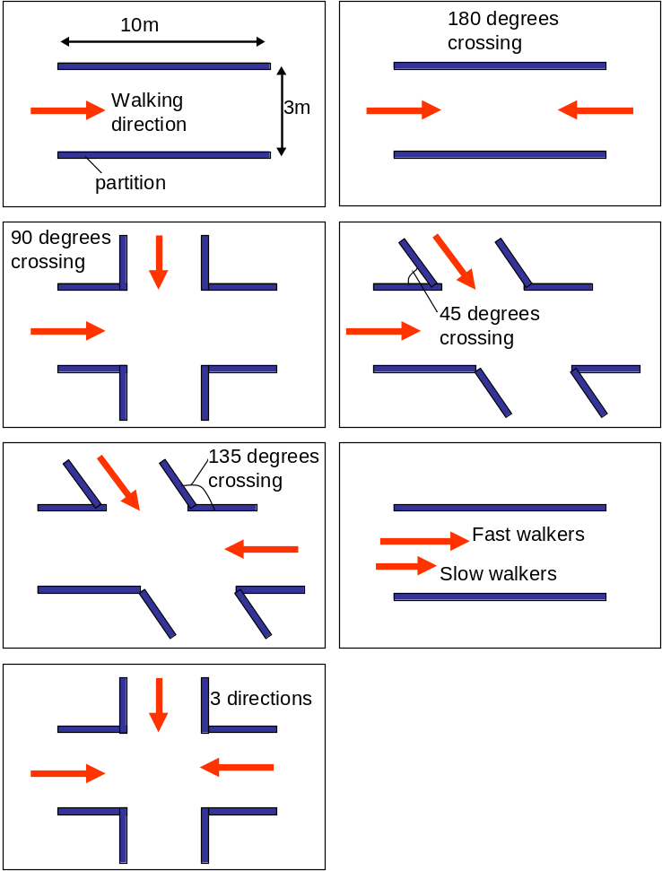
Figure 1: Patterns of experimental areas

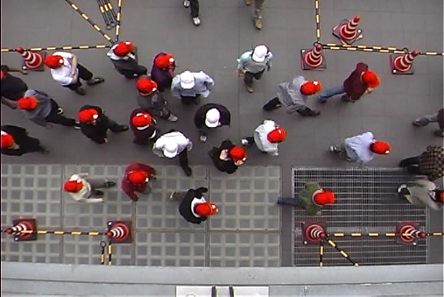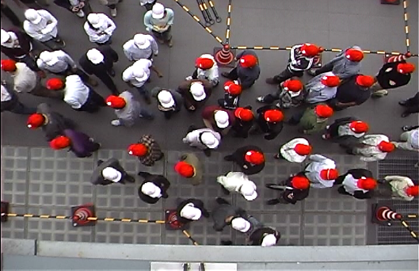
Figure 2: Snapshots of experiments

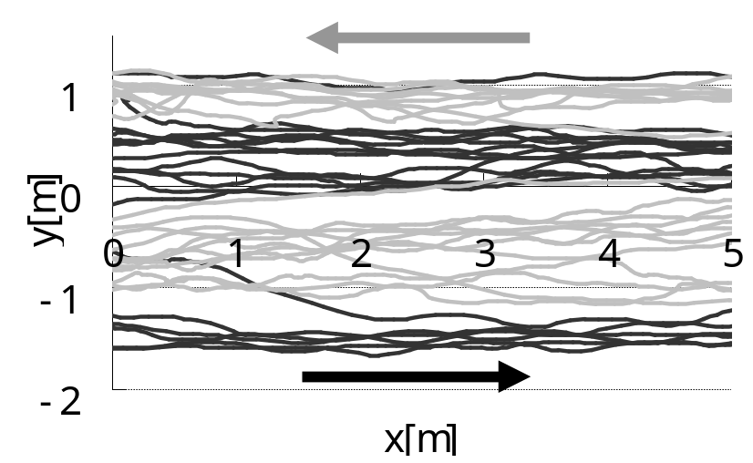
Figure 3: Trajectories of pedestrians in the experiment

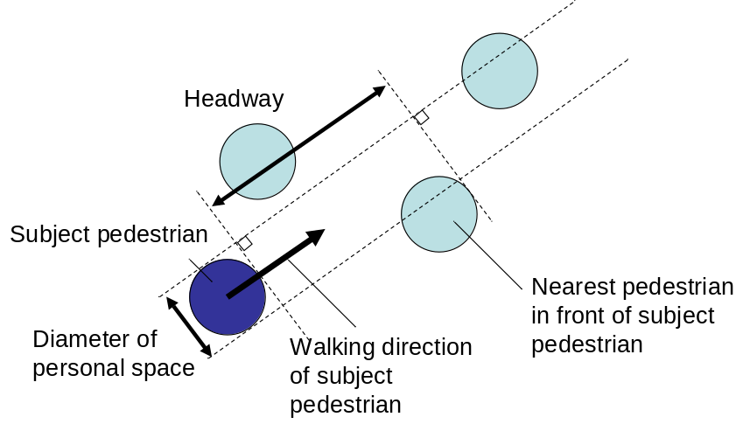
Figure 4: Definition of headway

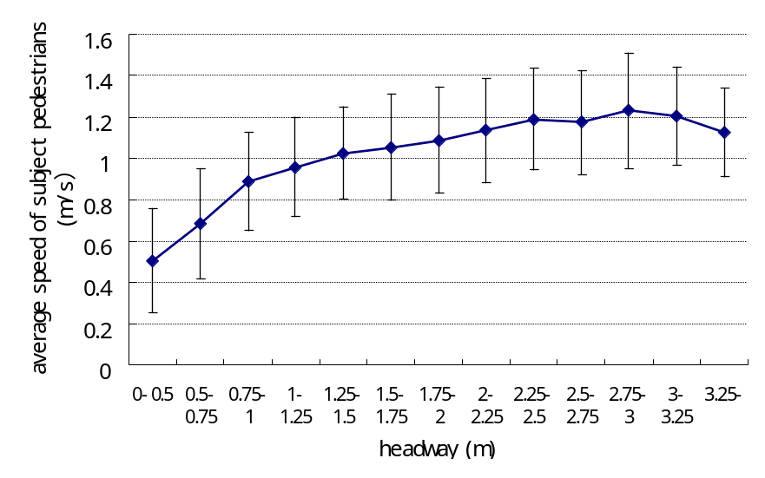
Figure 5: Headway-speed relationship of pedestrians in one-directional flow

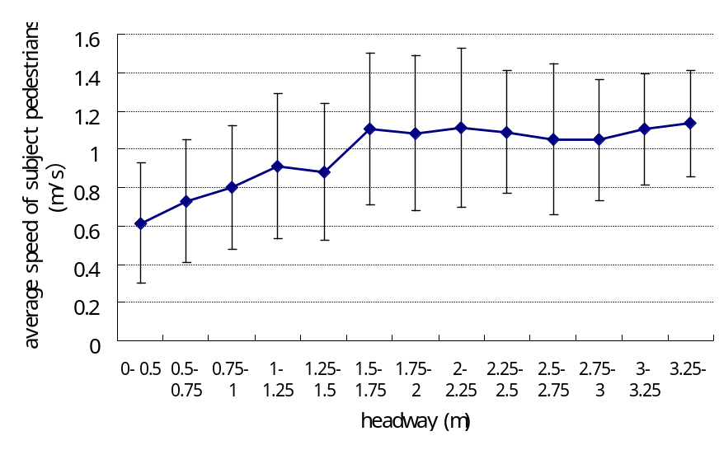
Figure 6: Headway-speed relationship of pedestrians in bi-directional flow
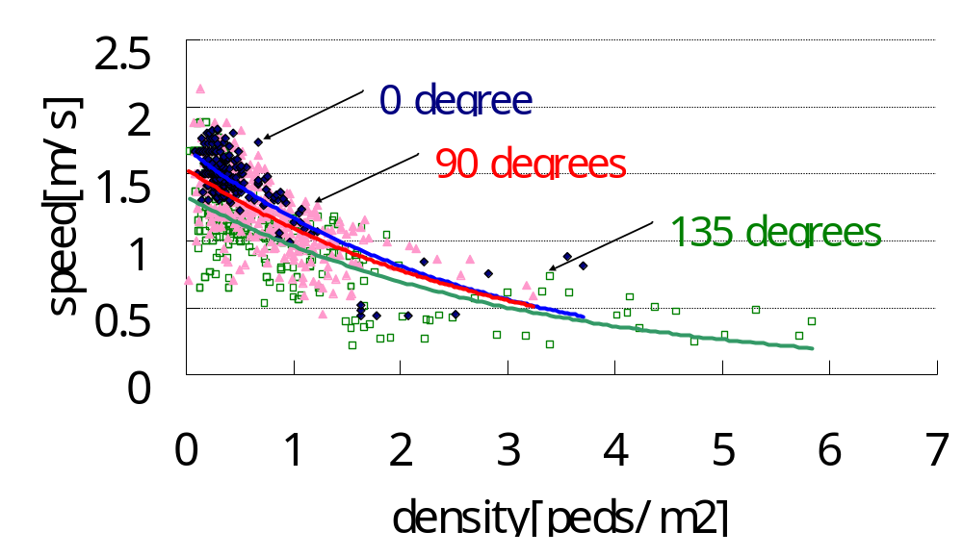
Figure 7: Speed – density relationship in different directional flows

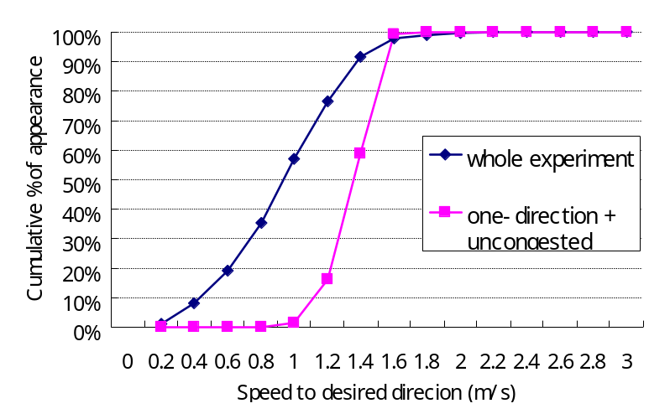
Figure 8: Instant speed distribution of pedestrians (N = 16639 in whole experiment, N = 1536 in one-directional + uncongested condition)

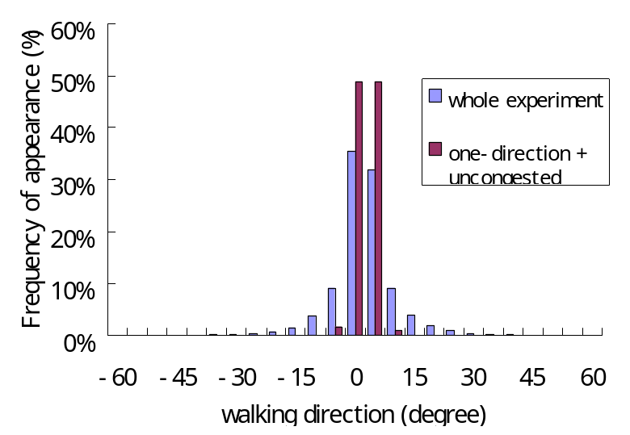
Figure 9: Distribution of chosen directions of walking velocities (right turn has positive value)
(N = 16639 in whole experiment, N = 1536 in one-directional + uncongested condition)

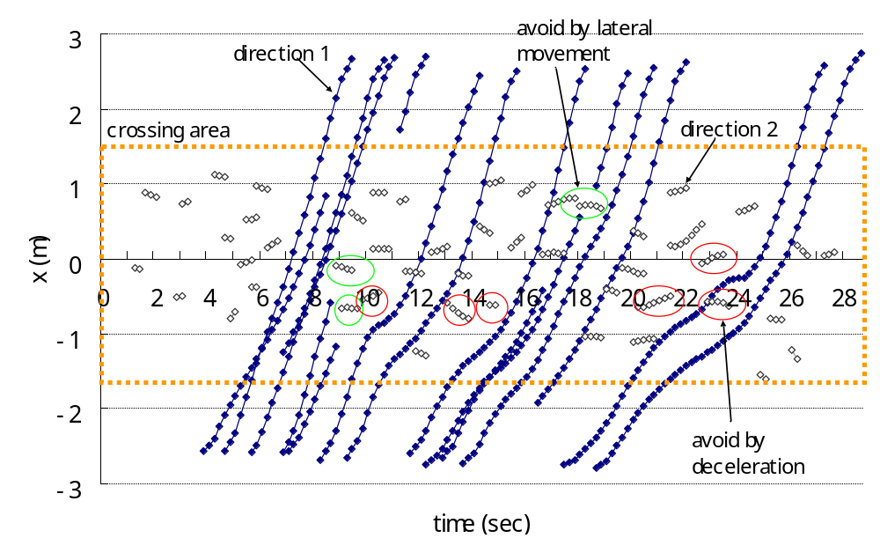
Figure 10: Trajectories at crossing area in 90 degrees bi-directional flow

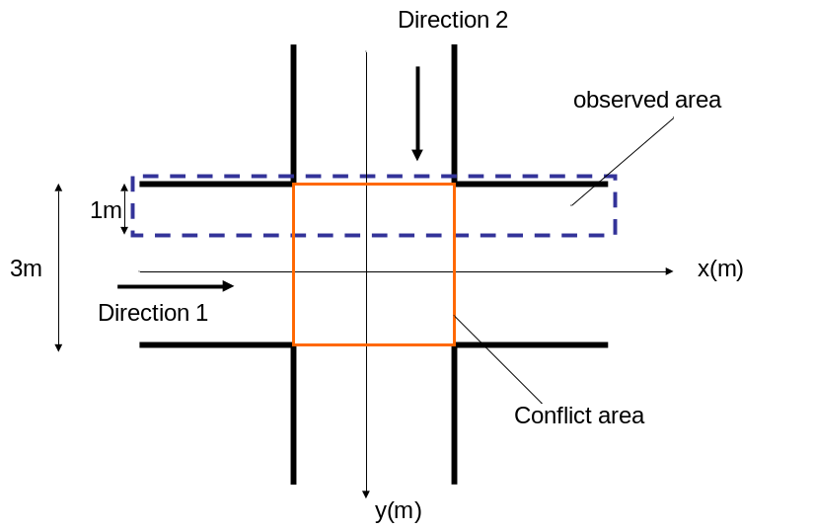
Figure 11: Area that trajectories shown in Figure 10 are measured

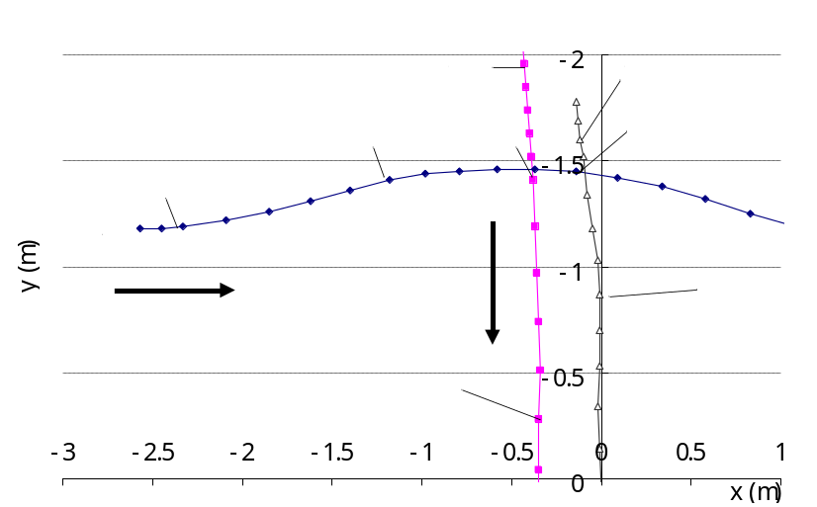
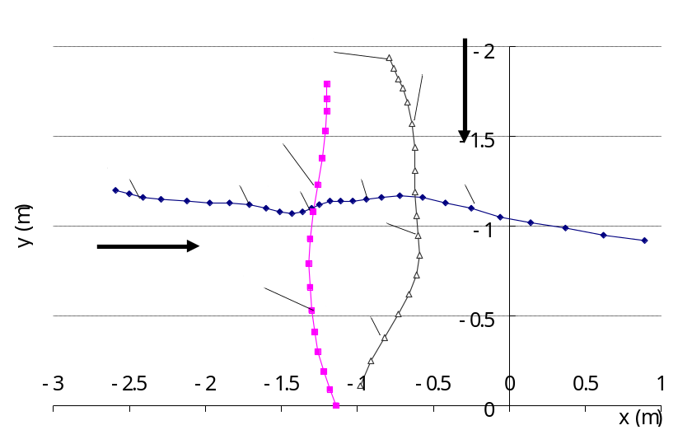
Figure 12: Trajectories of pedestrians in crossing
(12-a (above): collision avoidance by changing directions,
12-b (below): collision avoidance by deceleration)

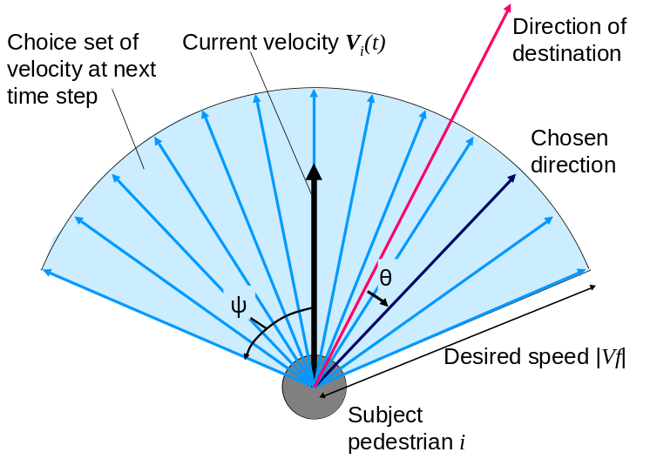
Figure 13: Range of velocities which are possible to be taken

wall
Detected pedestrians
R
ψ
Current walking direction
Subject pedestrian i
Undetected pedestrians
Searching area
Figure 14: Detection of surrounding pedestrians and walls
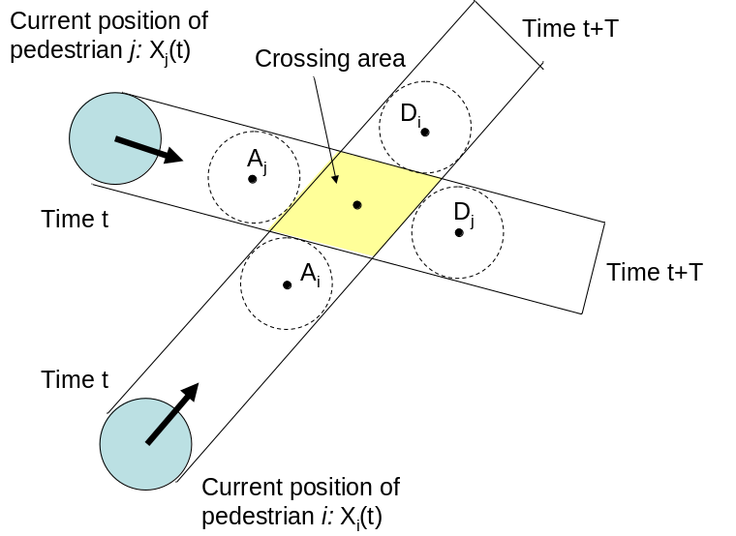
Figure 15: Crossing area of two pedestrians

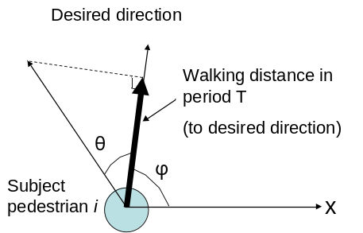
Figure 16: Evaluated walking distance toward desired direction

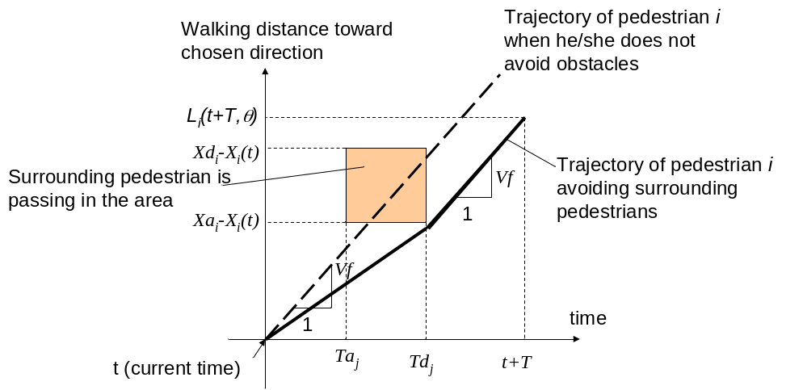
Figure 17: acceleration control in crossing behavior

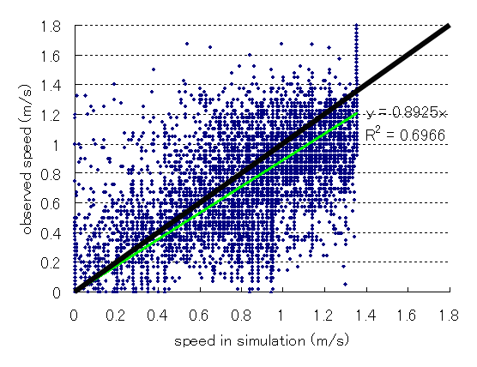
Figure 18: comparison of instantaneous speed of each pedestrian between observed and simulated

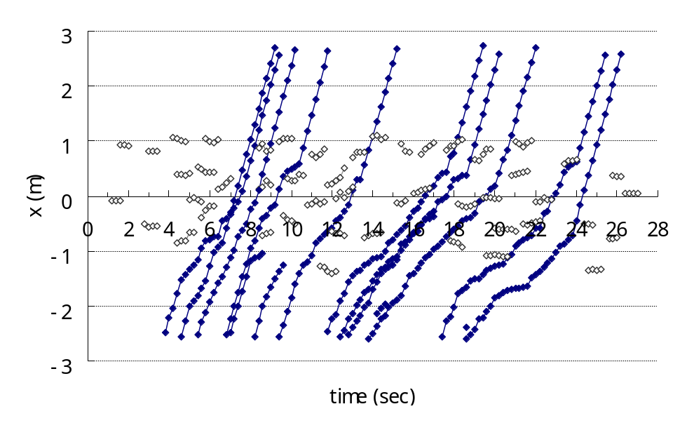
Direction 1
Direction 2
Figure 19: Trajectories of pedestrian in simulation under bi-directional flow
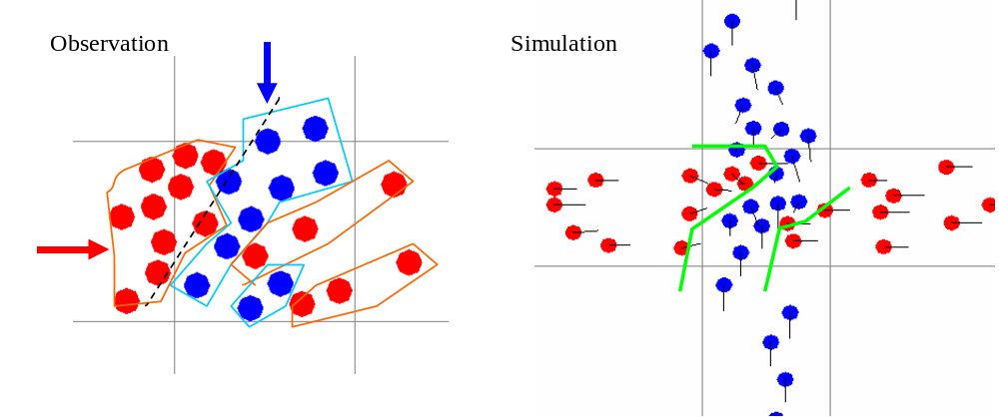
Figure 20: stripe shapes of bi-directional flow in observation and simulation

