Development of Integrated Signalized Intersection Evaluation Model
toward Realization of All-user-oriented Intersection

Kiichiro HATOYAMA* and Masao KENZAKI**

* Department of Civil Engineering, the University of Tokyo, 7-3-1, Hongo, Bunkyo-ku, Tokyo, JAPAN
** Fisheries Agency, Ministry of Agriculture, Forestry and Fisheries, 1-2-1, Kasumigaseki, Chiyoda-ku, Tokyo, JAPAN

Abstract
Long cycle times at large signalized intersections have come to be seen as a problem in Japan for reasons of environment, road efficiency and traffic safety. To solve the problem, it is necessary to consider pedestrian behavior in detail as well as vehicle movement. However, there are few simulators that are able to deal with this issue. To meet these technical and practical needs, we propose pedestrian behavior principles and an algorithm that reflects a pedestrian’s speed decision process, named PSD algorithm. Using this algorithm, we establish a new simulation system and verify it by modeling a real intersection. By simulating a reduction in cycle time, we find a significant improvement in the efficiency of vehicle and pedestrian behavior and isolate issues to be considered when putting such reductions into practice.

Keywords: Pedestrian Behavior, Signal Control, Traffic Simulation

- Introduction

  - Need for Cycle-time Shortening

Cycle times at large signalized intersections are generally quite long in Japan as compared with European countries (Ieda and Hatoyama, 2001). On arterial roads, it is common to come across intersections operating with cycle times of 140 seconds or longer. It has been thought that the longer cycle times are, the more efficiently they can utilize time in heavy traffic because they can decrease the rates of loss time caused by phase transitions. However, unless traffic is heavy, long cycle times may also have negative effects on road capacity, emotional response and even the environment. First, too long a green phase for vehicles can reduce the saturation flow rate, especially in the latter half of the phase while accumulations of right-or-left turning vehicles can reduce capacity by spilling over from extra turning lanes. Second, too long a red phase can cause irritation among both pedestrians and drivers, leading to more aggressive behavior that can induce accidents. Third, a long red phase can increase the concentration of exhaust gases emitted by stationary vehicles around intersections and also increase greenhouse gas emission because of increased travel times. All of these reasons demand that long cycle times at large intersections should be shortened if possible.
Unfortunately, a policy of reducing cycle times is hard to implement in actual practice. One of the biggest hurdles is the basic principle that adequate time for pedestrians to cross must be allowed by the pedestrian green (PG) phase if a pedestrian crossing is present (Ieda and Hatoyama, 2002). Traffic managers normally design PG in consideration of the length of the crossing and design pedestrian walking pace at 1.0m/s, which is very slow compared with the average pedestrian speed over a crossing. Even if a pedestrian refuge is provided in the middle of the crossing, this tends not to be taken into account for safety reasons. (If such island refuges were taken into consideration, it would be adequate to secure time for pedestrians to reach the islands.) Because of these two restrictions, long cycle times have remained in force and there has been hesitation to make changes. Conversely, there would be a possibility of reducing cycle times if a way can be found to achieve safer and smoother flows of both vehicles and pedestrians from theoretical and technical points of view. This means there is a need to verify the effectiveness of a policy of reduced cycle times.
* Tel.: +81-3-5841-6135; fax: +81-3-5841-8507
E-mail address: kii@civil.t.u-tokyo.ac.jp (K. Hatoyama)
** Tel.: +81-3-3502-8111; fax: +81-3-3581-0326
E-mail address: masao_kenzaki@nm.maff.go.jp
(M. Kenzaki)

  - Importance of an Integrated Simulation System for Both Pedestrian and Vehicle

To accomplish the aim of reducing cycle times, emphasis must be placed on the influence of pedestrian behavior as well as vehicle behavior. Pedestrian sentiments toward safety and comfort while crossing or waiting require particular consideration. One possible way to check the effects of cycle-time shortening is to use microscopic simulations, because there are considerable barriers to conducting experiments at real intersections. With existing microscopic traffic simulators, however, it is less feasible to simulate pedestrian behavior than to simulate vehicle behavior. Vehicle behavior is generally simulated using the Car-Following model and Lane- Changing model. In these simulators, pedestrian behavior is reproduced using the same algorithms. In reality, pedestrians typically rush to cross an intersection if the signal is about to turn red and this dynamic behavior is difficult to reproduce with existing microscopic simulators. This means that there is a pressing need to develop a simulation system that can consider pedestrian behavior in detail as well as vehicle behavior so as to measure pedestrian safety and comfort as well as impact on vehicles.

  - Objectives

Considering the practical and technical needs explained above, the objectives of this research are as follows.
- To establish a simulation system able to simulate both vehicles and pedestrians
- To verify the effectiveness of a cycle-time shortening policy

- Literature Review

Regarding the relationship of pedestrian and signal operations, many researchers have observed and experimented from the viewpoint of pedestrian behavior. Langlois et al. (1997) suggested the necessity to lengthen green time based on the behavior of elderly people. Hamed (2001) formulated a choice model to explain pedestrians’ crossing behavior considering their waiting time and existence of vehicles. Simpson et al. (2003) dealt with similar problems in virtual environments. Keegan et al. (2003) verified the effect of countdown timer units, one kind of remaining-time indicator. Several researches from a psychological perspective can also be found. Yagil (2000) explained the frequency of pedestrians’ ignoring a traffic light using a questionnaire asking about social norms and traffic conditions. Sisiopiku et al. (2003) discovered pedestrians’ preference on various crossing facilities to check the necessity of pedestrian crossing. There are, however, fewer researches that aim to shorten cycle times since it is quite common to use shorter cycle times in European countries.
Many researchers can be found in the field of traffic simulation system development. The details will be discussed later in Section 4.

- Principles of Pedestrian Crossing Behavior

As mentioned above, simulation systems for vehicles have been developed and applied to practical use in various assessments. Therefore it is highly necessary to think about detailed pedestrian behavior to develop a new simulation system for both vehicles and pedestrians. Here, some principles are proposed for expressing pedestrian behavior. Cycle-time shortening policy is expected mainly during off-peak period, and intersections are usually not so crowded during these periods. Therefore, the relationship between pedestrian density and walking speed is excluded from the principles, and all pedestrians are supposed to choose their speed freely by the principles.

  - Principles with Perfect Information

Before formulating a new simulation system, it is necessary to introduce the principles of pedestrian crossing behavior brought into this research. In previous works, we have found that a pedestrian tries to design his/her walking speed by estimating the remaining green time and remaining distance, not only after entering the intersection but also before starting to cross (Sugimori and Hatoyama, 2004). By taking this behavior into account, we can suggest certain principles of pedestrian behavior. Figure 1 expresses these principles of pedestrian behavior as a time-space diagram under conditions of perfect information. If a pedestrian has full information about the signal phases of an upcoming intersection, such as remaining time of the phases, then he/she can, after seeing the signal state, select an appropriate speed somewhere between a comfortable walking speed and the feasible speed limit peculiar to him/her. A comfortable walking speed is a speed that would be adopted if there were no constraint. A feasible speed limit is the maximum walking speed that the pedestrian can adopt when rushing. Based on these two particular concepts of speed, three types of spatiotemporal zones can be defined as below.

- Comfort zone
In this zone a pedestrian is able to cross without deviating from the comfortable speed.
- Rush zone
In this zone a pedestrian cannot finish crossing without walking faster than the comfortable speed, but no faster than the feasible speed limit. The speed used must be calculated from the remaining green time and remaining distance.
- Wait zone
In this zone a pedestrian cannot reach the other side of the intersection even at the feasible speed limit. He/she approaches the intersection at the comfortable speed and waits for the next green phase.

To provide information to pedestrians about signal phase, a variety of remaining-time indicators have been adopted in various countries (Figure 2).

  - Principles with Imperfect Information

As can be understood from Figure 1, when a pedestrian is in possession of perfect information he/she does not have to vary from the selected speed after noting the signal state. In reality, however, there are lots of uncertainties in a pedestrian's ability to design a suitable speed (Hatoyama, et al., 2003). For example, it is usually difficult to estimate the remaining green time with accuracy and it is hard to maintain the comfortable speed if the pedestrian density is high. In this situation of imperfect information, a pedestrian must redesign his/her speed from moment to moment as new information is received about the remaining green time (RT) and remaining distance (RD).
Figure 3 represents a Pedestrian Speed Decision (PSD) algorithm that explains how a pedestrian changes speed step by step. If there is no remaining time indicator at an intersection, the pedestrian perceives RT very roughly until the phase changes to flashing green. In this case, RT can be expressed by a normal distribution as shown in Formula (1) below. Here, if the signal phase changes to flashing green, the standard deviation must be reduced to 0 and a pedestrian can design his/her speed more appropriately. This is an easily understandable explanation for the tendency of pedestrians to rush across an intersection when the signal is about to change to red.

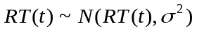 (1)

The new simulation system developed in this study incorporates this PSD algorithm as the pedestrian behavior control algorithm.

  - Pedestrian Irritation Curve

To analyze pedestrian safety and comfort, not only objective criteria, such as stopping time at an intersection, but also subjective criterion should be considered. In previous research (Hatoyama et al., 2003), pedestrians’ irritation had been taken as an important factor and the percentages of pedestrians irritated when imposed on discrete stopping time of 30, 60, 90 and 120 seconds have been observed. From this result, we can estimate a curve which represents the percentage of pedestrians that become irritated in continuous stopping time. Figure 4 shows the Pedestrian Irritation Ratio and the mathematical expression is defined in Formula (2); the correlation coefficient of this curve was 0.982. In this research, we decided to use this formula as a subjective criterion of pedestrian safety and comfort.

(2)

- Development of Traffic Simulation System that includes PSD Algorithm

The PSD algorithm is used to establish a new simulation system able to evaluate the effects of signal cycle times on pedestrians as well as vehicles as explained in this section.

  - Sample Intersections

In the evaluation process, it is essential that the constructed model be based on a real intersection so as to check whether the simulator can model the present status adequately. Therefore, the first step was to select a sample intersection. The selected intersection had to meet two requirements: substantial size with a long cycle time and readily available pedestrian and vehicle data. For this investigation, a large intersection named "Hiranobashi" in Hiroshima prefecture was chosen as a center intersection. To consider the effect of offset especially on vehicles, we decided to take the neighboring intersections into account and compare results from a simulation of single intersection with results from a simulation including the neighboring intersections. Figure 5 and Figure 6 show an overall view of the intersections and the detailed structure of the center intersection, respectively. (Actually, the center intersection of “Hiranobashi” has been classified as an intersection of high accident rate.) Operation is on a 160-second cycle time in the morning peak hour (7:00-8:00 am). Research concentrated particularly on vehicles traveling between legs A and B and pedestrians crossing between legs C and D. The flow of vehicles is approximately 2,000 per hour in each direction and that of pedestrians is 250 per hour in each direction at peak hour.

  - Basic Simulation Environment

Several types of microscopic simulators for pedestrian behavior have been proposed by recent researchers (Helbing et al., 2001; Hoogendoorn et al., 2004; Teknomo, 2006). In these researches pedestrian behavior is represented based on an economic or physical point of view. A cellular automata approach is often adopted to illustrate pedestrian movement (Dijkstra et al., 2001; Kerridge et al., 2001; Schadschneider, 2001). However, these simulators cannot deal with pedestrians’ dynamic change in walking speed. It is also difficult to combine vehicle behavior and pedestrian behavior in pedestrian crossing by these models because of their complexity. Therefore, it is more feasible to arrange a present simulator for vehicle movement that is composed of simpler but more suitable algorithms to represent pedestrians’ dynamic change. Several models of microscopic simulators for vehicle movement have already been developed (Horiguchi et al., 1994; Yoshii et al., 1995). After deliberate comparison of models, we decided to develop a new simulation system using a simulator known as AIMSUN developed by Transport Simulation Systems (TSS) of Spain. This simulator adopts the Car-Following model, Lane-Changing model and Gap-Acceptance model for vehicle behavior while pedestrian behavior can be represented by the same models. Therefore, pedestrians are basically represented as small vehicles that move in several narrow lanes. However, AIMSUN is differentiated from other similar products in that users are free to configure it in great detail, so it is also possible to incorporate the PSD algorithm. Figure 7 illustrates the appearance of the simulation.

  - Validity Evaluation of PSD Algorithm

After developing the new simulation using AIMSUN, the validity of the PSD algorithm had to be checked. Using video data collected on September 13, 2005, we first measured the actual speed of pedestrians. Removing instances in which a pedestrian was obviously rushing, we obtained a distribution of pedestrians’ comfortable speeds. The mean value was 5.38 km/h and the standard deviation was 0.62 km/h. We also calculated the mean value of rushing speed, or feasible speed limit, obtaining a value of 9.67 km/h. From these results, we set the feasible speed limit at 180% of each pedestrian’s comfortable speed. Figure 8 shows the distribution of actual pedestrian speeds within the intersection, along with simulations obtained both with and without PSD. There is no significant difference between the actual distribution and the results obtained with PSD in perfect information (t =1.08, p >0.1) whereas, in imperfect information, there is a considerable deviation between a simulation with PSD and without PSD (t =5.62, p <0.01 and t = 2.41, p <0.05). From this result, the speed distribution of pedestrians in the intersection is reproduced better with PSD in perfect information than the others. Although there is no information provided in reality, it is safe to say that the pedestrians could easily forecast the remaining time of the intersection since the cycle time was fairly constant in daytime and the pedestrians could keep a clear sight of the signal from substantial distances as well.

  - Simulation Case Design

To verify the effectiveness of a cycle-time shortening policy on both pedestrians and vehicles, we set up a total of five different phasing plans. The plans at Hiranobashi intersection are shown in Table 1. These plans are for vehicles and pedestrians moving between C and D. For each plan, we placed a pedestrian refuge island at the center of the crossing. In the simulation, a pedestrian stops at the refuge only if unable to finish crossing before the red light appears. Table 2 shows the phasing plans for vehicles passing the other two neighboring intersections. Needless to say, the same cycle time is used for the three intersections in each simulation. To take into account the fluctuations in data output, we replicated the simulation 10 times for each phasing plan and calculated the averages.

- Result and Discussion

This section gives the results of the simulations and discusses the effects of cycle-time shortening on both vehicles and pedestrians. As mentioned above, we conducted both a simulation of a single intersection and a simulation including the neighboring intersections in this research. For the latter simulation, it is natural to consider the optimal offset combination between every pair of intersections. Usually the offsets are set to 0% or 50% if there is no prior direction. Since the original cycle time is set at 160 seconds and the offsets at almost 0% in the intersections here, it is safe to say we can use the offsets of 0% or 50% even in shorter cycle times. The following results of the simulation including the neighboring intersections were obtained by the simulations with optimal combinations of offsets as is shown in Table 3. The offset of Intersection B are considered as a buffer to relieve cumulative vehicles during red lights between Hiranobashi and Intersection B.

  - Effect on Vehicles

To check the influence of cycle-time shortening on vehicles, we extracted average stopping times, which indicate the average duration of vehicle stops due mainly to the signals or congestion. Figure 9 expresses the average stopping time for both directions: from A to B and from B to A. Although the difference at the cycle time of 140 from A to B is less than the others, it is regarded as a transition stage from 0% offset to 50%. In either case, it is clear that cycle-time shortening can be significant for vehicles and that stopping time falls almost linearly with lower cycle times.

  - Effect on Pedestrians

In contrast, the situation is very different if pedestrians are provided with perfect information about remaining green time. The average stopping time for pedestrians with perfect information is indicated in Figure 10. In addition to stopping time, the percentage of irritated pedestrians can be calculated by using Pedestrian Irritation Ratio, also illustrated in this figure. From these results, the fall in stopping time and pedestrian irritation continues even with severe cycle-time shortening. It can be concluded that a cycle-time policy can be made acceptable to pedestrians by providing them with detailed information because the simulations assumed existence of information about signal phases.
This research also considers a pedestrian safety perspective. Figure 11 summarized the speed distribution of pedestrians for each cycle-time setting. (Because of its similarity in shape, the case of 140-second cycle time is omitted from this figure.) From this comparison, it is clear that for cycle times of 120 seconds or more, the distribution is fairly similar, especially in the lower speed ranges. On the other hand, if the cycle time is around 100 seconds, pedestrians with a lower comfortable speed are forced to rush. Finally, if the cycle time is 80 seconds, slower pedestrians can keep walking slowly to stop at the refuge and faster pedestrians, particularly those walking at more than 5 km/h, can get across the intersection by accelerating. From these findings, it can be said that there exist some cycle-time settings that compel lower-speed pedestrians to rush. It is necessary to consider this in designing cycle times from the pedestrian safety perspective.

- Conclusion and Future Work

The achievements of this study can be summarized as follows.

- We proposed pedestrian behavior principles for cases of perfect information and imperfect information in the form of the Pedestrian Speed Decision (PSD) algorithm.
- We established a new simulation system incorporating the PSD algorithm that can deal with both vehicles and pedestrians and apply it to a real intersection.
- From the simulations of a real intersection, it is found that:
i. Same tendencies have been observed both in the simulation of single intersection and in simulations including the neighboring intersections.
ii. Cycle-time shortening can improve vehicle stopping times;
iii. With perfect information, the stopping time of pedestrians is also reduced with a shorter cycle time;
iv. In some cases slower pedestrians may be forced to rush.

These results partially demonstrate the validity of cycle-time shortening policy at least during off-peak period. However, it is also speculated that this policy cannot always stand and has adverse effects in some cases, such as oversaturated traffic demands, pedestrian green phases with a duration that is too short, existence of a large number of elderly pedestrians and so forth. To move this research forward in the future, it is necessary to simulate various conditions of intersections to identify when and how cycle-time shortening is implemented. It is also important to analyze a comfortable speed and a feasible speed limit in various places and conditions by video surveys to understand regional and situational characteristics of pedestrian indices.
Furthermore, extensive researches on designing safer pedestrian refuges will be necessary since pedestrians will surely use pedestrian refuges more if cycle-time shortening policy is implemented. Finally, carrying out experiments at real intersections is also inevitable before full-fledged reformation. This will verify these findings, indicate how intersections should be designed in terms of structure, cycle time and provision of time information, and enable cycle-time shortening policies to be brought into practical use.

Acknowledgement

We would like to express our sincere gratitude to Prof. Akimasa Fujiwara and Prof. Zhang Junyi, Hiroshima University, and Katsuya Babazono, UDEC Inc., for the sufficient technical assistance. We would also like to make an acknowledgment to the Hiroshima Prefectural Police, Hiroshima National Highway Office, and the Ministry of Land Infrastructure and Transport for the cooperation for data collection.

References

Dijkstra, J., Jessurun, J., Timmermans, H., 2001. A Multi-Agent Cellular Automata Model of Pedestrian Movement, Pedestrian and Evacuation Dynamics, pp.173-179.
Hamed, M. M., 2001. Analysis of pedestrians' behavior at pedestrian crossings, Safety Science, 38, pp.63-82.
Hatoyama, K., Shimomura, S., Ieda, H., 2003. Pedestrian- oriented intersection design by the concept of spacio- temporal informativity toward effective cycle time shortening, Journal of EASTS, EASTS, pp. 2565-2580.
Helbing, D., Farkas, I. J., Molnar, P., Vicsek, T., 2001. Simulation of Pedestrian Crowds in Normal and Evacuation Situations, Pedestrian and Evacuation Dynamics, pp.21-58.
Hoogendoorn, S. P., Bovy, P. H. L., 2004. Pedestrian route-choice and activity acheduling theory and models, Transportation Research Part B, 38, pp.169-190.
Horiguchi, R., Katakura, M., Akahane, H., Kuwahara, M., 1994. The Case Studies of the Traffic Assessment Using ‘AVENUE’, IATSS Research, Vol. 18, No. 2, pp.76-79.
Ieda, H., Hatoyama, K., 2002. Experimental study on signalized intersection design toward aging society from pedestrians’ viewpoint, Journal of Traffic Engineering, JSTE, Vol. 37, No. 6, pp. 51-60.
Ieda, H., and Hatoyama, K., 2001. Toward a comprehensive signalized intersection design for the aging society considering pedestrians’ viewpoint, Transportation Science Society of the Philippines (TSSP) Proceedings of 9th Annual Conference (CD-ROM).
Keegan, O., O'Mahony, M., 2003. Modifying pedestrian behavior, Transportation Research Part A, 37, pp.889-901.
Kerridge, J., Hine, J., Wigan, M., 2001. Agent-based modelling of pedestrian movements: the questions that need to be asked and answered, Environment and Planning B: Planning and Design, Vol.28, No.3, pp.327-341.
Langlois, J. A., Keyl, P. M., Guralnik, J. M., Foley, D. J., Marottoli, R. A., Wallace, R. B., 1997. Characteristics of Older Pedestrians Who Have Difficulty Crossing the Street, American Journal of Public Health, Vol.87, No.3, pp.393-397.
Schadschneider, A., 2001. Cellular Automaton Approach to Pedestrian Dynamics – Theory, Pedestrian and Evacuation Dynamics, pp.75-85.
Simpson, G., Johnston, L., Richardson, M., 2003. An investigation of road crossing in a virtual environment, Accident Analysis & Prevention, 35, pp.787-796.
Sisiopiku, V. P., Akin, D., 2003. Pedestrian behaviors at and perceptions towards various pedestrian facilities: an examination based on observation and survey data, Transportation Research Part F, 6, pp.249-274.
Sugimori, S., and Hatoyama, K., 2004. Analysis on pedestrian behavior considering spaces before the crosswalk, Proceedings of 30th Conference of Infrastructure Planning Committee, JSCE, No.171 (CD-ROM).
Teknomo, K., 2006. Application of microscopic pedestrian simulation model, Transportation Research Part F, 9, pp.15-27.
Yagil, D., 2000. Beliefs, motives and situational factors related to pedestrians' self-reported behavior at signal-controlled crossings, Transportation Research Part F, 3, pp.1-13.
Yoshii, T., Kuwahara, M., 1995. SOUND: A Traffic Simulation Model for Oversaturated Traffic Flow on Urban Expressways, Preprint at 7th World Conference on Transportation Research, Sydney.

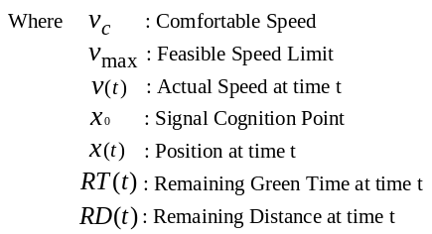
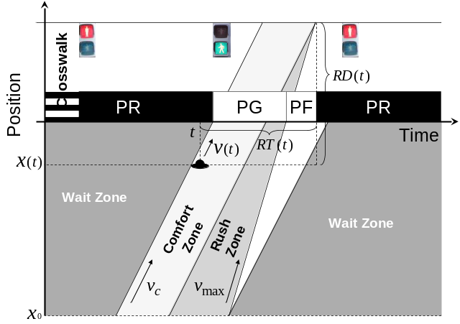
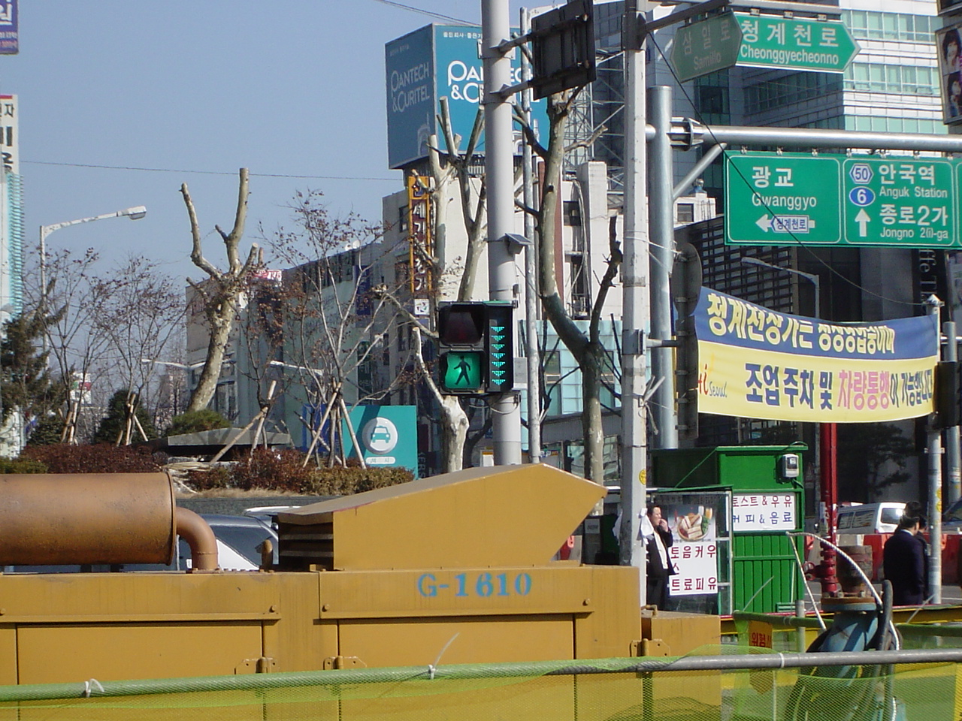
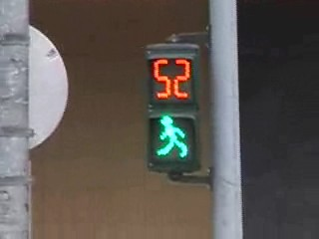
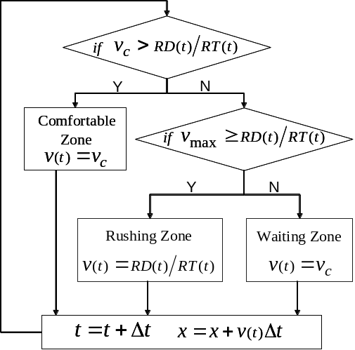
Figure 1: Pedestrian Behavior Principle under Perfect Information

Figure 2: Remaining Time Indicators in Seoul and Taipei
Figure 3: Algorithm for Pedestrian Speed Decision at time t
under Perfect Information

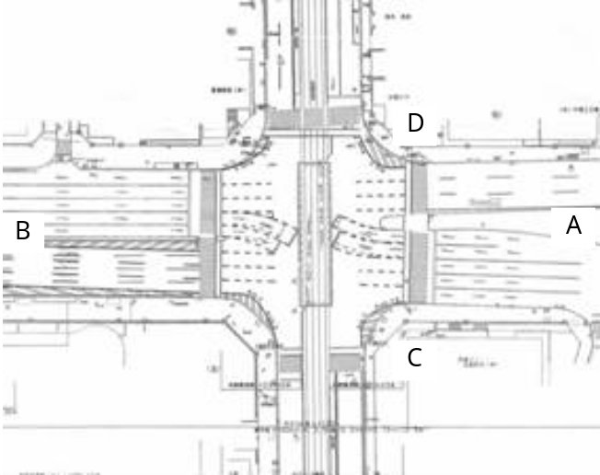
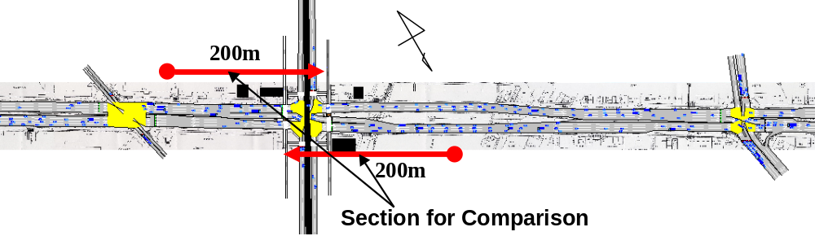
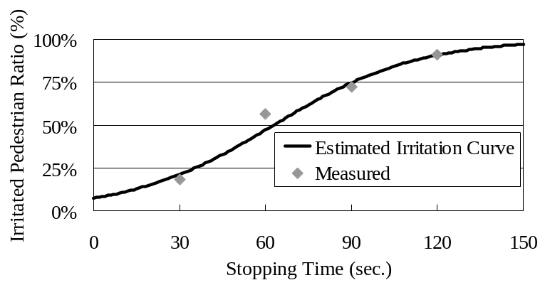
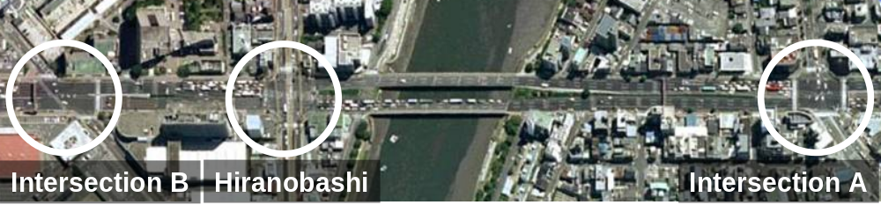
Figure 6: Detailed Structure of Hiranobashi Intersection

Figure 7: Scene of the Simulation with PSD Algorithm by AIMSUN

Figure 4: Relationship between Stopping Time and Irritated Pedestrian Ratio

Figure 5: Hiranobashi and Neighboring Intersections (from Google Earth)

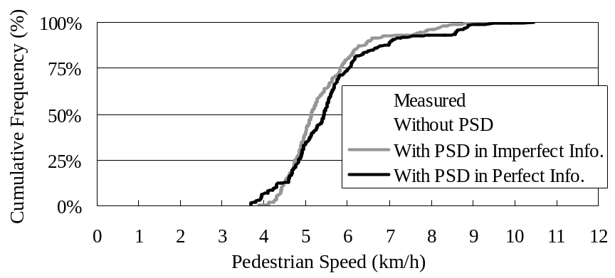
Figure 8: Comparison of Speed Distributions
Table 1: Phasing Plans of Hiranobashi Intersection
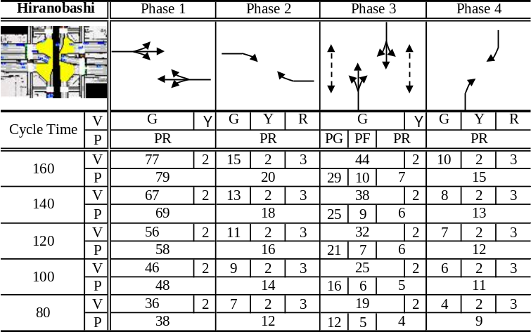
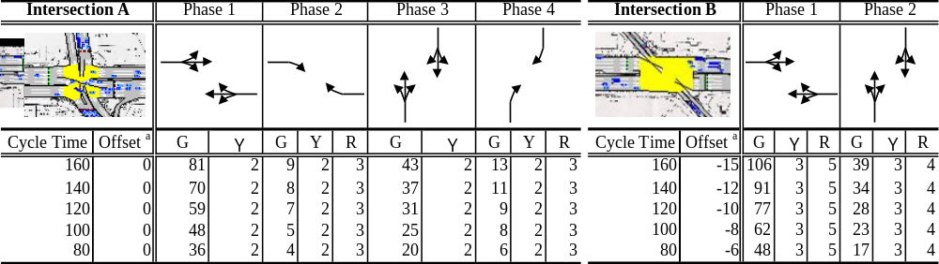
Table 2: Phasing Plans of Neighboring Intersections
ª The offsets are determined as a difference from Hiranobashi Intersection.

Table 3: Optimal Combination of the Offsets
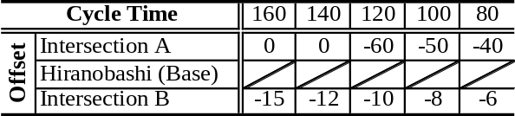

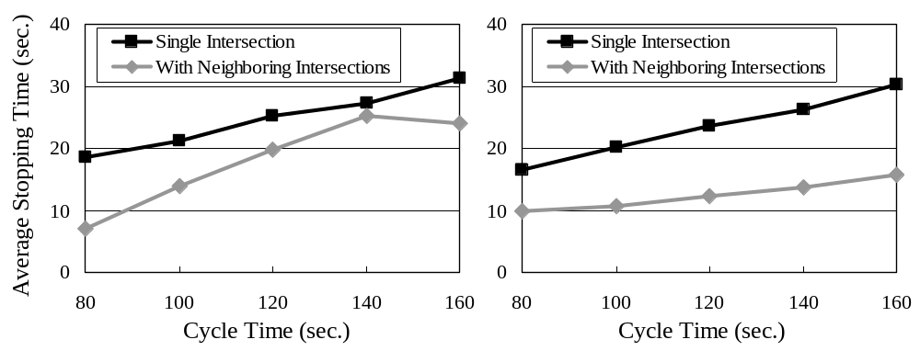
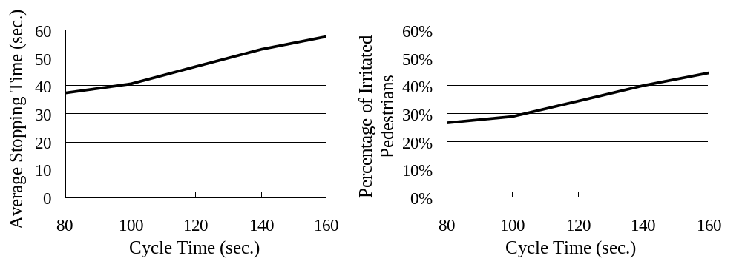
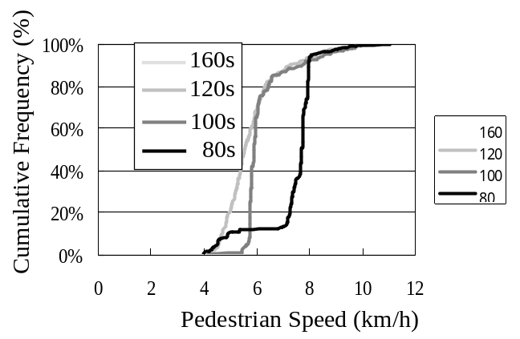
(a) From A to B (b) From B to A
Figure 9: Average Stopping Time of Vehicles in each Cycle Time

(a) Average Stopping Time (b) Percentage of Irritated Pedestrians
Figure 10: Relationship between Pedestrian Criteria and Cycle Times
Figure 11: Pedestrian Speed Distribution in Each Cycle Time

