Topic Area:
B4 Urban Goods Movement

Abstract Number:
1044

Authors:
Francesco Russo, Antonio Comi and Antonio Polimeni

Title:
A macro-model to analyze shops’ restocking services

Abstract:
This paper, recalling a modelling system proposed by the authors, analyses the shop’s restocking services in a metropolitan areas. The proposed model system aims at analysing the aspects for freight shipments to retailers inside urban or metropolitan areas and a modelling system is specified.
The analysis of the movement for which the decision-maker is the retailer is detailed. In particular, the paper presents the results of a specific macro-model inside the outline of a general modelling system proposed by the authors in previous studies where the freight urban mobility is analyzed. The freight transport multi-step model used considers a disaggregated approach for each decisional level.
The focus of the paper is on the step required to convert the quantities into vehicles. This step (vehicle level) is modeled as: Service macro-model, the model receives as input the demand in quantity for macro-area (demand in freight quantity for each macro-area) and gives as output quantity, zone and vehicle needed for restocking; Path macro-model, the model receives as input the demand in vehicles and gives as output the departure/arrival time and path used.

Keywords:
Urban goods movements, freight demand models, retailer’s restocking

Topic Area Code: B4
A MACRO-MODEL TO ANALYZE SHOPS’ RESTOCKING SERVICES

Francesco Russo
Department of Computer Science, Mathematics, Electronics and Transportation, Mediterranea University of Reggio Calabria, Italy
Feo di Vito, 89060 Reggio Calabria (Italy)
Tel: +39 0965 875 232
Fax: +39 0965 875 214
e-mail francesco.russo@unirc.it

Antonio Comi
Department of Civil Engineering, Tor Vergata University of Rome, Italy
Via del Politecnico 1, 00133 Rome (Italy)
Tel: +39 06 7259 7059
Fax: +39 06 7259 7060
e-mail comi@ing.uniroma2.it

Antonio Polimeni
Department of Computer Science, Mathematics, Electronics and Transportation, Mediterranea University of Reggio Calabria, Italy
Feo di Vito, 89060 Reggio Calabria (Italy)
Tel: +39 0965 875 360
Fax: +39 0965 875 214
e-mail antonio.polimeni@unirc.it

Introduction

More than 80% of today’s road freight trips in European conurbations are on distances below 80 km and can be defined as urban or urban-regional transport (Bestufs, 2003). Furthermore, it was showed that about 50% of this quantity is managed by the retailer that decided how and from where the freight must arrive to his shop.
In literature, on urban and metropolitan freight transport, there are only studies on cases where the goods movement is decided by wholesalers and by different types of decision–makers working on distribution centres.
This study is based on movements assuming the retailer as decision-maker. In particular it presents the results of specific macro-model inside the outline of general model system proposed by the authors in previous studies (Russo and Comi, 2006). The used freight transport multi-step model considers a disaggregated approach for each decisional level.
In the commodity level the calculation of the demand is done by freight type, by o-d consumption pair and d-w restocking pair starting from socioeconomic data; in the vehicle level the determination of the mode, service, used vehicle and time as well as the route chosen for restocking sales outlets are developed.
In the following the state of the art on urban and metropolitan studies on freight distribution (section 2), and the general structure of the modelling system are recalled (section 3), and the preliminary calibration results are also reported (section 4); some conclusions are given in section 5.

State of the art

The models and methods for urban and metropolitan freight transport can be divided in two main classes: models and methods, built to estimate the freight traffic demand and flow, and those referred to manage some types of infrastructures built for optimizing the freight distribution.
The idea to use these specific infrastructures was driven by the will to introduce some logistics terminals to optimize the freight distribution. These terminals are called Urban Distribution Centres (UDCs), and so some models have been developed to define the optimal size and location, as well as to assess the impacts of their introduction. The concept of logistic terminals (multi-company distribution centres) has been proposed in Japan (Kyoto-Osaka) to alleviate traffic congestion and reduce environmental, energy and labour costs. These facilities allow more efficient logistic systems to be established and aid the implementation of advanced information systems, as well as cooperative freight ones.
References for Urban Distribution Centre location and optimal size problems can be addressed to Taniguchi et alii (1999), where a mathematical model developed for determining the optimal size and location of logistics taking into account the conditions on the road network was developed and its application to an actual road network in the Kyoto-Osaka area was reported; Crainic et alii (2004) propose a integrated urban freight transportation system and the discussion of a number of associated deployment, management, and operation issues; while scheduling and routing problems can be deepened on Thompson and Taniguchi (1999) and Taniguchi et alii (2001).
For an overview on analytical methods developed in different countries, we can refer to Ambrosini and Routhier (2001).

To summarize the main characteristics of models and methods developed for the analysis of urban goods movements, can be useful to recall some classifications proposed by different authors on the basis of different criteria. For example, Ogden (1992) proposed a classification according to moved quantities (commodity-based) or used freight vehicles (truck-based); Regan and Garrido (2000) proposed a classification with two classes: multi-step/gravity and macro-economic models. Models with a structure similar to those used for passengers belong to the first class while the macro-economic models refer to:
- spatial price equilibrium models, that simulate the production and consumption of each zone and each economic sector through price-dependent demand and supply curves (Oppehiem, 1994);
- intersectorial models, that consider an explicit representation of economic sector interdependence in order to simulate the quantity of goods produced and exchanged among different zones; they simulate the level, quantity and spatial distribution of goods traded among different zones, producing as output the Origin-Destination matrixes (Harris and Liu, 1998).

Referring to some important elements, which characterise both the input and the output and structure of each modelling system, the developed studies on urban goods movements can be aggregate according to:
- modelling structure, which concerns partial share or direct/joint models (Ogden, 1992; Taniguchi et alii, 2001) to simulate explicitly or not, and sequentially or simultaneously, the mean characteristics of the system (Abelwahab and Sargious, 1992; Holguin-Veras, 2002);
- reference unit, that can be the commodity or the vehicles (Holguin-Veras and Thorson, 2000) or deliveries (Nuzzolo et alii, 2006);
- distribution channel, if the models treat the pull or push movements; a pull movement is defined as that movement determined by the last ring of the logistic chain, and the push movement is that determined by the first ring of the logistic chain;
- aggregation level, which regards the data aggregation used for both specification and calibration of the model and for its application (from Bayliss, 1995 to Matsumoto et alii, 2005, there are a lot of criteria for this type of classification);
- user behavioural assumptions, which refers to the use of behavioural (or descriptive (statistical relations only) models;
- integration with passenger models, which are models that treat freight mobility starting from end-consumer needs (Russo and Comi, 2002) or not.

General model structure

As stated above, a specific work was developed in Italy (Russo and Comi, 2006) to define the main model structure to analyze urban freight transport and logistics.
In the following some definitions and notations, linked with Figure 1, are reported:
- {o}, set of internal zones in which the end-consumer consumes the goods and the residences and services (offices) are located; in these zones the freight is used/consumed;
- {d}, set of internal zones in which the end-consumer purchases the goods and the retailer sells; the shops are located in these zones;
- {w}, set of internal zones in which the retailer purchases some goods sold in his/her shop;
- {z}, set of zones outside the study area where the retailer can purchase the complementary goods sold in his/her shops.

In the set of possible relations among the zones reported above, two relations can be identified at urban scale: attraction and acquisition. Attraction regards the connection between zone d in which the freight is bought by the end-consumer and zone o where the freight is consumed (o-d). The attraction regards end-consumer movements. Acquisition regards the connection between zone w/z, where the retailer brings the freight and the zone d where he/she sells it (d-w/z).

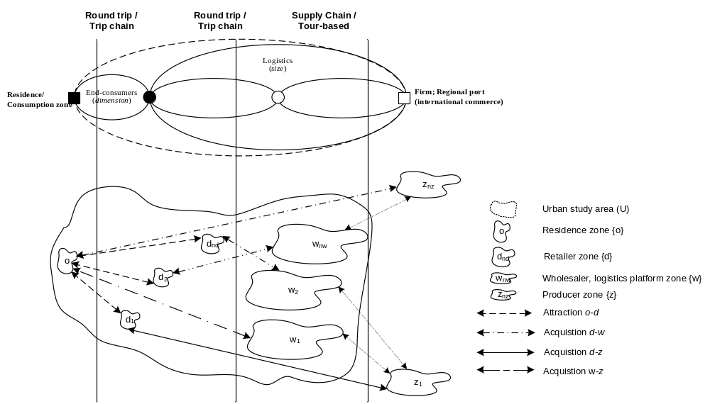Figure 1 - Definitions and notations

The decision-maker involved in the o-d process is considered the end-consumer, E. For d-w, several decision-makers can be considered who choose how and from where freight must arrive in zone d. This is investigated below. From the analysis carried out in different areas, it emerged that the main component of urban freight transport is given by the movement of some freight types in which restocking is done by retailer inside the study area. Hence, within acquisition below, we focus on the case in which restocking is done directly by retailer, r, who is also the decision-maker.
The general modelling system (Figure 2), concerns a medium-size city and considers a disaggregated approach for each decisional level:

- Commodity level
It concerns calculation of the demand by freight type, by o-d consumption pair and d-W/Z restocking pair starting from socio-economic data;
  - Attraction macro-model; this model refers to end-consumer quantities; it has as input general socio-economic data (residents, number of employees, etc.) and gives as output the freight quantity required by them (demand in freight quantity for each od pair);
  - Acquisition macro-model; this model concerns logistics trips from the retailer’s standpoint; in the literature several types of models have been developed and different decision-makers can be considered for each choice level; this model receives as input the freight quantity needed in each traffic zone d by the retailer and, analysing the restocking process, it gives the quantity that is acquired inside (zone w) or outside (zone z) the study area (demand in freight quantity for each macro-area).

- Vehicle level
concern determination of the service, vehicle and time used as well as the path chosen for restocking sales outlets;
  - Service macro-model; the model receives as input the demand in quantity for a macro-area (demand in freight quantity for each macro-area) and gives as output quantity, zone and vehicles needed for restocking;
  - Path macro-model; the model receives as input the demand in vehicles and gives as output the departure/arrival time and path used; it can be both static and dynamic; several models can be used to evaluate the probability of choosing the desired departure/arrival time and each path, considering within them the existence of a supply chain (Russo et alii, 2005).

The attraction macro-model consists of a set of elementary models that allow us to calculate, as final output, the freight quantities (disaggregated by freight type) that are consumed in zone o, purchased and thus required in d. In this approach, defined as trip-based, the models allow the o-d matrices in trips to be calculated, whether round trip or trip chaining (Russo and Comi, 2003).
The acquisition macro-model informs us whether the freight for restocking arrives from inside or outside the study area. Using the previous attraction models, the quantities of freight, disaggregated in different types s, required in each traffic zone d can be estimated.
The service macro-model allows us to analyse the restocking trip and to convert the quantity in vehicles. Finally, obtained the matrices for each vehicle type and for each w-d pair, the last step is to estimate the network flows, using the results obtainable with path macro-model.

In the following the attention is on the movements for which the decision-maker can be considered the retailer. In particular it presents the results of an acquisition and a service macro-models inside the outline described previously.

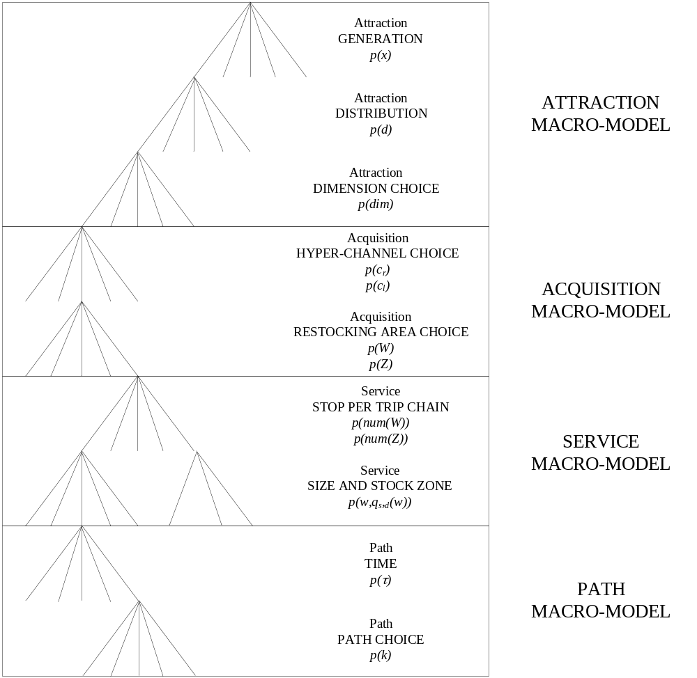Figure 2 - General modelling structure

Acquisition macro-model

In general, the acquisition macro-model informs us whether the freight for restocking arrives from inside or outside the study area. Using the previous models, the quantities of freight, disaggregated in different types s, required in each traffic zone d are estimated.
The freight leaves from producers to end-consumers and different distribution channels are used; the model gives the used distribution channel and gives from where (inside or outside the study area) the freight for restocking arrives in zone d.
When the large distribution strategy provides for the existence of wholesalers, a hyper-channel can be identified for freight distribution between wholesalers and retailers. So, two main hyper-channels may be defined:
- hyper-channel r (c_{r}); it includes all distribution channels in which the decision-maker can be considered the retailer who chooses how, where and when to go to acquire the freight for restocking d (pull hyper-channel);
- hyper-channel l (c_{l}); it includes the other distribution channels in which the decision-maker cannot be considered the retailer and in which many different decision-makers can be considered; in this case the retailer suffers the choice of other subjects involved who choose how and from where the freight must be delivered and can give some identifications regarding the delivery time (push hyper-channel).

In the case of hyper-channel r (c_{r}), the retailer can stock up in several ways in function of freight type s and the required quantity in each stop, q_{s,d}(w), and, in general, he can choose two different modalities: own account and third party transport.

The first model simulates the choices of retailer r referring the restocking modality of his/her shop.
The choice of hyper-channel is characterized by several factors:
- availability to own vehicle; the vehicle must have some characteristics to allow the transport of needed quantity for a given time period,
- acquisition place of freight; it characterizes the choice in terms of distance from selling zone d,
- type of freight; it affects the choice because bulky freight or freight that required special packages can influence its transport.

The probability p^{r}(c_{r}/ds), that the retailer with shop located in zone d, chooses the hyper-channel c_{r} for restocking of freight type s, can be expresses as:

The latter model, always in the case of hyper-channel c_{r}, allows us to simulate if the restocking is done inside (W) or outside (Z) the study area. The set of zones inside and outside the study area is called {A}={W} ∪ {Z}
The probability of a generic retailer r purchasing freight of type s, p (W/c_{r}ds), in macro-area W conditional upon being located in zone d and having chosen hyper-channel c_{r}, can be expressed as:

where W ⊂ A = {W, Z}, with W = {w} and Z = {z} and A is the set of stocking zones inside (W) and outside (Z) the study area. The choice of restocking macro-area also depends on the type of warehouse.

Service macro-model

The service macro-model allows us to analyze the restocking trip and consists of two elementary models: the stops per trip chain and the size and stock zone models. The former model estimates the number of stops made per trip in macro-area W or Z. In particular, it is possible to simulate how many warehouses are reached for each restocking trip. The second model is a joint model that calculates the size and zone of each warehouse stop.
As stated above and as demonstrated from surveys carried out in some Italian urban and metropolitan areas, it emerged that 48% of restocking is done using distribution channels in which the decision-maker is the retailer and in 46% it is effected from warehouses located inside the study area. Furthermore, in the case of self-restocking 90% of retailers supply from one traffic zone (one or more warehouses located in the same zone) and 83% of them use their own vehicles with a load capacity less than 10 m³.

Below, we focus on freight quantity of type s arriving in zone d from macro-area W using hyper-channel c_{r}, 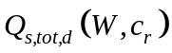, that can be calculated starting from knowledge of the output of attraction macro-model, 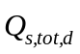 (total quantiy of freight type s attracted by zone d), as follows:

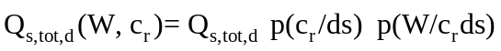

The stops per trip chain model gives the percentage (the retailer is the decision-maker)of having num(W) stops and can be expressed as:

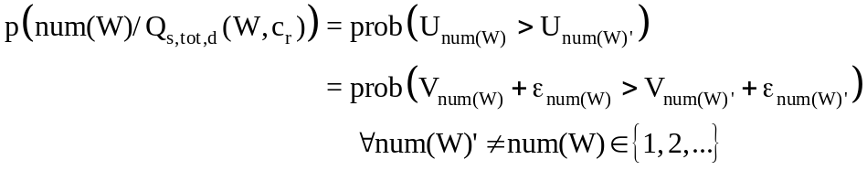

where
W is the set of zones inside the study area,
num(W) is the number of stops per trip in macro-area W.

Referring to data obtained from surveys (that will be described in the next section), this model was specified for the case in which the retailer is the decision-maker of restocking and he/she undertakes the round trip (base model). In this case, the choice set of the previous model consists of two alternatives (Figure 3):

Round trip (num(W)=1) = rt
Trip chain (num(W)>1) = tc

Round trip Trip chain
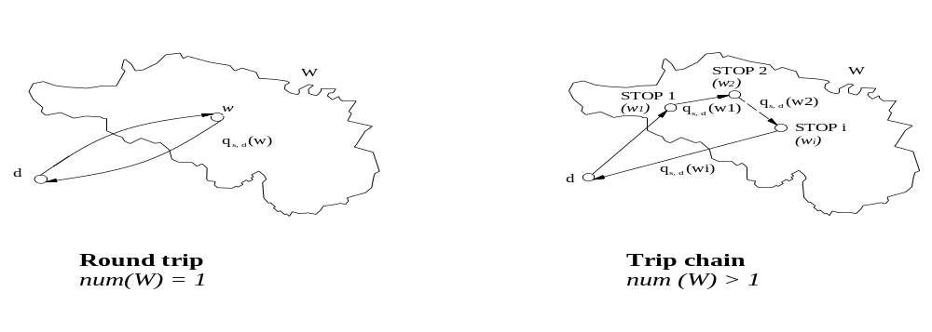Figure 3 – Example of types of restocking

The second model is the size and stock zone model. The freight quantity that is acquired from macro-zone W can be obtained in different stops done in a zone w. This model identifies the shipment size and the elementary zone (w) from where each sub-quantity, q_{s,d} (w), is acquired. It treats the choice of size and stock zone jointly; each alternative is defined by (w, q_{s,d} (w)):

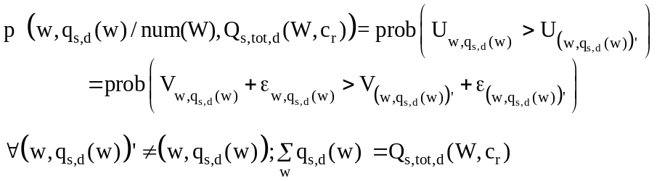

As stated above, from data collected in the surveys carried out in Italian urban and metropolitan areas, it emerges that the share (probability) of obtaining num(W)=1 is about 0.9.
Considering only the trip with num(W)=1, we can assume that decisions about stocks and zones are taken at two times and hence we have a two-step model:

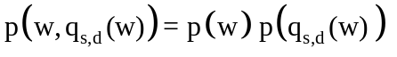

If 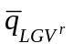 is the loading capacity of vehicle type 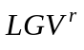, then in the case of num(W)=1 from the surveys, the probability of taking a quantity of freight in zone w is equal to the probability of loading the corresponding vehicles:

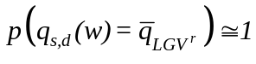,

and then the probability 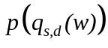 is equal to the probability that a retailer r has an vehicle, 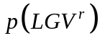:
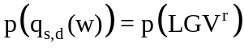
The probability, , that a retailer owns an vehicle can be expressed as:

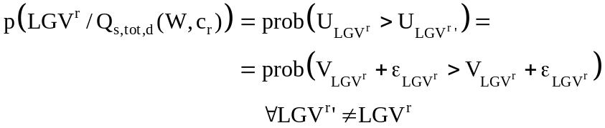

with , vehicle type with capacity .

The probability, p(w), can be expressed as:

where
w is the zone inside the study area in which the retailer purchases the goods sold in his/her shop.

Finally, it is possible to estimate the number of vehicles used by retailers of the study area to transport the freight s from w to d as follows:
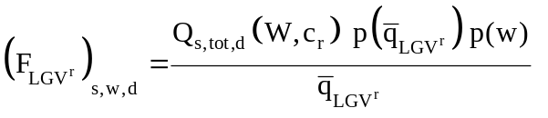
where
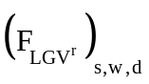 is the flow of vehicles of a retailer r from w to d for restocking freight of type s.

Specification and calibration

To test the goodness of proposed modelling system structure, some specific models are developed and in the following some results of specification and calibration phases are reported.
The dataset for calibration has been built using more than 1000 interviews to retailers carried out in the city of Reggio Calabria (Southern Italy) with a population of more than 180,000 inhabitants and in the city of Palermo (Southern Italy) with a population of more than 800,000 inhabitants. The attention was both on retail shops and on supermarkets.
The interviews allow us to know some characteristics that determine the choice of hyper-channel, acquisition macro-area and vehicle.
The interviews were carried out to have some general information on the retailer and shop as: location of the shop, dimension of shop, main type of sold freight, number of employees, average number of served customers for day and for week, availability of storing, etc.. The other part of questionnaire regards information on restocking trip and in particular if the restocking is done for own account or not, from where the freight is brought, if the restocking is done from a warehouse or directly from a producer, quantity of freight required for restocking trip and sold for week, the used vehicle, and so on. The interviews were detailed for each type of sold freight both in shop and in supermarket.
The sample of Palermo represents 14% of total wholesalers; it is composed by different size and number of employees. From the data it is possible to infer some characteristics of commercial supply: available area of each shop, loading and unloading area, schedule of loading and unloading movements, frequency and vehicles used for restocking, origins of each restocking trip (in and out of study area - city).
From these surveys (Palermo and Reggio Calabria) it emerged that about 48% of interviewees choose to do the restocking in own account and the 49% chooses the third party. The remaining 3% chooses both possibilities. The acquired quantity of freight for own account is less than what arrives to seller for third party (12 % against the 88%) and in the case of own account the used vehicle is a Light Goods Vehicle, but this statistics is highly influenced by the type of freight and the numerousness of different sold products.

The models were specified assuming that the random residuals are i.i.d. as a Gumbel variable. Under this hypothesis each previous described probability can be calculated by a multinomial logit model where the systematic utility, V, for a generic retailer r can be estimated as a linear function of some attributes, X_{i}:

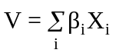

The first calibrated model is the hyper-channel model. It allow to know the probability to choose the hyper-channel c_{r} or hyper-channel c_{l}.
The systematic utility was assumed linear function of the following attributes:
- 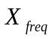, frequency that describes how many times the shop is restocked in a week;
- 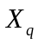, average quantity of freight of type s acquired in each restocking trip, expressed in m³;
- 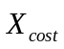, average travel cost, expressed in Euros;
- 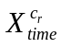, average travel time for own account, expressed in hours;
- 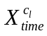, average travel time for third party, expressed in hours.

The results of the calibration are reported in Table 1. Two models are reported: one using the surveys carried out in the city of Reggio Calabria (model A) and one using the surveys carried out in the city of Palermo (model B). From the analysis of them we can observe that increasing the restocking quantity for trip and the restocking frequency, the probability to choose the hyper-channel c_{l} increases.

Table 1 – Hyper-channel model: calibration results
Attribute |  | Unit | Parameter | Model A | Model B
Frequency | 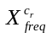 | delivery/week | 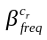 | -0.330
Quantity | 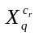 | m³ | 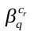 | -0.100
Travel cost | 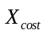 | € | 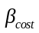 | -0.020 | -0.003
Travel time | 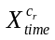 | hours | 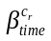 | -0.400 | -0.520
Travel time | 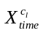 | hours | 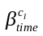 | -2.040 | -0.520

The second calibrated model is the restocking area choice model. It allow to know the probability to choose to restock inside or outside the study area referring to hyper-channel c_{r}.
The systematic utility was assumed as a linear function of the following attributes:
- 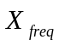, frequency that describes how many times the shop is restocked in a week;
- 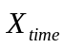, average travel time to take unit of freight inside or outside the study area, and it was estimated as weighted average respect the total restocked quantity;
- 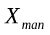, dummy variable that is equal to 1 if the restocking is done by a man, 0 otherwise;
- 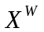, dummy variable that is equal to 1 if the restocking is done within the study area, 0 otherwise.

In Table 2, the results of the calibration for the city of Reggio Calabria are reported. In the model A, it is possible to note that increasing the restocking frequency there is an increase of probability to restock inside the study area and the same happens if the retailer is male.

Table 2 – Restocking area choice model: calibration results
Attribute |  | Unit | Parameter | Model A | Model B
Frequency | 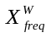 | deliveries/week | 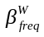 | 0.540
Travel time | 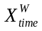 | hours | 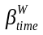 |  | -0.600 (ln)
Travel time | 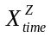 | hours | 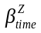 |  | -1.300 (ln)
Travel time | 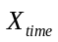 | hours | 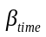 | -0.390
ASA (male) | 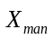 | 0/1 | 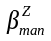 | 1.000
ASA (W) | 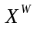 | 0/1 | 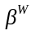 | 0.300 | 1.560

The service macro-model, described in the general modelling structure, provides jointly the choice of size shipment and stock zone. In the first phase of experimentation the two choices will be considered independently, as described in section 3:

Under these assumptions, stock zone model was investigated, specified and calibrated. It was specified assuming that the random residuals are i.i.d. as a Gumbel variable. Under this hypothesis the probability of bringing the freight from w can be expressed by a multinomial logit model where the systematic utility, 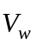, for a generic retailer r to purchase the freight of type s in zone w, can be expressed as a linear function of some attractive attributes:
- C_{time} is the natural logarithm of the travel time from/to d to/from w (in minutes);
- X_{shop} is the number of shops in each acquisition zone w;
- 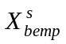 is the number of wholesale employees of freight type s in zone w;
- 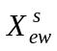 is the ratio between number of wholesale employees and number of freight warehouses of type s of zone w;
- X_{centre} is equal to 1 if zone w is in the historic centre of the area, 0 otherwise;
- X_{dwc} is equal to 1 if zones d and w are the same and are in the historic centre of area, 0 otherwise;
- 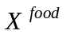 is equal to 1, just for s = food, if in zone w there is a fruit and vegetable market, 0 otherwise;
- 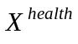 is equal to 1, just for s = health, if in zone w there are most health warehouses in the area, 0 otherwise.

Table 3 – Stock zone model: calibration results
Attribute |  | Unit | Parameter | Value
Travel time | C_{time} | hours |  | -0.73
Shops | X_{shop} |  | 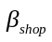 | 2.45 E-4
Wholesaler employees | 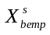 |  | 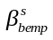 | 3.39 E-3
Average wholesale employees | 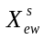 |  | 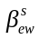 | 5.19 E-2
ASA (historic centre) | X_{centre} | 0/1 | 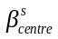 | -1.13
ASA (d = w and inside the historic centre) | X_{dwc} | 0/1 | 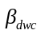 | 21.08
ASA (s = food) | 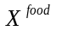 | 0/1 | 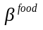 | 0.17
ASA (s = health) | 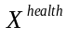 | 0/1 | 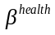 | 3.14

Parameter 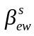 gives the dimension of warehouses of zone w and the numerical value is higher than 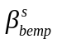; the value of parameter 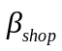 is negative because it states that zone w is a shopping zone and not an acquisition zone; the high value of parameter 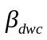 explains that in the historic centre we have many small warehouses that serve the many shops present in the city centre. These attributes were used because they give good results and are easily found in Italy. The Italian National Institute of Statistics (ISTAT) gives them for each urban area.

The probability, , that a retailer owns an vehicle can be expressed as the vehicle holding model. In literature there are different models developed for car holding, but in the knowledge of the authors there are not models proposed for truck holding. This prototypal model simulates the choice between two classes of vehicles:
- V_{L}, given by the vehicles that have a loading capacity less than 10 m³;
- V_{H}, given by the vehicles that have a loading capacity more than 10 m³.

The systematic utility was also considered a linear function of some attributes that are described in the following:
- 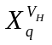, it is the natural logarithm of average quantity of freight type s moved by an employee in a week:
- 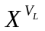, dummy variable that is equal to 1 if the holden vehicle is a vehicle that has a loading capacity less than 10 m³, 0 otherwise;
- 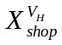, it is the available surface of shop, expressed in m²;
- 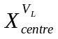, dummy variable that is equal to 1 if the shop is located in the historic centre of the city, 0 otherwise.

The preliminary results of calibration (obtained with a reduced sample that consists of about 8% of interviews described before that have all needed information), demonstrate (Table 4) that, in the case of large shops with a lot of moved freight for week and for employees, the probability to use a V_{H} vehicle increases.

Table 4 – Vehicle holding model: calibration results
Attribute |  | Unit | Parameter | Model B
Average quantity | X^{VH}_{q} | m³/(employees. week) | 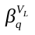 | 0.32
ASA_{VL} | X^{VL} | 0/1 | 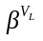 | 1.18
Dimension of shop_{p} | X^{VH}_{shop} | m² | 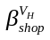 | 0.01
ASA_{centre} | X^{VL}_{centre} | 0/1 | 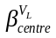 | 0.55

Conclusions
In the paper the shops restocking services when the decision-maker is the retailer are analysed. Some results of a specific macro-model inside the outline of a general model system is reported. The attention is been on the analysis of restocking trip and some preliminary results are reported. The service macro-model allows to analyze the restocking journey. The macro-model is composed by two elementary models: the stops per trip chain and the size and stock zone models. The first models allows to estimate the number of stops done per each journey in the macro-zone inside (W) or outside (Z) the study area. In particular, it is possible to know how many warehouses are reached for each restocking journey. The second model is a joint model that allows to calculate the size and the zone of each warehouse stops. Finally, from the outputs of these models the vehicles needed for restocking can be obtained.

References

Abdelwahab, W.M. (1998). Elasticities of Mode Choice Probabilities and Market Elasticities of Demand: Evidence from a Simultaneous Mode Choice/Shipment Size Freight Transport Models. In Transportation Research Part E: Logistics & Transportation Review Vol. 34 (4).
Ambrosini, C. and Routhier, J. (2001). Objectives, methods and results of surveys carried out in the field of urban freight transport: a international comparison. In Proceedings of 9th World Conference on Transport Research, Seoul, South Korea.
Bayliss, B. (1988). The Measurement of Supply and Demand in Freight Transport. Hants, England, Avebury Grower Publishing Company Ltd.
Bestufs (2003). Consolidated Best Practice Handbook. www.bestufs.net.
Crainic, T. G., Ricciardi, N. and Storchi, G. (2004). Advanced freight transportation systems for congested urban areas. In Transportation Research Part C 12, Elsevier Science.
Harris, R. I. and Liu, A. (1998). Input-output modelling of the urban and regional economy: the importance of external trade. In Regional Studies, 32 (9).
Holguin-Veras, J. and Thorson, E. (2000). An investigation of the relationships between the trip length distributions in commodity-based and trip-based freight demand modeling, In Proceedings of 79th Transportation Research Record, Washington, USA.
Holguín-Veras, J., (2002). Revealed Preference Analysis of the Commercial Vehicle Choice Process. In Journal of Transportation Engineering, Vol. 128 (4), American Society of Civil Engineers.
Matsumoto, S., Sano, K. and Wisetjindawat, W. (2005). Supply chain simulation for modeling the interactions in freight movement. In Journal of the Eastern Asia Society for Transportation Studies, Vol. 6.
Nuzzolo, A., Crisalli, U. and Comi, A. (2006). A modelling system for urban freight movements. In Proceedings of 11th International Conference of Hong Kong Society for Transportation Studies - Sustainable Transportation, Hong Kong, China.
Ogden, K. W. (1992). Urban Goods Movement. Ashgate, Hants, England.
Oppenheim, N. (1994). Urban Travel Demand Modeling. John Wiley & Son, New York.
Regan, A. C. and Garrido, R. A. (2000). Modeling Freight Demand and Shipper Behaviour: State of the Art, Future Directions. In Preprints of IATBR, Sydney.
Russo, F. and Comi, A. (2002). A general multi-step model for urban freight movements. In Proceedings of European Transport Conference - PTRC 2002, London, England.
Russo, F. and Comi, A. (2003). Urban freight movements: quantity attraction and distribution models. In Sustainable Planning & Development eds E. Beriatos, C. A. Brebbia, H. Coccossis and A. Kungolos, WIT Press.
Russo, F. and Comi, A. (2006). Demand models for city logistics: a state of the art and a proposed integrated system. In Recent Advances in City Logistics - Proceedings of the 4th International Conference on City Logistics edited by Thompson, R. G. and Taniguchi, E., Elsevier Ltd., United Kingdom, 2006.
Russo, F., Comi , A. and Vitetta, A. (2005). Calibration of generalized cost models for road freight vehicles within an intermodal chain: an experimental application in Italy. In Proceedings of European Transport Conference - PTRC 2005, Strasbourg, France.
Taniguchi, E., Noritake, M., Yamada, T. and Izumitani, T. (1999). Optimal size and location planning of public logistics terminals. In Transportation Research Part E 35, Elsevier Science.
Taniguchi, E., Thompson, R. G., Yamada, T. And van Duin, R. (2001). City Logistics – network modelling and intelligent transport systems. Pergamon.
Thompson, R. and Taniguchi, E. (1999). Routing of Commercial Vehicles Using Stochastic Programming. In Proceedings of 1st International Conference on City Logistics, Cairns, Australia.

