CALL FOR PAPERS FOR A SPECIAL SESSION ON

GENDER AND TRANSPORT NEXUS IN ASIA-PACIFIC:
achieving a more equitable and inclusive society

12th International Conference of Eastern Asia Society for Transportation Studies
in Binh Duong, Vietnam, 18-21 Sept. 2017

The Eastern Asia Society for Transportation Studies (EASTS) announces that the 12th International Conference will be held in Binh Duong, Vietnam from 18 to 21 September 2017.

Prospective authors are cordially invited to submit their contributions to a Special Session on Gender and Transport in Asia and the Pacific.

Papers in this session will aim to address and advance knowledge in the topic of gender and transport in Asia and the Pacific. The theme is designed to broaden awareness and understanding of gender-related challenges, barriers and facilitators, and opportunities in the transportation sector, including its wider global implications.

The purpose of this special session is to create stronger representation and advocacy of gender issues, particularly of women, in transportation, and increase women-initiated collaborative linkages and innovations.

Topics may include:
- Transportation needs, household structure and stage of life
- Women and Public transport
- Gender issues and integration in transport planning and policymaking
- Women and Active transport
- Women, work and the transportation Sector
- Women in Transportation leadership
- Impact of emerging technologies on gender participation and use in transportation

KEY DATES (for Reviewed Papers, Academic or Practical)
February 15, 2017 Deadline of submission of full papers
May 16, 2017 Notification of review results of full papers
July 11, 2017 Deadline of submission of revised papers
July 11, 2017 Deadline of registration for presentation at the Conference
September 18-21, 2017 the 12th EASTS Conference in Ho Chi Minh City (HCMC)

OFFICIAL LANGUAGE: English

PAPER SUBMISSION GUIDELINES can be found from this link. When submitting, submit your paper to "IRG-29-2016: Gender and transport nexus: Achieving a more equitable and inclusive society" to be considered for financial support.

FINANCIAL SUPPORT
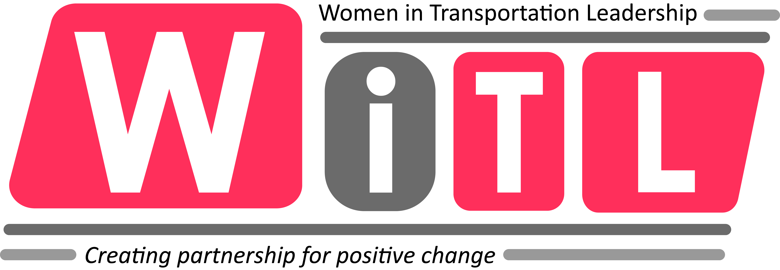
It is anticipated 3-5 authors with papers accepted to the IRG Special session will receive financial support. Proudly supported by Women in Transport Leadership Knowledge Network
www.witl.info

